Research Goal
The current proposed qualitative research will evaluate a variety of concept executions to explore both graphical and text-based communications as potential modifications to the Government 5-Star Safety Ratings section of the Monroney label (vehicle window sticker) with the intent of finding the most effective way to display information related to vehicle safety. The research will accomplish this through the following objectives:
- Evaluate the overall appeal of each concept and identify specific likes and dislikes associated with individual components of the concepts (award badges, names of designations, etc.)
- Measure the clarity and ease of comprehension for each concept and understand which visual and text features are most effective at conveying safety information
- Assess the distinctiveness of how the information is displayed and understand how best to make the safety information stand out on the Monroney label
- Identify additional areas of improvement related to the three main sections relating to safety protection, safety technology and overall performance

To achieve these objectives, we will conduct in-person focus groups among U.S. drivers ages 18 and older who are in the vehicle purchase or leasing mindset. The geographic markets are yet to be determined but will include a mix of geographies such as Arlington, Virginia; Dallas, Texas; Columbus, Ohio; and San Jose, California. Two groups will be conducted per market (for a total of eight groups). Both groups will have the same screening criteria. Due to social distancing restrictions, the Arlington, Virginia facility limits groups to six participants per group (other markets are limited to nine participants per group). Assuming those restrictions are in place when it is time to field, we will recruit eight participants to seat six per group in Arlington and, for all other markets, we would recruit a total of 14 to seat approximately nine participants per group. If restrictions are lifted, we will revise the design and recruit 14 to seat nine for all groups in all markets and adjust costs accordingly. Focus groups would last up to 90 minutes.

To ensure we are collecting data from a relevant audience, survey respondents will be screened based on the following criteria:
- Respondents must be 18 years or older.
- Respondents must currently possess a valid driver’s license.
- Respondents must be in the vehicle purchase or leasing mindset. That is, they have either purchased or leased a vehicle in the past six months, or plan to do so within the next 12 months.
- Respondents must be the primary or a shared decision-maker for vehicle purchases in their household.
- Respondents must live in one of four targeted markets (TBD).

During the 90-minute session, participants will review and discuss a variety of concept executions to explore both graphical and text-based communications included in the Government 5-Star Safety Ratings section of the Monroney label.

NOTE TO MODERATOR: When group is fully assembled, read:

This focus group is being conducted to collect information that will help us better understand your opinions about an important highway safety issue.

This collection of information is voluntary and will be used for formative purposes only so that we may develop communications programs designed to reduce the number of traffic-related injuries and deaths. A federal agency may not conduct or sponsor, and a person is not required to respond to, nor shall a person be subjected to a penalty for failure to comply with a collection of information subject to the requirements of the Paperwork Reduction Act unless that collection of information displays a current valid OMB Control Number. The OMB Control Number for this information collection is 2127-New. Your participation today in this collection of information is estimated to average 90 minutes, including the time for reviewing instructions. All responses to this collection of information are voluntary.

- Warm-up [5 minutes/5 minutes total]
  - Welcome & Introduction
    - Please have a seat. You each have a workbook in front of you. Please don’t open those until you are instructed to do so, but go ahead and write your name on the front page.
    - GO AROUND THE ROOM AND MAKE INTRODUCTIONS.
    - This evening we will be talking about how people collect and use information to help shape their purchase decision when buying a new vehicle.

- Window Sticker Evaluation – Current Design [15 minutes/20 minutes total]
Our discussion this evening is going to focus on the vehicle window sticker you would find on new vehicles. This is also known as the Monroney label, which is required to be displayed in all new vehicles that are available for sale in the United States and includes the listing of certain official information about the vehicle being sold.

Let’s take a look at an example of a window sticker. DISPLAY FULL SIZE WINDOW STICKER.

- Here’s an example of a current window sticker you would find on a vehicle. If you turn to the ACTIVITY 1 on page two in your workbook, you will see a smaller version. I’d like you to take a minute to review the version in your workbook and indicate…
  - If there are certain portions of the window sticker you would pay more attention to—please draw circles around those sections.
  - If there are any sections you find confusing, please draw a box around those sections.
  - Once everyone is done, we will have a short discussion—PROBE ON ITEMS BELOW
    - Are there certain portions of this sticker you pay more attention to than others? Why?
    - Are there any sections you find confusing? If so, which ones, and why?
    - GO BACK AND PROBE ON THE 5-STAR SAFETY RATINGS SECTION IF IT DOESN’T COME UP IN DISCUSSION.

- Now let’s focus on the right side of the sticker, which has information relating to safety ratings. Please take a minute and complete ACTIVITY 2 on page three of your workbook.

  - What are your reactions to this section of the label? Is that a positive/negative?
  - Is the information related to safety displayed in a way that is clear and understandable?
  - How well does the information in this section grab your attention?
  - What are your reactions to the size?
  - What are your reactions to the black and white color?
  - Are there other places or sources, beyond the window sticker, where you might look for 5-Star Safety Ratings?
  - There is limited space on the window sticker and it currently shows high-level information related to vehicle safety – imagine that you could also access more detailed information related to vehicle safety on a government sponsored website. Would having two different types of information, one more high-level on the window sticker and one more detailed on the website be helpful or confusing? Explain

NOTE: ROTATE ORDER OF ALTERNATIVE DESIGNS A, B & C BETWEEN GROUPS

- Window Sticker Evaluation – Alternative Design A [20 minutes/40 minutes total]
Let’s take a look at a different way of displaying the safety information. Please turn to ACTIVITY 3 on page four in your workbook and take a minute to review the information in this section carefully.
PLACEHOLDER FOR ALTERNATE DESIGN A - (LABEL 1 VERSION 1A – AWARDED)
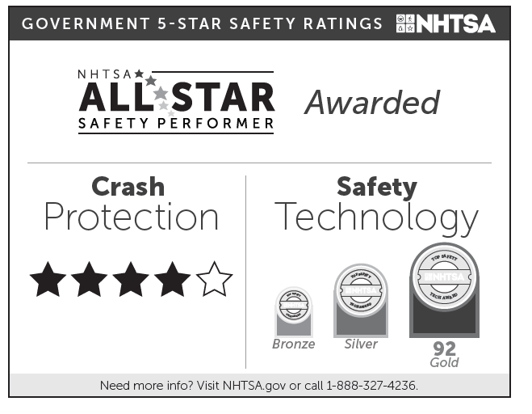

- While you are reviewing the information in this section, I would like you to…
- Please draw a circle around the information that would be helpful to you when purchasing a new vehicle.
- Please draw a box around any parts you find unclear or confusing.
- Answer the questions below the image on page four in your workbook. Once everyone is done, we will have a short discussion.

- DISCUSSION – Let’s talk a little bit about this concept.
    - Thinking about this concept overall, what are your reactions? Is that positive or negative?
    - Is the information related to safety displayed in a way that is clear and understandable?
      - Looking at the information shown in this concept, would you consider this to be a safe vehicle? Tell me why/why not.
    - What do you think about the types of information displayed?
      - Is it clear that there are different types of safety information?
        - PROBE: What do you think the All Star Performer Award represents?
        - PROBE: What do you think the Crash Protection information represents?
        - PROBE: What do you think the Safety Technology information represents?
      - Is it helpful to have different types of ratings systems for safety information?
    - How does this compare to the 5-Star section found on the current version of the sticker we looked at earlier?
      - PROBE: How is it better/worse?
      - PROBE: Is this concept more or less effective at conveying safety information than the government 5-star ratings section on existing window stickers?
- Window Sticker Evaluation – Alternative Design B [20 minutes/60 minutes total]
Let’s take a look at a different way of displaying the safety information. Please turn to ACTIVITY 4 on page five in your workbook and take a minute to review the information in this section carefully.
PLACEHOLDER FOR ALTERNATE DESIGN B – (LABEL 2 VERSION 1A AWARDED)
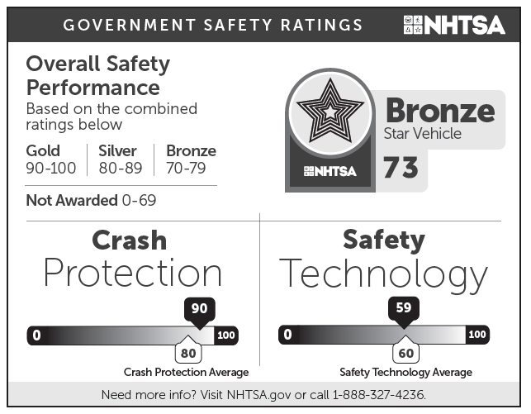

- While you are reviewing the information in this section, I would like you to…
- Please draw a circle around the information that would be helpful to you when purchasing a new vehicle.
- Please draw a box around any parts you find unclear or confusing.
- Answer the questions below the image on page five in your workbook. Once everyone is done, we will have a short discussion.

- DISCUSSION – Let’s talk a little bit about this concept.
    - Thinking about this concept overall, what are your reactions? Is that positive or negative?
    - Is the information related to safety displayed in a way that is clear and understandable?
      - Looking at the information shown in this concept, would you consider this to be a safe vehicle? Tell me why/why not.
    - What do you think about the types of information displayed?
      - Is it clear that there are different types of safety information?
        - PROBE: What do you think the Overall Safety Performance Rating represents?
        - PROBE: What do you think the Crash Protection information represents?
        - PROBE: What do you think the Safety Technology information represents?
      - Is it helpful to have different types of safety information (i.e., information relating to crash protection, safety technology, and overall safety)?
    - How does this compare to the 5-Star section found on the current version of the sticker we looked at earlier?
      - PROBE: How is it better/worse?
      - PROBE: Is this concept more or less effective at conveying safety information than the government 5-star ratings section on existing window stickers?

- Window Sticker Evaluation – Alternative Design C [20 minutes/80 minutes total]
Let’s take a look at a different way of displaying the safety information. Please turn to ACTIVITY 5 on page six in your workbook and take a minute to review the information in this section carefully.
PLACEHOLDER FOR ALTERNATE DESIGN C – (LABEL 3 VERSION 1A AWARDED)
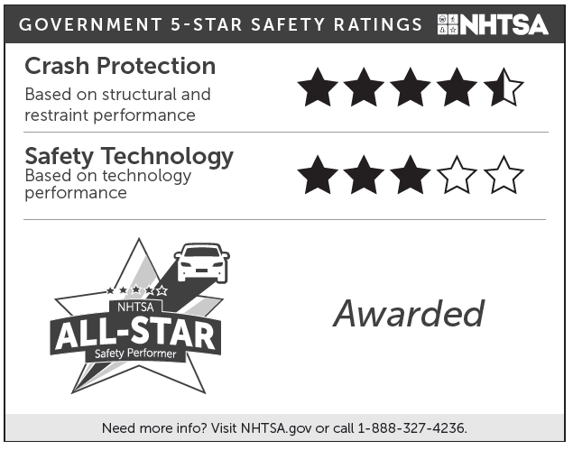
- While you are reviewing the information in this section, I would like you to…
- Please draw a circle around the information that would be helpful to you when purchasing a new vehicle.
- Please draw a box around any parts you find unclear or confusing.
- Answer the questions below the image on page six in your workbook. Once everyone is done, we will have a short discussion.

- DISCUSSION – Let’s talk a little bit about this concept.
    - Thinking about this concept overall, what are your reactions? Is that positive or negative?
    - Is the information related to safety displayed in a way that is clear and understandable?
      - Looking at the information shown in this concept, would you consider this to be a safe vehicle? Tell me why/why not.
      - This concept shows a vehicle with 4.5 stars in crash protection and 3 stars in safety technology. Imagine there was a vehicle with 5 stars in crash protection and NO stars for safety technology – which vehicle would you prefer?
    - What do you think about the types of information displayed?
      - Is it clear that there are different types of safety information?
        - PROBE: What do you think the All Star Performer Award represents?
        - PROBE: What do you think the Crash Protection information represents?
        - PROBE: What do you think the Safety Technology information represents?
      - Is it helpful to have different types of safety information (i.e., information relating to crash protection, safety technology, and overall safety)?
    - How does this compare to the 5-Star section found on the current version of the sticker we looked at earlier?
      - PROBE: How is it better/worse?
      - PROBE: Is this concept more or less effective at conveying safety information than the government 5-star ratings section on existing window stickers?

- Comparison of Concepts & Wrap-up/Close [45 minutes/125 minutes total]

- Now, I would like to focus on the three alternative designs. I’d like to get your reactions on which one you feel most effectively conveys safety information about the vehicle (NOT WHICH VEHICLE IS THE SAFEST). Please turn to ACTIVITY 6 on page seven and draw a circle around the alternative you feel is most effective at conveying safety information and write a short sentence or two that explains why you picked the one you did. PAUSE AND LET PARTICIPANTS COMPLETE EXERCISE. I’m going to go around the room and I want each of you to tell me which one you think is most effective at conveying safety information and why.
Alternative A | Alternative B | Alternative C

- Let’s go back and look at all four examples of how we can show safety information on a window sticker. Please turn to ACTIVITY 7 on page eight in your workbook and review the four examples we’ve reviewed during the session today. Draw a circle around the one that you feel is MOST EFFECTIVE at conveying safety information and write a sentence or two explaining why. If you select the Existing design give me some specific reasons you chose that over the Alternatives, if you select an Alternative design, tell me why you like that better than the Existing design and what makes it better than the other Alternatives. PAUSE AND LET PARTICIPANTS COMPLETE EXERCISE. I’m going to go around the room and I want each of you to tell me which one you think is most effective at conveying safety information and why.
Existing | Alternative A | Alternative B | Alternative C

- We have seen several different ways of showing crash protection and safety technology information in the 5-Star section of the window sticker. The different formats including using a 5 star rating system, Gold/Silver/Bronze level awards with a number score, and a 0-100 scale showing how a specific vehicle compares to the average performance for its category. Think of the different examples, which way of showing information is the most effective and why?
  - Is it more effective to show the information for crash protection in the same format as safety technology? Or is it more effective to use a different format for each?

- When vehicles are tested and receive high scores, they can qualify for an award. Two of the concepts we looked at had bronze, silver and gold scores, but they are shown in black and white. Would you have any concerns over your ability to understand the differences when showing that information in black and white (versus displaying it in color)? In other words, do these need to be shown in color in order to work or can they be shown in black and white and still be just as easy to understand?

- Still thinking about the awards for high scoring vehicles, which of the following names do you prefer to use for vehicles that are chosen for an award?
  - All-Star Safety Choice
  - Safety Driven Vehicle
  - All-Star Safety Performer
  - Top Safety Performer
  - OTHERS?

- If you were to create your ideal safety label using the elements from Alternatives A through C, which element(s) would you incorporate from each of the alternatives?
  - How would you display overall performance?
  - How would you display crash protection information?
  - How would you display safety technology information?
  - How would you display information that designates a vehicle as being a top performer?
  - Would a vehicle designated as a top performer help you (1) better understand the safety benefits of a vehicle’s crash protection and safety technologies and (2) make informed purchasing decision?

- We’ve talked a lot about vehicle safety today – I’d like to do one last exercise to help understand the relative importance of different types of vehicle safety information when thinking about purchasing a new vehicle.
  - First, I’d like to get your reactions to including additional safety information beyond crash protection, safety technology and overall safety. Can you think of any other type of safety information that would be beneficial to include?
  - What do you think about including safety information on protecting people outside of the vehicle (like pedestrians)?
  - Now, I would like you to rate the following types of safety information using a scale of 1 to 10 where 1 is Low importance and 10 is High importance…
    - Overall vehicle safety
    - Crash protection
    - Safety technology
    - Ability to protect people outside of the vehicle in a crash
Wrap-up and Close
- Is there anything else you would like to add or share before we wrap up?

On behalf of the Department of Transportation, we thank you for being so generous with your time and honest in your feedback throughout the course of this session.

