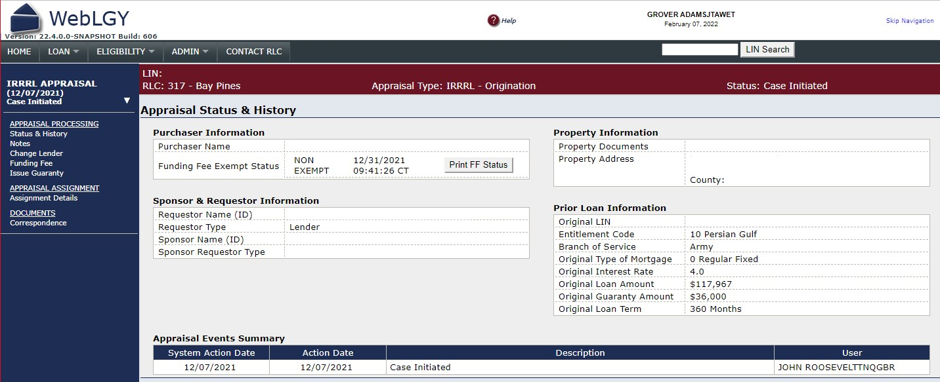
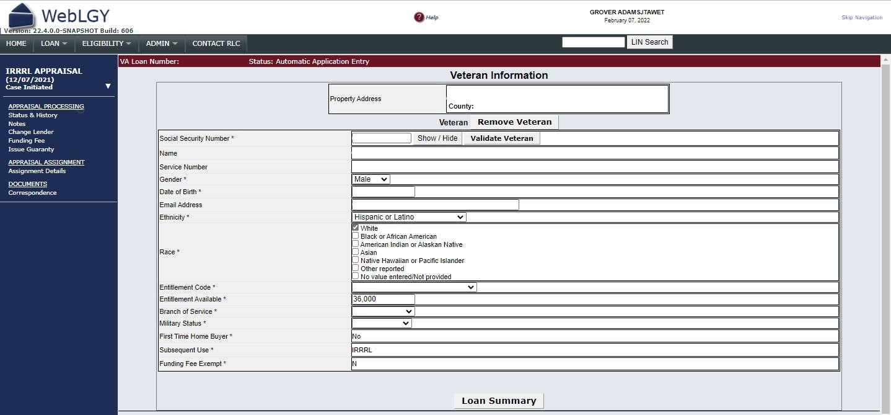
RESPONDENT BURDEN: This information is needed to issue evidence of guaranty for a VA home loan. Title 38, U.S.C., section 3702, authorizes collection of this information. We estimate that you will need an average of 5 minutes to review the instructions, find the information, and complete this form. VA cannot conduct or sponsor a collection of information unless a valid OMB control number is displayed. You are not required to respond to a collection of information if this number is not displayed. Valid OMB control numbers can be located on the OMB Internet Page at www.reginfo.gov/public/do/PRAMain. If desired, you can call 1-800-827-1000 to get information on where to send comments or suggestions about this form.
OMB Control No. 2900-XXXX
Respondent Burden: 5 minutes
Expiration Date: XX/XX/XXXX

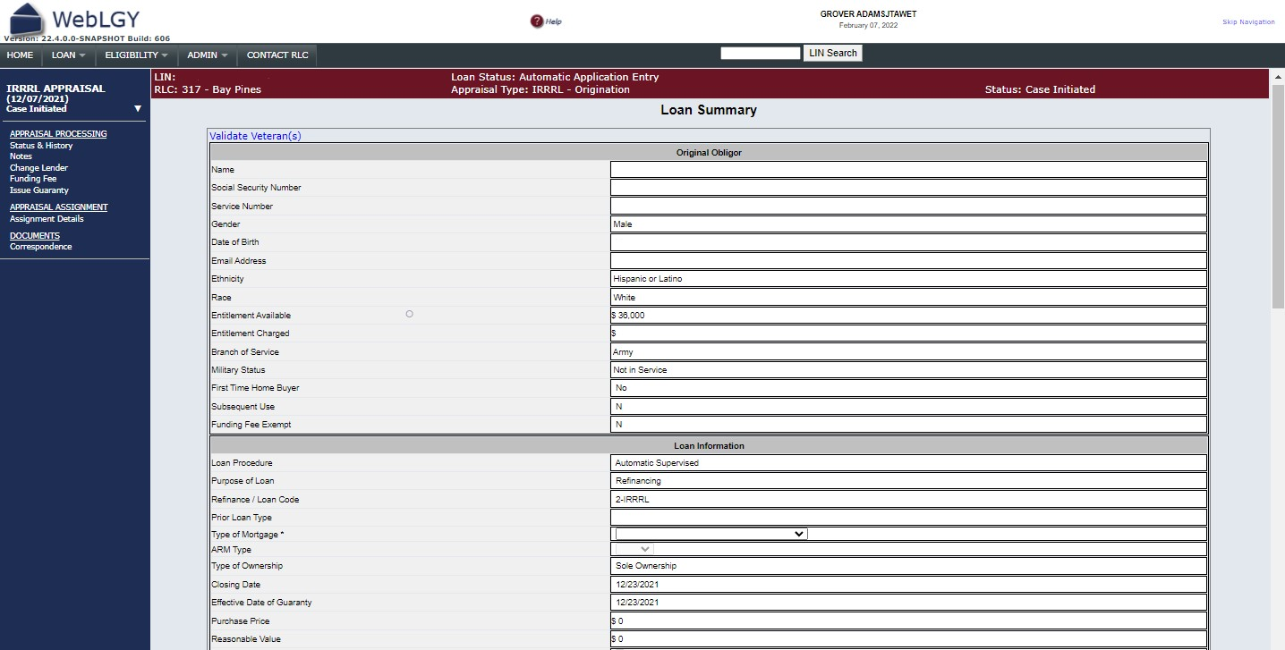
OMB Control No. 2900-XXXX
Respondent Burden: 5 minutes
Expiration Date: XX/XX/XXXX
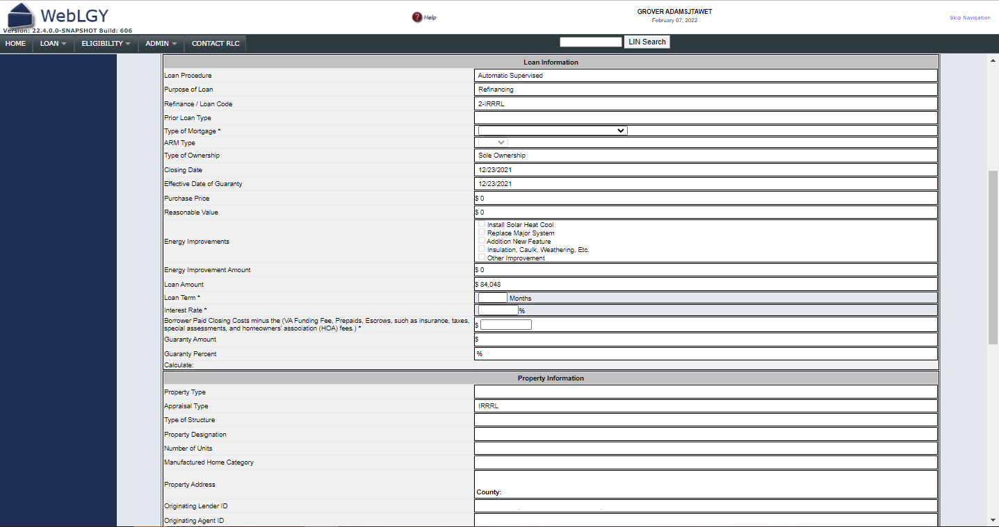
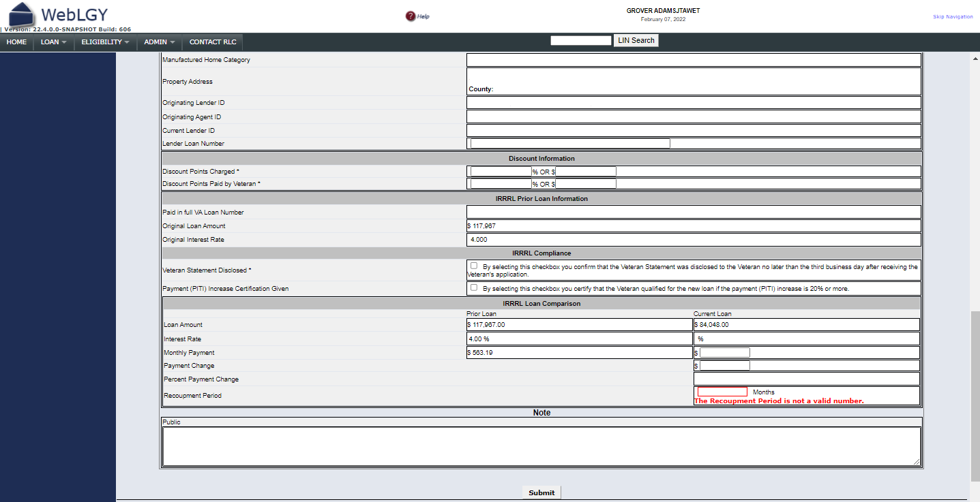
RESPONDENT BURDEN: This information is needed to issue evidence of guaranty for a VA home loan. Title 38, U.S.C., section 3702, authorizes collection of this information. We estimate that you will need an average of 5 minutes to review the instructions, find the information, and complete this form. VA cannot conduct or sponsor a collection of information unless a valid OMB control number is displayed. You are not required to respond to a collection of information if this number is not displayed. Valid OMB control numbers can be located on the OMB Internet Page at www.reginfo.gov/public/do/PRAMain. If desired, you can call 1-800-827-1000 to get information on where to send comments or suggestions about this form.

