{CITY} Resident *12345678A* 12345678A
{ADDRESS}
{CITY}, {ST} {ZIP}
***************AUTO**MIXED AADC 270
DDFAAAAATATFFATTDFDATATATTAFAAAFFAFFTTFFFDAFDFTFFFADAFTAA
1 1
Dear {CITY} Resident, {MONTH} 2021
I recently wrote to you asking for your help with a national survey conducted by the National Highway Traffic Safety Administration (NHTSA) about your personal transportation experiences. If someone in your household has already completed the survey, thank you! If not, please follow the instructions below to complete the survey online or by mail. We know you are busy, but your participation in this short, 20-minute survey is very important.
Eligible participants will receive a ${“5”, “10”} Amazon.com gift code for completing the survey.
Your household was randomly chosen to participate in this survey and cannot be replaced with another household. Your answers will be confidential and combined with answers from all other participants to protect your privacy.


Here’s how your household can participate in the survey
Step 1: Give this letter to the adult in your household with the next birthday

Online…

Step 2: Go to www.USTransportationSurvey.com
and enter {12345678A}
OR
Scan this code
By mail…

Step 2: Fill out the enclosed survey

Step 3: Return it in the postage-paid envelope
OR
[QR CODE]
If you have any questions about the survey, please see the FAQ in the online survey or contact ICF, an independent research firm hired to conduct this study. They can be reached at USTransportationSurvey@icfsurvey.com or by phone at [SUPPORT PHONE].
We greatly appreciate you taking part in this important survey!
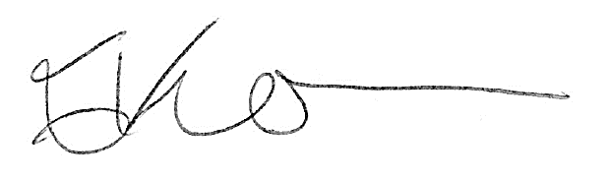
Sincerely,

Essie Wagner
Director, Office of Behavioral Safety Research
National Highway Traffic Safety Administration

