

Transformed Medicaid Statistical Information System (T-MSIS)
Data Dictionary Record Segment Relationships
Version: v2.4.0
December 04, 2020

List of Tables
Table 1: T-MSIS Record Segment Definitions 2

List of Figures
Figure 1: Claim IP File – Claim Record Segment Relationships 9
Figure 2: Claim LT File – Claim Record Segment Relationships 10
Figure 3: Claim OT File – Claim Record Segment Relationships 11
Figure 4: Claim RX File – Claim Record Segment Relationships 12
Figure 5: Eligible File – Eligible Person Record Segment Relationships 13
Figure 6: Provider File – Provider Record Segment Relationships 15
Figure 7: Managed Care File – Managed Care Entity Record Segment Relationships 17
Figure 8: Third-Party Liability (TPL) File – TPL Record Segment Relationships 19

T-MSIS Record Segment Definitions and Relationships
This document contains definitions and diagrams that depict T-MSIS Record Segment Relationships. On all joins, the effective date of the child must fall completely with the set of effective date span of the active parent records. There shall be no dates where a child is active without a corresponding active parent.

Table 1: T-MSIS Record Segment Definitions
File Name | Record Segment Name | Record Identifier | Record Segment Definition | Record Segment Length
Claim Inpatient File | FILE-HEADER-RECORD-IP | CIP00001 | A record containing metadata necessary to identify the file itself, when it was created and the number of records it contains. | 2,100
Claim Inpatient File | CLAIM-HEADER-RECORD-IP | CIP00002 | A record to capture data about an inpatient claim or encounter that applies to the claim in its totality. | 2,100
Claim Inpatient File | CLAIM-LINE-RECORD-IP | CIP00003 | A record to capture data about specific goods or services rendered to a Medicaid/CHIP enrollee during the hospital stay. | 2,100
Claim Long-term Care File | FILE-HEADER-RECORD-LT | CLT00001 | A record containing metadata necessary to identify the file itself, when it was created and the number of records it contains. | 1,900
Claim Long-term Care File | CLAIM-HEADER-RECORD-LT | CLT00002 | A record to capture data about a long-term care claim or encounter that applies to the claim in its totality. | 1,900
Claim Long-term Care File | CLAIM-LINE-RECORD-LT | CLT00003 | A record to capture data about specific goods or services rendered to a Medicaid/CHIP enrollee during a long-term care stay. | 1,900
Claim Other File | FILE-HEADER-RECORD-OT | COT00001 | A record containing metadata necessary to identify the file itself, when it was created and the number of records it contains. | 1,750
Claim Other File | CLAIM-HEADER-RECORD-OT | COT00002 | A record to capture data about another type of claim or encounter (besides IP, LT, and RX) that applies to the claim in its totality. | 1,750
Claim Other File | CLAIM-LINE-RECORD-OT | COT00003 | A record to capture data about specific goods or services rendered to a Medicaid/CHIP enrollee during an outpatient visit. | 1,750
Claim Prescription File | FILE-HEADER-RECORD-RX | CRX00001 | A record containing metadata necessary to identify the file itself, when it was created and the number of records it contains. | 1,450
Claim Prescription File | CLAIM-HEADER-RECORD-RX | CRX00002 | A record to capture data about a pharmacy claim or encounter that applies to the claim in its totality. | 1,450
Claim Prescription File | CLAIM-LINE-RECORD-RX | CRX00003 | A record to capture data about specific prescription goods or services rendered to a Medicaid/CHIP enrollee. | 1,450
Eligible File | FILE-HEADER-RECORD-ELIGIBILITY | ELG00001 | A record containing metadata necessary to identify the file itself, when it was created and the number of records it contains. | 1,000
Eligible File | PRIMARY-DEMOGRAPHICS-ELIGIBILITY | ELG00002 | A record to capture basic demographic information about the individual. | 1,000
Eligible File | VARIABLE-DEMOGRAPHICS-ELIGIBILITY | ELG00003 | A record to capture additional demographic information that is more prone to periodic changes than primary demographics. | 1,000
Eligible File | ELIGIBLE-CONTACT-INFORMATION | ELG00004 | A record to capture addresses and phone numbers of the individual. | 1,000
Eligible File | ELIGIBILITY-DETERMINANTS | ELG00005 | A record to capture factors that influence an individual’s eligibility for basic Medicaid/CHIP, as well as the various waivers and demonstrations. | 1,000
Eligible File | HEALTH-HOME-SPA-PARTICIPATION-INFORMATION | ELG00006 | A record to capture the eligible person's participation in the state's health home initiative. | 1,000
Eligible File | HEALTH-HOME-SPA-PROVIDERS | ELG00007 | A record to capture the identity of the health home entity in which the eligible person is enrolled, as well as the identity of the provider with primary responsibility for coordinating the delivery of health home services. | 1,000
Eligible File | HEALTH-HOME-CHRONIC-CONDITIONS | ELG00008 | A record to capture an eligible person's chronic conditions that qualified him/her for participation in the health home initiative. | 1,000
Eligible File | LOCK-IN-INFORMATION | ELG00009 | A record to capture the provider, or providers, to whom the eligible person is restricted, as well as the time periods during which the lock-in provisions are in force. | 1,000
Eligible File | MFP-INFORMATION | ELG00010 | A record to capture information about an eligible person's participation in the Money Follows the Person demonstration program. | 1,000
Eligible File | STATE-PLAN-OPTION-PARTICIPATION | ELG00011 | A record to capture the identity of the State Plan Options in which an eligible person is enrolled. | 1,000
Eligible File | WAIVER-PARTICIPATION | ELG00012 | A record to capture the identity of the waivers in which an eligible person is enrolled. | 1,000
Eligible File | LTSS-PARTICIPATION | ELG00013 | A record to capture the level of care an eligible person receives at various points in time while in a long-term care facility. | 1,000
Eligible File | MANAGED-CARE-PARTICIPATION | ELG00014 | A record to capture information about an eligible person's enrollment in a managed care plan. | 1,000
Eligible File | ETHNICITY-INFORMATION | ELG00015 | A record to capture information about an eligible person's ethnicity. | 1,000
Eligible File | RACE-INFORMATION | ELG00016 | A record to capture information about an eligible person's race. | 1,000
Eligible File | DISABILITY-INFORMATION | ELG00017 | A record to capture information about an eligible person's disabilities. | 1,000
Eligible File | 1115A-DEMONSTRATION-INFORMATION | ELG00018 | A record to capture an eligible person's 1115A participation. | 1,000
Eligible File | HCBS-CHRONIC-CONDITIONS-NON-HEALTH-HOME | ELG00020 | A record to capture an eligible person's chronic conditions for which an eligible person is receiving home and community-based care. | 1,000
Eligible File | ENROLLMENT-TIME-SPAN-SEGMENT | ELG00021 | A record to capture the eligible person's type of enrollment and time spans of enrollment. | 1,000
Eligible File | ELG-IDENTIFIERS | ELG00022 | A record to capture the identifiers assigned to a beneficiary by various entities. | 1,000
Managed Care Plan Information File | FILE-HEADER-RECORD-MANAGED-CARE | MCR00001 | A record containing metadata necessary to identify the file itself, when it was created and the number of records it contains. | 1,000
Managed Care Plan Information File | MANAGED-CARE-MAIN | MCR00002 | A record to capture basic, generally static information about a managed care entity. | 1,000
Managed Care Plan Information File | MANAGED-CARE-LOCATION-AND-CONTACT-INFO | MCR00003 | A record to capture addresses, phone numbers, fax numbers, and email addresses of the managed care organization. | 1,000
Managed Care Plan Information File | MANAGED-CARE-SERVICE-AREA | MCR00004 | A record to capture the zip codes, counties, or other geographic descriptors that define the managed care entity’s service area. | 1,000
Managed Care Plan Information File | MANAGED-CARE-OPERATING-AUTHORITY | MCR00005 | A record to capture information about the operating authority, waivers and demonstrations under which a managed care entity is contracted with the state. | 1,000
Managed Care Plan Information File | MANAGED-CARE-PLAN-POPULATION-ENROLLED | MCR00006 | A record to capture the identity of the Medicaid/CHIP eligibility groups that the managed care entity is authorized to enroll. | 1,000
Managed Care Plan Information File | MANAGED- CARE-ACCREDITATION-ORGANIZATION | MCR00007 | A record to capture information concerning the accreditations that the managed care entity has. | 1,000
Managed Care Plan Information File | NATIONAL-HEALTH-CARE-ENTITY-ID-INFO | MCR00008 | A record to capture the national health plan identifiers associated with the managed care entity. | 1,000
Managed Care Plan Information File | CHPID-SHPID-RELATIONSHIPS | MCR00009 | A record to link a managed care entity Sub-Health Plan IDs with the appropriate Controlling Health Plan IDs. | 1,000
Provider File | FILE-HEADER-RECORD-PROVIDER | PRV00001 | A record containing metadata necessary to identify the file itself, when it was created and the number of records it contains. | 1,100
Provider File | PROV-ATTRIBUTES-MAIN | PRV00002 | A record to capture basic, generally static information about each provider.  A provider is an individual person (medical or non-medical), a group of individuals, or an organization (e.g. institution, facility, agency, hospital, nursing facility, home health agency, school, or transportation organization) that delivers or facilitates health-related treatments, health care services, or living supports. | 1,100
Provider File | PROV-LOCATION-AND-CONTACT-INFO | PRV00003 | A record to capture addresses, phone numbers, and email addresses of the provider.  Each PROV-LOCATION-AND-CONTACT-INFO record segment represents the set of contact information for a single provider location.  The state can enter as many sets of contact information (i.e., multiple PROV-LOCATION-AND-CONTACT-INFO record segments) as it considers necessary. The value selected for the ADDR-TYPE field describes the type of contact information on that particular record (e.g., provider service location, provider billing address, etc.). The PROV-LOCATION-ID differentiates one PROV-LOCATION-AND-CONTACT-INFO record segment from another when the ADDR-TYPE value on both records is the same. | 1,100
Provider File | PROV-LICENSING-INFO | PRV00004 | A record to capture licensing and accreditation information relevant to the provider. | 1,100
Provider File | PROV-IDENTIFIERS | PRV00005 | A record to capture the identifiers assigned to the provider entity by various governmental, professional, and payer entities. | 1,100
Provider File | PROV-TAXONOMY-CLASSIFICATION | PRV00006 | A record to classify the provider into areas of specialty, as well as the authorized categories of service for which the provider entity has been authorized by the state to render to Medicaid/CHIP eligibles. | 1,100
Provider File | PROV-MEDICAID-ENROLLMENT | PRV00007 | A record to capture the provider’s periods of participation in the state's Medicaid/CHIP programs, and the reason for a change in enrollment status. | 1,100
Provider File | PROV-AFFILIATED-GROUPS | PRV00008 | A record to capture a provider’s relationship(s) with other provider(s). | 1,100
Provider File | PROV-AFFILIATED-PROGRAMS | PRV00009 | A record to capture the Medicaid/CHIP health plans, waivers, health home entities, etc. that the provider entity is associated with. | 1,100
Provider File | PROV-BED-TYPE-INFO | PRV00010 | A record to capture the number of beds available for various categories of bed at provider entities that are facilities. | 1,100
Third-party Liability File | FILE-HEADER-RECORD-TPL | TPL00001 | A record containing metadata necessary to identify the file itself, when it was created and the number of records it contains. | 900
Third-party Liability File | TPL-MEDICAID-ELIGIBLE-PERSON-MAIN | TPL00002 | A record to capture basic, generally static information to identify Medicaid/CHIP enrollees for whom third party funds may be available to offset some or all of their Medicaid/CHIP costs. | 900
Third-party Liability File | TPL-MEDICAID-ELIGIBLE-PERSON-HEALTH-INSURANCE-COVERAGE-INFO | TPL00003 | A record to capture insurance policy information needed to facilitate pursuit of the third party liability. | 900
Third-party Liability File | TPL-MEDICAID-ELIGIBLE-PERSON-HEALTH-INSURANCE-COVERAGE-CATEGORIES | TPL00004 | A record to capture TPL insurance coverage information to support the applicability assessment of the third party insurance coverage to the Medicaid/CHIP costs incurred on behalf of the Medicaid/CHIP enrollee. | 900
Third-party Liability File | TPL-MEDICAID-ELIGIBLE-OTHER-THIRD-PARTY-COVERAGE-INFORMATION | TPL00005 | A record to flag Medicaid/CHIP enrollees who potentially have non-insurance sources of funds that could be used to offset Medicaid/CHIP expenditures. | 900
Third-party Liability File | TPL-ENTITY-CONTACT-INFORMATION | TPL00006 | A record to capture addresses and phone numbers of the entity providing TPL insurance coverage. | 900

Claim IP File – Record Segment Relationships

Diagram 1: Claim IP File – Claim Record Segment Relationships
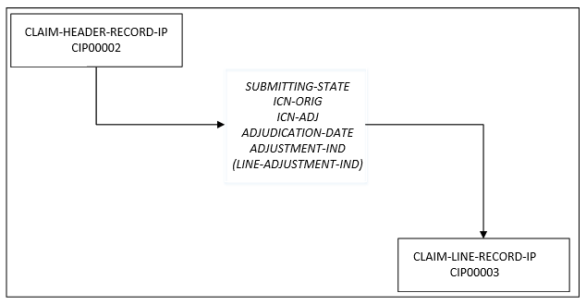
Figure 1: Claim IP File – Claim Record Segment Relationships
Description of Diagram 1:
Each claim record in the T-MSIS inpatient claims file is composed of two types of record segments: One claim header segment and multiple claim line segments. Each claim line segment joins to its claim header segment on the following four data elements:
- SUBMITTING-STATE
- ICN-ORIG
- ICN-ADJ
- ADJUDICATION-DATE
- ADJUSTMENT-IND (LINE-ADJUSTMENT-IND)

Claim LT File – Claim Record Segment Relationships

Diagram 2: Claim LT File – Claim Record Segment Relationships
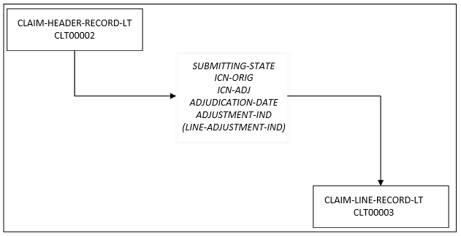
Figure 2: Claim LT File – Claim Record Segment Relationships

Description of Diagram 2:
Each claim record in the T-MSIS long-term care claims file is composed of two types of record segments: One claim header segment and multiple claim line segments. Each claim line segment joins to its claim header segment on the following four data elements:
- SUBMITTING-STATE
- ICN-ORIG
- ICN-ADJ
- ADJUDICATION-DATE
- ADJUSTMENT-IND (LINE-ADJUSTMENT-IND)

Claim OT File – Claim Record Segment Relationships

Diagram 3: Claim OT File – Claim Record Segment Relationships
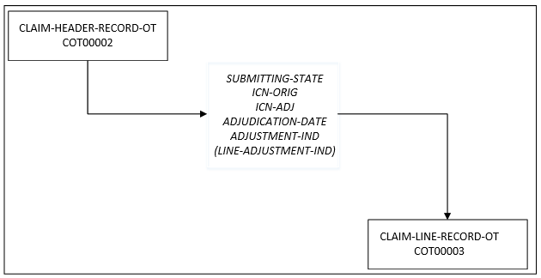
Figure 3: Claim OT File – Claim Record Segment Relationships

Description of Diagram 3:
Each claim record in the T-MSIS other claims file is composed of two types of record segments: One claim header segment and multiple claim line segments. Each claim line segment joins to its claim header segment on the following four data elements:
- SUBMITTING-STATE
- ICN-ORIG
- ICN-ADJ
- ADJUDICATION-DATE
- ADJUSTMENT-IND (LINE-ADJUSTMENT-IND)

Claim RX File – Claim Record Segment Relationships

Diagram 4: Claim RX File – Claim Record Segment Relationships
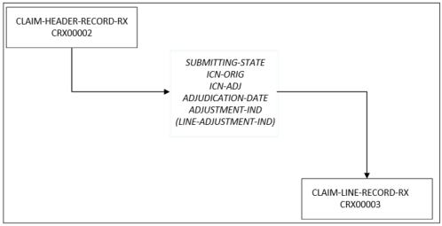
Figure 4: Claim RX File – Claim Record Segment Relationships

Description of Diagram 4:
Each claim record in the T-MSIS prescription drug (RX) claims file is composed of two types of record segments: One claim header segment and multiple claim line segments. Each claim line segment joins to its claim header segment on the following four data elements:
- SUBMITTING-STATE
- ICN-ORIG
- ICN-ADJ
- ADJUDICATION-DATE
- ADJUSTMENT-IND (LINE-ADJUSTMENT-IND)

Eligible File – Eligible Person Record Segment Relationships

Diagram 5: Eligible File – Eligible Person Record Segment Relationships
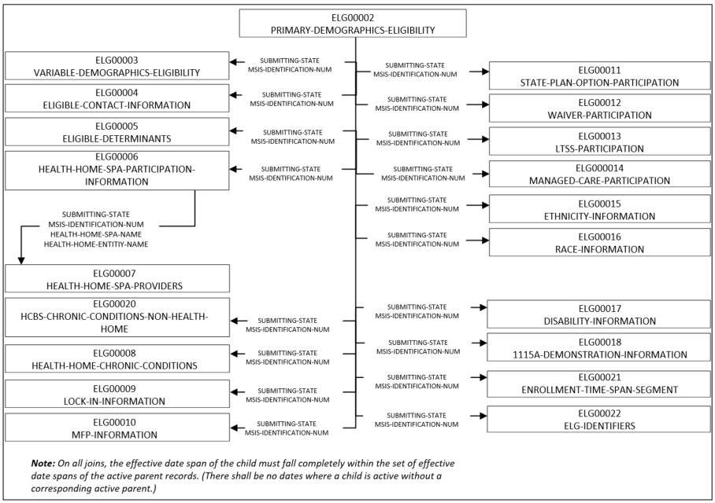
Figure 5: Eligible File – Eligible Person Record Segment Relationships
Description of Diagram 5:
Each eligible person in T-MSIS has a record in the T-MSIS eligibility file. Each of these records is comprised of up to twenty different types of record segments. The PRIMARY-DEMOGRAPHICS-ELIGIBILITY (ELG00002) segment is the parent segment and all other segments, except for the HEALTH-HOME-SPA-PROVIDERS (ELG00007) segment, join to it on the following two data elements:
- SUBMITTING-STATE
- MSIS-IDENTIFICATION-NUM
The exception (the HEALTH-HOME-SPA-PROVIDERS (ELG00007) segment) is a child of the HEALTH-HOME-SPA-PARTICIPATION-INFORMATION (ELG00006) segment and joins to it on:
- SUBMITTING-STATE
- MSIS-IDENTIFICATION-NUM
- HEALTH-HOME-SPA-ID
- HEALTH-HOME-ENTITY-NAME

Provider File – Provider Record Segment Relationships

Diagram 6: Provider File – Provider Record Segment Relationships
Figure 6: Provider File – Provider Record Segment Relationships

Description of Diagram 6:
Each provider in T-MSIS (regardless of whether the provider is a single individual, a group of practitioners, a facility, or a group of facilities) must have a record in the T-MSIS providers file. Each provider record is comprised of up to nine different types of record segments. The PROV-ATTRIBUTES-MAIN (PRV00002) segment is the parent segment to five segments: PROV-TAXONOMY-CLASSIFICATION (PRV00006), PROV-MEDICAID-ENROLLMENT (PRV00007), PROV-AFFILIATED-GROUPS (PRV00008), PROV-AFFILIATED-PROGRAMS (PRV00009), and PROV-LOCATION-AND-CONTACT-INFO (PRV00003), all of which join to PROV-ATTRIBUTES-MAIN on the following two data elements:
- SUBMITTING-STATE
- SUBMITTING-STATE-PROV-ID
In addition, the PROV-LOCATION-AND-CONTACT-INFO (PRV00003) segment is a parent segment in its own right to three additional subordinate segments: PROV-IDENTIFIERS (PRV00005), PROV-LICENSING-INFO (PRV00004), PROV-BED-TYPE-INFO (PRV00010). These three segments join to the PROV-LOCATION-AND-CONTACT-INFO segment on:
- SUBMITTING-STATE
- SUBMITTING-STATE-PROV-ID
- PROV-LOCATION-ID

Managed Care File – Managed Care Entity Record Segment Relationships

Diagram 7: Managed Care File – Managed Care Entity Record Segment Relationships
Figure 7: Managed Care File – Managed Care Entity Record Segment Relationships
Description of Diagram 7:
Each managed care entity in T-MSIS must have a record in the T-MSIS managed care file. Each managed care record is comprised of up to eight different types of record segments. The MANAGED-CARE-MAIN (MCR00002) segment is the parent segment to six segments: MANAGED-CARE-LOCATION-AND-CONTACT-INFO (MCR00003), MANAGED-CARE-SERVICE-AREA (MCR00004), MANAGED-CARE-OPERATING-AUTHORITY (MCR00005), MANAGED-CARE-PLAN-POPULATION-ENROLLED (MCR00006), MANAGED- CARE-ACCREDITATION-ORGANIZATION (MCR00007), and NATIONAL-HEALTH-CARE-ENTITY-ID-INFO (MCR00008), all of which join to PROV-ATTRIBUTES-MAIN on the following two data elements:
- SUBMITTING-STATE
- STATE-PLAN-ID-NUM
In addition, the NATIONAL-HEALTH-CARE-ENTITY-ID-INFO (MCR00008) segment is a parent segment in its own right to the CHPID-SHPID-RELATIONSHIPS (MCR00009) segment, which joins to the NATIONAL-HEALTH-CARE-ENTITY-ID-INFO segment on:
- SUBMITTING-STATE
- STATE-PLAN-ID-NUM
- NATIONAL-HEALTH-CARE-ENTITY-ID*
- NATIONAL-HEALTH-CARE-ENTITY-ID-TYPE*.
* = MCR00008.NATIONAL-HEALTH-CARE-ENTITY-ID would join to either MCR00009.CHPID or MCR00009.SHPID based on the value in MCR00008.NATIONAL-HEALTH-CARE-ENTITY-ID-TYPE.

Third-Party Liability (TPL) File – Record Segment Relationships

Diagram 8: Third-Party Liability (TPL) File – TPL Record Segment Relationships
Figure 8: Third-Party Liability (TPL) File – TPL Record Segment Relationships

Description of Diagram 8:
Each instance of potential third-party liability for T-MSIS eligibles must have a record in the T-MSIS TPL file. There are actually two sets of information captured (called “subject areas”) in the TPL file: One set of records captures general information about non-Medicaid, non-Medicare health insurers, while the other set of records captures information about third party sources of funds that individual Medicaid/CHIP eligibles have.

TPL Health Insurance Entity Subject Area
Two types of record segments comprise the “TPL health insurance entity subject area:” the TPL-ENTITY-CONTACT-INFORMATION (TPL00006) and TPL-MEDICAID-ELIGIBLE-PERSON-HEALTH-INSURANCE-COVERAGE-CATEGORIES (TPL00004) segments. There is a one-to-many relationship between these segment types (one TPL-ENTITY-CONTACT-INFORMATION segment type to many TPL-MEDICAID-ELIGIBLE-PERSON-HEALTH-INSURANCE-COVERAGE-CATEGORIES segments). The TPL-MEDICAID-ELIGIBLE-PERSON-HEALTH-INSURANCE-COVERAGE-CATEGORIES segment joins to the TPL-ENTITY-CONTACT-INFORMATION segment on two fields:
- SUBMITTING-STATE
- INSURANCE-CARRIER-ID-NUM

Medicaid/CHIP Enrollees with TPL Funding Subject Area
Three types of segments make up the “Medicaid/CHIP Enrollees with TPL Funding Subject Area.” The TPL-MEDICAID-ELIGIBLE-PERSON-MAIN
(TPL00002) segment type is the parent segment, with TPL-MEDICAID-ELIGIBLE-PERSON-HEALTH-INSURANCE-COVERAGE-INFO (TPL00003) and TPL-MEDICAID-ELIGIBLE-OTHER-THIRD-PARTY-COVERAGE-INFORMATION (TPL00005) being the subordinate segments. The two subordinate segments join to TPL-MEDICAID-ELIGIBLE-PERSON-MAIN (TPL00002) segment on:
- SUBMITTING-STATE
- MSIS-IDENTIFICATION-NUM
PRA Disclosure Statement The Transformed Medicaid Statistical Information System (T-MSIS) is used to assist the Centers for Medicare & Medicaid Services (CMS) with monitoring and oversight of Medicaid and CHIP programs, to enable evaluation of demonstrations under section 1115 of the Social Security Act and to calculate quality measures and other metrics, including those reported through the new Medicaid and CHIP Scoreboard. Section 4735 of the Balanced Budget Act of 1997 included a statutory requirement for states to submit claims data, enrollee encounter data, and supporting information. Section 6504 of the Affordable Care Act strengthened this provision by requiring states to include data elements the Secretary determines necessary for program integrity, program oversight, and administration. Under the Privacy Act of 1974 any personally identifying information obtained will be kept private to the extent of the law. According to the Paperwork Reduction Act of 1995, no persons are required to respond to a collection of information unless it displays a valid OMB control number. The valid OMB control number for this information collection is 0938-0345 (Expires: 07/31/2022). The time required to complete this information collection is estimated to average 10 hours per response, including the time to review instructions, search existing data resources, gather the data needed, and complete and review the information collection. If you have comments concerning the accuracy of the time estimate(s) or suggestions for improving this form, please write to: CMS, 7500 Security Boulevard, Attn: PRA Reports Clearance Officer, Mail Stop C4-26-05, Baltimore, Maryland 21244-1850.

