Individual: sociodemographic characteristics and clinical history  Interviewer name:  Group number  XX #  Interview date: MM / DD / YYYY  Participant number (HHID P PID): X X # # # # P # #  Eligibility criteria and consent  Sleeps in this house 4+ nights/week Yes  Does not have definite plans to move (6 mo) Yes  Consent (individuals 21+, parents of minors 1-20)  Assent (minors only: verbal 7-11, written 12-20)  Name:  _______________ ________________ ______________ ____  Paternal Last Name Maternal Last Name First Name Initial  Sex: Male Female Other  Date of birth: _____ /_____ /_____  MM DD YYYY  CLINICAL HISTORY Now I will ask you some questions about your medical history.  C1_0. Have you participated in any research study in which you received a vaccine for Zika or dengue?  Zika | Dengue | No  - Females only: -  C1_1. Are you pregnant? Yes | No C1_2. How many weeks pregnant are you? _______  C2_0. Do you have a fever currently or in the last 7 days?  Yes | No  C2_1. Date that the fever began: ___ /___ /_____  MM DD YYYY  C2_2. Have you had any of the following symptoms?  Read all the options. Mark all that apply.  C2_3. Did you see a doctor for these symptoms?  Yes | No  C2_4. Did the doctor diagnose you with any of the following illnesses?  C2_5. Were you hospitalized? Yes | No  C2_6. How many days were you hospitalized? _____ days  C2_7. In which hospital?  C2_8. How many days of work did you miss for being sick? ________ days  C2_9. How many days of school did you miss for being sick? ________ days  C2_10. Did someone else have to miss work to help you while you were sick?  If multiple people took care of the participant, Yes | No  add all the days missed together.  C2_11. How many days of work did they miss? ______  C2_12. Did someone else have to miss school to help you while you were sick?  Add all the days missed together. , Yes | No  C2_13. How many days of school did they miss? ______ |  | Individual: sociodemographic characteristics and clinical history  D1. What is the highest level of education that you have obtained?  D2. What is your current employment status?  Probe if necessary.  D3. Which of the following best describes your place of work?  D4. Do you currently have medical insurance?  Yes | No  D4a. Type of insurance:  Read all options. Mark all that apply.  D5. How long have you been living in this community?  _______ (years)  D6. From 6am - 8pm, (14 hrs) how much time do you spend in your house or in this community or urbanization?  C2_14. Approximately how much money did you spend during the illness, including doctor’s visits, medications, and transportation costs? $_____ Does not recall  C3_0. Have you had (another) fever in the last 12 months, since this month of the past year? Yes | No  C3_1. Date that the fever began: ___ /___ /_____  MM DD YYYY  C3_2. Did you have any of the following symptoms?  Read all the options. Mark all that apply.  C3_3. Did you see a doctor for these symptoms?  Yes | No  C3_4. Did the doctor diagnose you with any of the following illnesses  C3_5. Were you hospitalized? Yes | No  C3_6. How many days were you hospitalized? _____ days  C3_7. In which hospital?  C3_8. How many days of work did you miss for being sick?  ________ days  C3_9. How many days of school did you miss for being sick? ________ days  C3_10. Did someone else have to miss work to help you while you were sick?  If multiple people took care of the participant, Yes | No  add all the days missed together.  C3_11. How many days of work did they miss? ______  C3_12. Did someone else have to miss school to help you while you were sick?  Add all the days missed together. , Yes | No  C3_13. How many days of school did they miss? ______  C3_14. Approximately how much money did you spend during the illness, including doctor’s visits, medications, and transportation costs? $_____ Does not recall
  Age: ______ years  1-50  Emancipated minor: | Lives independently  from parents  Married  Has children
  Written consent completed.
  Agree to do the questionnaire.
  Agree to give a blood sample.
  Agree to the use of blood sample for future studies.
  Agree to be contacted periodically in relation to
  this study.
  Written consent completed (12-20).
  Verbal consent completed (7-11).
  Agree to do the questionnaire.
  Agree to give a blood sample.
  Agree to the storage of blood sample for use in
  future studies.
  Agree to be contacted periodically in relation to
  this study.
  Cell phone:  Text message:  House phone:  Work phone:  Other phone:  Email: | 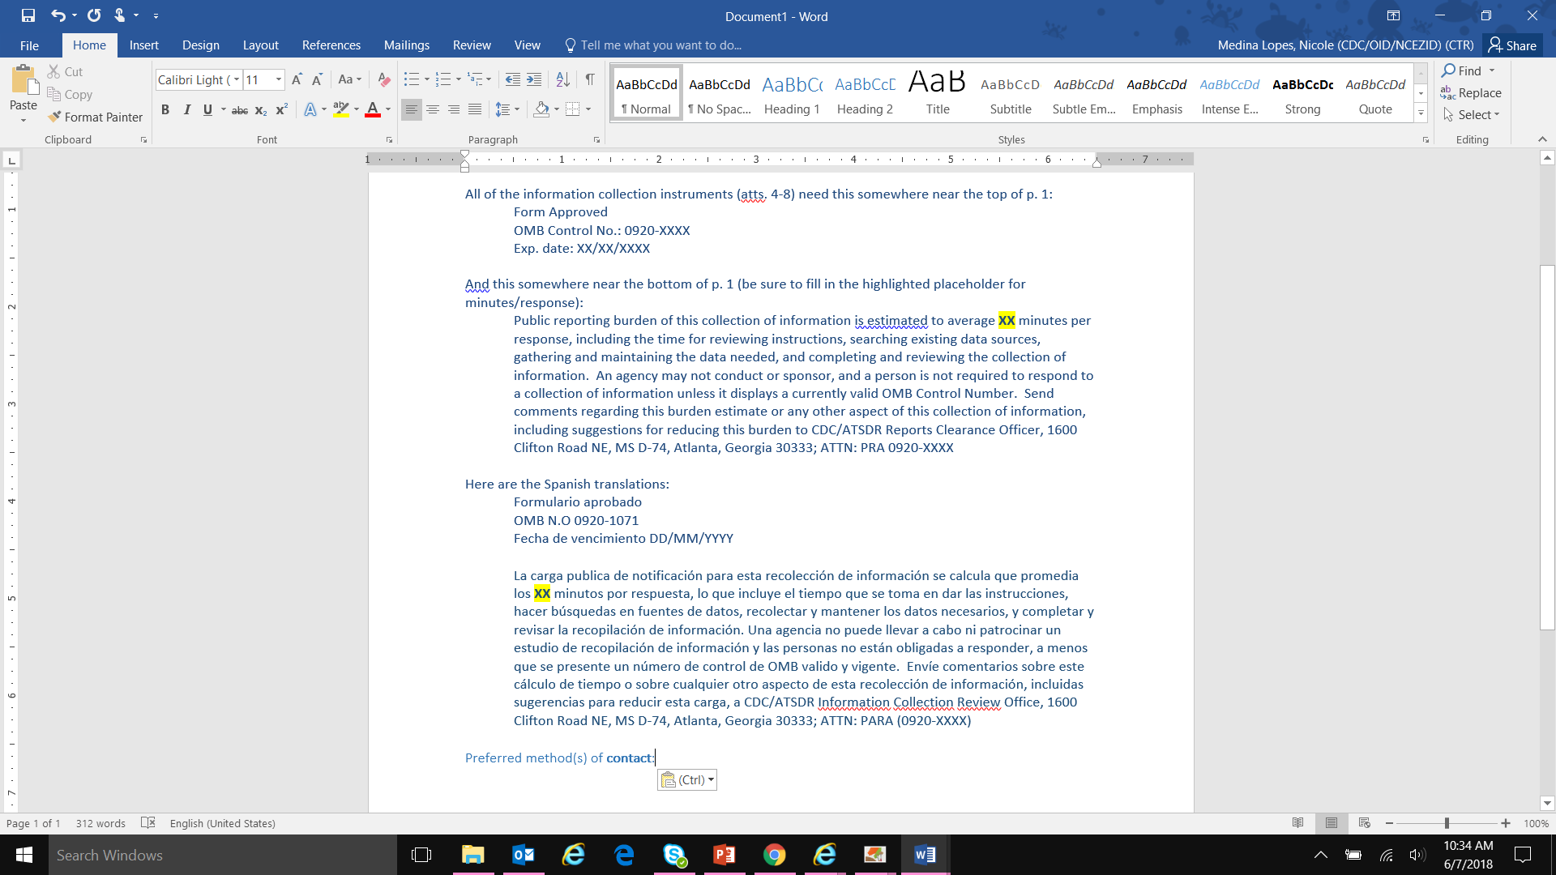  _______________________  _______________________  _______________________  _______________________  _______________________  _______________________
  Mail
  Use Household Representative information
  Nasal congestion  Diarrhea  Abdominal pain  Joint pain  Headache  Sore throat  Muscle pain  Eye pain  Calf pain  Chills  Nausea/vomiting | Red eyes  Light bleeding  (gums, nose, petechial,  and/or bruising)  Heavy bleeding  (bloody vomit/cough/  stool, heavy vaginal  bleeding)  Rash  Cough  Other: _________________
  Dengue  Chikungunya  Zika | Viral syndrome  Influenza  Other: _______________
  San Lucas  Damas  San Cristóbal  Metropolitano/  Dr. Pila  Menonita/Guayama | Concepción/  San Germán  Metropolitano/  San Germán  Pavía/Yauco  Otro: __________________
  No school
  Grades 1 to 5
  Grades 6 to 8
  Grades 9 to 11
  Completed grade 12/GED
  Technical or associate’s degree
  Bachelor’s degree
  Professional degree
  Post-graduate study
  Part-time employee
  Full-time employee
  Business owner
  Casual or Informal work
  Student
  Student and working
  Retired
  Unemployed
  Unable to work due to health problems
  Homemaker
  Other: ____________________
  Primarily indoor work
  Primarily outdoor work
  Travel between different buildings or places of work
  Mostly in a car
  Variable
  Other: ____________________
  Reforma/Plan Mi Salud  Medicare  Medicaid  Private | Tricare  Other: _____________
  Monday: _________ hours  Tuesday: _________ hours  Wednesday: _____ hours  Thursday: ________ hours | Friday: ________ hours  Saturday: _____ hours  Sunday: _______ hours
  Nasal congestion  Diarrhea  Abdominal pain  Joint pain  Headache  Sore throat  Muscle pain  Eye pain  Calf pain  Chills  Nausea/vomiting | Red eyes  Light bleeding  (gums, nose, petechial,  and/or bruising)  Heavy bleeding  (bloody vomit/cough/  stool, heavy vaginal  bleeding)  Rash  Cough  Other: _________________
  Dengue  Chikungunya  Zika | Viral syndrome  Influenza  Other: _______________
  San Lucas  Damas  San Cristóbal  Metropolitano/  Dr. Pila  Menonita/Guayama | Concepción/  San Germán  Metropolitano/  San Germán  Pavía/Yauco  Otro: __________________

