Sample Study Invitation Email

The sample email will be modified using the information provided below.
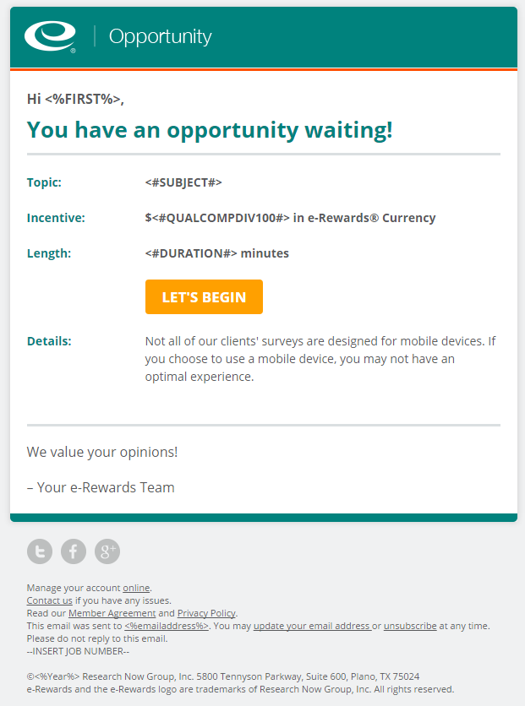

Topic: Prescription Drug information
Incentive: [approximately $5 in e-Rewards currency]
Length: 20 minutes
Details: This survey is not designed for use by mobile devices.

