Attachment D – Screen Shots for Modifications to FMS Host Site Module
OMB CONTROL NUMBER 0920-0765
FELLOWSHIP MANAGEMENT SYSTEM
NON-SUBSTANTIVE CHANGE REQUEST

PROPOSED MODIFICATIONS FOR FMS HOST SITE MODULE
DATE SUBMITTED: June 2021
Revised public burden statement
Privacy Act and Public Burden Information
Privacy Act Information
The Privacy Act applies to this information collection. Information collected will be kept private as noted in the System of Records Notice is 09-20-0112, Fellowship Program and Guest Researcher Records.
Public Burden Information
Form Approved
OMB No. 0920-0765
Exp. Date 03/31/2023
Public reporting burden of this collection of information is an estimated average of 71 minutes per response, including the time for reviewing instructions, searching existing data sources, gathering and maintaining the data needed, and completing and reviewing the collection of information. An agency may not conduct or sponsor, and a person is not required to respond to a collection of information unless it displays a currently valid OMB control number. Send comments regarding this burden estimate or any other aspect of this collection of information, including suggestions for reducing this burden to CDC/ATSDR Reports Clearance Officer; 1600 Clifton Road NE, MS D-74, Atlanta, Georgia 30333; ATTN: PRA (0920-0765).

6.11.1 LONG-TERM TRAINEE SUPPORT AND PROJECTS

PMR/F

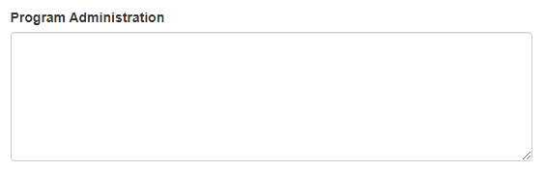

PMR/F

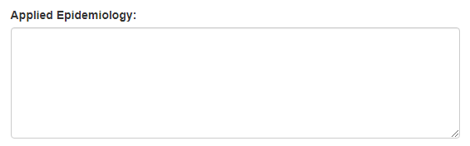

PMR/F



PMR/F



7.3 SUPERVISOR EXPERIENCE

6.3 Position Assignment Environment

PHIFP

