Appendix C2: Newton County Recruitment Flyer

Newton County Recruitment Flyer
Newton County mine tailings pile and mine
How do high lead levels harm health?
In children under 6 years of age, high lead levels can cause problems with
- Paying attention
- Learning
- School performance
- Behavior
- IQ
Pregnant women with high blood lead levels may give birth to babies with
- Lower birth weight
- Slower growth after birth
ATSDR will be in Newton County, MO to conduct free blood lead tests for children under 6 years old, pregnant women, and women who may become pregnant. ATSDR will collect 300 blood samples (from 225 children and 75 women) on a first come first serve basis. EPA and MDHSS will conduct free indoor and outdoor lead sampling for all participants.
DATE: TIME: PLACE:

Why is ATSDR testing blood?
- The soil in Newton County has high lead levels from historic mining, milling, and smelting.
- People may have contact with lead in the soil, especially children who play outdoors or in the dirt.
- Children and pregnant women in Newton County who have had contact with lead are at a higher risk for health problems.
- Since lead is found in other sources, ATSDR will review other indoor and outdoor samples collected by state and federal partners.
- Testing will identify vulnerable people like young children and pregnant women whose blood lead levels are high enough to require follow-up with a doctor, as well as potential sources for lead.

EPA Remediation in Newton County

Picture of child eating dirt

Picture of child eating dirt

Picture of child eating dirt
Wash pets regularly
Who are we?
- Agency for Toxic Substance and Disease Registry (ATSDR).
- Environmental Protection Agency (EPA)
- Missouri Department of Health and Senior Services (MDHSS)
- Mid-America Pediatric Environmental Health Specialty Unit (MAPEHSU)
How will we test for lead?
- ATSDR will conduct FREE blood lead tests in children younger than 6 years old, and women who are pregnant or of childbearing age.
- ATSDR will ask some questions about people’s households, family, and lifestyle.
- MDHSS will conduct FREE indoor lead sampling and outdoor paint samples as well as public drinking water sampling.
- EPA will conduct FREE soil and private well drinking water sampling for lead.
- Each participant will receive a $20 gift card.
- We will send the private results to each participant.
When and where will we do blood testing?
- Testing will take place at
  - Location:

  - Dates:
  - Time: 10 am to 7 pm
- To make an appointment or to ask questions, TBD
- A $20 cash gift card will be sent to every eligible participant with their individual results.

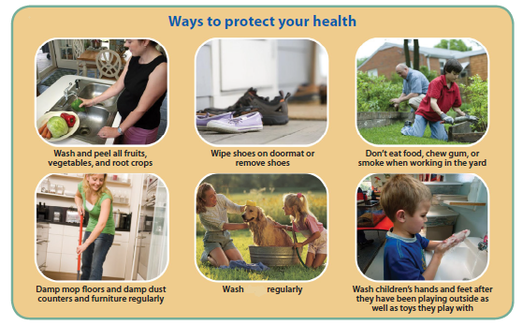

When and where will we do blood testing?
- Testing will take place at
  - Location:

  - Dates:
  - Time: 10 am to 7 pm
- To make an appointment or to ask questions, call 833-678-2724 or email MOLead@cdc.gov.

