
Keep Lead Out of the Body by Eating Healthy Foods
Information for communities near waste sites with possible lead contamination

Ensure that you and your family regularly eat…
vitamin-C-rich foods, | iron-rich foods,
- Strawberries, kiwifruit, oranges, orange juice, grapefruits, grapefruit juice, and black currants  - Tomatoes and tomato juice  - Green peppers, broccoli, brussels sprouts, snow peas, and kale | - Cereals high in iron and seeds (pumpkin seeds, quinoa)  - Dried fruits, such as raisins or prunes  - Spinach and legumes  - Lean red meats, fish, chicken, shellfish, and organ meats (e.g., liver)
calcium-rich foods, | and routinely feed your child these healthy foods.
- Milk, yogurt, cheese, and other dairy products  - Green leafy vegetables (spinach, kale, rhubarb, collard greens, etc.)  - Legumes (beans, lentils, edamame, chickpeas, etc.)  - Sardines, salmon, etc. | - Feed your child three healthy meals a day and healthy snacks. Children with empty stomachs may absorb more lead.
Eating healthy foods can help slow down how the body takes in lead and help keep lead out the body. Lead poisoning can cause learning, hearing, and behavioral problems and can harm your child's brain. Some of these health effects can last a lifetime. Lead exposure is particularly harmful for children younger than 6 years of age because of their rapidly developing brain and frequent hand-to-mouth behavior. Here are some things you can do to help keep lead out of the body:
Include image/illustration of child eating healthy food. Include a caption that explains how the food matches your recommendations (iron-rice, calcium-rich, etc.)

Practice these steps to further protect yourself from lead exposures
- Wash hands before preparing and eating food.
- Wash fruits and vegetables well, discard outer leaves of leafy vegetables, and peel root vegetables, such as carrots.
- Limited studies suggest that avoiding high fat foods such as french fries, hot dogs, and potato chips might help your body absorb less lead.
- Bake or broil food instead of frying.
- Use only clean cold water for drinking, cooking, and making baby formula. Hot water from the faucet is more likely to contain lead. Run cold water 30 to 60 seconds before using to flush out impurities that might have gotten into the water from plumbing materials.
- Do not store food in glazed pottery from other countries. If contaminated, the glaze might release lead into the food.

This fact sheet is provided by the Agency for Toxic Substances and Disease Registry—Region (insert region number).
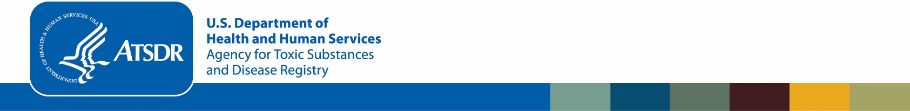
If you have questions about lead exposure, contact your local health agency (if provided at a specific site of concern, insert name and contact information for the local health agency contact person or office), or call or email (insert name) with Region (insert region number, ATSDR office location, telephone number, and email address of ATSDR contact person).

References
- Barltrop D, Khoo HE. 1975. The influence of nutritional factors in lead absorption. Postgraduate Medical Journal. 5(1):795–800.
- Brown SL, Chaney RL, Hettiarachchi, GM. 2016. Lead in urban soils: a real or perceived concern for urban agriculture? Journal of Environmental Quality. 45(1):26–36.
- Ku Y, Alvares HG, Mahaffey KR. 1978. Comparative effects of feeding lead acetate and phospholipid-bound lead on blood and tissue lead concentrations in young and adult rats. Bulletin of Environmental Contamination and Toxicology. 20(4):561–567.
- Quarterman J, Morrison JN, Humphries WR. 1975. The influence of high dietary intakes of calcium on lead retention in rats. Proceedings of the Nutrition Society. 34(2):89A–90A.

