File Name: NEFSC IC_Instruction Sheet for the Greater Atlantic Region Commercial Fishing Cost Survey for 20XX
Instruction Sheet for the

Greater Atlantic Region Commercial Fishing Cost Survey for 20XX

General Instructions

For all questions:
- DO refer to calendar year 20XX. All references to “the year” refer to calendar year 20XX.

For questions about costs:
- DO consult your records;
- Use your Schedule C (Form 1040, 1099, or corporate tax return form) of your 20XX federal tax return pertaining to calendar year 20XX.
- If you cannot find the information in your records or cannot consult your records, please use your best estimates of the costs you incurred.

- DO remember to check the “No Cost” option if you incurred $0.00 (no cost) for a cost category in 20XX unless prompted to skip.

For questions about costs for the selected vessel (where the “selected vessel” is identified on the first page of the survey):

- DO report combined costs for all state and federal commercial fishing activity, including Research Set-Aside (RSA) trips.
- DO report costs or indicate “no cost” even if the vessel did not take any trips in 20XX unless prompted to SKIP.

NOTE: There may be questions that do not pertain to you. In these cases, please SKIP those questions/sections as instructed.

If you are not the best person to answer questions about commercial fishing costs:
- DO send the survey to the person that is the best equipped to answer cost-related questions.
- DO answer questions from the owner’s perspective when asked about the number of vessels owned etc.
Flip to the back
for detailed instructions on individual survey questions

Thank you for taking the survey
If you have any questions pertaining to any part of the survey,
do not hesitate to call: X-XXX-XXX-XXXX

Personally identifiable information will be kept confidential.
Information collected will not be used for tax purposes.
Question 3. Example of an upgrade: Investing in (purchasing) a more advanced GPS system. Example of maintenance or repair: Repairing a GPS unit you own because it was damaged.
Specific Question Directions and Examples

Question 5. This question refers to a subset of the trip (operating) costs which were identified as the most significant on fishing trips. Any costs you feel were missed can be captured at the end of the survey in Question 21.

Question 6. This question refers to how trip costs are paid for, not including the cost of leasing in quota/ Das at Sea (DAS).Trip costs include the cost of fuel, bait, ice, water, supplies, groceries, oil, and other trip-level expenditures.
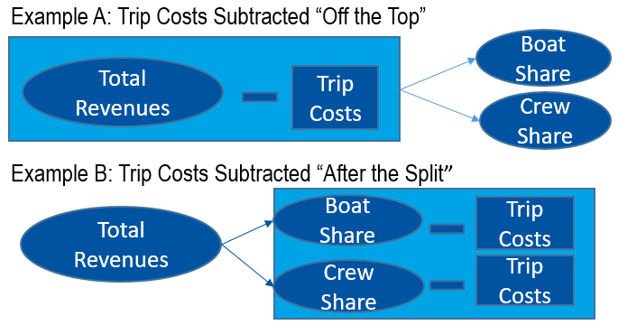
Question 7. Please refer to the schematic for how trip costs were subtracted from pay:

Question 9. Here, a flat rate system refers to payments made per unit time (for example $/hour, $/trip, etc.). A share system refers to revenues split between the boat and crew based on a percentage (for example, crew share and boat share as a percentage of total revenue).

Question 11. Benefits include: retirement benefits; health, life, or disability insurance; unemployment insurance; bonuses; profit sharing; and fringe benefits. Only include benefit expenses for crew and hired captains.

Question 12. Overhead costs refer to costs that generally do not vary by the number of trips taken. Please provide the overhead cost attributed to the selected vessel ONLY. If you are unsure or unable to provide the cost associated with the selected vessel, please go to the “Total Cost for All OWNED Vessels” column and write the total overhead cost for all owned vessels.

Question 13. On how many permitted vessels (state or federal) were you listed as an owner in 20XX to which your overhead costs from Question 12 apply?

Question 15-20. These questions include longer directions in the survey to clarify what information to provide. If you need assistance on how to answer these questions, please call: X-XXX-XXX-XXXX.

Question 21. Personal costs refer to costs not directly related to fishing business activities associated with the selected vessel. For example, do not include driving a personal vehicle to and from the docks or home insurance in this section.

