Development of CDC’s Let’s Stop HIV Together Social Marketing Campaign for Consumers

Attachment 7: Concepts

Attachment 7: Concepts

Topic | Asset
HIV Stigma | 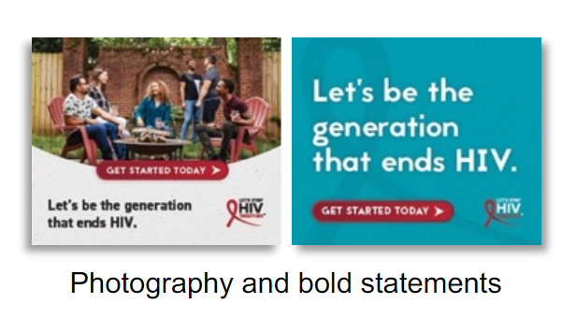
HIV Treatment | 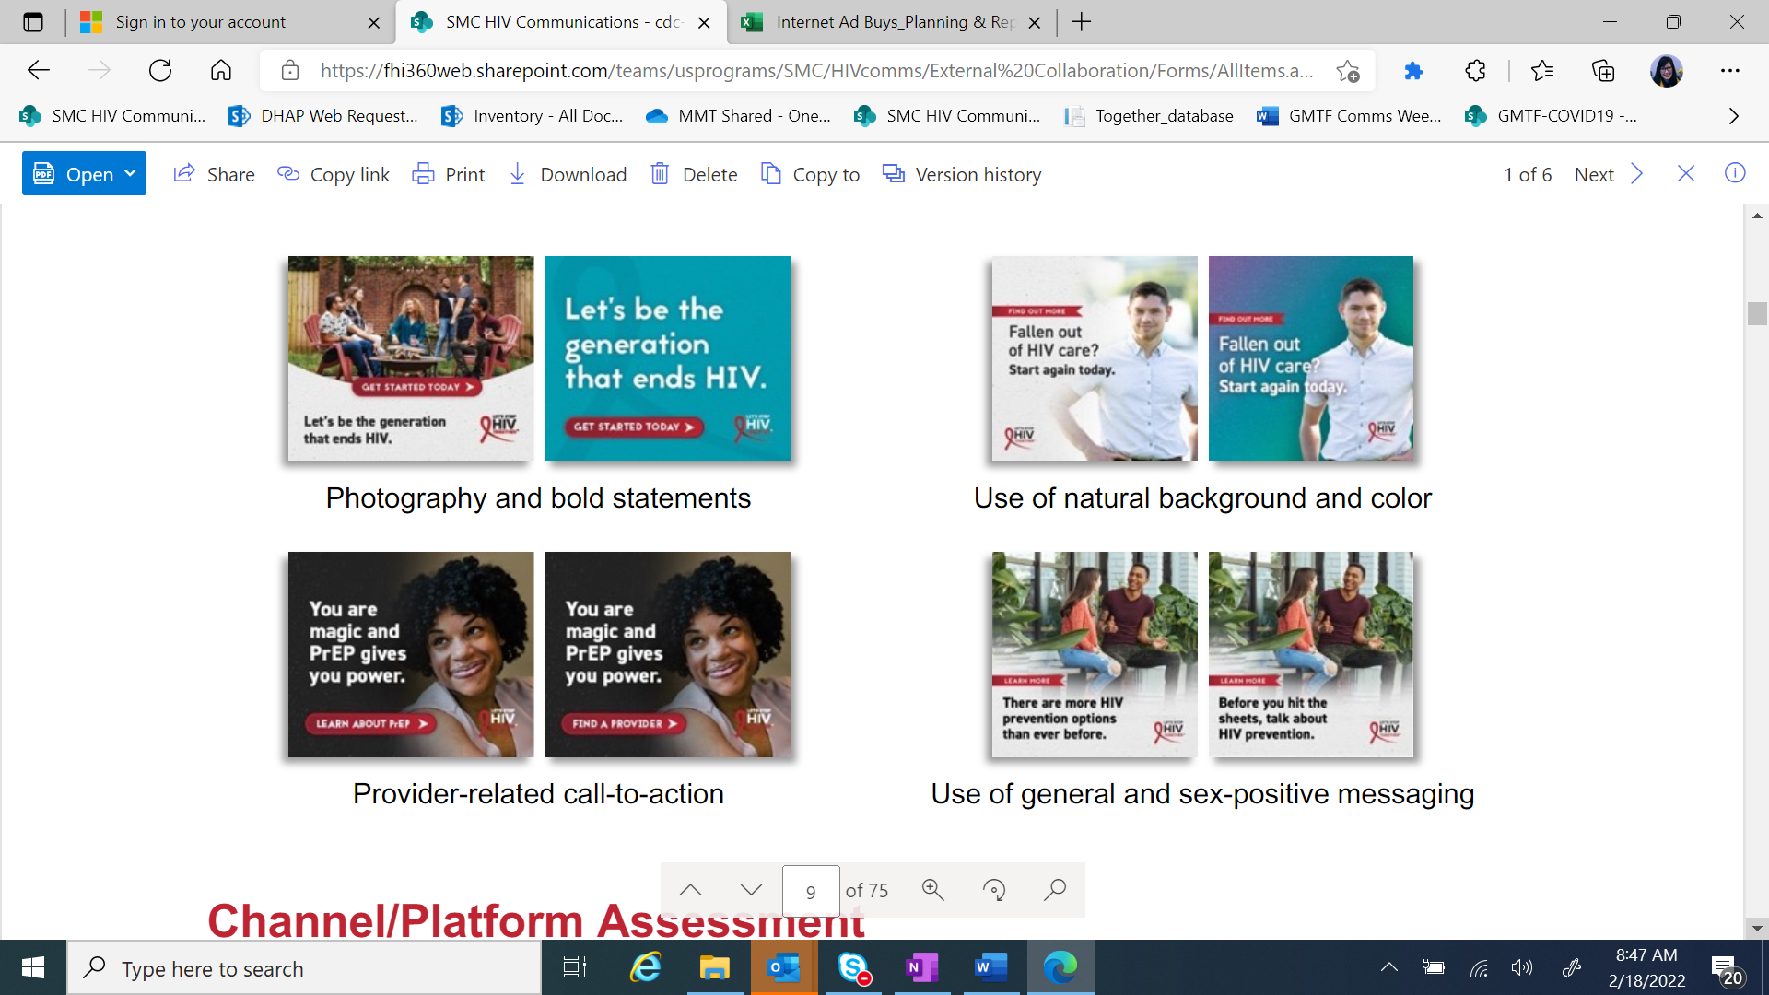
HIV Prevention | 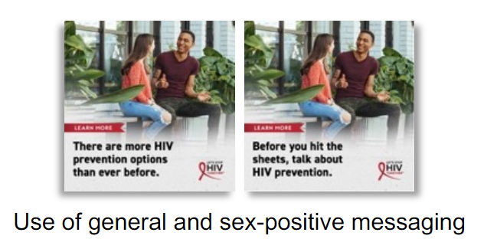
HIV Prevention/PrEP | 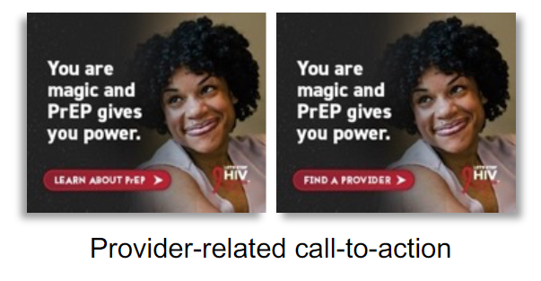
HIV Stigma | 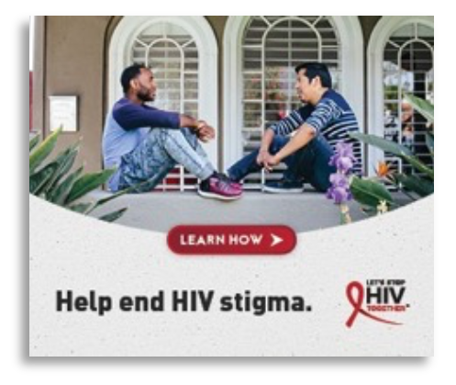
HIV Stigma | 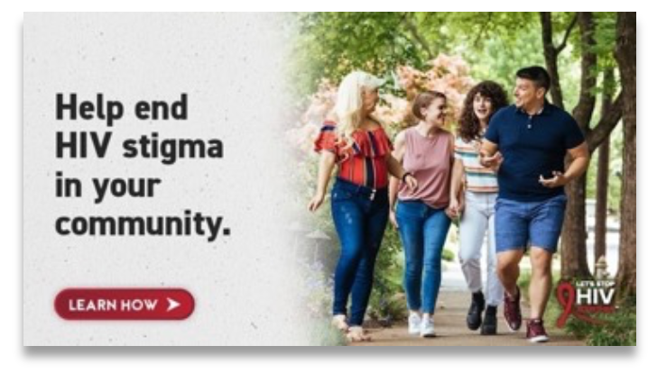
HIV Prevention | 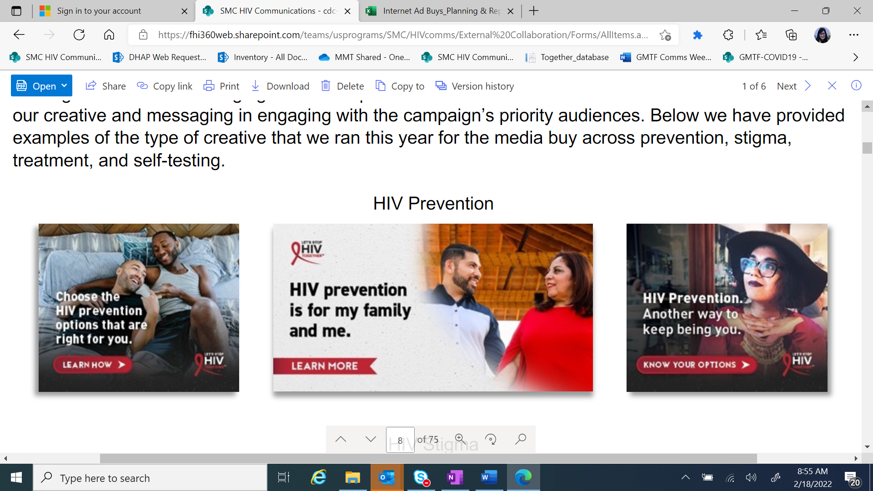
HIV Prevention
HIV Treatment | 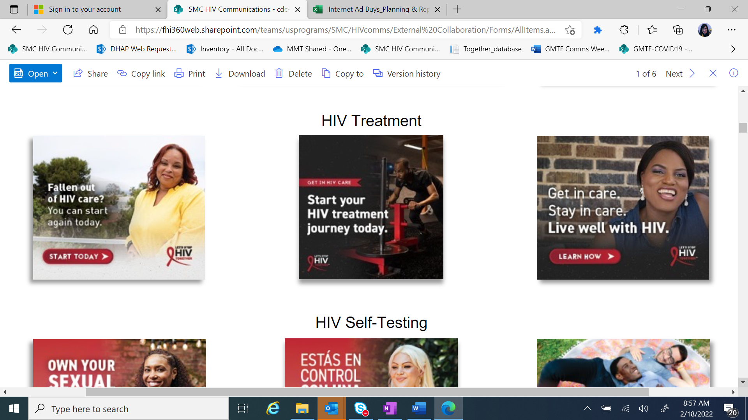
HIV Treatment
HIV Testing/HIV Self-Testing | 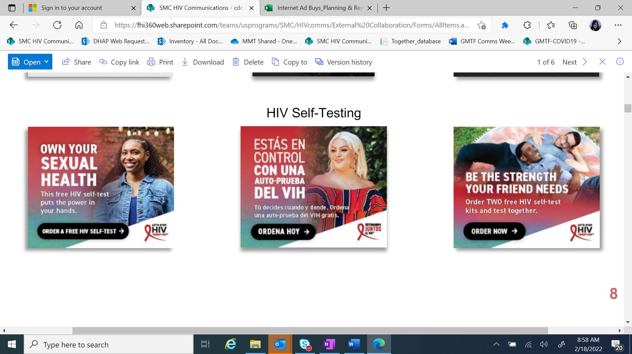
HIV Testing/HIV Self-Testing

