TAPS Teen Survey
https://atest-cawi.norc.org/SE/?st=tT6ZyQXGSUMTXYzwn9YFmGFShWrNwVZo3EbJdy5X%2b5s%3d&tui=auto&nocookie=1

[DISPLAY-WINTRO_1]



CONSENT.
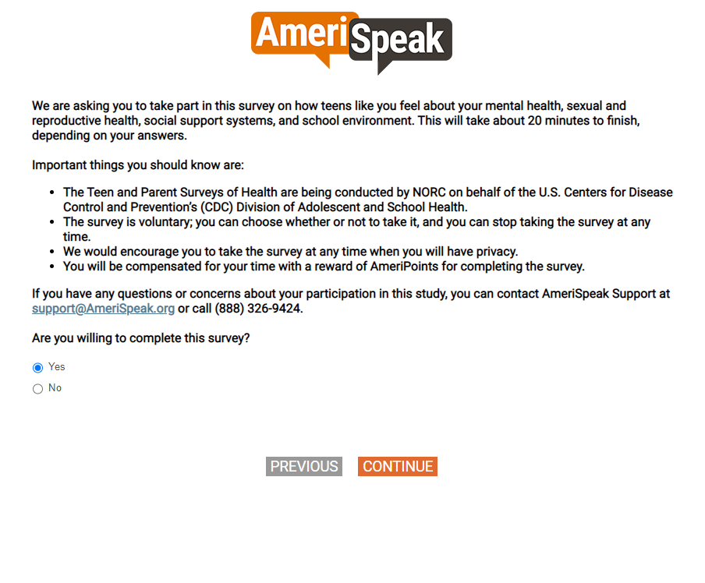

[DISPLAY – INTRO2]
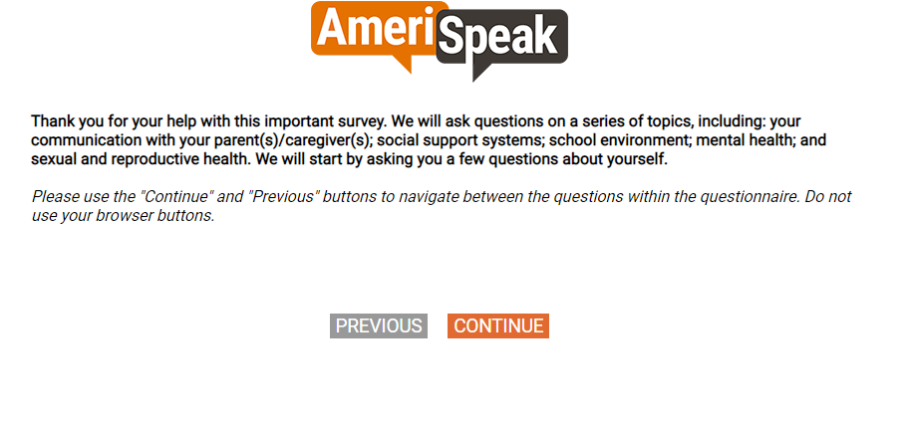

Q1.
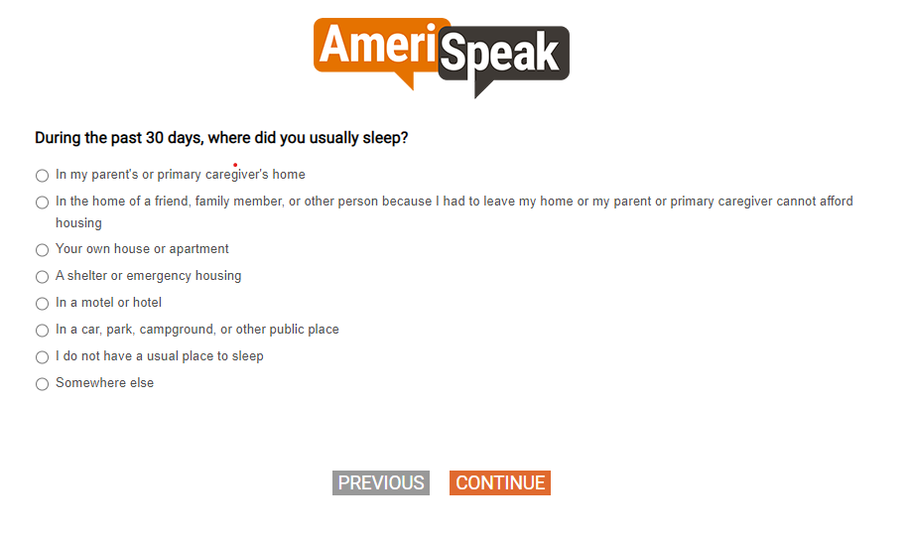
Q2.

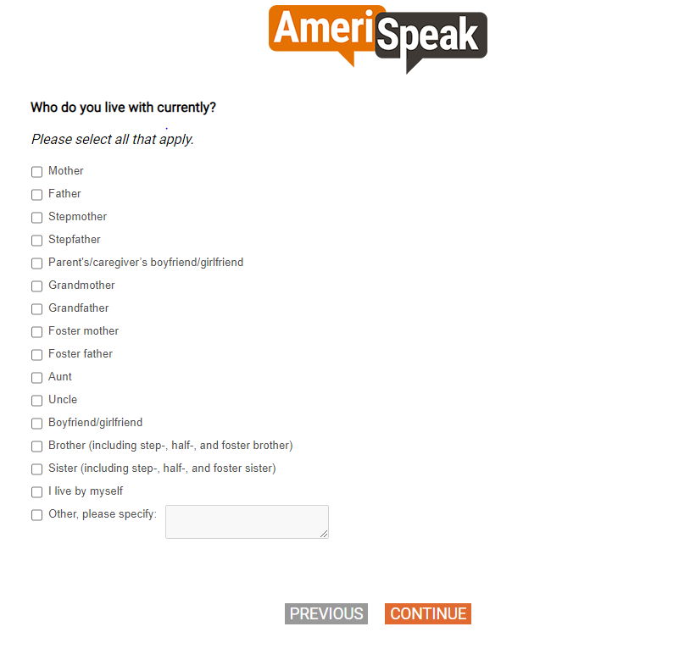
[SHOW IF S_AGE=15-17]
[SP]
Q3a.
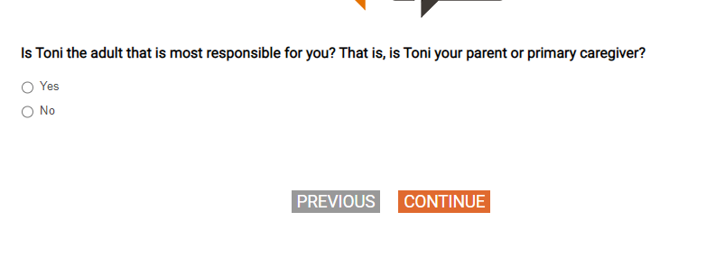

[SHOW IF Q3A=2, 77, 98, 99 or S_AGE>=18]
[SP]
Q3b.
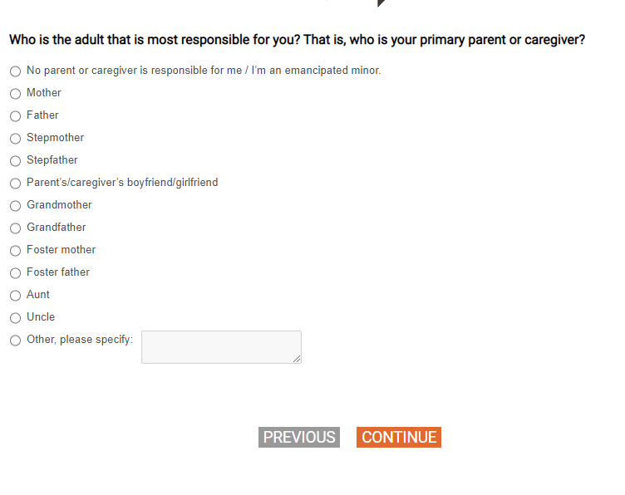
[SHOW ON SAME PAGE AS Q3B]
[SHOW IF Q3B=2-13]
[SMALL TEXTBOX]
Q3c.
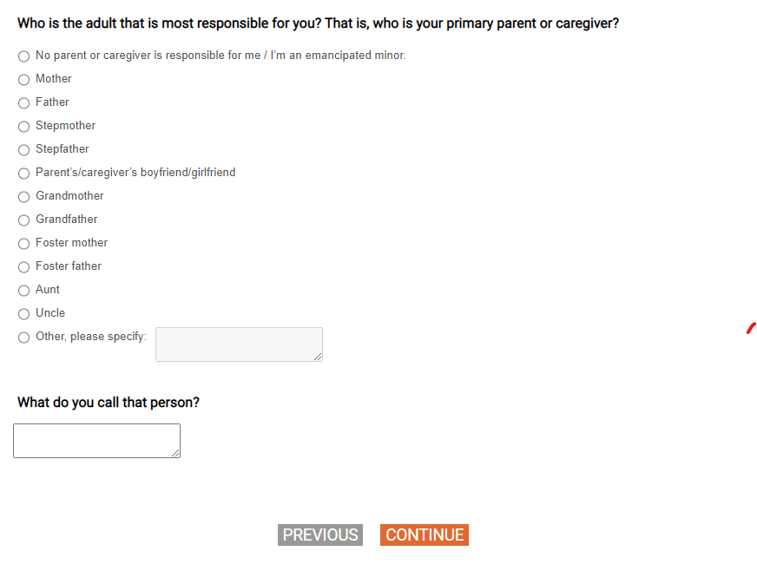
[SP]
Q4.
[IF MONTH=MAY-AUGUST] What grade will you be enrolled in this Fall?
[IF MONTH=SEPTEMBER-APRIL]What grade are you in?
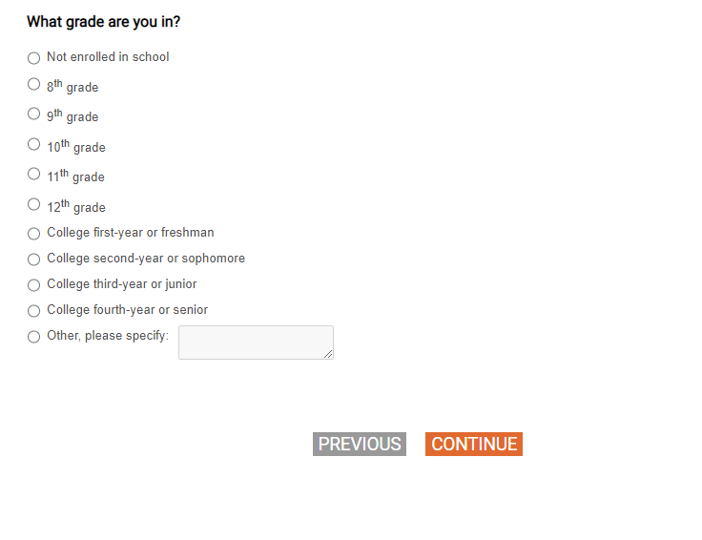
[SHOW IF Q4=2-11]
Q4_A

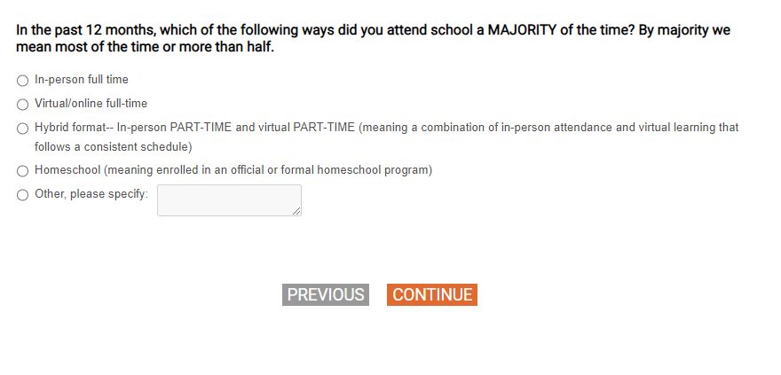
[SHOW IF Q4=2-11]
[SP]
Q4_B
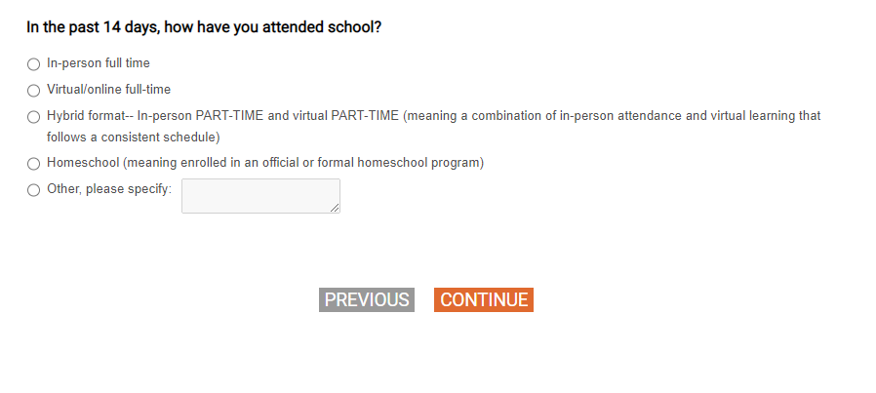
[SP]
Q5.
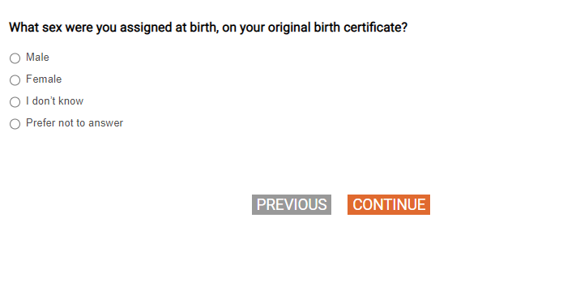
[SP]
Q5b.

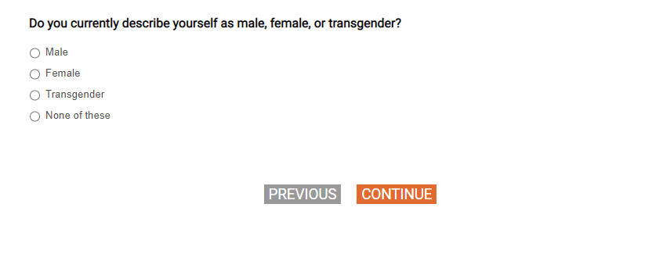
[SHOW IF (Q5=1 and Q5b=2) or (Q5=2 and Q5b=1)]
[CUSTOM PROMPT ONCE IF Q5C=2:
CAWI: "You can go back to change your answer to the last questions by clicking the 'Back' button"
CATI: IF R CHOOSES 2, ASK: “Would you like to change your answer to the last two questions?”]
[SP]
Q5c.

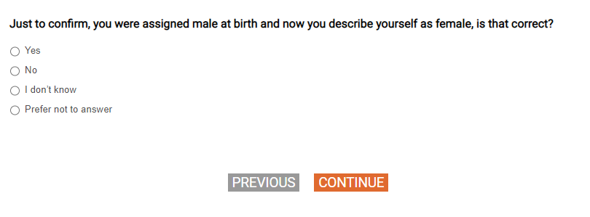
Q6
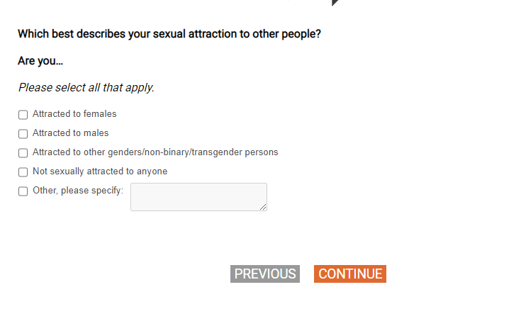
Q7
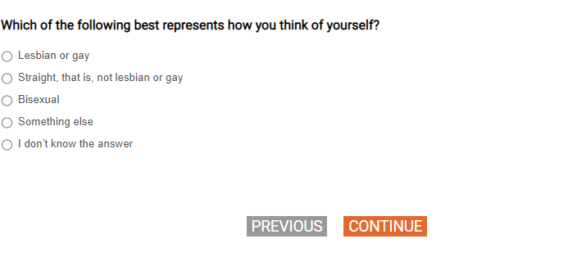
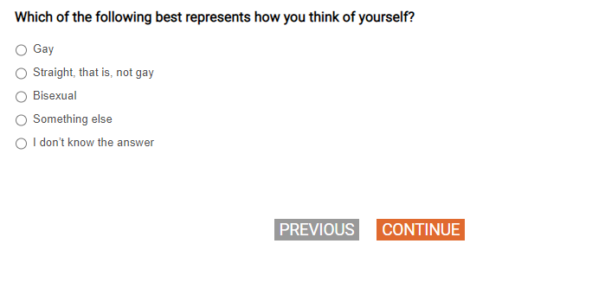
Q8
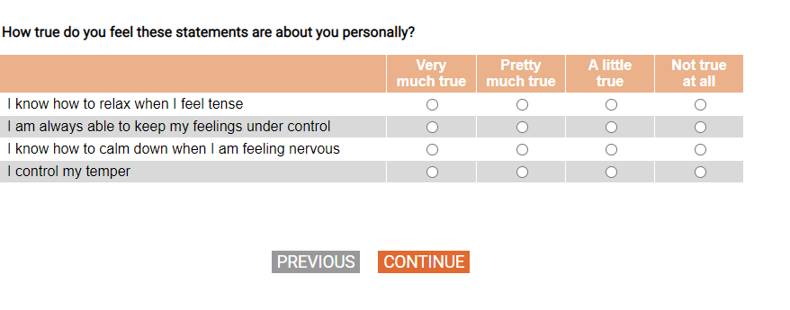
Q9
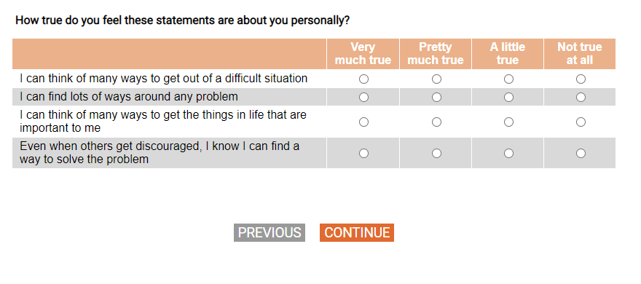

[SHOW IF Q4=2-11]
[GRID, SP]
Q10.
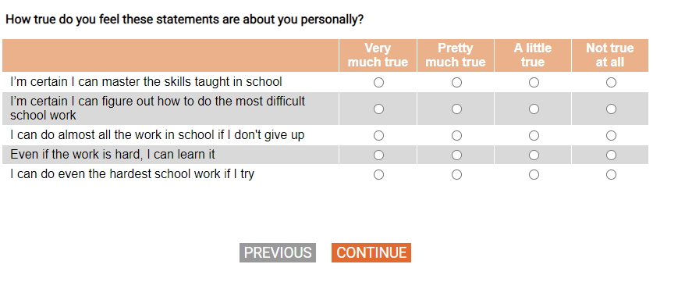
Q11
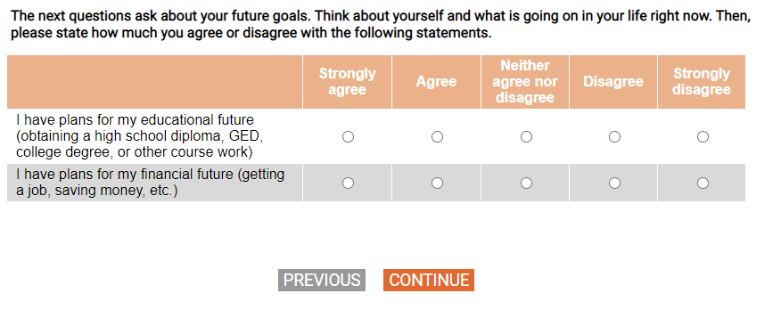
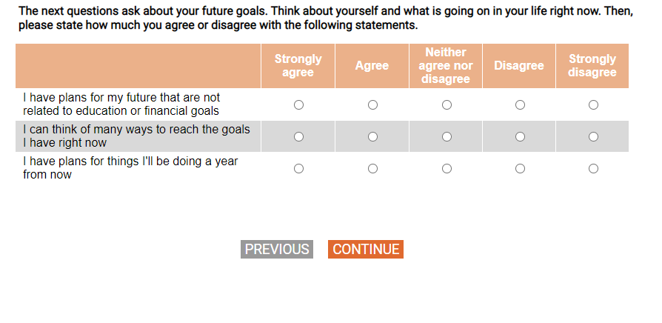
[DISPLAY – SECTC_INTRO]


Q12
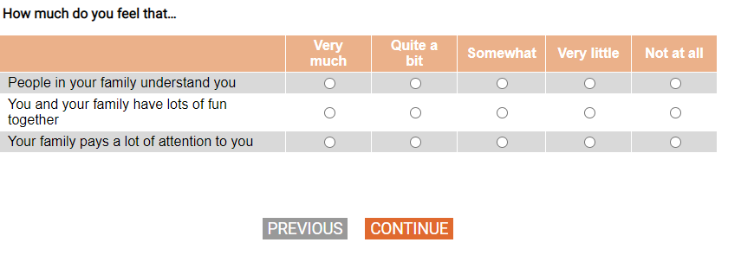
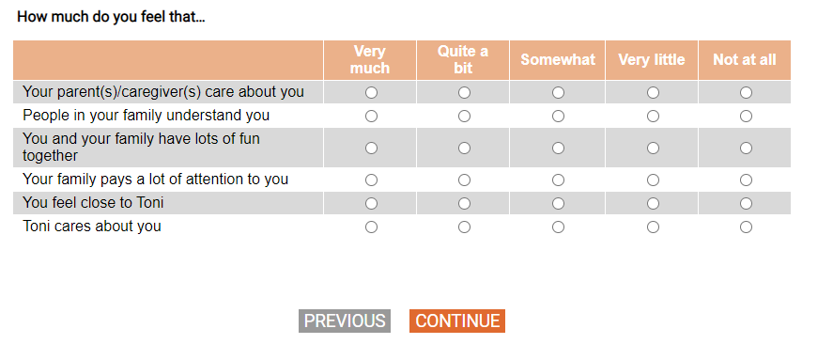
[SHOW IF Q3A=1 or Q3B=2-13]
[SP]
Q13.

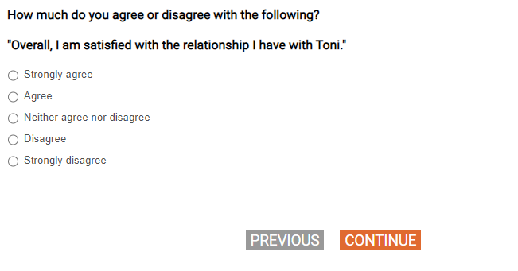
[SHOW IF Q3A=1 or Q3B=2-13]
[DISPLAY – SECTC_1]



[SHOW IF Q3A=1 or Q3B=2-13]
[GRID, SP; 4, 4]
Q14.

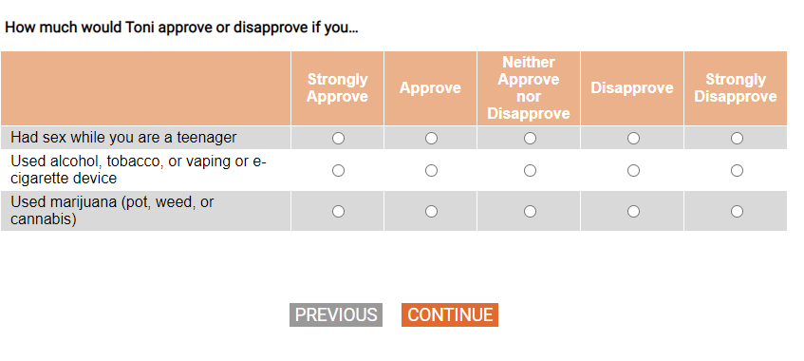
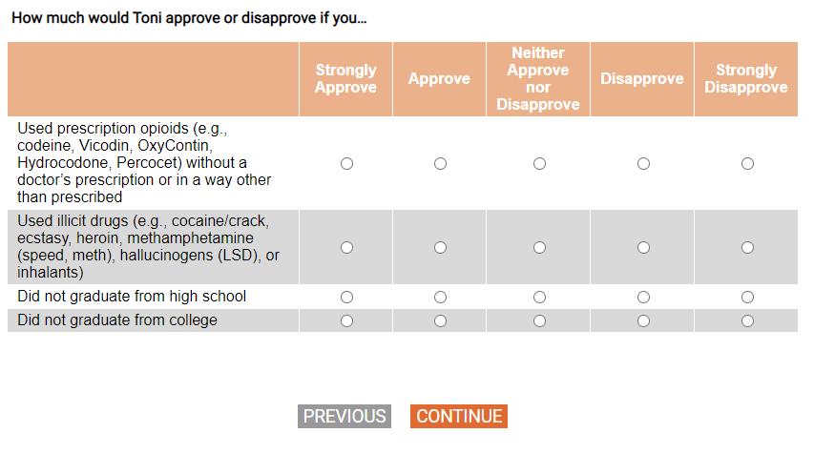
[SHOW IF Q3A=1 or Q3B=2-13]
[DISPLAY – SECTC_2]

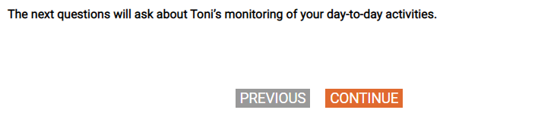
[SHOW IF Q3A=1 or Q3B=2-13]
[GRID, SP]
Q15.
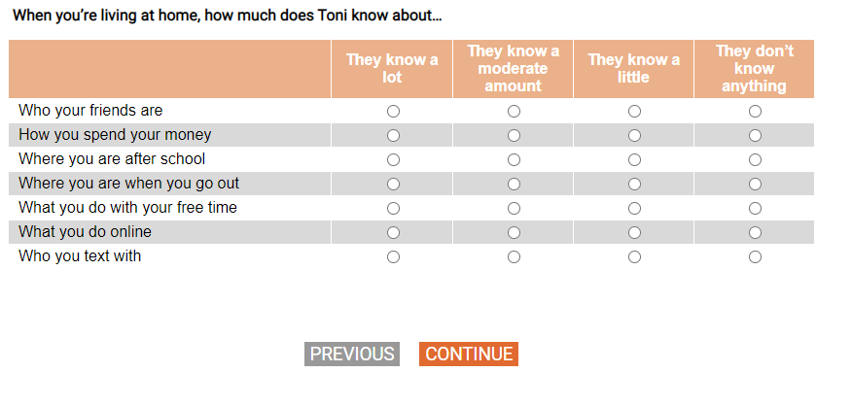
[SHOW IF Q3A=1 or Q3B=2-13]
[GRID, SP]
Q16.
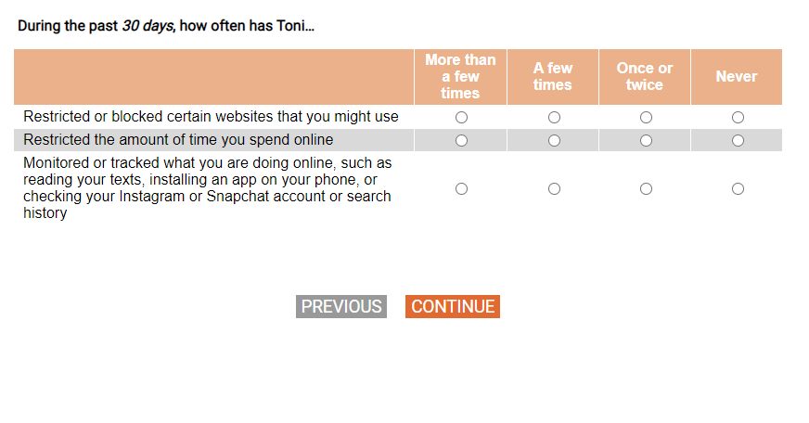
[SHOW IF Q3A=1 or Q3B=2-13]
Q17.
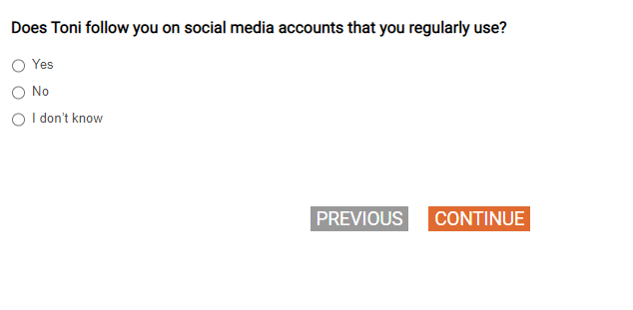
[SHOW IF Q3A=1 or Q3B=2-13]
[SP]
Q18.

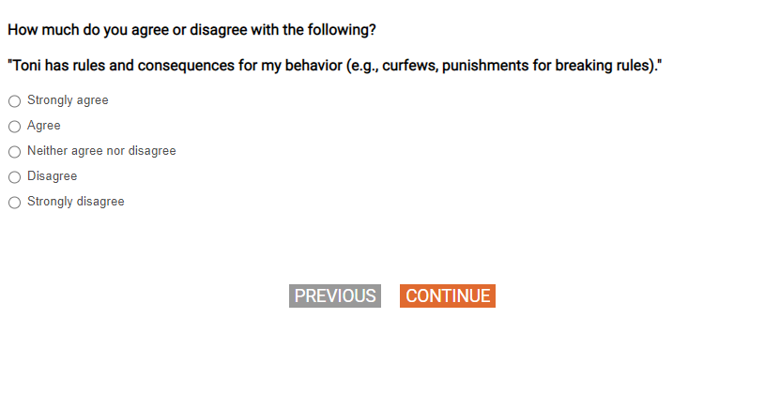
[SHOW IF Q3A=1 or Q3B=2-13]
[DISPLAY – SECTC_3]



[SHOW IF Q3A=1 or Q3B=2-13]
[GRID, SP; 4, 4, 4, 4]
Q19.
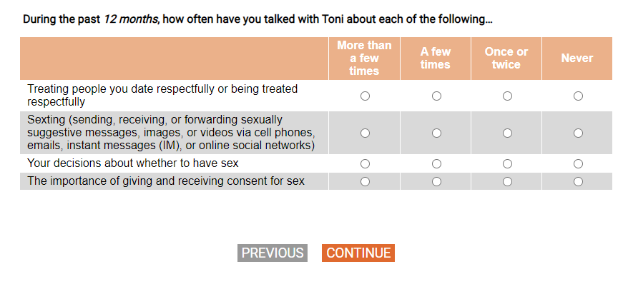
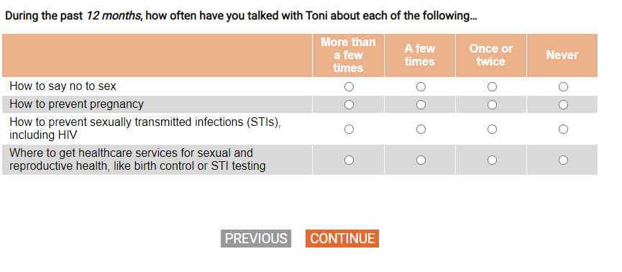
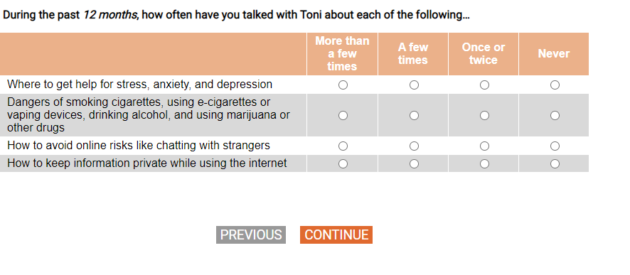

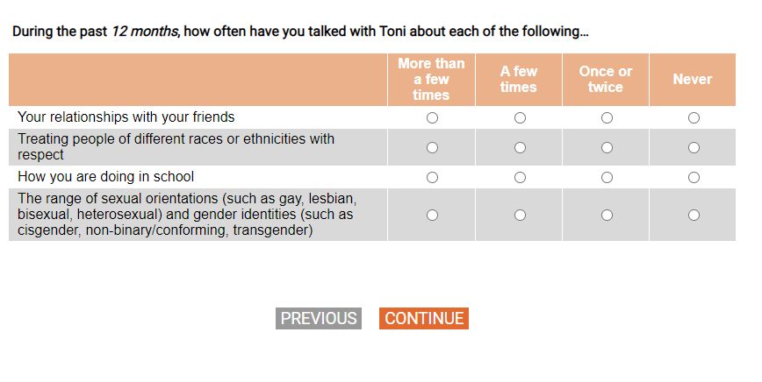
[SHOW IF Q3A=1 or Q3B=2-13]
[GRID, SP]
Q20.
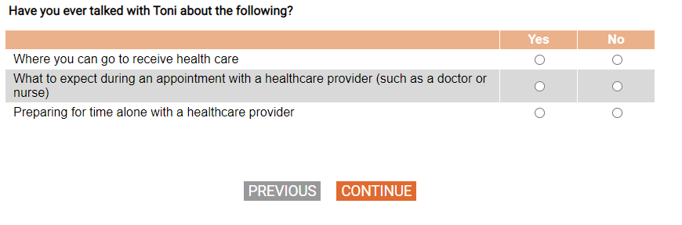
[SHOW IF Q3A=1 or Q3B=2-13]
[SP]
Q21.
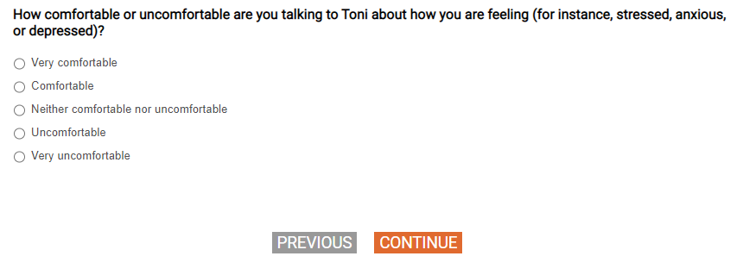
[SHOW IF Q3A=1 or Q3B=2-13]
[SP]
Q22.

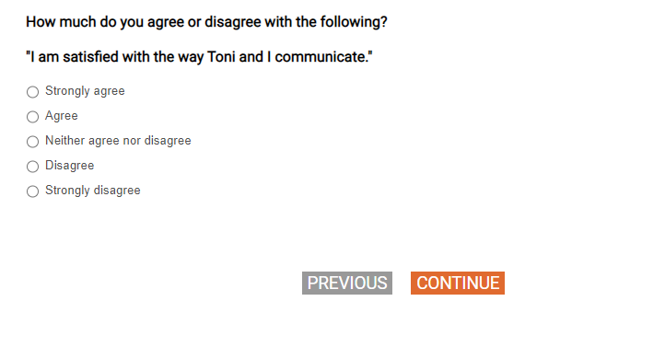

[DISPLAY – SECTD_INTRO]
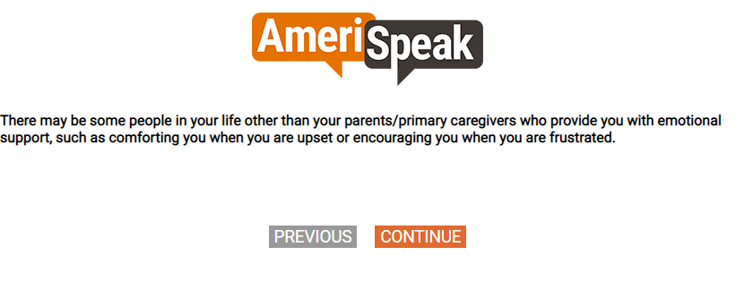

Q23
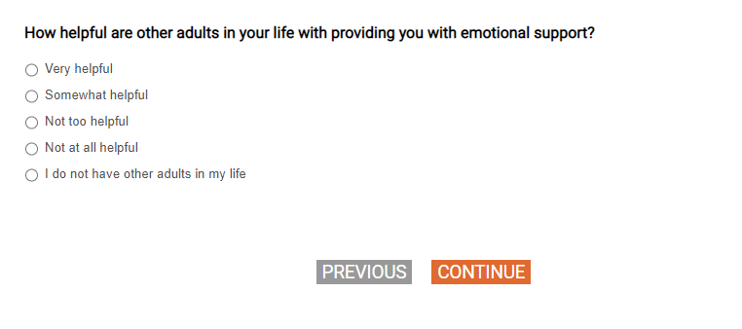
Q24
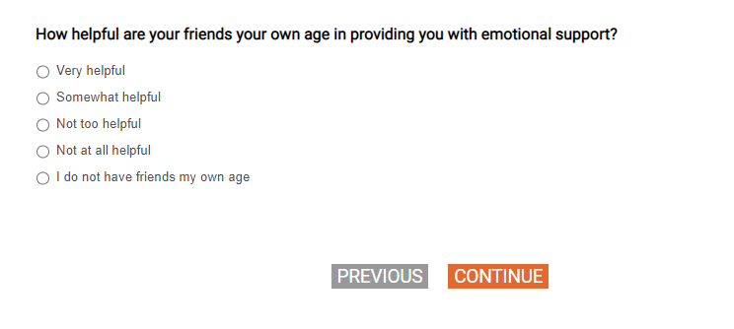

[SHOW IF Q4_B = 1,2,3,5]
[DISPLAY – SECTD_1]

[GRID, SP]
[SHOW IF Q4_B = 1,2,3,5]
Q25.
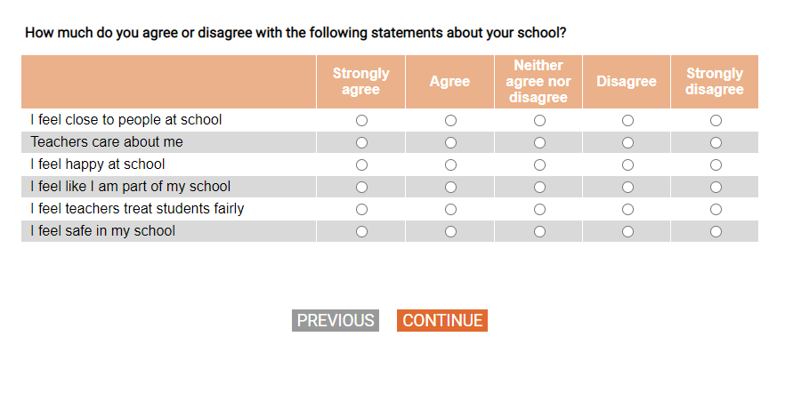
[SP]
[SHOW IF Q4_B = 1,2,3,5]
Q26.
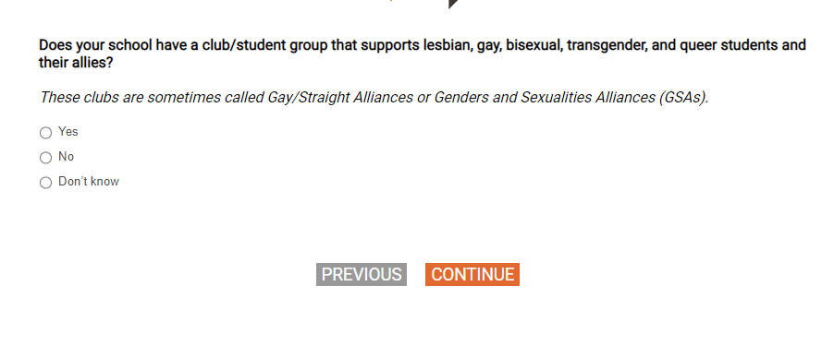
[SHOW IF Q26=1]
[SP]
Q27.
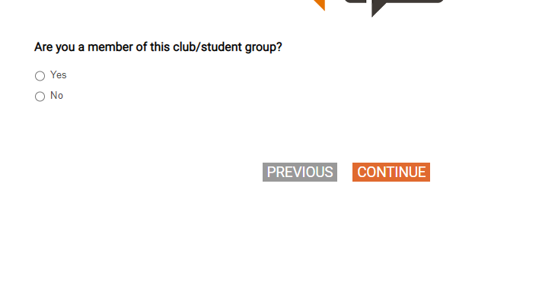

[DISPLAY – SECTE_INTRO]
IF Q4=2-11: The next questions ask about your feelings about your school and neighborhood.

IF Q4=1,77,98,99: The next questions ask about your feelings about your neighborhood.

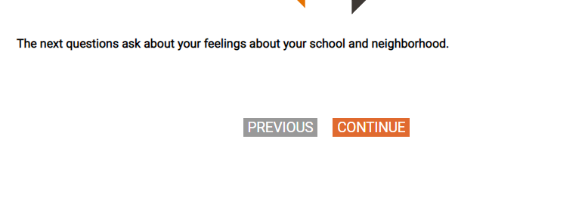
[SHOW IF Q4=2-11]
[SP]
Q28.
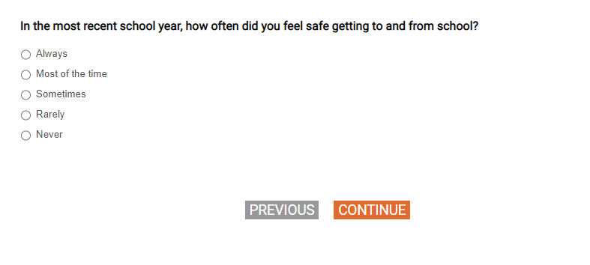
Q29
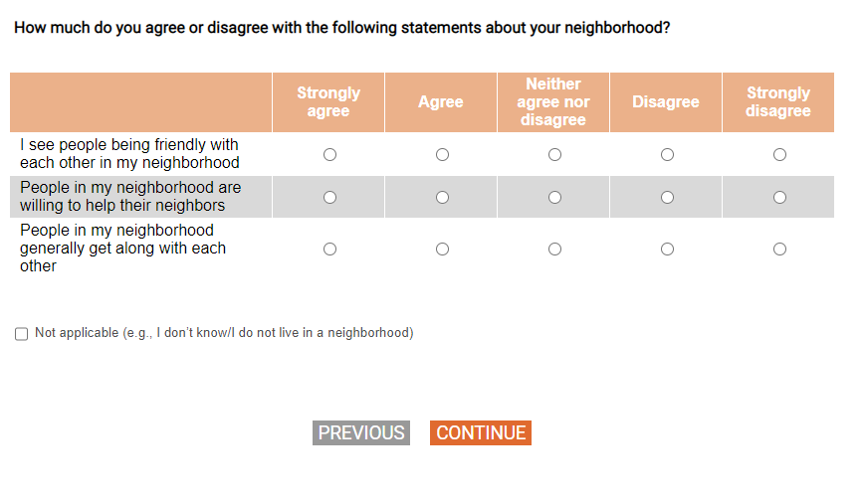
[DISPLAY – SECTF_INTRO]

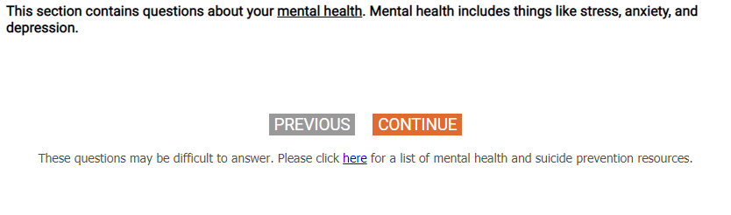

Q30
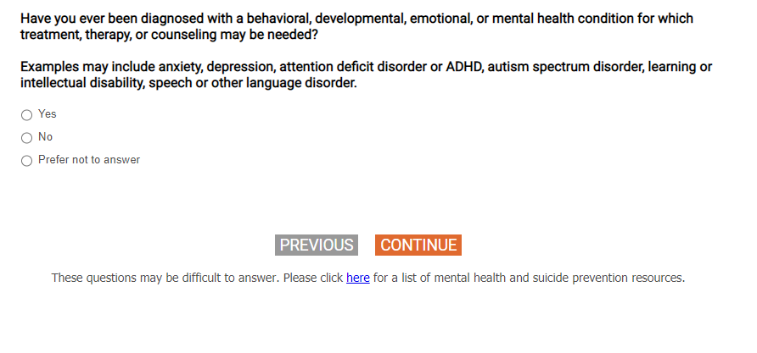
Q31
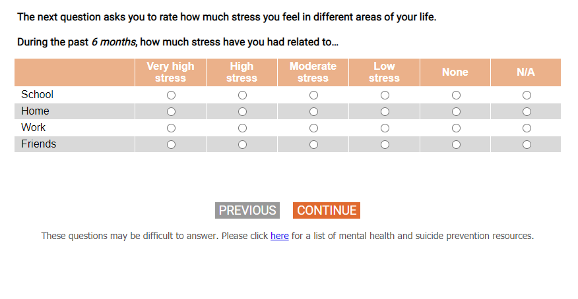
Q32
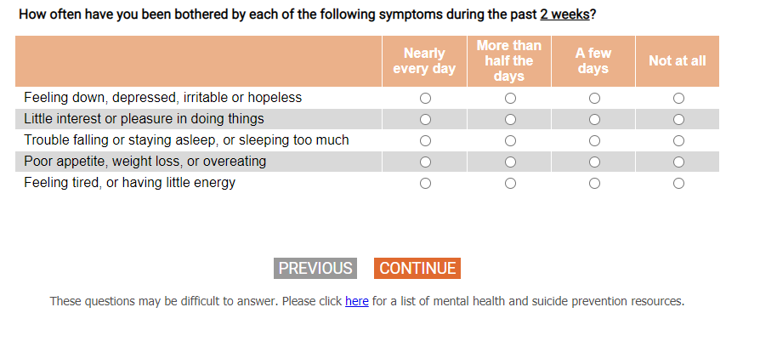
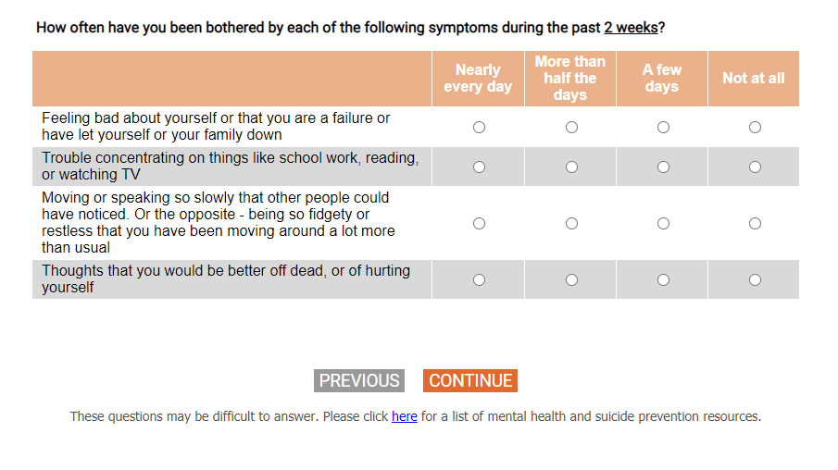
Q33
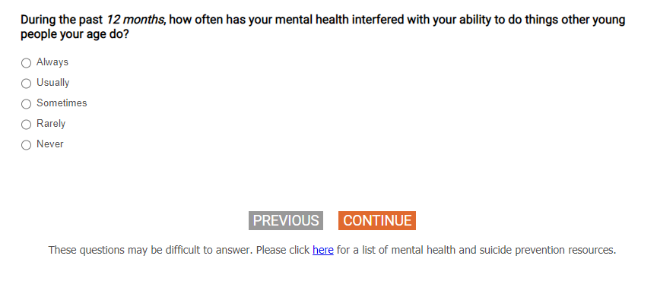
Q34
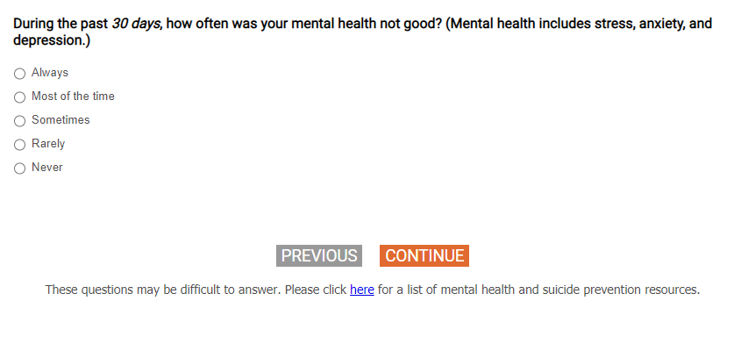
[DISPLAY – SECTF_1]

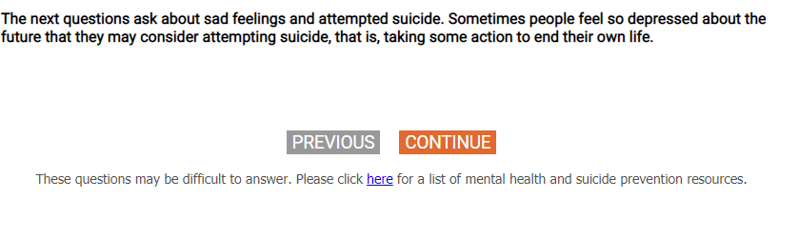
Q35
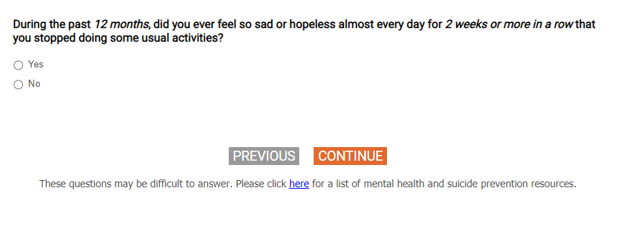
Q36
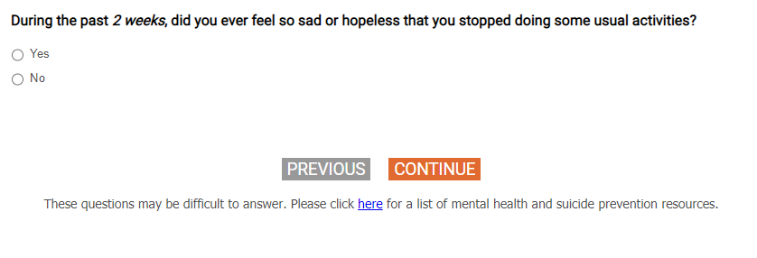

Q37
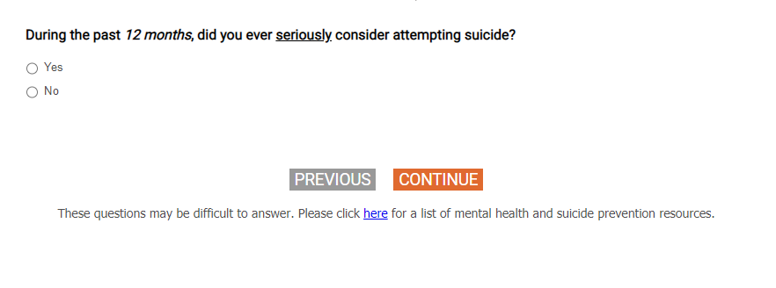

[SHOW IF Q37=1, 77, 98, 99]
[SP]
Q38.

[DISPLAY – SECTF_2]

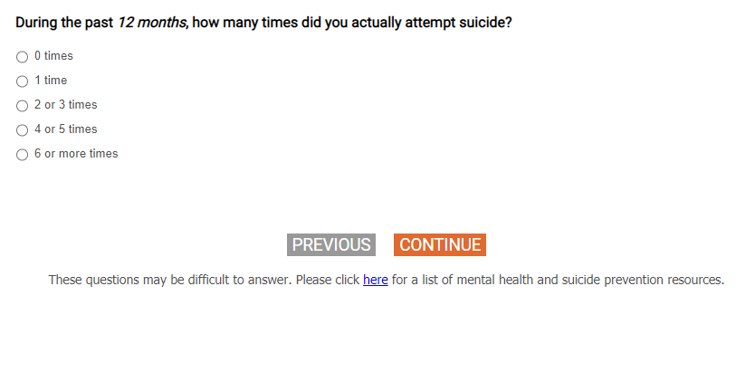

[DISPLAY – SECTF_2]

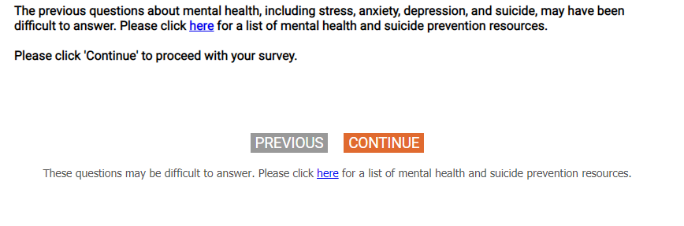
Q39
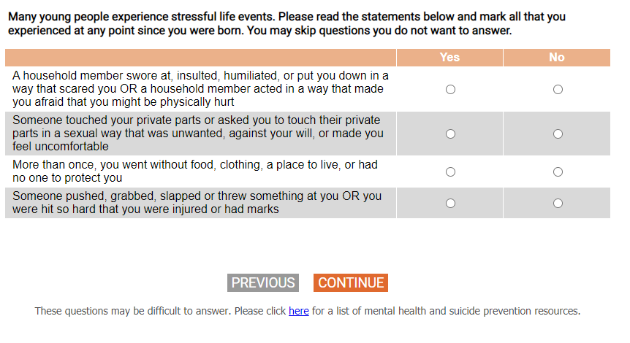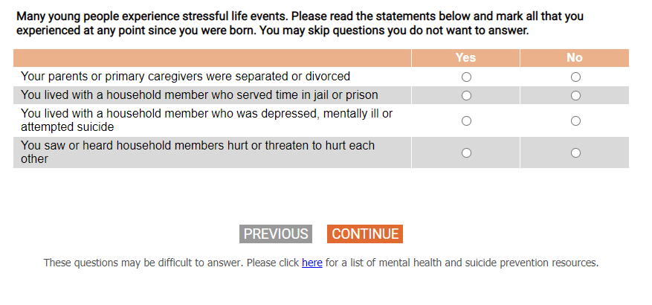

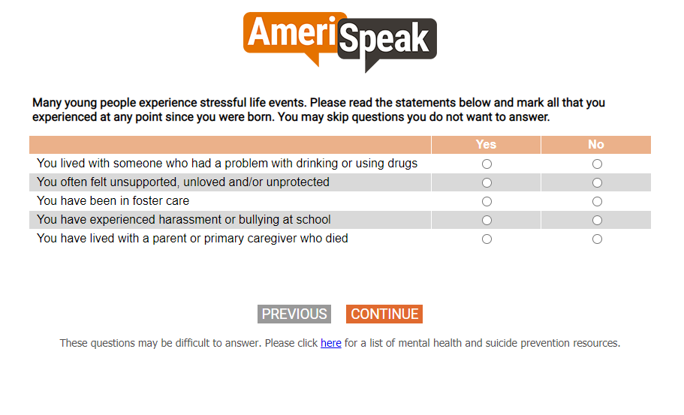
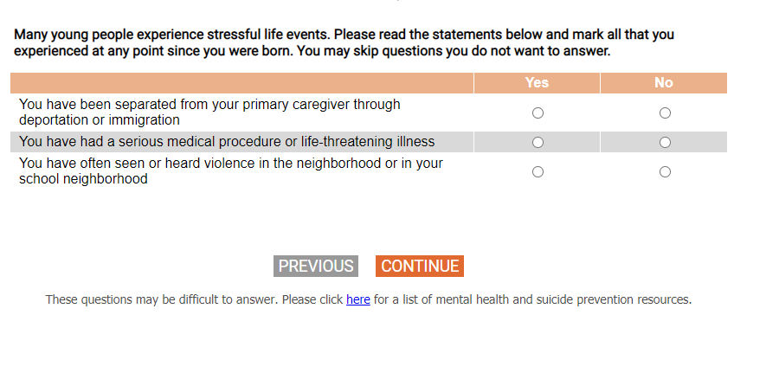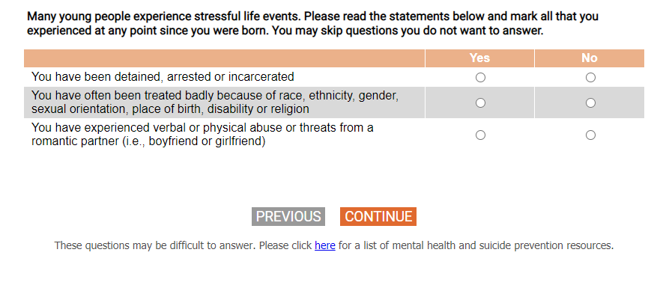
Q40
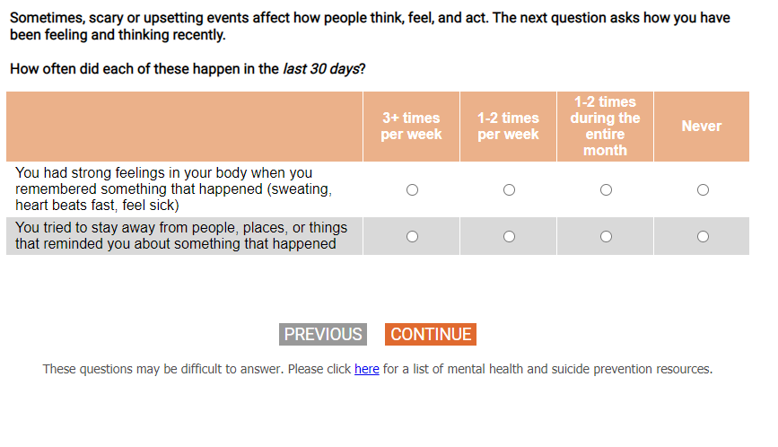

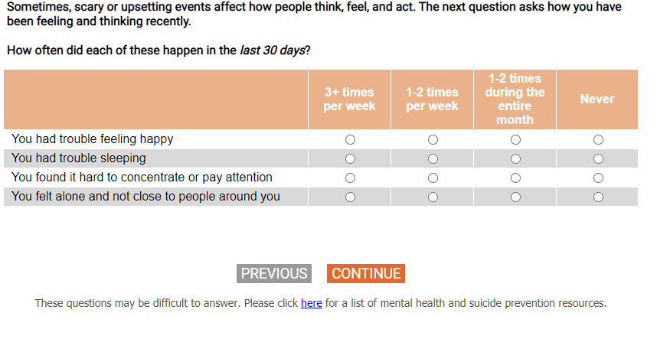

[DISPLAY – SECTH_INTRO]
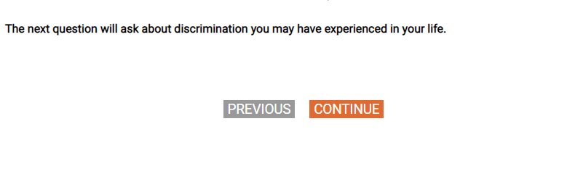

Q41

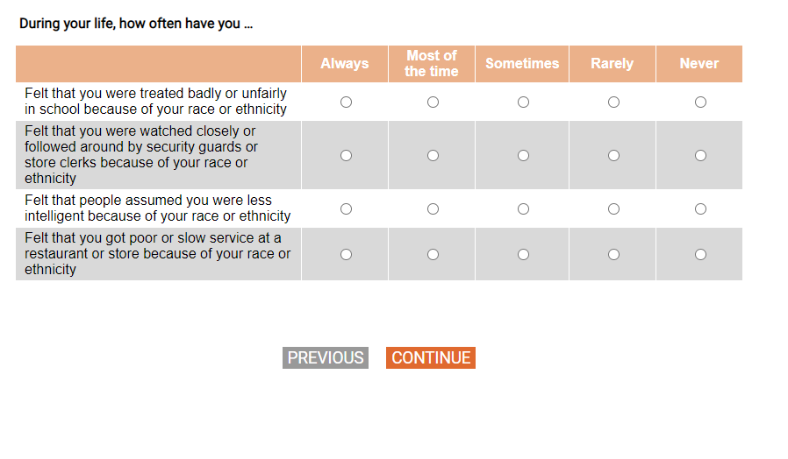
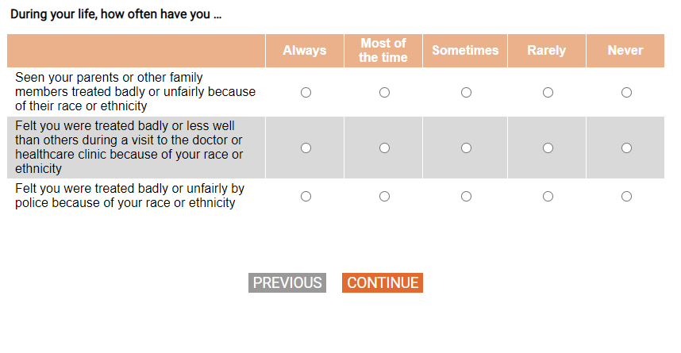
[DISPLAY – SECTI_INTRO]
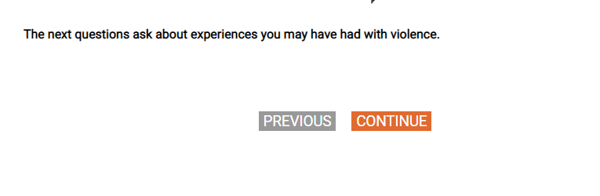
[SP]
[SHOW IF Q4 = 2-11]
Q42_1.

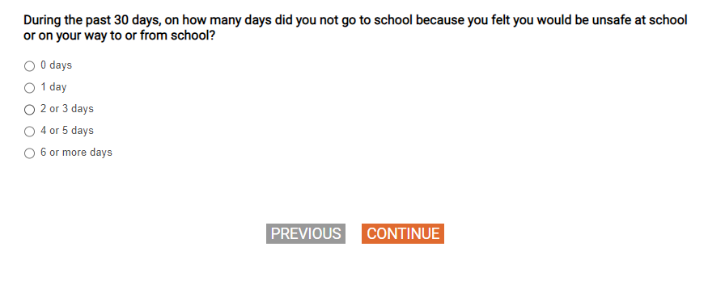

Q42_2.
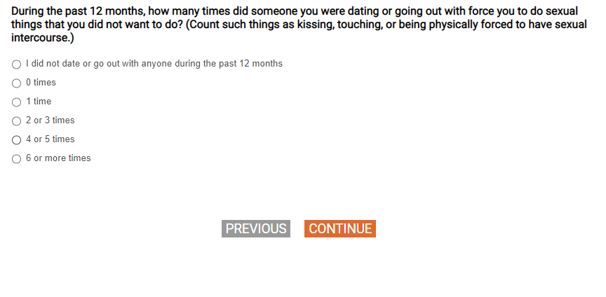
[SHOW IF Q42_2=2-6, 77, 98, 99]
[SP]
Q43.

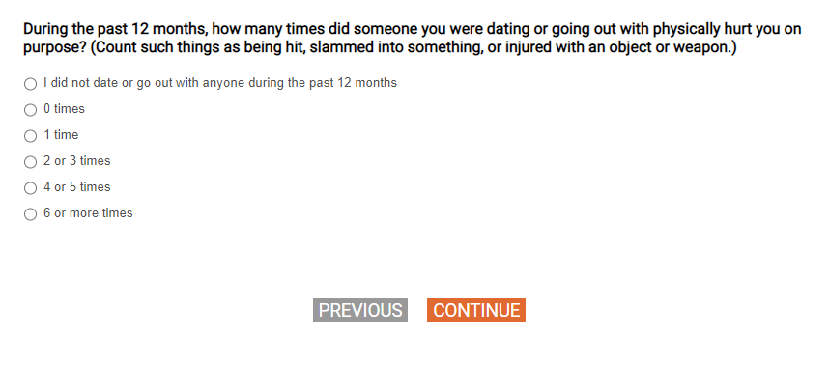

[SHOW IF Q43 = 2-6, 77, 98, 99]
[SP]
Q44.

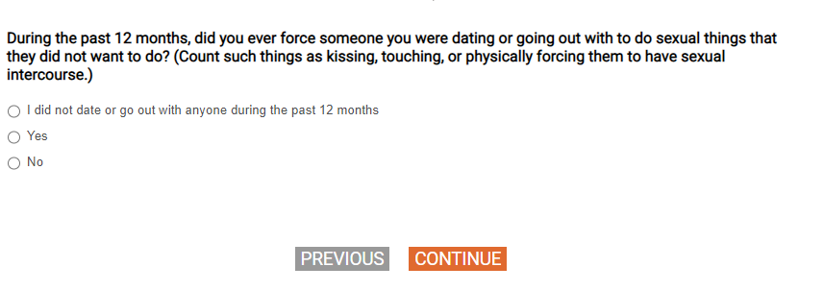
Q45
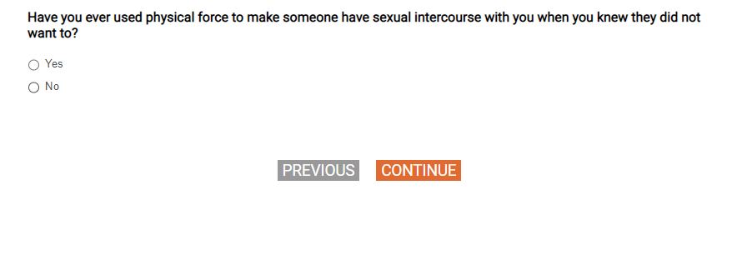
Q46
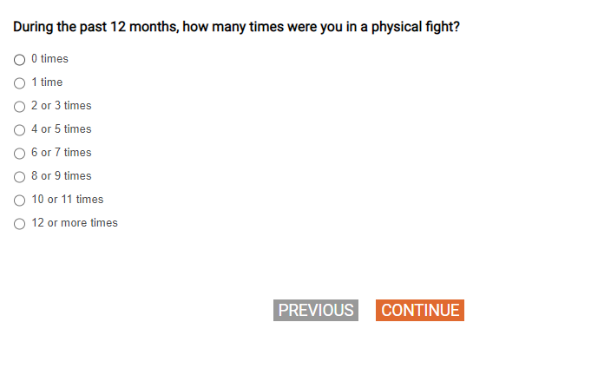
Q47
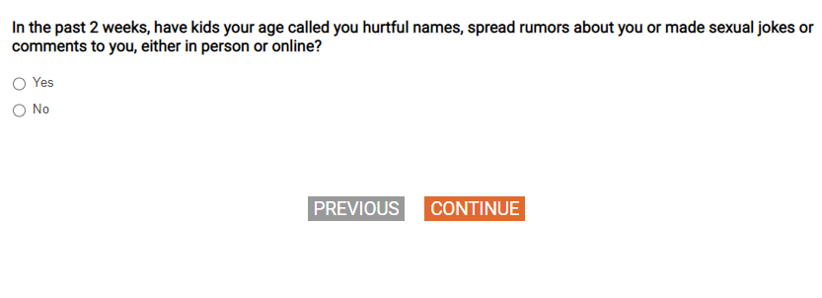
Q48
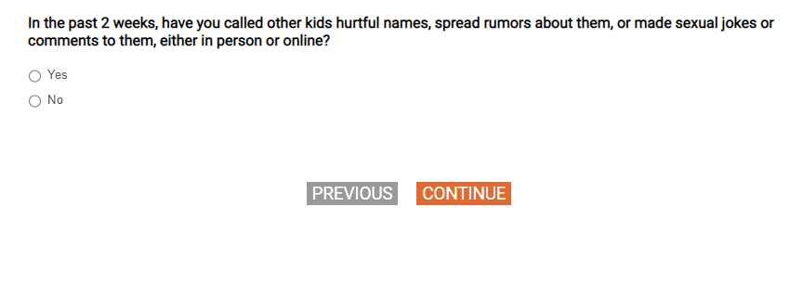
[DISPLAY – SECTJ_INTRO]



Q49
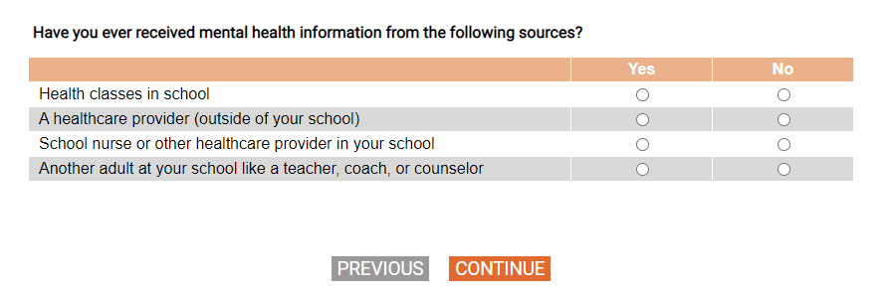
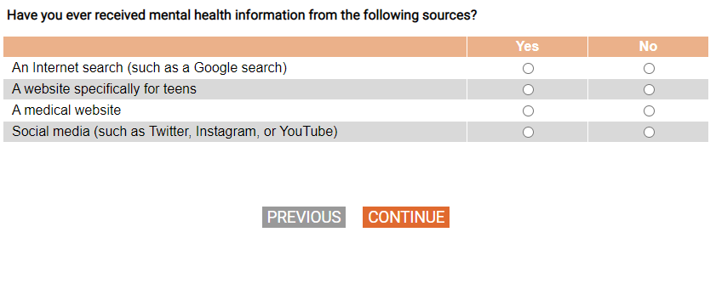
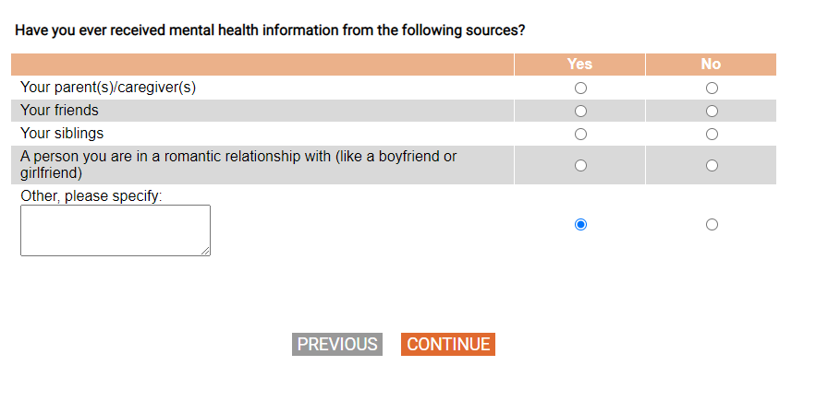

[SHOW IF ANY Q49a-m=1]
[GRID, SP; SHOW NUMERIC LABELS]
Q50.

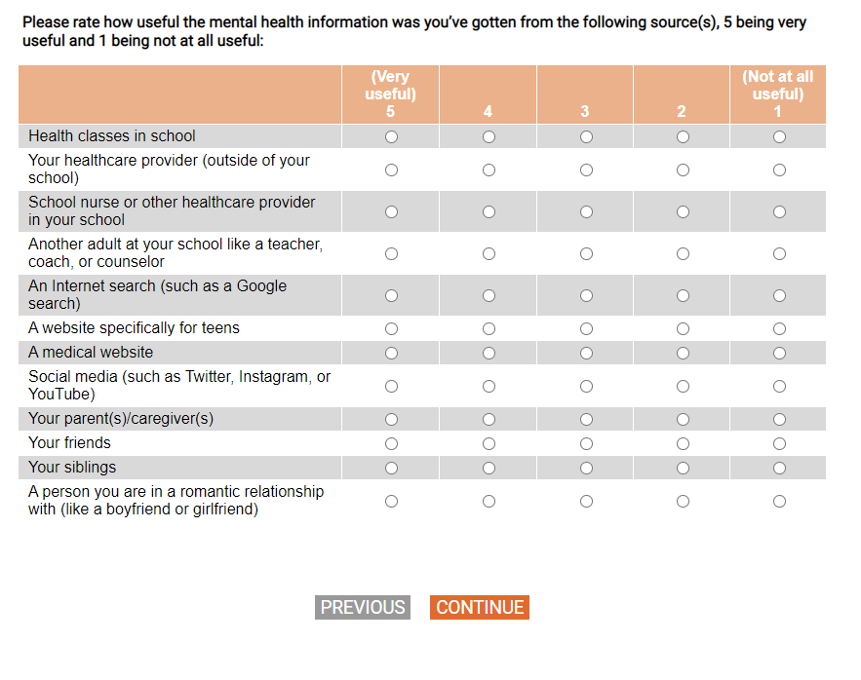
Q51

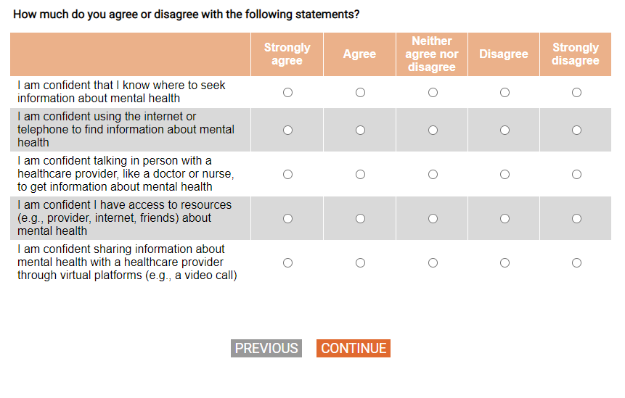
[DISPLAY – SECTJ_1]
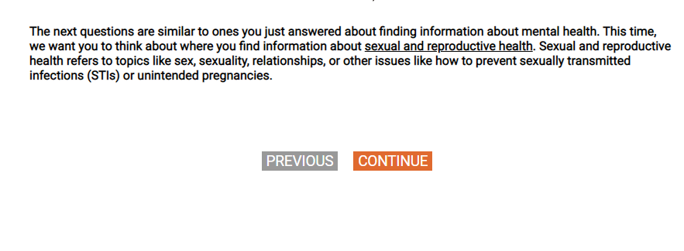
Q52
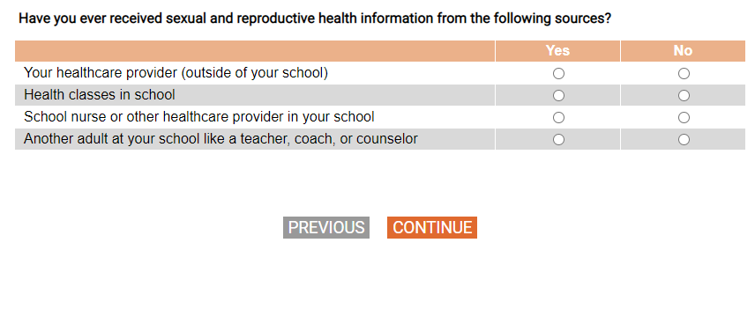
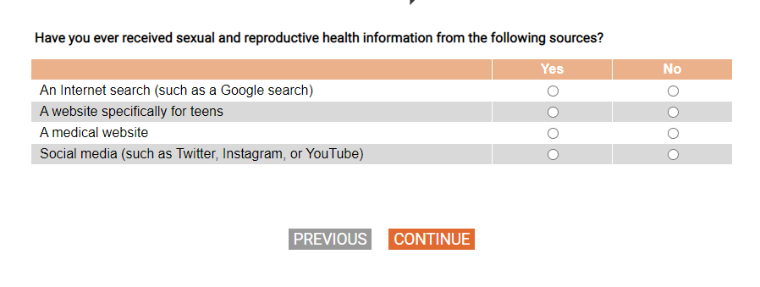

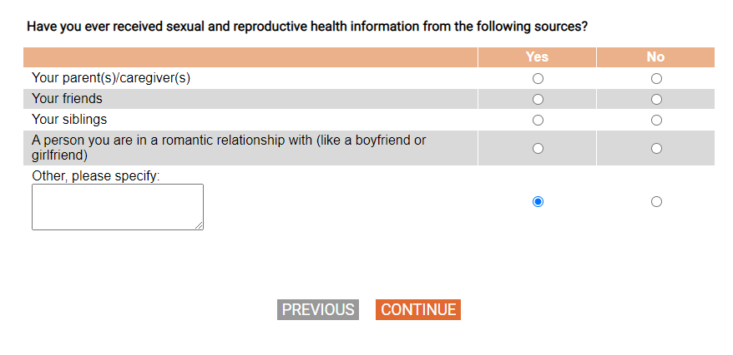
[SHOW IF ANY Q52A-M=1]
[GRID, SP; SHOW NUMERIC LABELS]
Q53.
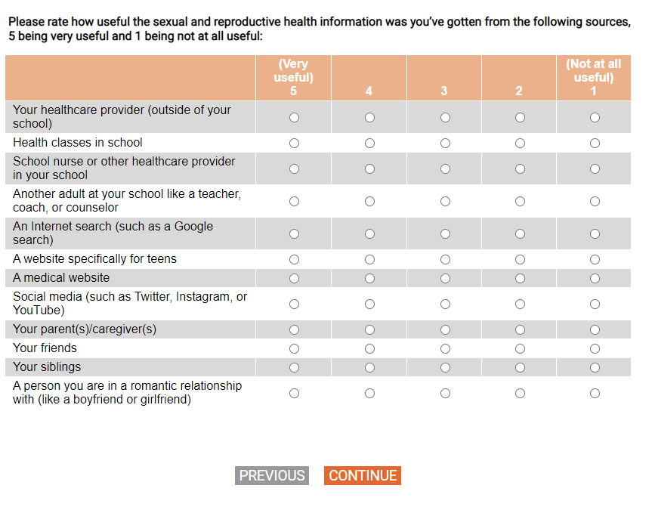

Q54
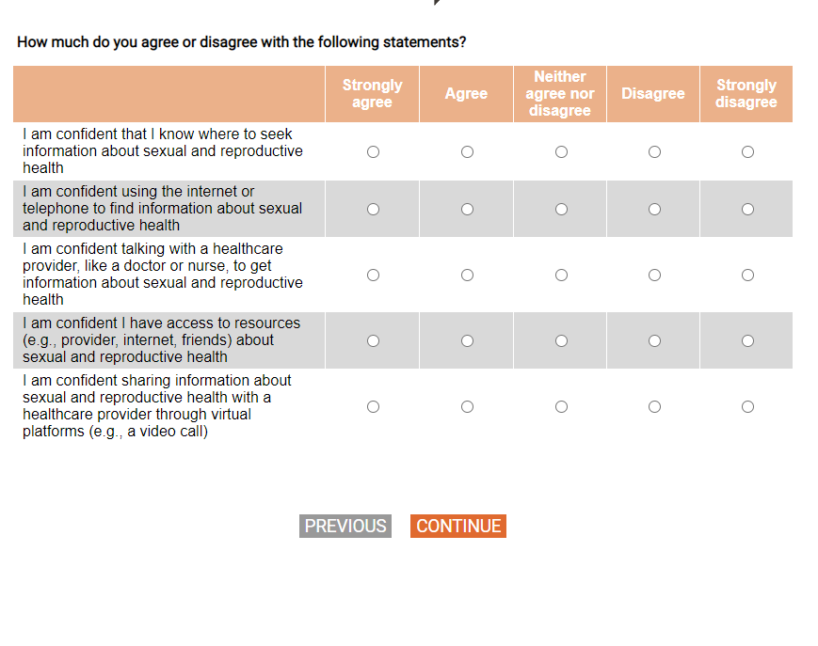

Q55
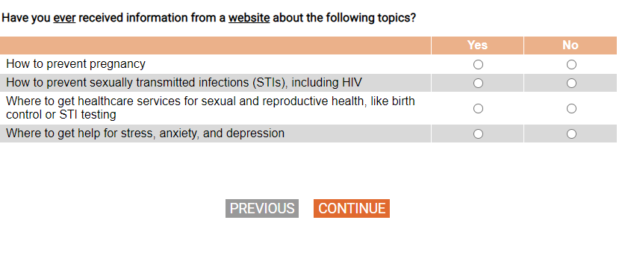

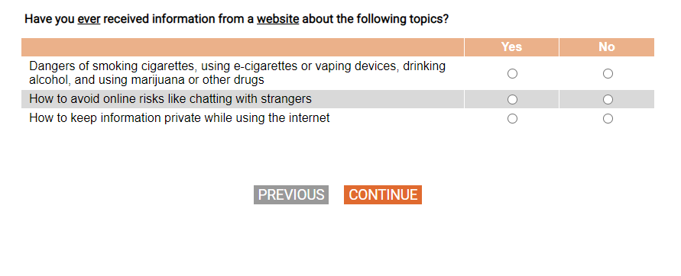

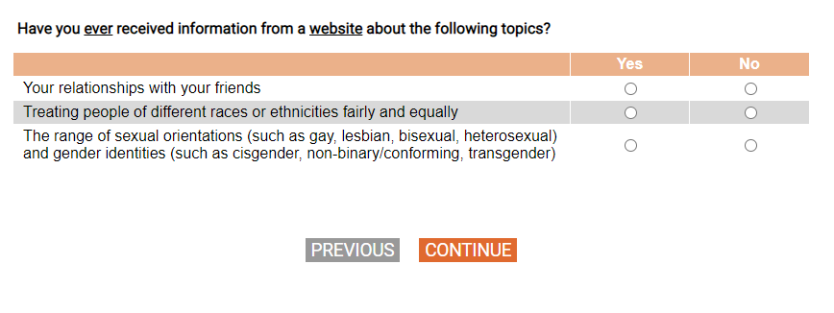

Q56
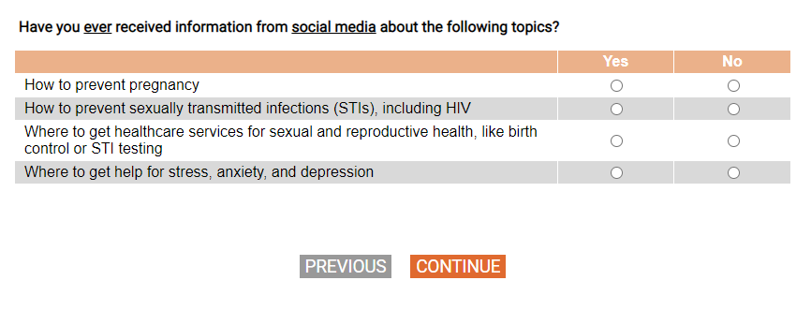
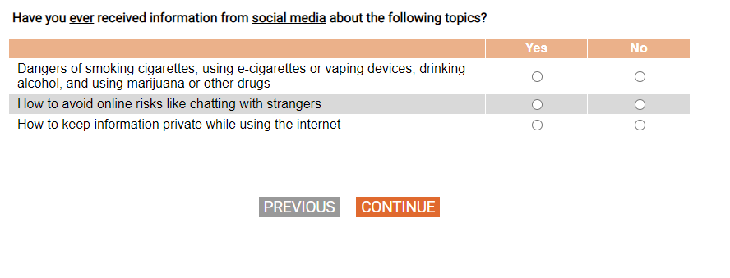
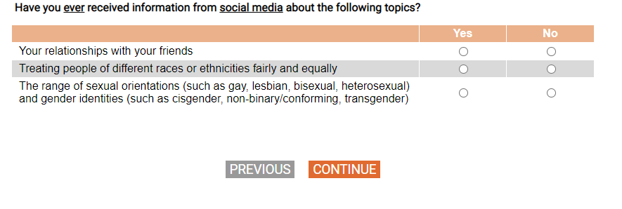
[DISPLAY – SECTJ_2]

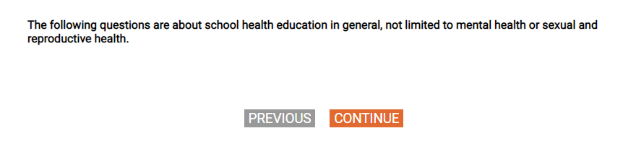

Q57
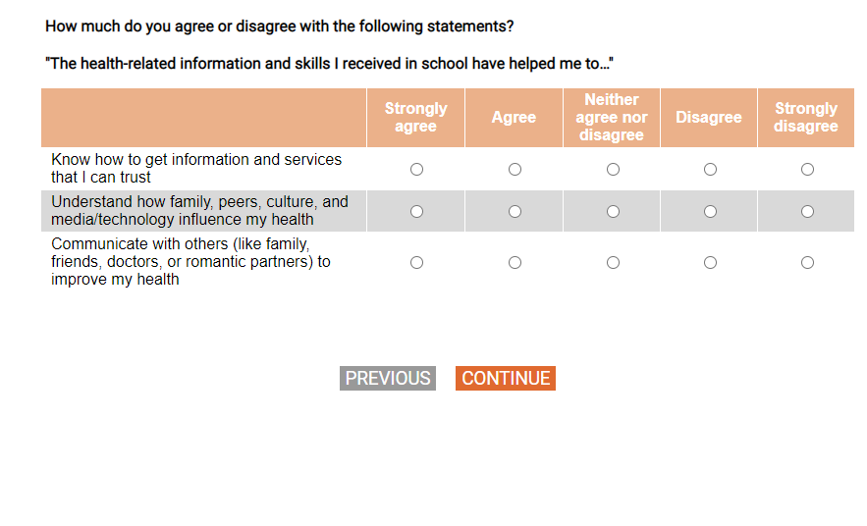

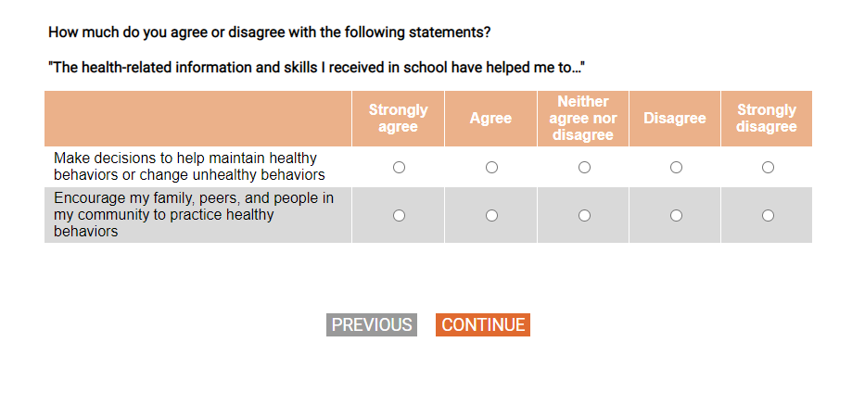
Q58
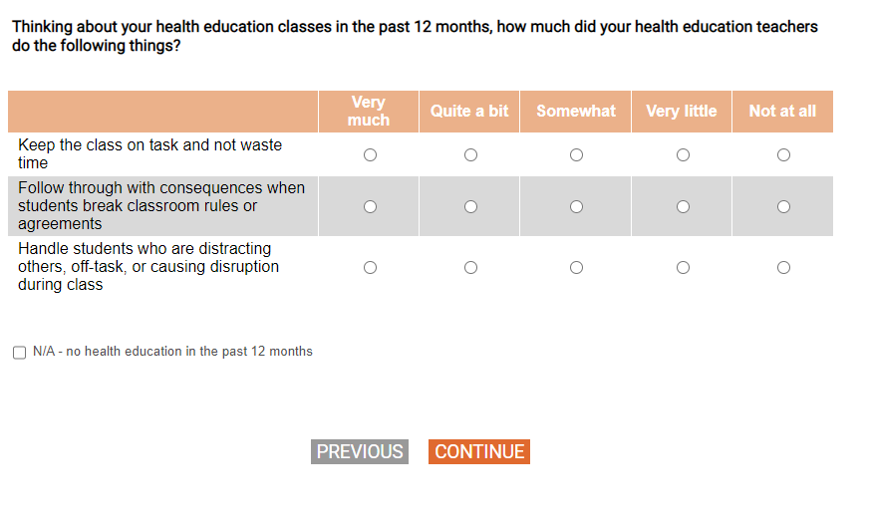
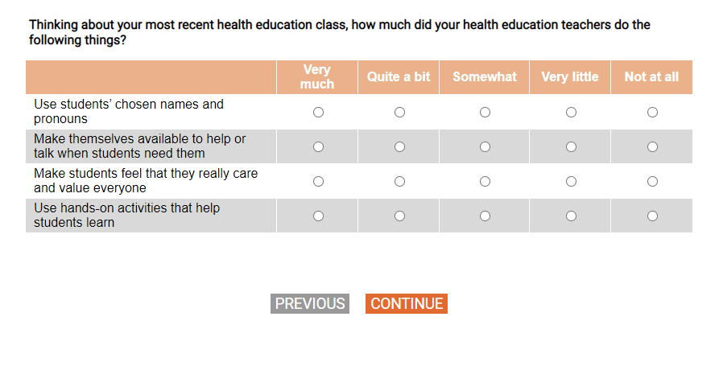
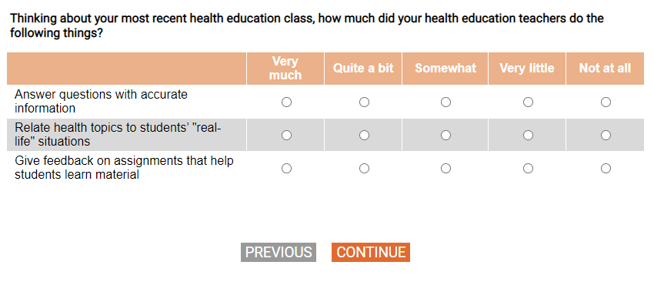

[DISPLAY – SECTK_INTRO]

[SHOW IF S_AGE>=18]
[SP]
Q59.
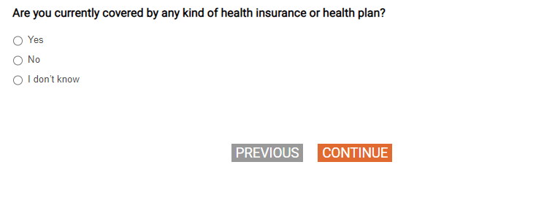
[SHOW IF Q59=1]
[SP]
Q60
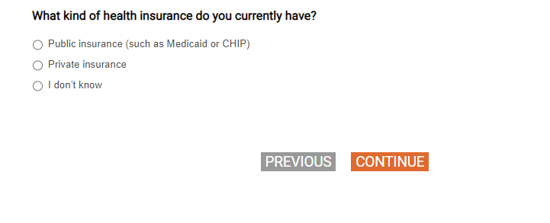

Q61
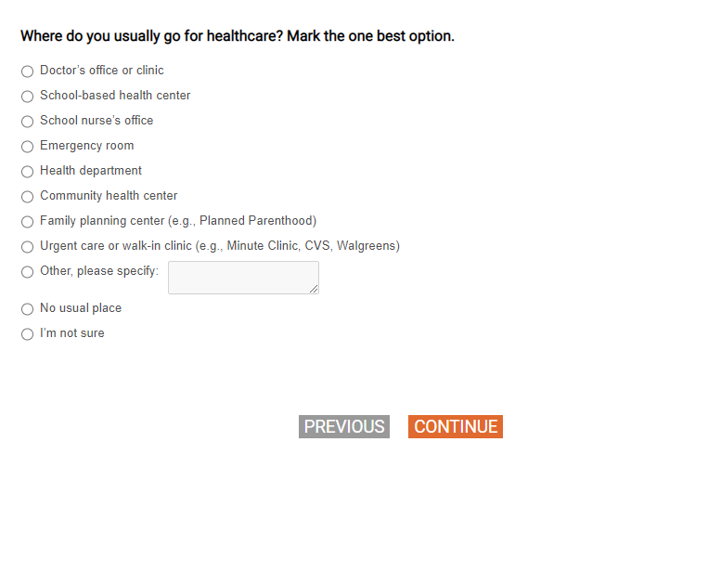
[DISPLAY – SECTK_1]
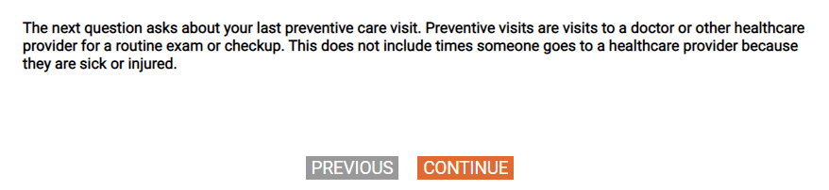

Q62
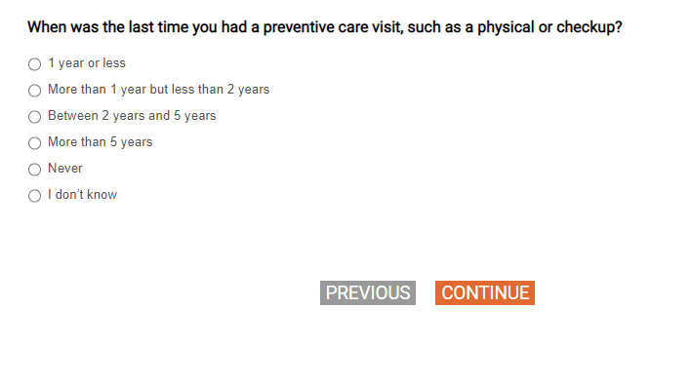

[DISPLAY – SECTK_2]
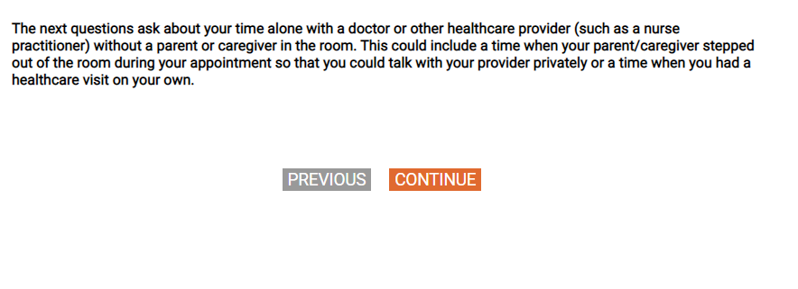

Q63
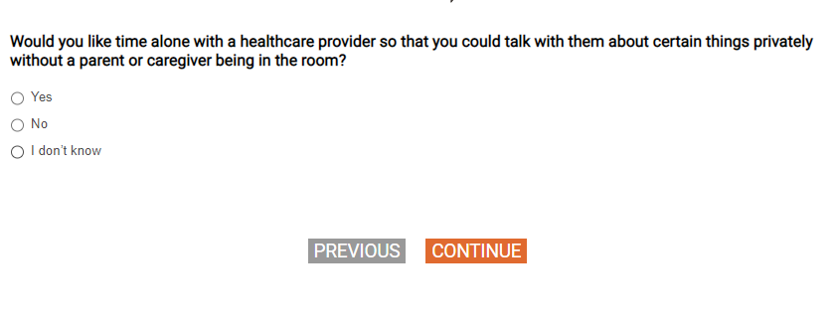
Q64
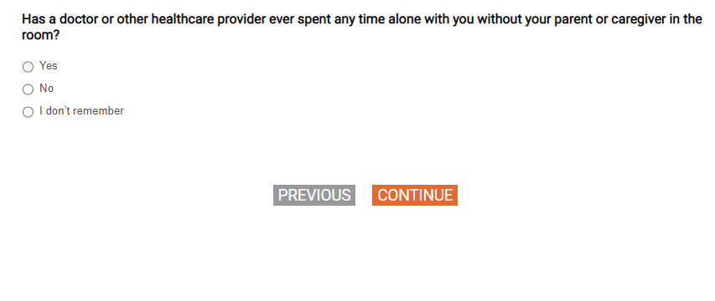

[SHOW IF Q64=1 and Q62=1, 2, 3, 4]
[SP]
Q65.
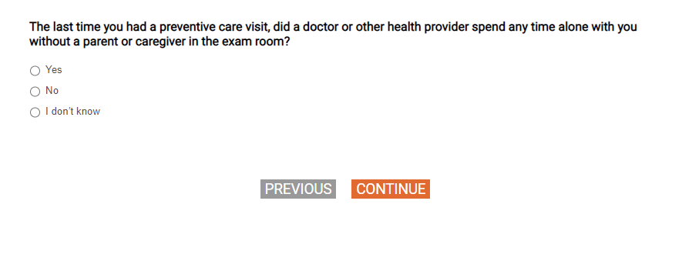

[SHOW IF Q64=1 or Q65=1]
[SP]
Q66.
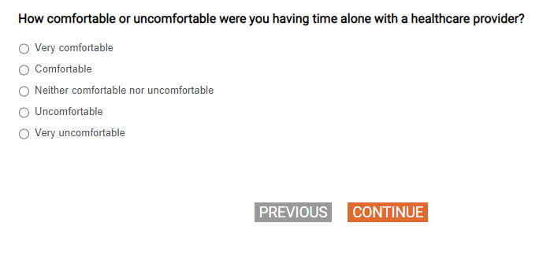

[SHOW IF Q62=5, 77, 98, 99 (never had/dk preventative visit) and Q64=2, 77, 98 (never spent time alone with doctor/dk)]
[SP]
Q67.

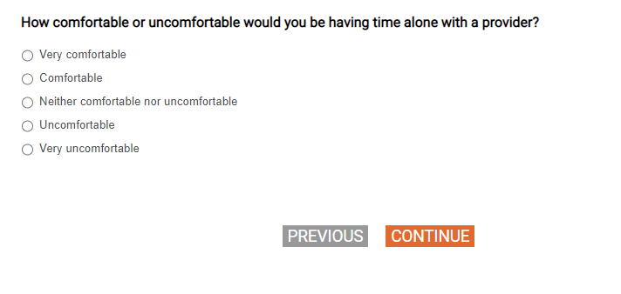
[SHOW IF Q66=4, 5 or Q67=4,5]
[MP]
Q68.
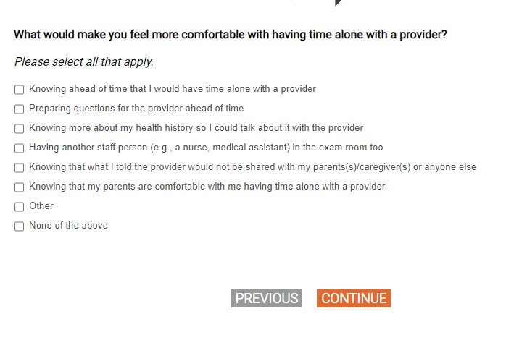

[SHOW IF Q68=7, show on same page as Q68]
[MEDIUM TEXTBOX]
Q68_OE.
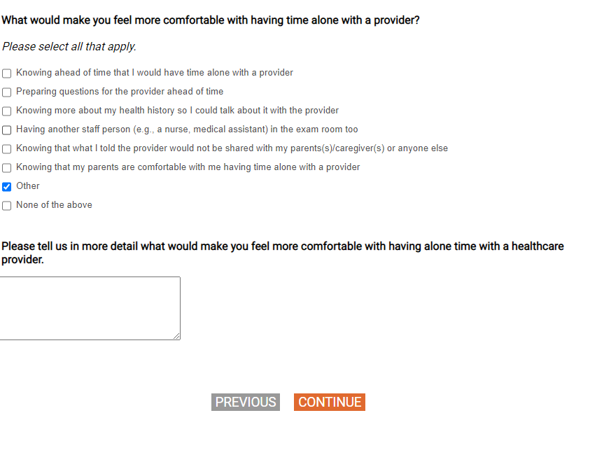

[SHOW IF Q62=1, 2, 3, 4]
[SP]
Q69.
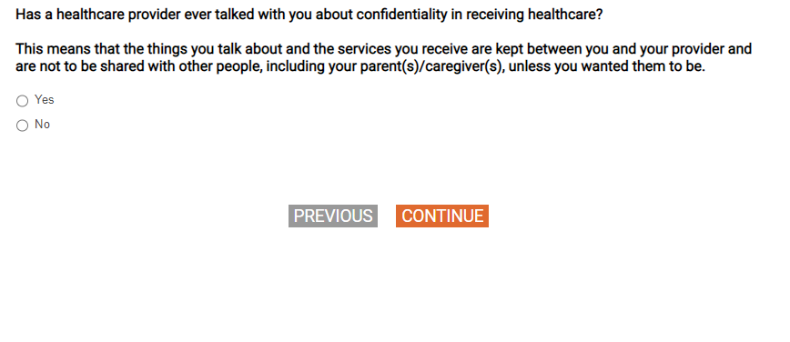
[SHOW IF Q62=1, 2, 3, 4]
[MP]
Q70.
[RESPONDENTS ASSIGNED MALE AT BIRTH GET RESPONSE OPTIONS 8-11 ONLY.]
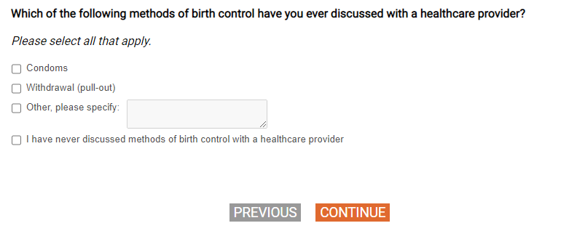

[SHOW IF Q62=1, 2, 3, 4]
[DISPLAY – SECTK_3]
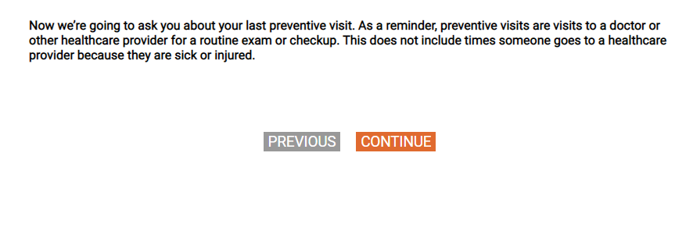

[SHOW IF Q62=1, 2, 3, 4]
[GRID, SP; 4, 4, 4] [DO NOT SHOW NUMERIC LABELS]
Q71.
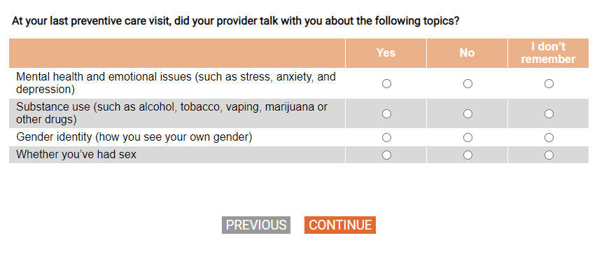
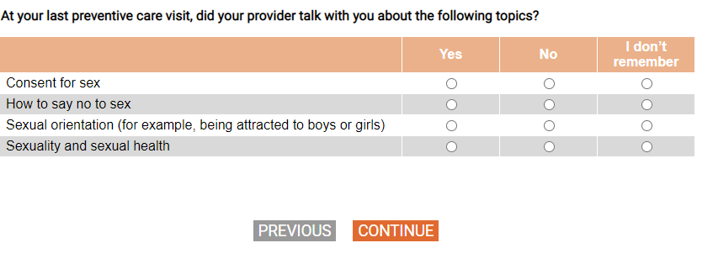
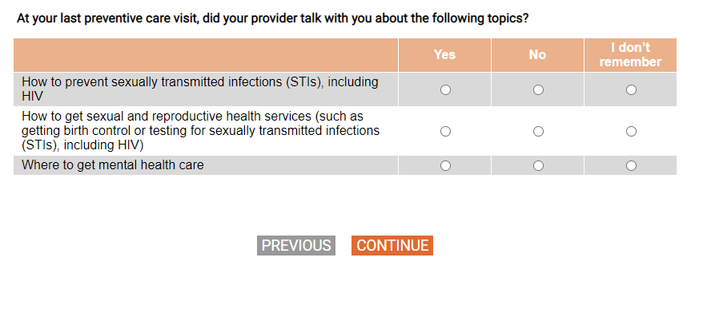
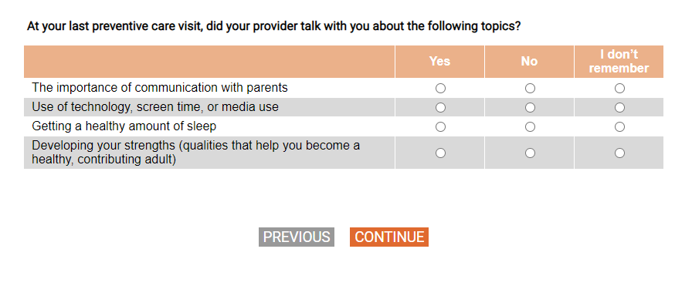
[SHOW IF Q62=1, 2, 3, 4]
[GRID, SP]
Q72.

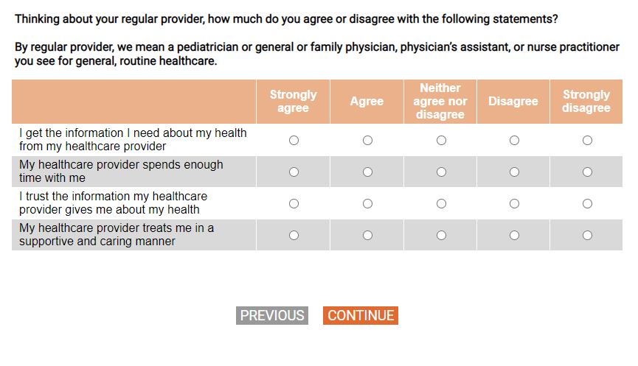
Q73


[SHOW IF S_AGE>=18 AND IF Q73=1, 2]
[SP]
Q74.
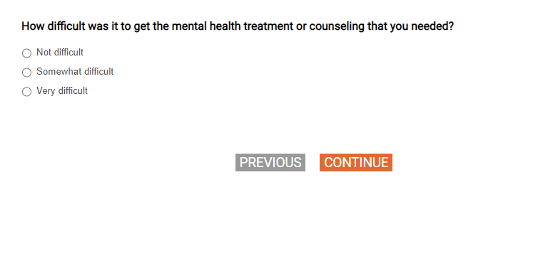
[DISPLAY-SECTL_INTRO]

Q75
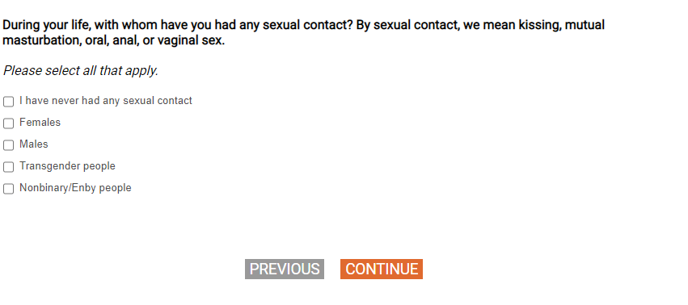
SHOW IF Q75=2, 3, 4, or 5]
[NUMBOX 0-100; record DK=777, SKP=998, REF=999]
Q76
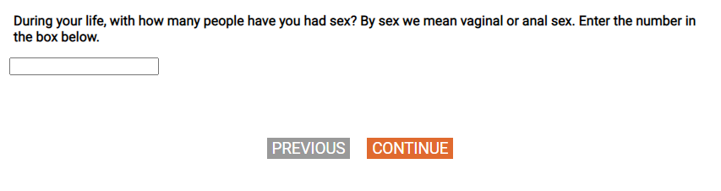
[SHOW IF Q76=1 - 100]
[NUMBOX 0 to S_AGE]
[CUSTOM PROMPT IF Q77>S_AGE: The age you entered is older than your current age.]
Q77.

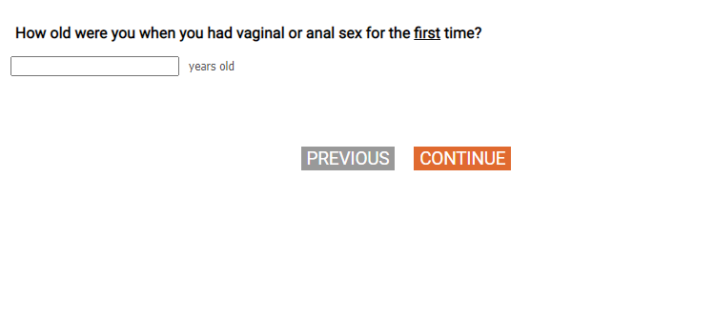
[SHOW IF Q76=1 - 100]
[GRID, SP; 2, 2, 2]
Q78.

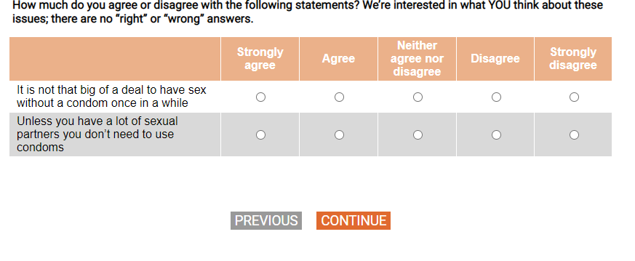
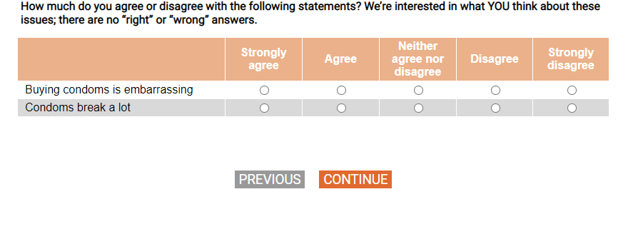

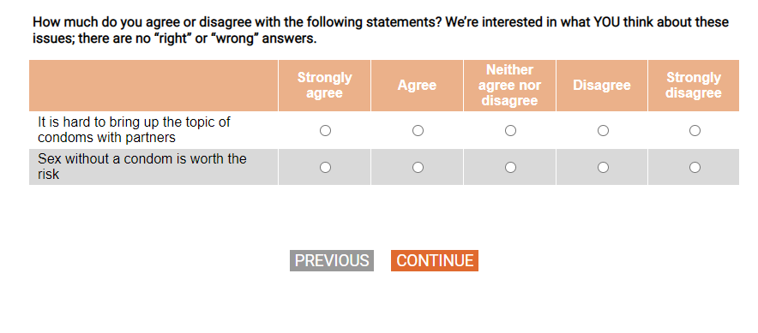
[SHOW IF Q76=1 - 100]
[SP]
Q79.

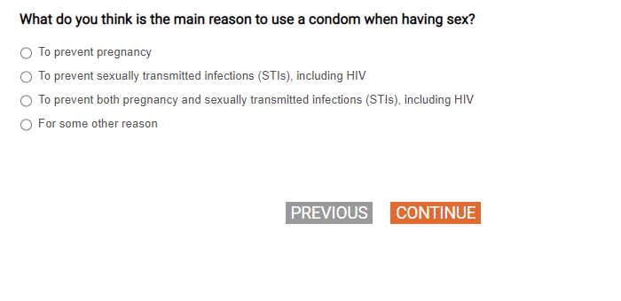

[SHOW IF Q76=1 - 100]
[MP]
Q80.
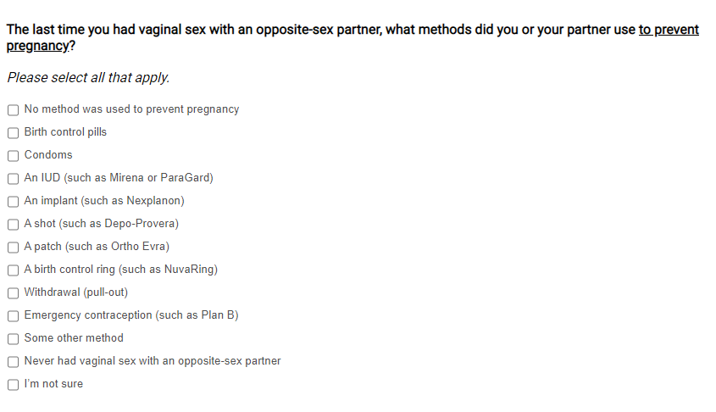

[SHOW IF Q76=1 - 100]
[MP]
Q81.
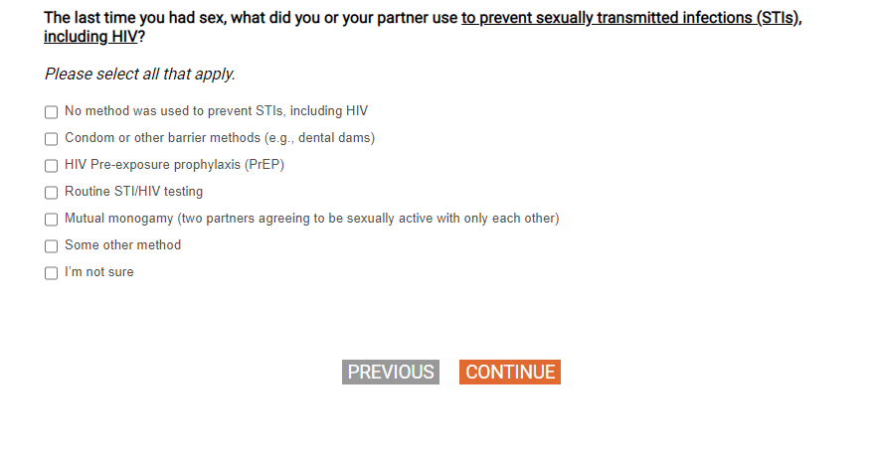
[SHOW Q78 and Q79 ON SAME PAGE]

[SHOW IF Q76=1 – 100 and Q75=3 (males)]
[NUMBOX 0-100; record DK=777, SKP=998, REF=999]
Q82_1.

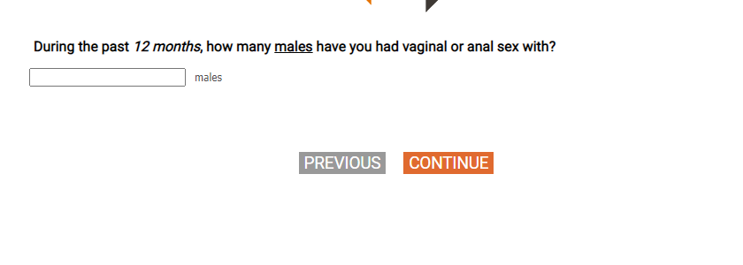

[SHOW IF Q76=1 – 100 and Q75=2 (Females)]
[NUMBOX 0-100; record DK=777, SKP=998, REF=999]
Q82_2.
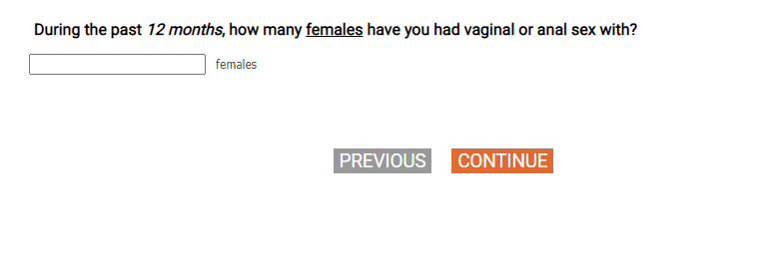

[SHOW IF Q76=1 – 100]
[SP]
Q83.
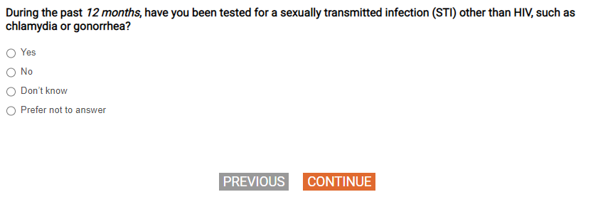
[SHOW IF Q83=1]
[SP]
Q84.
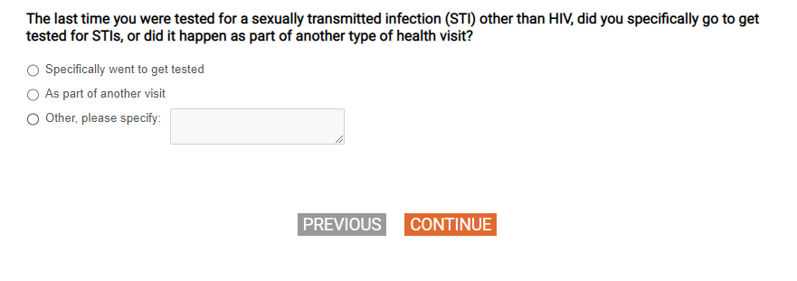
[SHOW IF Q76=1 – 100]
[SP]
Q85.
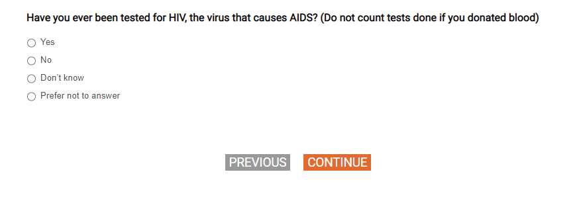
[SHOW IF Q76=1 – 100]
[SP]
Q86.
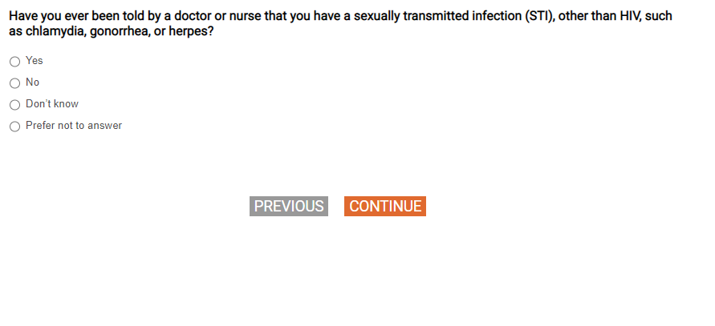

[SHOW IF Q86=1]
[SP]
Q87.
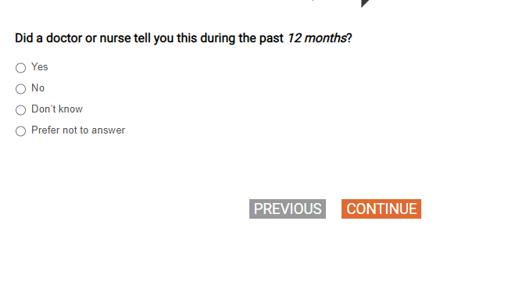
[SHOW IF Q76=1 – 100]
[DISPLAY – SECTL_1]
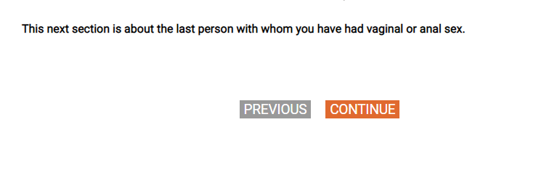
[SHOW IF Q76=1 – 100]
[SP]
Q88.
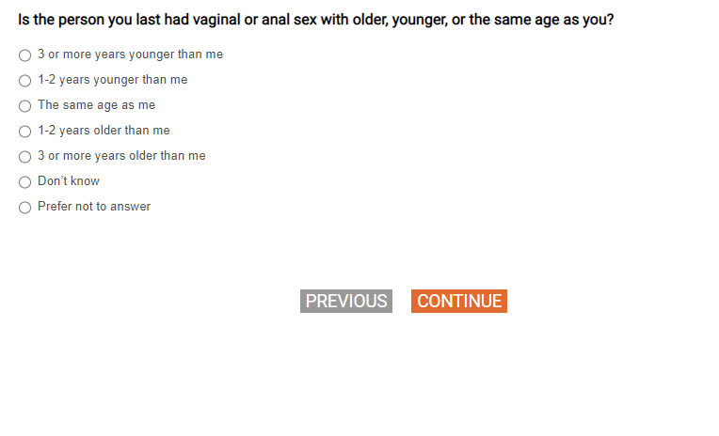

[SHOW IF Q76=1 – 100]
[SP]
Q89.
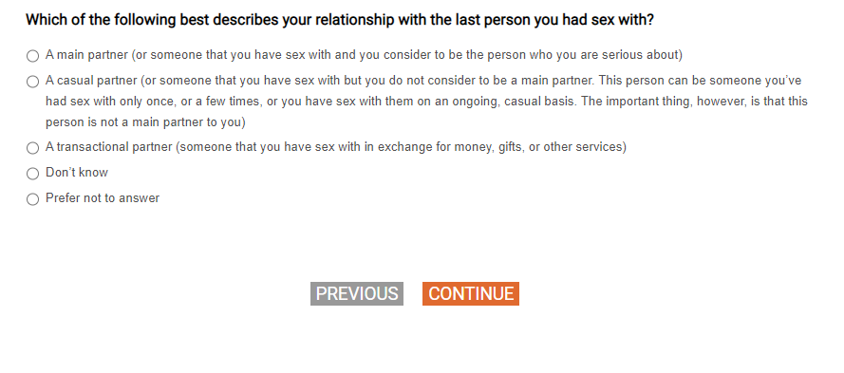

[SHOW IF Q76=1 – 100]
[SP]
Q90.
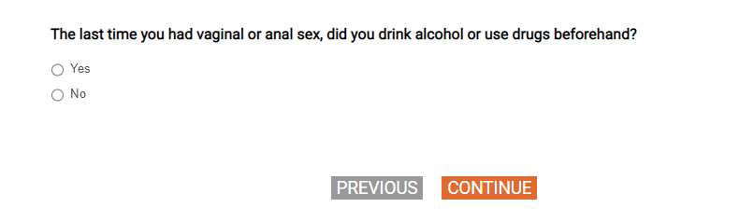

[SHOW IF Q76=1 – 100]
[SP]
Q91.
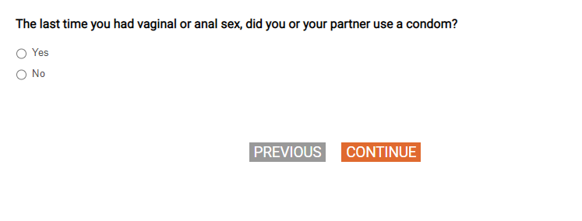

Q92
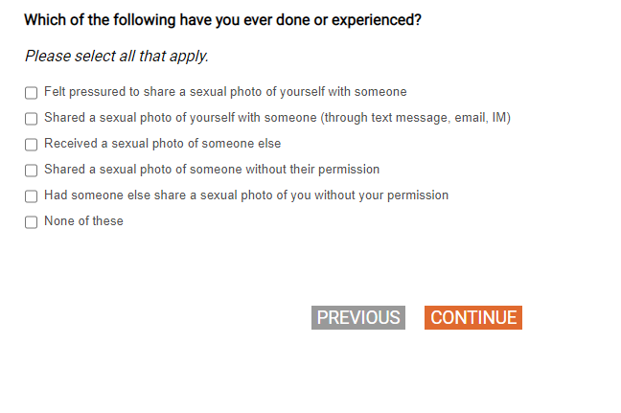
Q93
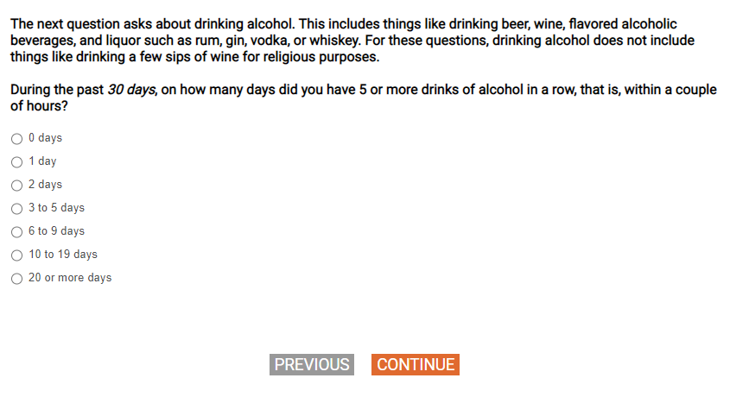
Q94
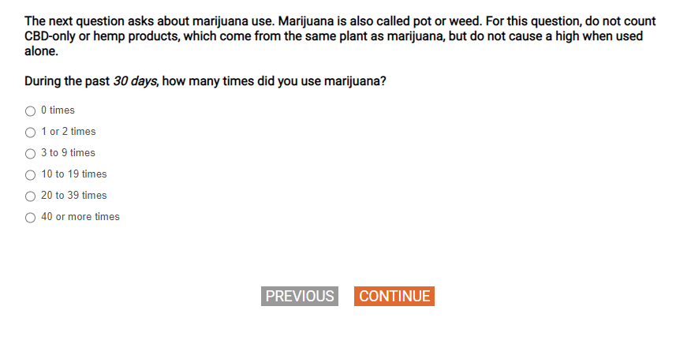
Q95
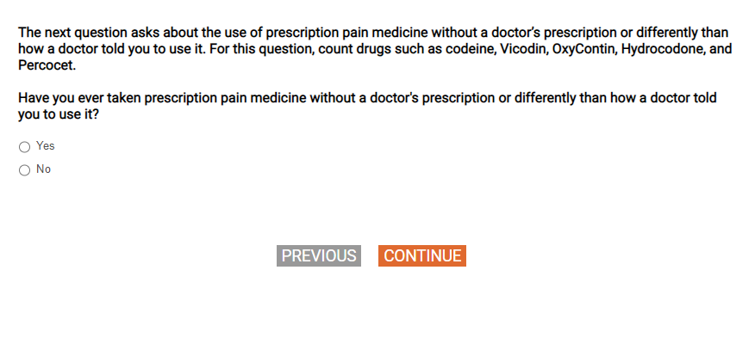
[SHOW IF Q95=1]
[SP]
Q96.
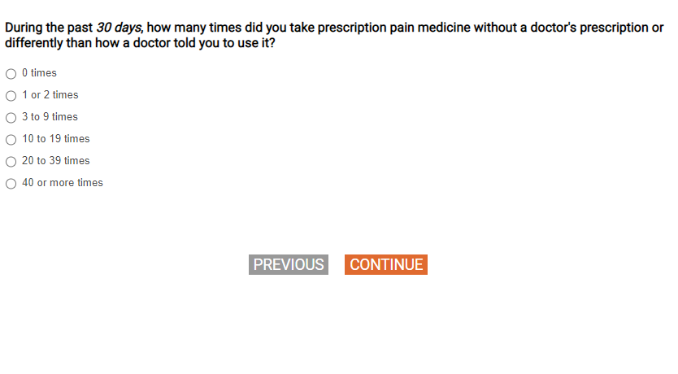
Q97
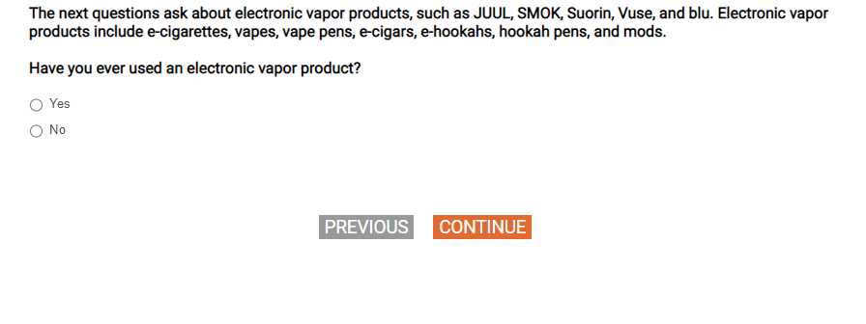

[SHOW IF Q97=1]
[SP]
Q98.

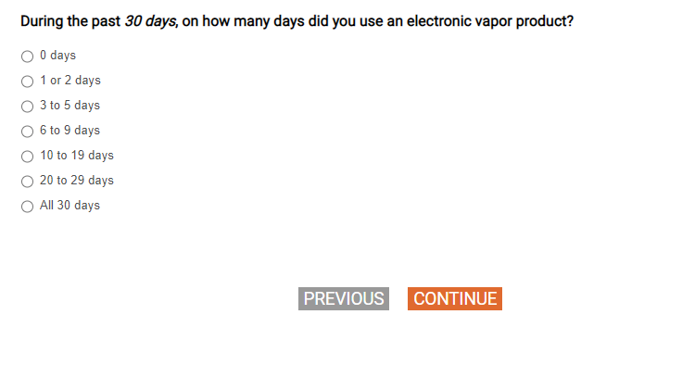
QFINAL1.
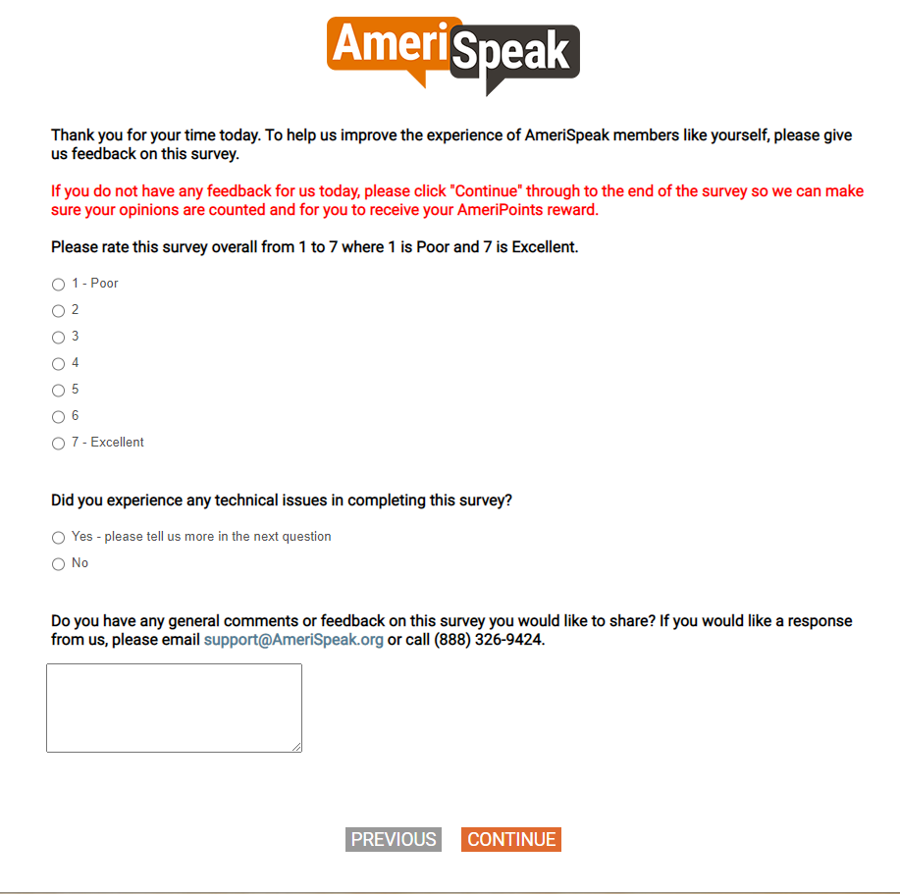

[DISPLAY]
END.

