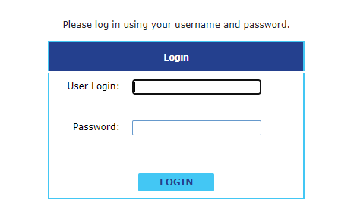
The Study of Title II-A Use of Funds is examining how states and districts are using their Title II, Part A funds provided through the Elementary and Secondary Education Act (ESEA). The study includes surveys of officials from all state education agencies and from a representative sample of school district officials from each state. The purpose of this survey is for the U.S. Department of Education to gain a better understanding of how school districts are using their Title II, Part A funds. The United States (U.S.) Department of Education, Office of the Chief Data Officer (OCDO) is sponsoring this study. While participation in the LEA survey is not mandatory, it is strongly encouraged in order to provide the Title II, Part A program office with information important that the Department can use to benefit to the program. The study, including this survey, is being conducted by Westat.

Paperwork Reduction Act of 1995
According to the Paperwork Reduction Act of 1995, no persons are required to respond to a collection of information unless such collection displays a valid OMB control number. The valid OMB control number for this information collection is 1810-0618. Public reporting burden for this collection of information is estimated to average 120 minutes per response, including time for reviewing instructions, searching existing data sources, gathering and maintaining the data needed, and completing and reviewing the collection of information. The obligation to respond to this collection is voluntary. If you have any comments concerning the accuracy of the time estimate, suggestions for improving this individual collection, or if you have comments or concerns regarding the status of your individual form, application or survey, please contact directly the U.S. Department of Education, 400 Maryland Ave., SW, Washington, DC 20210-4537 or email ICDocketMgr@ed.gov and reference the OMB Control Number 1810-0618.

Notice of Confidentiality
Information collected for this study comes under the confidentiality and data protection requirements of the Institute of Education Sciences (The Education Sciences Reform Act of 2002, Title I, Part E, Section 183). Responses to this data collection will be used only for statistical purposes. The reports prepared for the study will summarize findings across the sample and will not associate responses with a specific district or individual. We will not provide information that identifies you or your district to anyone outside the study team, except as required by law.



Change Password | Log Out
State:
List of Questions

This page contains links to all survey questions. Click on a link below to work on a specific question. When a question has been completed a blue checkmark will appear next to the title. Orange arrows will appear next to questions that have not yet been completed.
= Completed = Incomplete
Please review the instructions before completing the survey.

Contact Information
Question 1: Allocations to LEAs
Question 2: Total allocated to your state in 2021-22

After you have completed all questions, please print or save a copy of the allocations request for your records by clicking on the link below. To submit your completed allocations request, please remember to click “Submit Completed Allocations Request” below. You may not modify your responses to the allocations request after submission. If you need to modify your responses, please contact the toll-free survey hotline at 1-855-817-1704, or send an e-mail to title2afunds@westat.com.

List of Survey Questions | Log Out

State:
Contact Information
Please provide the following contact information for the individual completing the survey.
First Name:
Last Name:
Position:
Phone: | () - Extension:
Email address:

List of Survey Questions | Log Out

Instructions:

Navigate through the survey by answering each question and clicking the "Save" button or the "Save and Mark as Complete" button. When you click the "Save" button, the responses you entered will be saved without navigating you away from the page. The "Save and Mark as Complete" button will designate the section as complete and navigate you back to the “List of Questions” page. You may return to any section by clicking the “List of Questions” link at the top of the screen. You may enter or change answers to questions any time prior to submission, even if a question is marked as complete.
You do not have to complete the allocations request all at once. You may return at a later time to complete the allocations request.
All respondents must complete Questions 1 and 2. You do not need to respond to the questions in order.
Once you have completed all sections, please be sure to click on the “Submit Completed Survey” button after the list of questions.
If you have any questions or need assistance, please contact the toll-free survey hotline at 1-855-817-1704, or send an e-mail to title2afunds@westat.com.

The districts below are being surveyed about their use of funds under Title II, Part A. In order to verify the amount of these funds used by each district, please provide the dollar amount of Title II, Part A funds allocated to each of these districts in federal fiscal year 2021-22. Do not include carryover funds.
If a district is no longer operational, please enter $0 for the funds allocated to that district, enter "CLOSED" for the coordinator name, and leave the e-mail cell blank.
If you do not have the contact information for a district’s Title II, Part A coordinator, you may leave those cells blank.
Instead of completing the table in your browser, you may complete and upload an Excel template with the data. Click the “Download Excel Template” link below to download the template for your survey.

Download Excel Template
Once you have downloaded the template, enter the Title II, Part A funds allocated to each district in the “FundsAllocated” column, and the Title II, Part A coordinator name and e-mail address in the “CoordinatorName” and “CoordinatorEmail” columns. Do not modify the column names or structure of the template, as doing so will prevent the data from being uploaded.
After completing the Excel file, click on “Choose file” to select the compeleted template, and then click “Upload file” to upload the data. Please note that uploading a file will overwrite all existing data in the table.

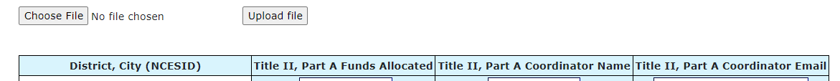

Question 2: Total allocated to your state in 2021-22

Please provide the total Title II, Part A funds allocated to your state in federal fiscal year 2021-22.
Please provide the total Title II, Part A funds allocated to your state in federal fiscal year 2021-22. | $
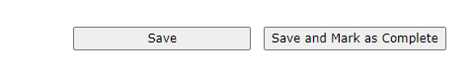

Excel template (available to download, for optional use)

LEA ID | State | District Name | Funds Allocated | Coordinator Name | Coordinator Email

