Attachment C: Nursing Home Site Information Form
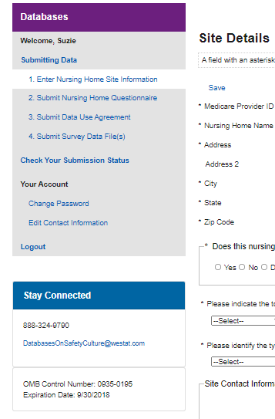
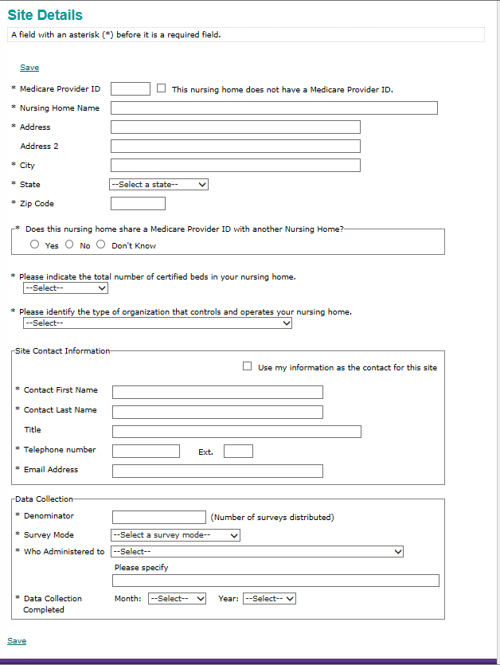
Response options for Who Administered to:
- All staff/Sample of staff
- Selected departments/units only (please specify)
- Selected staff positions only (please specify)
- Selected departments/units and selected staff positions (please specify)

Response options for Survey Mode:
- Paper
- Web
- Mixed mode (paper & web)
- Other

Response options for control/operation:
- For profit
- Non profit
- Government

Public reporting burden for this collection of information is estimated to average 5 minutes per response, the estimated time required to complete the survey. An agency may not conduct or sponsor, and a person is not required to respond to, a collection of information unless it displays a currently valid OMB control number. Send comments regarding this burden estimate or any other aspect of this collection of information, including suggestions for reducing this burden, to: AHRQ Reports Clearance Officer Attention: PRA, Paperwork Reduction Project (0935-XXXX) AHRQ, 5600 Fishers Lane, # 7, Rockville, MD 20857.

