
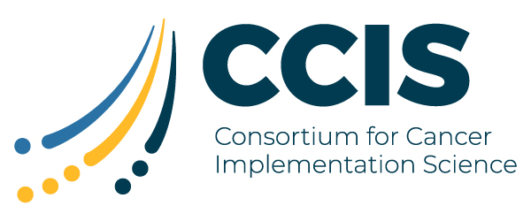
Call for Proposals to Support the Development of Public Goods for Implementation Science
The Consortium for Cancer Implementation Science (CCIS) was founded in 2019 as an open consortium where MoonshotSM investigators as well as other researchers and practitioners work together to address key challenges and advance the implementation science (IS) agenda in cancer. Each year, an annual meeting is held where action groups meet to start or continue planning related to the development of publicly available tools and resources to move IS in cancer forward in the coming year.

To support the development of publicly available tools and resources and expand the reach to individuals at organizations with limited funding in implementation science, the National Cancer Institute is accepting applications for personal service contracts from individuals who are willing to dedicate time to develop and deliver specific tools and resources that have been prioritized by the action groups.

Visit the website for more details as to eligibility requirements, application process, and responses to frequently asked questions. The submission period will be open from July 29 to September 2, 2021.

Join us for a webinar on Thursday, July 22, 2021, from 3:00 – 4:00 pm EST to learn more about this call for proposals.
Apply

Subject Line: SAVE THE DATE: Call for Proposals and Webinar to Support Development of Public Goods for Implementation Science

