2020 CQR-L-05
<Entity Name>
<Entity ID>

<Date>

<Name>
<Position>
<Department Name>
<Mailing Address>
<City> <State> <ZIP>

RE: 2020 Census CQR Case Number <CaseID#>

Dear <Position> <Last Name>:

Thank you for your submission to the 2020 Census Count Question Resolution operation (CQR). This letter serves as the official determination for your submission.

We reviewed the documentation you provided in conjunction with official 2020 Census records as part of our research to resolve your question(s). Our research found an error(s) within the legal boundary of your governmental unit and we have made the correction; however, the correction did not change the counts for your total housing and population, so there is no change to your official 2020 Census counts. The revised housing counts by block, introduced by the correction(s), are available at <www.census.gov/programs-surveys/decennial-census/decade/2020/planning-management/evaluate/cqr.html>.

Thank you for sharing your concerns, and for your efforts to ensure that the 2020 Census counts are accurate. If you have questions, please contact the CQR Help Desk by phone at
1-(888) 369-3617 or by email at <dcmd.2020.cqr.submissions@census.gov>. Please cite your 2020 Census CQR case number in your communication.

Sincerely,

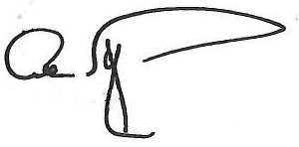

Albert E. Fontenot, Jr.
Associate Director for
Decennial Census Programs

