This first screenshot is what respondents would see as soon as they open the survey,
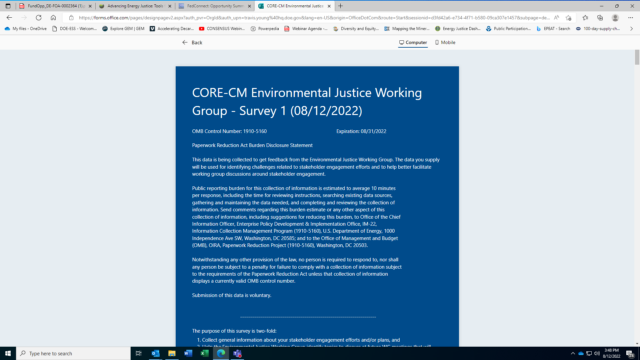

This second screenshot is a zoomed out version of the survey to show that it is one continuous page

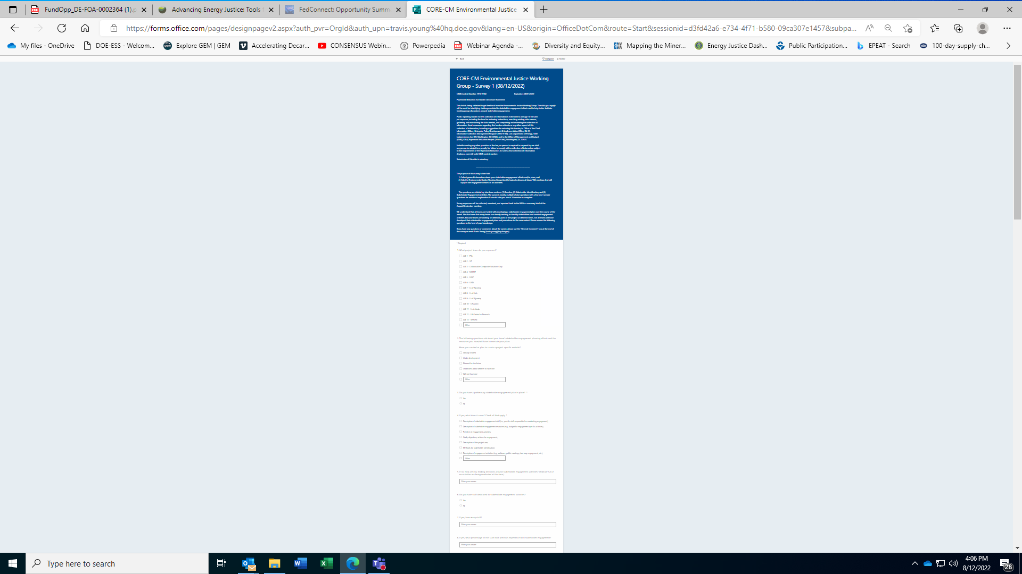

This third screenshot is a zoomed out version of the end of the survey

