

Technical Bulletin #1
Originally issued on August 19, 2019

Title IV-E Prevention Program Data Elements
Revised: MONTH DAY, 2021
Table of Contents
Background 2
Overview of Technical Bulletin 2
Reporting Population 3
Data File Structure 3
Information Common to other Children’s Bureau’s Data Sets 3
Overview of XML 4
Requirements for the Structure of Title IV-E Prevention Services XML Data Files 4
XML Data Tags 5
Title IV-E Prevention Services Data File Structural Hierarchy 5
Grouping of Elements 6
Appendix A – Group Element Diagram for Title IV-E Prevention Services Data File 7
Appendix B – Data Elements and XML Tags for Title IV-E Prevention Services Data File 8
Appendix C – XML Schema Definition for the Title IV-E Prevention Services Data File 13

THE PAPERWORK REDUCTION ACT OF 1995 (Pub. L. 104-13) Public reporting burden for this collection of information is estimated to average 31 hours per response, including the time for reviewing instructions, gathering and maintaining the data needed, and reviewing the collection of information. An agency may not conduct or sponsor, and a person is not required to respond to, a collection of information unless it displays a currently valid OMB control number.

Background
On February 9, 2018 the Family First Prevention Services Act (Family First) was enacted to authorize new optional title IV-E funding for time-limited (one year) prevention services for mental health/substance abuse, and in-home parent skill-based programs for:
- a child who is a candidate for foster care (as defined in section 475(13) of the Act),
- pregnant or parenting youth in foster care, and
- the parents/kin caregivers of those children and youth (sections 471(e), 474(a)(6), and 475(13) of the Act).
The prevention program authorized by Family First is referred to as the title IV-E prevention program, and the services being provided under this program are referred to as title IV-E prevention services. States that elect to implement the title IV-E prevention program are required to submit a five-year prevention program plan. Additionally, they must provide an assurance in the plan that the agency will report child-specific data to HHS as required by section 471(e)(4)(E) of the Act for each child who receives title IV-E prevention services. Please see the following resources for more information:
- IM-18-02 - Published: April 12, 2018 - This Information Memorandum (IM) informs States and Tribes of the enactment of the Family First Prevention Services Act and provides basic information on the new law.
- PI-18-09 - Published: November 30, 2018 - This Program Instruction (PI) provides instruction for state title IV-E agencies on the title IV-E prevention program requirements.
- PI-18-10 - Published: November 30, 2018 – To instruct tribal title IV-E agencies administering or supervising the administration of title IV-E under sections 479B and 471(a) of the Act on the title IV-E prevention program requirements.
The Children’s Bureau will use the information from states and tribes operating a title IV-E prevention program to calculate annual title IV-E prevention services measures in accordance with section 471(e)(6)(A) of the Act. In addition, the Children’s Bureau may use this data to assess the extent to which the provision of the services and programs reduces the likelihood of foster care placement, increases kinship arrangements or improves child well-being in accordance with section 476(d)(3) of the Act.

Overview of Technical Bulletin
The purpose of this Technical Bulletin is to provide detailed information on the data elements and information that is required to create and submit the title IV-E prevention services data files. Title IV-E agencies must submit data files in a format that meets ACF specifications. CB revised this technical bulletin to explain these specifications, including the Extensible Markup Language (XML) structure of the title IV-E prevention services data files to be used in the transmission of data to the system (appendix C) and data elements to be reported (appendix B). Title IV-E agencies will be required to submit data on all children with a prevention plan on a six-month (per Federal Fiscal Year) basis with a transmission period of 45 days.

Reporting Population
There are two distinct reporting populations that title IV-E agencies must include in their submissions.
Title IV-E agencies must include program and service data for any candidate for foster care (as defined in section 475(13) of the Act) whose title IV-E prevention plan start date (element 8) falls in the reporting period. Title IV-E agencies must continue to submit program and services data for each reporting period until the candidate exits the reporting population 24 months after the prevention plan start date. This means that states will submit services data from prior reporting periods as long as the candidate remains in the reporting population.
Title IV-E agencies must submit program and services data for any pregnant or parenting youth who enters the reporting population. A pregnant or parenting foster youth enters the reporting population on the title IV-E prevention plan start date (element 8) and exits the reporting population 12 months after the start date. Title IV-E agencies are not required to submit elements 13 and 14 for pregnant or parenting youth.

Data File Structure

Information Common to other Children’s Bureau’s Data Sets
Information that is in the title IV-E prevention services data set, and is also reported in either the Adoption and Foster Care Analysis and Reporting System (AFCARS), National Child Abuse and Neglect Data System (NCANDS), and National Youth in Transition Database (NYTD) needs to be consistent across data systems. This information includes, but may not be limited to:
- Title IV-E Agency (element 1). The specifications for the agency identifier will be provided once the implementation of the title IV-E prevention program begins and the file format and transmission guidance are issued.
- Child Identifier (element 2). This identifier should be the unique identifier associated with the candidate or pregnant or parenting youth in foster care. For candidates, the AFCARS Record Number should be used if it has already been assigned. If an identifier/record number has never been assigned to a candidate, the title IV-E agency should assign a unique value that will become their AFCARS Record Number if they enter foster care. For pregnant or parenting youth in foster care, the AFCARS record number will be their child identifier for this data file.
This supports the Children Bureau’s ability to follow the experiences of individuals through our data systems. The title IV-E agency must apply and retain the same encryption routine or method for the child identifier across all report periods. The child identifier must be encrypted in accordance with ACF standards.

Overview of XML
Extensible Markup Language (XML) uses tags (angle brackets) to mark up, structure, and annotate data in a way that is both readable by computers and legible to users. Extensible means that users can define and extend markup elements to meet their own requirements.
XML was chosen for use with the title IV-E prevention services data file because it offers distinct advantages as a file format.
- XML is stored in plain text, for maximum system compatibility.
- XML is widely used and is based on defined standards.
- Because of its extensibility, XML may be tailored to the requirements of the title IV-E prevention services system.
- XML is self-documenting, so the markup provides semantic information on the file contents.
- XML provides a flexible means of providing contextual structure to hierarchical and other complex data.
- XML is easily parsed, so the marked-up information may be read and extracted from the file without difficulty.

Requirements for the Structure of Title IV-E Prevention Services XML Data Files
      - A valid transmission will consist of a title IV-E prevention services data file.
      - The data file will be well-formed XML documents in accordance with defined World Wide Web Consortium (W3C) XML standards (see http://www.w3.org/TR/REC-xml).
      - The overall structure of the XML-based data file is dictated by an associated W3C XML Schema (Family_First_XMLSchema.xsd), See Appendix C.
      - The XML data file structure must begin with a proper XML declaration, including the appropriate character encoding.
    - The suggested encoding is UTF-8 Unicode, with the corresponding initial declaration: <?xml version="1.0" encoding="utf-8" ?>.
    - If the use of UTF-8 is specified, only the 128 characters defined by the ASCII encoding scheme may be included in the file. UTF-8 is backwards compatible with the ASCII standard.
    - Title IV-E agencies that use extended ASCII encodings in their encrypted child identifier numbers must specify an extended ASCII encoding for their title IV-E prevention services data files. These agencies should use a declaration corresponding to the extended ASCII encoding/code page they utilize, such as <?xml version="1.0" encoding="ISO-8859-1" ?> or <?xml version="1.0" encoding="windows-1252" ?>.
  - With the exception of characters used in the encrypted child identifier (data element 2), all other data in the file should be standard (not extended) printable ASCII and should exclude the defined control characters (0 to 31, and 127).
- Additionally, the data within XML element tags must exclude several characters with special syntactic meaning in XML:
  - the ampersand character (&),
  - the left-angle bracket character (<),
  - the right-angle bracket character (>),
  - the single quotation mark ('), and
  - the double quotation mark (").

XML Data Tags
The naming convention for XML tags is based on the title IV-E prevention services data elements, as defined in Appendix B. The name of the XML tag for a title IV-E prevention services data element consists of an initial “F”, plus the element number, followed by a descriptive name in lower-case, with underscores separating words, for example:
<F1_title_iv_agency> = Element 1: Title IV-E Agency
A list of the XML tags for each title IV-E prevention services data element listed in Technical Bulletin #1 is provided in Appendix B.

Title IV-E Prevention Services Data File Structural Hierarchy
XML provides a structural hierarchy to a data file by organizing the data into nested sets of tags to reflect one-to-many and other dependent relationships between elements. For example, one child may have multiple service records. Figure 1 shows an overview of a title IV-E prevention service data file’s structural hierarchy. The data for both title IV-E prevention service XML files is nested within the top-level XML tag, <acf:data>. Directly within this are two data elements pertaining to the entire file - the title IV-E agency and the reporting period. The remainder of the file consists of Children-Youths records for each individual child.

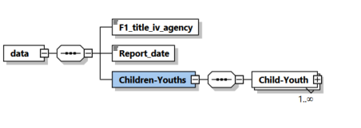

Grouping of Elements
The XML schema for each file groups some of the elements for two purposes:
- To logically group a set of related elements; and
- To nest an element, or series of elements, that can occur more than once, e.g., services.
The title IV-E prevention services data file consist of a top level (root) element, <acf:data>. Data elements containing data global to the whole file are included directly under <acf:data>, e.g., <F1_title_iv_agency>. Beneath <acf:data> each file includes a group element, <records>, which contains multiple <record> group elements: each child <record> corresponds to all the title IV-E prevention service data for an individual child. Appendix A shows diagrams of the groupings.

Appendix A – Group Element Diagram for Title IV-E Prevention Services Data File
The following diagrams illustrate the grouping of the elements for the title IV-E prevention services data file.
Record
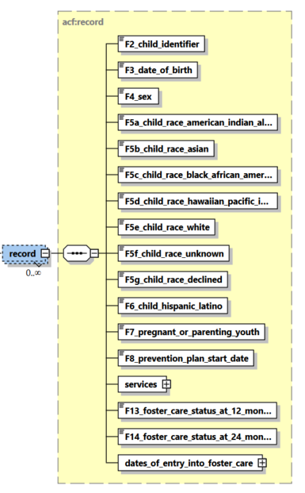
Services
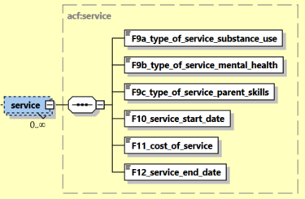
Dates of Entry into Foster Care
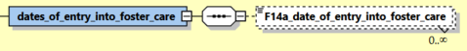

Appendix B – Data Elements and XML Tags for Title IV-E Prevention Services Data File

Element No. | Element name | Definition | XML tag name | Data Constraint
1 | Title IV-E Agency | Indicate the title IV-E agency responsible for submitting the data. | F1_title_iv_agency | String  State agencies: 2 digit state FIPS code  Tribal agencies: 3 digit EPA Tribal standard code
2 | Child Identifier | Indicate the child's identifier/record number. This is an encrypted, unique person identification number that is the same for the child across all report periods state/tribal-wide. | F2_child_identifier | String  Encrypted (by ACF Standards), Unique within title IV-E Agency
3 | Date of Birth | Month, day, and year of the child’s birth. | F3_date_of_birth | Date  YYYYMMDD
4 | Sex | Indicate as appropriate. | F4_sex | Numeric  1 = Male  2 = Female
5a | Race - American Indian or Alaska Native | A person having origins in any of the original peoples of North or South America (including Central America), and who maintains tribal affiliation or community attachment. | F5a_child_race_american_indian_alaska_native | Numeric  0 = No  1 = Yes
5b | Race - Asian | A person having origins in any of the original peoples of the Far East, Southeast Asia, or the Indian subcontinent including, for example,  Cambodia, China, India, Japan, Korea, Malaysia, Pakistan, the Philippine Islands, Thailand, and Vietnam. | F5b_child_race_asian | Numeric  0 = No  1 = Yes
5c | Race – Black or African American | A person having origins in any of the black racial groups of Africa. | F5c_child_race_black_african_american | Numeric  0 = No  1 = Yes
5d | Race – Native Hawaiian or Other Pacific Islander | A person having origins in any of the original peoples of Hawaii, Guam, Samoa, or other Pacific Islands. | F5d_child_race_hawaiian_pacific_islander | Numeric  0 = No  1 = Yes
5e | Race – White | A person having origins in any of the original peoples of Europe, the Middle East, or North Africa. | F5e_child_race_white | Numeric  0 = No  1 = Yes
5f | Race – Declined | The child or parent(s) or legal guardian(s) has declined to identify a race. | F5f_child_race_unknown | Numeric  0 = No  1 = Yes
5g | Race – Unknown | The child's race is unknown because the race, or at least one race of the child is unknown, or the child and/or parent is not able to communicate the child’s race. | F5g_child_race_declined | Numeric  0 = No  1 = Yes
6 | Hispanic or Latino Ethnicity | Answer “yes” if the child is of Mexican, Puerto Rican, Cuban, Central or South American origin, or a person of other Spanish cultural origin regardless of race. Whether or not a person is Hispanic or Latino is determined by how they define themselves or by how others define them. In the case of young children, parents determine the ethnicity of the child.  Declined - The child or parent(s) or legal guardian(s) has declined to identify ethnicity.  Unknown - The child and/or parent is unable to communicate the child’s ethnicity | F6_child_hispanic_latino | Numeric  0 = No  1 = Yes  8 = Declined  9 = Unknown
7 | Pregnant or Parenting Youth in Foster Care | Is the child a pregnant or parenting youth in foster care as described in section 471(e)(2)(B) of the Act? | F7_pregnant_or_parenting_youth | Numeric  0 = No  1 = Yes
8 | Prevention Plan Start Date | Indicate the month, day, and year that the title IV-E agency identified the child in a prevention plan. | F8_prevention_plan_start_date | Date  YYYYMMDD
9a | Type of Service - Mental health | Identify the title IV-E prevention service category for each service provided during the 12-month period beginning on the prevention plan start date. | F9a_type_of_service_mental_health | Numeric  0 = No  1 = Yes
9b | Types of Service - Substance abuse prevention and treatment services | Identify the title IV-E prevention service category for each service provided during the 12-month period beginning on the prevention plan start date. | F9b_type_of_service_substance_abuse | Numeric  0 = No  1 = Yes
9c | Types of Service - In-home parent skill-based programs | Identify the title IV-E prevention service category for each service provided during the 12-month period beginning on the prevention plan start date. | F9c_type_of_service_parent_skills | Numeric  0 = No  1 = Yes
10 | Service Start Date(s) | Enter the start date(s) of the title IV-E prevention service(s). | F10_service_start_date | Date  YYYYMMDD
11 | Cost of Service(s) | Enter the total expenditures for each title IV-E prevention service provided within the 12 months following the prevention plan start date. | F11_cost_of_service | Numeric  Dollar amount (round to the nearest dollar)
12 | Service End  Date(s) | Enter the date(s) that each title IV-E prevention service ended. Note: This date cannot be after the 12 months following the prevention plan start date.  If the title IV-E prevention service is still being provided as of the end of the report period, please indicate not applicable. | F12_service_end_date | Date  YYYYMMDD  Null
13 | Foster Care Placement Status at 12 months from prevention plan start date | Indicate whether the candidate entered foster care 12 months from the prevention plan start date. | F13_foster_care_status_at_12_months | Numeric  0 = No  1 = Yes  Null
14 | Foster Care Entry | Did the candidate enter foster care as defined in 45 CFR 1355.20 within 24 months of the prevention plan start date? | F14_ foster_care_status_at_24_months | Numeric  0 = No  1 = Yes  Null
14a | Date of Entry into Foster Care | If yes to #14, enter month, day, and year of each entry into foster care. | F14a_date_of_entry_into_foster_care | Date  YYYYMMDD

Appendix C – XML Schema Definition for the Title IV-E Prevention Services Data File
This schema document can be downloaded from the Children’s Bureau website.
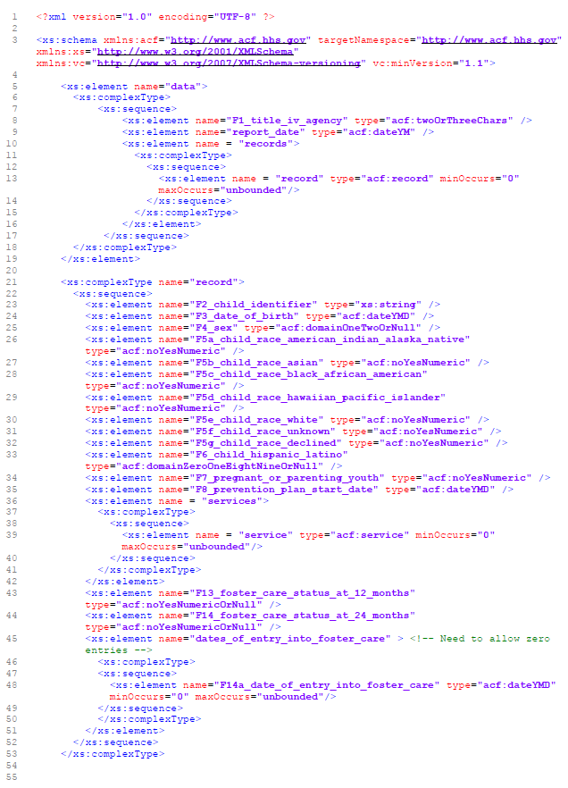

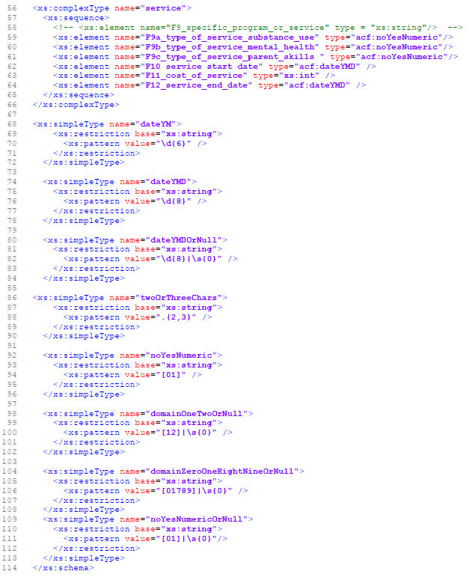

OMB Approval number: 0970-0529, Expiration Date: 07/31/2022
For information on encryption, see AFCARS Technical Bulletin #21 - Technical Bulletin 21: XML File Structure & Encryption https://www.acf.hhs.gov/cb/training-technical-assistance/technical-bulletin-21-xml-file
Census FIPS Codes: https://www.census.gov/geographies/reference-files/2017/demo/popest/2017-fips.html 4
EPA Tribal identifier data standards: https://www.epa.gov/data-standards/tribal-identifier-data-standard

