NATIONAL CENTER FOR EDUCATION STATISTICS NATIONAL ASSESSMENT OF EDUCATIONAL PROGRESS

National Assessment of Educational Progress (NAEP)2022
Materials Update #1

Appendix J2

2022 Teacher Questionnaires

OMB# 1850-0928 v.23

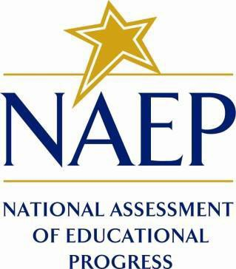

June 2021

Appendix J2 provides updated teacher survey questionnaires to be used in NAEP 2022. The change tables indicate any revisions that have been made to the previous versions of the SQs. If further revisions are required, they will be submitted in this Appendix in Amendment #2 by August 2021.
Table of Contents
Teacher Questionnaires
Teacher Questionnaire Login Screens 3
Appendix J2-1: Summary of Changes Operational Grade 4 CORE 4
Appendix J2-2: Operational Grade 4 CORE 11
Appendix J2-3: Summary of Changes Operational Grade 8 CORE 19
Appendix J2-4: Operational Grade 8 CORE 27
Appendix J2-5: Summary of Changes Operational Grade 4 Mathematics 37
Appendix J2-6: Operational Grade 4 Mathematics 42
Appendix J2-7: Summary of Changes Operational Grade 8 Mathematics 49
Appendix J2-8: Operational Grade 8 Mathematics 55
Appendix J2-9: Summary of Changes Operational Grade 4 Reading 63
Appendix J2-10: Operational Grade 4 Reading 67
Appendix J2-11: Summary of Changes Operational Grade 8 Reading 72
Appendix J2-12: Operational Grade 8 Reading 77
Appendix J2-13: Summary of Changes Operational Grade 8 Social Studies 82
Appendix J2-14: Operational Grade 8 Social Studies 91
Appendix J2-15: Summary of Operational Grade 4 COVID-19 100
Appendix J2-16: Operational Grade 4 COVID-19 105
Appendix J2-17: Summary of Operational Grade 8 COVID-19 109
Appendix J2-18: Operational Grade 8 COVID-19 113

Teacher Questionnaire Login Screens

The teacher login screens will have the updated OMB expiration dates added in Amendment #2 in August 2021.
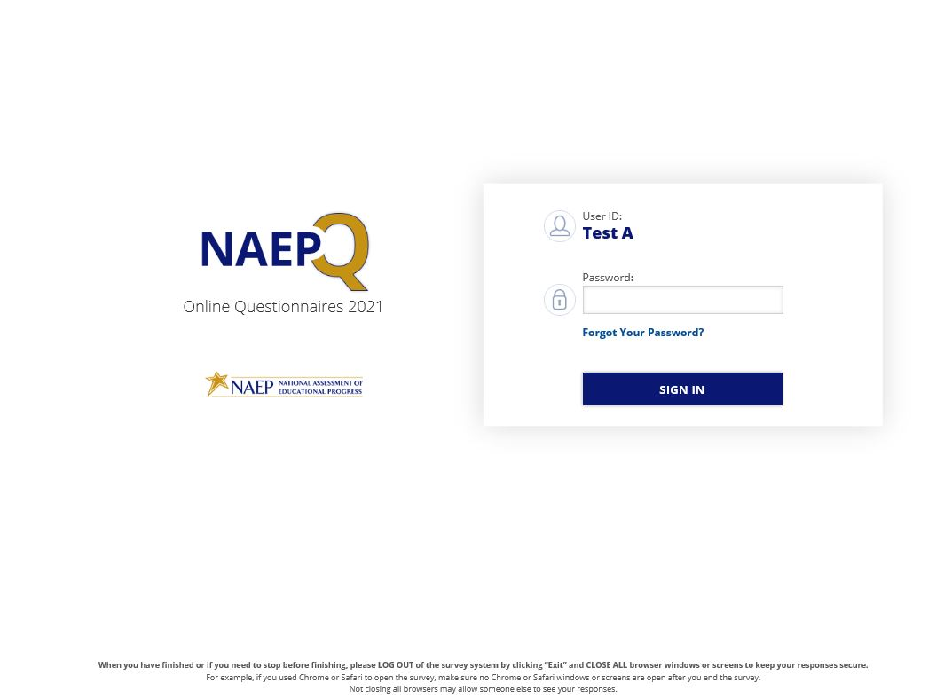
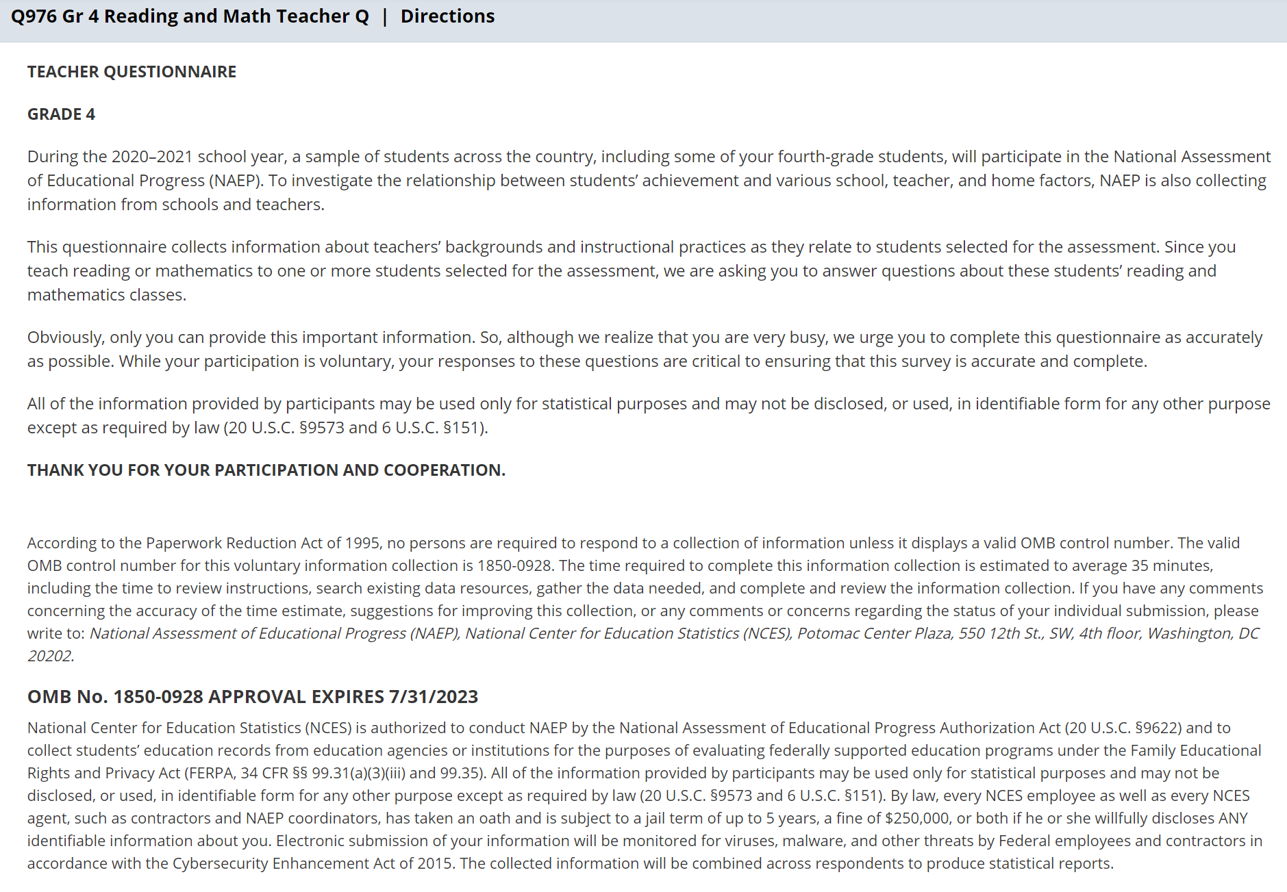

Appendix J2-1: Summary of Changes Operational Grade 4 CORE
2022 Operational Grade 4 Core Teacher

Previous item | 2022 item | D/A/ R/NC+ | Rationale
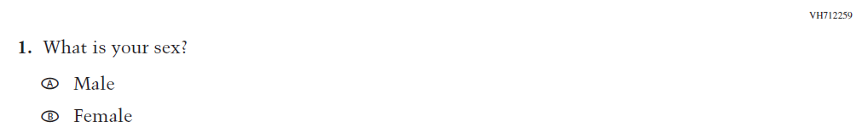  (2021 Grade 4) | 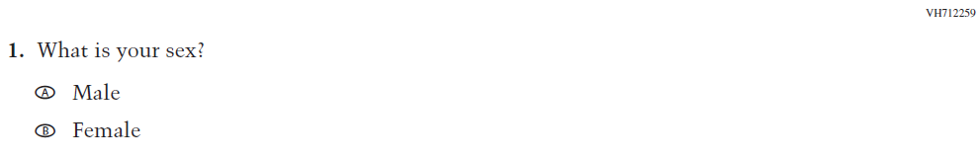  Issue: Gender | NC | N/A
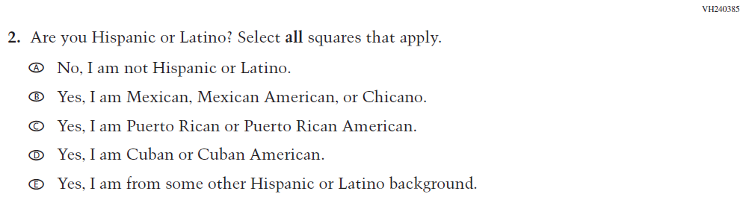  (2021 Grade 4) | 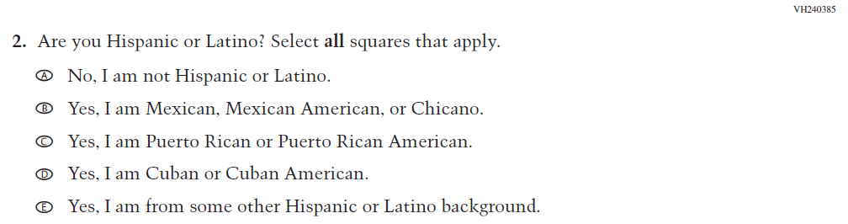  Issue: Race/Ethnicity | NC | N/A
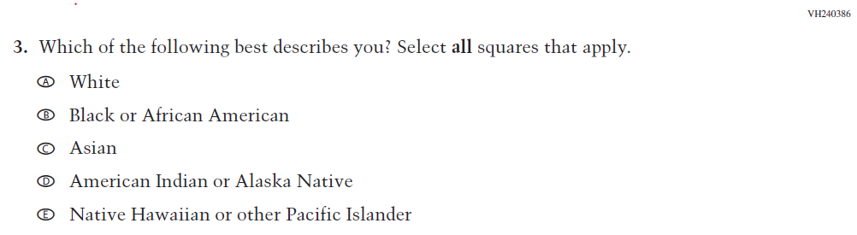  (2021 Grade 4) | 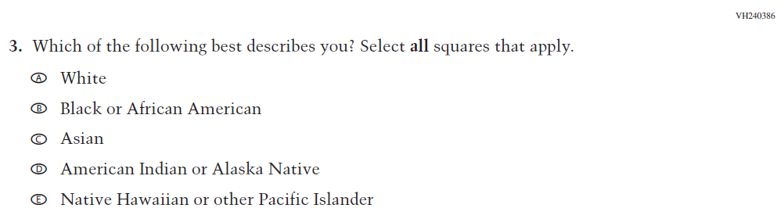  Issue: Race/Ethnicity | NC | N/A
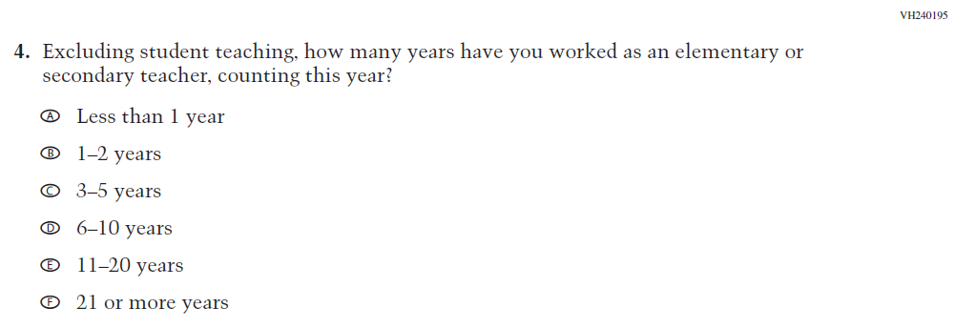  (2021 Grade 4) | 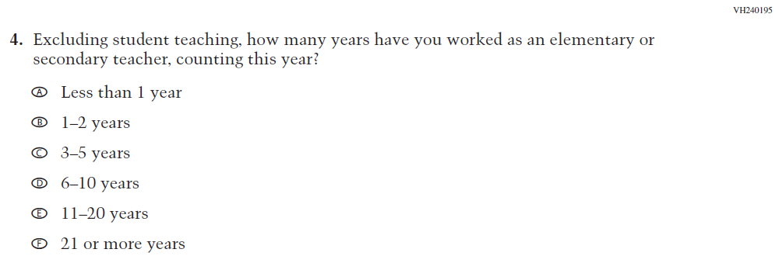  Issue: Teacher Preparation | NC | N/A

2022 Operational Grade 4 Core Teacher

Previous item | 2022 item | D/A/ R/NC+ | Rationale
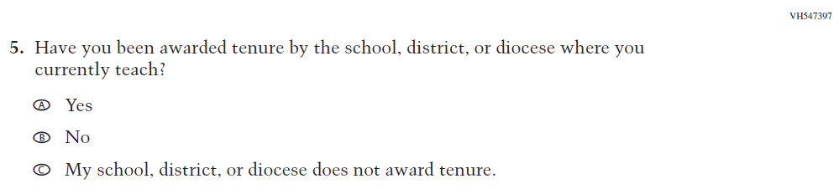  (2021 Grade 4) | 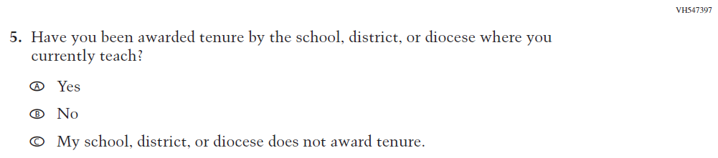  Issue: Teacher Preparation | NC | N/A
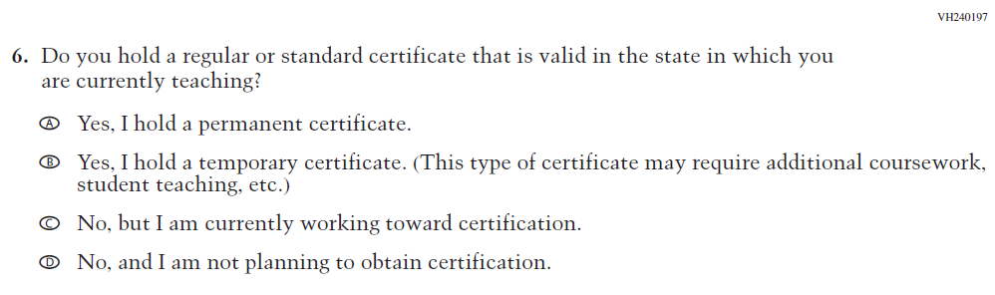  (2021 Grade 4) | 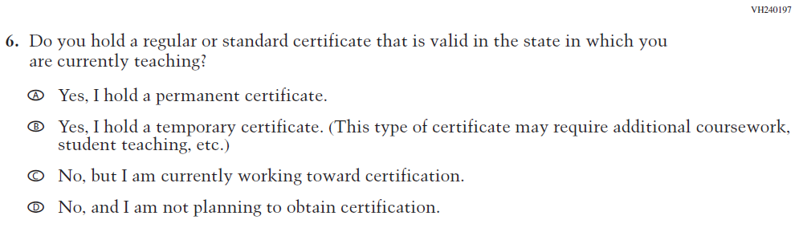  Issue: Teacher Preparation | NC | N/A
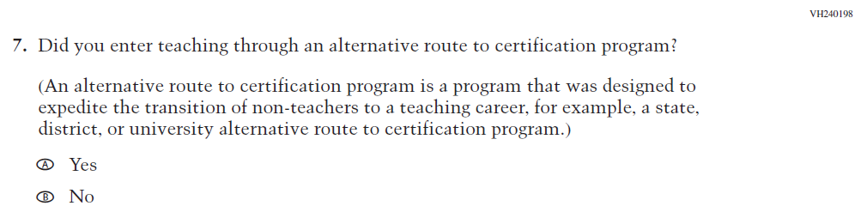  (2021 Grade 4) | 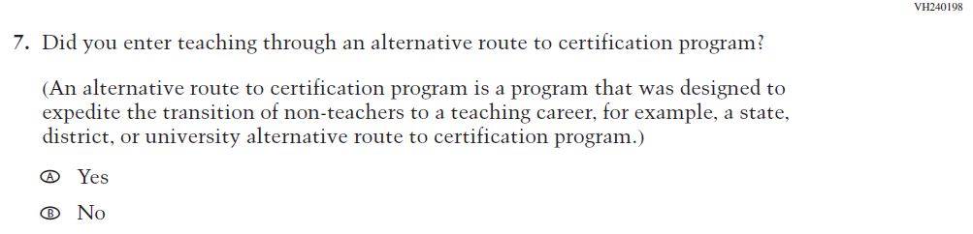  Issue: Teacher Preparation | NC | N/A

2022 Operational Grade 4 Core Teacher

Previous item | 2022 item | D/A/ R/NC+ | Rationale
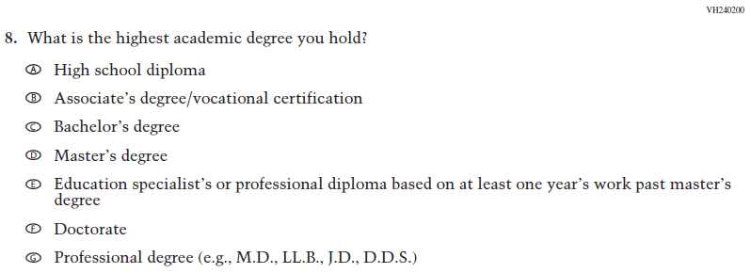  (2021 Grade 4) | Issue: Teacher Preparation | NC | N/A
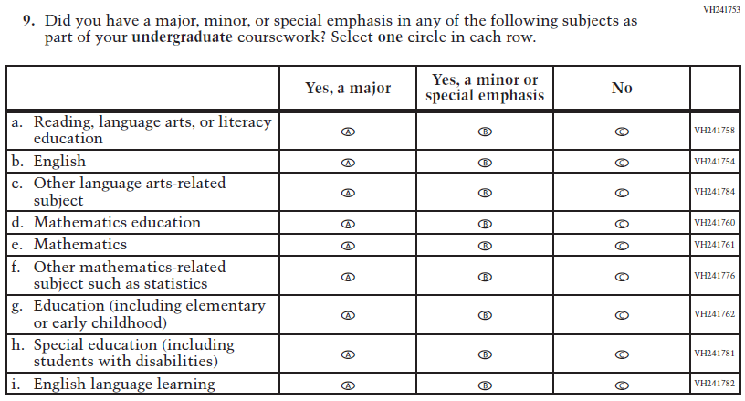  (2021 Grade 4) | Issue: Teacher Preparation | NC | N/A
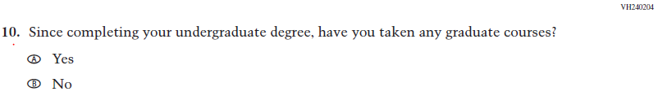  (2021 Grade 4) | Issue: Teacher Preparation | NC | N/A

2022 Operational Grade 4 Core Teacher

Previous item | 2022 item | D/A/ R/NC+ | Rationale
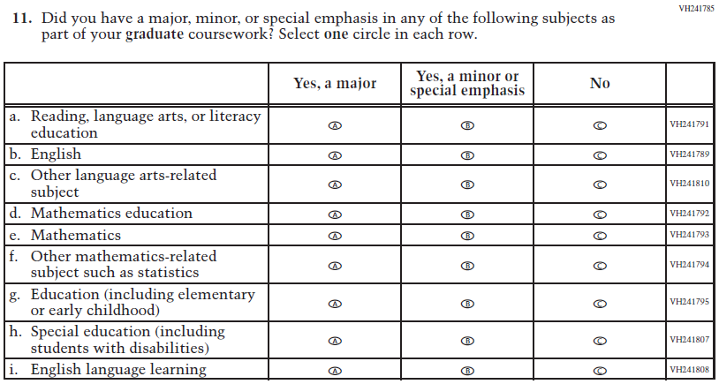  (2021 Grade 4) | Issue: Teacher Preparation | NC | N/A
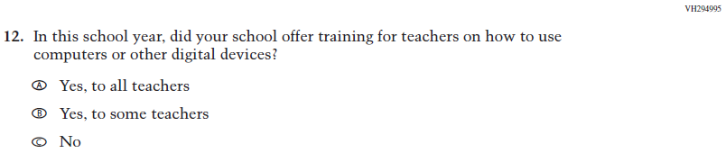  (2021 Grade 4) | 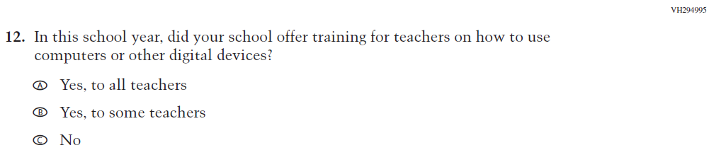  Issue: Technology Use | NC | N/A
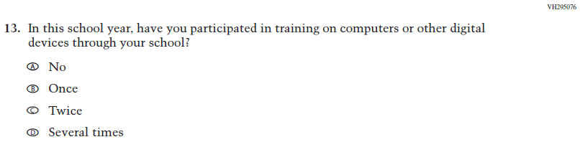  (2021 Grade 4) | Issue: Technology Use | NC | N/A
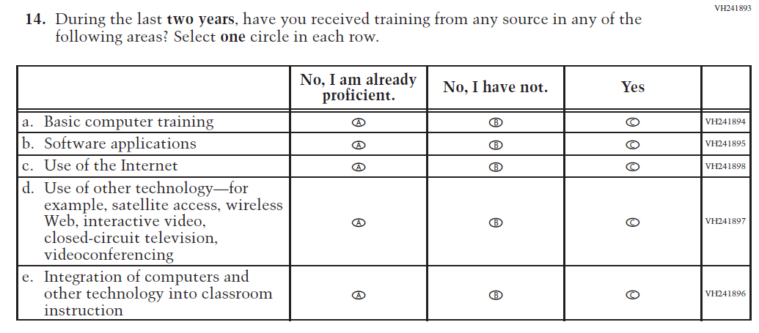  (2021 Grade 4) | 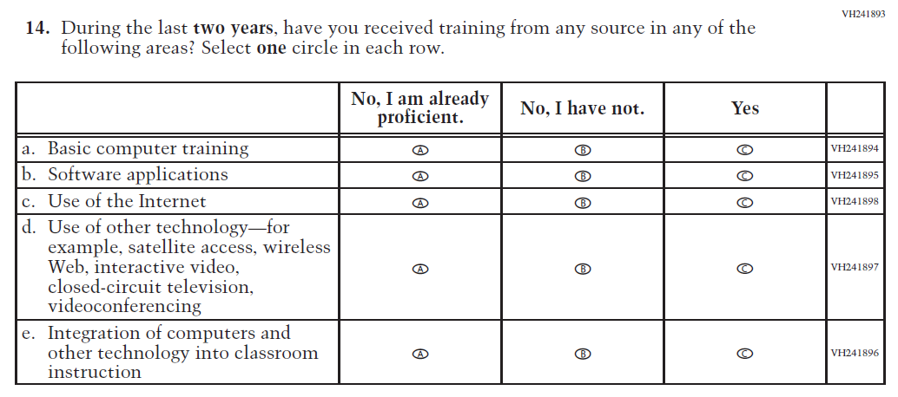  Issue: Teacher Preparation | NC | N/A
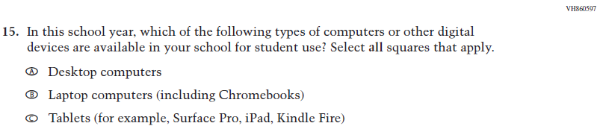  (2021 Grade 4) | Issue: Technology Use | NC | N/A
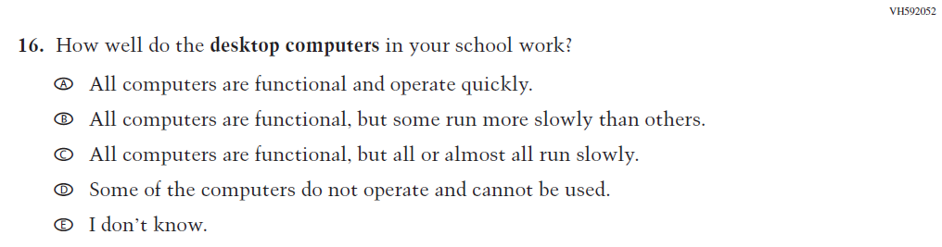  (2021 Grade 4) | Issue: Technology Use | NC | N/A
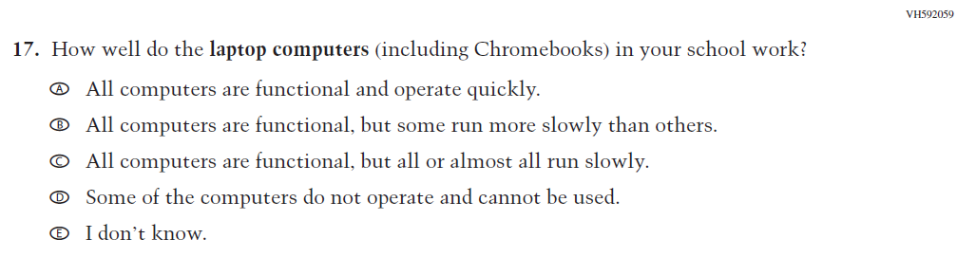  (2021 Grade 4) | Issue: Technology Use | NC | N/A

2022 Operational Grade 4 Core Teacher

Previous item | 2022 item | D/A/ R/NC+ | Rationale
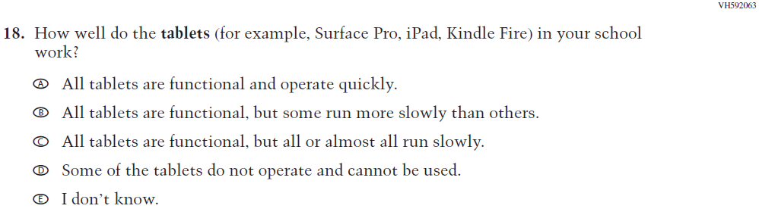  (2021 Grade 4) | Issue: Technology Use | NC | N/A
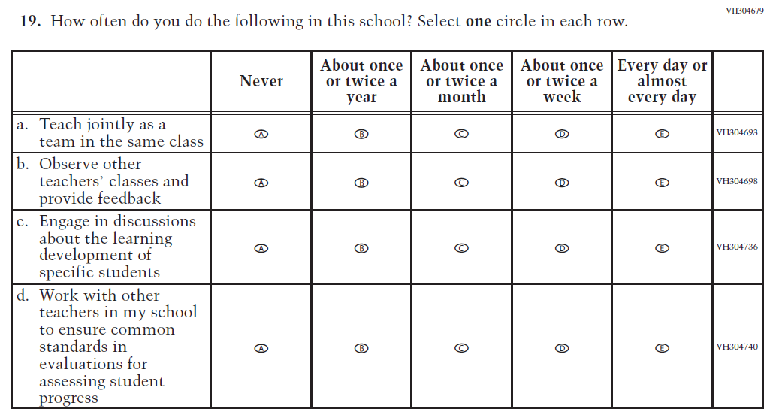  (2021 Grade 4) | Issue: School Climate | NC | N/A
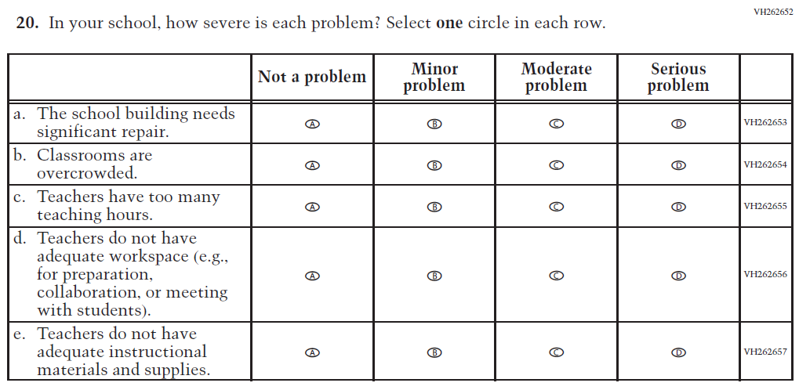  (2021 Grade 4) | Issue: School Climate | NC | N/A

2022 Operational Grade 4 Core Teacher

Previous item | 2022 item | D/A/ R/NC+ | Rationale
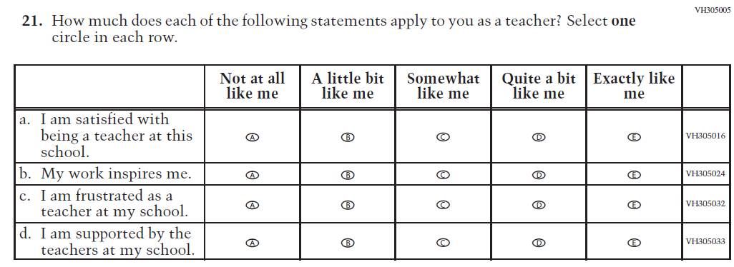  (2021 Grade 4) | Issue: School Climate | NC | N/A
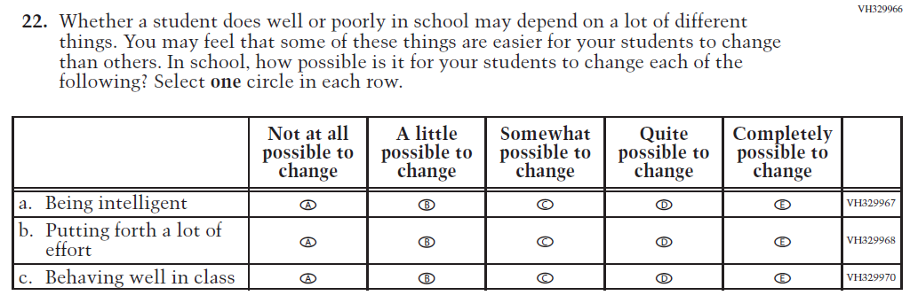  (2021 Grade 4) | Issue: Desire for Learning | NC | N/A

Appendix J2-2: Operational Grade 4 CORE
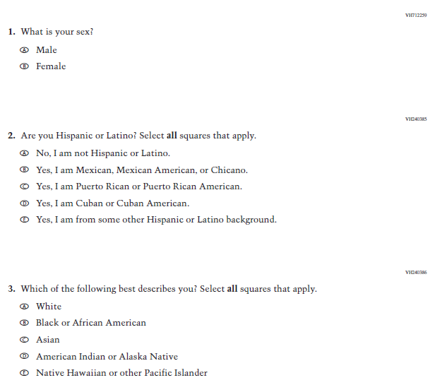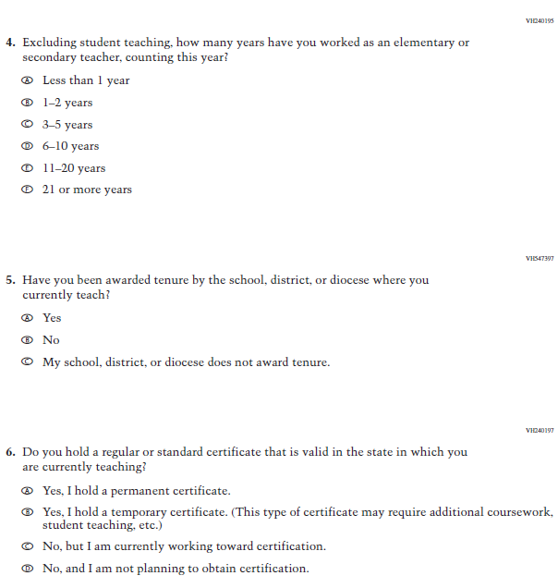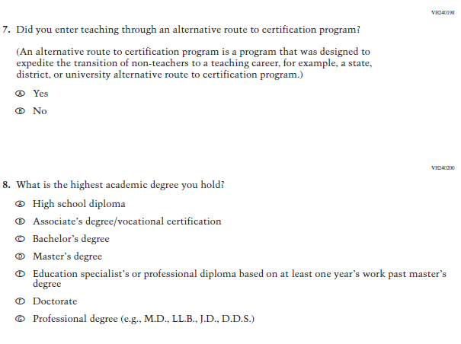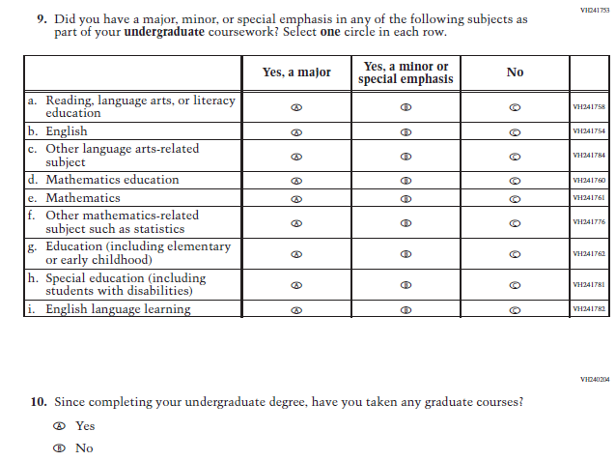
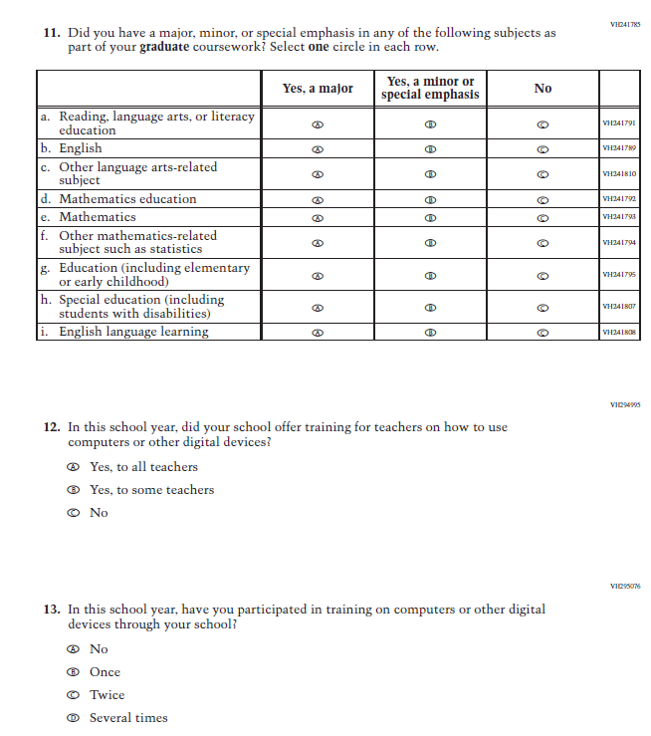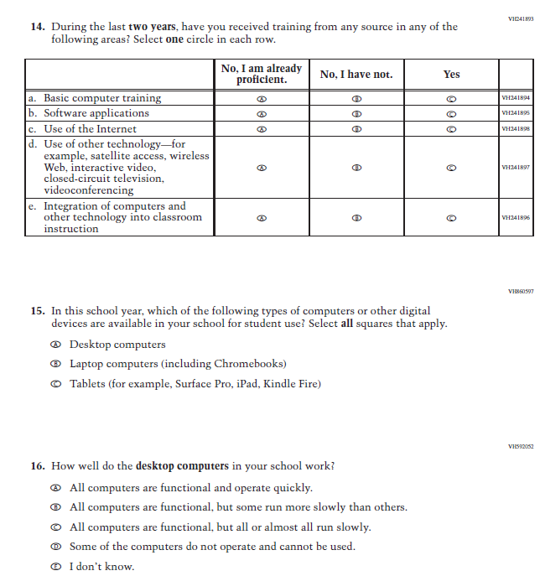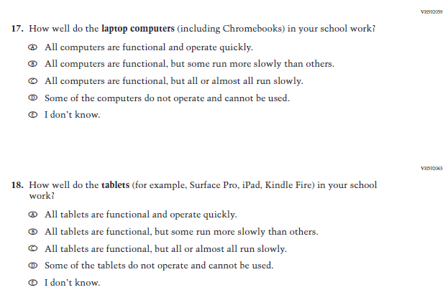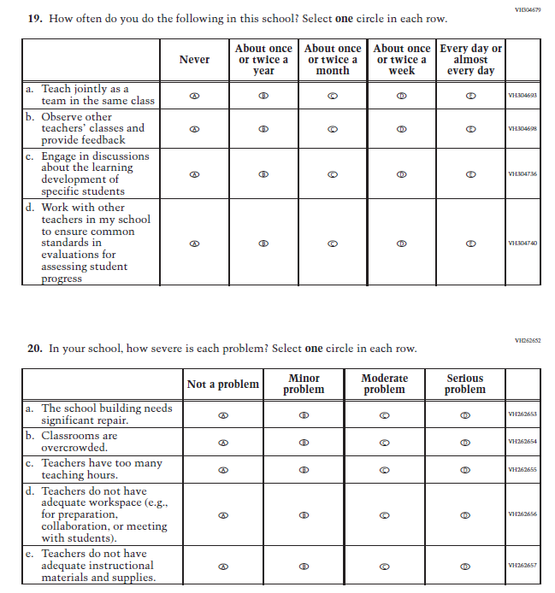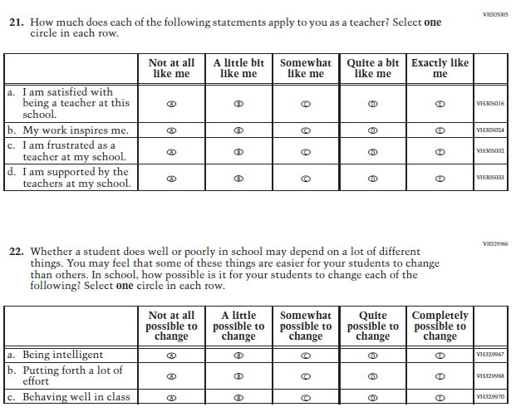

Appendix J2-3: Summary of Changes Operational Grade 8 CORE
2022 Operational Grade 8 Core Teacher

Previous item | 2022 item | D/A/ R/NC+ | Rationale
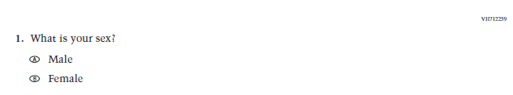  (2021 Grade 8) | Issue: Gender | NC | N/A
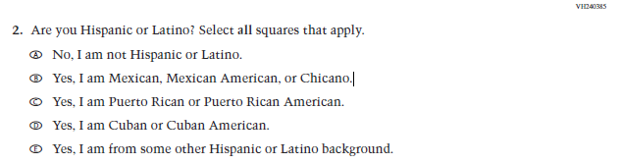  (2021 Grade 8) | Issue: Race/Ethnicity | NC | N/A
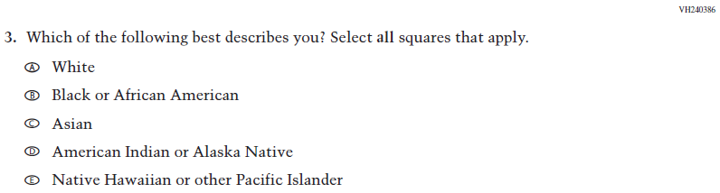  (2021 Grade 8) | Issue: Race/Ethnicity | NC | N/A
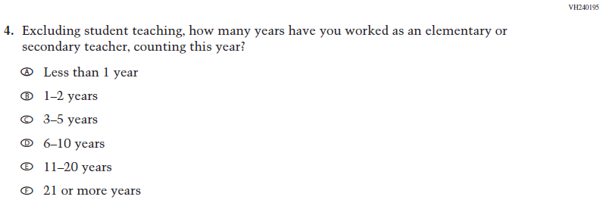  (2021 Grade 8) | Issue: Teacher Preparation | NC | N/A
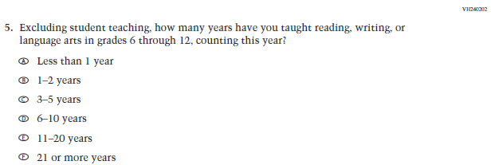  (2021 Grade 8) | Issue: Teacher Preparation | NC | N/A
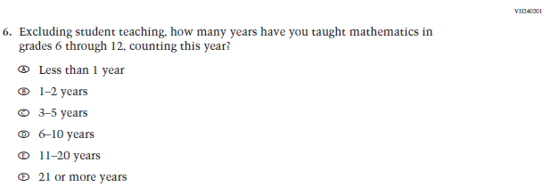  (2021 Grade 8) | Issue: Teacher Preparation | NC | N/A
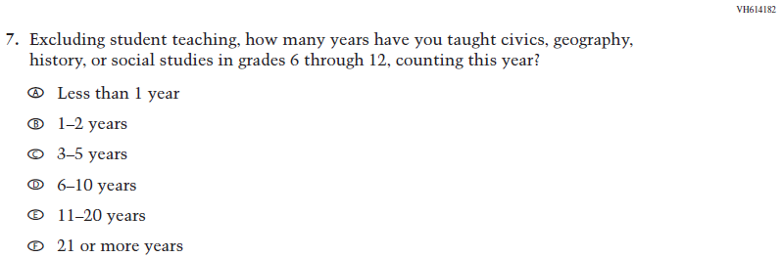  (2021 Grade 8) | Issue: Teacher Preparation | NC | N/A
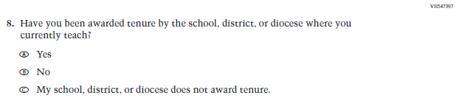  (2021 Grade 8) | Issue: Teacher Preparation | NC | N/A
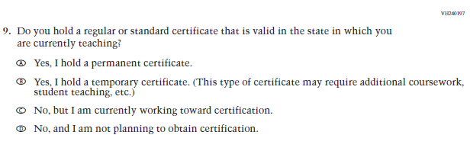  (2021 Grade 8) | Issue: Teacher Preparation | NC | N/A
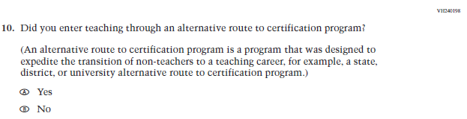  (2021 Grade 8) | Issue: Teacher Preparation | NC | N/A
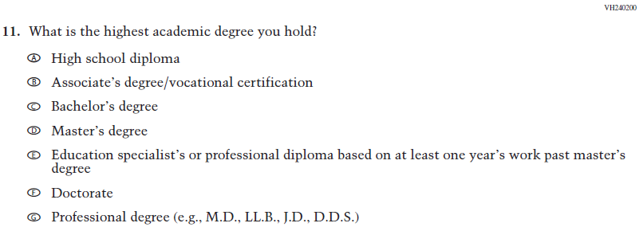  (2021 Grade 8) | Issue: Teacher Preparation | NC | N/A
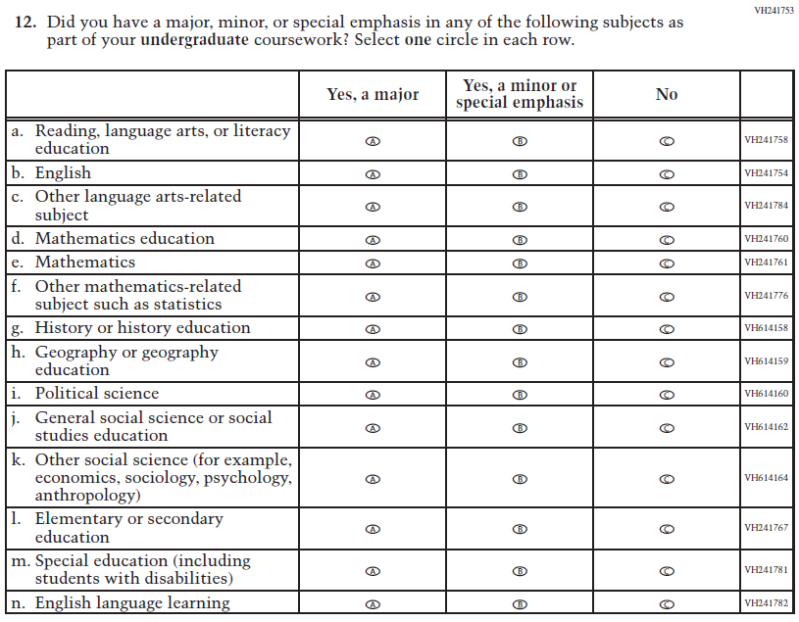  (2021 Grade 8) | Issue: Teacher Preparation | NC | N/A
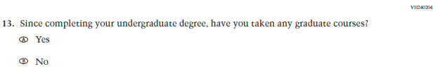  (2021 Grade 8) | Issue: Teacher Preparation | NC | N/A
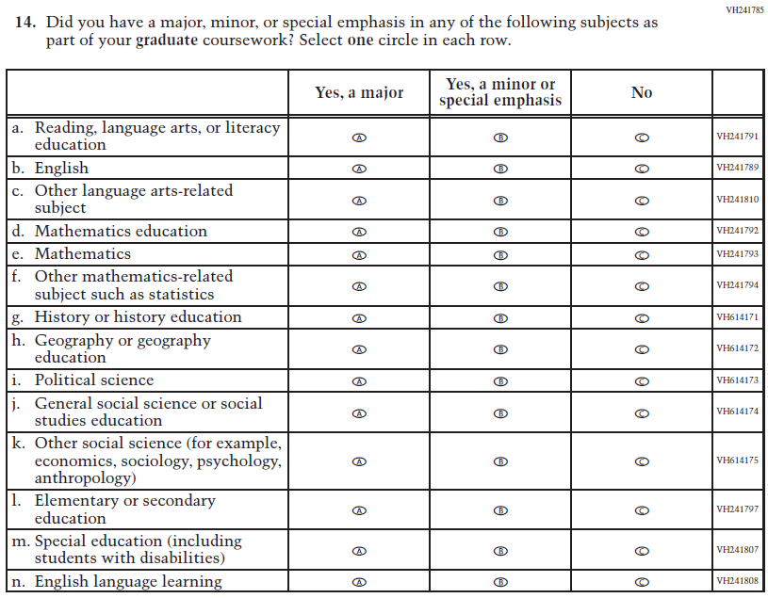  (2021 Grade 8) | Issue: Teacher Preparation | NC | N/A
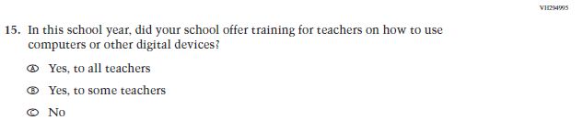  (2021 Grade 8) | Issue: Technology Use | NC | N/A
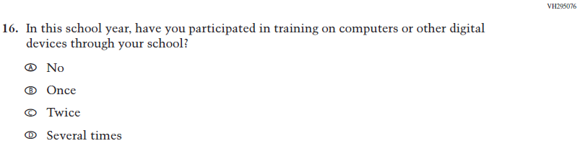  (2021 Grade 8) | Issue: Technology Use | NC | N/A
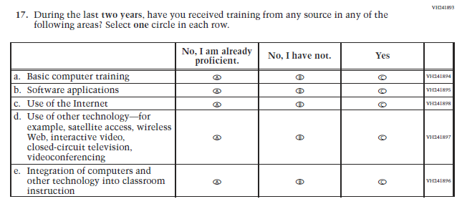  (2021 Grade 8) | Issue: Teacher Preparation | NC | N/A
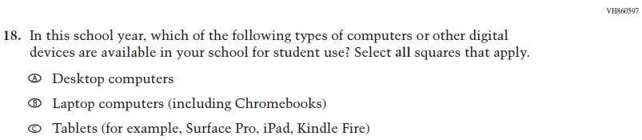  (2021 Grade 8) | Issue: Technology Use | NC | N/A
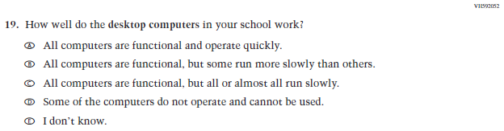  (2021 Grade 8) | Issue: Technology Use | NC | N/A
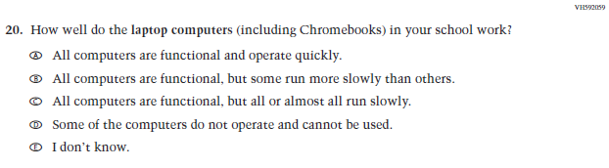  (2021 Grade 8) | Issue: Technology Use | NC | N/A
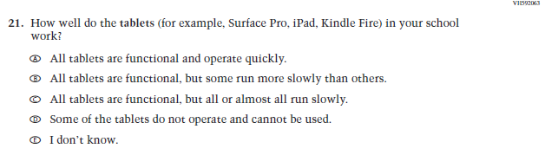  (2021 Grade 8) | Issue: Technology Use | NC | N/A
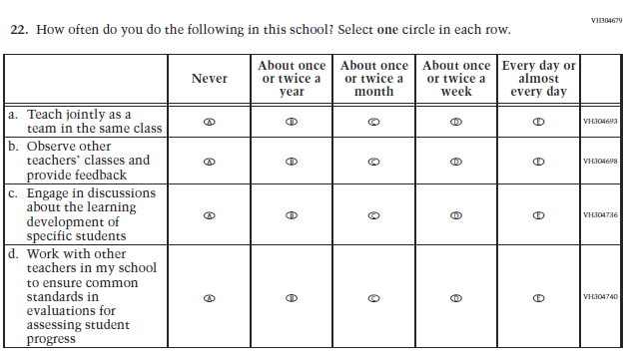  (2021 Grade 8) | Issue: School Climate | NC | N/A
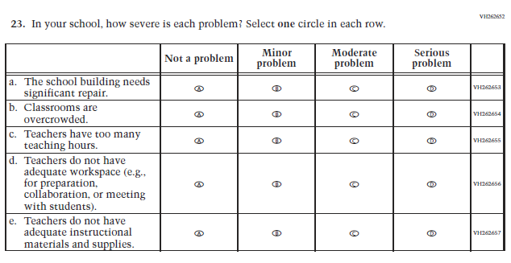  (2021 Grade 8) | Issue: School Climate | NC | N/A
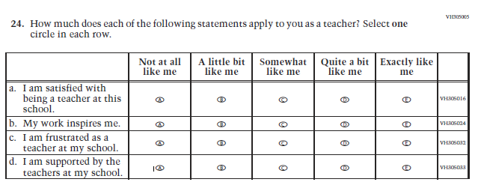  (2021 Grade 8) | Issue: School Climate | NC | N/A
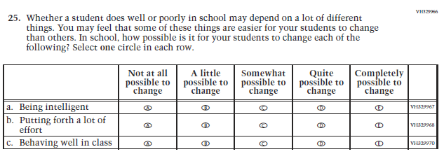  (2021 Grade 8) | Issue: Desire for Learning | NC | N/A

Appendix J2-4: Operational Grade 8 CORE
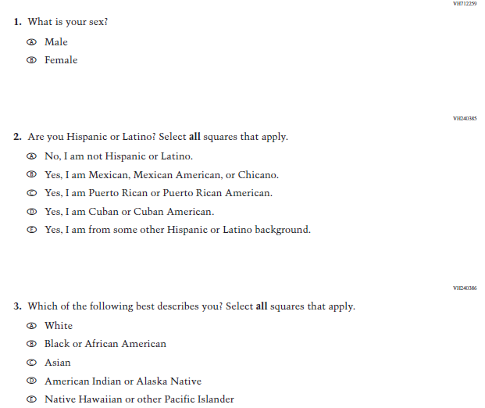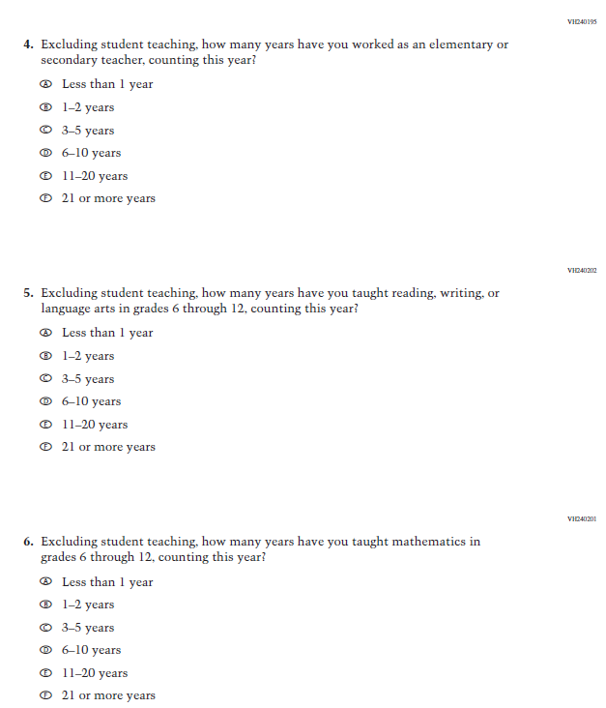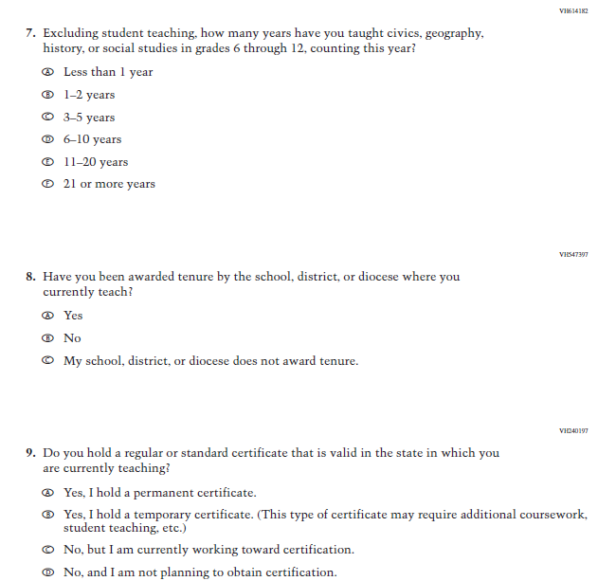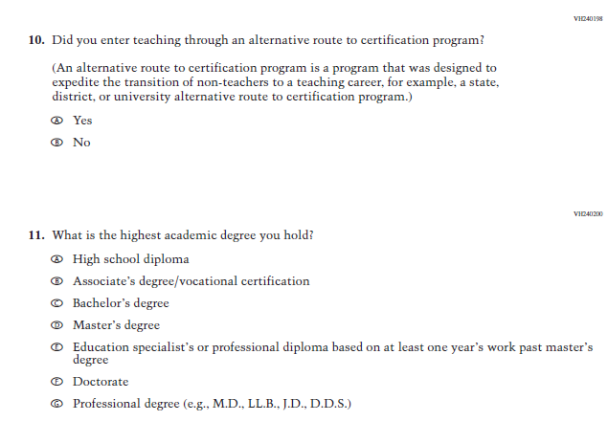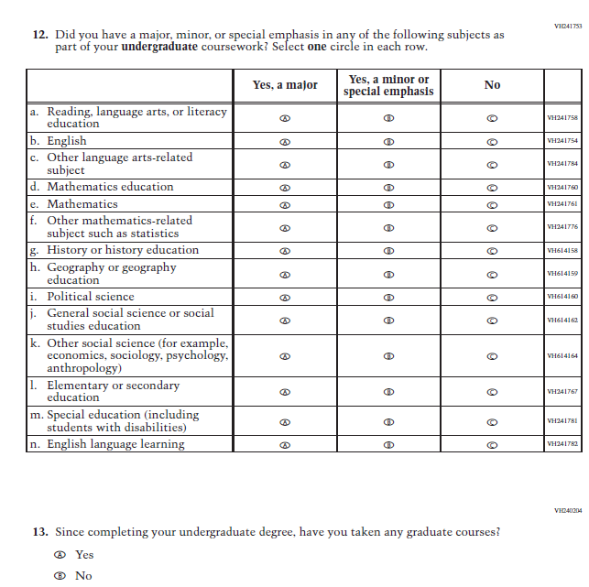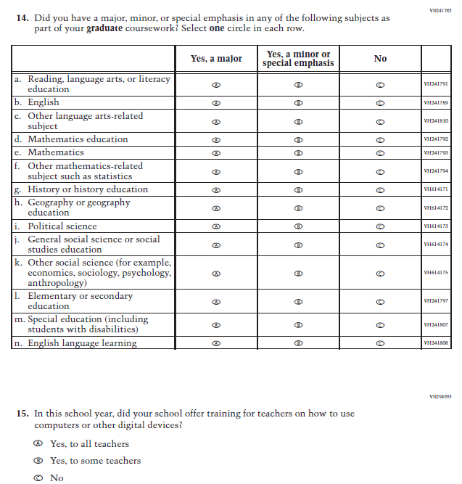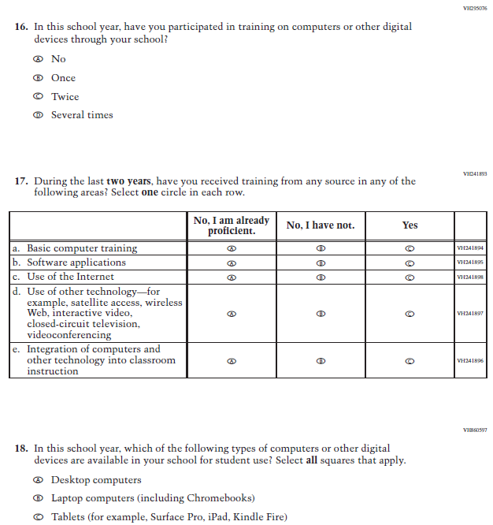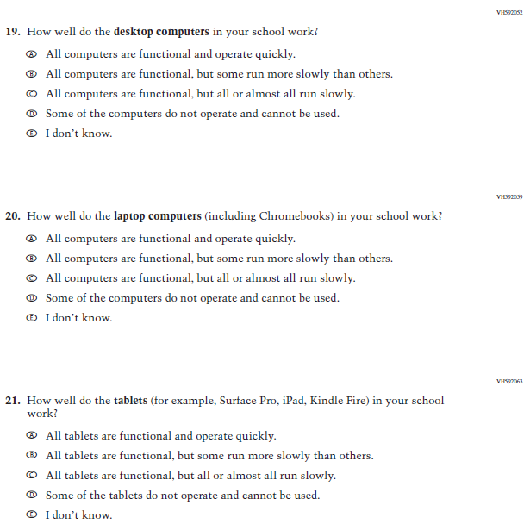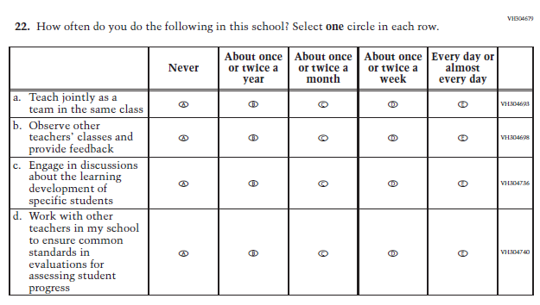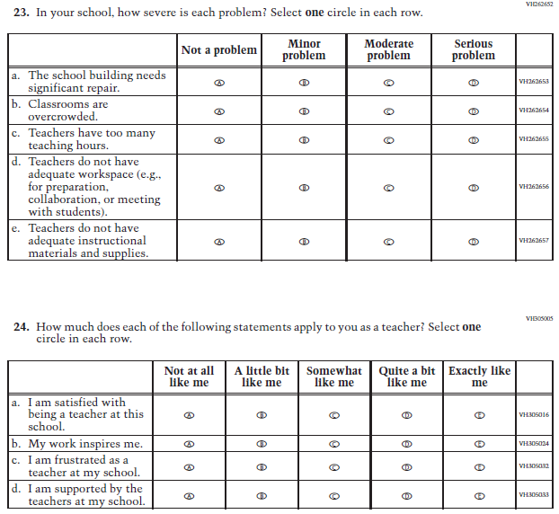
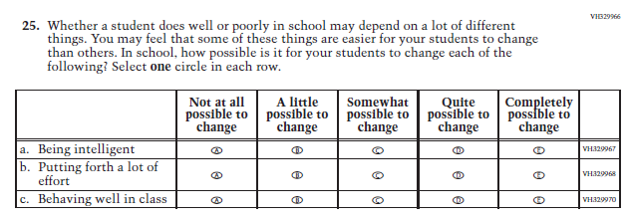

Appendix J2-5: Summary of Changes Operational Grade 4 Mathematics
2022 Operational Grade 4 Mathematics Teacher

Previous item | 2022 item | D/A/ R/NC+ | Rationale
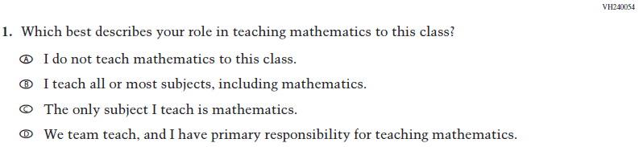  (2021 Grade 4) | Issue: Resources for Learning and Instruction | NC | N/A
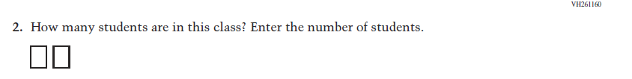  (2021 Grade 4) | Issue: Resources for Learning and Instruction | NC | N/A
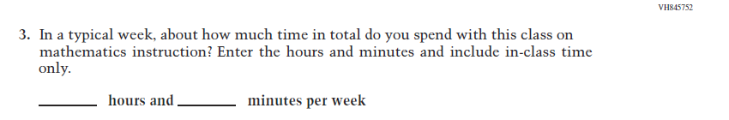  (2021 Grade 4) | Issue: Resources for Learning and Instruction | NC | N/A
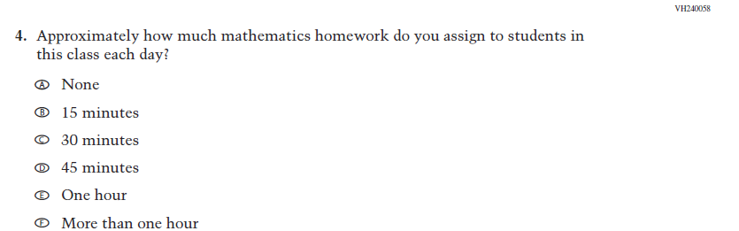  (2021 Grade 4) | Issue: Organization of Instruction | NC | N/A
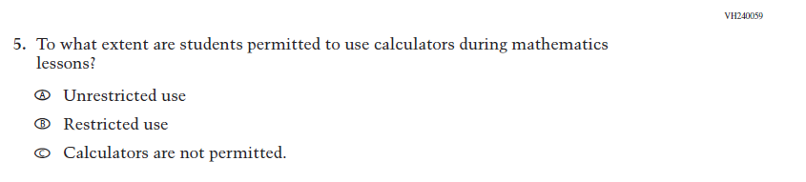  (2021 Grade 4) | Issue: Organization of Instruction | NC | N/A
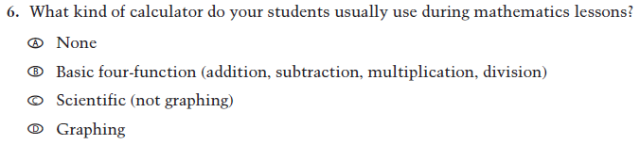  (2021 Grade 4) | Issue: Resources for learning and instruction | NC | N/A
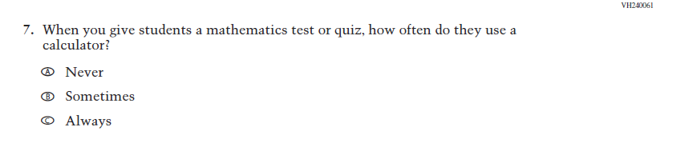  (2021 Grade 4) | Issue: Organization of Instruction | NC | N/A
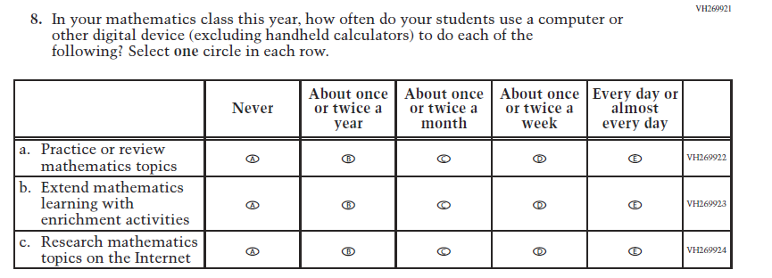  (2021 Grade 4) | Issue: Organization of Instruction | NC | N/A
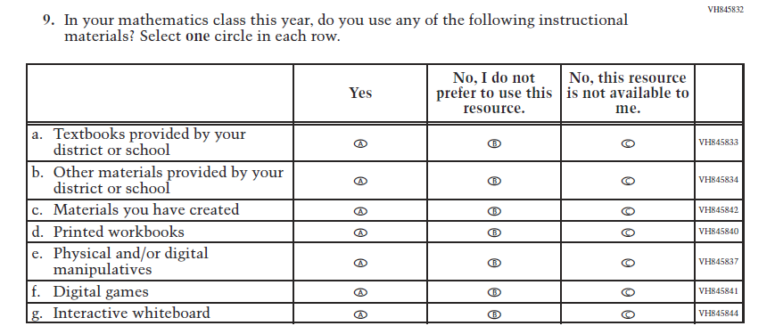  (2021 Grade 4) | Issue: Resources for Learning and Instruction | NC | N/A
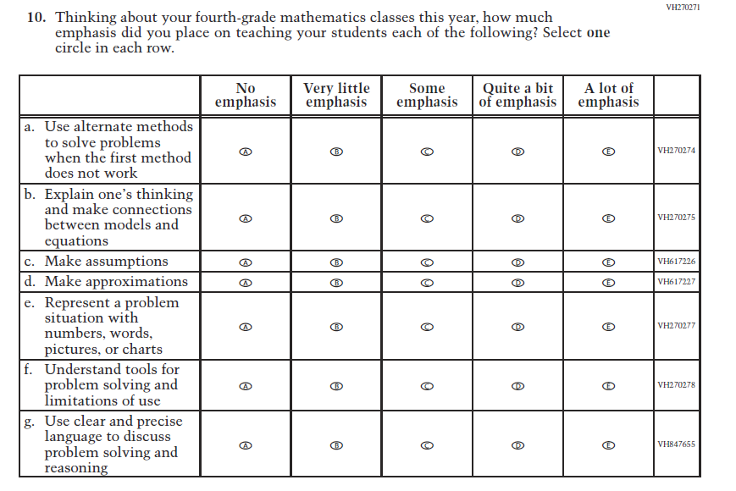  (2021 Grade 4) | Issue: Organization of Instruction | NC | N/A
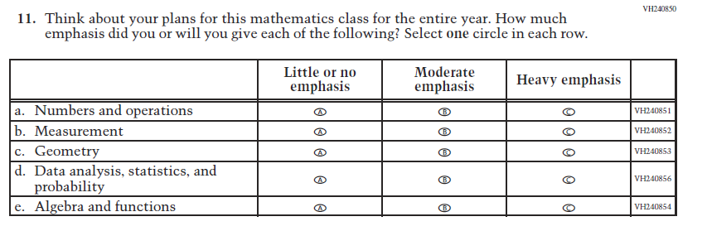  (2021 Grade 4) | Issue: Organization of Instruction | NC | N/A
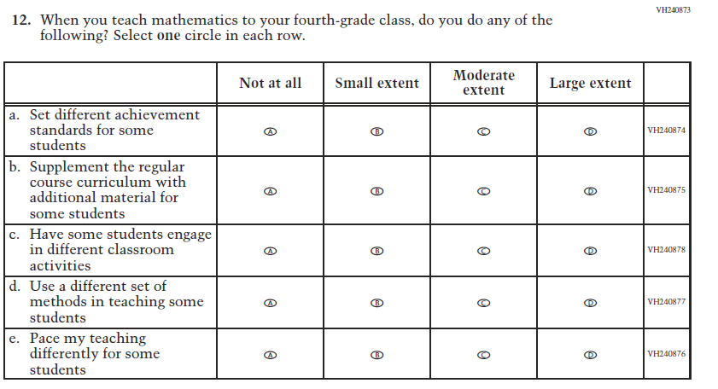  (2021 Grade 4) | Issue: Organization of Instruction | NC | N/A
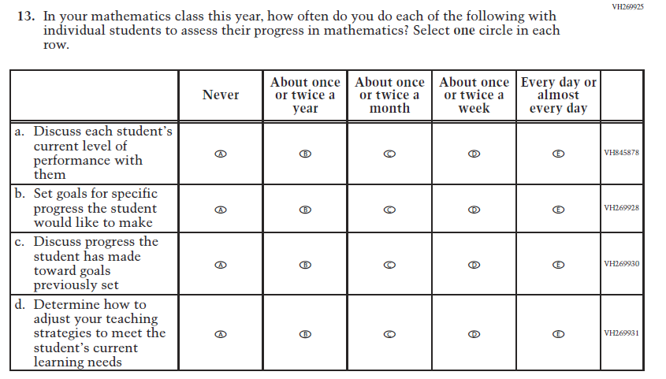  (2021 Grade 4) | Issue: Organization of Instruction | NC | N/A
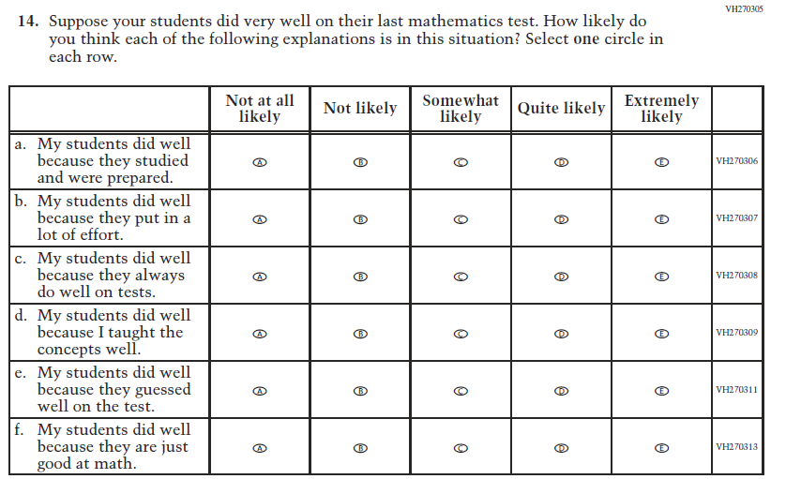  (2021 Grade 4) | Issue: Teacher Preparation | NC | N/A
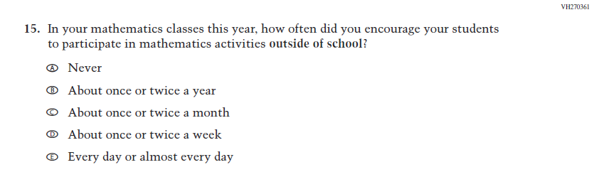  (2021 Grade 4) | Issue: Resources for Learning and Instruction | NC | N/A
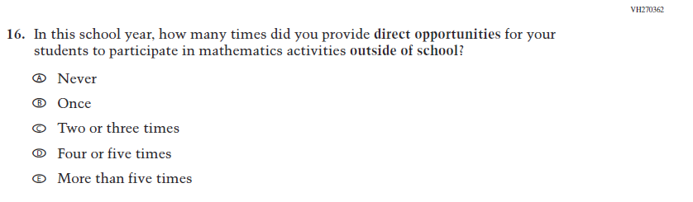  (2021 Grade 4) | Issue: Resources for Learning and Instruction | NC | N/A

Appendix J2-6: Operational Grade 4 Mathematics

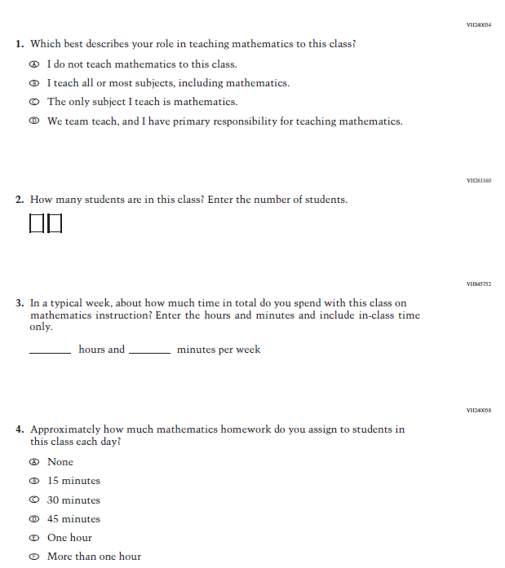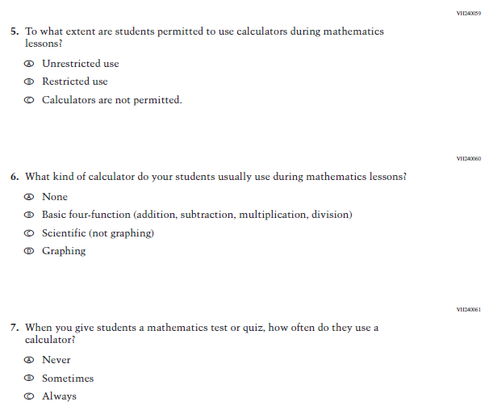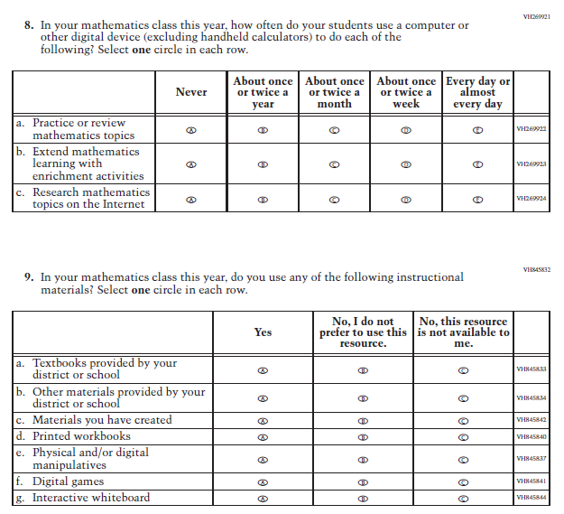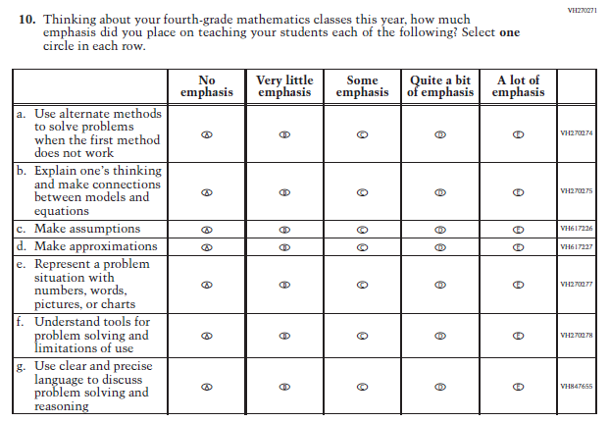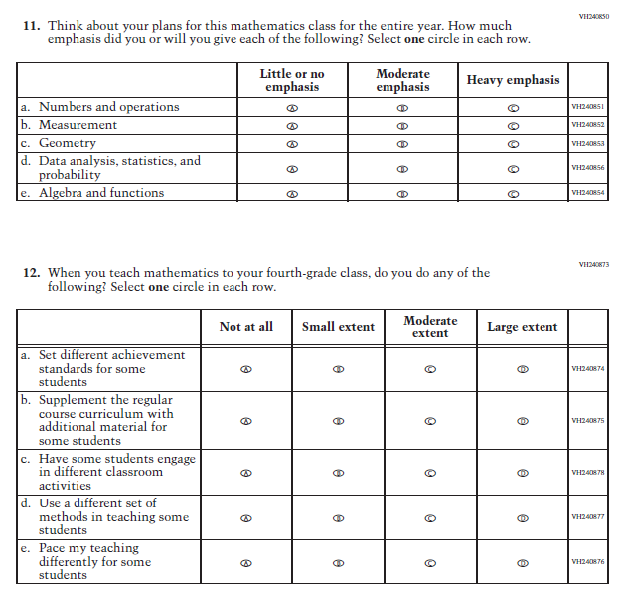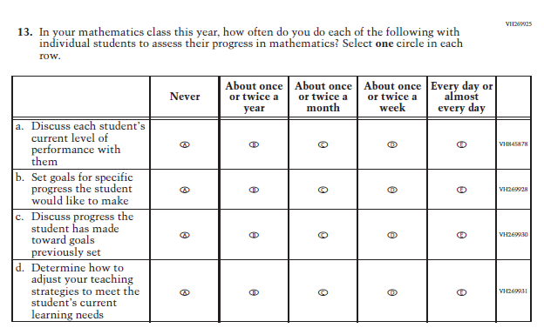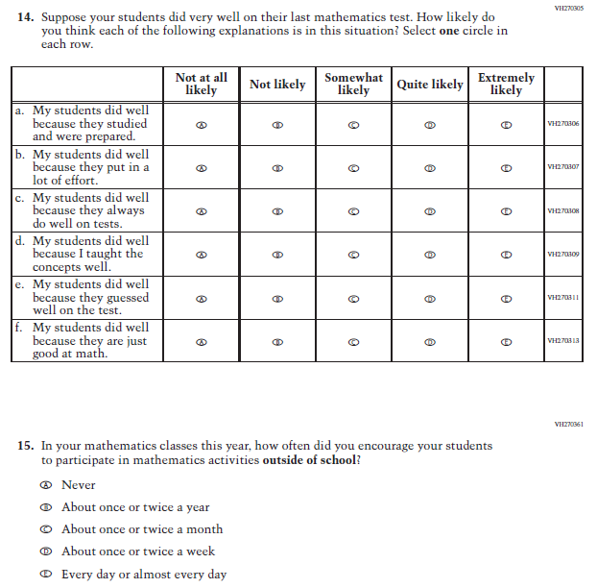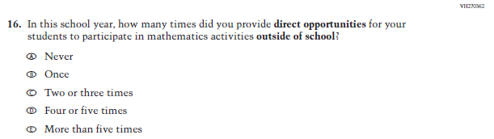

Appendix J2-7: Summary of Changes Operational Grade 8 Mathematics
2022 Operational Grade 8 Mathematics Teacher

Previous item | 2022 item | D/A/ R/NC+ | Rationale
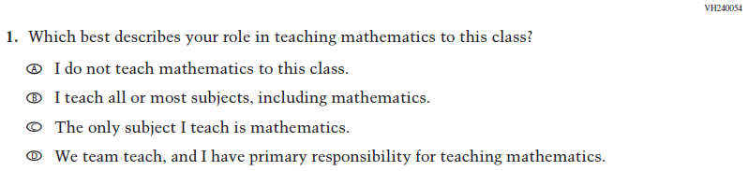  (2021 Grade 8) | Issue: Resources for Learning and Instruction | NC | N/A
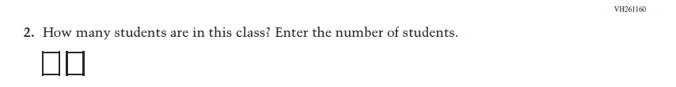  (2021 Grade 8) | 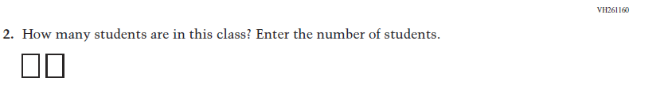  Issue: Resources for Learning and Instruction | NC | N/A
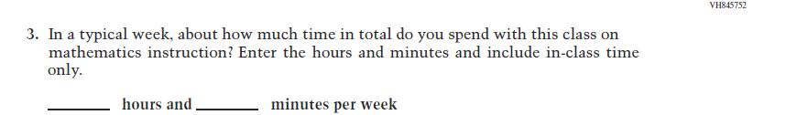  (2021 Grade 8) | Issue: Resources for Learning and Instruction | NC | N/A
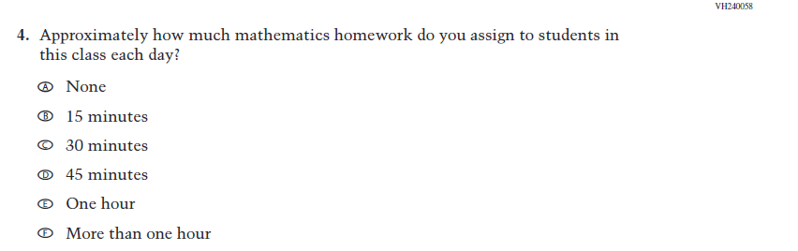  (2021 Grade 8) | Issue: Organization of Instruction | NC | N/A
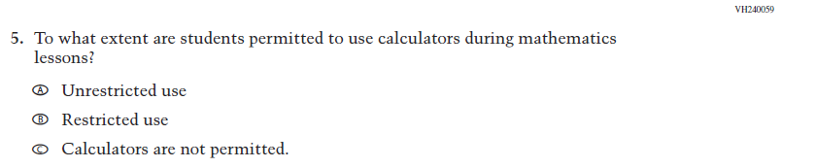  (2021 Grade 8) | Issue: Organization of Instruction | NC | N/A
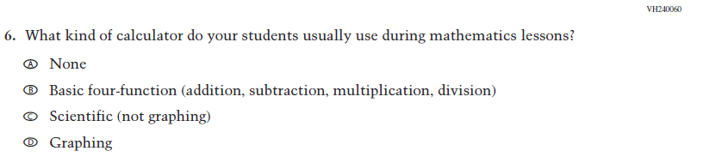  (2021 Grade 8) | Issue: Resources for Learning and Instruction | NC | N/A
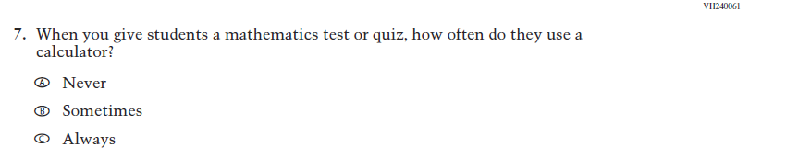  (2021 Grade 8) | Issue: Organization of Instruction | NC | N/A
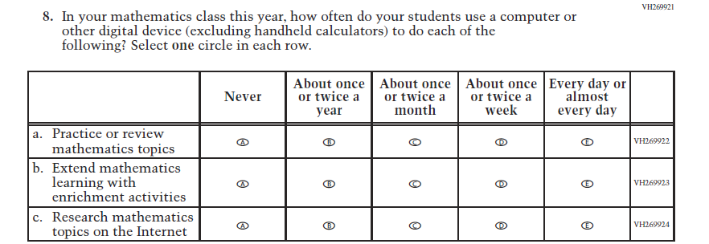  (2021 Grade 8) | Issue: Organization of Instruction | NC | N/A
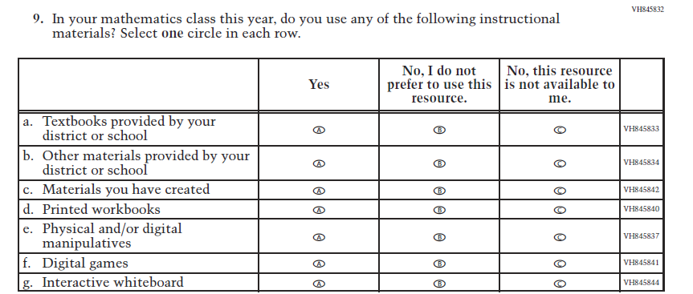  (2021 Grade 8) | Issue: Resources for Learning and Instruction | NC | N/A

2022 Operational Grade 8 Mathematics Teacher

Previous item | 2022 item | D/A/ R/NC+ | Rationale
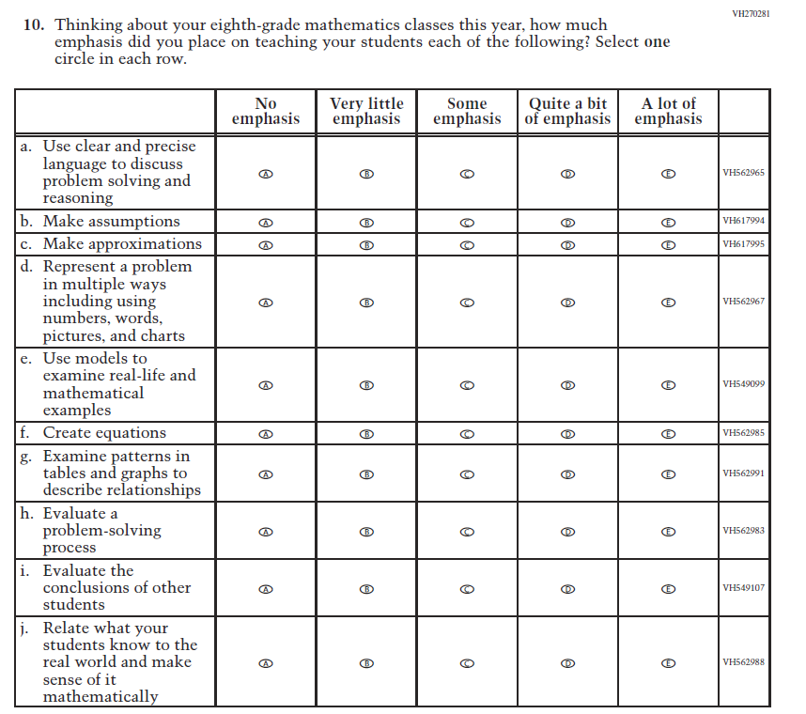  (2021 Grade 8) | Issue: Organization of Instruction | NC | N/A
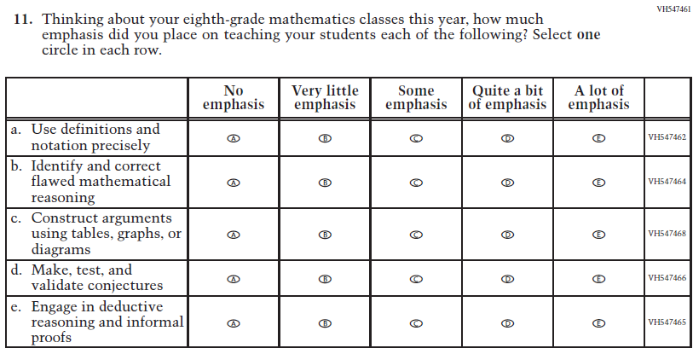  (2021 Grade 8) | Issue: Organization of Instruction | NC | N/A

2022 Operational Grade 8 Mathematics Teacher

Previous item | 2022 item | D/A/ R/NC+ | Rationale
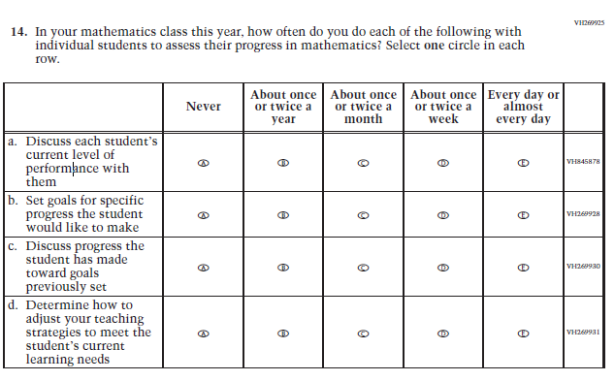  (2021 Grade 8) | Issue: Organization of Instruction | NC | N/A
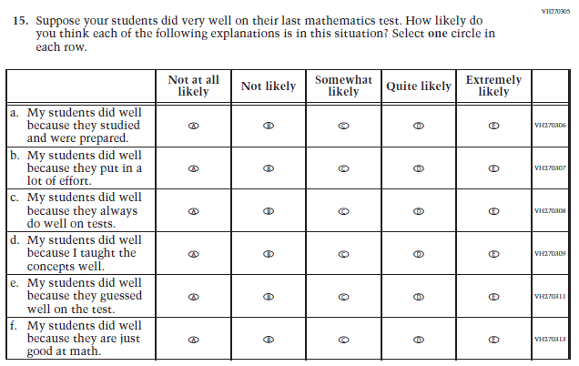  (2021 Grade 8) | Issue: Teacher Preparation | NC | N/A

2022 Operational Grade 8 Mathematics Teacher

Previous item | 2022 item | D/A/ R/NC+ | Rationale
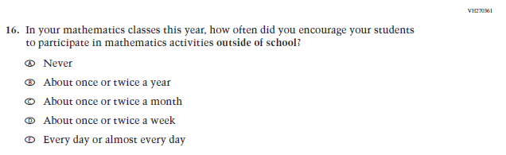  (2021 Grade 8) | Issue: Resources for Learning and Instruction | NC | N/A
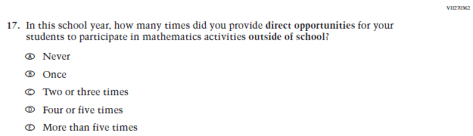  (2021 Grade 8) | Issue: Resources for Learning and Instruction | NC | N/A
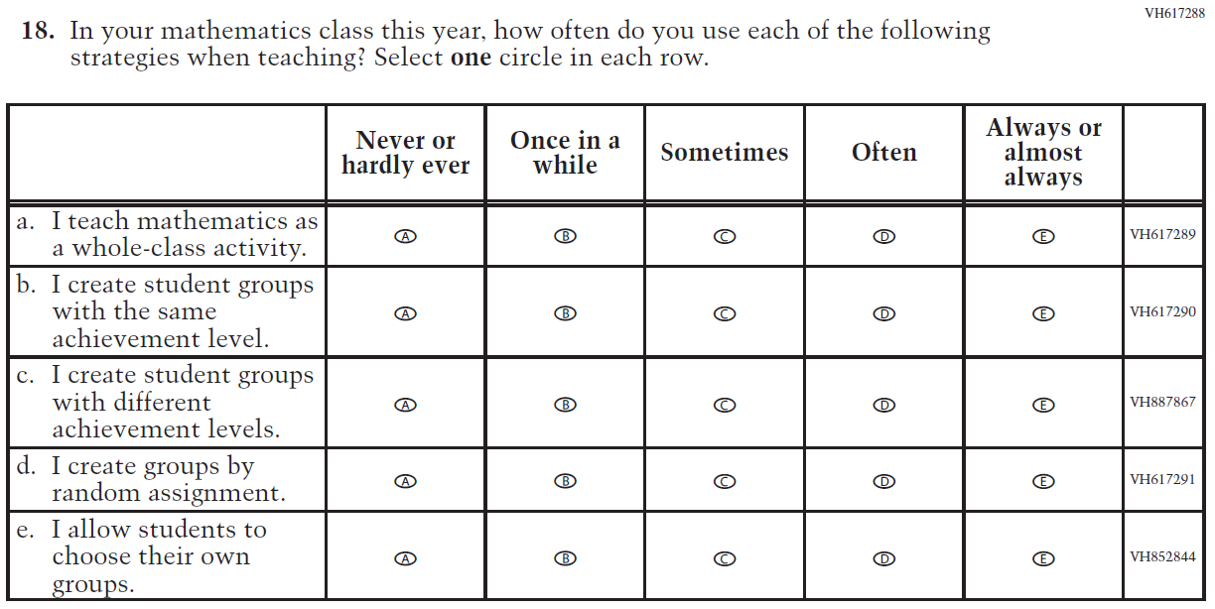  (2021 Grade 8) | Issue: Organization of Instruction | NC | N/A

Appendix J2-8: Operational Grade 8 Mathematics
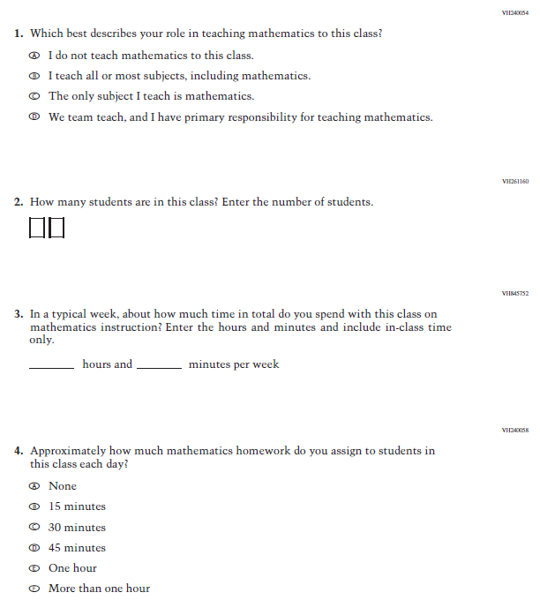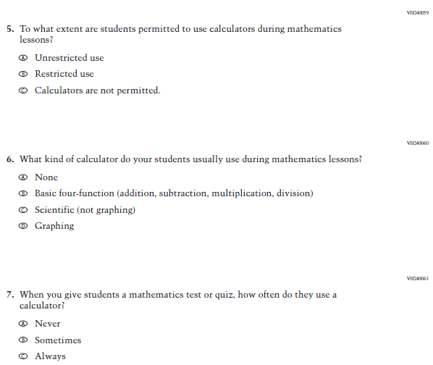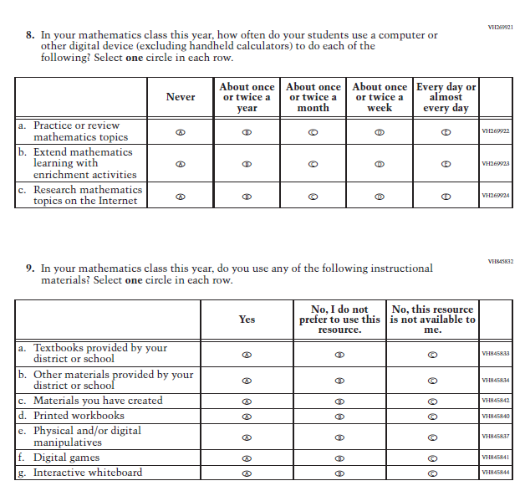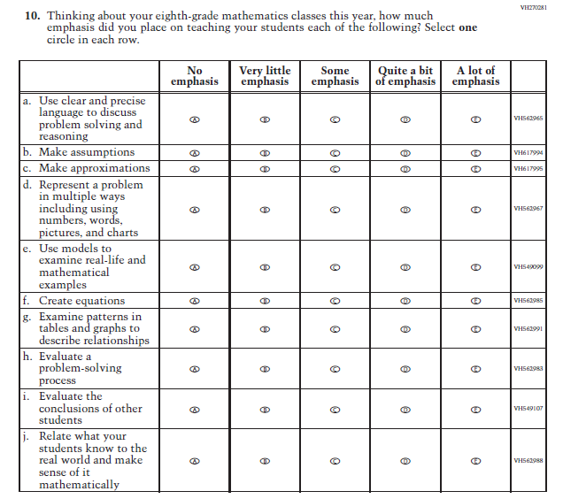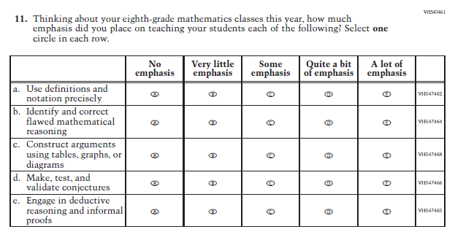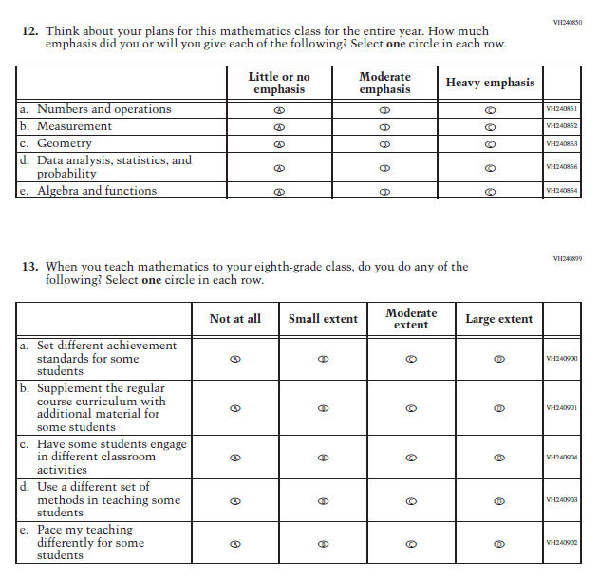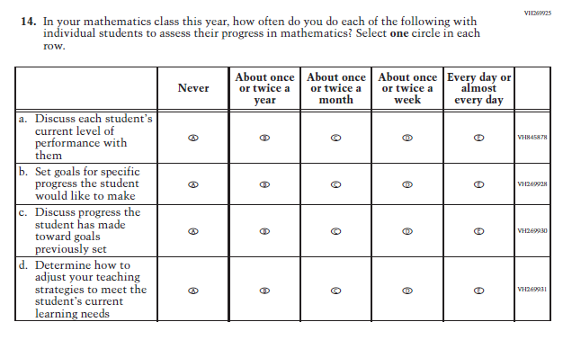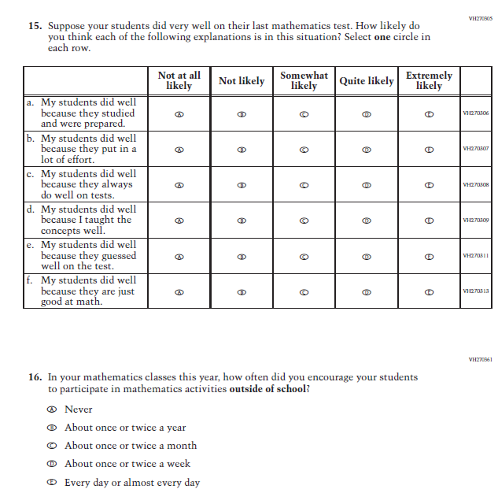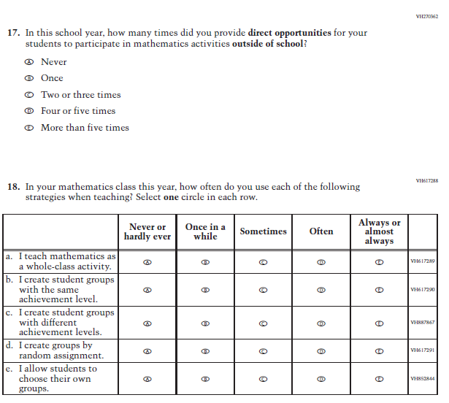

Appendix J2-9: Summary of Changes Operational Grade 4 Reading
2022 Operational Grade 4 Reading Teacher

Previous item | 2022 item | D/A/ R/NC+ | Rationale
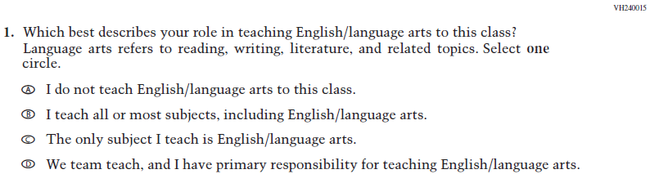  (2021 Grade 4) | Issue: Resources for Learning and Instruction | NC | N/A
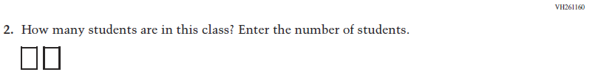  (2021 Grade 4) | Issue: Resources for Learning and Instruction | NC | N/A
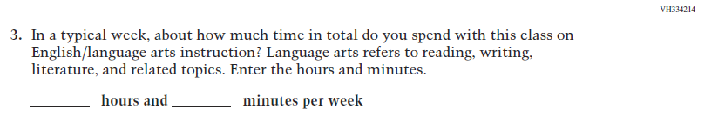  (2021 Grade 4) | Issue: Resources for Learning and Instruction | NC | N/A
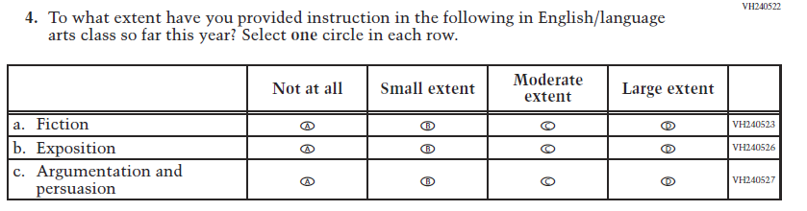  (2021 Grade 4) | Issue: Organization of Instruction | NC | N/A

2022 Operational Grade 4 Reading Teacher

Previous item | 2022 item | D/A/ R/NC+ | Rationale
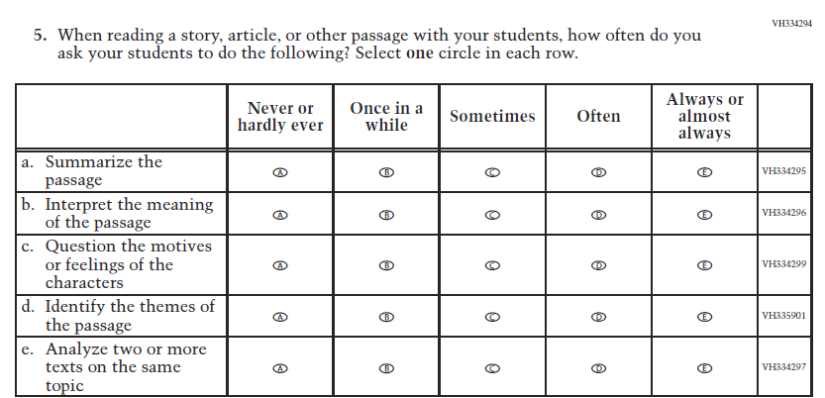  (2021 Grade 4) | Issue: Organization of Instruction | NC | N/A
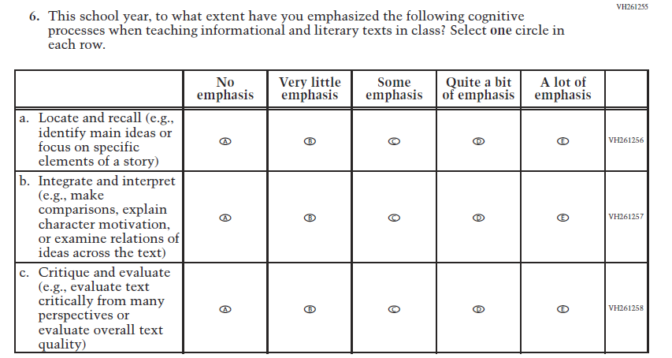  (2021 Grade 4) | Issue: Organization of Instruction | NC | N/A

2022 Operational Grade 4 Reading Teacher

Previous item | 2022 item | D/A/ R/NC+ | Rationale
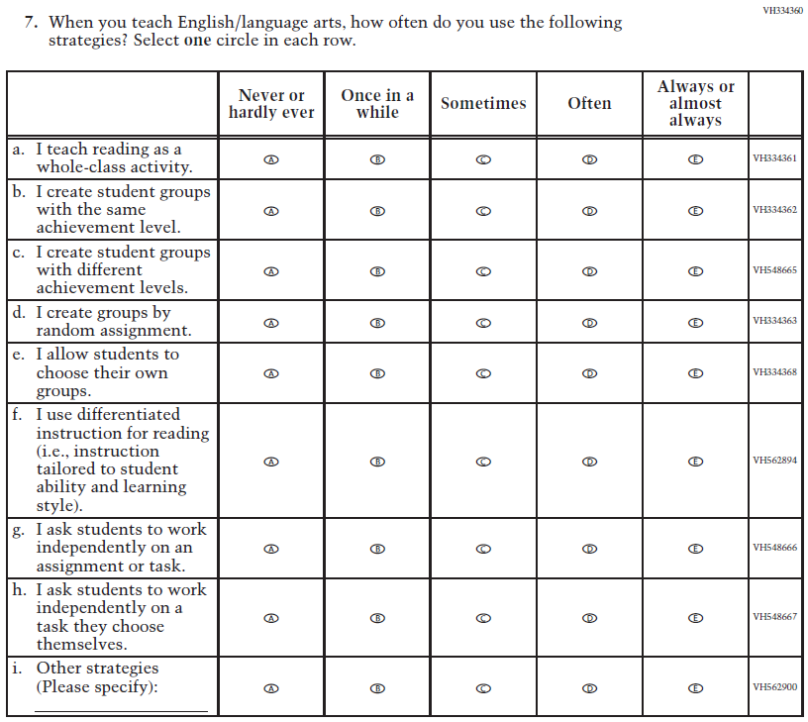  (2021 Grade 4) | Issue: Organization of Instruction | NC | N/A

2022 Operational Grade 4 Reading Teacher

Previous item | 2022 item | D/A/ R/NC+ | Rationale
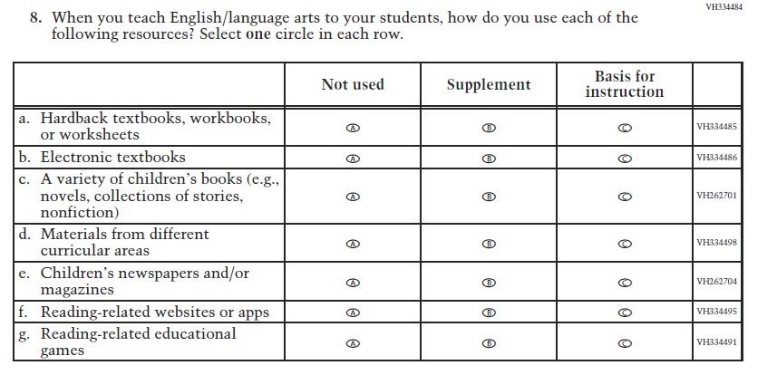  (2021 Grade 4) | Issue: Organization of Instruction | NC | N/A
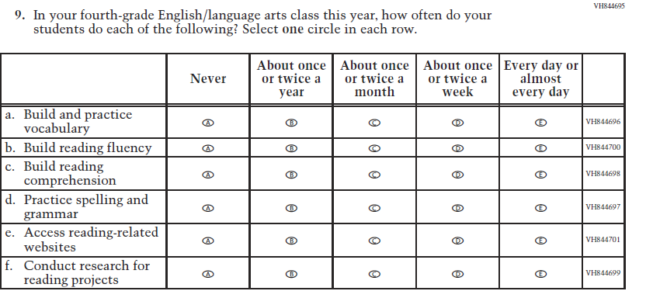  (2021 Grade 4) | Issue: Organization of Instruction | NC | N/A

2022 Operational Grade 4 Reading Teacher

Previous item | 2022 item | D/A/ R/NC+ | Rationale
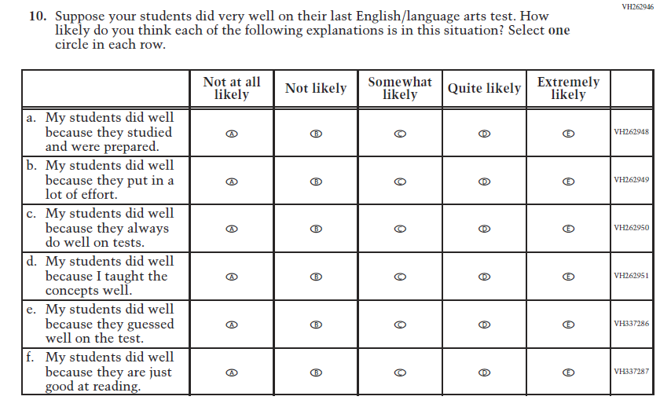  (2021 Grade 4) | Issue: Teacher Preparation | NC | N/A
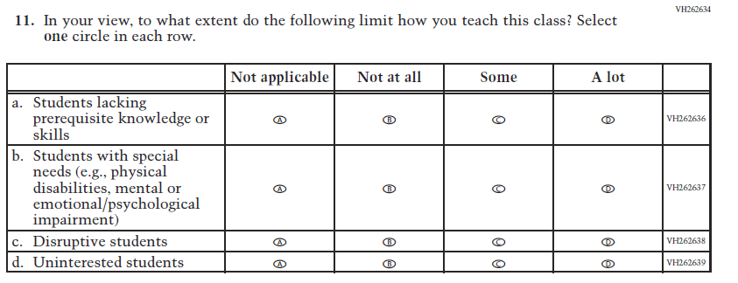  (2021 Grade 4) | Issue: Resources for Learning and Instruction | NC | N/A

Appendix J2-10: Operational Grade 4 Reading
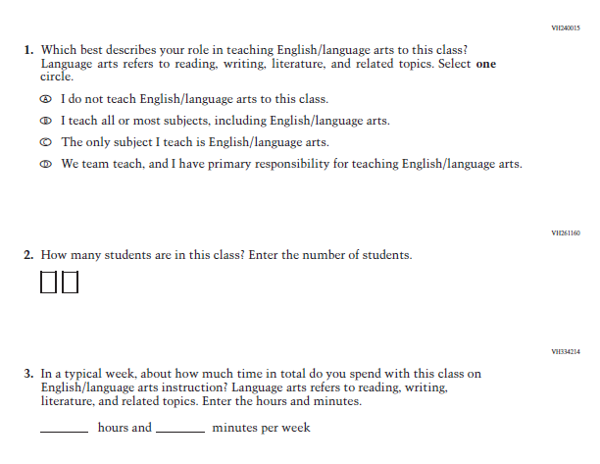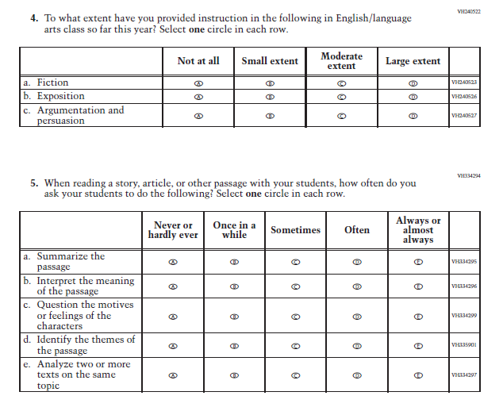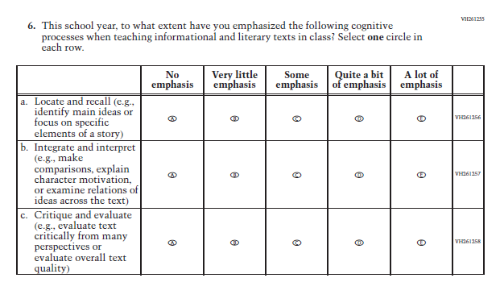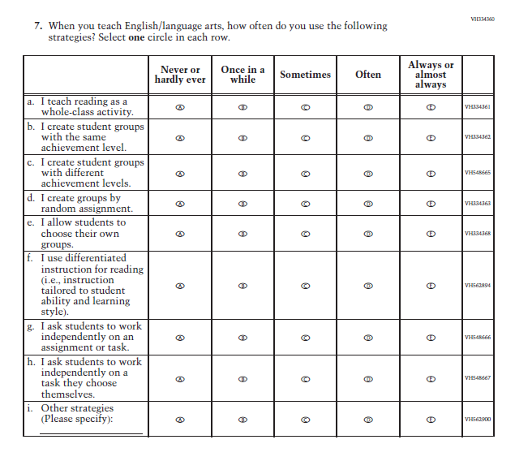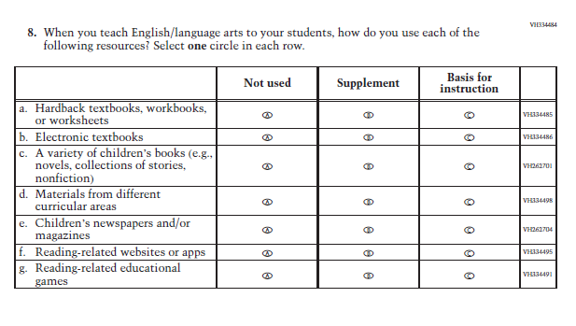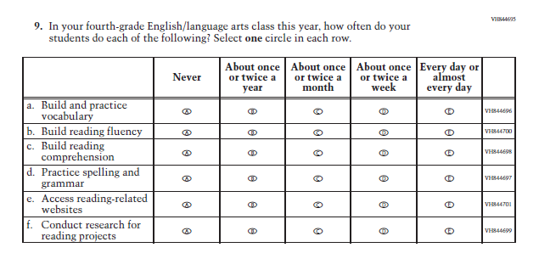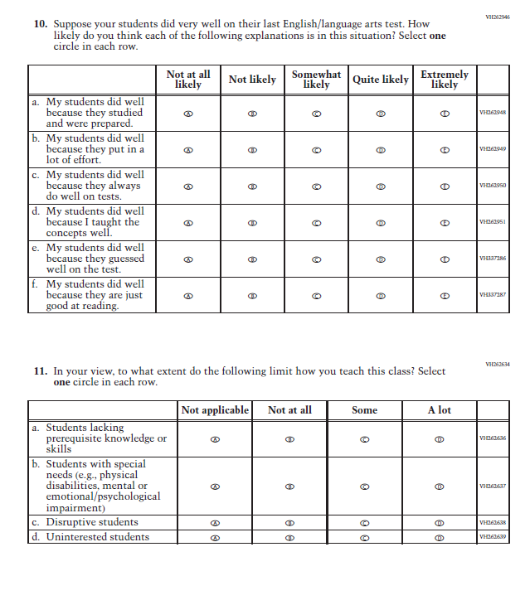

Appendix J2-11: Summary of Changes Operational Grade 8 Reading
2022 Operational Grade 8 Reading Teacher

Previous item | 2022 item | D/A/ R/NC+ | Rationale
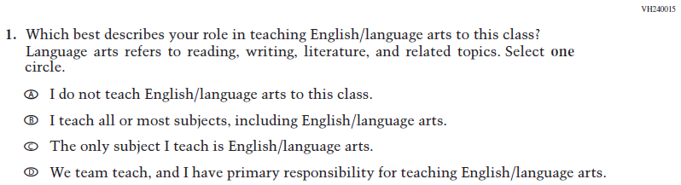  (2021 Grade 8) | Issue: Resources for Learning and Instruction | NC | N/A
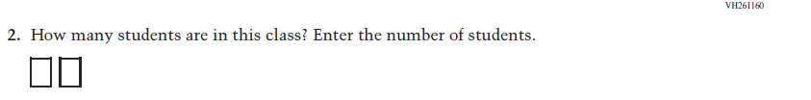  (2021 Grade 8) | Issue: Resources for Learning and Instruction | NC | N/A
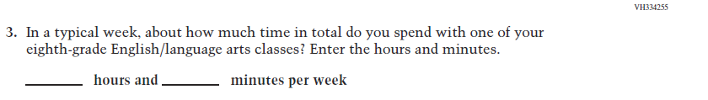  (2021 Grade 8) | Issue: Resources for Learning and Instruction | NC | N/A
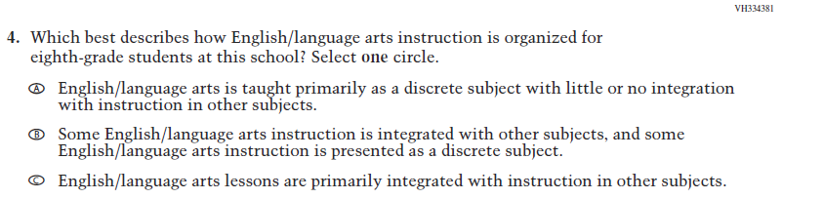  (2021 Grade 8) | Issue: Organization of Instruction | NC | N/A

2022 Operational Grade 8 Reading Teacher

Previous item | 2022 item | D/A/ R/NC+ | Rationale
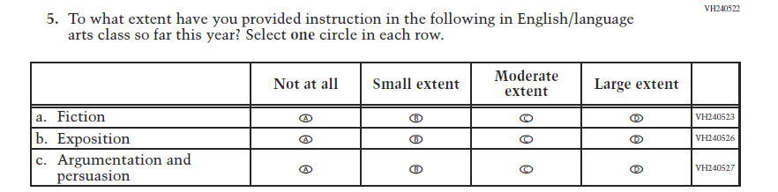  (2021 Grade 8) | Issue: Organization of Instruction | NC | N/A
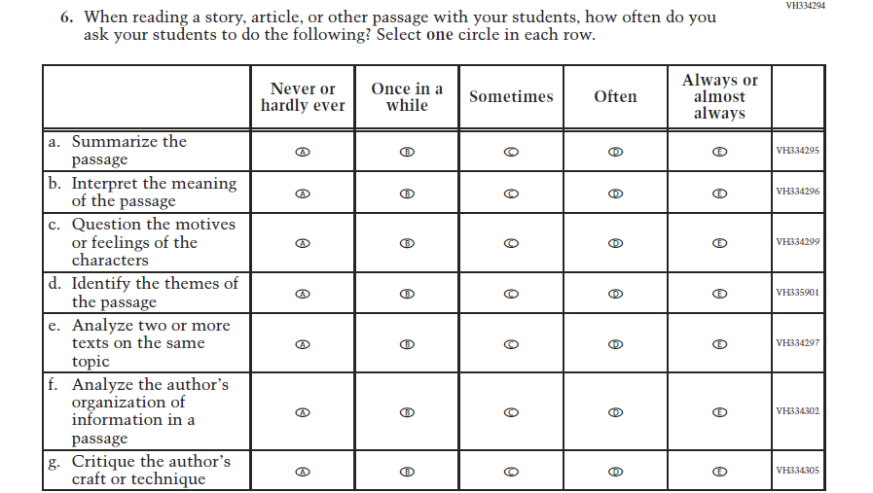  (2021 Grade 8) | Issue: Organization of Instruction | NC | N/A

2022 Operational Grade 8 Reading Teacher

Previous item | 2022 item | D/A/ R/NC+ | Rationale
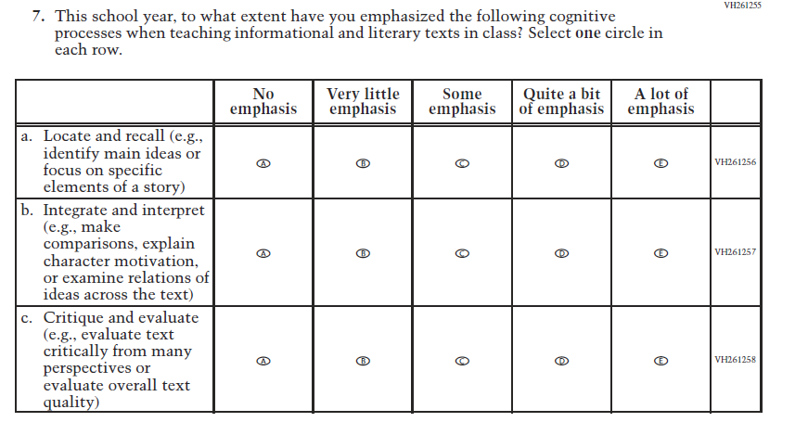  (2021 Grade 8) | Issue: Organization of Instruction | NC | N/A
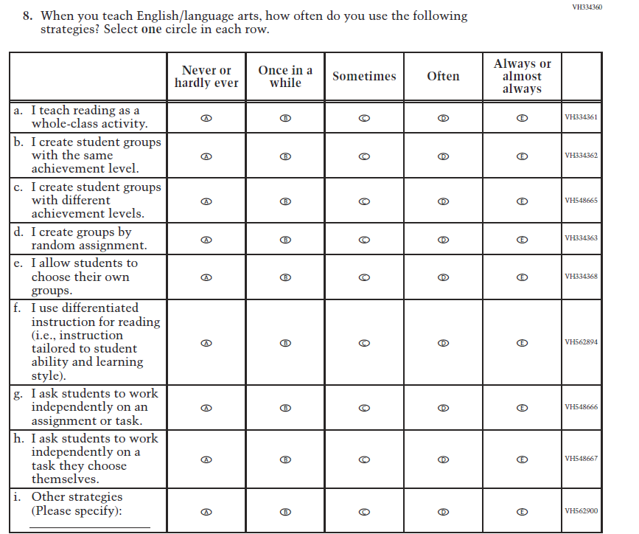  (2021 Grade 8) | Issue: Organization of Instruction | NC | N/A

2022 Operational Grade 8 Reading Teacher

Previous item | 2022 item | D/A/ R/NC+ | Rationale
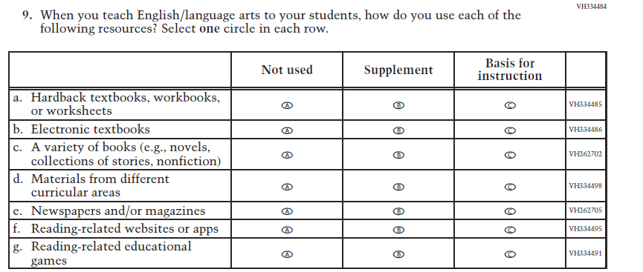  (2021 Grade 8) | Issue: Organization of Instruction | NC | N/A
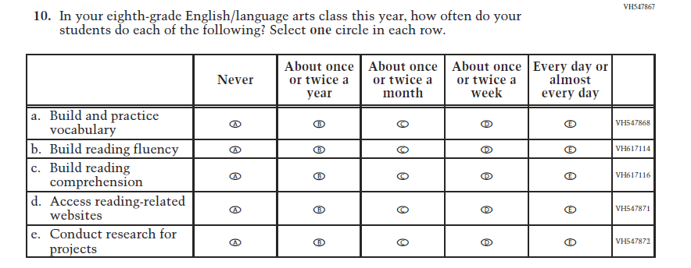  (2021 Grade 8) | Issue: Organization of Instruction | NC | N/A

2022 Operational Grade 8 Reading Teacher

Previous item | 2022 item | D/A/ R/NC+ | Rationale
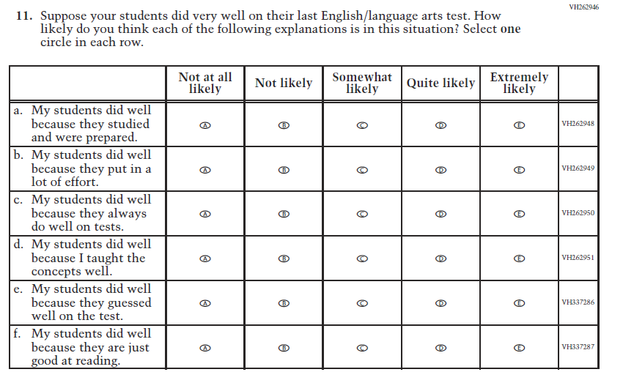  (2021 Grade 8) | Issue: Teacher Preparation | NC | N/A
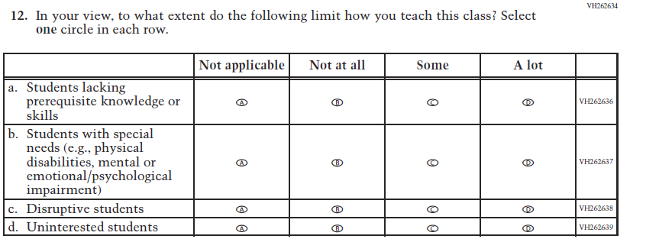  (2021 Grade 8) | Issue: Resources for Learning and Instruction | NC | N/A

Appendix J2-12: Operational Grade 8 Reading
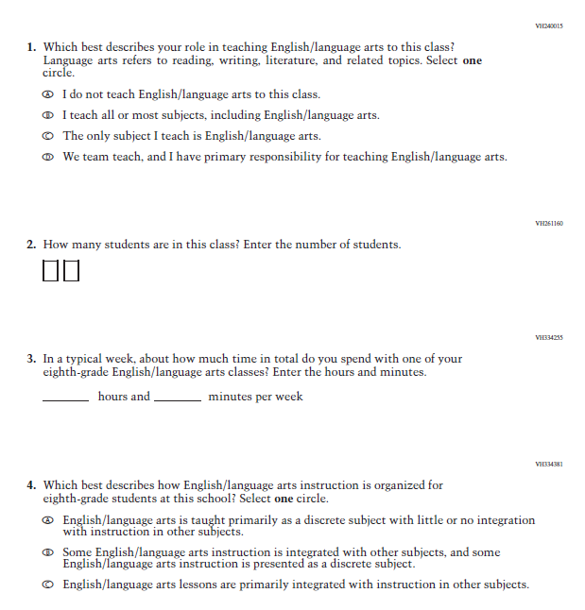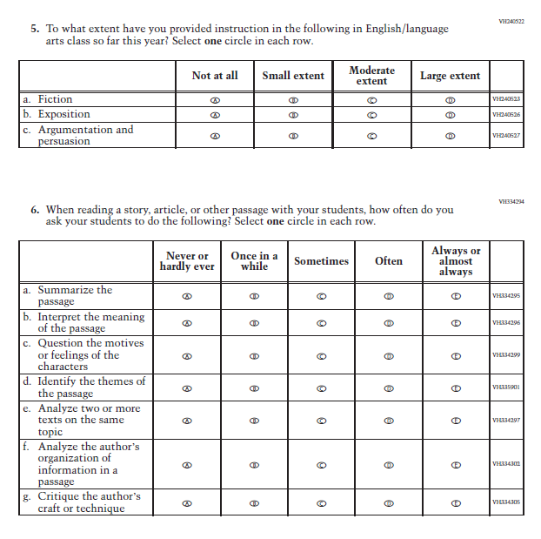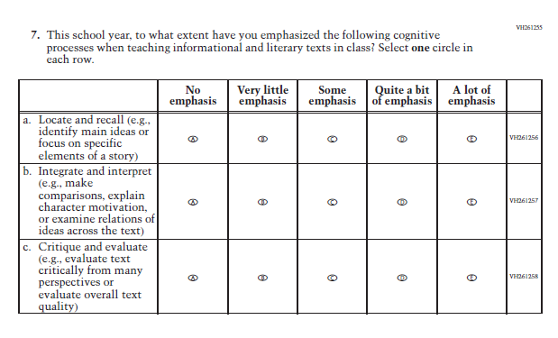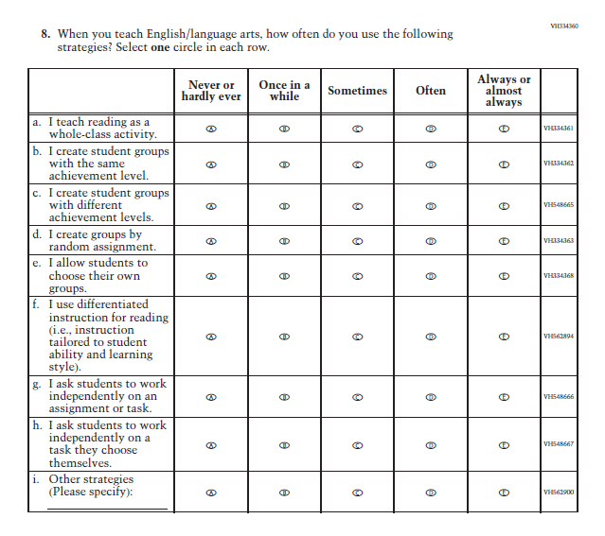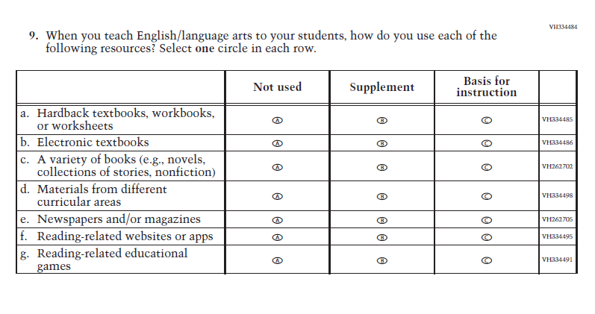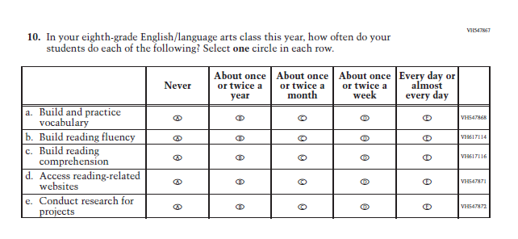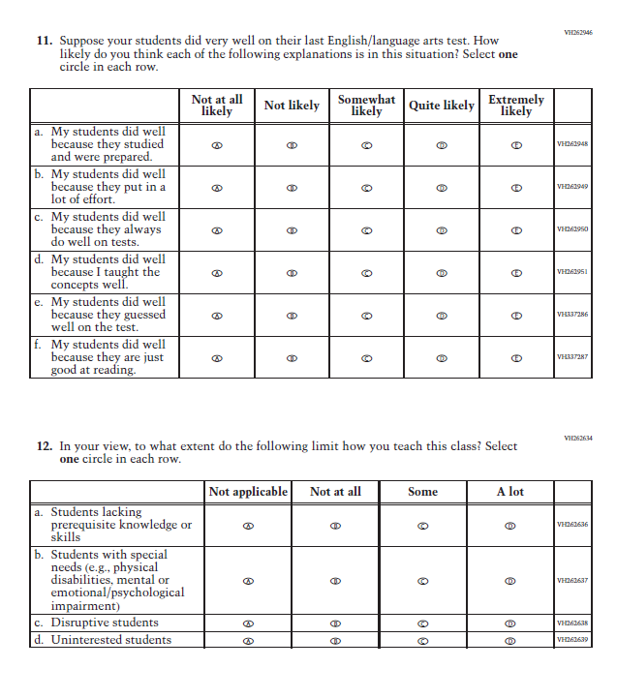

Appendix J2-13: Summary of Changes Operational Grade 8 Social Studies
2022 Operational Grade 8 Social Studies Teacher
Previous item | 2022 item | D/A/ R/NC+ | Rationale
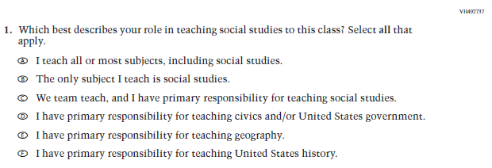  (2018 Grade 8) | Issue: Resources for Learning and Instruction | NC | N/A
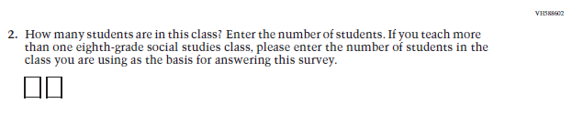  (2018 Grade 8) | Issue: Resources for Learning and Instruction | NC | N/A
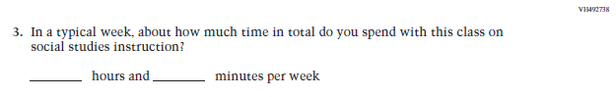  (2018 Grade 8) | Issue: Resources for Learning and Instruction | NC | N/A
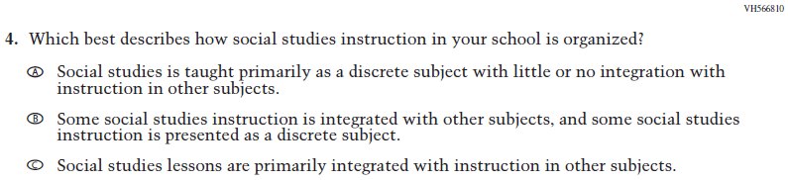  (2018 Grade 8) | Issue: Organization of Instruction | NC | N/A
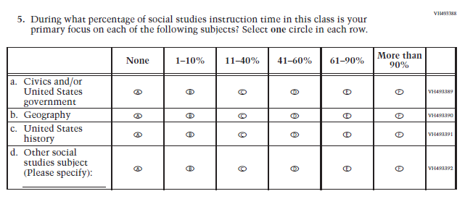  (2018 Grade 8) | Issue: Resources for Learning and Instruction | NC | N/A
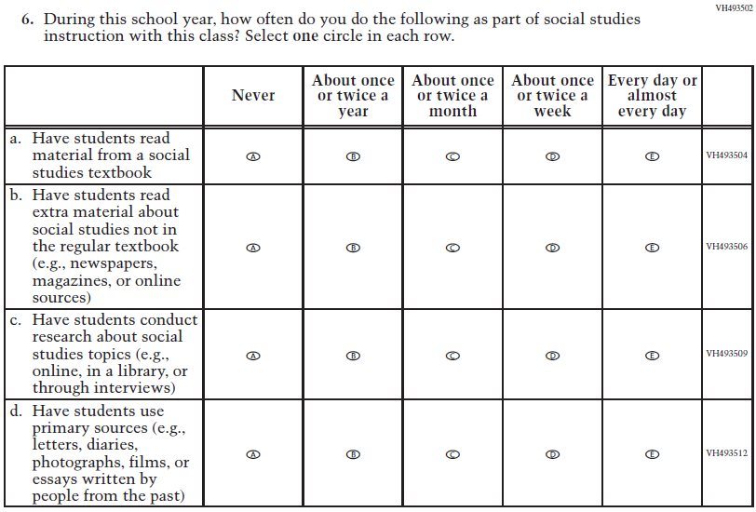  (2018 Grade 8) | Issue: Organization of Instruction | NC | N/A
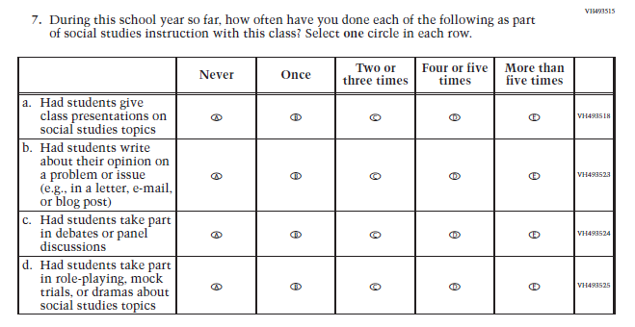  (2018 Grade 8) | Issue: Organization of Instruction | NC | N/A
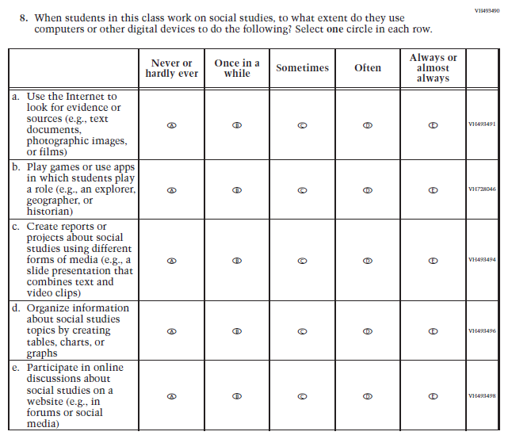  (2018 Grade 8) | Issue: Organization of Instruction | NC | N/A
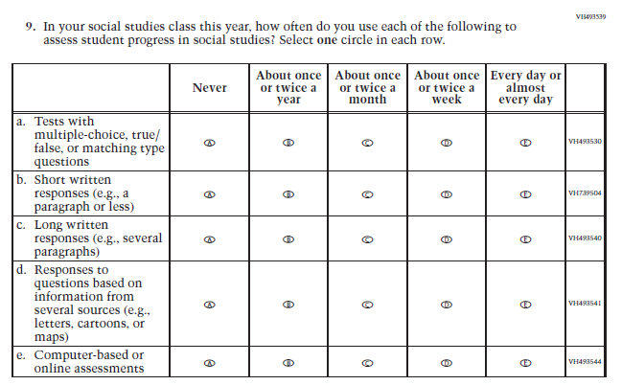  (2018 Grade 8) | Issue: Organization of Instruction | NC | N/A
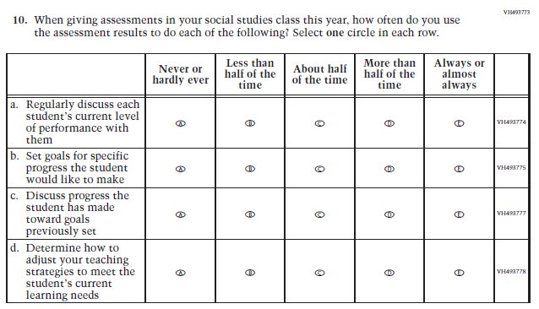  (2018 Grade 8) | Issue: Organization of Instruction | NC | N/A
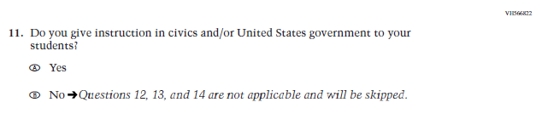  (2018 Grade 8) | 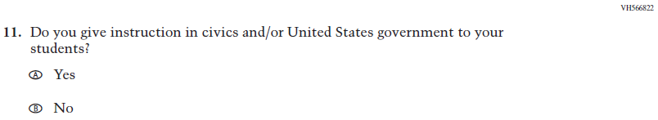  Issue: Organization of Instruction | NC | Please note skip pattern directions have been removed given the transition from PPT to DBA.
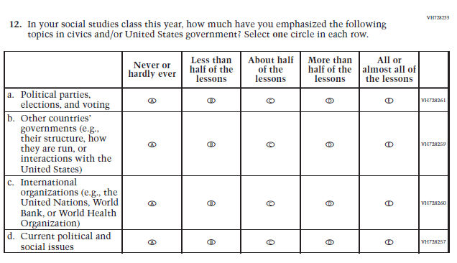  (2018 Grade 8) | Issue: Organization of Instruction | NC | N/A
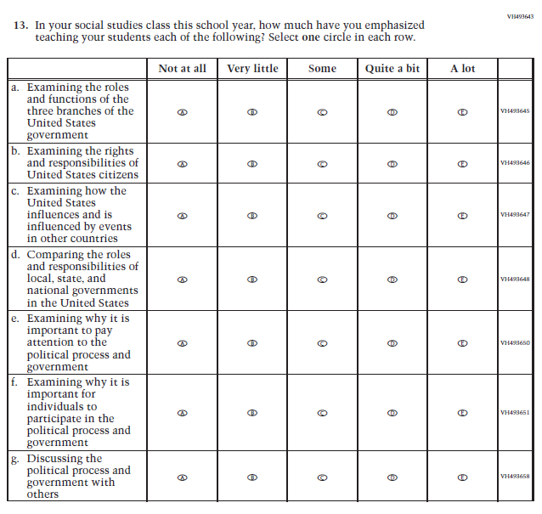  (2018 Grade 8) | Issue: Organization of Instruction | NC | N/A
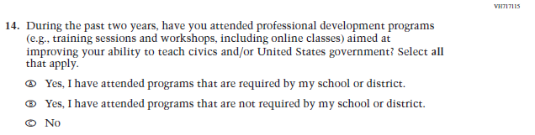  (2018 Grade 8) | Issue: Teacher Preparation | NC | N/A
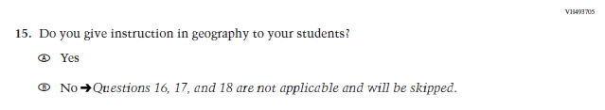  (2018 Grade 8) | N/A | D | The item was dropped because geography will not be administered in 2022.
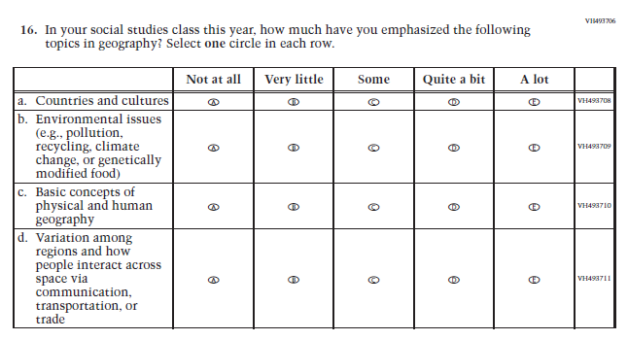  (2018 Grade 8) | N/A | D | The item was dropped because geography will not be administered in 2022.
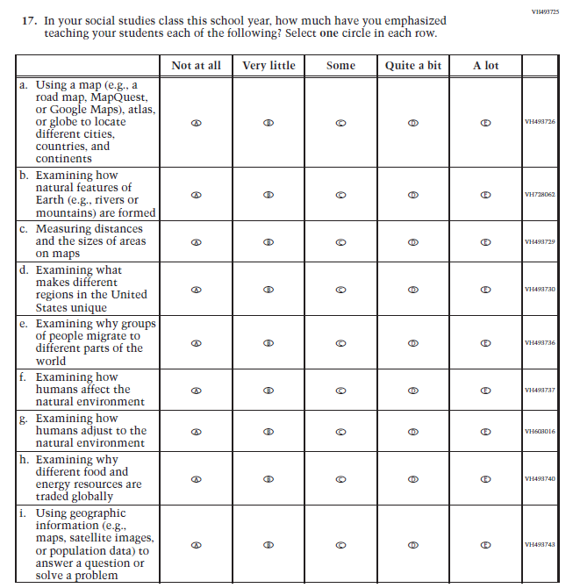  (2018 Grade 8) | N/A | D | The item was dropped because geography will not be administered in 2022.
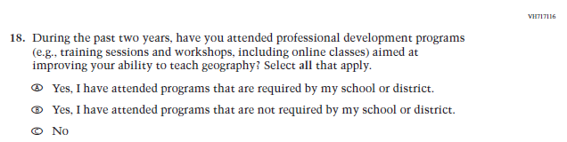  (2018 Grade 8) | N/A | D | The item was dropped because geography will not be administered in 2022.
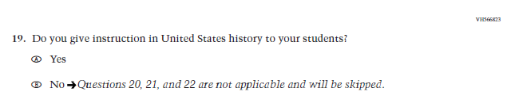  (2018 Grade 8) | 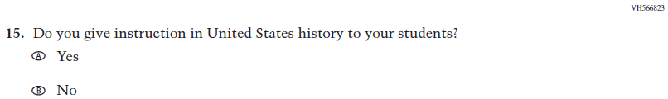  Issue: Organization of Instruction | NC | Please note skip pattern directions have been removed given the transition from PPT to DBA.
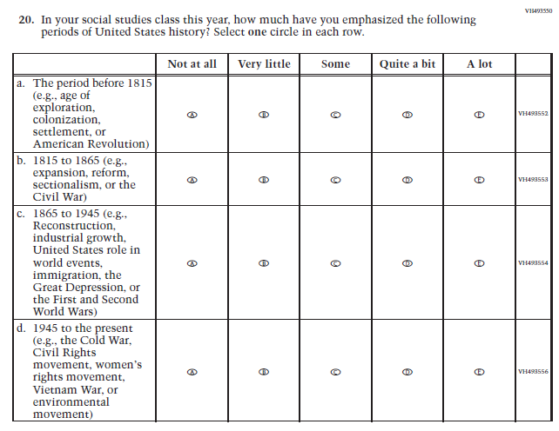  (2018 Grade 8) | 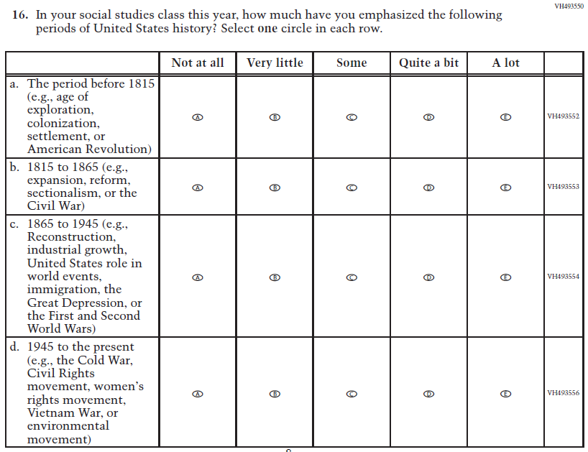  Issue: Organization of Instruction | NC | N/A
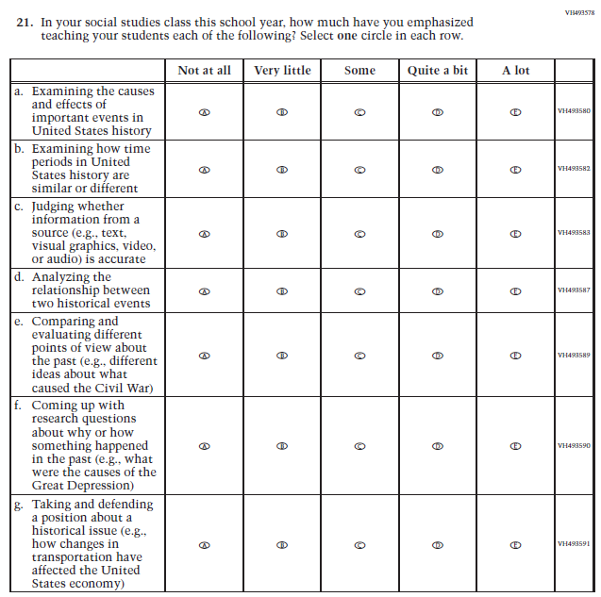  (2018 Grade 8) | 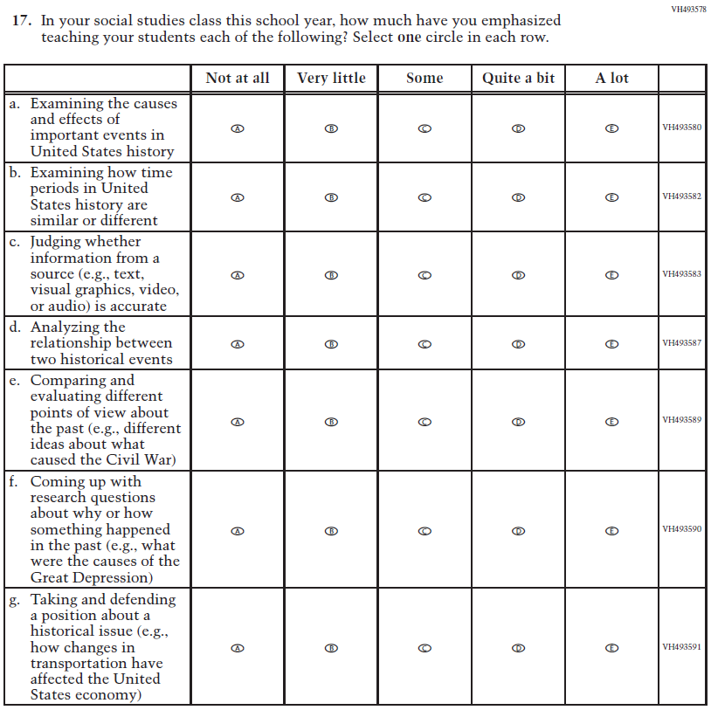  Issue: Organization of Instruction | NC | N/A
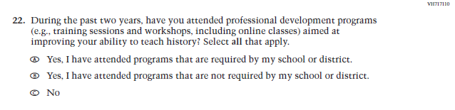  (2018 Grade 8) | 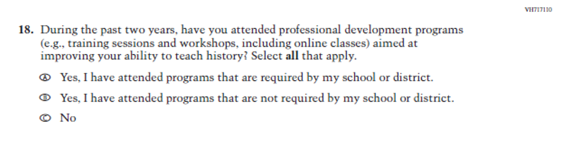Issue: Teacher Preparation | NC | N/A
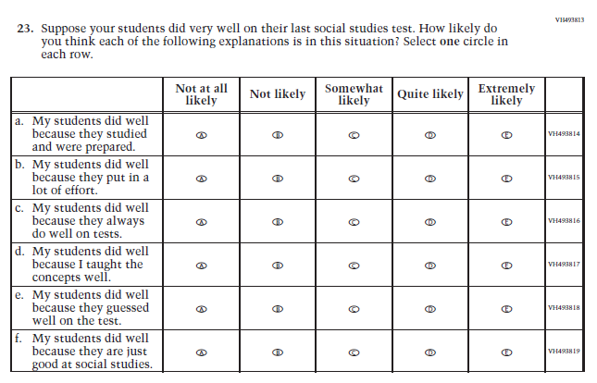  (2018 Grade 8) | 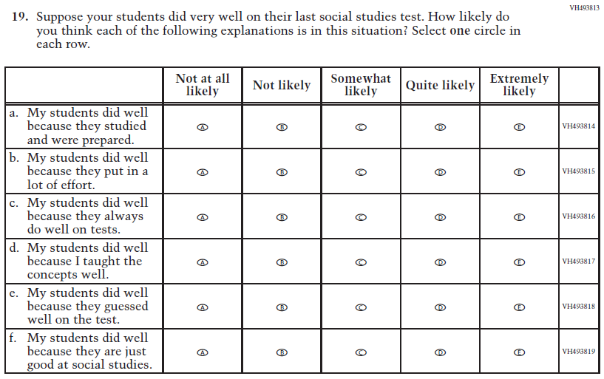  Issue: Teacher Preparation | NC | N/A

Appendix J2-14: Operational Grade 8 Social Studies
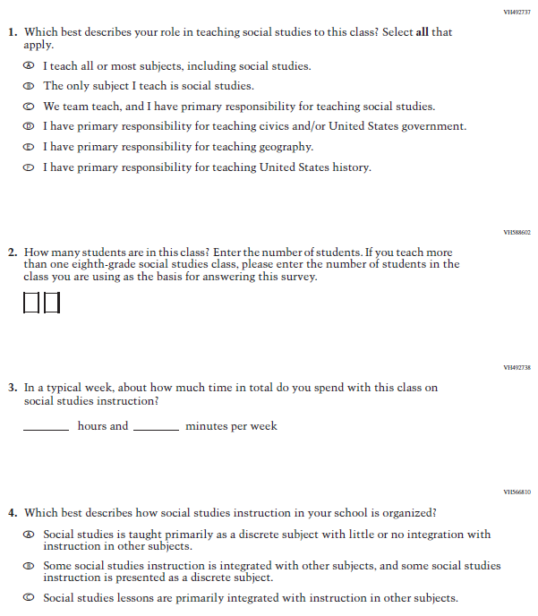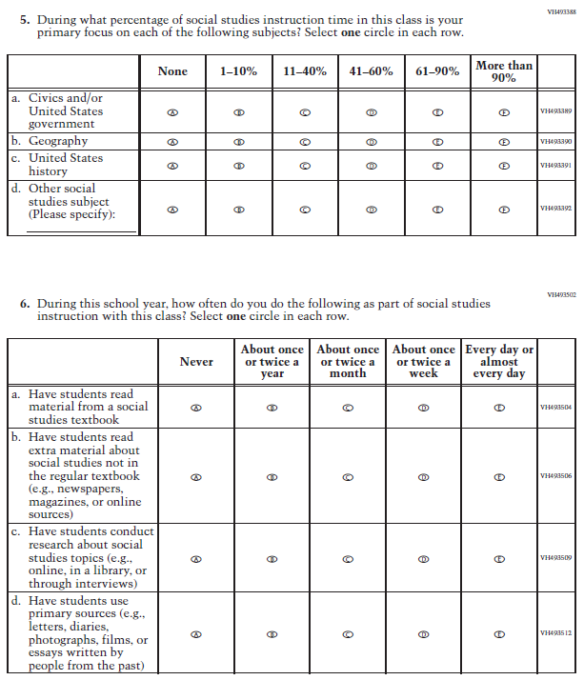
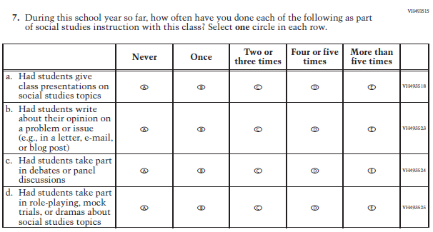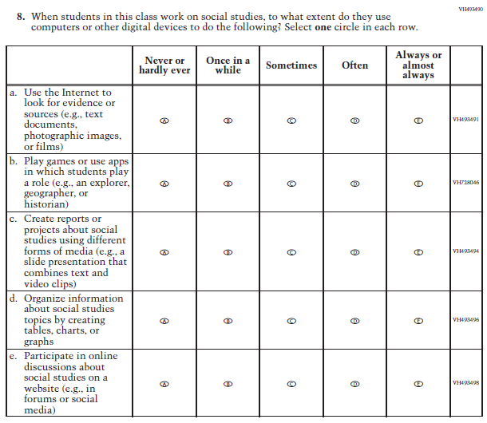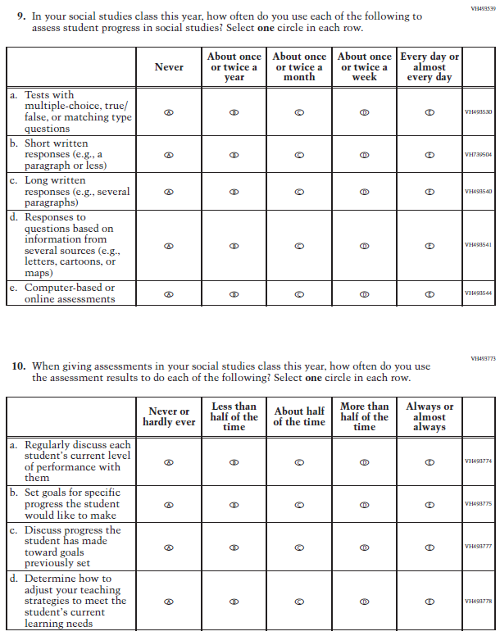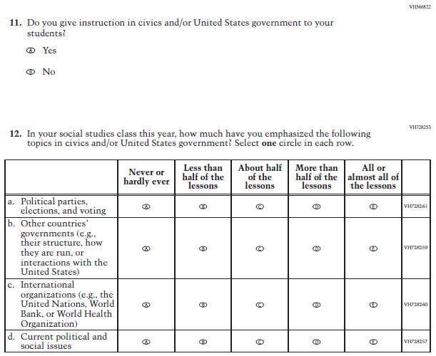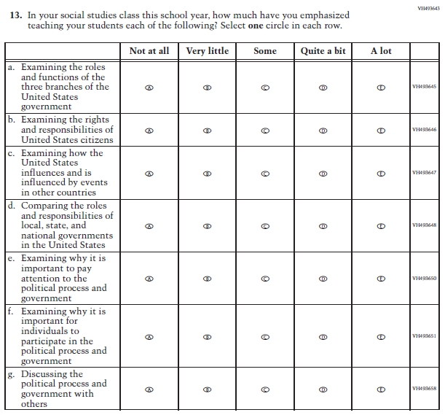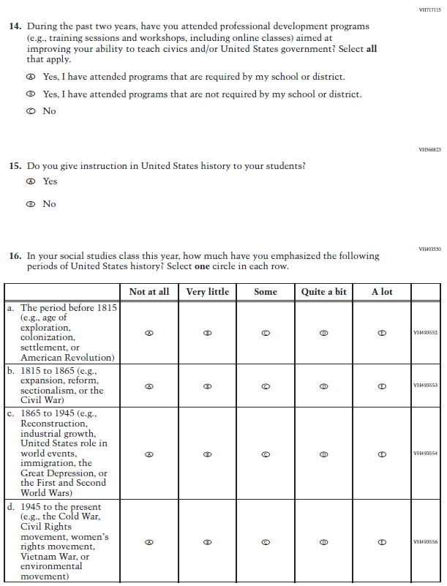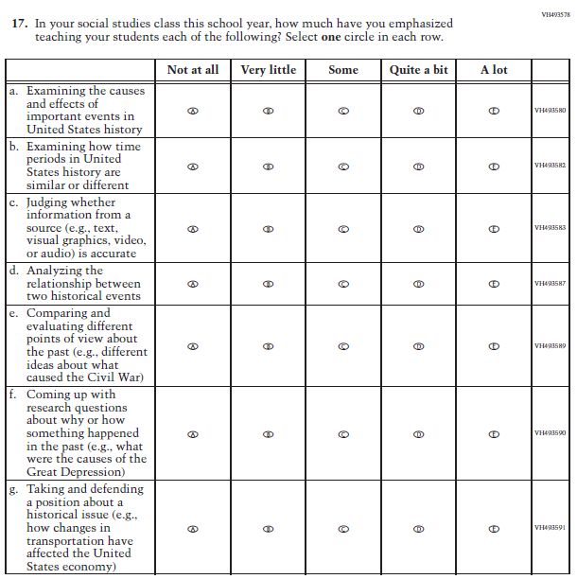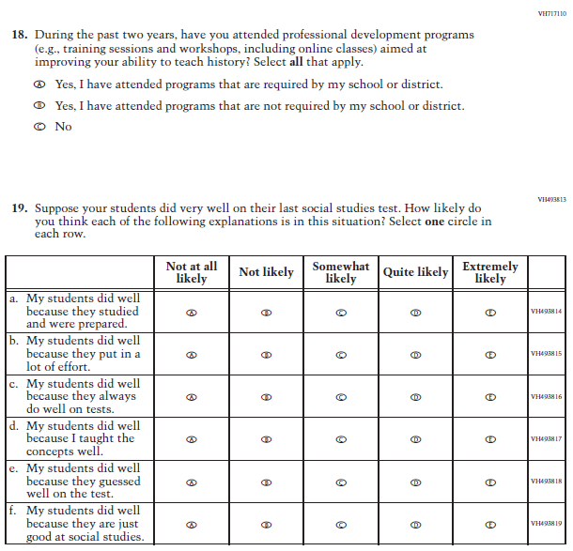

Appendix J2-15: Summary of Operational Grade 4 COVID-19
2022 Operational Grade 4 COVID-19 Teacher Items
Previous item | 2022 item | D/A/R/NC+ | Rationale
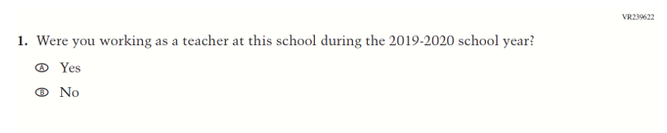  (2021 Grade 4) | 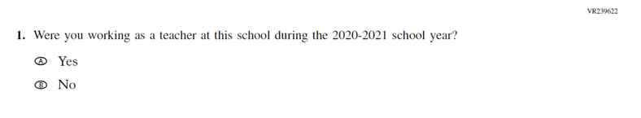  Issue: Organization of Instruction | R | This item has been updated to reference the correct academic year for the 2022 administration.
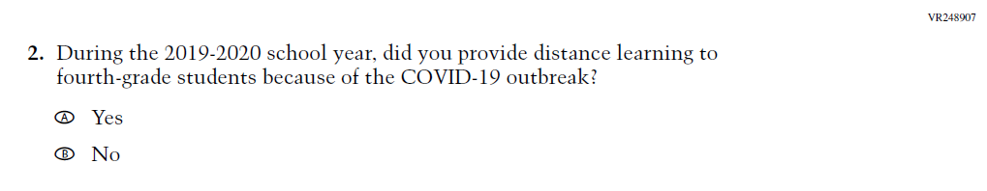  (2021 Grade 4) | 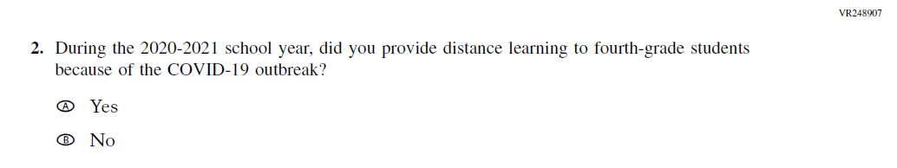  Issue: Organization of Instruction | R | This item has been updated to reference the correct academic year for the 2022 administration.

2022 Operational Grade 4 COVID-19 Teacher Items
Previous item | 2022 item | D/A/R/NC+ | Rationale
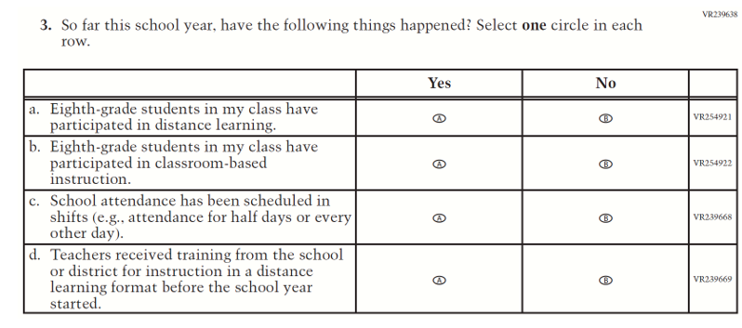  (2021 Grade 4) | Issue: Organization of Instruction | NC | N/A
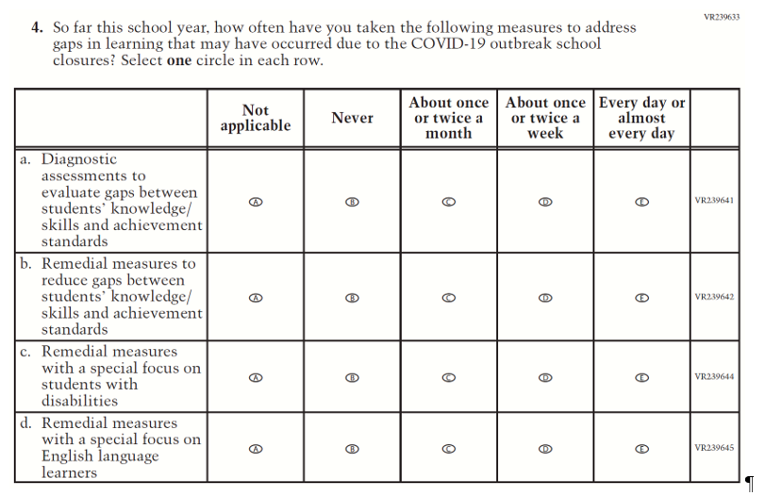  (2021 Grade 4) | Issue: Organization of Instruction | NC | N/A

2022 Operational Grade 4 COVID-19 Teacher Items
Previous item | 2022 item | D/A/R/NC+ | Rationale
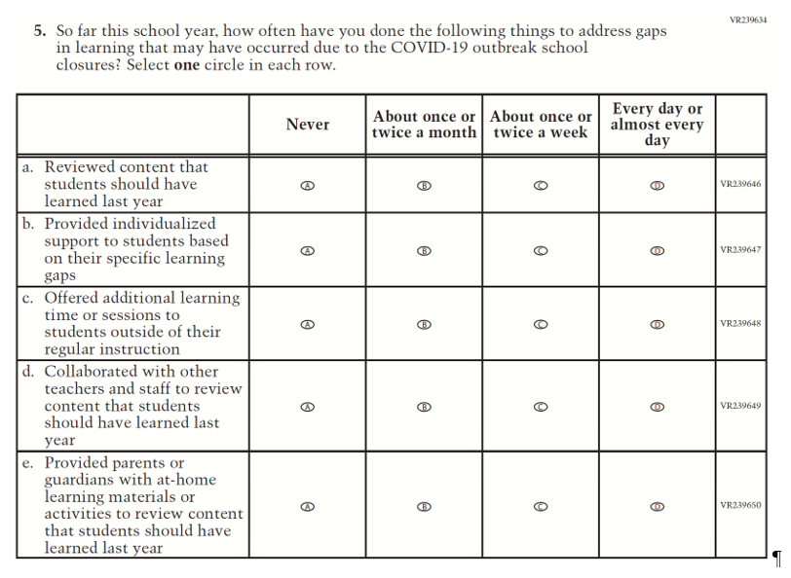  (2021 Grade 4) | Issue: Organization of Instruction | NC | N/A
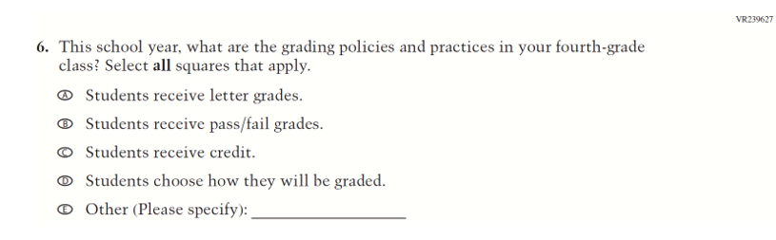  (2021 Grade 4) | Issue: Organization of Instruction | NC | N/A

2022 Operational Grade 4 COVID-19 Teacher Items
Previous item | 2022 item | D/A/R/NC+ | Rationale
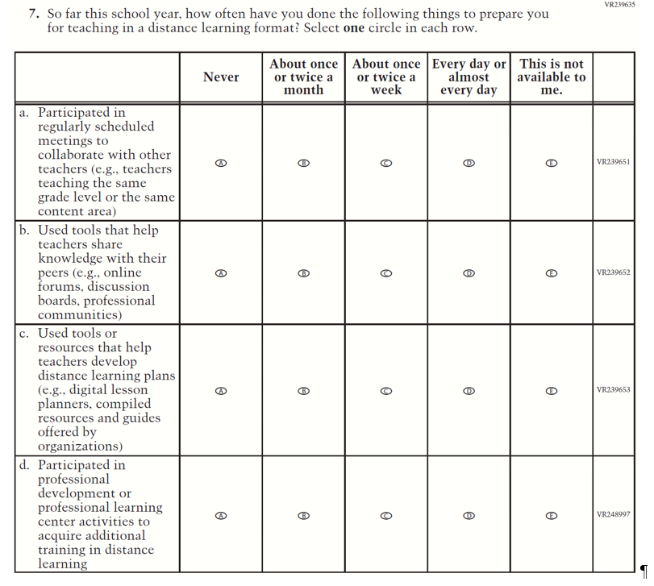  (2021 Grade 4) | Issue: Teacher Preparation | NC | N/A
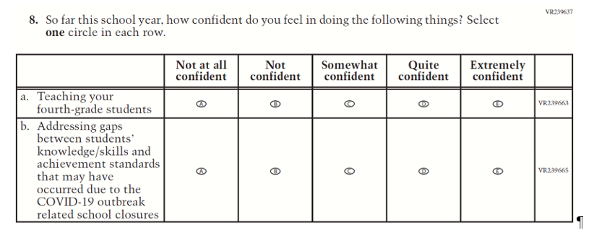  (2021 Grade 4) | Issue: Self-efficacy | NC | N/A

2022 Operational Grade 4 COVID-19 Teacher Items
Previous item | 2022 item | D/A/R/NC+ | Rationale
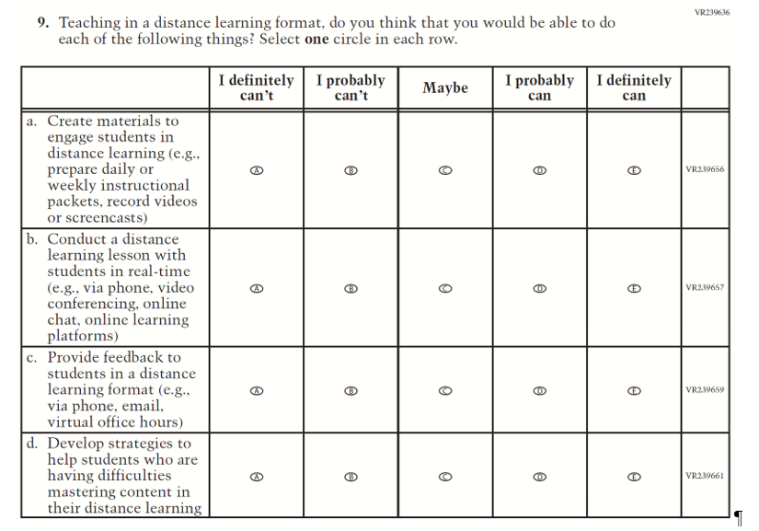  (2021 Grade 4) | Issue: Self-efficacy | NC | N/A

Appendix J2-16: Operational Grade 4 COVID-19
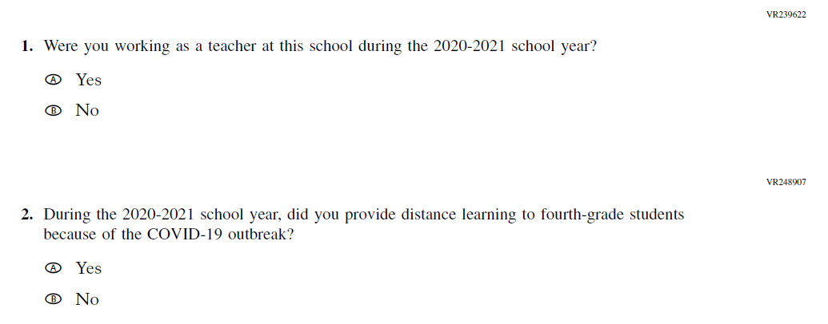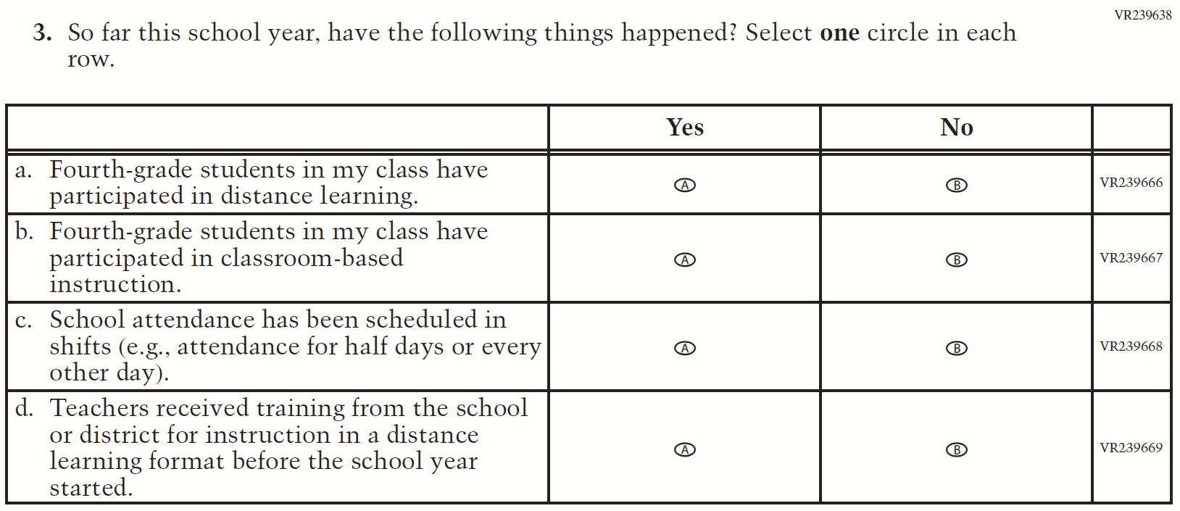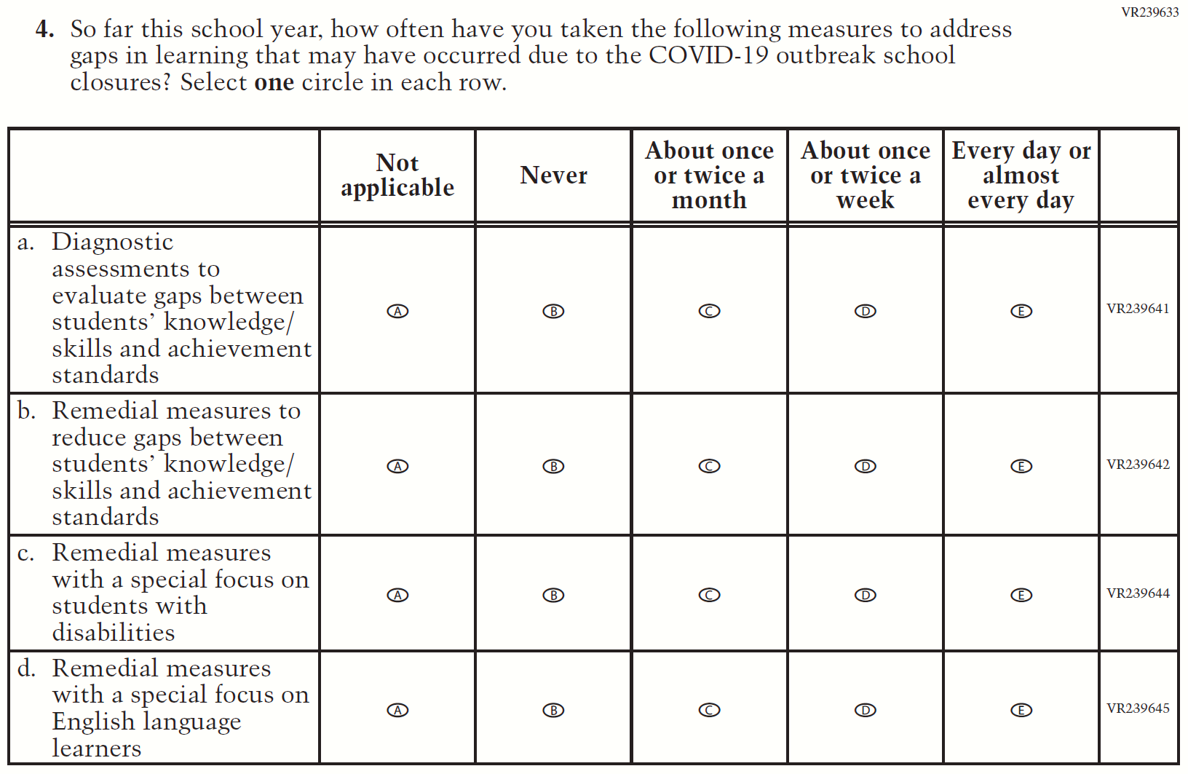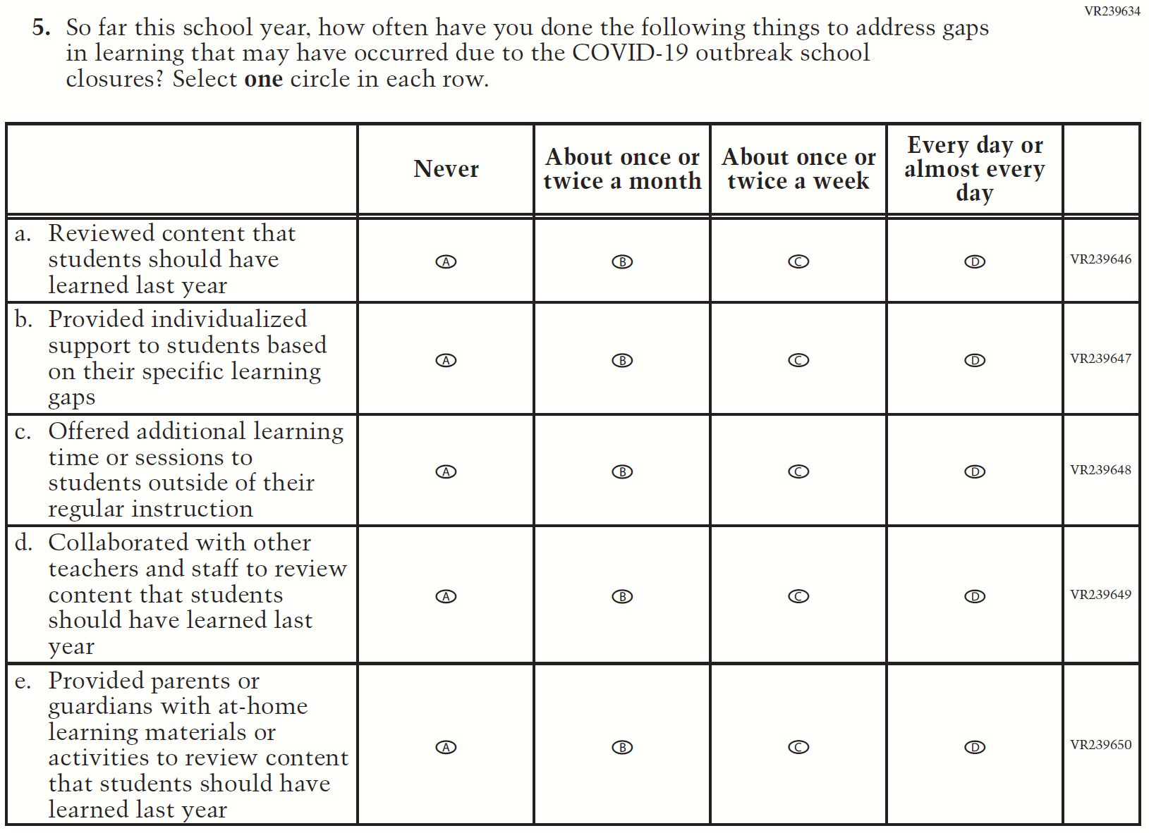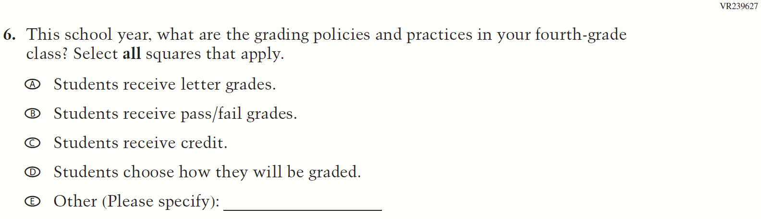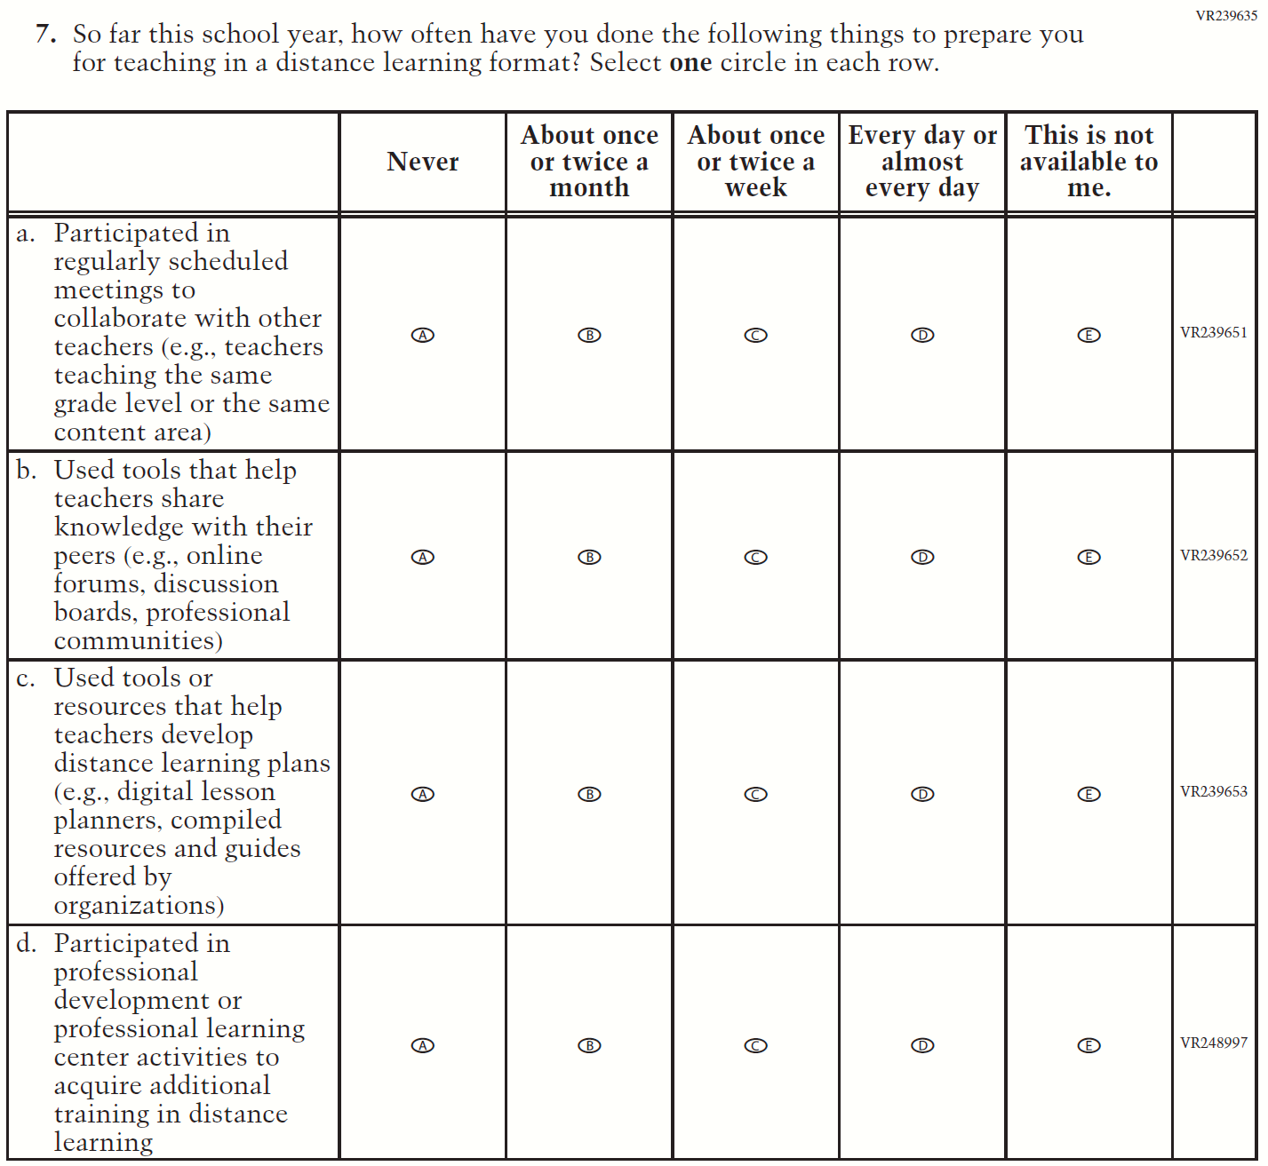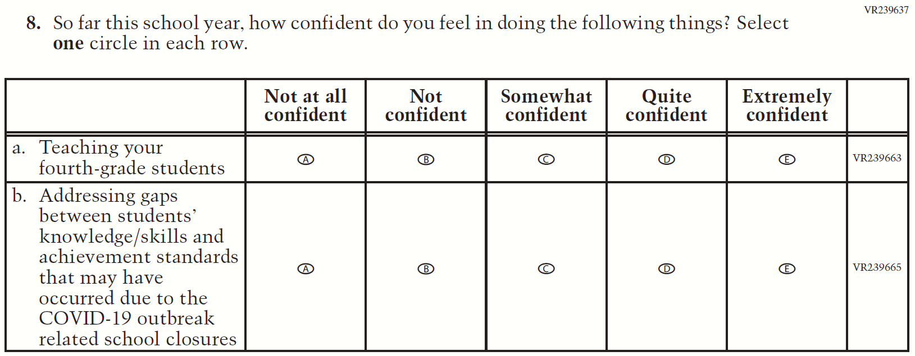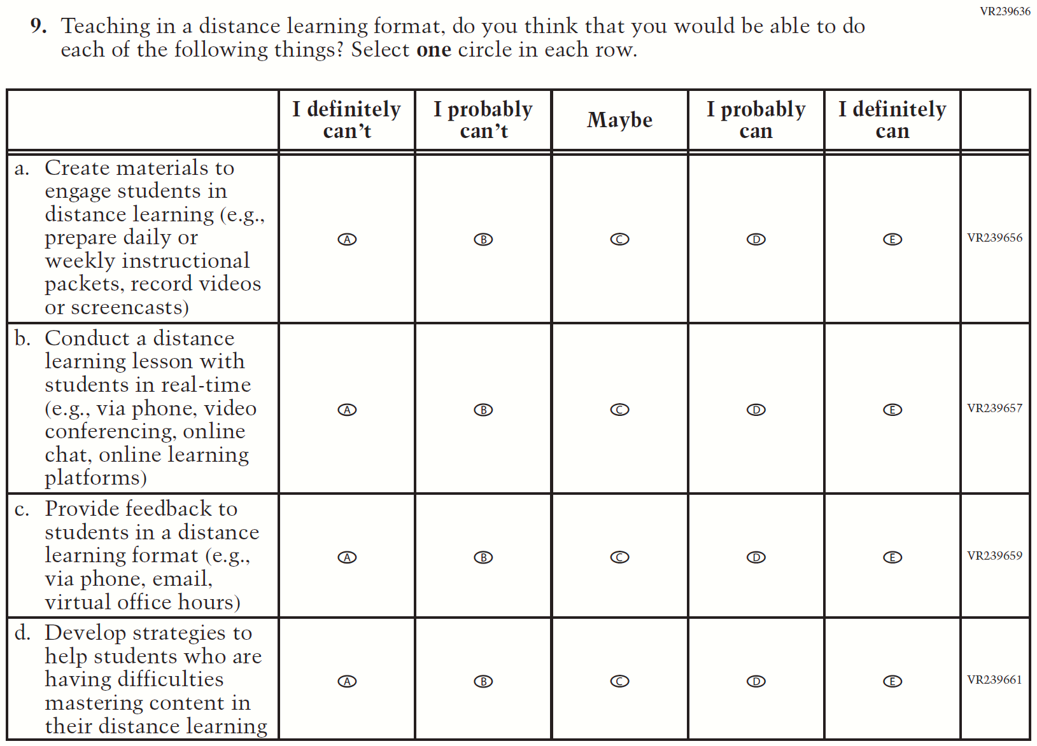

Appendix J2-17: Summary of Operational Grade 8 COVID-19
2022 Operational Grade 8 COVID-19 Teacher Items
Previous item | 2022 item | D/A/R/NC+ | Rationale
(2021 Grade 8) | Issue: Organization of Instruction | R | This item has been updated to reference the correct academic year for the 2022 administration.
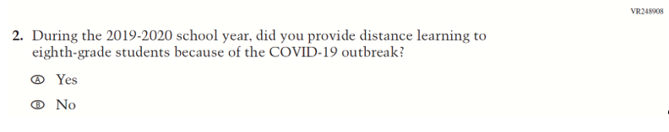  (2021 Grade 8) | 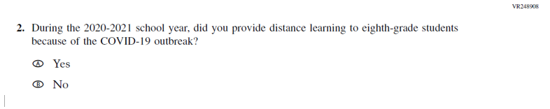  Issue: Organization of Instruction | R | This item has been updated to reference the correct academic year for the 2022 administration.

2022 Operational Grade 8 COVID-19 Teacher Items
Previous item | 2022 item | D/A/R/NC+ | Rationale
(2021 Grade 8) | Issue: Organization of Instruction | NC | N/A
(2021 Grade 8) | Issue: Organization of Instruction | NC | N/A

2022 Operational Grade 8 COVID-19 Teacher Items
Previous item | 2022 item | D/A/R/NC+ | Rationale
(2021 Grade 8) | Issue: Organization of Instruction | NC | N/A
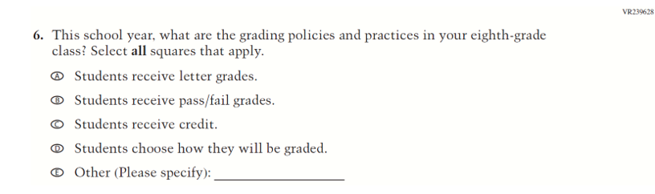  (2021 Grade 8) | Issue: Organization of Instruction | NC | N/A

2022 Operational Grade 8 COVID-19 Teacher Items
Previous item | 2022 item | D/A/R/NC+ | Rationale
(2021 Grade 8) | Issue: Teacher Preparation | NC | N/A
(2021 Grade 8) | Issue: Self-efficacy | NC | N/A

2022 Operational Grade 8 COVID-19 Teacher Items
Previous item | 2022 item | D/A/R/NC+ | Rationale
(2021 Grade 8) | Issue: Self-efficacy | NC | N/A

Appendix J2-18: Operational Grade 8 COVID-19
