Project evaluation
OMB Control Number: 1028-NEW
Expiration Date: xxxx

The Paperwork Reduction Act of 1995 (44 U.S.C. 3501), states that an agency may not conduct or sponsor, and you are not required to respond to a collection of information unless it displays a currently valid OMB control number and expiration date. Response to this survey is voluntary and expected to take 27 minutes to complete.You may submit comments on any aspect of this collection. Please note that comments submitted in response to this collection are public record. Comments on this collection should be sent to the Clearance Office at gs-info_collections@usgs.gov.

Angler Participation Study Survey (Pre-survey Postcard)

Dear Colorado River Angler:

The National Park Service has requested that Arizona State University gather information from people who have fished the stretch of the Colorado River from the base of Glen Canyon Dam downstream to just below Lees Ferry within the past 18 months. Your name was randomly selected from a list of people who recently completed an Arizona Game and Fish Department creel survey. Within the next week or two, you will receive a letter in the mail from Arizona State University. The letter contains a link to an online survey. The information collected will be used to understand participation in the Lees Ferry fishery and in the National Park Service’s Brown Trout Incentivized Harvest Program.

Only a select number of people are being asked to take part in this study, so your participation is very important. Once you receive the letter, we will ask that you partake in the online survey as soon as possible. The survey should take about 25 minutes to complete. We are asking that you and everyone receiving a letter from us complete the online survey as soon as possible.

Thank you in advance for your help.

Sincerely,

Dr. Joshua Abbott, Principal Investigator
Arizona State University

OMB Control Number: 1028-XXXX
Expiration Date: XX/XX/XXXX

Angler Participation Study Survey (Initial Contact Letter)

Dear Colorado River Angler:

You are receiving this letter because within the last 18 months you completed an on-site creel survey conducted by the Arizona Game and Fish Department at the Colorado River below Glen Canyon Dam. You have been selected to participate in a study conducted by Arizona State University to understand participation in the Lees Ferry fishery and in the National Park Service’s Brown Trout Incentivized Harvest Program. Your responses to this survey will help fishery managers better understand their options for managing the Lees Ferry fishery.

Below you will find an url and a scannable QR code, either of which will take you to an online survey. We expect the survey will take about 25 minutes of your time, and those who complete and return this survey will be entered into a raffle for a $200 Cabela’s gift card. There are no known or anticipated risks to participating in this survey. All information you provide will remain confidential and will be grouped with the answers of others. Grouped results of this study may be published in professional journals and presented at conferences. Participation in this study is voluntary, and you may decline to answer or participate in any or all components of this study, should you wish. You cannot withdraw the information you provided once you have completed and returned the survey.

[insert url]

[inset QR code]

If you have any questions about the survey, please contact Dr. Joshua Abbott (Arizona State University) at Joshua.k.abbott@asu.edu. If you have questions about your rights as a participant in this research or if you feel you have been placed at risk, you can contact the Chair of the Human Subjects Institutional Review Board through the ASU Office of Research Integrity and Assurance at 480-965-6788. The plan for this study has also been reviewed for its adherence to ethical guidelines by the Office of Management and Budget.

By continuing to the survey, I acknowledge that I am at least 18 years old, have read the above information, and provide my consent to participate under the terms above.

Dr. Joshua Abbott, Principal Investigator
Arizona State University

OMB Control Number: 1028-XXXX
Expiration Date: XX/XX/XXXX

Angler Participation Study Survey (Reminder Postcard)

Dear Colorado River Angler:

About two weeks ago you received a letter in the mail from Arizona State University inviting you to participate in an online survey of anglers who have recently fished the Colorado River below Glen Canyon Dam. If you have already completed the online survey, please accept our sincere thanks. We are very grateful for your participation because it will help us understand anglers’ attitudes about the use and management of the Colorado River below Glen Canyon Dam.

If you have not completed the online survey please access the survey using the url or QR code below. We would like to express how important it is that we hear from you soon. You are one of a small number of people selected to give your opinions on this matter. Your response will help us understand how Colorado River management decisions affect fishing in Glen Canyon.

[insert url]

[inset QR code]

We are anxious for you to complete the online survey. I would like to encourage you to complete the survey today. Your contribution will add to the success of this study and your time is greatly appreciated.

Thank you!

Sincerely,

Dr. Joshua Abbott, Principal Investigator
Arizona State University

OMB Control Number: 1028-XXXX
Expiration Date: XX/XX/XXXX

Angler Participation Study Survey (Final Reminder Postcard)

Dear Colorado River Angler:

About three weeks ago you received a reminder postcard from the University of Arizona inviting you to participate in a survey of people who have fished the Colorado River below Glen Canyon Dam within the past 18 months. As of our last tally you have not completed the online questionnaire. I am writing to tell you that there is still time to complete the online survey. If you have completed the survey within the past few days, please accept our thanks.

If not, we would like to ask that you consider taking the time to respond to the online survey today. It should take about 25 minutes to complete, and it does not require any special knowledge - we just ask that you consider each question and respond with your own opinion. Your participation is completely voluntary, and your responses will be anonymous.

Please use the following url or QR code to access the online survey.

[insert url]

[inset QR code]

We are looking forward to hearing from you. If you have any questions, please contact me at 480-965-5528.

Sincerely,

Dr. Joshua Abbott, Principal Investigator
Arizona State University

OMB Control Number: 1024-XXXX
Expiration Date: XX/XX/XXXX

Angler Participation Survey (Online Survey in Qualtrics)

Angler Participation Survey Title Page

Angler Specialization Questions

Question 1 will be used to allow anglers to self-identified skill level. This question is important for characterizing angler competence and self-identified level of avidity as it relates to participation in the BTIH program.

- There are many different types of anglers. Which of the four angler descriptions below is most similar to yourself? Please note that not every criterium must be met, but select the description that generally describes you the best. (Please choose only one)

Committed Angler | Someone for whom fishing is the central focus of life and whose social life revolves around angling. Committed anglers fish as often as possible, devoting most of their free time to angling-related activities.  Some characteristics of the committed angler may include:  - Usually selects fishing waters based on their premium fishing quality, even if they are distant.  - Uses high quality, species-specific fishing tackle and applies the latest innovations in fishing techniques and equipment. Has an impressive collection of specialized fishing tackle.  - Always targets a particular species on a given trip and tends to release any fish that are caught.  - Typically continues to fish even when the fish do not appear to be biting.  - Uses many sources of information about fishing and may subscribe to angling magazines devoted to certain species or fishing styles.
Advanced Angler | Someone for whom fishing is the most important leisure activity and whose circle of friends includes many anglers. Advanced anglers fish often, devoting a substantial fraction of their leisure time to fishing.  Some characteristics of the advanced angler may include:  - Usually selects fishing waters according to fishing quality and may travel long distances to particularly good waters.  - Prefers high quality fishing tackle and is aware of the latest innovations in fishing techniques and equipment. May have a considerable amount of fishing equipment, including some specialized equipment to target certain species.  - Usually targets a particular species and often releases fish back into the water.  - Rarely loses interest even when the fish are not biting.  - Uses various information sources and may subscribe to a general angling magazine.
Active Angler | Someone for whom angling is one leisure activity among many, and who occasionally goes fishing with a few friends. Active anglers fish regularly, but also invest considerable time in other leisure activities.  Some characteristics of an active angler may include:  - Usually selects fishing sites that are relatively easy to access, often close to home.  - Prefers common techniques and proven fishing tackle, and has some knowledge of the latest innovations in fishing techniques and equipment. Has a moderate amount of fishing equipment, primarily consisting of general-purpose tackle.  - Often targets a particular species of fish on a given day, and usually takes home any legal fish that are caught.  - Occasionally loses interest when the fish do not appear to be biting.  - May use easily available general angling media and buy the occasional issue of an angling magazine.
Casual Angler | Someone for whom fishing is not an important leisure activity and whose social life does not involve angling. Casual anglers fish only occasionally and spend much of their leisure time pursuing other activities.  Some characteristics of a casual angler may include:  - Almost always selects fishing waters based on convenience and easy access.  - Prefers common techniques and proven tackle and is not aware of the latest innovations in techniques and equipment. Has a small amount of general fishing tackle.  - Primarily targets whatever species is biting on a given trip, and harvests all fish that are legal to keep.  - Often loses interest when the fish are not biting well.  - Very rarely uses information in the public domain about fishing.

Native Species Questions

Questions 2 - 12 will be used to identify attitudes toward native and invasive aquatic species and awareness of fisheries management practices within Glen Canyon National Recreation Area and Grand Canyon National Park. These questions are important when determining reasons for angler willingness to participate in the BTIH program.

- It is important to protect native species (please choose one)
  - Strongly disagree
  - Somewhat disagree
  - Neither agree nor disagree
  - Somewhat agree
  - Strongly agree

- Invasive species should be controlled where they do damage to native species (please choose one)
  - Strongly disagree
  - Somewhat disagree
  - Neither agree nor disagree
  - Somewhat agree
  - Strongly agree

- There is a population of humpback chub 62 miles downriver from Lees Ferry at the Little Colorado River confluence.
  - Not aware or familiar
  - Somewhat aware or familiar
  - Very aware or familiar

- The humpback chub 62 miles downriver from Lees Ferry at the Little Colorado River confluence is considered threatened by the U.S. Fish and Wildlife Service
  - Not aware or familiar
  - Somewhat aware or familiar
  - Very aware or familiar

- Wild, non-native species have as much a right to exist in the Colorado River as native species
  - Agree
  - Disagree
  - Not sure

- Lees Ferry brown trout are wild
  - Agree
  - Disagree
  - Not sure

- Lees Ferry brown trout are native
  - Agree
  - Disagree
  - Not sure

- Lees Ferry brown trout are a threat to native humpback chub at the Little Colorado River confluence (downriver from Lees Ferry)
  - Agree
  - Disagree
  - Not sure

- Lees Ferry brown trout should be controlled to protect the humpback chub population at the Little Colorado River confluence (downriver from Lees Ferry)
  - Agree
  - Disagree
  - Not sure

- Please rank the following management objectives for the Lees Ferry fishery from most to least important (1 being the highest priority and 5 being the lowest)
  - Managing for a large number of rainbow and brown trout
  - Increasing the number of trophy-sized (>20”) rainbow and brown trout
  - Protecting native species
  - Hydropower production to meet fluctuating energy demand
  - Mobilizing sediment to build beaches through river flows
  - Other (please specify) _____________

- If you have additional comments about managing the Lees Ferry fishery or about managing wild or native species, please type them in the space provided.

Fishing Recall Questions

Questions 13 - 17 will be used to identify trip frequency while also gathering important information regarding the COVID-19 pandemic and angler behavior as related to participation in the BTIH program.

- Has the COVID-19 pandemic affected how often you’ve taken fishing trips?
  - Yes, I have taken more fishing trips due to COVID-19
  - Yes, I have taken fewer fishing trips due to COVID-19
  - No, COVID-19 has not affected how many fishing trips I took

- In the past 12 months, how many trips have you taken for the primary purpose of angling? _____ trips

- In what year did you take your first fishing trip to Lees Ferry? ______

- How many fishing trips, on average, do you take to Lees Ferry each year?

- In the past 12 months, how many fishing trips did you take to Lees Ferry? ______

Please think of your most recent trip to Lees Ferry when answering the following questions. If you took photos during the trip, please consider reviewing them for relevant information like dates, fish caught, and conditions.

Trip Characteristics Questions

Questions 18 - 19 will be used to identify key characteristics of the fishing trips (type of fishing, catch, perceived quality of trip), and some of the reasons the anglers fished this stretch of water, as well as query the importance of a broad range of trip features to the respondent.

- In which month and year was your most recent fishing trip at Lees Ferry? ______

- On that trip, was fishing the
  - Sole purpose of your trip
  - Major purpose of your trip
  - One of many equally important reasons
  - An incidental reason or spur of the moment decision

- Did you do any research into fishing at Lees Ferry prior to your trip?
  - I stopped by a fly or bait and tackle shop and asked about the fishery
  - I read about the fishery on a website
  - I heard about the fishery on the television or radio
  - I learned about the fishery from word-of-mouth
  - I watched a YouTube video about the fishery
  - I did not do any research

- How important was the brown trout incentivized harvest program in your decision to take that trip?
  - Very important
  - Somewhat important
  - Not very important
  - Not at all important
  - I was not aware of the program when planning this trip

- During that fishing trip were you using a hired fishing guide? Yes /No
  - If YES, did you discuss the brown trout incentivized harvest program with your guide? Yes / No / Don’t remember

- On that trip, what was your primary method of fishing (SELECT ONE)?
  - From a boat
  - From a kayak, canoe, or paddleboard
  - From the bank
  - Other (please specify) _____________

- During that trip, what type of equipment did you use (SELECT ONE)?
  - Fly fishing only
  - Only spin fishing
  - Both fly and spin fishing

- How many days did you spend fishing at Lees Ferry on that trip?
_____ Days

- How many total hours (not per-day) did you, personally, have your line in the water?
_____ Hours

- To what degree do you agree with the following statement?

It is possible to target for either rainbow trout or brown trout separately at Lees Ferry (If they respond “disagree” skip to 34).
  - Strongly Agree
  - Somewhat Agree
  - Neither Agree nor Disagree
  - Somewhat Disagree
  - Strongly Disagree

- How do you adjust your fishing strategy to target for rainbow trout or brown trout?

- How many of the total hours that you, personally, had your line in the water were you fishing for (but did not necessarily catch):
  - Rainbow trout ________
  - Brown trout ________
  - Either rainbow trout or brown trout _________

- Have you seen the National Park Service’s video on best baits and locations when fishing for Lees Ferry brown trout? [LINK TO VIDEO] Yes /No

- How many fish did you, personally, catch on that trip? (Include any fish that you may have released.)
  - Rainbow trout
  - Brown trout

- How many of the fish that you caught did you retain?
  - Rainbow trout
  - Brown trout

- (If # brown trout retained > 0) How many brown trout did you turn-in for payment through the National Park Service’s Incentivized Harvest Program?

Trip Travel Questions

Questions 34 - 38 will be used to identify key aspects of the mode of travel the anglers used to access the Lees Ferry fishing site. The responses will be used to inform and interpret estimated trip costs for anglers.

- What type of transportation did you use to travel to Lees Ferry? (select all that apply)
  - Airplane
  - Personal vehicle
  - Rental vehicle
  - Other, please specify __________________________________

- How much time did you spend driving to Lees Ferry, one-way? ____Hours

- Did you pull a boat and trailer? (skip if they selected “Airplane”) Yes /No

- How many people travelled with you (in the same vehicle) to Lees Ferry (skip if they did not select “Personal vehicle” or “Rental vehicle”)? Myself and other people

- Did you spend one or more night away from home during this trip?
Yes No (Skip to question 39)

For questions 39-40, the respondent will use the map below to indicate the locations in the “area” where they made purchases or spent money for lodging, gas, etc. This is used in cost estimation models that will help establish the level of spending by anglers on the trip and to identify the locations of spending. The areas that we are interested to know more about are within the framed areas on the map below (specifically, locations in Washington, Kane and San Juan Counties, Utah; Clark County, Nevada; Mohave, Coconino, Navaho and Apache Counties, Arizona).
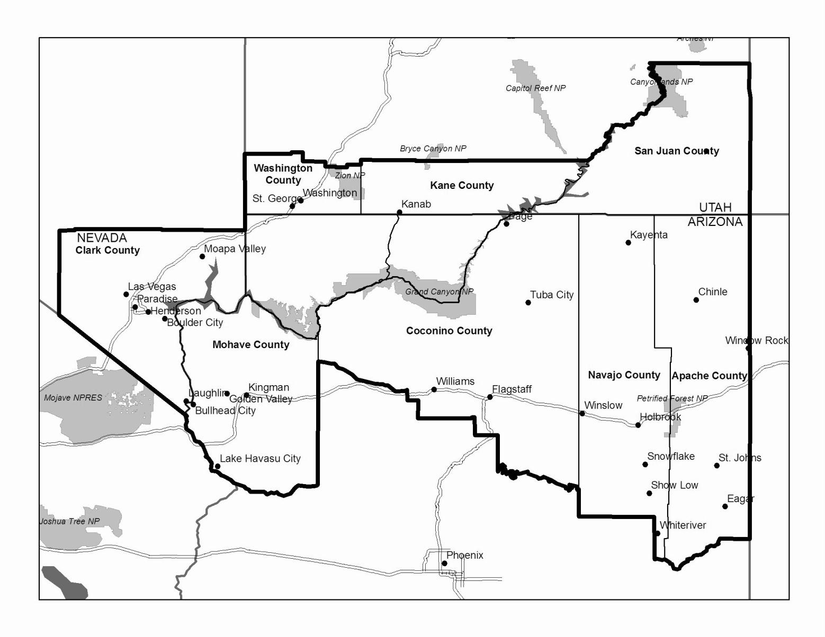
- Using the map above, please tell us where you stayed during your trip to the Lees Ferry area. The map above shows the location of the cities listed. Please indicate the number of nights spent in each place or add any place you stayed that is outside the area or not listed on the map.

Location | Number of nights
Kanab, UT
St. George, UT
Page, AZ
Grand Canyon Village, AZ
Flagstaff, AZ
Kingman, AZ
Boulder City, NV
Henderson, NV
Las Vegas, NV
Marble Canyon, AZ

- Please estimate how much this trip cost. The estimates should only include the cost for you (and not the cost you may have paid for others in your group). Include only money spent on items specifically for this trip. Please include the sum of your costs below the table.

Item | Total Spent on Trip (USD)
Guide fees and gratuity
Airfare
Car rental
Gas and oil for vehicle and boat(s)
Food and beverages (from grocery stores)
Restaurant meals
Lodging (motels and hotels- before and after trip)
Camping fees
Personal gear (suntan lotion, sunglasses, film for camera, artificial lures)
Boat gear purchased specifically for this trip
Gifts and souvenirs
Total costs

Brown Trout Incentivized Harvest Participation Questions

Questions 41-42 will be used to identify willingness to participate in the BTIH program.

The Colorado River below Glen Canyon Dam is home to native fish species like razorback sucker and humpback chub, which are considered endangered or threatened by U.S. Fish and Wildlife. Native fish are susceptible to predation by other fish like brown trout. The increase in number of brown trout in Glen Canyon has raised concerns for fish managers. As the Glen Canyon brown trout population grows, some could migrate downstream and pose an immediate threat to native fish species like the endangered humpback chub.

In November 2020, the National Park Service introduced an experimental Brown Trout Incentivized Harvest program in which anglers are paid a reward for removing brown trout from Lees Ferry. The initial research into the use of this tool is designed to last 3 to 4 years at which time the program will be evaluated for its effectiveness. It is not designed to eliminate brown trout, but to reduce their numbers to pre-2014 levels. Effective harvest and management of brown trout numbers through the Brown Trout Incentivized Harvest program may avoid the need to implement other removal measures along this segment of the Colorado River in the future.

- Have you participated or would you be willing to participate in the brown trout Incentivized Harvest Program at Lees Ferry?
  - I have participated or am willing to participate
  - Unsure
  - I am unwilling to participate

- (If “I am unwilling to participate) What factors make you unwilling to participate in the Incentivized Harvest Program? (select all that apply)
  - The per-fish payments are too low
  - It’s not worth the trouble to retain fish
  - I want to keep fish in the river to catch again
  - Releasing fish is the right thing to do
  - I’m not convinced it is important to control the Lee’s Ferry brown trout population
  - Other (Please specify): ______________________________

Choice Experiment Questions

After reading explanatory material, each respondent will be asked to answer 6 variants of the choice question. Each variant (or choice occasion) will present a choice between taking 2 hypothetical Lee’s Ferry fishing trips that differ with respect to one or more key trip attributes. Respondents may also choose neither hypothetical trip (choose the “Not Visit” option).

In this section, you will be presented with two hypothetical Lees Ferry fishing trips on which you expect to catch different quantities of rainbow trout, non-trophy (below XX”) brown trout, and trophy (XX” and above) brown trout. On each trip, you also have the option to retain any of the brown trout caught for a given per-fish reward through the Incentivized Harvest program. The per-brown trout rewards presented with these trips fall within the range of feasible rewards under the Incentivized Harvest program’s approved budget. You will be asked to choose which—if either—Lees Ferry fishing trip you would choose to take if those were your only two options. If you choose one of the two trips, you will then be asked how many—if any—brown trout you would turn-in to the Incentivized Harvest program for a reward on your selected trip.

[next page]

When considering the following scenarios, please assume that everything about the proposed trips, including your cost to take a trip, is the same as your most recent Lees Ferry fishing trip except for the trip features which are described for each scenario.
Please note: selecting one of the two trips means that you would choose to take that trip, not that you would necessarily participate in the brown trout Incentivized Harvest Program on that trip.

Features |  | Trip A | Trip B | Not Visit
 |  | Assume that everything about your Lees Ferry trip was the same except the following. | Assume that everything about your Lees Ferry trip was the same except the following. | I would not choose to take a Lees Ferry fishing trip if these were my only choices.
Number of rainbow trout caught |  | [0, 1, 3, 6, 9] | [0, 1, 3, 6, 9]
Number of brown trout caught | Non-Trophy | [0, 1, 3, 5] | [0, 1, 3, 5]
Number of brown trout caught | Trophy (>20" long) | [0, 1, 2, 3] | [0, 1, 2, 3]
Harvest incentive: reward per-brown trout |  | [$20, $35, $50, $65, $80] | [$20, $35, $50, $65, $80]
I would choose (choose only one) |  | Trip A | Trip B | Not Visit

- If you selected Trip A or Trip B, how many of the brown trout that you caught on that trip would you turn-in to the Incentivized Harvest program for a reward?

____non-trophy brown trout ____trophy brown trout

Demographics Questions

Question 27-34 will be used to determine baseline demographics about anglers. This is important to control for these factors when determining reasons an angler would or would not participate in the BTIH program.

In this final section, we would like to ask some questions about your background and occupation which will help us compare your answers with those of other people. We stress that all of your answers are completely anonymous.

- How old are you? ___ years old

- What is your gender?
  - Male
  - Female
  - Other

- Which of the following indicates your level of education? (SELECT ONE)
  - 8th grade or less
  - 9th to 11th grade
  - 12th grade (high school graduate)
  - Some college
  - College graduate
  - Some graduate work
  - Masters, Doctoral, or Professional Degree

- Which of the following best describes your employment status? (SELECT ONE)
  - Employed, full time
  - Employed, part time
  - Retired, but working full time
  - Retired, but working part time
  - Retired, not working
  - Homemaker
  - Unemployed
  - Student
  - Other (Please specify) ___________

- How many hours do you work in a typical work week? ____HOURS

- Are you Hispanic or Latino? YES / NO

- Which of the following best describes your race? (SELECT ALL THAT APPLY)
  - American Indian or Alaskan Native
  - Asian
  - Black or African-American
  - Native Hawaiian or other Pacific Islander
  - White

- Do you or either of your parents belong to any of the following tribes? (SELECT ALL THAT APPLY OR LEAVE BLANK IF NOT APPLICABLE)
  - Apache
  - Havasupai
  - Hopi
  - Hualapai
  - Navajo
  - Pueblo
  - Zuni
  - Other (Please specify):__________________________________

- Which of the following best describes your annual household income before taxes? (SELECT ONE)
  - Less than $50,000
  - $50,000 - $74,999
  - $75,000 - $99,999
  - $100,000 - $124,999
  - $125,000 - $149,999
  - $150,000 - $199,000
  - $200,000 - $250,000
  - Greater than $250,000

