Screen 1

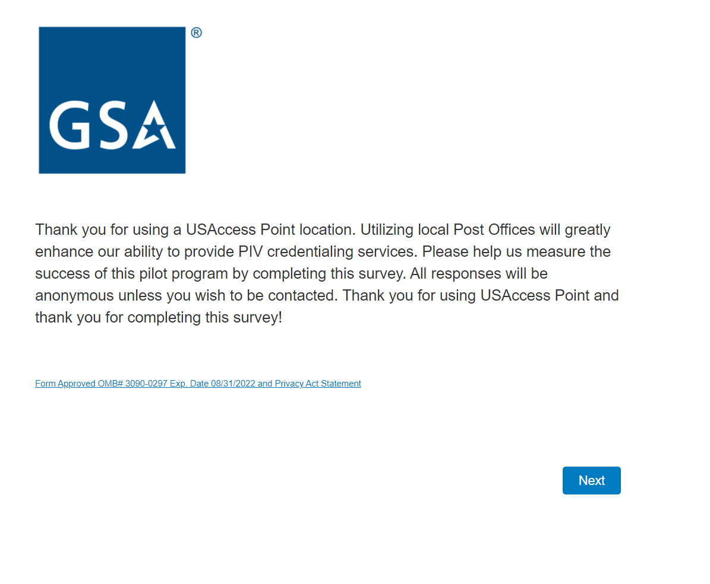

Screen 2

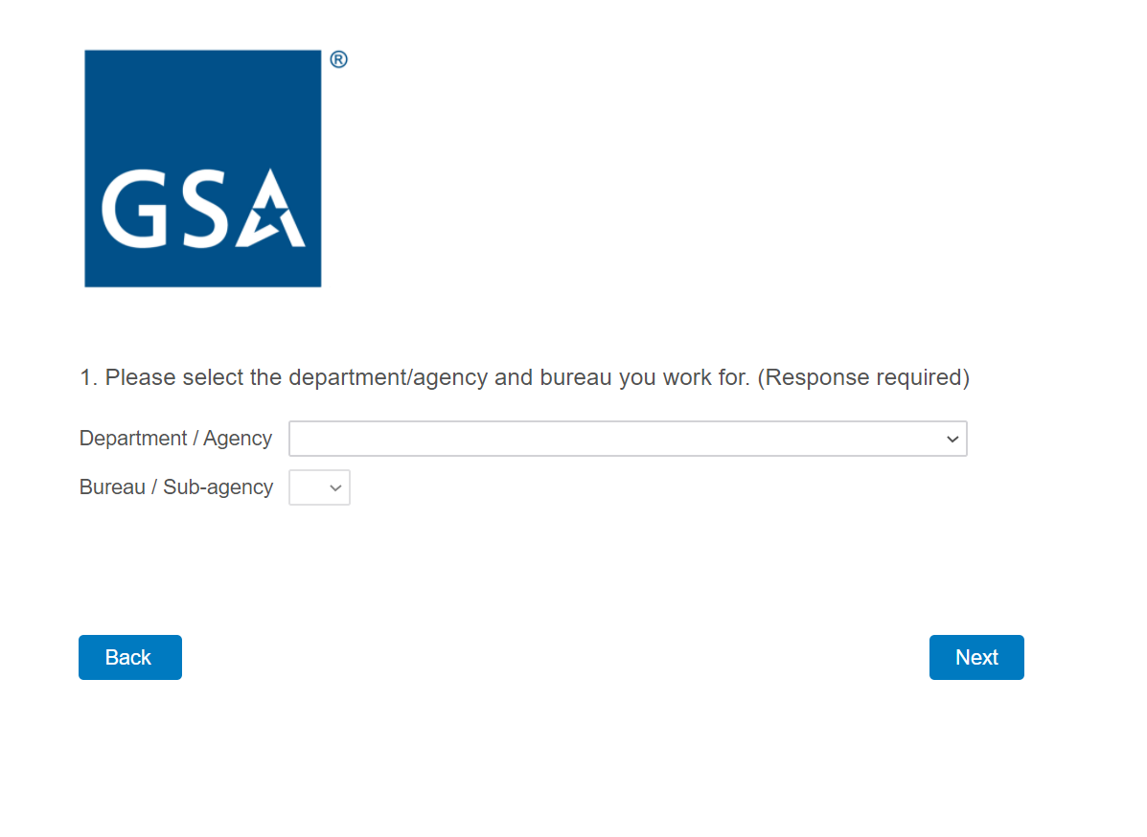
Notes: Complete agency and sub-agency lists are populated in the drop-down menus.
Screen 3

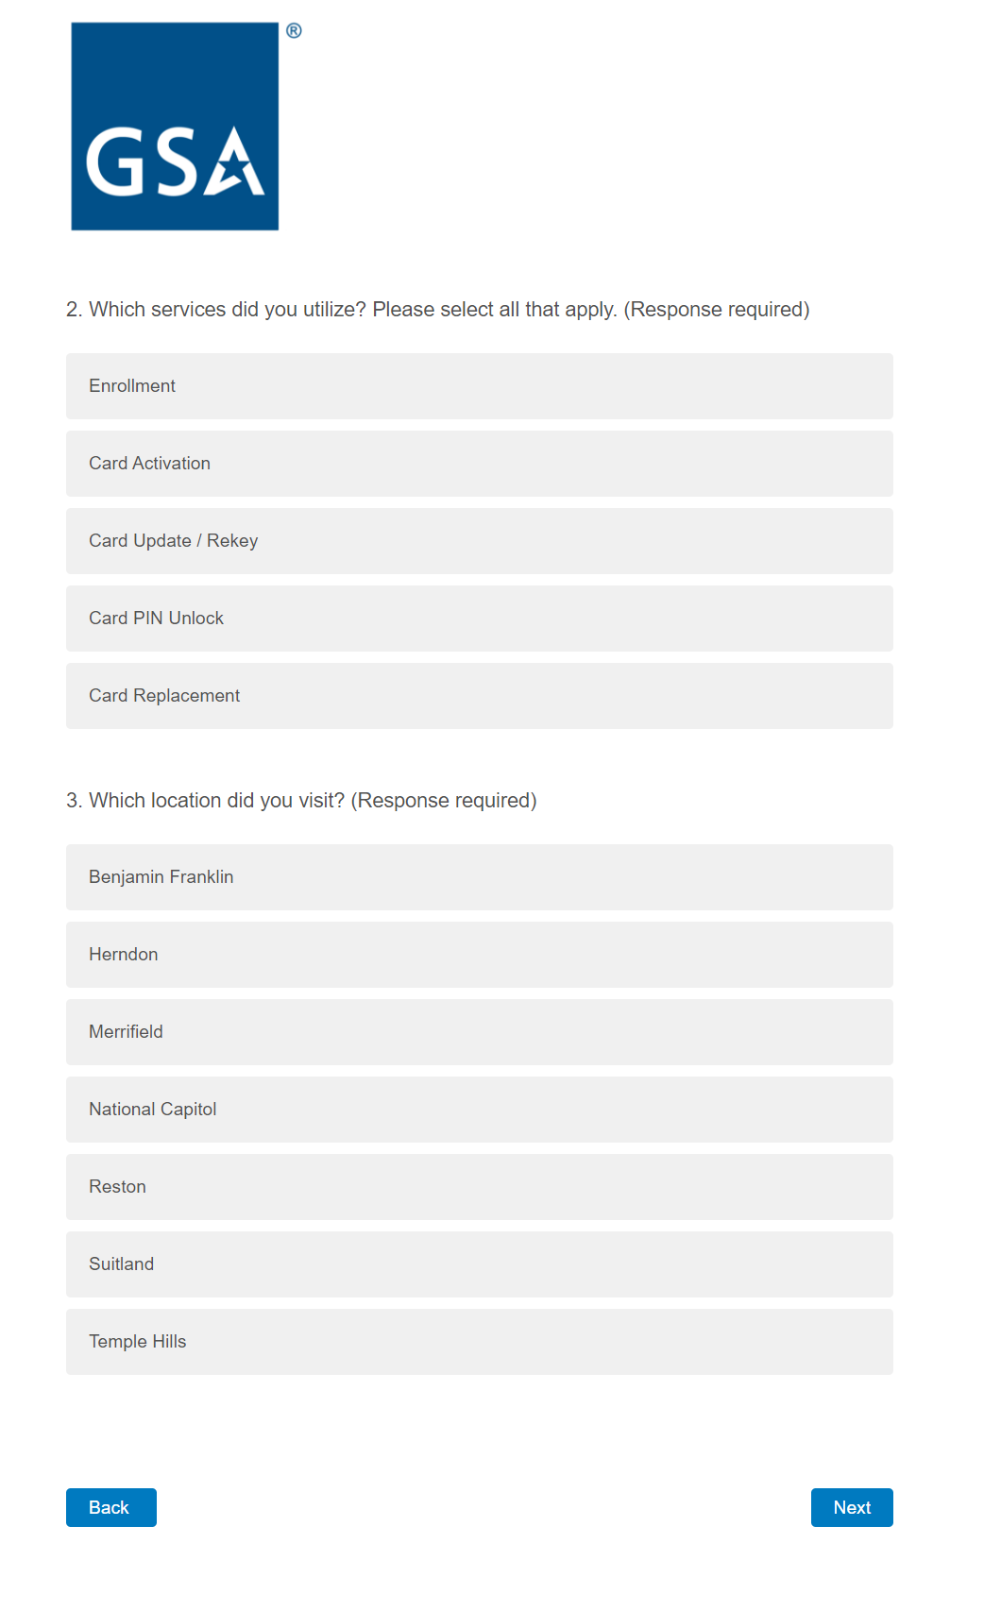
Screen 4

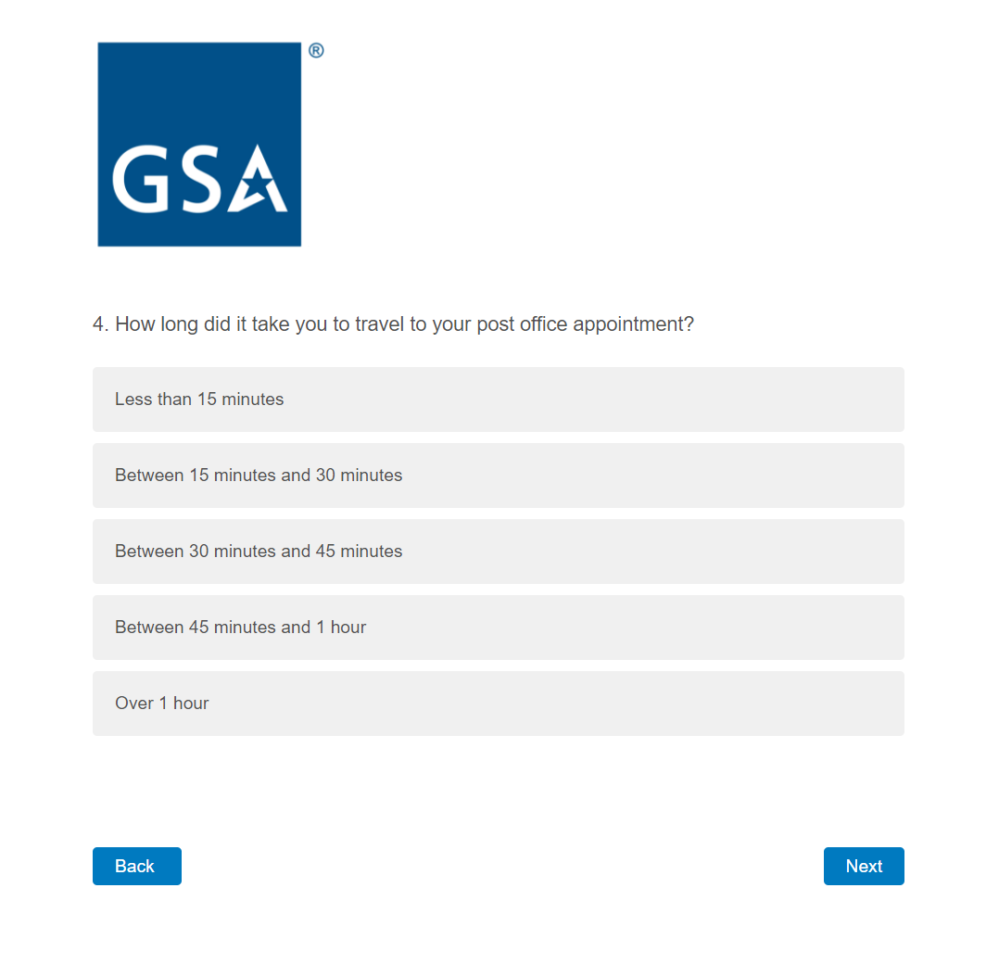

Screen 5

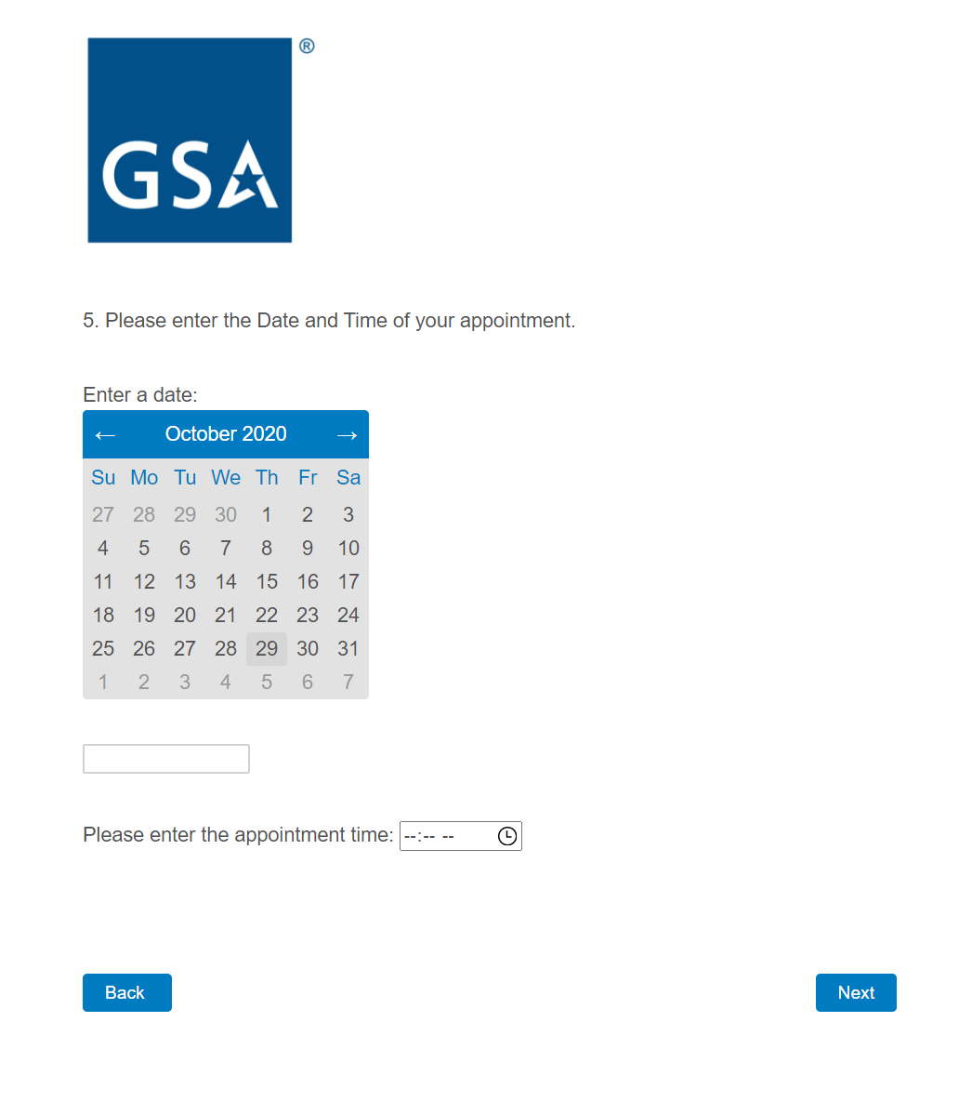
Screen 6a

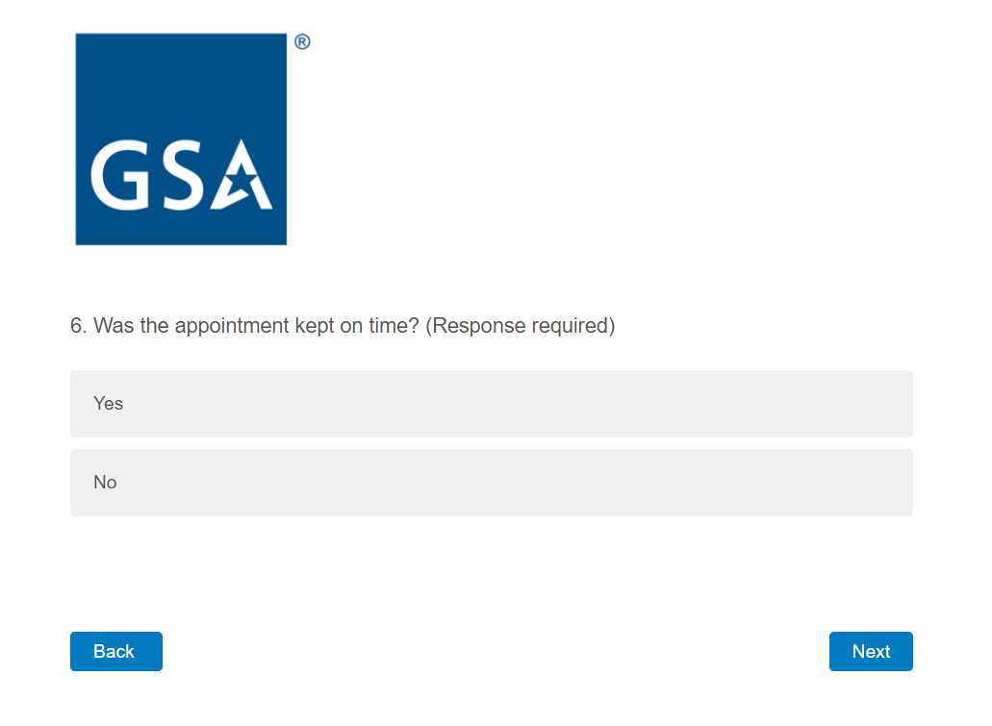

If the respondent answers No, the following screen is displayed, otherwise skip to question 7.

Screen 6b

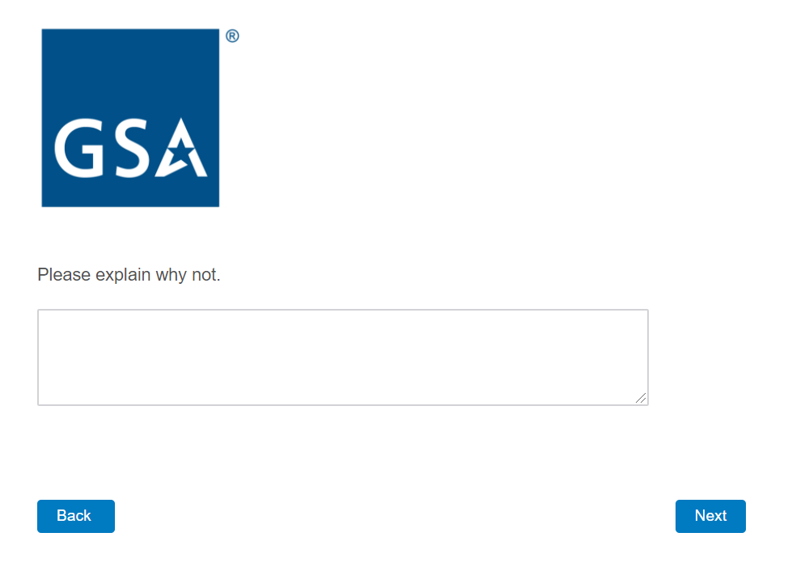
Screen 7

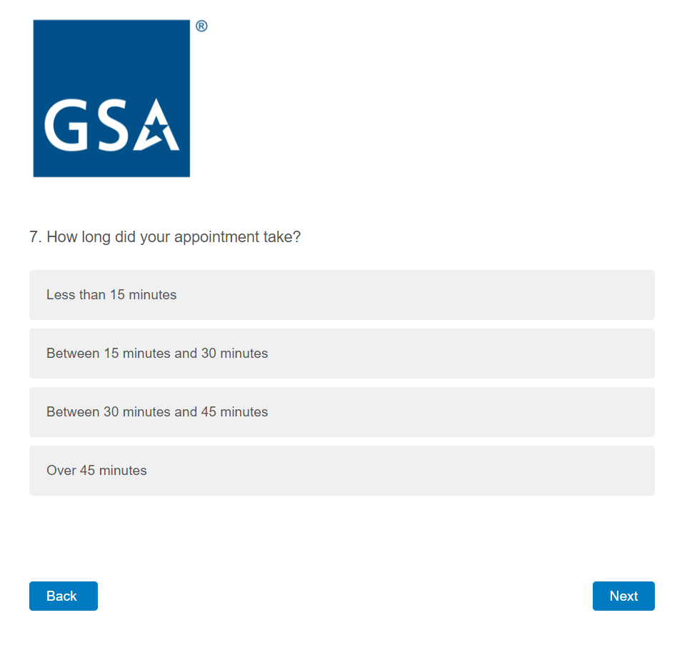

Screen 8a

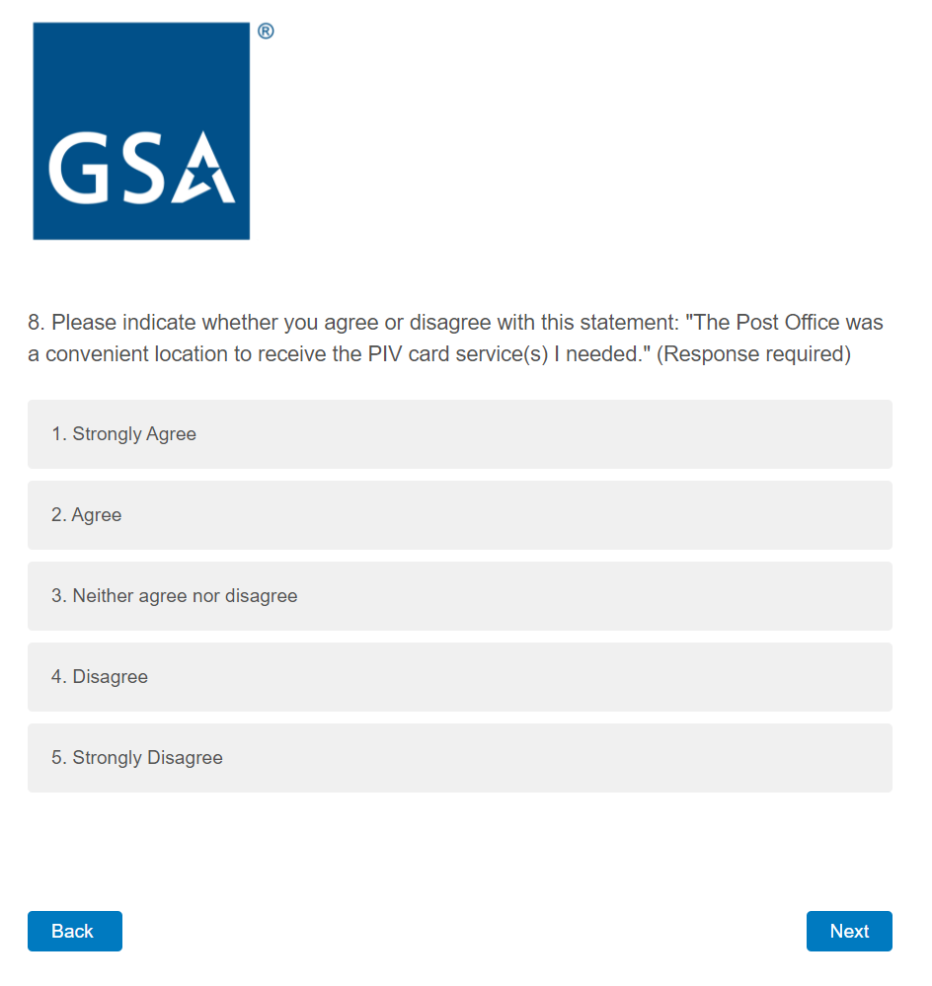
If the respondent answers with 3, 4, or 5, the following screen is displayed, otherwise skip to question 9.

Screen 8b

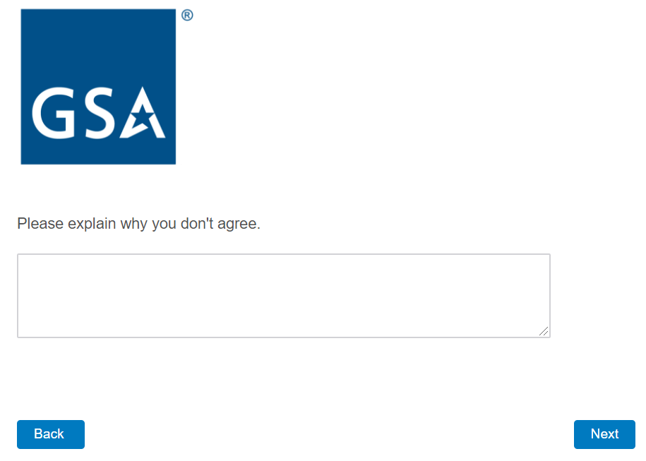
Screen 9a

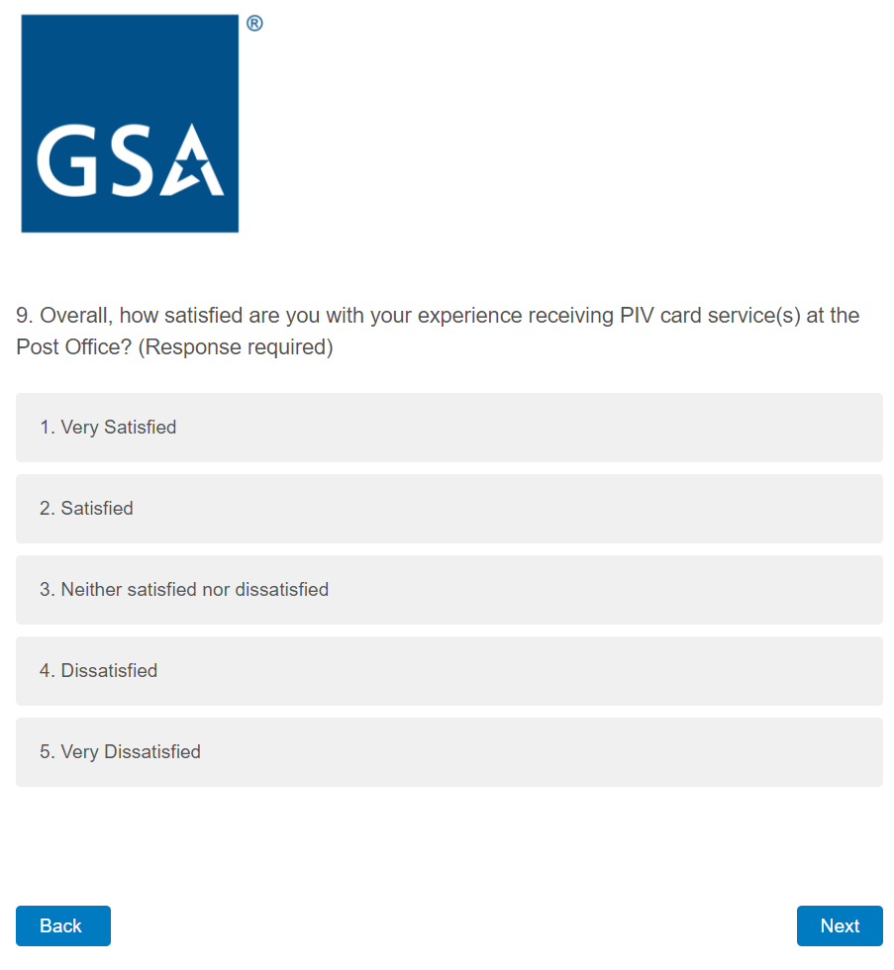
If the respondent answers with 3, 4, or 5, the following screen is displayed, otherwise skip to question 10.

Screen 9b

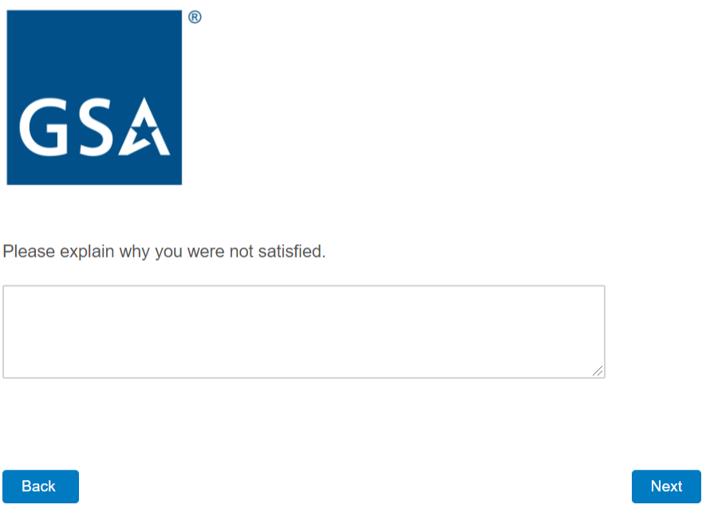

Screen 10

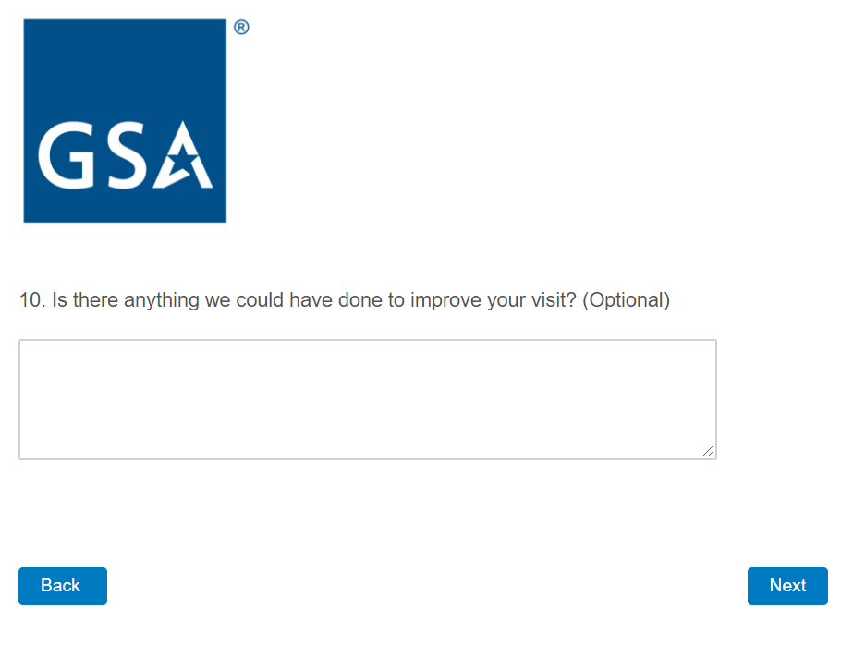

Screen 11

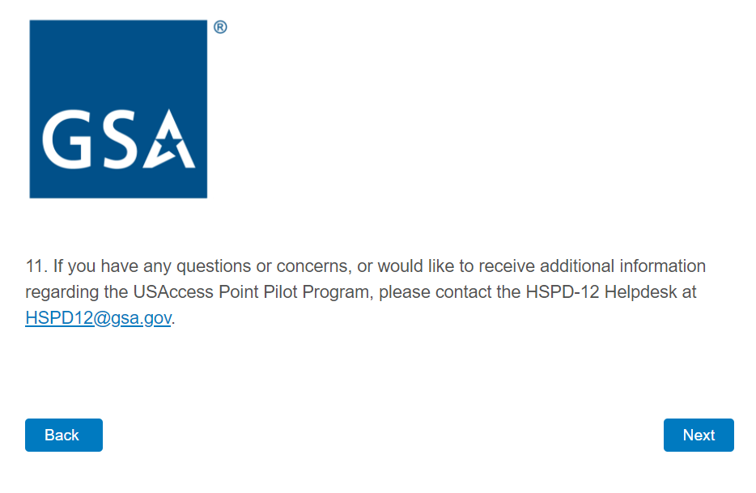
Screen 12

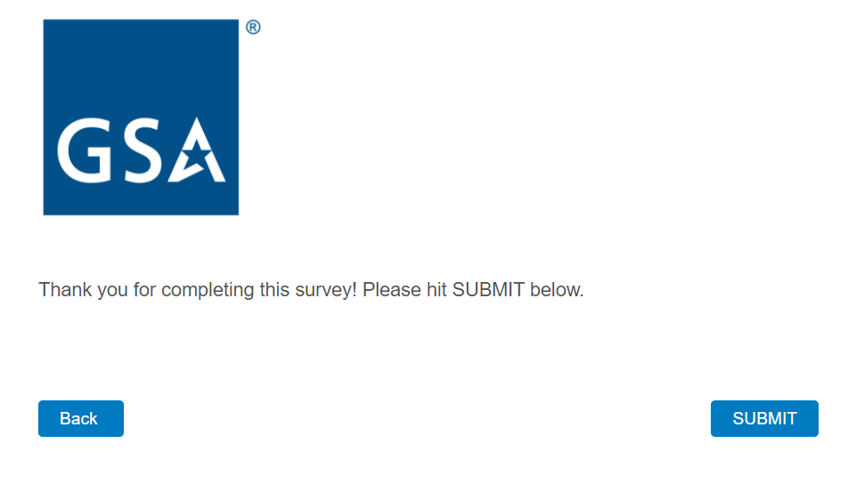

Screen 13

