Screenshots of GSA PPM Survey for GSAXcess and MySales
Req-30

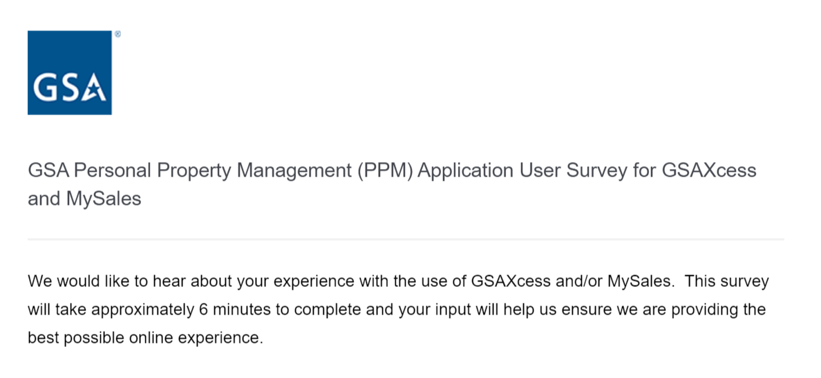
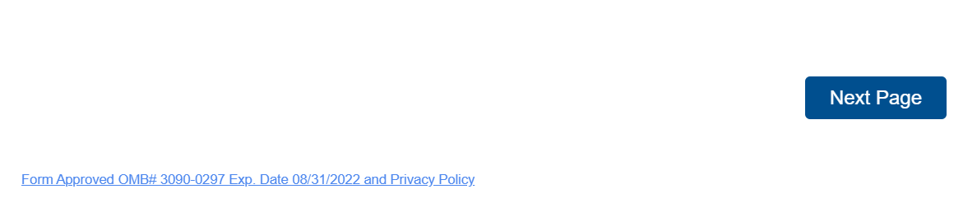

SURVEY QUESTIONS FOR THE RESPONDENT THAT SELECTS “FEDERAL GOVERNMENT”
AS THE STAKEHOLDER

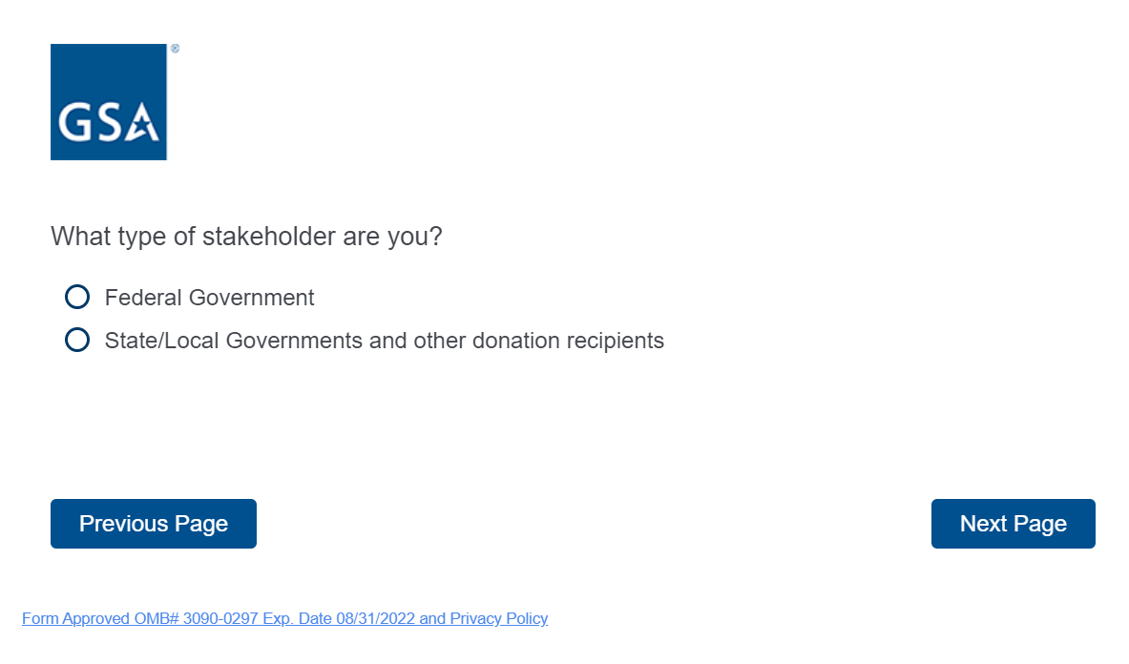
If the respondent selects “Federal Government” from above, the following questions will appear.

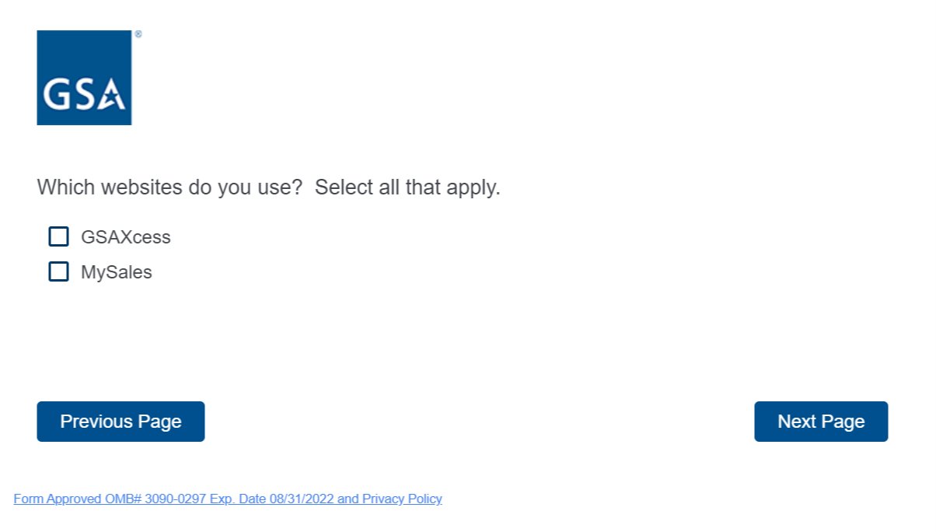
The respondent can select one or both websites above. If they select, GSAXcess, the following questions will appear.
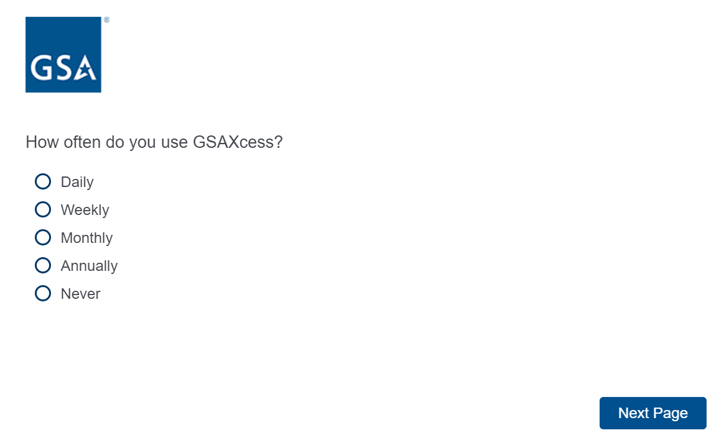

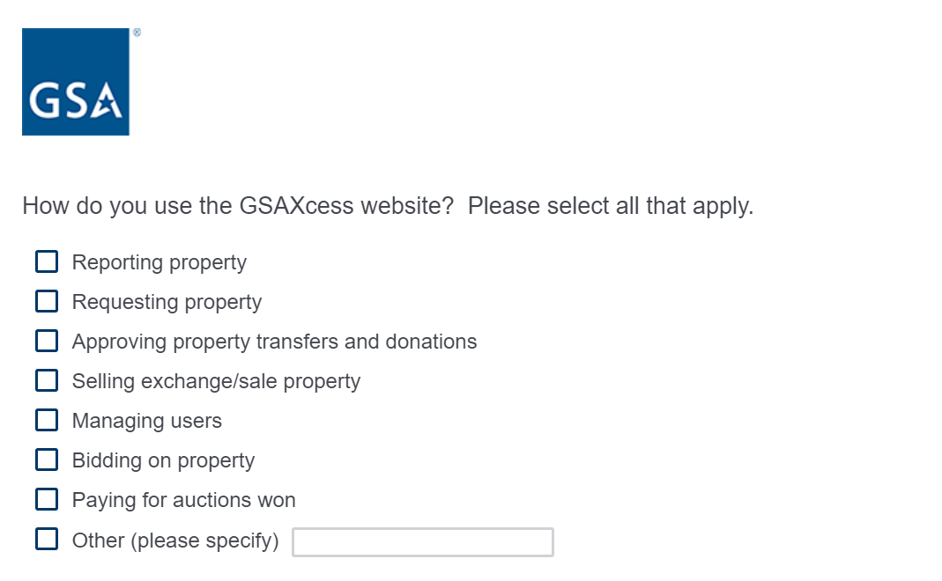
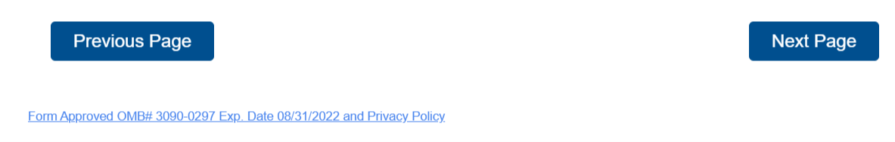

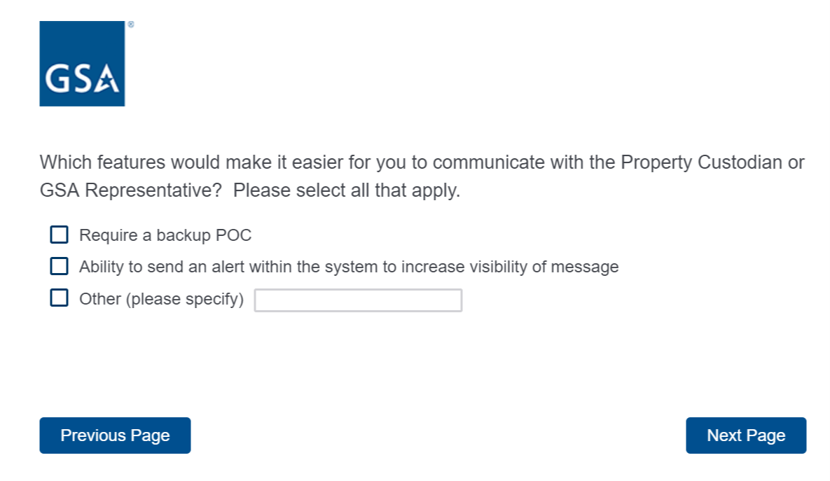

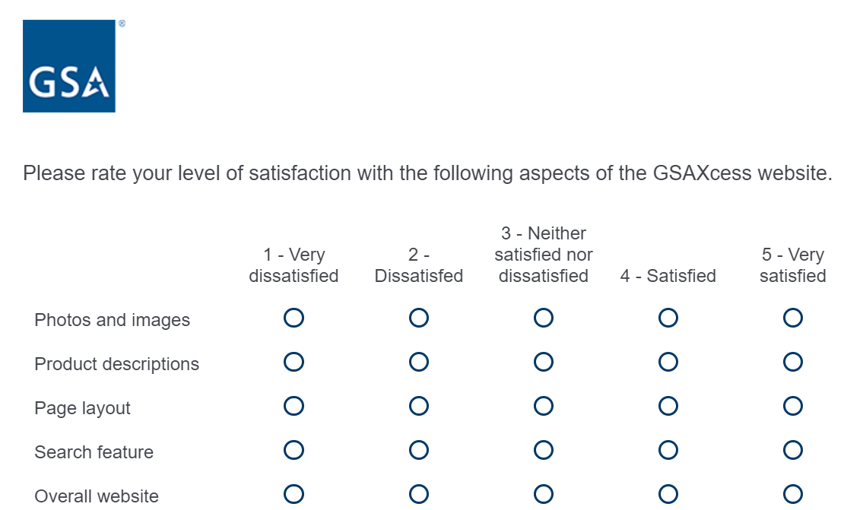
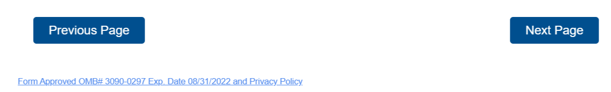

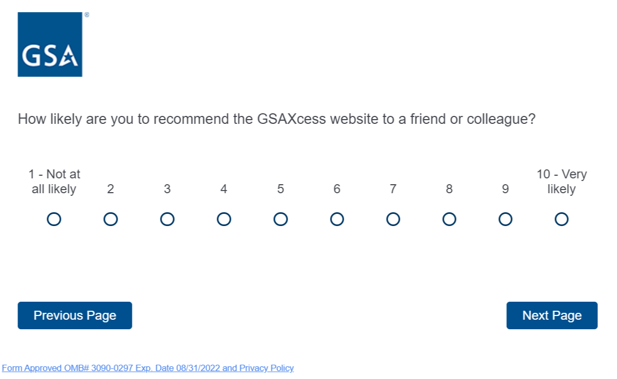

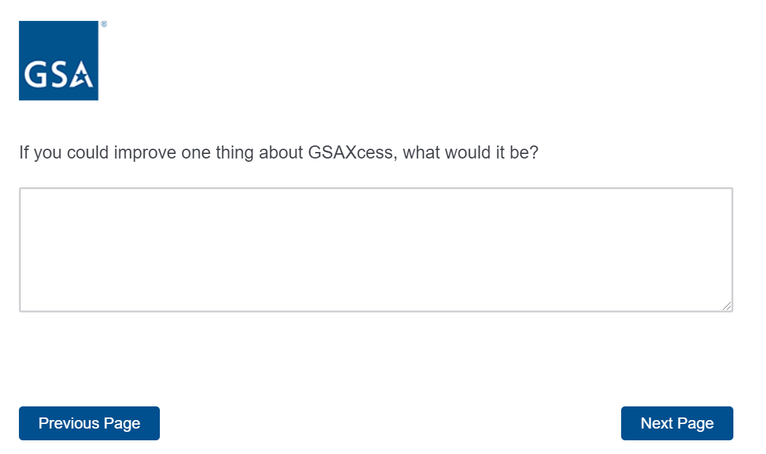

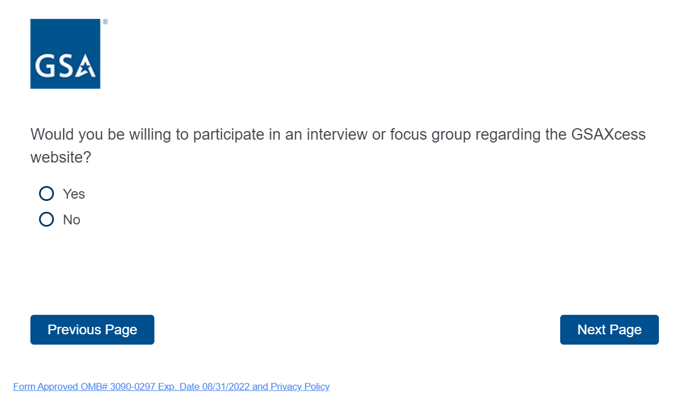
If the respondent selects yes from the question above, it will bring up the below contact question. If the respondent selects no, it will continue them through the survey or take them to the end of the survey.
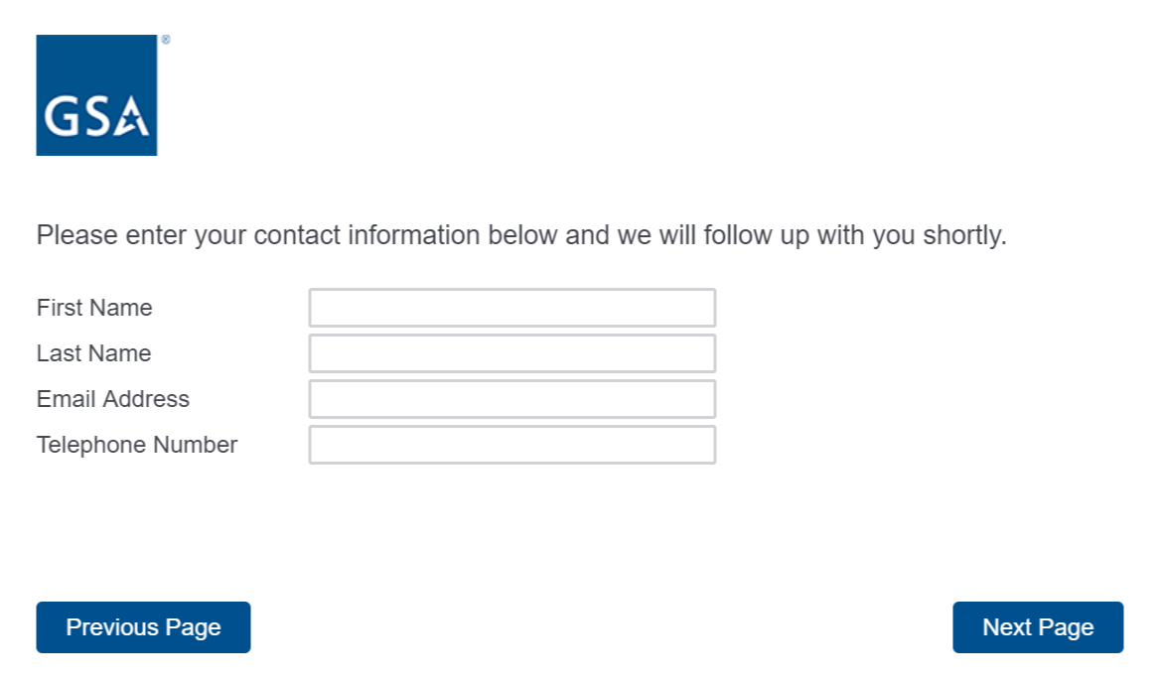

If the respondent selects MySales, the following questions will appear.
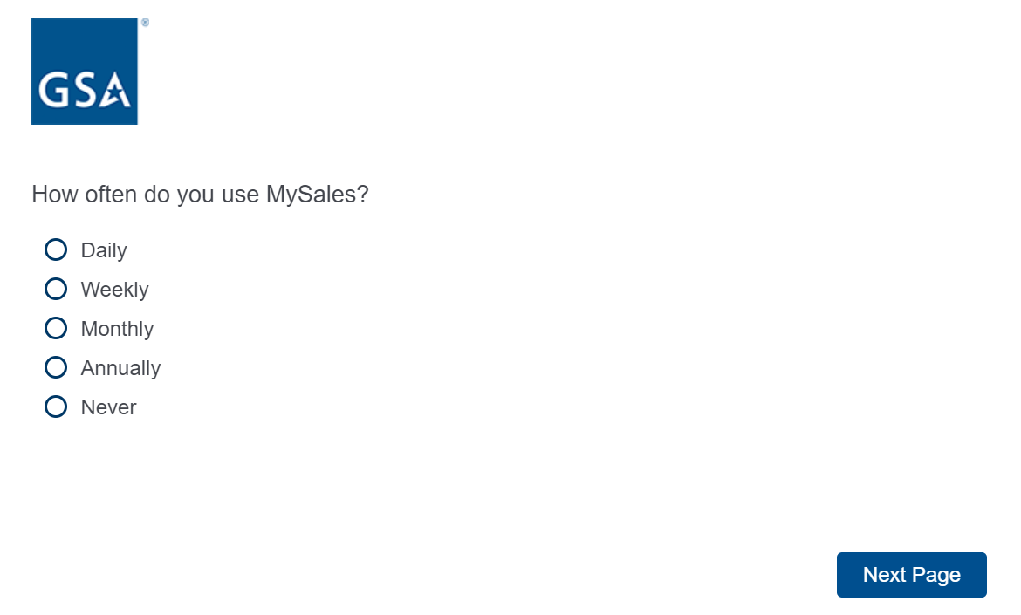

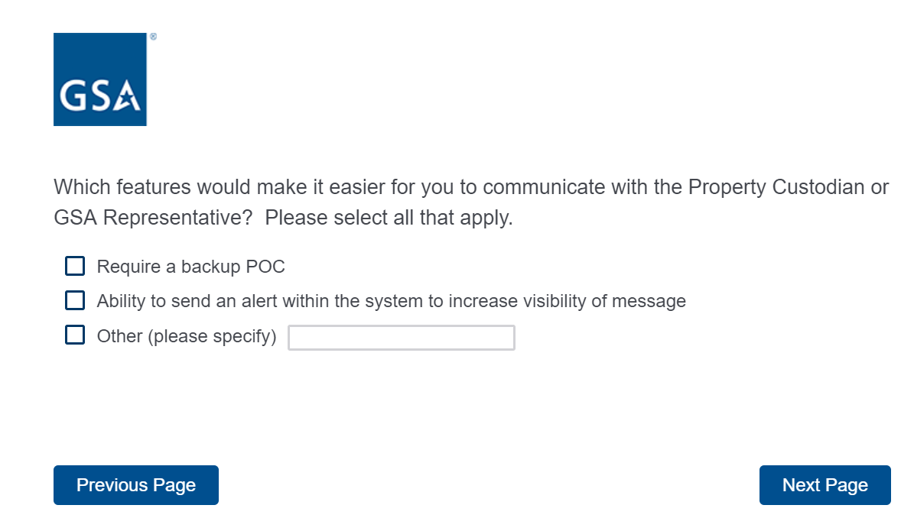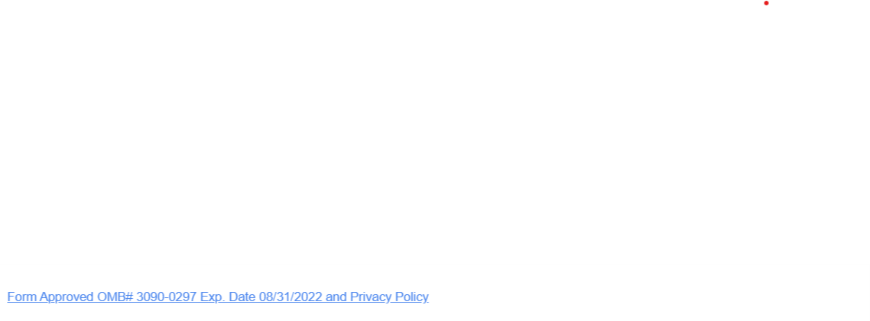

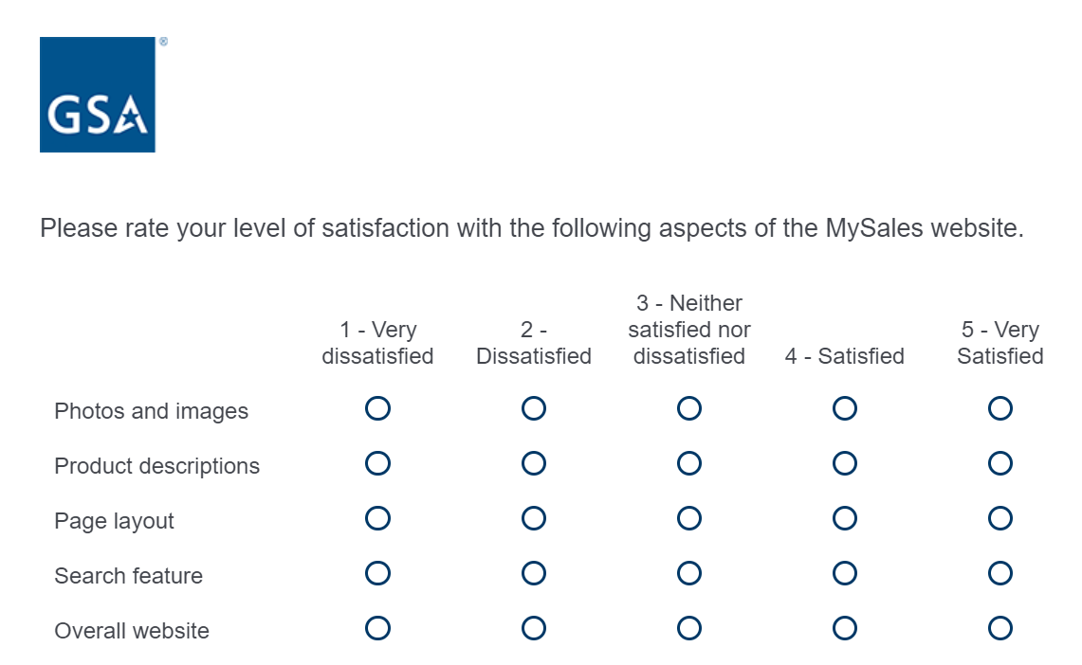
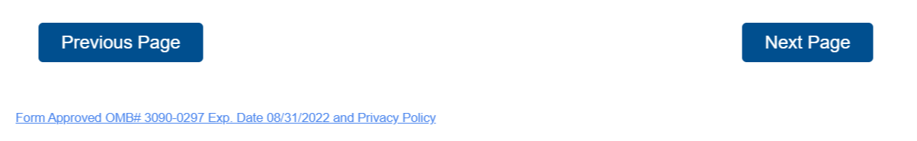

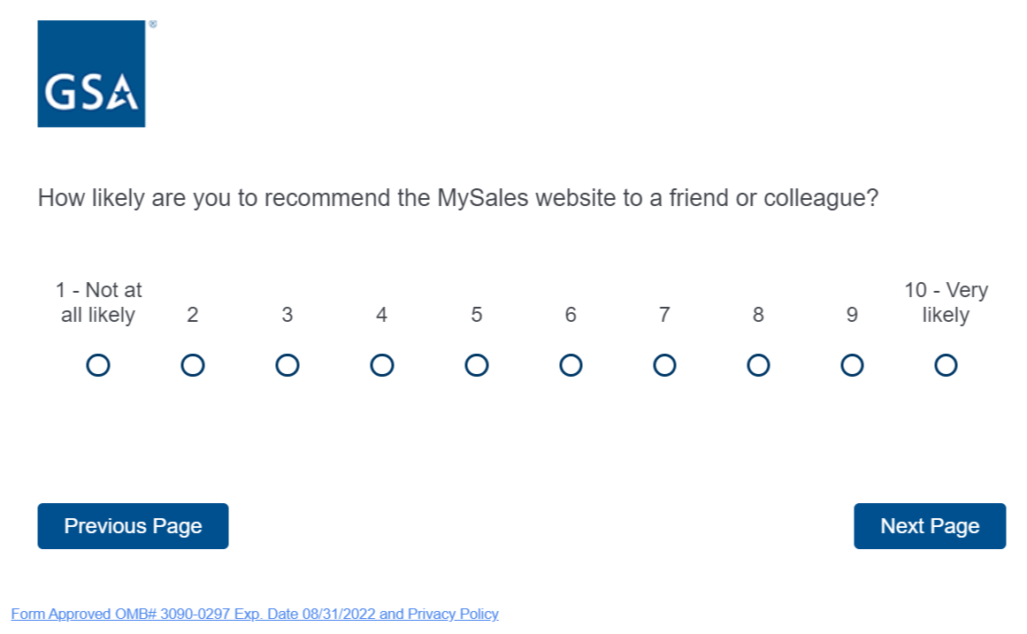

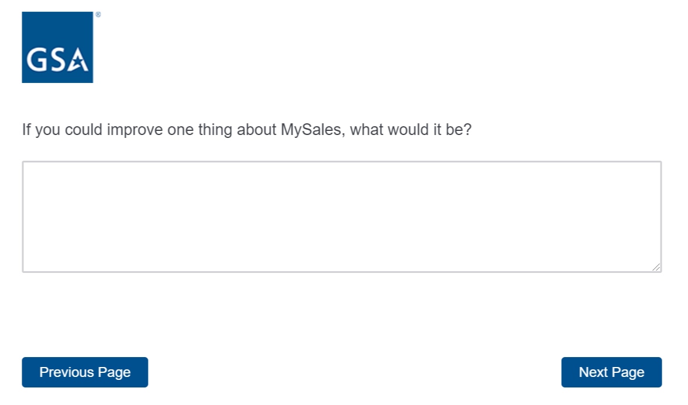

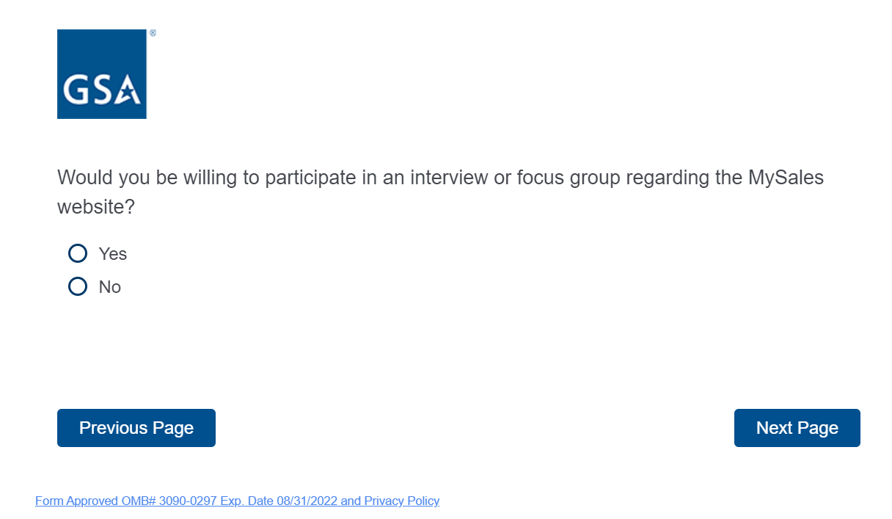
If the respondent selects yes from the question above, it will bring up the below contact question. If the respondent selects no, it will continue them through the survey or take them to the end of the survey.

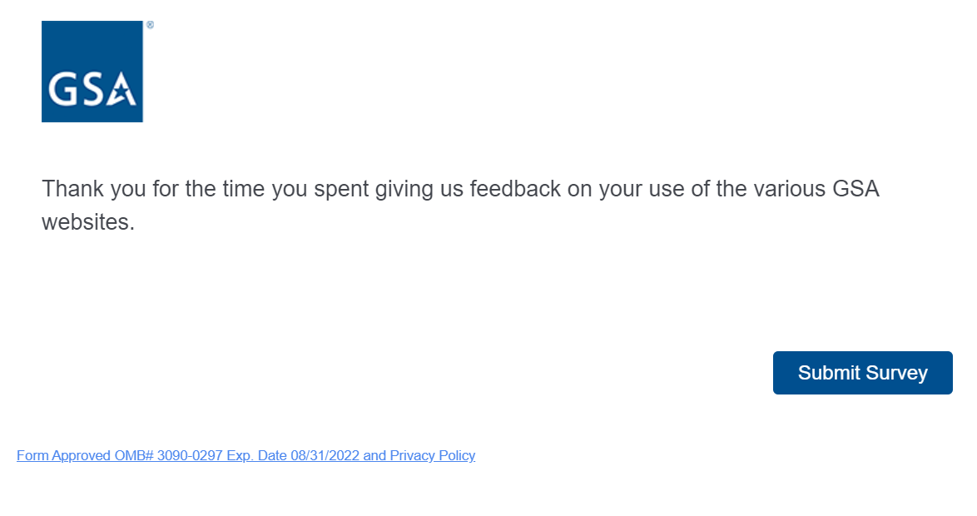

SURVEY QUESTIONS FOR THE RESPONDENTS THAT SELECTS “STATE/LOCAL GOVERNMENT
OR OTHER DONATION RECIPIENTS” AS THE STAKEHOLDER

If the respondent selects, “State/Local Governments and other donation recipients” from above, the following questions will appear.

The respondent can select one or both websites above. If they select, GSAXcess, the following questions will appear.

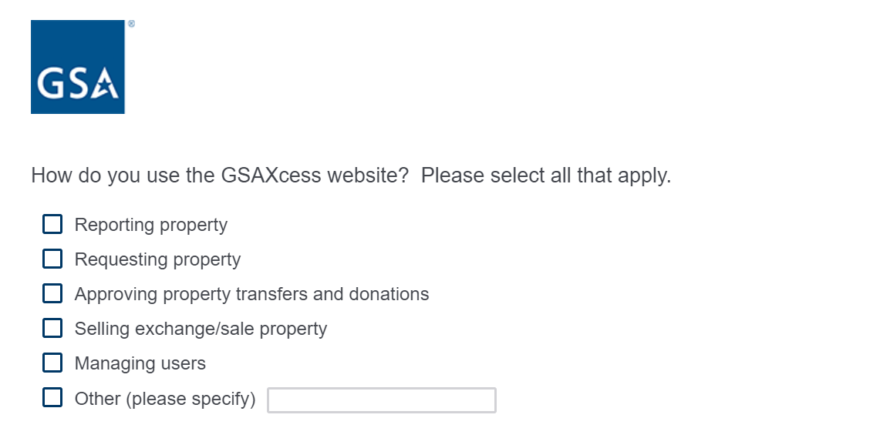

If the respondent selects yes from the question above, it will bring up the below contact question. If the respondent selects no, it will continue them through the survey or take them to the end of the survey.

If the respondent selects MySales, the following questions will appear.

If the respondent selects yes from the question above, it will bring up the below contact question. If the respondent selects no, it will continue them through the survey or take them to the end of the survey.

