ETRS FORMS - Screenshots

Figure 1.

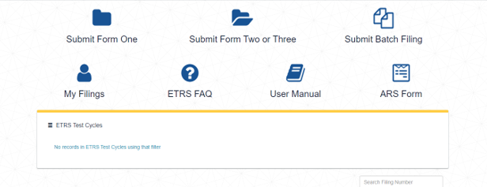

Figure 2.

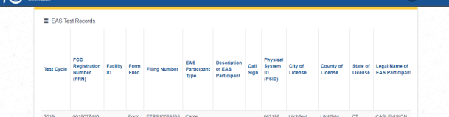

Figure 3.

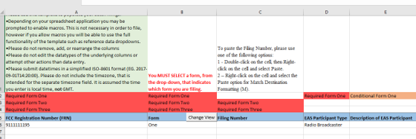

Figure 4.

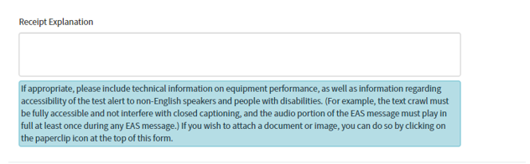

Figure 5.

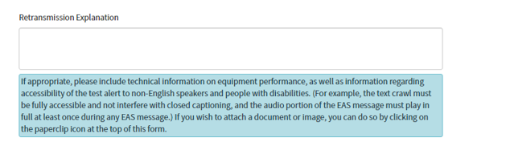

Figure 5.

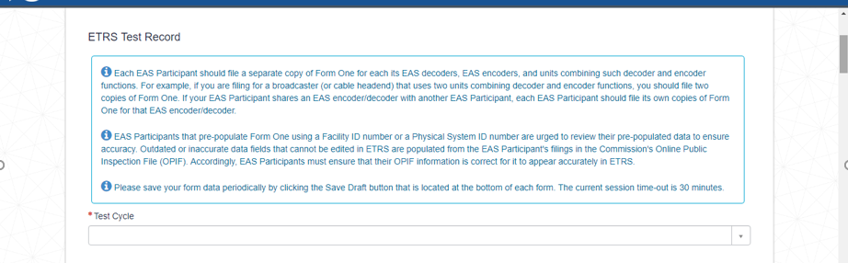

Figure 6.
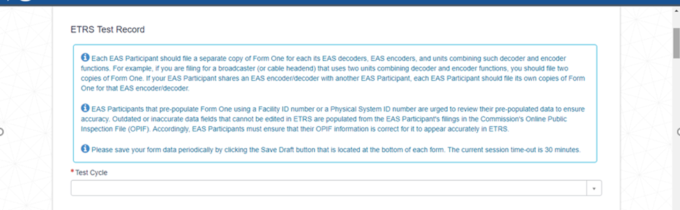

Figure 7.

