The templates below provide sample prompts for PHAs to respond to in submitting required information so that HUD can perform certain up-front civil rights reviews as described in the RAD Fair Housing, Civil Rights, and Relocation Notice and in order to assess compliance with RAD relocation requirements. Please see Attachment 1A “Financing Plan Requirements and Feasibility Benchmarks” Paragraphs E and L for more information. Certain templates and questions within each template will only apply based on the specific details of a proposed conversion. HUD intends to make these prompts available on the RAD Resource Desk so that PHAs can readily determine which questions are relevant to their transaction.

- New Construction Site and Neighborhood Standards
- Unit Reduction or Configuration Change
- Change in Occupancy
- Transfer of Assistance
- Remedial Agreements and Orders
- Accessibility
- Relocation

- New Construction Site Selection & Neighborhood Standards Documentation
For new construction, upload the below information as well as documentation that the site meets Site Selection & Neighborhood Standards requirements. This is due prior to Financing Plan submission pursuant to the requirements of the Notice.
Instructions: Submit the information below using this template or in a format of your choosing. Once complete, upload to the RAD Resource Desk Financing Plan grid by selecting “New Construction Site Selection & Neighborhood Standards Documentation” as the Milestone Document type.

1) General Project Information:

PIC Development Number:
Name of Project:
Address (or cross-streets) of project:
Financing Plan Submission Date: (expected or actual)
Total Number of Units at the project by type of assistance for the units (e.g., number of PBV/PBRA units, LIHTC, market rate units):
Occupancy Type of Project (e.g., elderly, family, disabled):
The neighborhood of the project:
The housing market area of the Project:

- The racial/ethnic characteristics of the census tract, the census tract together with all adjacent census tracts, and the MSA from the most recent Decennial Census (2010 Census, DP-1). The following format may be used:

Hispanic or Latino and Race | Census Tract % | Census Tract together with all adjacent census tracts | MSA  %
Hispanic or Latino (total)
Not Hispanic or Latino
Black or African American alone
American Indian and Alaska Native alone
Asian alone
Native Hawaiian and Other Pacific Islander alone
Two or More Races
Some Other Race
Total
- The PHA’s determination of whether the site is located in an area of minority concentration, based on the racial/ethnic data for the neighborhood and housing market area. A site is considered to be in an area of minority concentration when either (i) the percentage of persons of a particular racial or ethnic minority within the area of the site is at least 20 percentage points higher than the percentage of that minority group in the housing market area as a whole or (ii) the total percentage of minority persons within the area of the site is at least 20 points higher than the total percentage of minorities in the housing market area as a whole.

☐ The site is not located in an area of minority concentration. Skip the rest of this question and continue to item #4.

☐ The site is located in an area of minority concentration. Identify and provide a complete justification of which of the following exceptions applies: (1) sufficient, comparable opportunities or (2) overriding housing need. For a definition of these exceptions, please see Section 5.4 of the RAD Civil Rights Notice and 24 CFR 983.57 for PBV or Appendix III of the RAD Notice for PBRA. The PHA must submit a narrative discussion of how it determined that the site meets the applicable exception and the information that it relied upon to make this determination.

- The PHA’s determination of whether the site is located in a racially mixed area. A racially mixed area is an area that is neither minority concentrated, nor a non-minority area. A non-minority area is an area in which the minority population is lower than 10 percent.

☐ The site is not located in a racially mixed area. Skip the rest of this question.

☐ The site is located in a racially mixed area. The PHA must demonstrate that the project will not cause a significant increase in the proportion of minority to non-minority residents in the area.

- Unit Reduction or Configuration Change
Upload the below information if the conversion includes a reduction in the number of units or a change in the unit configuration as a result of conversion. A description of the proposed change, justification for the change, a discussion of compliance with accessibility requirements, and a discussion on how the residents’ right to return will be impacted should also be included.

RAD Scenario: Reduction of units or change in unit configuration, including when occurring during a transfer of assistance

Instructions: Complete items 1-10 below. Once complete, upload to the RAD Resource Desk Financing Plan grid by selecting “Unit or Configuration Change” as the Milestone Document type.

- Financing Plan Submission date (expected or actual): Click here to enter a date.
- PHA Name:
- PIC Development Number: Click here to enter text.
- Project Name: Click here to enter text.
- Project Address: Click here to enter text.
- Complete the grid below with information on current and proposed unit changes. Except where indicated, all fields should be completed for a single converting property.
- Please identify the occupancy type of the overall housing stock, the number of UFAS mobility accessible units, the number of UFAS sensory accessibility units, the number of families on the waiting list requesting UFAS mobility and sensory units, and if the applicable occupancy type is mixed, please also provide the bedroom information by occupancy type.

 | Public Housing Information: All conversions that involve a reduction of units or change in unit configuration must complete this section. |  |  |  |  |  |  |  |  |  |  |  |  |  |  | UFAS Information: Complete this section only if the conversion will involve a reduction of units, an increase above 10% mobility or 4% sensory, or change in unit configuration of UFAS units.
 | PHA’s Public Housing Stock |  |  |  |  |  |  | Public Housing Waiting List |  |  |  |  |  |  |  | UFAS-Accessibility |  |  |  |  | UFAS Waiting List |  |  | UFAS Waiting List
Bedrooms | PHA’s Public Housing Stock |  |  |  | Current # of public housing units at the property | # of occupied units | Post-conversion # of RAD units at the property | # of families on the public housing waiting list |  |  | PHA’s UFAS Public Housing Stock |  |  |  |  |  | Current # of UFAS mobility accessible public housing units at the property | Current # of UFAS sensory accessible public housing units at the property | Post-conversion # of UFAS mobility accessible units at the property | Post-conversion # of UFAS sensory accessible units at the property | # of families on the waiting list requesting UFAS mobility units |  |  | # of families on the waiting list requesting UFAS sensory units
Bedrooms | General | Mixed | Elderly Only | Disabled Only | Current # of public housing units at the property | # of occupied units | Post-conversion # of RAD units at the property | Total | Elderly | Disabled | General | Mixed |  | Elderly Only | Disabled Only |  |  |  |  |  | Elderly | Disabled | Family
0
1
2
3
4
5
Total

- A narrative description of the proposed change:

- A justification for the changes, including data from the Consolidated Plan or Census that support the need for the proposed changes:

- Provide an explanation, backed by sufficient evidence, of how the PHA determined that the proposed change will not result in discrimination on the basis of race, color, national origin, religion, sex, disability, familial status, actual or perceived sexual orientation, gender identity or marital status.

- Describe the impact that the reduction or reconfiguration of UFAS units will have on the ability of the PHA to be in compliance with the requirement that a minimum of 5% of units be accessible to persons with mobility impairments and 2% be accessible to persons with hearing/vision impairments and the requirement that accessible units be available in a range of bedroom sizes. If the conversion will result in an increase in the number of UFAS mobility accessible units beyond 10% of the units in a covered project or an increase in the number of UFAS sensory accessible units beyond 4% of the units in a covered project, describe the justification for this increase, including whether accessible units are distributed throughout the Public Housing Authority’s portfolio and whether there is a local need for the number of UFAS units based on the population of PHA residents or in the market area based on census data:

- Describe whether any families that need an accessible unit reside in any of the UFAS units being eliminated or reconfigured. If yes, describe how the PHA will accommodate the family so that they can return to the project, if they choose. A family requiring an accessible unit cannot be denied their right to return to the project due to the lack of an accessible unit.:

- Describe whether any families that currently reside at the project will not be able to return due to a reduction in units or change in bedroom distribution. If yes, provide the demographic information (i.e., race, national origin, disability, familial status) below:
    - For reductions in units, provide the demographic characteristics of the residents of the units being eliminated, the residents of the project, the residents of the PHA, the census tract of the site, and the PHA’s jurisdiction.
    - For changes in bedroom distribution, provide the demographic characteristics of the residents that will not be able to return due to the change in bedroom distribution, the residents of the project, the residents of the PHA, the census tract of the site, and the PHA’s jurisdiction.

- If you are eliminating or reconfiguring units resulting in a loss of two, three, four bedroom or larger units, please provide data on the racial/ethnic characteristics of the families occupying those unit sizes at the project, as well as the racial/ethnic characteristics of the families in the public housing portfolio, the census tract and the MSA:

- Would the unit reduction or reconfiguration significantly reduce or eliminate certain types of units (e.g. units of particular bedroom size or occupancy type or UFAS-accessible units) from the public housing stock? If yes, does the PHA have comparable units in its other programs (e.g. PBV or PBRA)?:

- Change in Occupancy
Upload the below information if your conversion includes a change in occupancy type. Changes in occupancy include admissions preferences (e.g., residency preferences or restrictions) that would alter the occupancy of the property (e.g., family units converting to elderly units, elderly/disabled units converting to elderly only units). A description of the proposed change, justification for the change, a description of any alternative housing resources that are available to the group that will no longer be eligible to reside at the project at a comparable rent/size, a discussion on how the residents’ right to return will be impacted should also be included. Further, these preferences, restrictions, or geographic residency preferences must be reflected in a PBRA project’s Affirmative Fair Housing Marketing Plan (AFHMP) or, for a PBV project, the PHA’s administrative plan.
Instructions: Complete items 1-9 below. Once complete, upload to the RAD Resource Desk Financing Plan grid by selecting “Change in Occupancy” as the Milestone Document type.

- Financing Plan Submission date (expected or actual): Click here to enter a date.
- Name of PHA:
- PIC Development Number: Click here to enter text.
- Project Name: Click here to enter text.
- Project Address: Click here to enter text.
- Current occupancy type
- Proposed occupancy type
- Complete the grid below with information on current and proposed unit changes. Except where indicated, all fields should be completed for a single converting property.
- Please provide a separate chart for each subsidy type (public housing, PBV and PBRA).

PHA’s Public Housing Stock |  |  |  |  |  |  |  |  |  |  |  |  |  |  | Public Housing Waiting List |  |  | UFAS-Accessibility |  |  |  |  |  |  |  |  |  |  |  | UFAS Waiting List
Bedrooms | PHA’s Public Housing Stock |  |  |  |  | Current # of public housing units at the property |  | Type of families in occupied units at the property |  |  | Type of families in occupied units PHA-wide |  |  |  | # of families on the public housing waiting list |  |  | PHA’s UFAS Public Housing Stock |  |  | Current # of UFAS accessible public housing units at the property | Types of families occupying UFAS units at the property. (Provide this information only for families that need the accessible features of the unit.) |  |  |  | Types of families occupying UFAS units PHA-wide. (Provide this information only for families that need the accessible features of the unit.) |  |  |  | # of families on the waiting list requesting UFAS units
Bedrooms | General | Mixed | Elderly Only | Disabled Only |  |  | Family |  | Elderly | Disabled | Family | Elderly | Disabled | Total |  | Elderly | Disabled | General | Elderly Only | Disabled Only |  |  | Family | Elderly | Disabled |  | Family | Elderly | Disabled |  | Family | Elderly | Disabled
0
1
2
3
4
5
Total

- A narrative description of the proposed change:

- A justification for the changes which demonstrates that the proposed change is consistent with the demand for affordable housing in the jurisdiction, including the demographics of the current occupancy, the demographics of the waiting list, and data from the Consolidated Plan, a market study, or the Census that support the need for the proposed changes:

- Describe any alternative housing resources that are actually available to the group that will no longer be eligible to reside at the project (i.e., families with children or non-elderly disabled families) at a comparable rent to the designated public housing units and of a comparable size to those being designated:

- Indicate whether any families that currently reside at the project will not be able to return due to a change in occupancy. If yes, provide the demographic characteristics of the residents that will not be able to return due to the change in occupancy type, the residents of the project, the residents of the PHA, the census tract of the site, and the PHA’s jurisdiction. Also, provide the demographic characteristics of the group that will no longer be eligible (i.e., families with children or non-elderly disabled families) in the PHA’s programs, the census tract of the site, and the PHA’s jurisdiction, and the demographic characteristics of the elderly population in the PHA’s programs, the census tract of the site, and the PHA’s jurisdiction.

- Provide the demographic characteristics of the group that will no longer be eligible (i.e., families with children or non-elderly disabled families) in the PHA’s programs, the census tract of the site, and the PHA’s jurisdiction, and the demographic characteristics of the elderly population in the PHA’s programs, the census tract of the site, and the PHA’s jurisdiction.

- If you are changing to elderly occupancy, please provide data on the racial/ethnic characteristics of the households occupying the project, as well as the racial/ethnic characteristics of the elderly population in the public housing portfolio, the census tract and the MSA:

- Transfer of Assistance
If proposing a transfer of assistance to a new site, the PHA should upload documentation containing the address or geographical description of the new site, the poverty concentration of the zip code in which the site is located, a brief description of the proposed transaction, a description of the existing public housing site(s) form which assistance is being transferred (including whether conversion on-site is economically non-viable and whether the existing site is physically obsolete or severely distressed), and a description of the impact the transfer will have on residents of the existing site. If the assistance will be transferred to an existing LIHTC property, a description of whether the transfer is necessary to help with the de-concentration of poverty and/or the de-densification of a public housing project with extensive capital needs should also be included. The PHA should also indicate if the DOT will be released in conjunction with closing or at a later date, including all supporting documentation. Additionally, the documentation should address: (1) The accessibility of the proposed site for persons with disabilities, and if the transfer is to an existing building, if the building(s) comply with UFAS, the 2010 ADA Standards, and the Fair Housing Act; (2) The ability of the RAD conversion to remediate accessibility concerns; (3) Whether the transfer of assistance would result in assisted units being located in an area where the total percentage of minority persons is significantly higher than the total percentage of minority persons in the area of the original public housing site or in an area where the percentage of persons of a particular racial or ethnic minority is significantly higher than the percentage of that minority group in the area of the original public housing site. For purposes of this analysis, HUD will examine the minority concentration of: (a) the census tract of the original public housing site compared to the census tract of the proposed site; and (b) an area comprised of the census tract of the original public housing site together with all adjacent census tracts compared to an area comprised of the census tract of the proposed site together with all adjacent census tracts. (4) Whether the site selection has the purpose or effect of: (a) Excluding individuals from, denying them the benefits of, or subjecting them to discrimination under the RAD program or the applicable rental assistance program; (b) Excluding qualified individuals with disabilities from or denying them the benefit of the RAD program or the applicable rental assistance program, or otherwise subjecting them to discrimination; (c) Defeating or substantially impairing the accomplishment of the objectives of the RAD program or the applicable rental assistance program with respect to qualified individuals with disabilities; and (d) Excluding individuals with disabilities (including members of the public with disabilities), denying them benefits or subjecting them to discrimination.

- Remedial Agreements and Orders
Is the Converting Project or PHA subject to an enforcement action or binding voluntary compliance agreement, settlement agreement, conciliation agreement, or consent decree or order?
___Yes ___No
If yes, provide additional information about the remedial agreement or order:

- Accessibility
 |  |  | # OF UNITS IN PROJECT FOLLOWING NEW CONSTRUCTION OR SUBSTANTIAL ALTERATION |  | % OF TOTAL UNITS
TOTAL UNITS
Section 504 MOBILITY UNITS
Section 504 HEARING AND VISION UNITS
[if at least 5%/2% not met; fatal error; PHA must modify project plans]
Which accessibility standard will be used? (Please check one): UFAS 2010 ADA Standards, in conjunction with HUD’s Deeming Notice
Is the RAD project subject to a remedial order or agreement that prescribes a higher number or percentage of accessible units than required under Section 504? Yes No
If yes, please explain and attach a copy of the order or agreement.
6.3 CERTIFICATIONS AND SIGNATURE
By checking this box, I affirm that I have read and hereby certify to the two (2) statements listed below the signature and that these statements are true and correct with regard to this project.
PHA EXECUTIVE DIRECTOR NAME |  |  |  |  |  |  | DATE
By signing above, I hereby certify the following:
(1) I am legally authorized to represent the public housing authority (PHA) in this matter; and
(2) All information provided in this checklist is true and accurate as of the date of this certification.
(3) All information provided in this checklist is compliant with the RAD Notice [H-2019-09 PIH-2019-23 (HA)] and the Fair Housing and Relocation Notice [H 2016-17 PIH 2016-17 (HA)
]

- Relocation

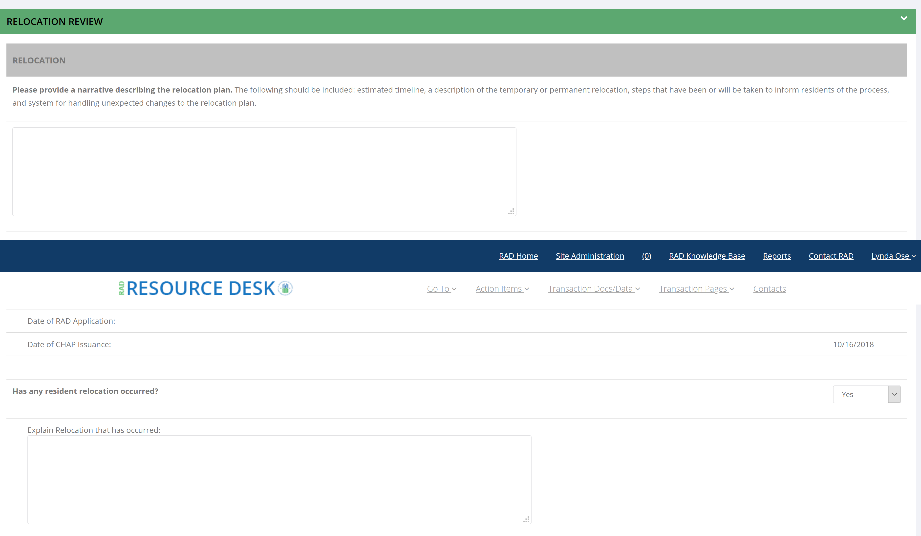

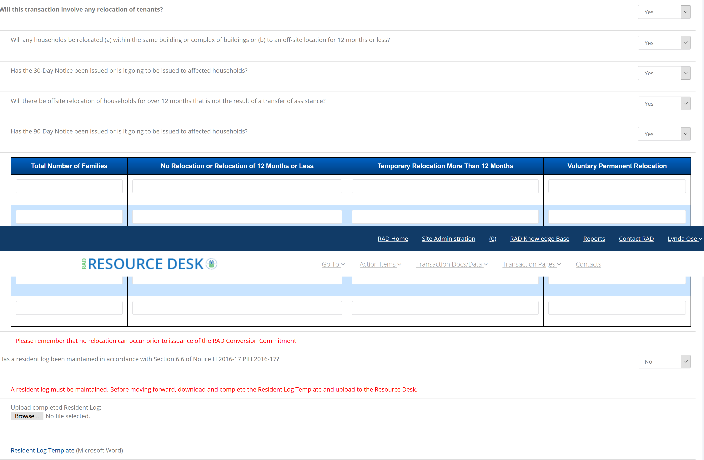

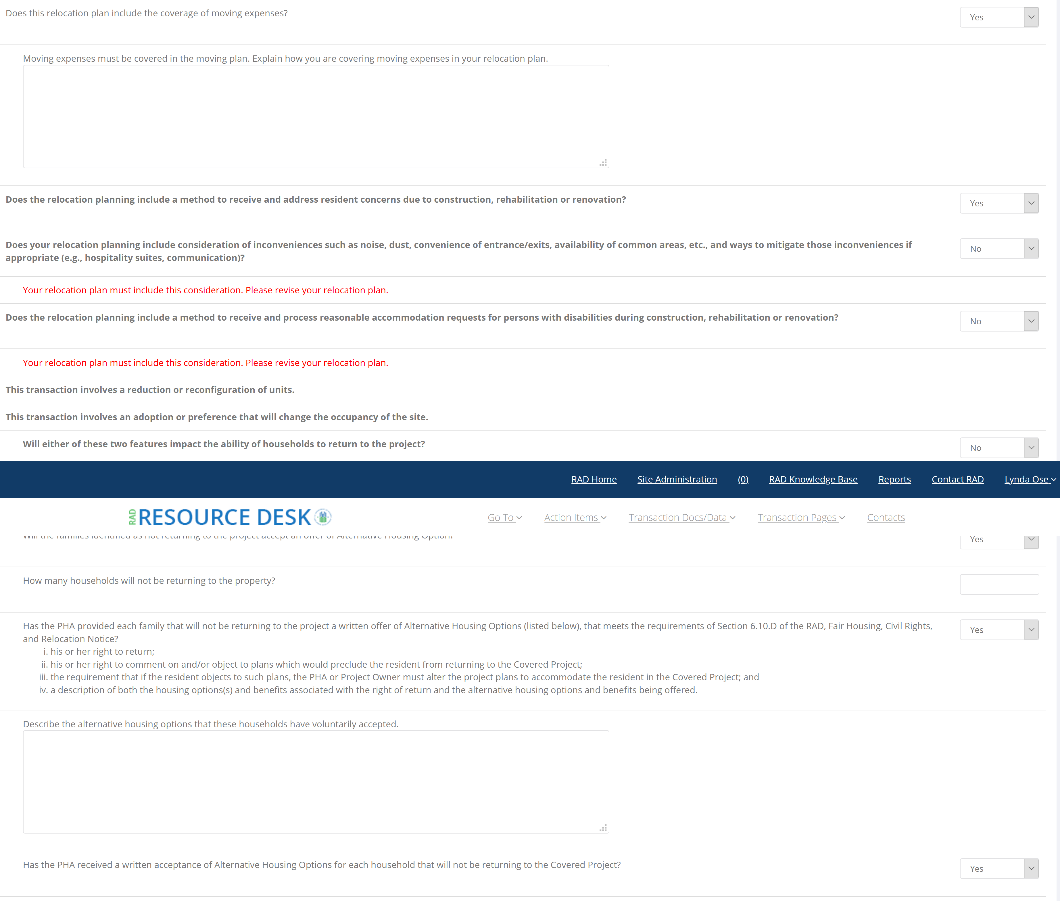

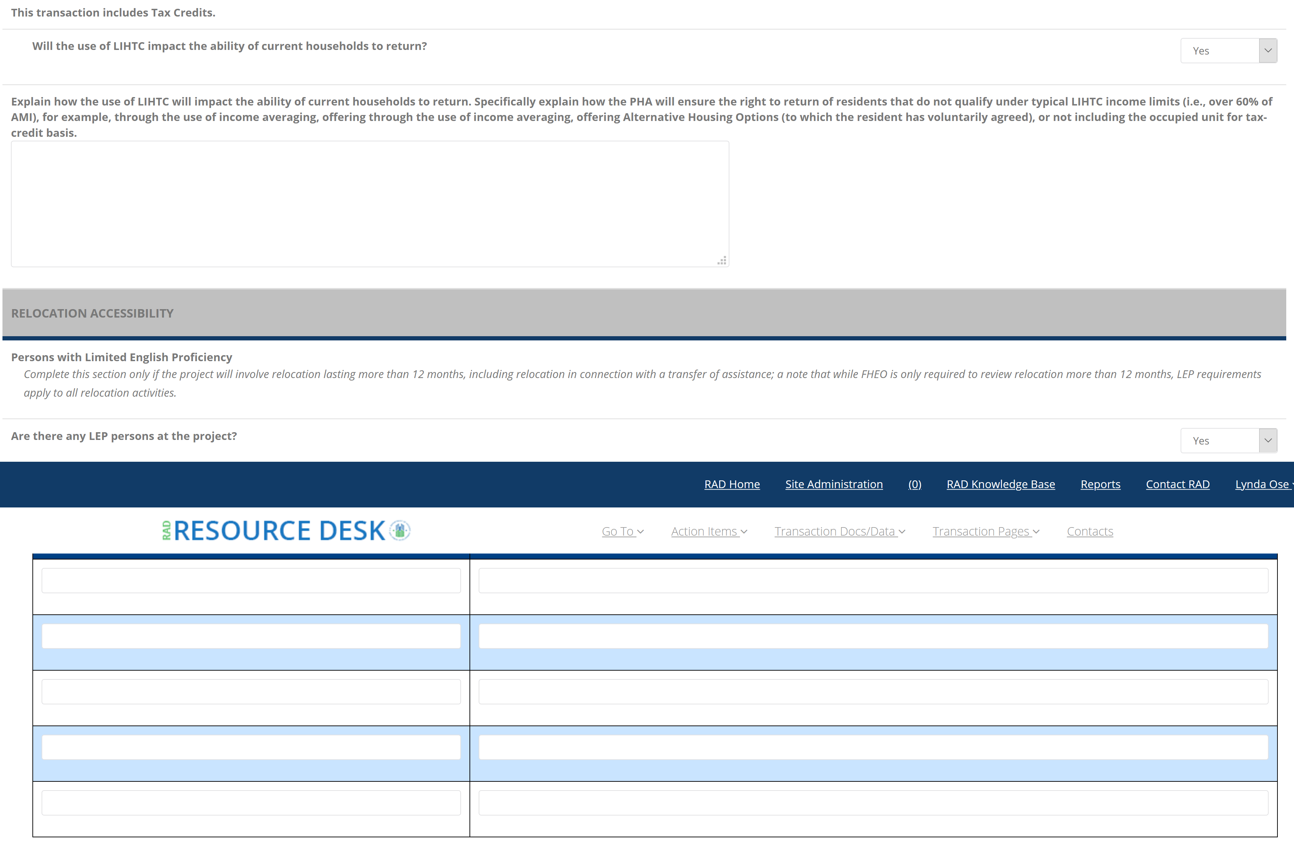

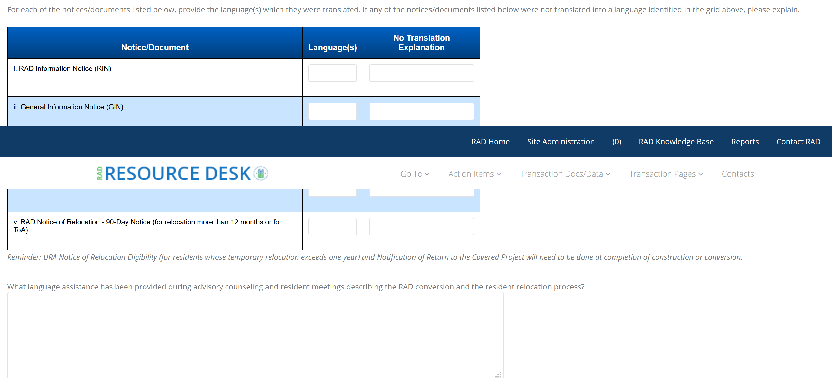

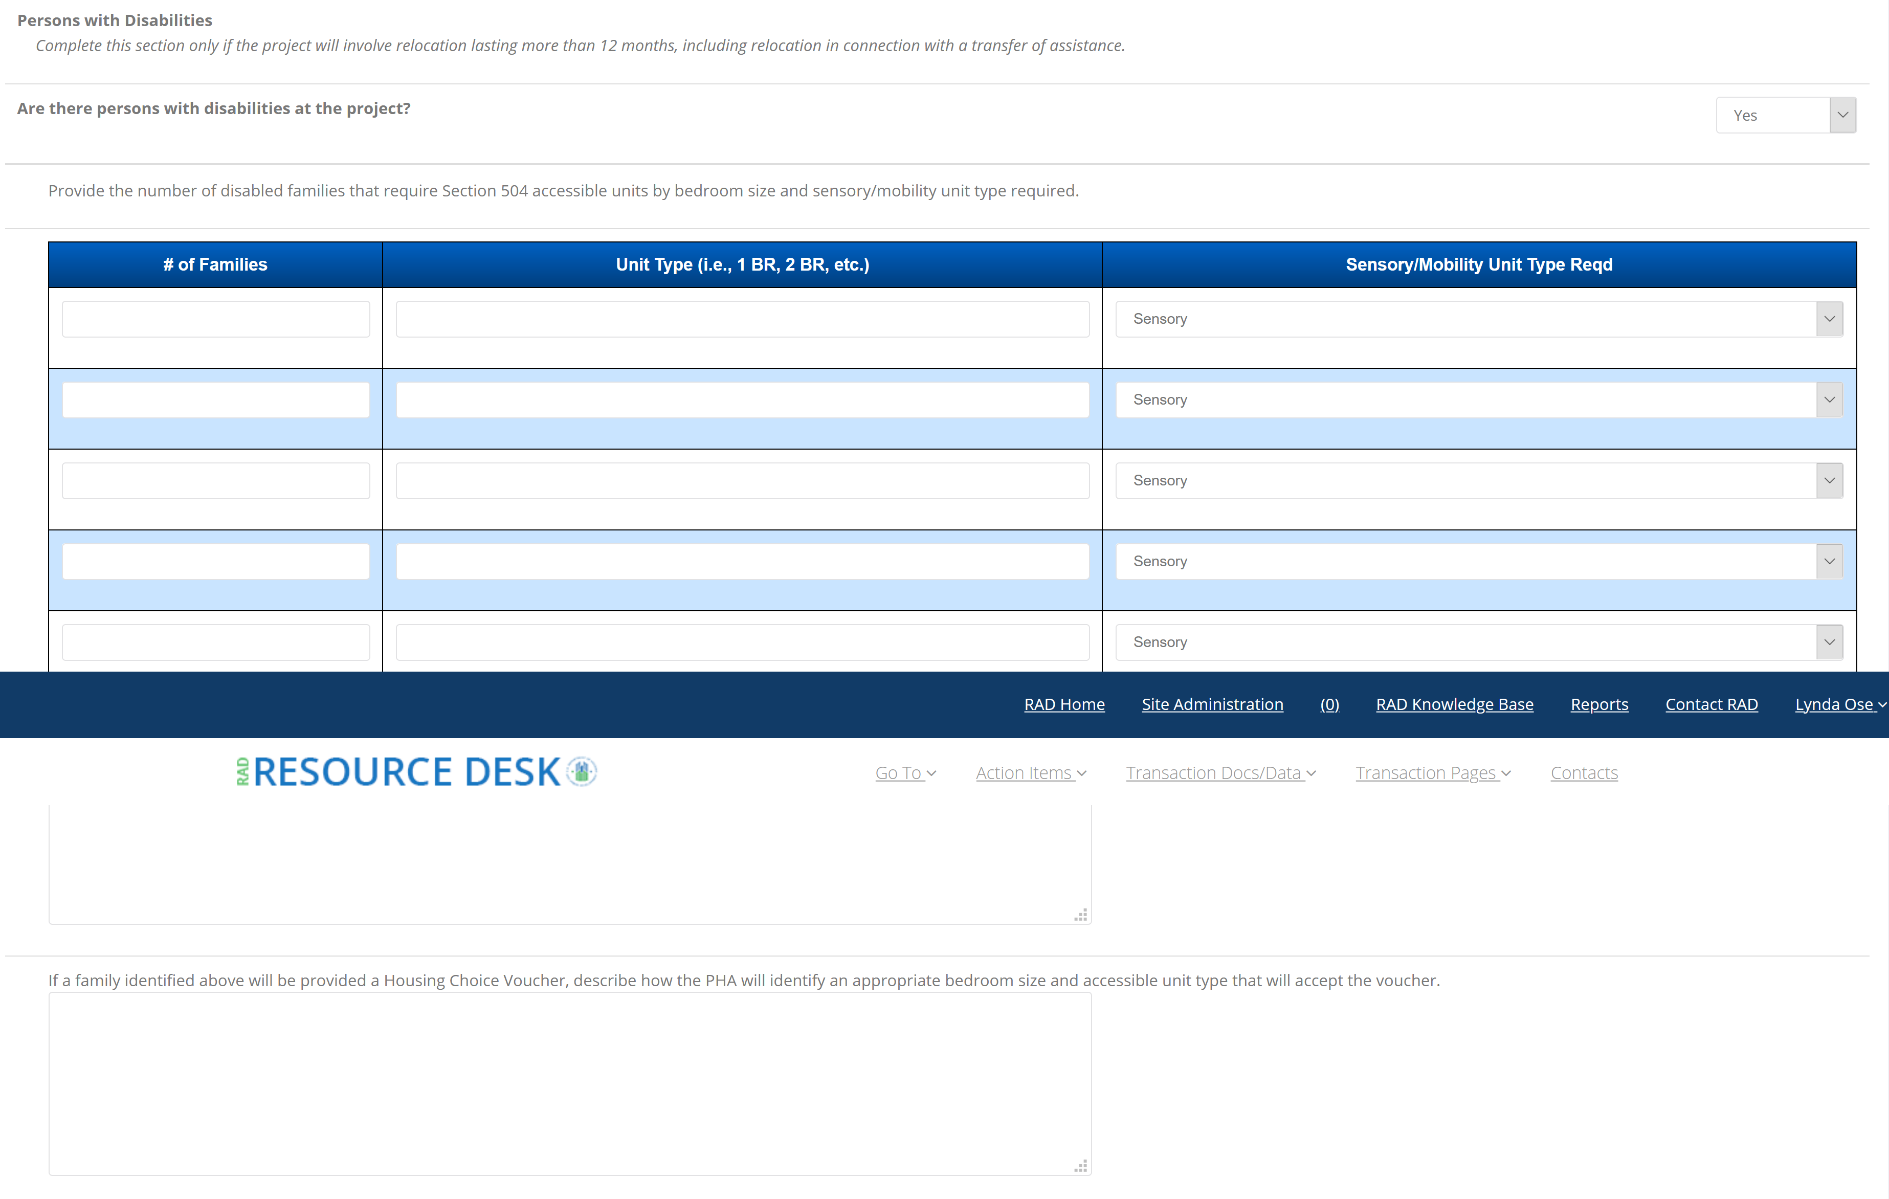

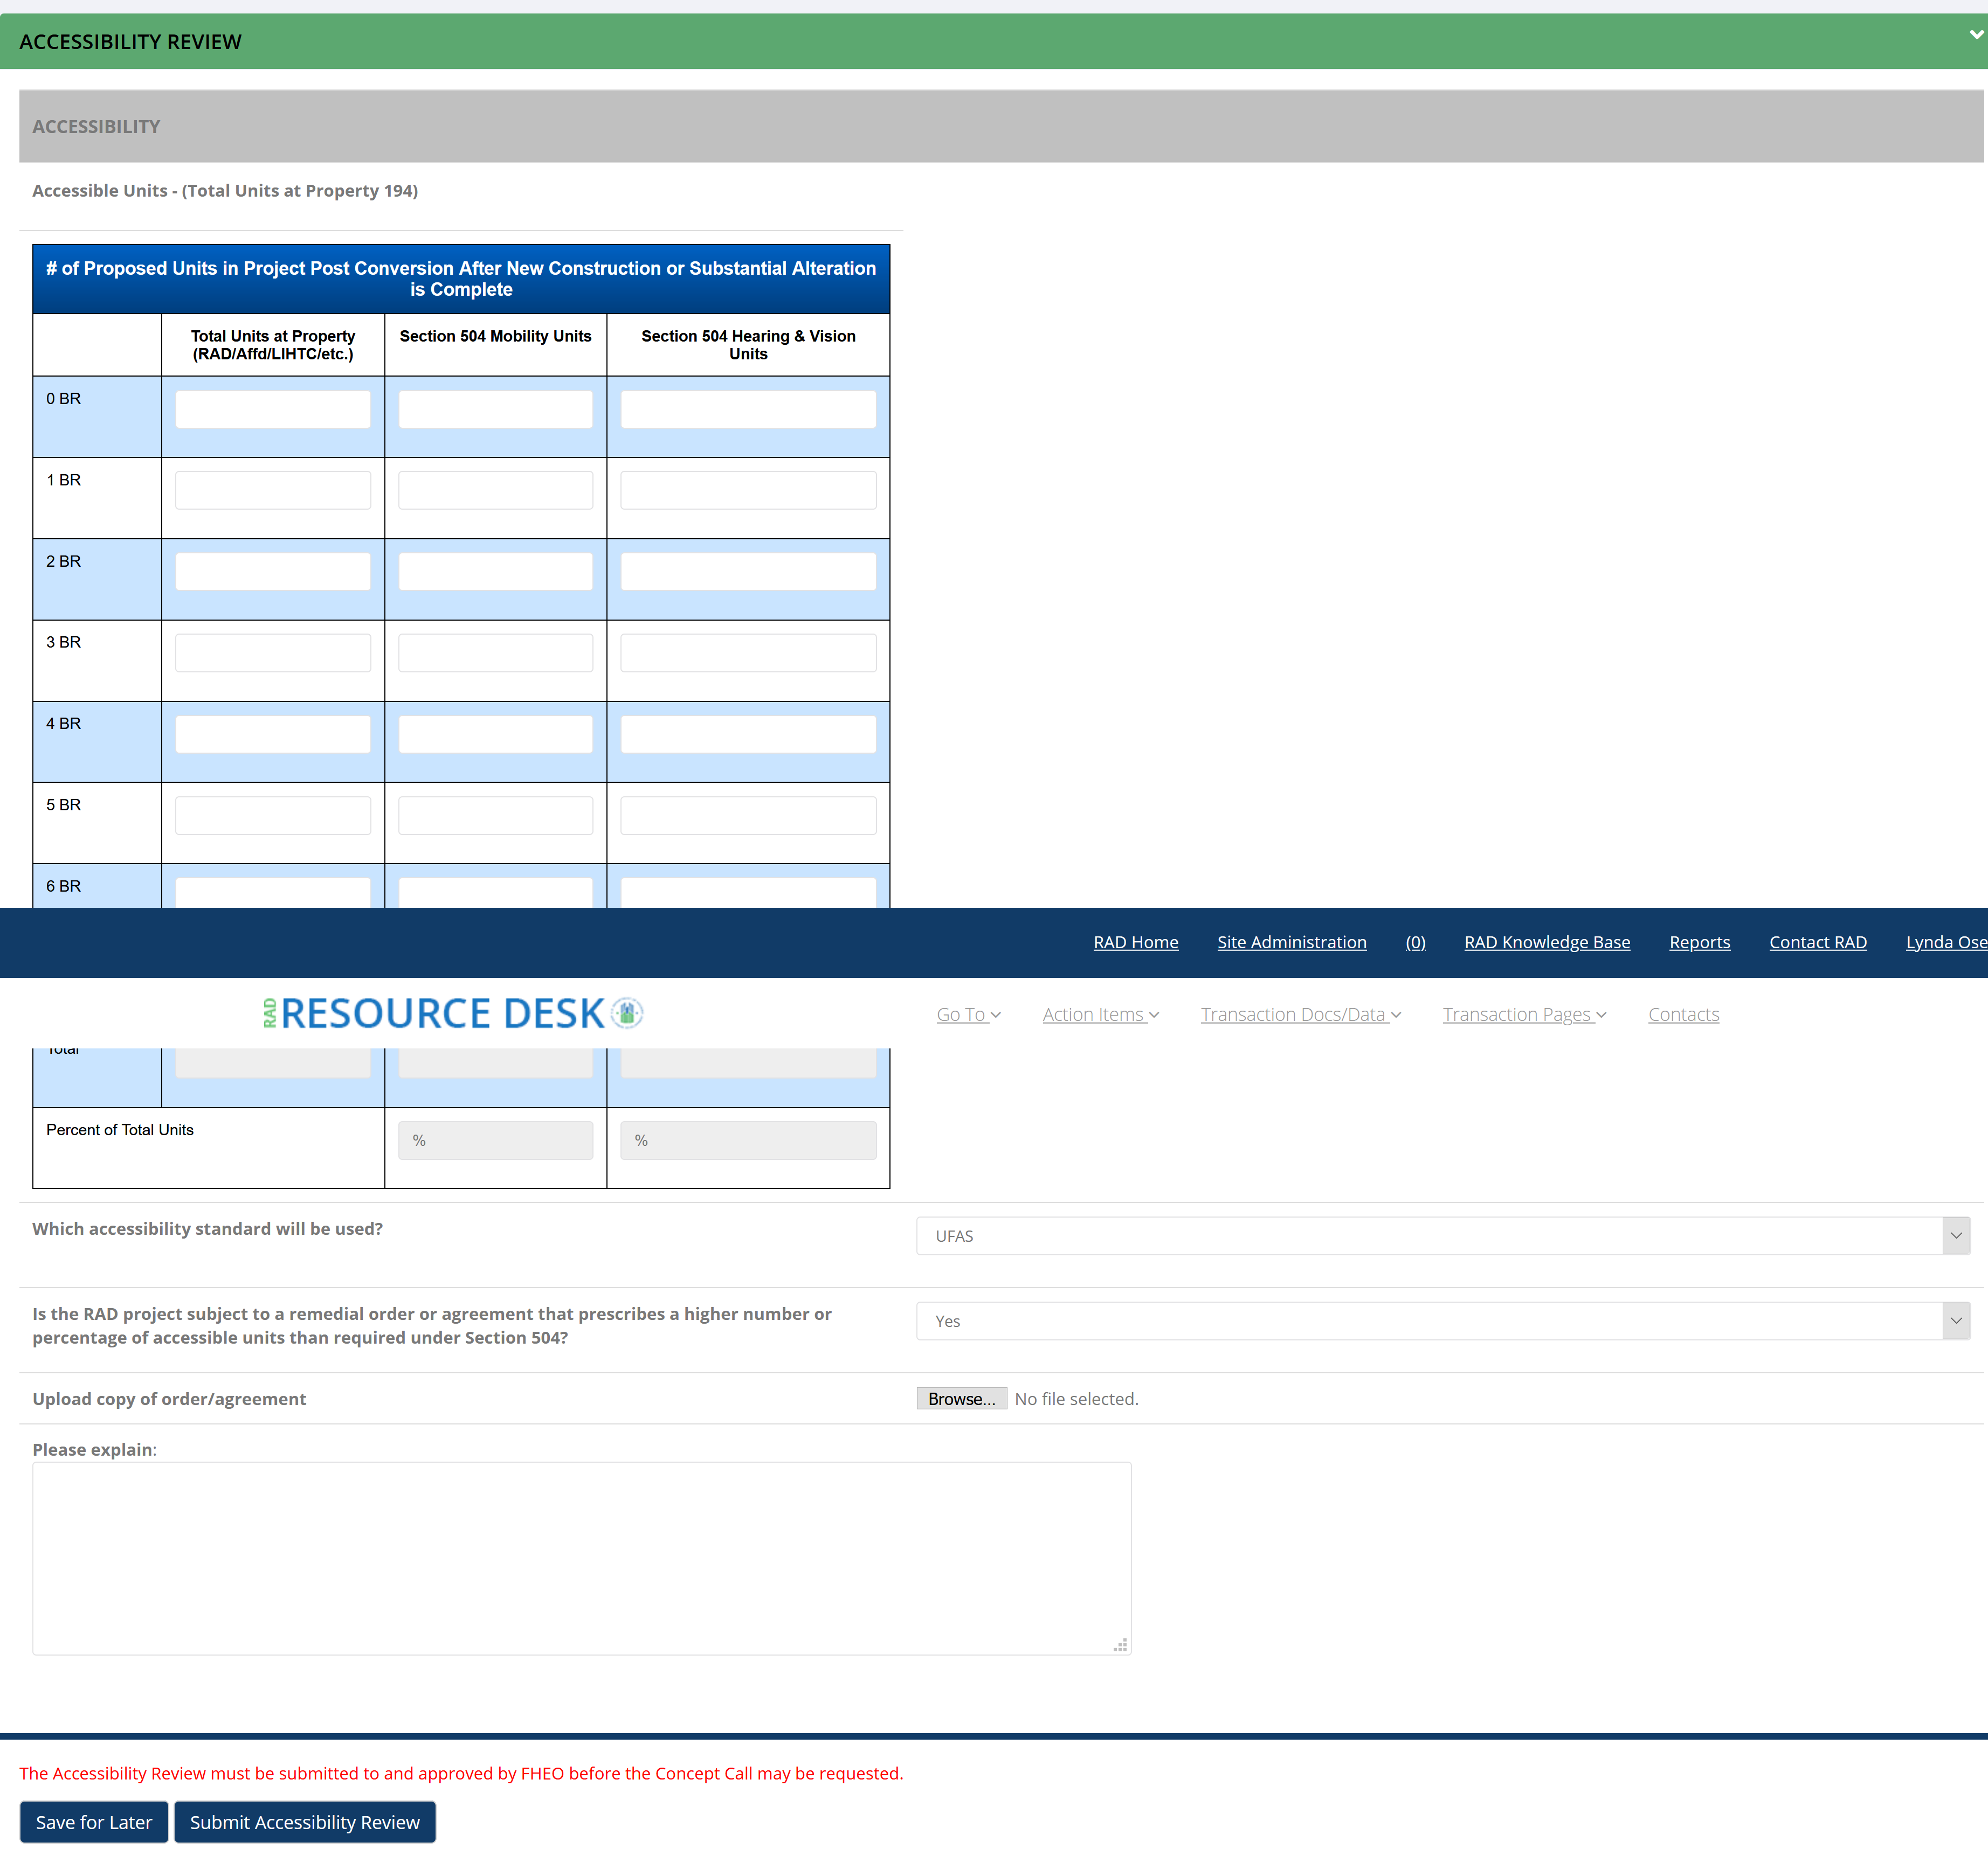

In general, the analysis should use (1) the Census Tract and (2) the census tract together with adjacent census tracts as proxies for the neighborhood. To identify your Census Tract, enter the address here: http://factfinder.census.gov/faces/nav/jsf/pages/searchresults.xhtml?ref=addr&refresh=t
A housing market area is the geographic region from which it is likely that residents of the housing at the proposed site would be drawn for a given multifamily project. A housing market area generally corresponds to, as applicable: (1) the Metropolitan Statistical Area (MetroSA), (2) the Micropolitan Statistical Area (MicroSA), or (3) if the site is in neither a MetroSA or a MicroSA, either (x) the county or statistically equivalent area or (y) the PHA’s service area, whichever is larger. To identify your MetroSA or MicroSA, enter the address here: http://factfinder.census.gov/faces/nav/jsf/pages/searchresults.xhtml?ref=addr&refresh=t
DP-1 is available here: http://factfinder.census.gov/faces/tableservices/jsf/pages/productview.xhtml?pid=DEC_10_DP_DPDP1&src=pt

