NATIONAL CENTER FOR EDUCATION STATISTICS NATIONAL ASSESSMENT OF EDUCATIONAL PROGRESS

National Assessment of Educational Progress (NAEP)
2022

Appendix J3

2022 School Questionnaires

OMB# 1850-0928 v.22

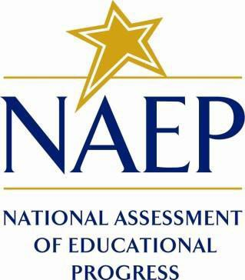

March 2021
No changes since November 2020 (1850-0928 v.21)

Appendix J3 provides a sample from 2020 (OMB# 1850-0928 v.21). Depending on the status of School Survey Questionnaires, final versions may be available for Amendment #1 by June 2021, or some combination of Amendment #1 (by June 2021) and Amendment #2 (by August 2021).
Table of Contents
School Questionnaires
NAEPq School Login 3
Appendix J3-1: Summary of Changes Operational Grade 4 CORE 4
Appendix J3-2: Operational Grade 4 CORE 14
Appendix J3-3: Summary of Changes Operational Grade 8 CORE 25
Appendix J3-4: Operational Grade 8 CORE 35
Appendix J3-4: Summary of Changes Operational Grade 4 and 8 Charter School 46
Appendix J3-6: Operational Grade 4 and 8 Charter School 49
Appendix J3-7: Summary of Changes Operational Grade 4 Mathematics 51
Appendix J3-8: Operational Grade 4 Mathematics 54
Appendix J3-9: Summary of Changes Operational Grade 8 Mathematics 58
Appendix J3-10: Operational Grade 8 Mathematics 62
Appendix J3-11: Summary of Changes Operational Grade 4 Reading 67
Appendix J3-12: Operational Grade 4 Reading 71
Appendix J3-13: Summary of Changes Operational Grade 8 Reading 76
Appendix J3-14: Operational Grade 8 Reading 81
Appendix J3-15: Operational Grade 4 COVID-19 School Items (New) 86
Appendix J3-16: Operational Grade 8 COVID-19 School Items (New) 95

NAEPq School Login

School Administrator Questionnaire Login Screen
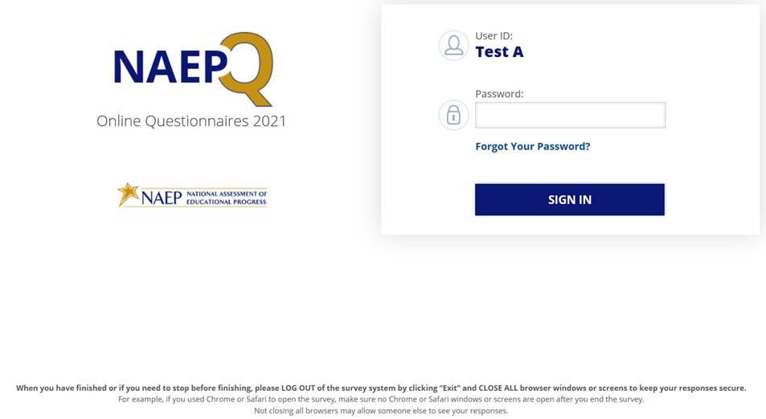
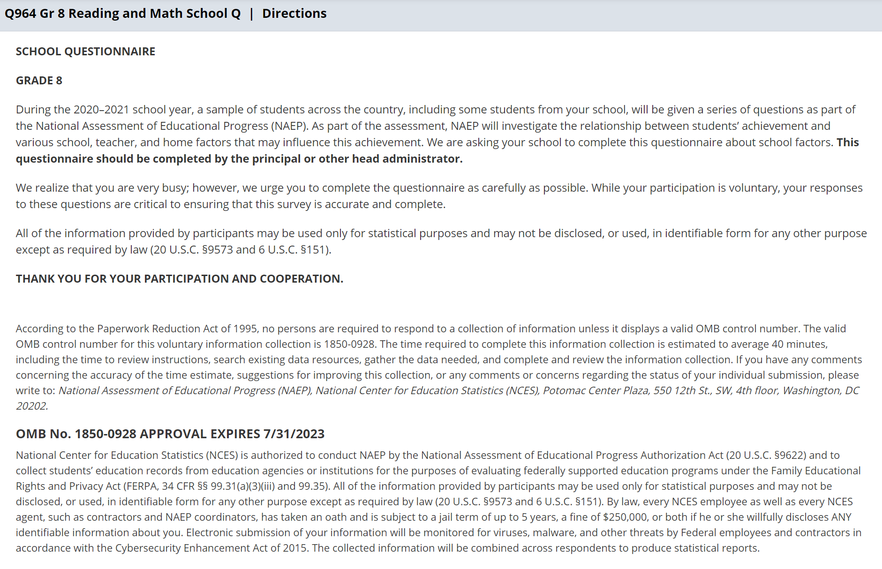

Appendix J3-1: Summary of Changes Operational Grade 4 CORE

2021 Operational Grade 4 Core School

Previous item | 2021 item | D/A/ R/NC+ | Rationale
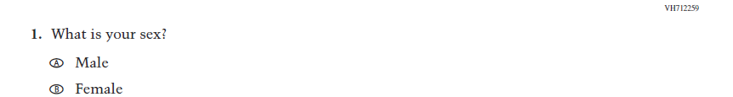  (2019 Grade 4) | 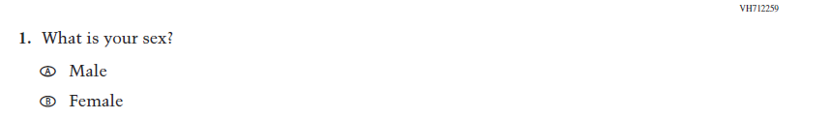  Issue: Gender | NC | N/A
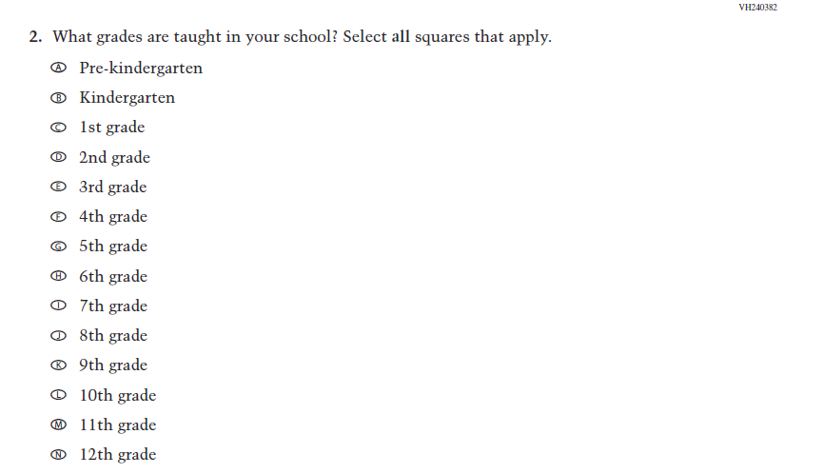  (2019 Grade 4) | 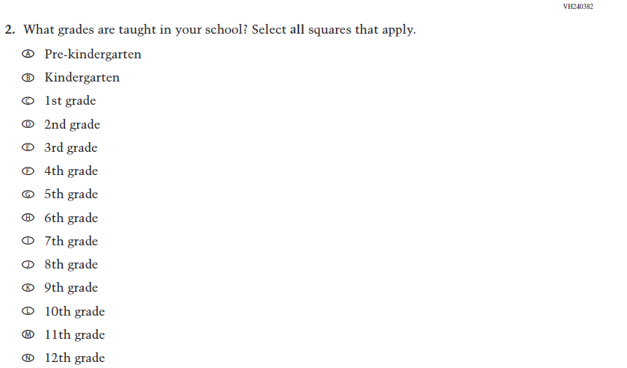  Issue: School Climate | NC | N/A
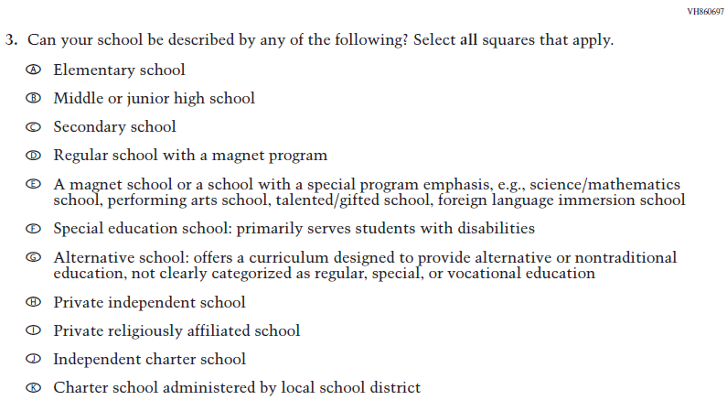  (2019 Grade 4) | Issue: School Climate | NC | N/A
2021 Operational Grade 4 Core School

Previous item | 2021 item | D/A/ R/NC+ | Rationale
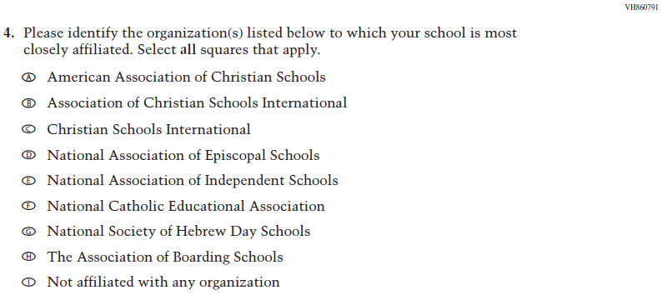  (2019 Grade 4) | Issue: School Climate | NC | N/A
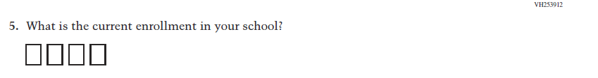  (2019 Grade 4) | 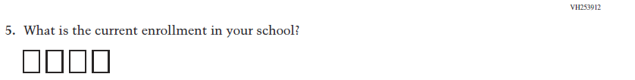  Issue: School Climate | NC | N/A
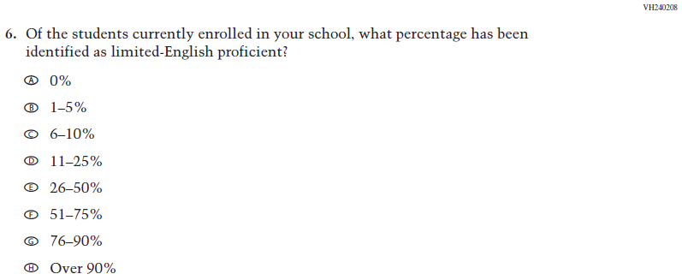  (2019 Grade 4) | Issue: School Climate | NC | N/A
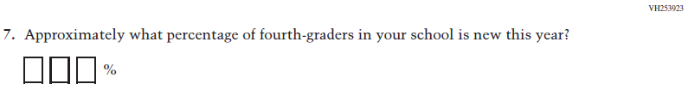  (2019 Grade 4) | Issue: School Climate | NC | N/A

2021 Operational Grade 4 Core School

Previous item | 2021 item | D/A/ R/NC+ | Rationale
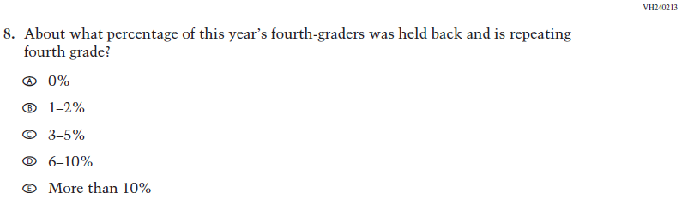  (2019 Grade 4) | Issue: School Climate | NC | N/A
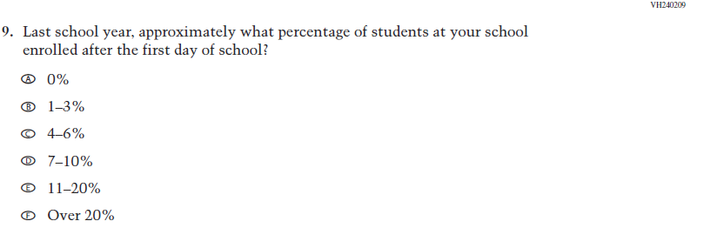  (2019 Grade 4) | Issue: School Climate | NC | N/A
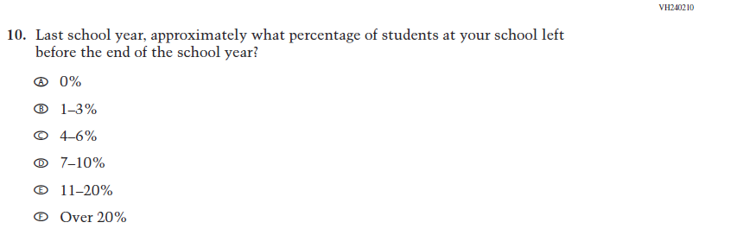  (2019 Grade 4) | Issue: School Climate | NC | N/A

2021 Operational Grade 4 Core School

Previous item | 2021 item | D/A/ R/NC+ | Rationale
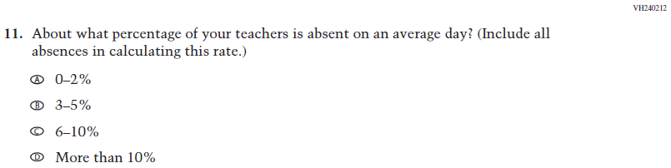  (2019 Grade 4) | Issue: School Climate | NC | N/A
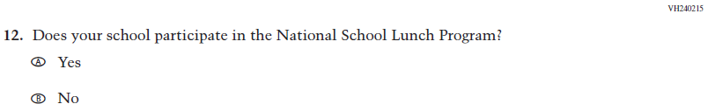  (2019 Grade 4) | Issue: Socioeconomic Status | NC | N/A
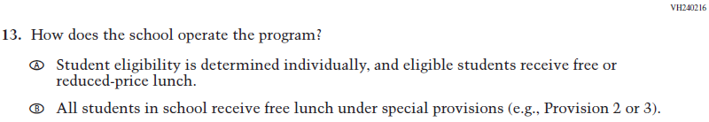  (2019 Grade 4) | Issue: Socioeconomic Status | NC | N/A
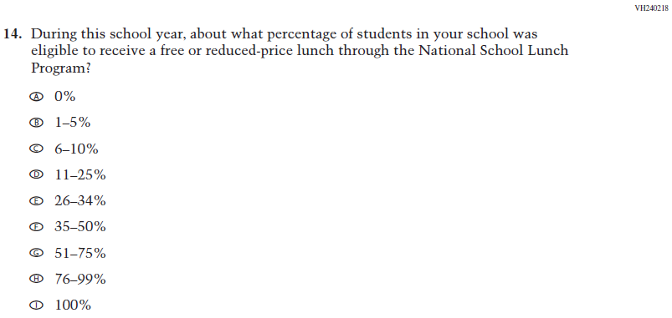  (2019 Grade 4) | Issue: Socioeconomic Status | NC | N/A
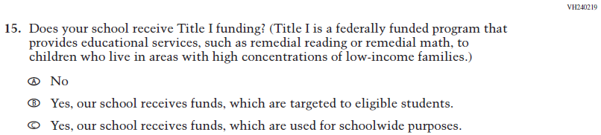  (2019 Grade 4) | Issue: Socioeconomic Status | NC | N/A
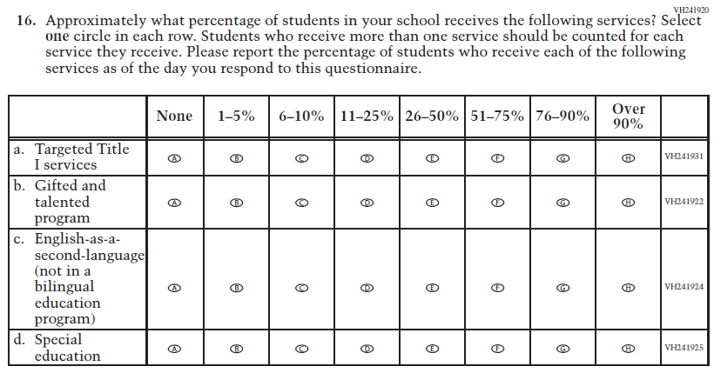  (2019 Grade 4) | Issue: School Climate | NC | N/A
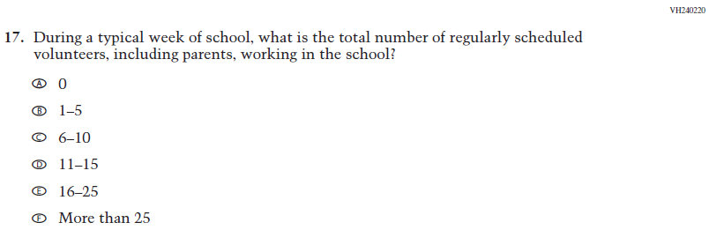  (2019 Grade 4) | Issue: School Climate | NC | N/A
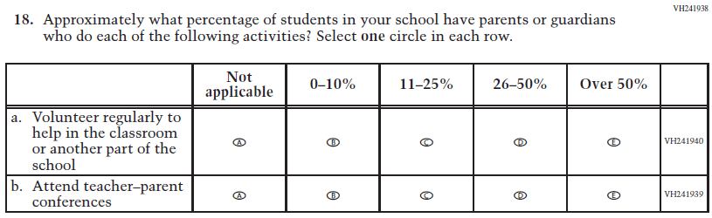  (2019 Grade 4) | Issue: School Climate | NC | N/A
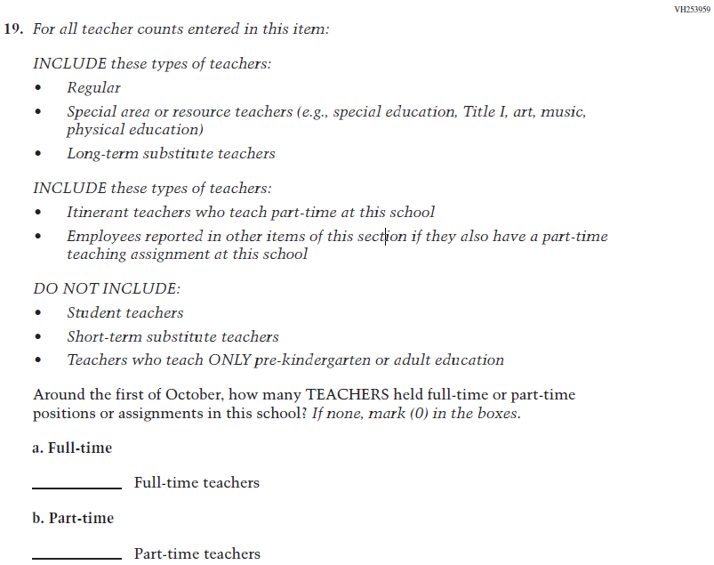  (2019 Grade 4) | Issue: School Climate | NC | N/A

2021 Operational Grade 4 Core School

Previous item | 2021 item | D/A/ R/NC+ | Rationale
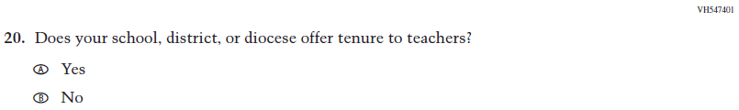  (2019 Grade 4) | Issue: School Climate | NC | N/A
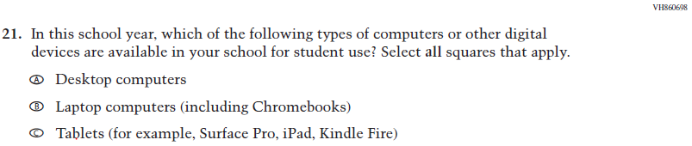  (2019 Grade 4) | Issue: Technology Use | NC | N/A
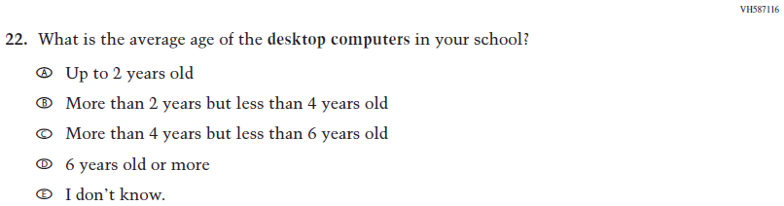  (2019 Grade 4) | Issue: Technology Use | NC | N/A
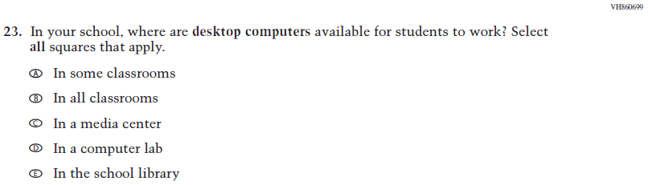  (2019 Grade 4) | Issue: Technology Use | NC | N/A
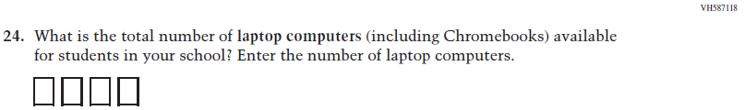  (2019 Grade 4) | Issue: Technology Use | NC | N/A
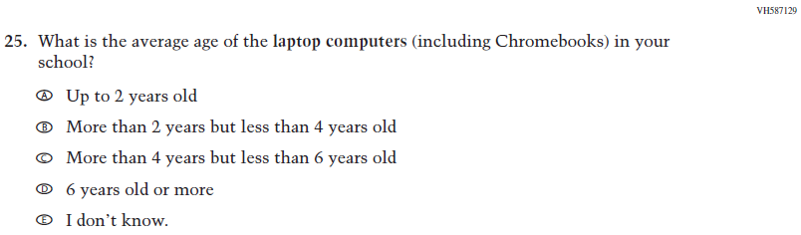  (2019 Grade 4) | Issue: Technology Use | NC | N/A
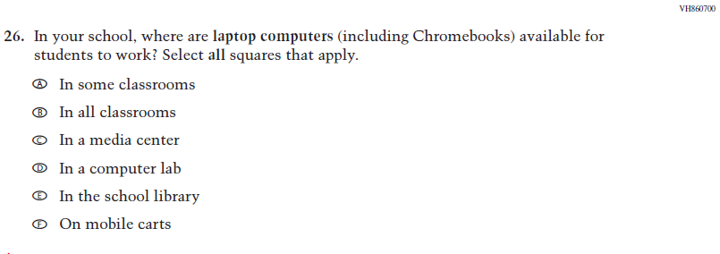(2019 Grade 4) | Issue: Technology Use | NC | N/A
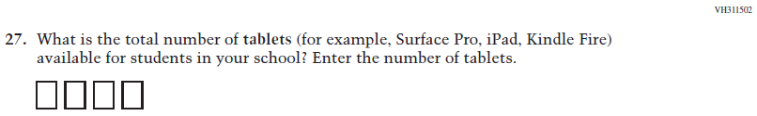  (2019 Grade 4) | Issue: Technology Use | NC | N/A
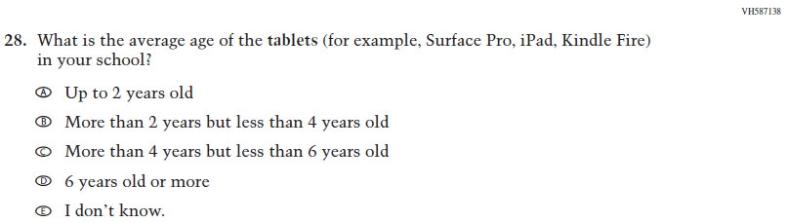  (2019 Grade 4) | Issue: Technology Use | NC | N/A
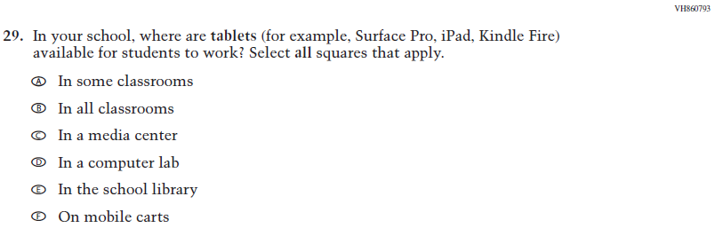  (2019 Grade 4) | Issue: Technology Use | NC | N/A
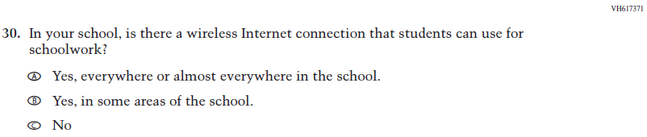  (2019 Grade 4) | Issue: Technology Use | NC | N/A

Appendix J3-2: Operational Grade 4 CORE

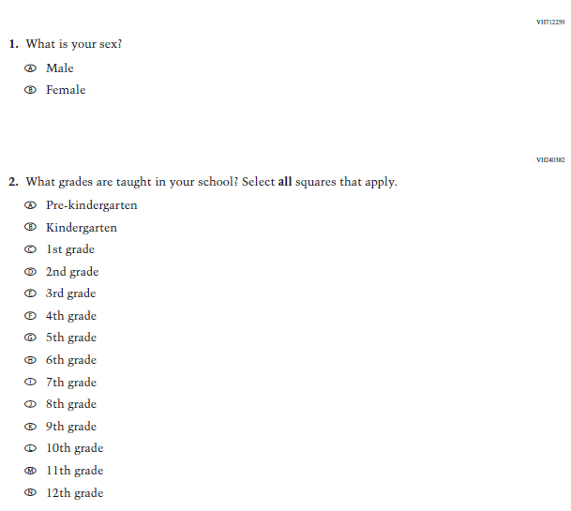
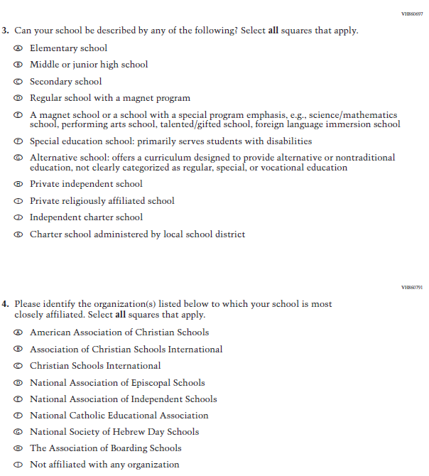

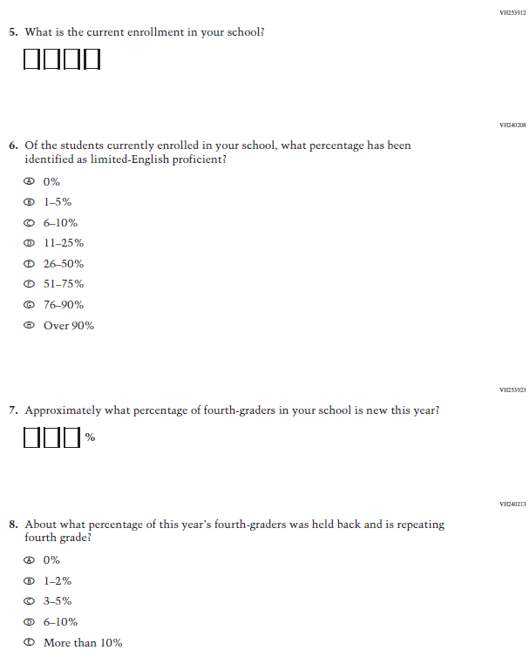

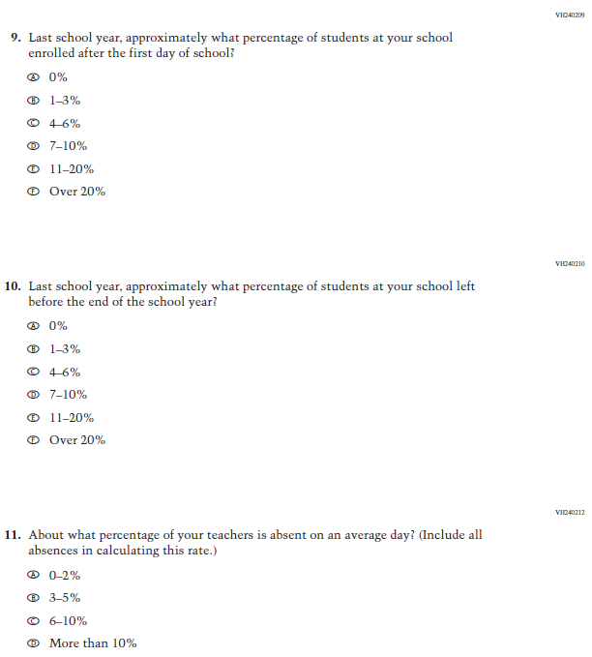

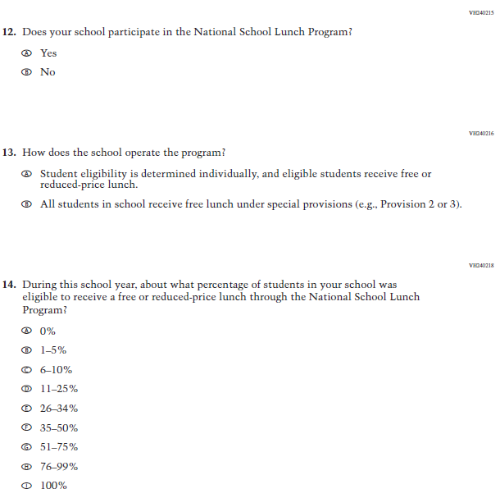

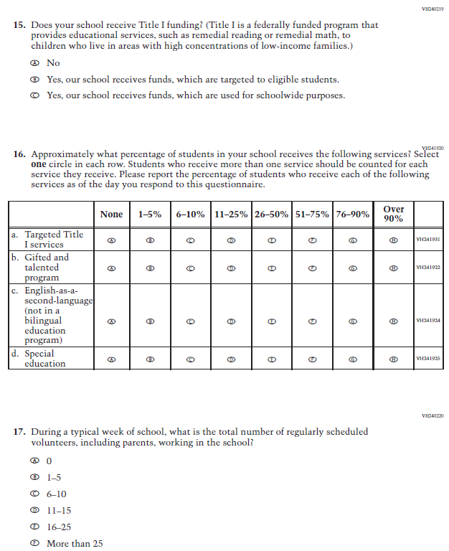

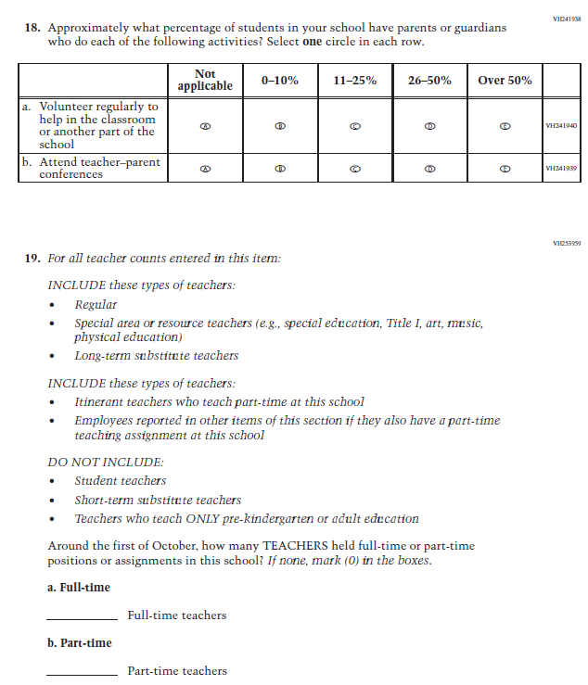

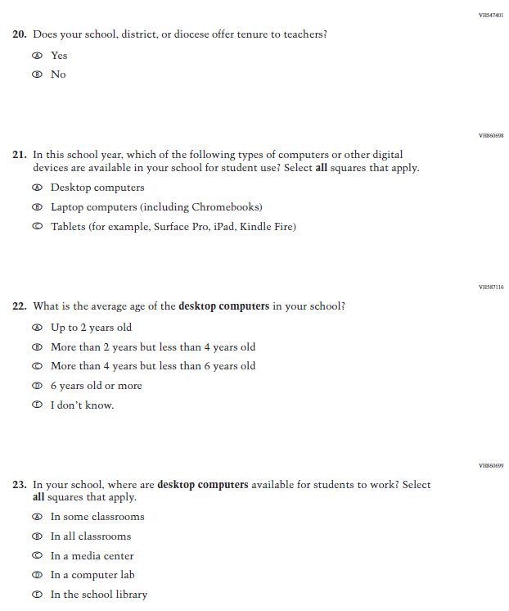

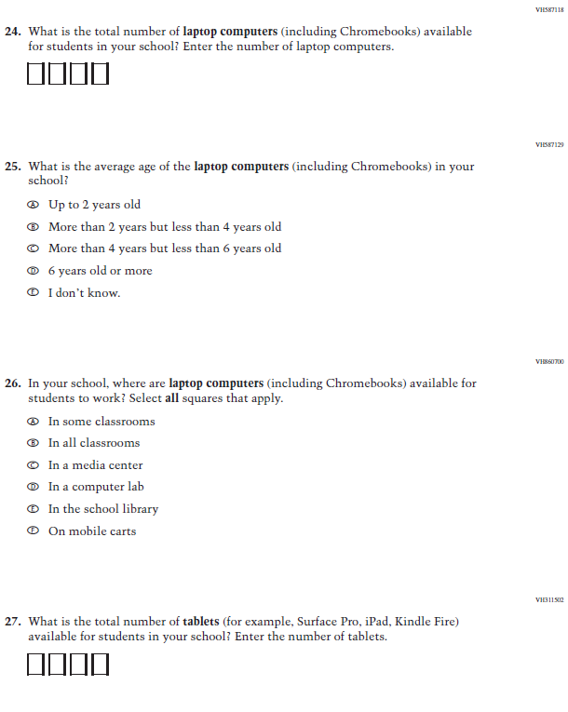

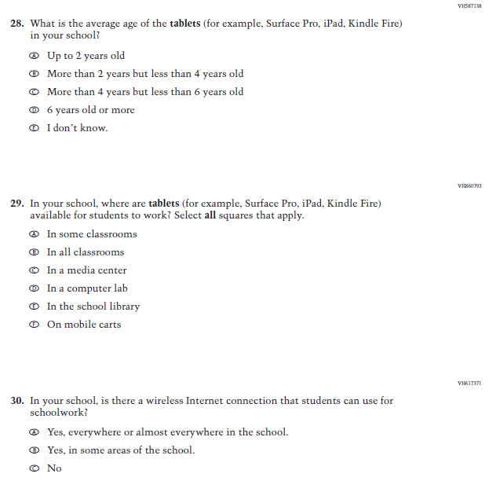

Appendix J3-3: Summary of Changes Operational Grade 8 CORE

2021 Operational Grade 8 Core School
Previous item | 2021 item | D/A/ R/NC+ | Rationale
(2019 Grade 8) | Issue: Gender | NC | N/A
(2019 Grade 8) | Issue: School Climate | NC | N/A
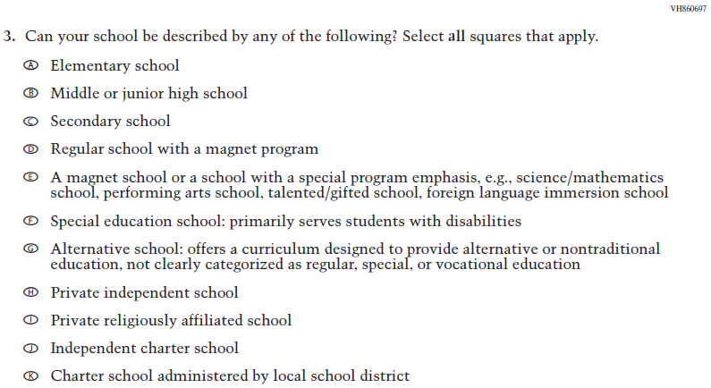  (2019 Grade 8) | Issue: School Climate | NC | N/A
2021 Operational Grade 8 Core School

Previous item | 2021 item | D/A/ R/NC+ | Rationale
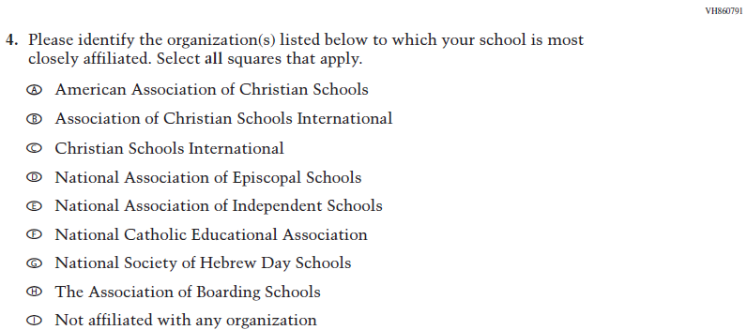  ((2019 Grade 8) | Issue: School Climate | NC | N/A
(2019 Grade 8) | Issue: School Climate | NC | N/A
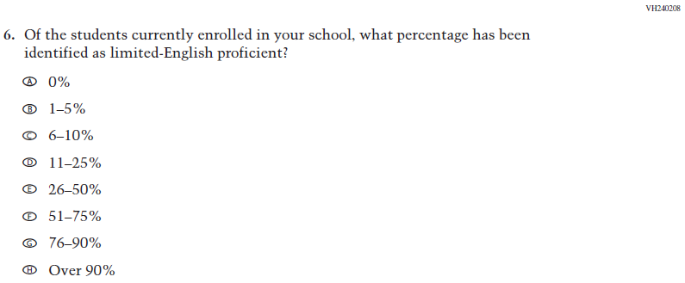  (2019 Grade 8) | Issue: School Climate | NC | N/A
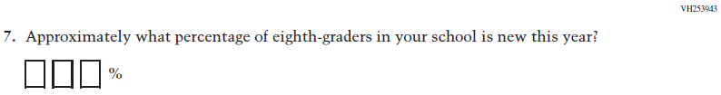  (2019 Grade 8) | Issue: School Climate | NC | N/A

2021 Operational Grade 8 Core School

Previous item | 2021 item | D/A/ R/NC+ | Rationale
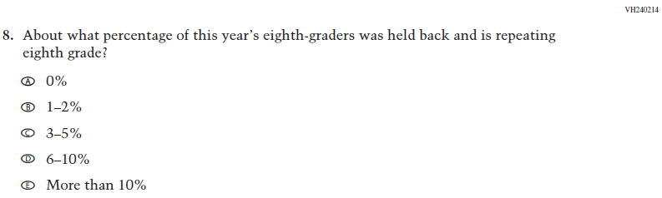  (2019 Grade 8) | Issue: School Climate | NC | N/A
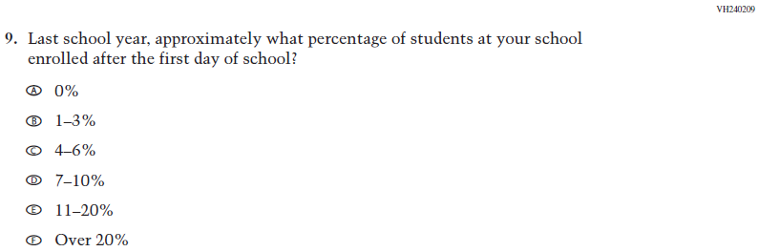  (2019 Grade 8) | Issue: School Climate | NC | N/A
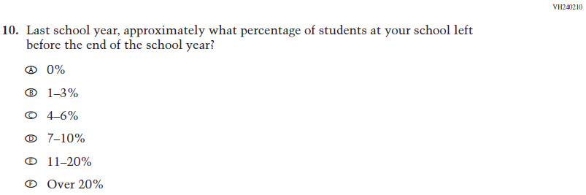  (2019 Grade 8) | Issue: School Climate | NC | N/A

2021 Operational Grade 8 Core School

Previous item | 2021 item | D/A/ R/NC+ | Rationale
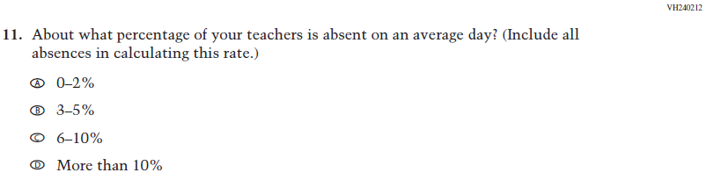  (2019 Grade 8) | Issue: School Climate | NC | N/A
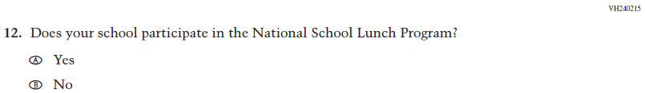  (2019 Grade 8) | Issue: Socioeconomic Status | NC | N/A
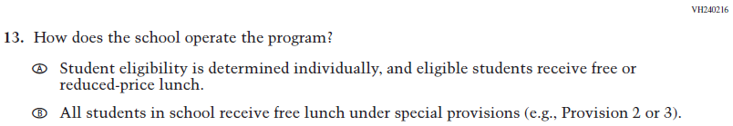  (2019 Grade 8) | Issue: Socioeconomic Status | NC | N/A
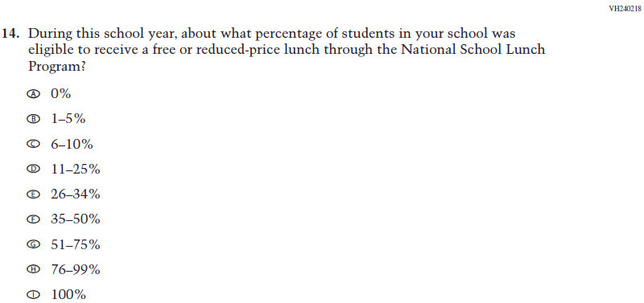  (2019 Grade 8) | Issue: Socioeconomic Status | NC | N/A
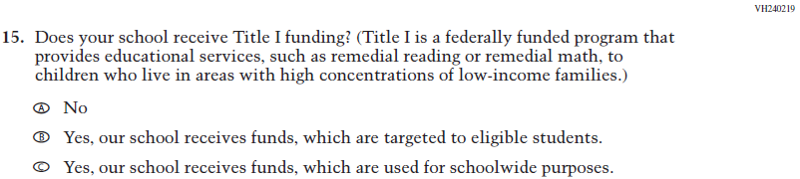  (2019 Grade 8) | Issue: Socioeconomic Status | NC | N/A
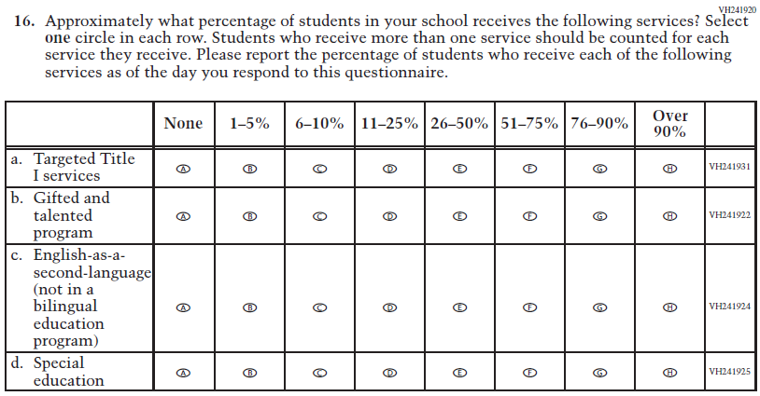  (2019 Grade 8) | Issue: School Climate | NC | N/A
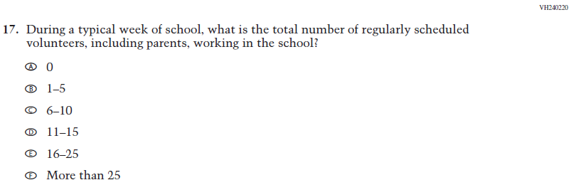  (2019 Grade 8) | Issue: School Climate | NC | N/A
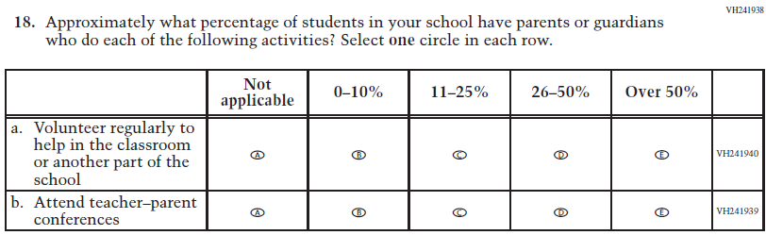  (2019 Grade 8) | Issue: School Climate | NC | N/A
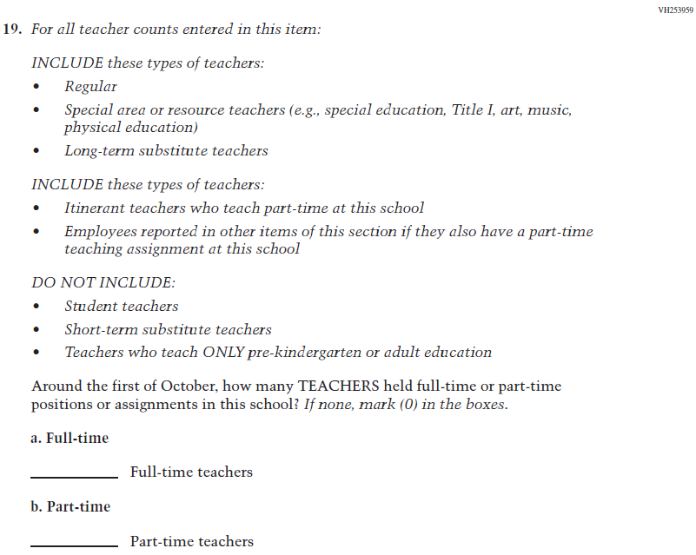  (2019 Grade 8) | Issue: School Climate | NC | N/A

2021 Operational Grade 8 Core School

Previous item | 2021 item | D/A/ R/NC+ | Rationale
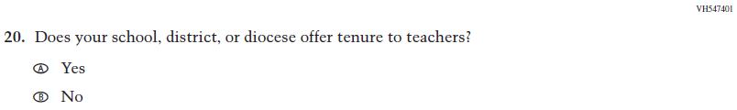  (2019 Grade 8) | Issue: School Climate | NC | N/A
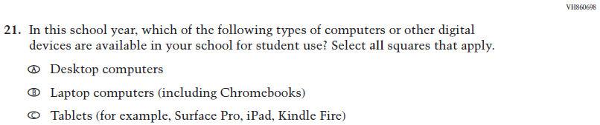  (2019 Grade 8) | Issue: Technology Use | NC | N/A
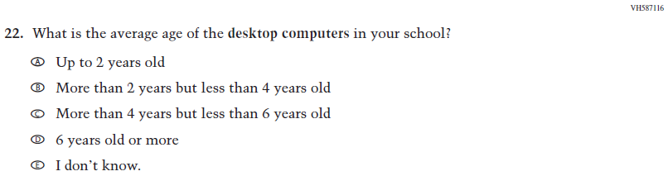  (2019 Grade 8) | Issue: Technology Use | NC | N/A
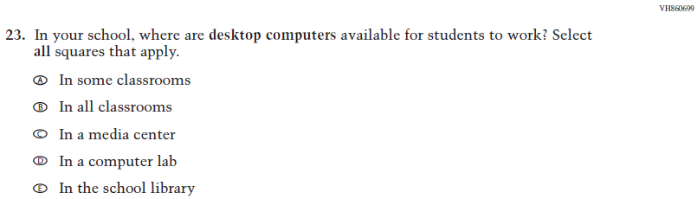  (2019 Grade 8) | Issue: Technology Use | NC | N/A
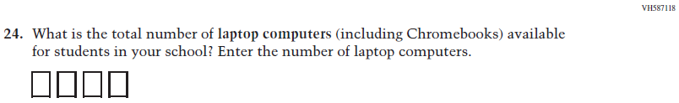  (2019 Grade 8) | Issue: Technology Use | NC | N/A
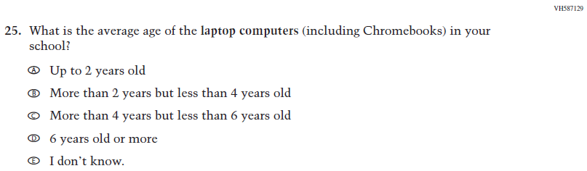  (2019 Grade 8) | Issue: Technology Use | NC | N/A
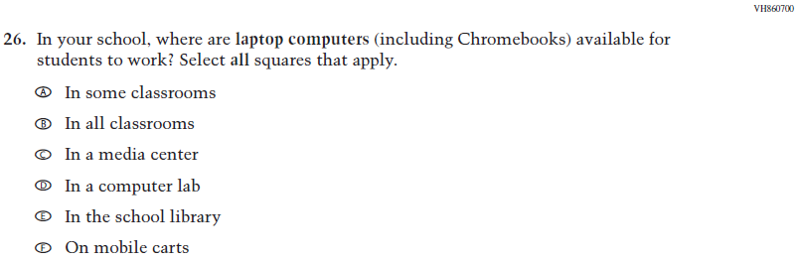  (2019 Grade 8) | Issue: Technology Use | NC | N/A
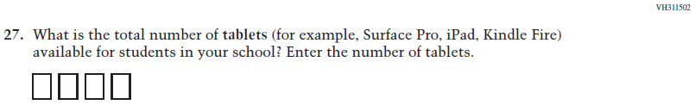  (2019 Grade 8) | Issue: Technology Use | NC | N/A

2021 Operational Grade 8 Core School

Previous item | 2021 item | D/A/ R/NC+ | Rationale
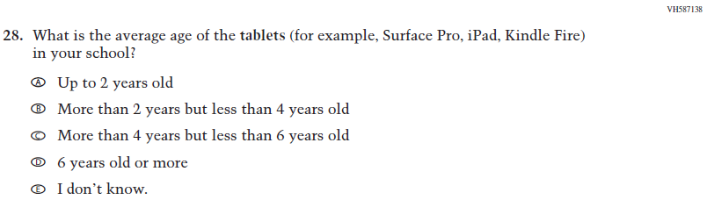  (2019 Grade 8) | Issue: Technology Use | NC | N/A
(2019 Grade 8) | Issue: Technology Use | NC | N/A
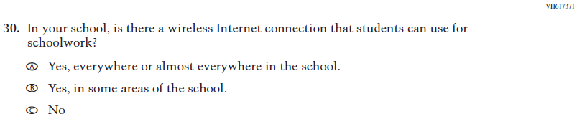  (2019 Grade 8) | Issue: Technology Use | NC | N/A

Appendix J3-4: Operational Grade 8 CORE

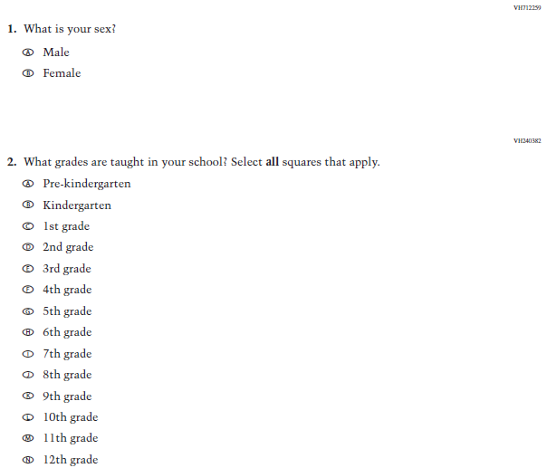

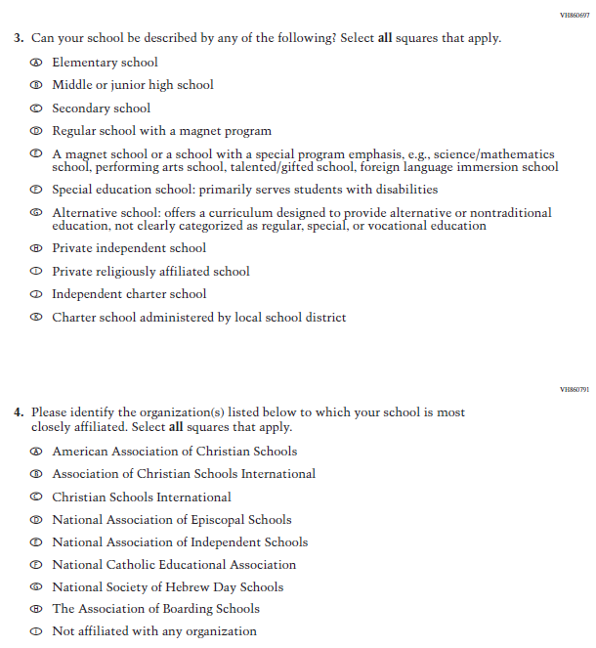

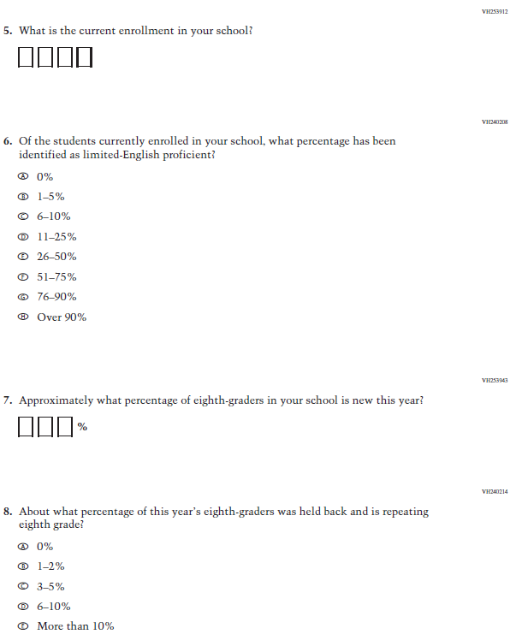

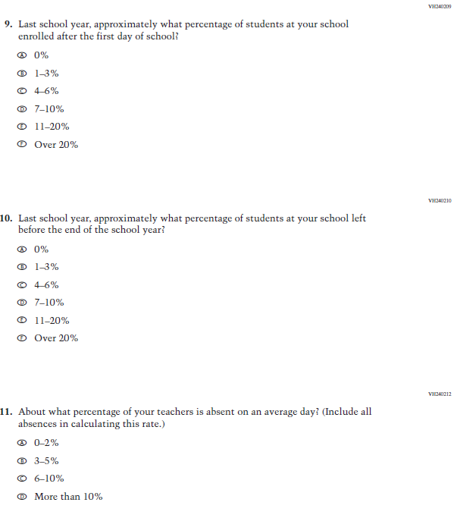

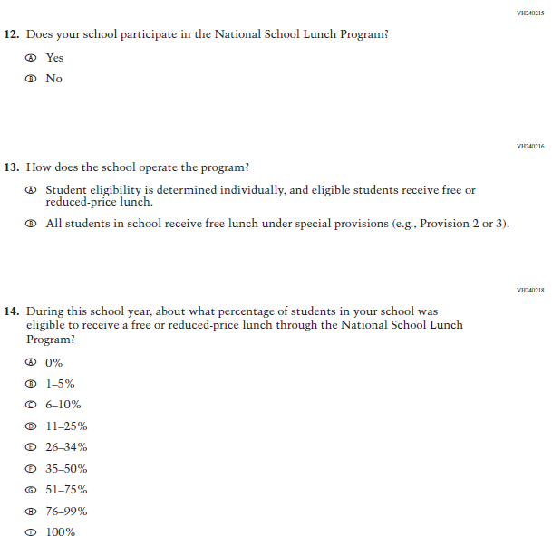

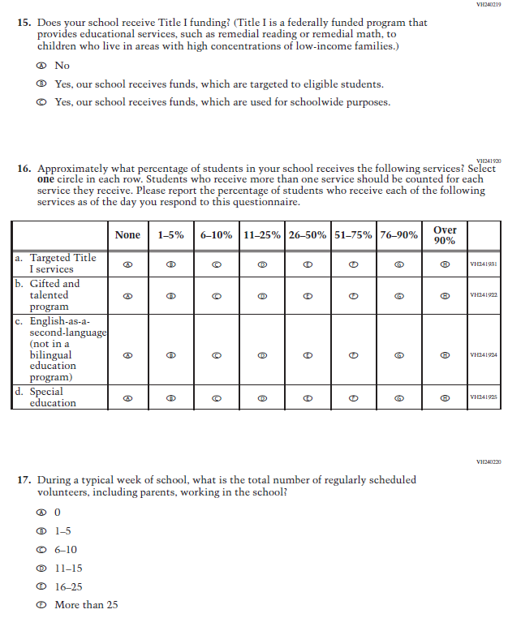

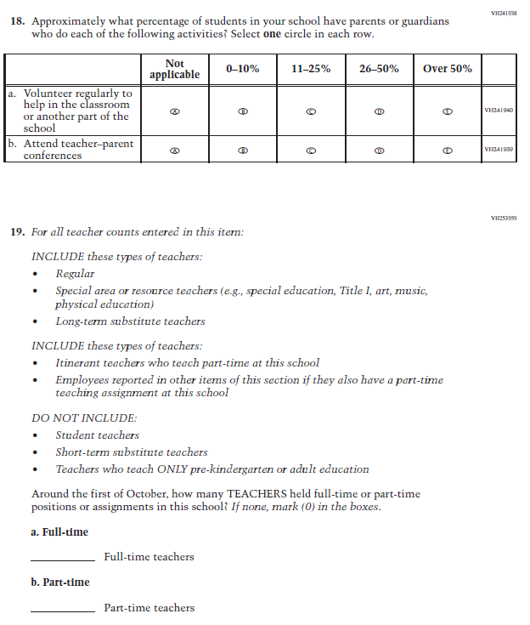

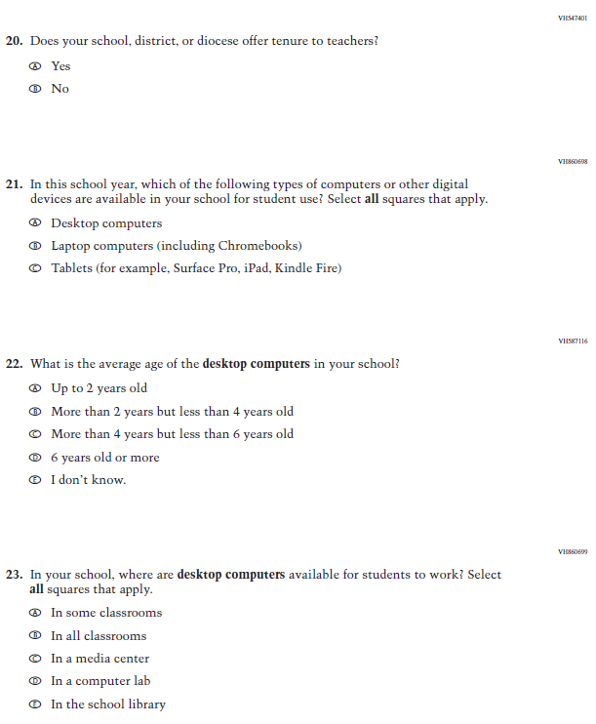
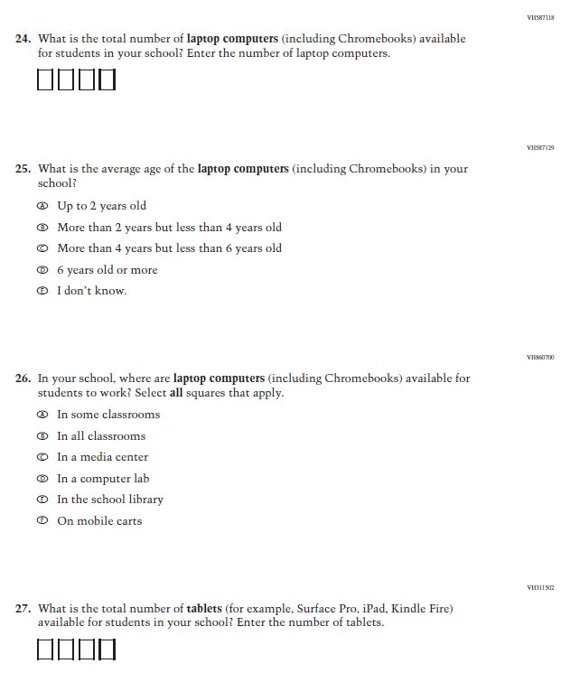

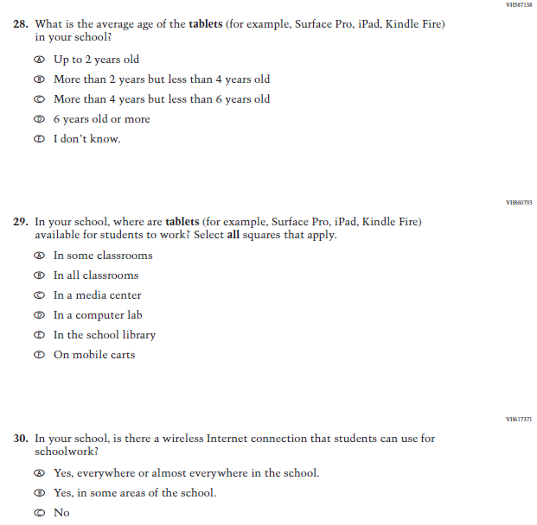

Appendix J3-4: Summary of Changes Operational Grade 4 and 8 Charter School

2021 Operational Grade 4 and 8 Charter School

Previous item | 2021 item | D/A/ R/NC+ | Rationale
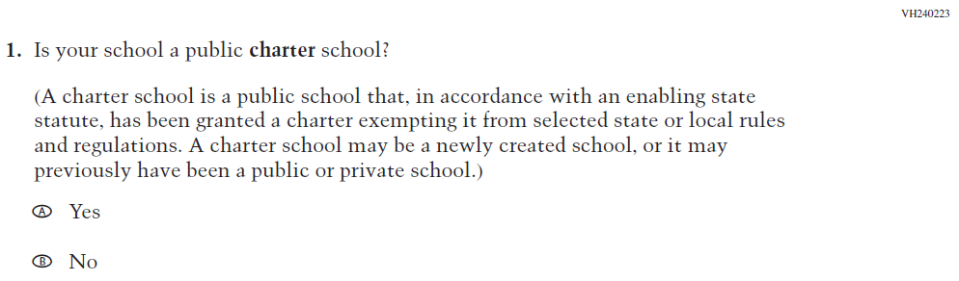  (2019 Grade 4, 8, and 12) | 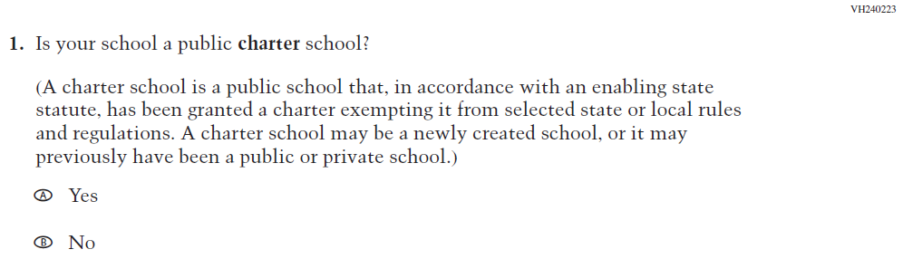  Issue: School Climate | NC | N/A
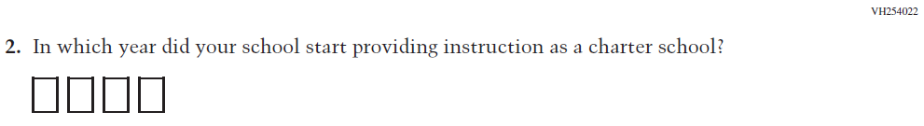  (2019 Grade 4, 8, and 12) | 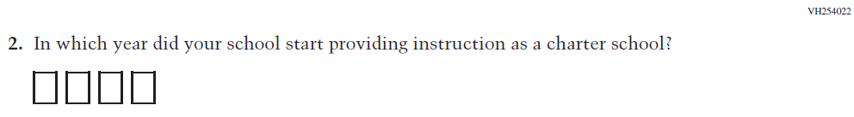  Issue: School Climate | NC | N/A
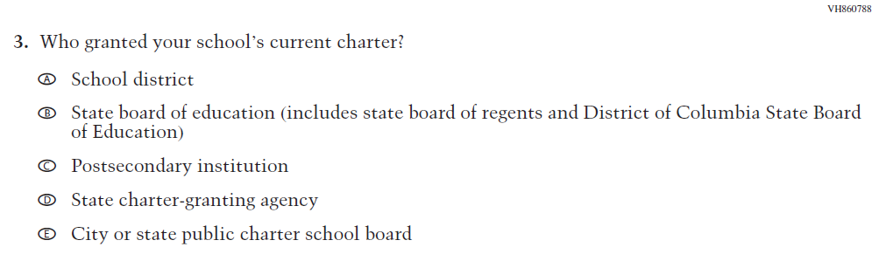  (2019 Grade 4, 8, and 12) | Issue: School Climate | NC | N/A
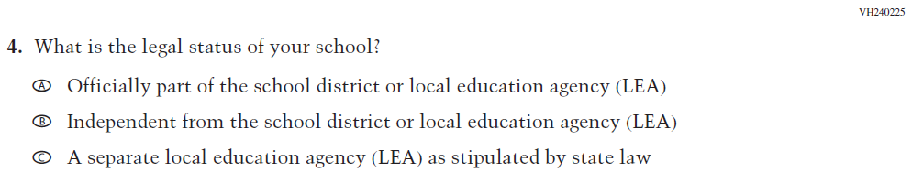  (2019 Grade 4, 8, and 12) | 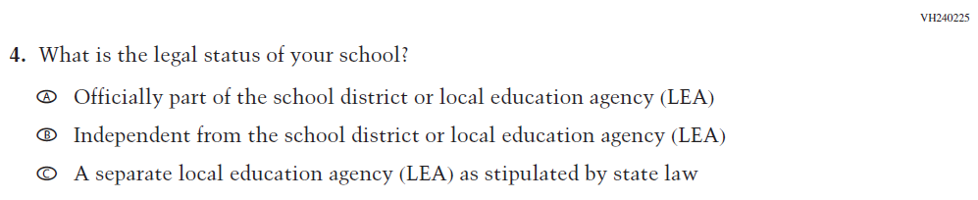  Issue: School Climate | NC | N/A

2021 Operational Grade 4 and 8 Charter School

Previous item | 2021 item | D/A/ R/NC+ | Rationale
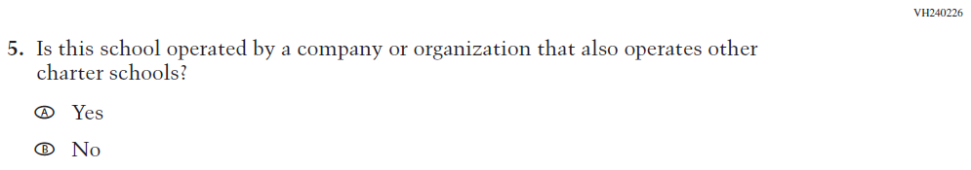  (2019 Grade 4, 8, and 12) | 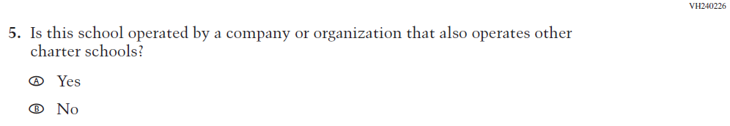  Issue: School Climate | NC | N/A
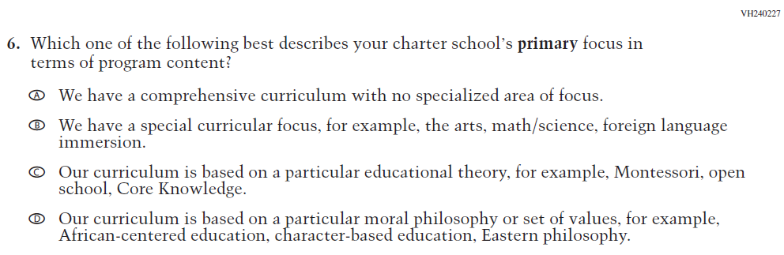  (2019 Grade 4, 8, and 12) | 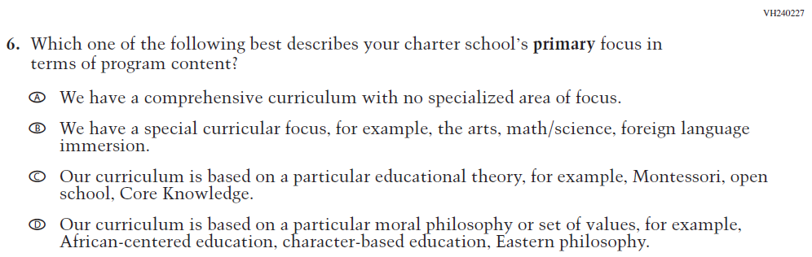  Issue: School Climate | NC | N/A
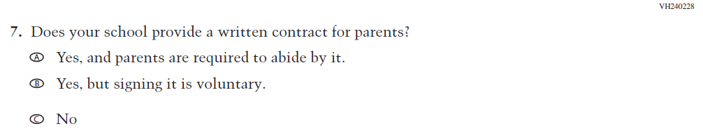  (2019 Grade 4, 8, and 12) | 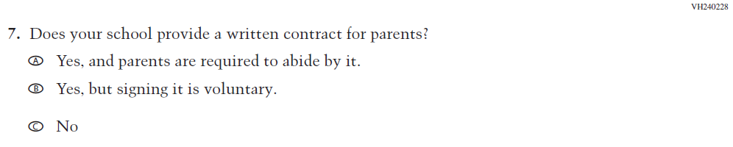  Issue: School Climate | NC | N/A
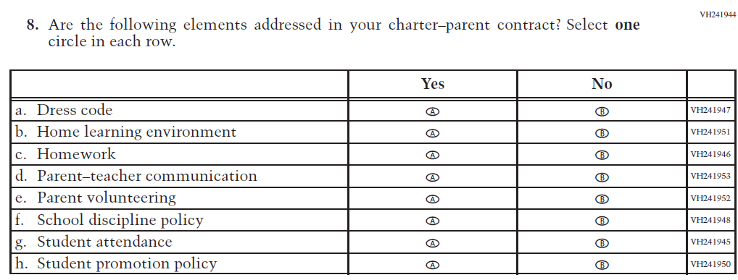  (2019 Grade 4, 8, and 12) | Issue: School Climate | NC | N/A

Appendix J3-6: Operational Grade 4 and 8 Charter School
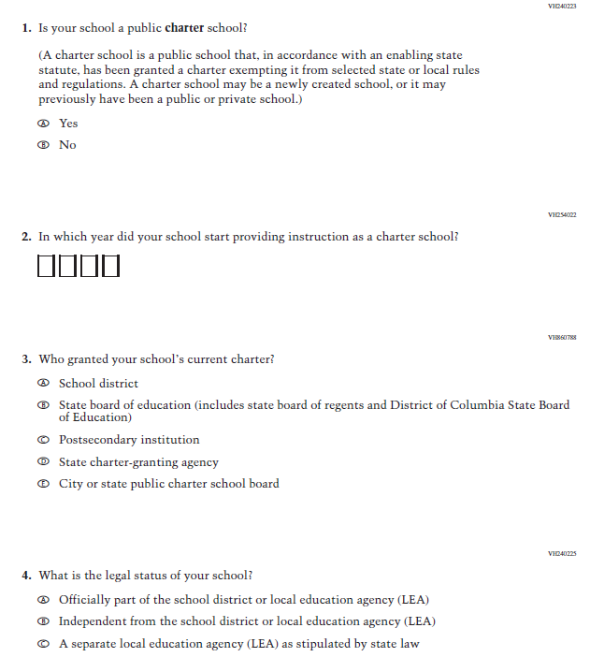

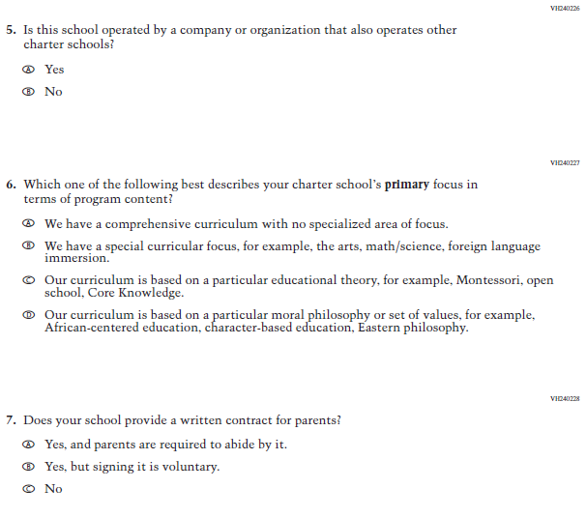

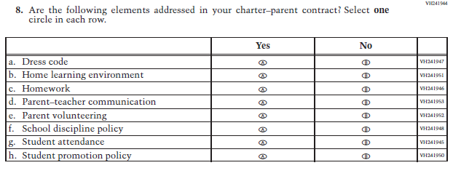

Appendix J3-7: Summary of Changes Operational Grade 4 Mathematics
2021 Operational Grade 4 Mathematics School

Previous item | 2021 item | D/A/ R/NC+ | Rationale
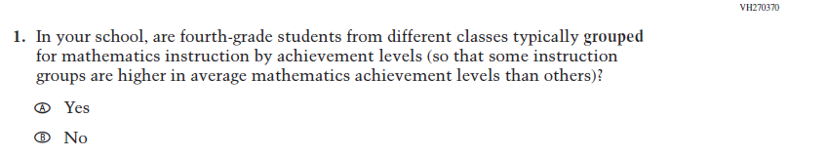  (2019 Grade 4) | Issue: Resources for Learning and Instruction | NC | N/A
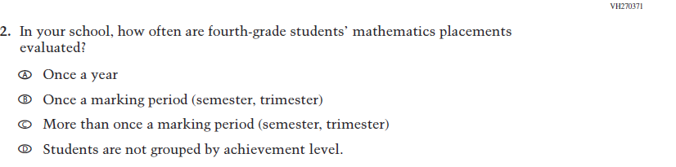  (2019 Grade 4) | Issue: Organization of Instruction | NC | N/A
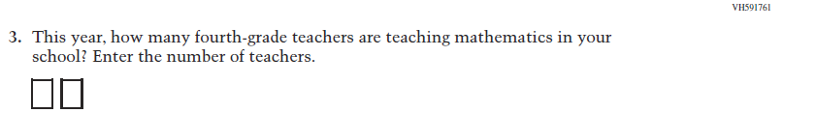  (2019 Grade 4) | Issue: Resources for Learning and Instruction | NC | N/A
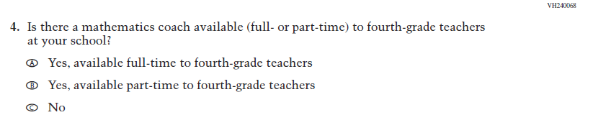  (2019 Grade 4) | Issue: Resources for Learning and Instruction | NC | N/A

2021 Operational Grade 4 Mathematics School

Previous item | 2021 item | D/A/ R/NC+ | Rationale
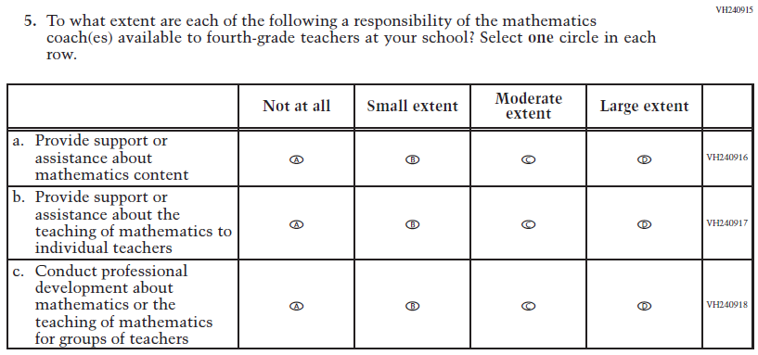  (2019 Grade 4) | Issue: Resources for Learning and Instruction | NC | N/A
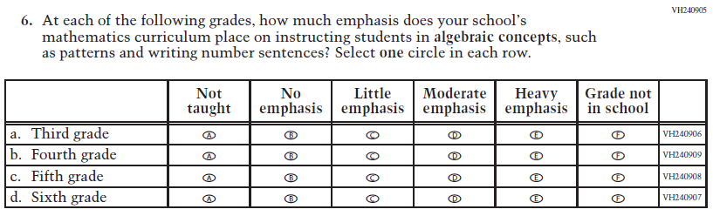  (2019 Grade 4) | Issue: Organization of Instruction | NC | N/A
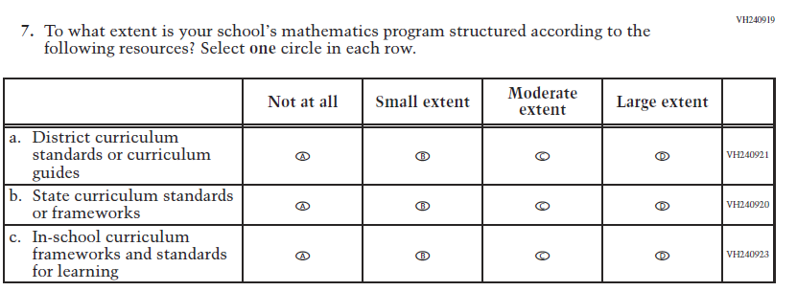  (2019 Grade 4) | Issue: Organization of Instruction | NC | N/A

2021 Operational Grade 4 Mathematics School

Previous item | 2021 item | D/A/ R/NC+ | Rationale
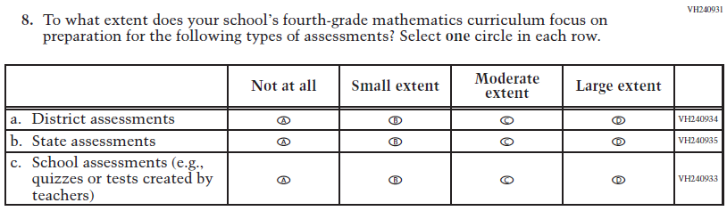  (2019 Grade 4) | Issue: Organization of Instruction | NC | N/A
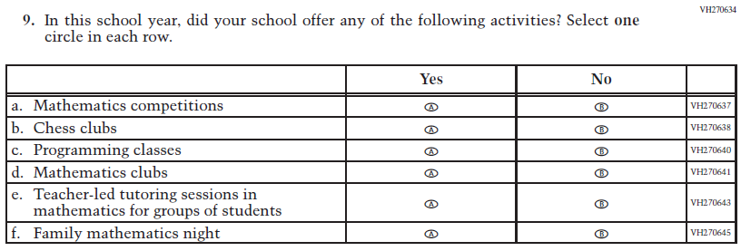  (2019 Grade 4) | Issue: Resources for Learning and Instruction | NC | N/A

Appendix J3-8: Operational Grade 4 Mathematics

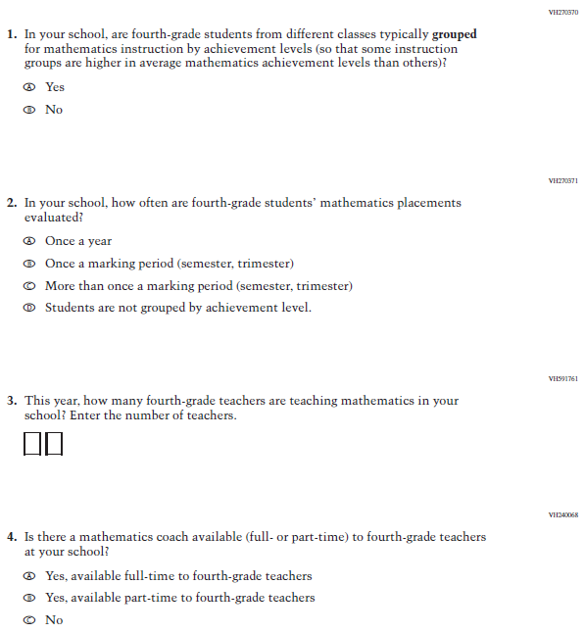

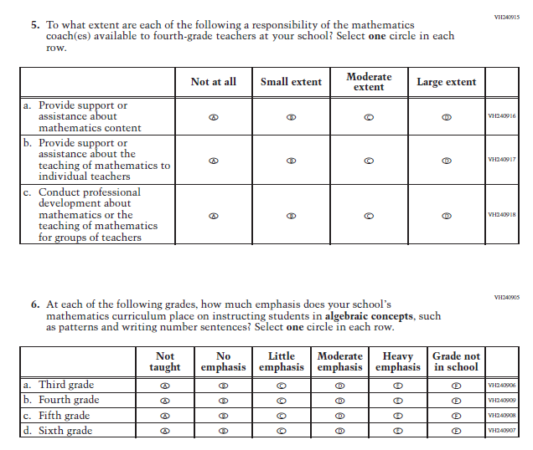

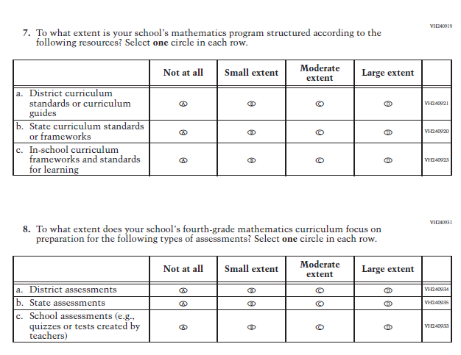

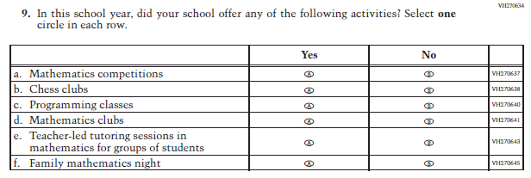

Appendix J3-9: Summary of Changes Operational Grade 8 Mathematics

2021 Operational Grade 8 Mathematics School

Previous item | 2021 item | D/A/ R/NC+ | Rationale
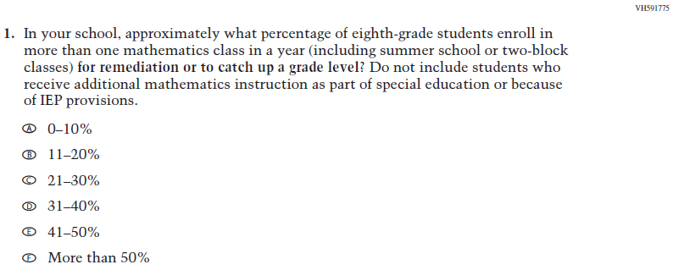  (2019 Grade 8) | Issue: Organization of Instruction | NC | N/A
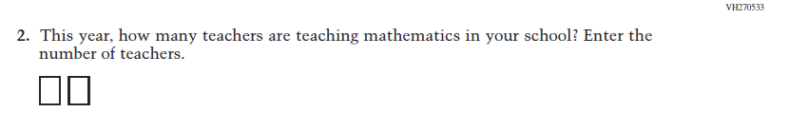  (2019 Grade 8) | Issue: Resources for Learning and Instruction | NC | N/A
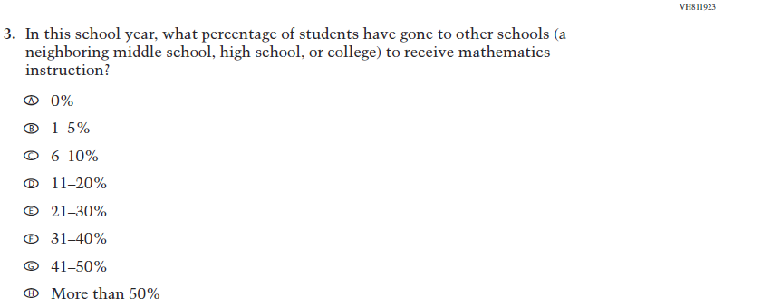  (2019 Grade 8) | Issue: Resources for Learning and Instruction | NC | N/A
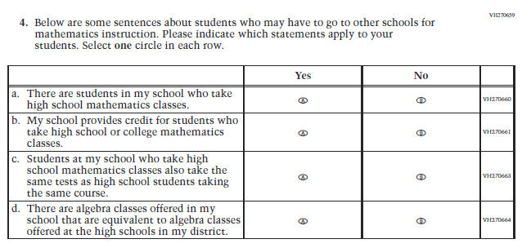(2019 Grade 8) | Issue: Resources for Learning and Instruction | NC | N/A
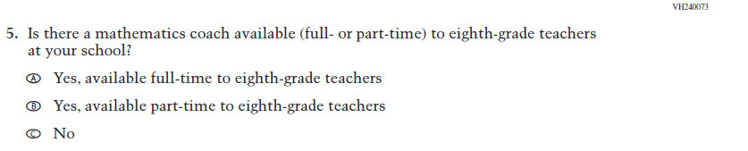  (2019 Grade 8) | Issue: Resources for Learning and Instruction | NC | N/A
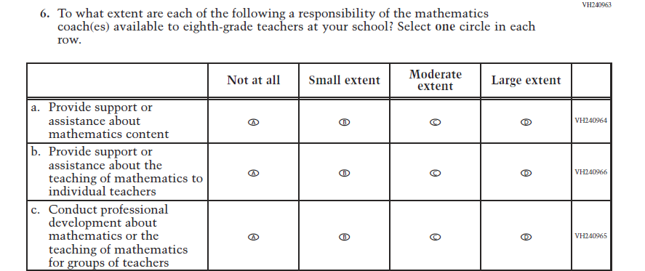  (2019 Grade 8) | Issue: Resources for Learning and Instruction | NC | N/A
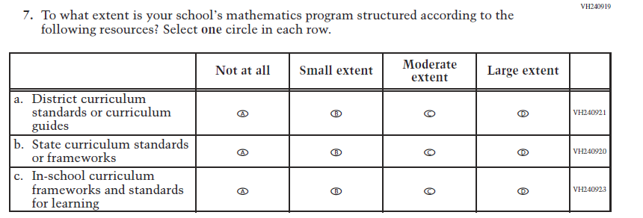  (2019 Grade 8) | Issue: Organization of instruction | NC | N/A
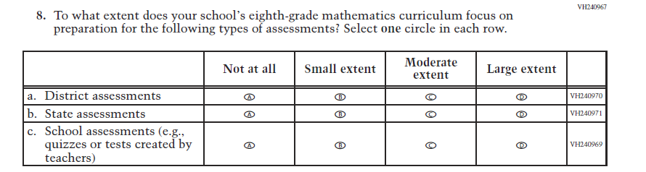  (2019 Grade 8) | Issue: Organization of instruction | NC | N/A
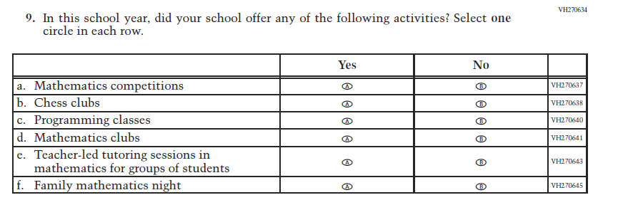  (2019 Grade 8) | Issue: Resources for Learning and Instruction | NC | N/A

Appendix J3-10: Operational Grade 8 Mathematics

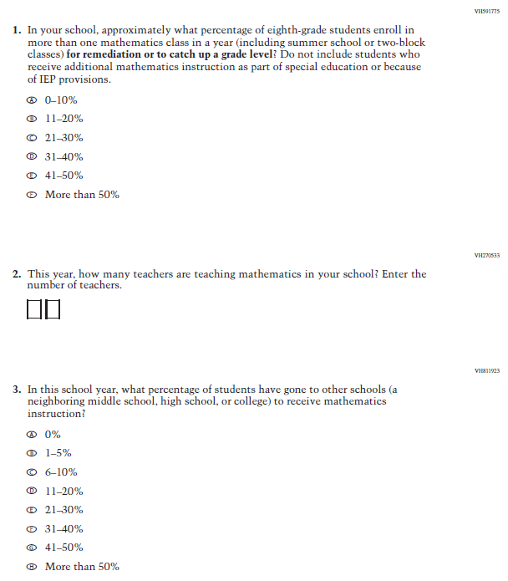

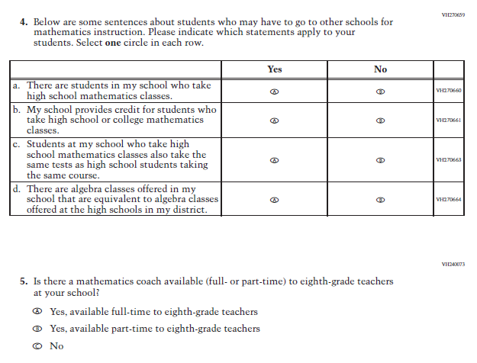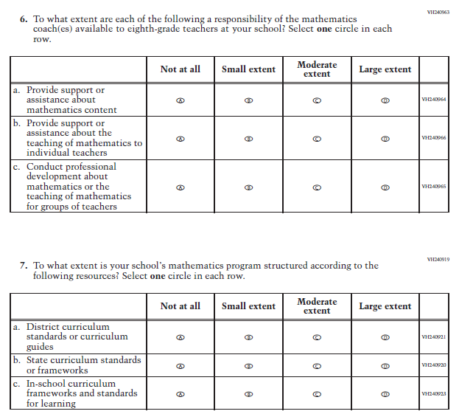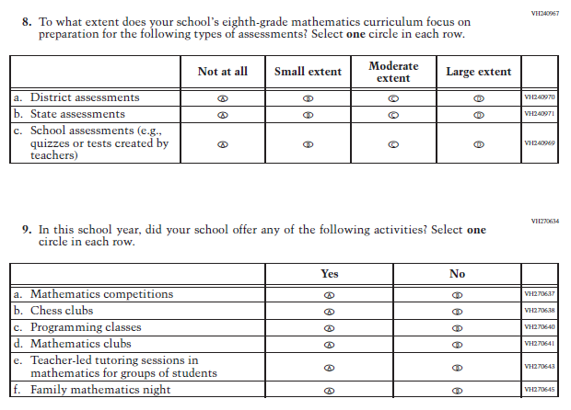

Appendix J3-11: Summary of Changes Operational Grade 4 Reading

2021 Operational Grade 4 Reading School

Previous item | 2021 item | D/A/ R/NC+ | Rationale
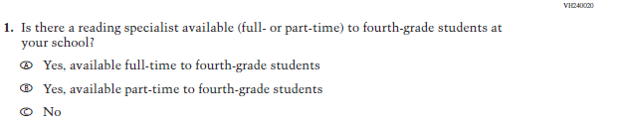  (2019 Grade 4) | Issue: Resources for Learning and Instruction | NC | N/A
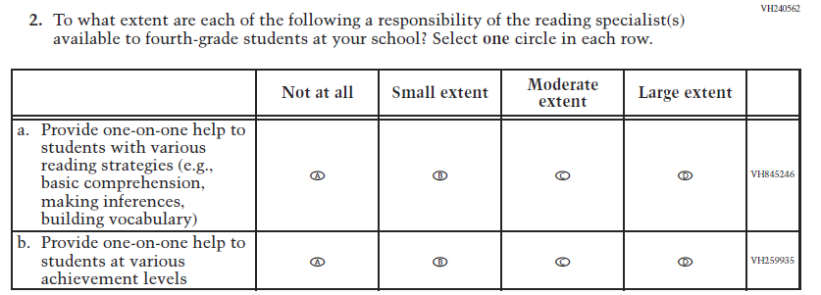  (2019 Grade 4) | Issue: Resources for Learning and Instruction | NC | N/A
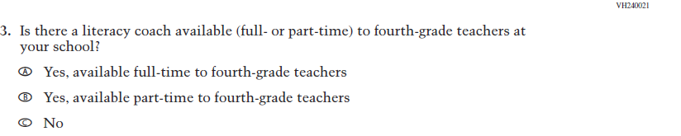  (2019 Grade 4) | Issue: Resources for Learning and Instruction | NC | N/A

2021 Operational Grade 4 Reading School

Previous item | 2021 item | D/A/ R/NC+ | Rationale
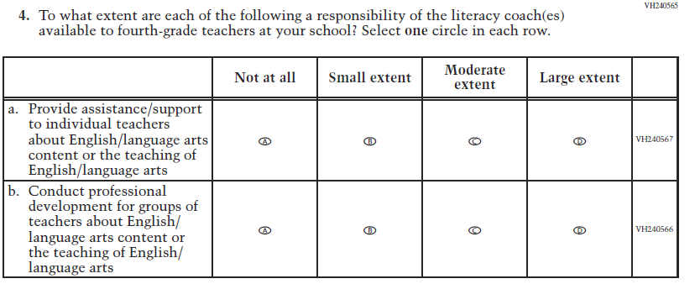  (2019 Grade 4) | Issue: Resources for Learning and Instruction | NC | N/A
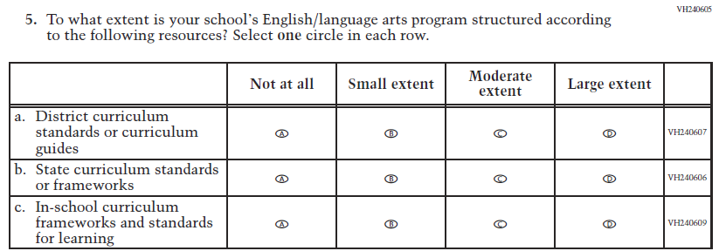  (2019 Grade 4) | Issue: Organization of Instruction | NC | N/A
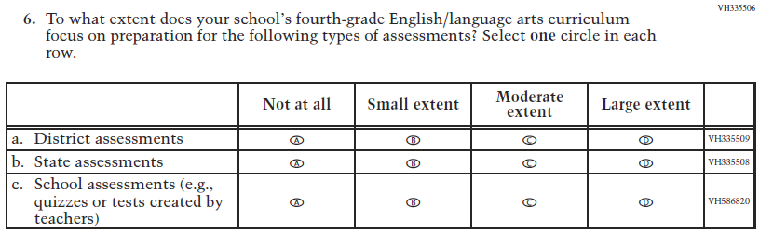  (2019 Grade 4) | Issue: Organization of Instruction | NC | N/A

2021 Operational Grade 4 Reading School

Previous item | 2021 item | D/A/ R/NC+ | Rationale
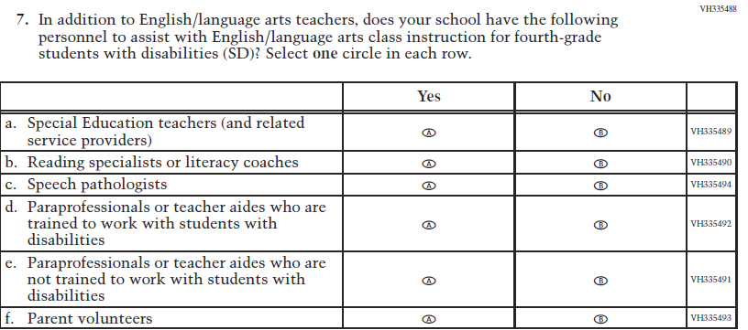  (2019 Grade 4) | Issue: Resources for Learning and Instruction | NC | N/A
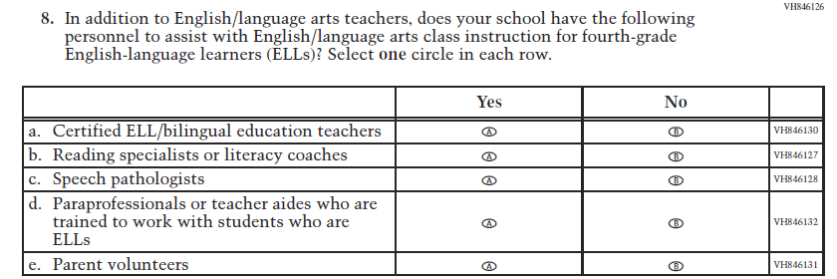  (2019 Grade 4) | Issue: Resources for Learning and Instruction | NC | N/A
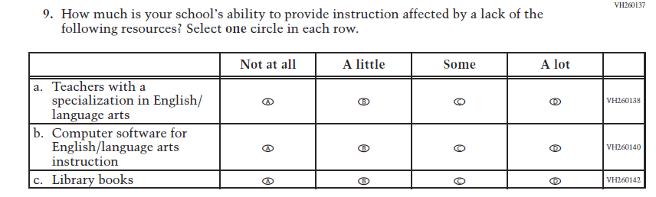  (2019 Grade 8) | Issue: Resources for Learning and Instruction | NC | N/A

Appendix J3-12: Operational Grade 4 Reading

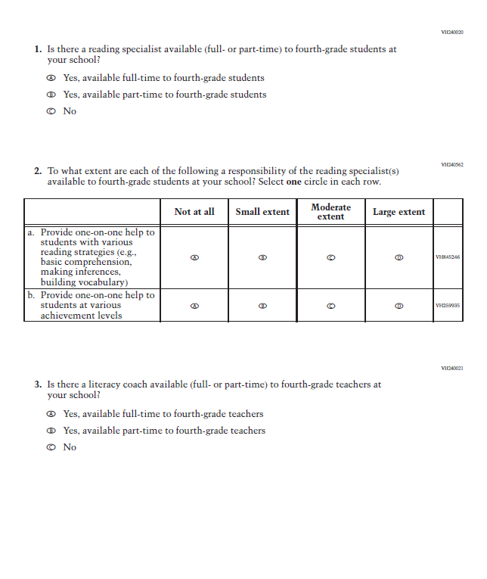

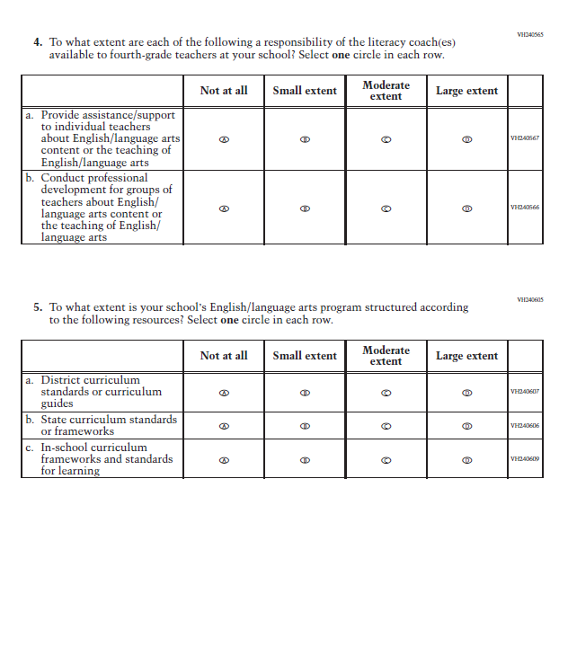

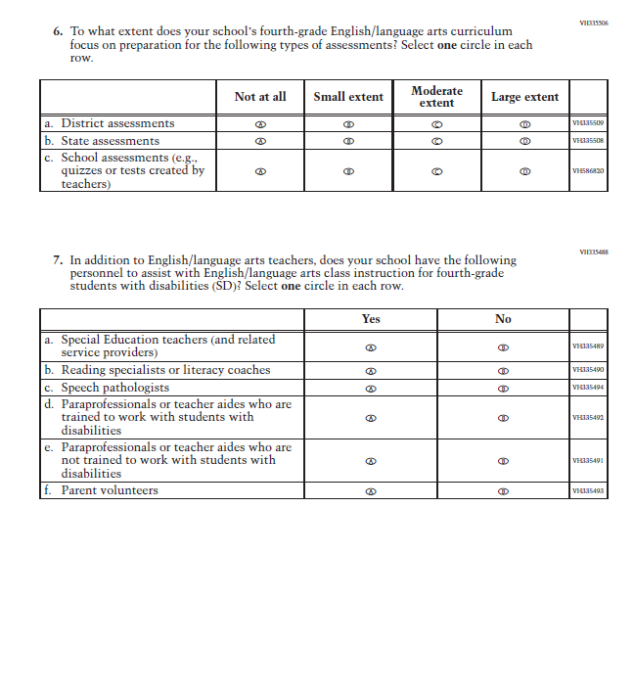
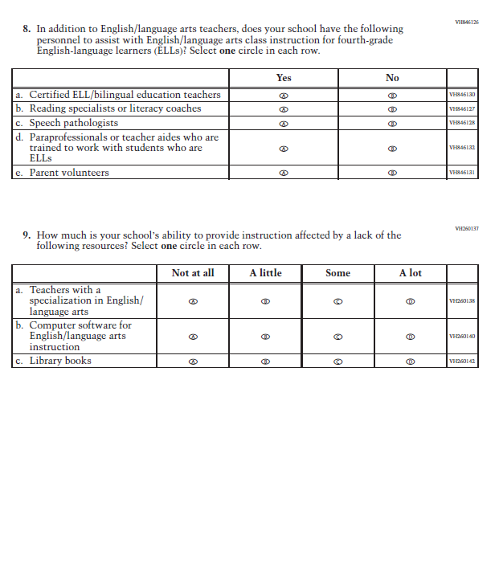

Appendix J3-13: Summary of Changes Operational Grade 8 Reading

2021 Operational Grade 8 Reading School

Previous item | 2021 item | D/A/ R/NC+ | Rationale
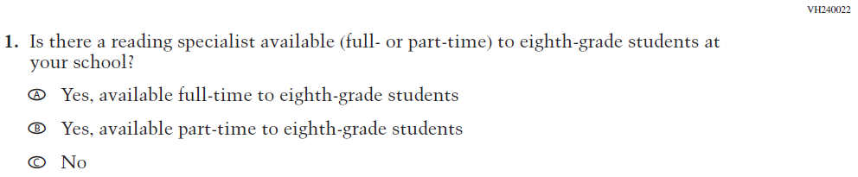  (2019 Grade 8) | Issue: Resources for Learning and Instruction | NC | N/A
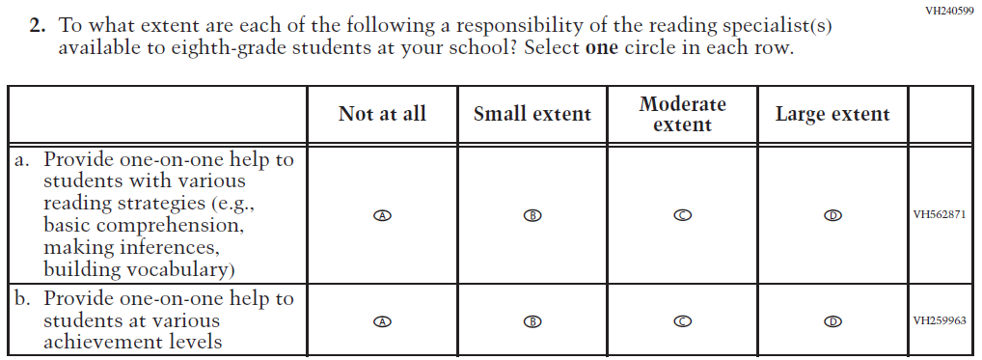  (2019 Grade 8) | Issue: Resources for Learning and Instruction | NC | N/A

2021 Operational Grade 8 Reading School

Previous item | 2021 item | D/A/ R/NC+ | Rationale
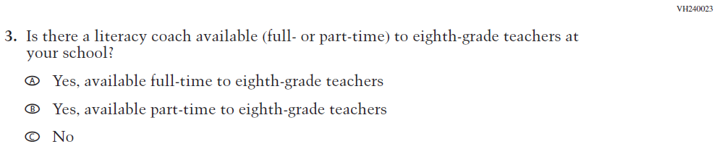  (2019 Grade 8) | Issue: Resources for Learning and Instruction | NC | N/A
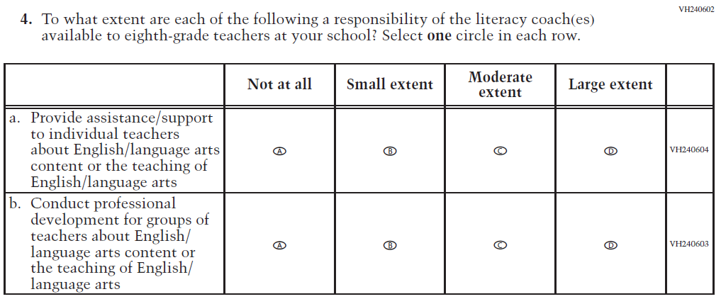  (2019 Grade 8) | Issue: Resources for Learning and Instruction | NC | N/A
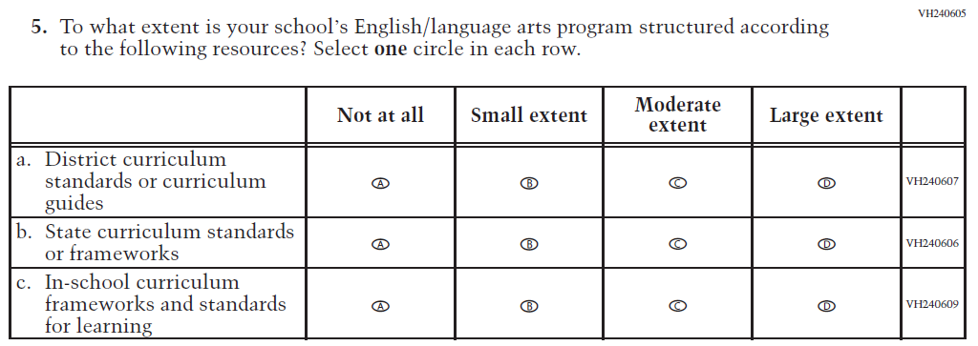  (2019 Grade 8) | Issue: Organization of Instruction | NC | N/A

2021 Operational Grade 8 Reading School

Previous item | 2021 item | D/A/ R/NC+ | Rationale
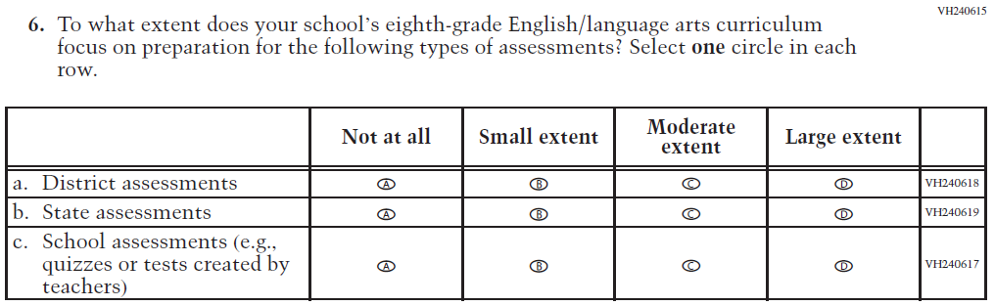  (2019 Grade 8) | Issue: Organization of Instruction | NC | N/A
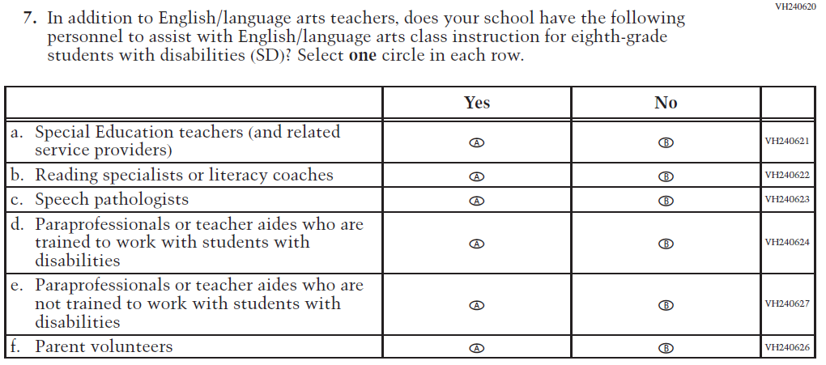  (2019 Grade 8) | Issue: Resources for Learning and Instruction | NC | N/A

2021 Operational Grade 8 Reading School

Previous item | 2021 item | D/A/ R/NC+ | Rationale
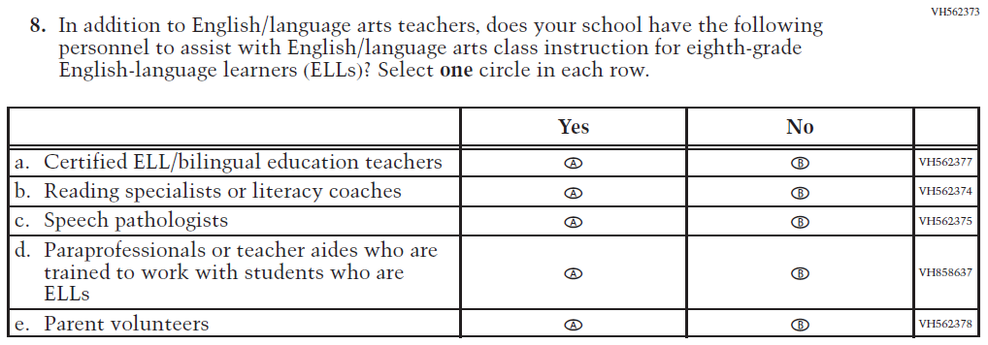  (2019 Grade 8) | Issue: Resources for Learning and Instruction | NC | N/A
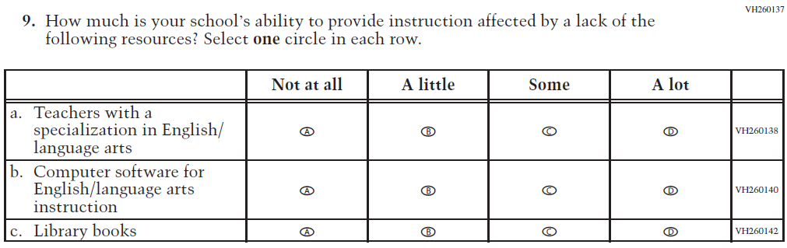  (2019 Grade 8) | Issue: Resources for Learning and Instruction | NC | N/A

.

Appendix J3-14: Operational Grade 8 Reading

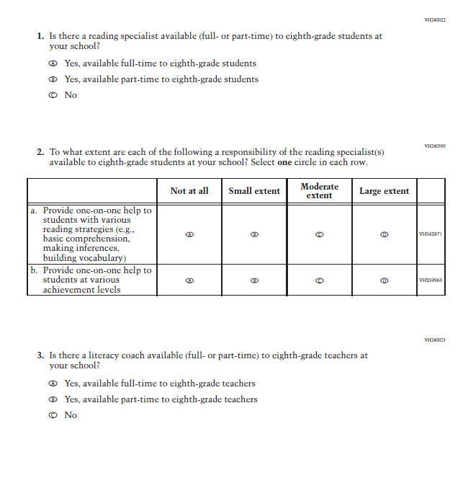
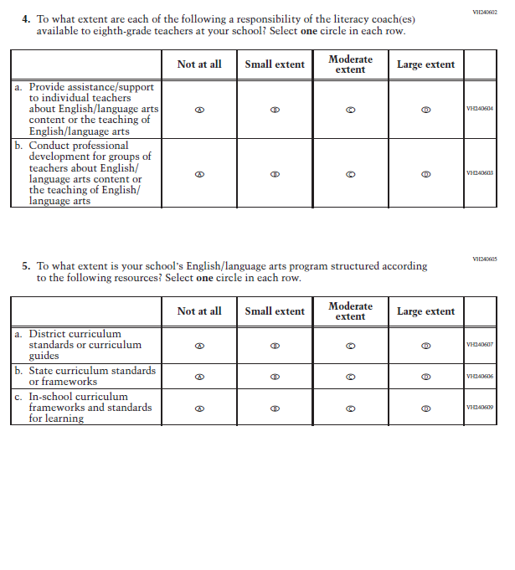
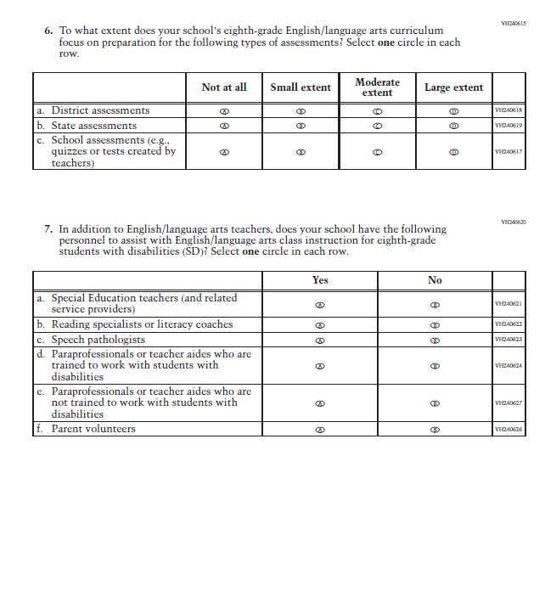
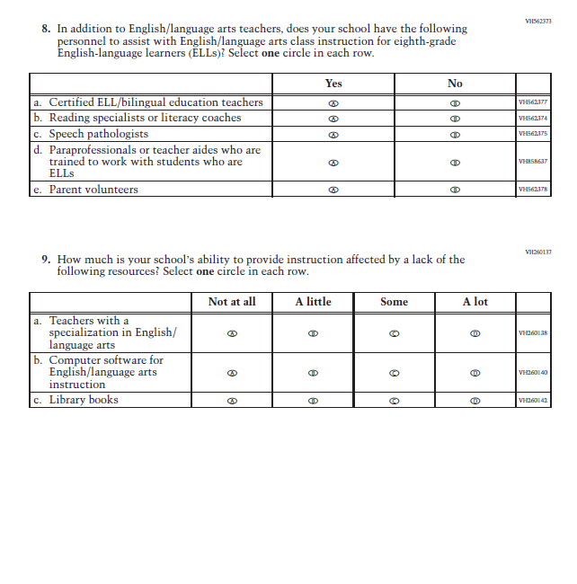

Appendix J3-15: Operational Grade 4 COVID-19 School Items (New)

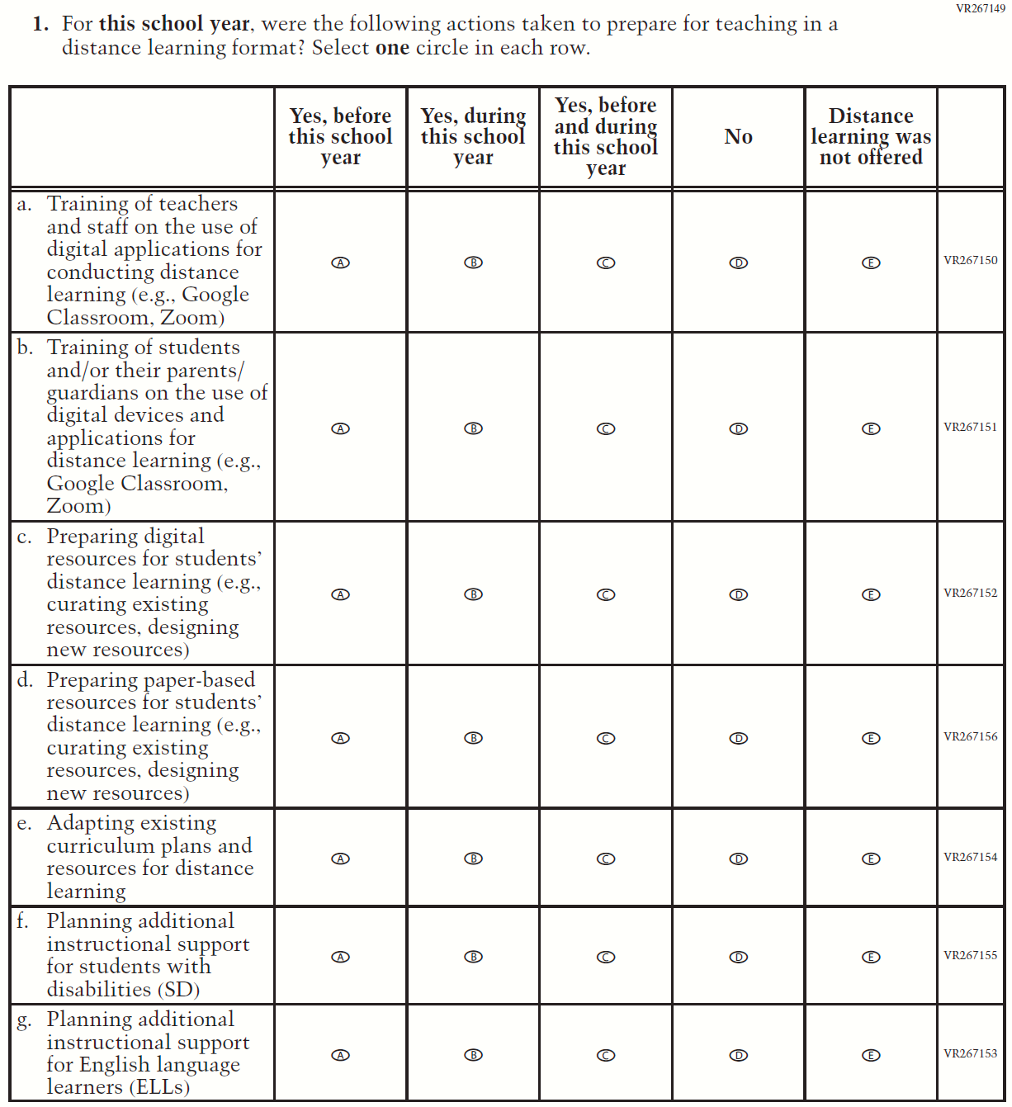

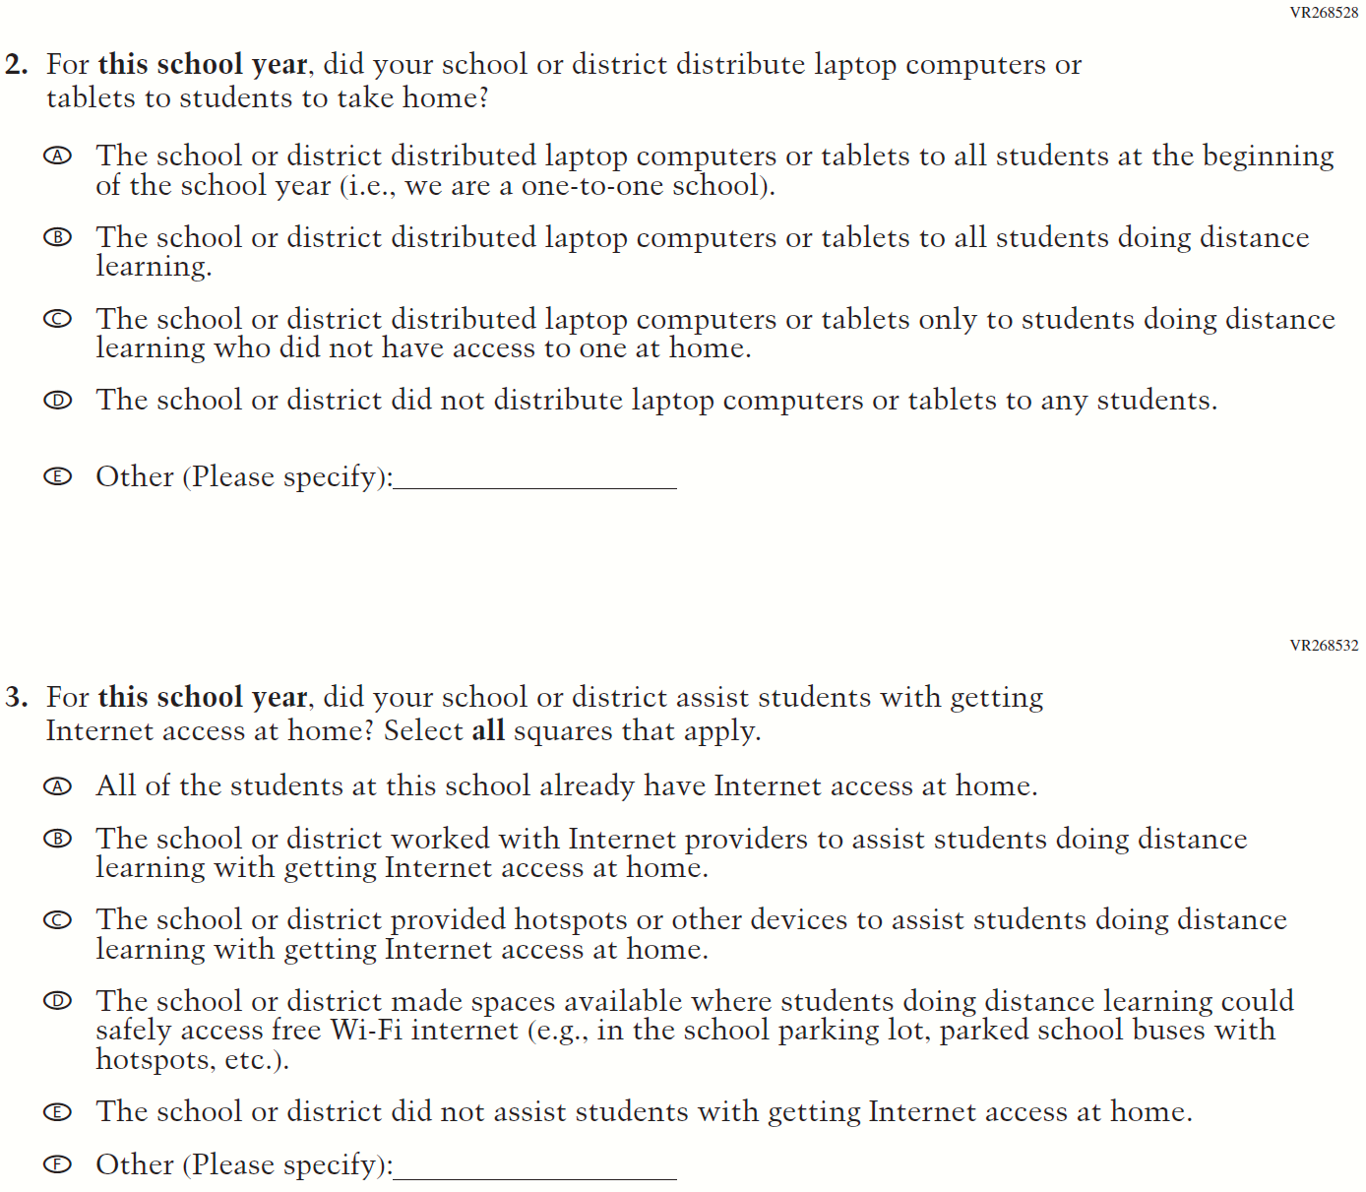

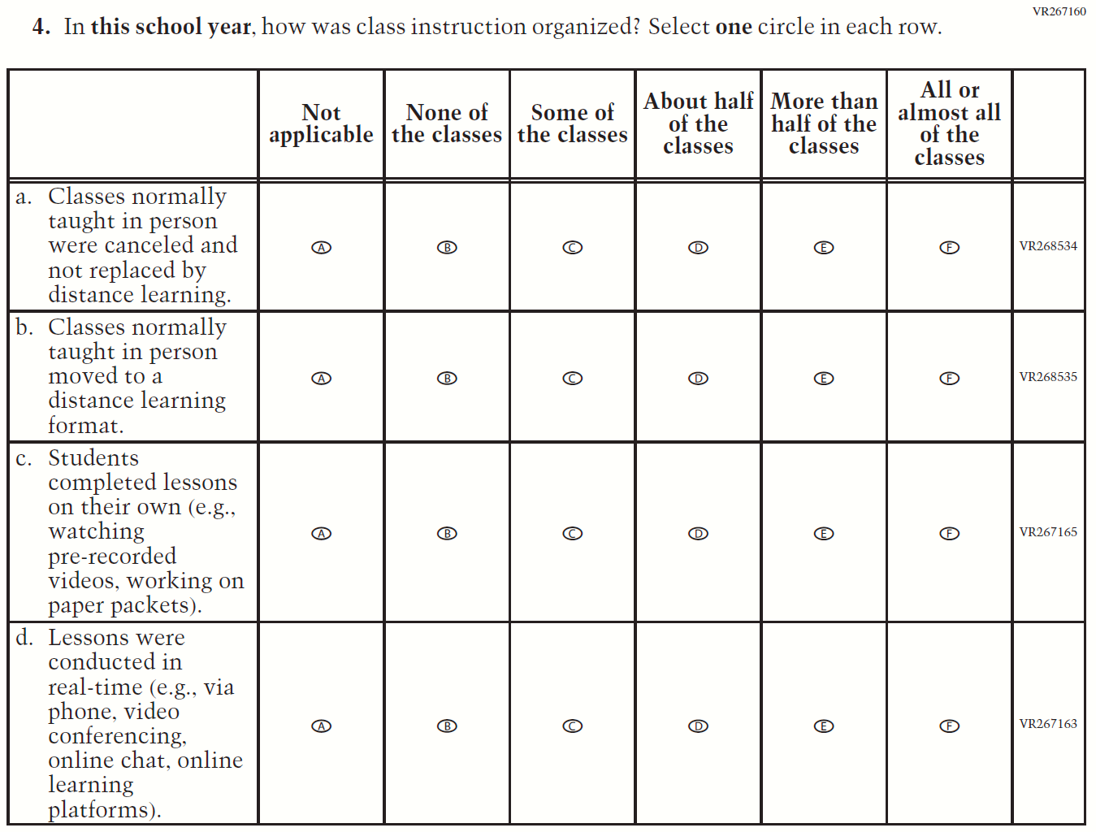
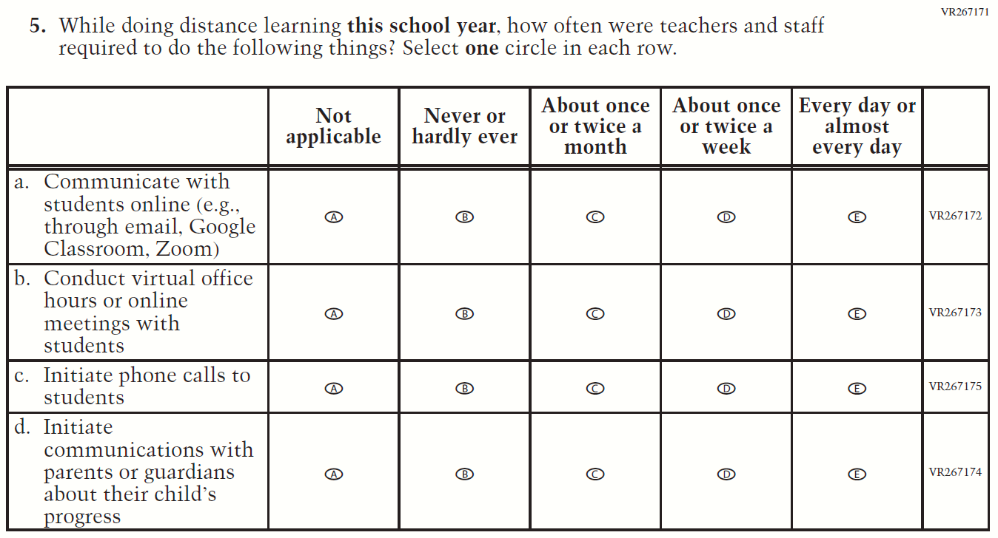

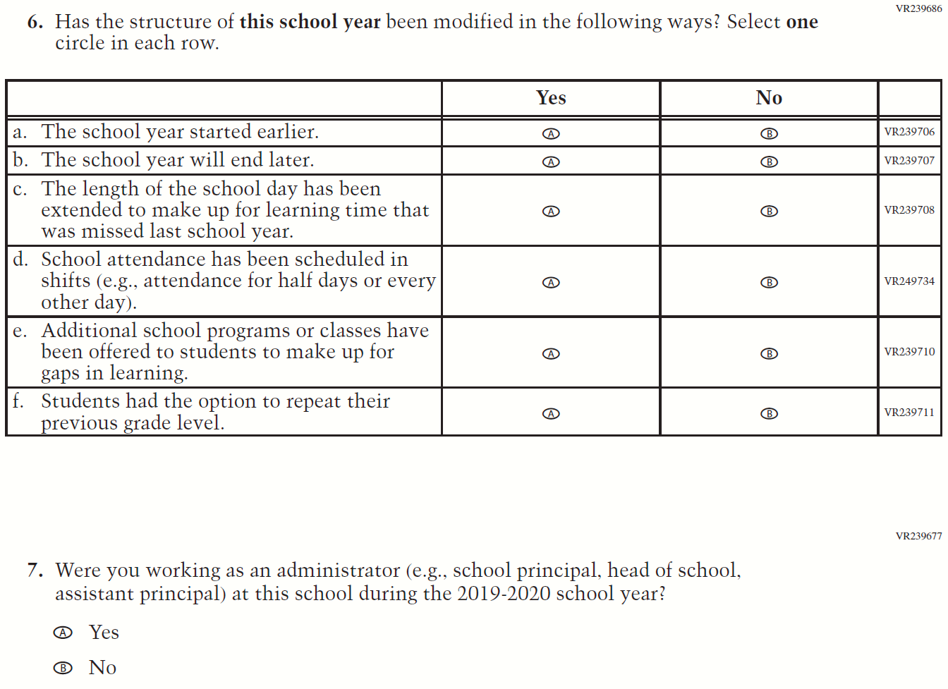

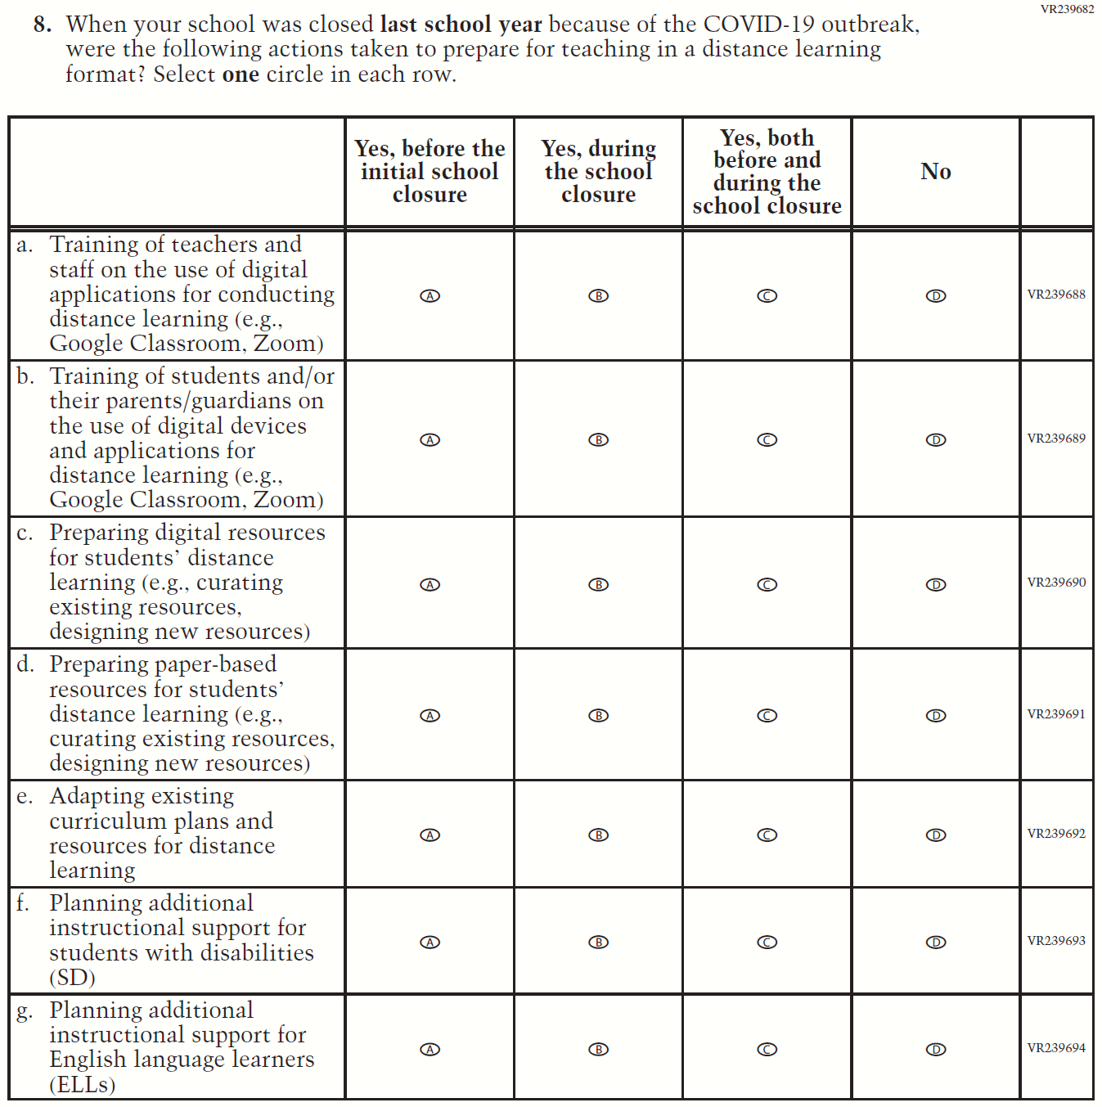

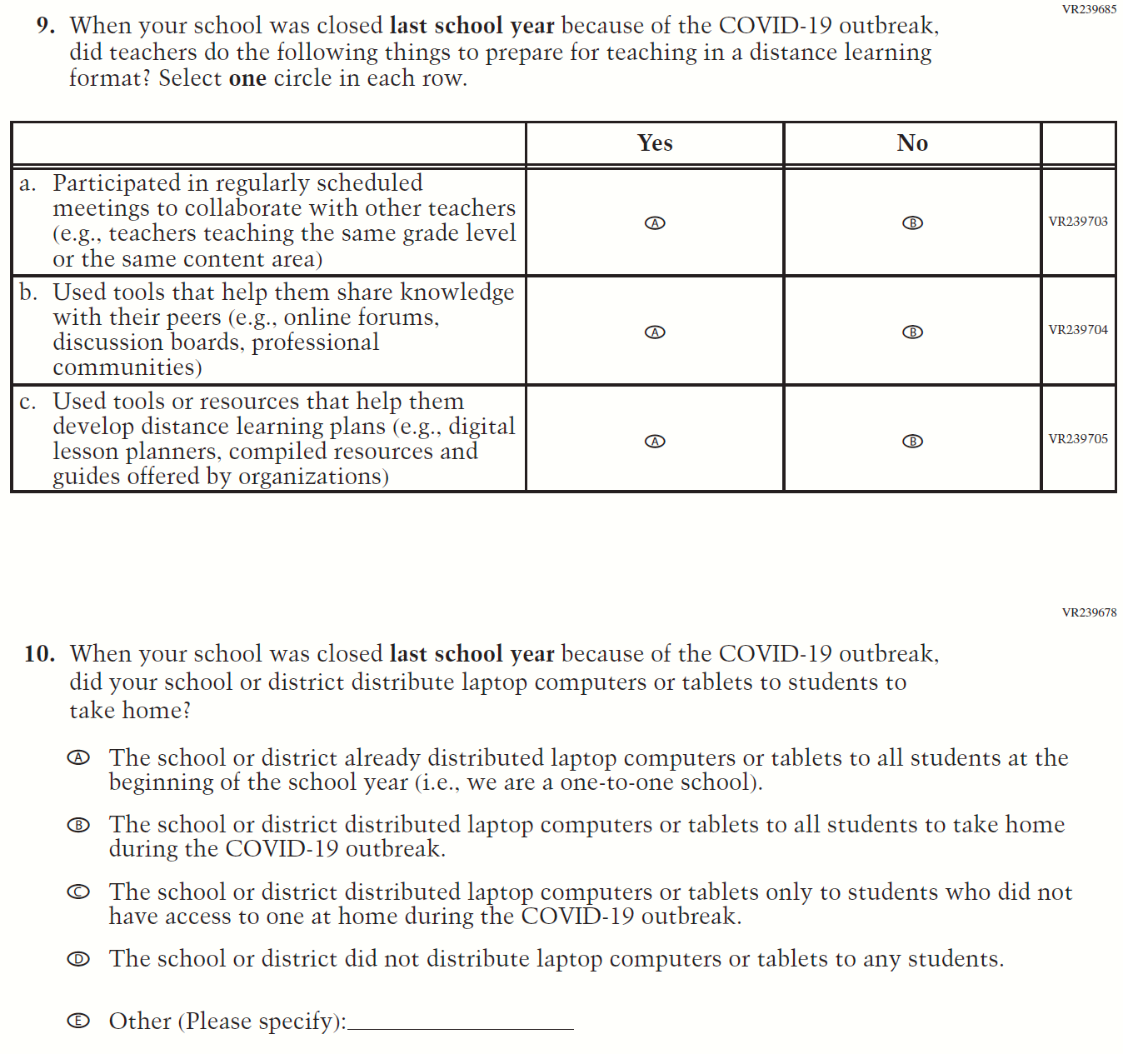

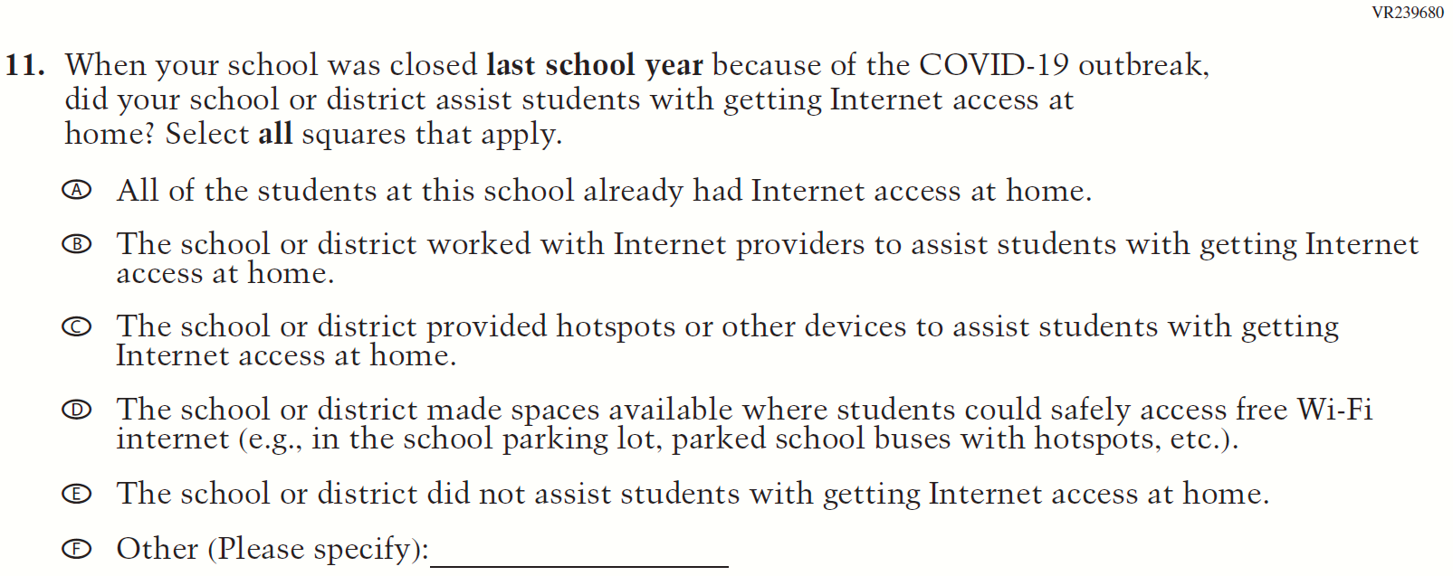

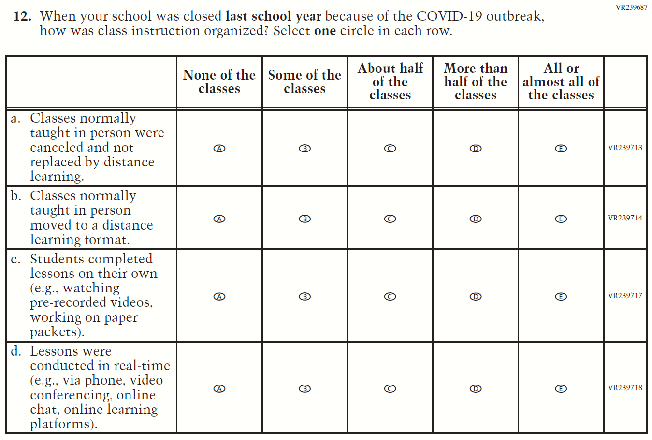

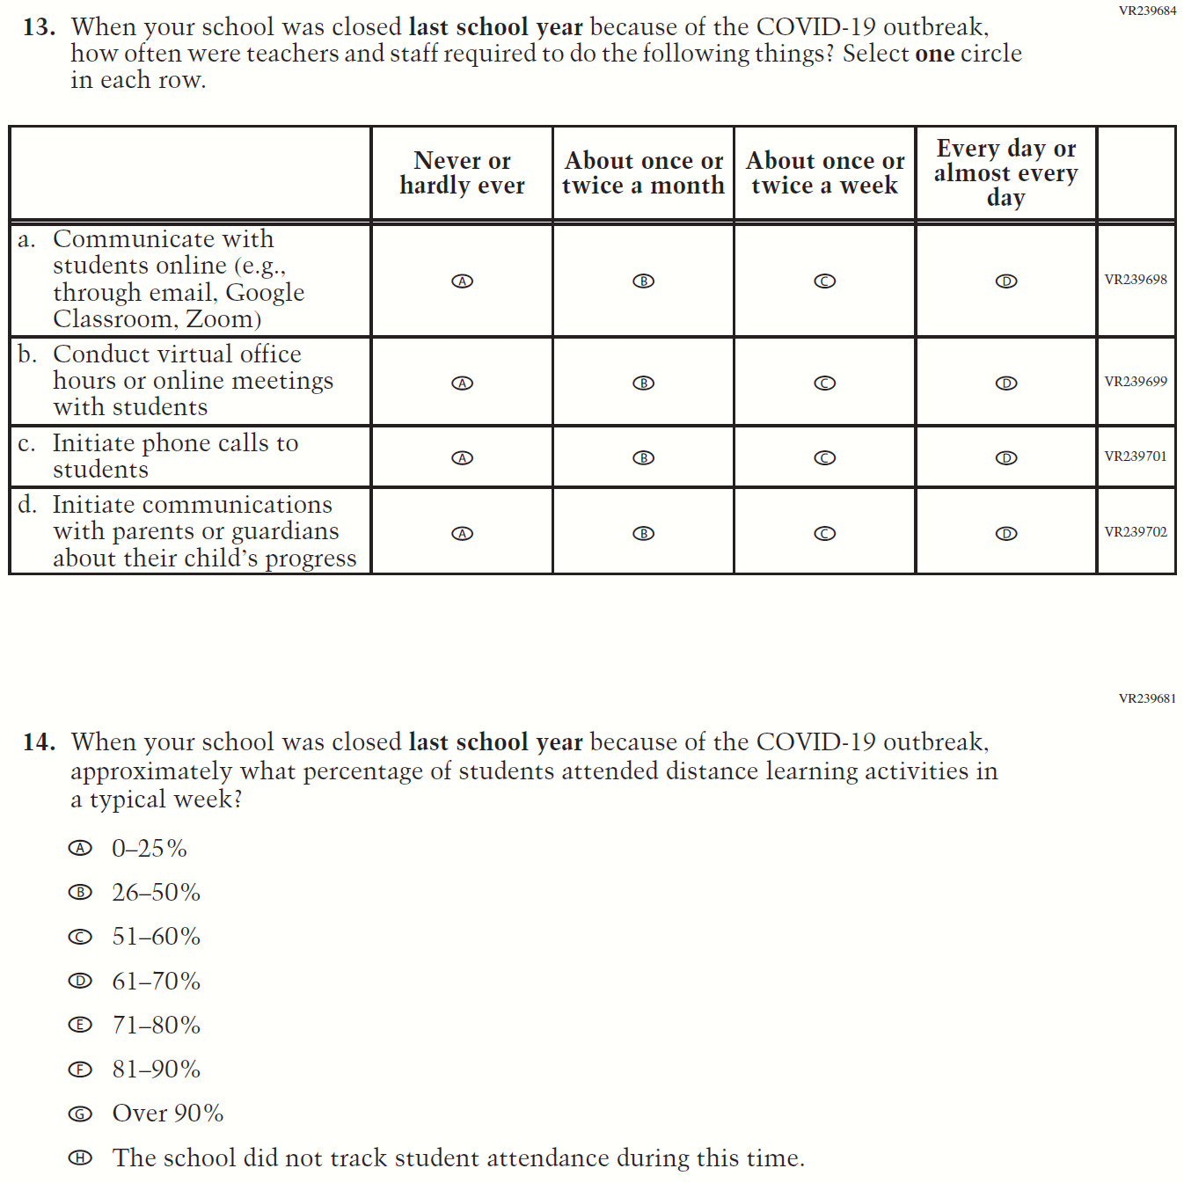

Appendix J3-16: Operational Grade 8 COVID-19 School Items (New)

