Recruitment E-mail




Hello [XXXX]
As you are a Toluna Influencer, we value your opinion highly. Today you can earn [~$1.50 in points] by filling in this survey.
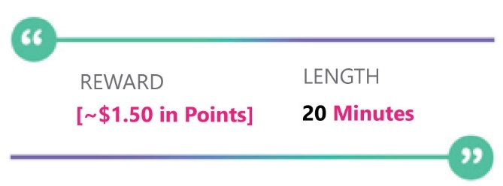

Survey ID: XXXXXXX-US

Thank you for your participation,
The Toluna Team

More Details:
You may not re-enter the survey once you leave it.
Expected Study Availability: {SurveyEndDate}. Although we expect the study to be open until the above date, please remember that this study will be closed as soon as we receive enough participants. Please try to complete the survey as soon as possible to ensure that we have space for you.
Terms and conditions | Unsubscribe | Login | Contact Us | Privacy
There are quality check questions in this survey, so please read each question carefully and select the answer that best describes your opinion.
Toluna SAS, 5 avenue du Château, 94300, Vincennes, France

