ATTACHMENT 2: screener/survey – LCC

Form Approved
OMB Control No. 0910-0810
Exp. Date 10/31/2021

PROGRAMMER NOTE: FORCE RESPONSES TO ALL SCREENER QUESTIONS.

[SCNR_INTRO]

Welcome to the Your Voice Now Survey!

The U.S. Food and Drug Administration (FDA) is developing education programs that will improve the health of youth and young adults.
​
To inform these education programs, the FDA is conducting a survey in partnership with RTI International, a non-profit research organization.
- You are being asked to answer a few questions to see if you are eligible for a study of approximately 750 youth and young adults in the United States per quarter.
- You may only complete this questionnaire one time.
- It will take less than 3 minutes to see if you are eligible.
- If we determine you are eligible, you will have the opportunity to continue and complete an additional online survey for a $5 electronic gift card as a token of our appreciation.
- You may only take that survey one time and you will only receive one $5 electronic gift card if you complete it. If we find that you have completed the survey more than once, you may not receive a gift card. Once we complete this check, we will send you a $5 electronic gift card to the email address you provide. The gift card will be sent within 1-2 weeks.
- Your answers to the questions will be kept private to the fullest extent allowable by law and your participation is voluntary.

ASK: All respondents

[SCNR_ASSENT]
Do you agree to participate in this short survey?
- Yes, I agree to participate in this short survey
- No, I do not want to participate in this short survey
ASK: All respondents

[EXIT_1] [IF SCNR_ASSENT = 2]
Thank you for your time.

ASK: Ask respondents who do not provide assent

[FB_TXT] [IF SCNR_ASSENT = YES & RESPONDING FROM FACEBOOK]
RTI International, a non-profit research organization, is doing a survey to learn more about people like you. We (“RTI International”) want to make sure that the person who is taking the survey is who they say they are and does not take the survey more than once. Facebook will help us do this by making sure that you have a real Facebook account. This document will explain what kinds of information Facebook or RTI International may learn about you if you click on the “agree” button.

When you click on “agree,” you are allowing Facebook and RTI International to collect your email that you use to log in to Facebook and your unique Facebook user id number to make sure that you do not take the survey more than once. The information collected will help Facebook check that you have a real account. If you do not agree to allow Facebook and RTI International to collect this information, you should not take this survey. The information about you that we collect here may be added to other information we have about you.

We will protect the information we collect as much as possible. However, since this survey is online, there is still a chance that other people may see some information about you. This is a risk that is part of using the internet. We will do our best to make sure this does not happen.

This document (the Authorization Statement) only talks about the information that could be learned about you as part of the process that Facebook uses to make sure that you have a real Facebook account. Facebook will not share any other information about your account with us. It is possible that other people or organizations could also access this information about you.

ASK: Respondents who provide informed assent and are responding from Facebook

[FB_AUTH] [IF SCNR_ASSENT = YES & RESPONDING FROM FACEBOOK]
Please click the link to read the Authorization Statement to learn more about how Facebook and others may use the information that is collected. Facebook Authorization Statement
- I have read the Authorization Statement and agree to provide my Facebook information for such purposes.
- I decline to provide my information for such purposes

ASK: All respondents

[EXIT_2] [IF FB_AUTH = 2]
Thank you for your time.

ASK: Respondents who do not agree to allow Facebook to collect information for account verification

[IG_TXT] [IF SCNR_ASSENT = YES & RESPONDING FROM INSTAGRAM]
RTI International, a non-profit research organization, is doing a survey to learn more about people like you. We (“RTI International”) want to make sure that the person who is taking the survey is who they say they are and does not take the survey more than once. Instagram will help us do this by making sure that you have a real Instagram account. This document will explain what kinds of information Instagram or RTI International may learn about you if you click on the “agree” button.

When you click on “agree,” you are allowing Instagram and RTI International to collect your email that you use to log in to Instagram and your unique Instagram user id number to make sure that you do not take the survey more than once. The information collected will help Instagram check that you have a real account. If you do not agree to allow Instagram and RTI International to collect this information, you should not take this survey. The information about you that we collect here may be added to other information we have about you.

We will protect the information we collect as much as possible. However, since this survey is online, there is still a chance that other people may see some information about you. This is a risk that is part of using the internet. We will do our best to make sure this does not happen.

This document (the Authorization Statement) only talks about the information that could be learned about you as part of the process that Instagram uses to make sure that you have a real Instagram account. Instagram will not share any other information about your account with us. It is possible that other people or organizations could also access this information about you.

ASK: Respondents who provide informed assent and are responding from Instagram

[IG_AUTH] [IF SCNR_ASSENT = YES & RESPONDING FROM INSTAGRAM]
Please click the link to read the Authorization Statement to learn more about how Instagram and others may use the information that is collected. Instagram Authorization Statement
- I have read the Authorization Statement and agree to provide my Instagram information for such purposes.
- I decline to provide my information for such purposes

ASK: All respondents

[EXIT_3] [IF IG_AUTH = 2]
Thank you for your time.

ASK: Respondents who do not agree to allow Instagram to collect information for account verification

[LAND] [IF R IS ON MOBILE DEVICE]

It looks like you are viewing this survey on a mobile device. This survey works best in landscape mode. Taking the survey on a mobile device might take longer.

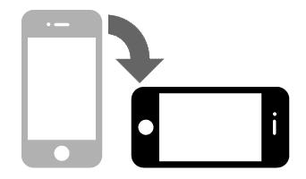

NEXT

ASK: All respondents who access the survey via a mobile device.

[PRIV]
Please make sure that you can answer the questions in private where no one can see your answers.
- Next

ASK: All respondents

[DRIV]
Do not answer the questions while driving.
- Next

ASK: All respondents

[SCNR_INTRO2] [IF FB_AUTH = 1 OR IG_AUTH = 1]
The first part of the survey asks a couple general questions about yourself.

ASK: Respondents who agree to FB or IG authorization

[AGE]
How old are you?

_____________years old [RANGE: 5-100]
99. Prefer not to answer

ASK: All respondents

[GENDER]
What sex were you assigned at birth, on your original birth certificate?
- Female
- Male
- Don’t know
99. Prefer not to answer

ASK: All Respondents

[GENDER_IDENTITY]
Do you currently describe yourself as male, female or transgender?
- Female
- Male
- Transgender
- None of these
- Prefer not to answer

ASK: All Respondents
[HISPANIC]
Are you Hispanic, Latino/a, or of Spanish origin?
- Yes
- No
- Prefer not to answer

ASK: All Respondents
[RACE]
What race or races do you consider yourself to be? (You can choose one answer or more than one answer.)
- American Indian or Alaska Native
- Asian
- Black or African American
- Native Hawaiian or Other Pacific Islander
- White
- Other (please specify_____________)
- Prefer not to answer

ASK: All Respondents

[MEDIA_USE]
Next, we’d like to ask you about your use of TV and other media. What electronic device do you use most often to watch TV shows or movies?
- TV
- Computer (laptop or desktop)
- Tablet (iPad or Android)
- Smartphone (iPhone or Android)
- I don’t watch TV shows or movies
- Prefer not to answer

ASK: All respondents

[MEDIA_USE2]
On an average day, how much time do you spend watching TV or videos on a television, computer, tablet, or smartphone?
- None
- Less than 1 hour
- 1 to 3 hours
- More than 3 hours

[SOCIAL_MED]
About how often do you visit social media sites, such as Facebook, Twitter, Tumblr, YouTube, Instagram, Pinterest, TikTok, or Snapchat?
- More than once a day
- About once a day
- 3-5 days a week
- 1-2 days a week
- Every few weeks or less
- I do not have a social media account
ASK: All respondents

[CIG_HEARD]
The next questions are about cigarillos, filtered cigars, and traditional cigars. These products go by lots of different names, so please use these descriptions and photos to understand what they are.

Some common brands of Cigarillos and filtered cigars are Black & Mild, Swisher Sweets, Dutch Masters, Phillies Blunts, Zig Zag, Prime Time, Game cigars and Cheyenne [note: example brands to be updated before fielding based on focus group data]. Cigarillos and filtered cigars contain tightly rolled tobacco that is wrapped in a tobacco leaf and are are usually brown. Some are the same size as cigarettes, and some come with filters or with plastic or wooden tips. [SHOW IMAGES OF CIGARILLOS AND FILTERED CIGARS]

Traditional cigars are larger than cigarillos and filtered cigars. Some common brands of cigars include Macanudo, Romeo y Julieta, Arturo Fuente, and Cohiba, but there are many others.
[SHOW GENERIC IMAGE OF TRADITIONAL CIGARS]

These products can be used with or without marijuana added. For the purposes of this survey, please think about these products without marijuana, unless specified.

Have you ever seen or heard of a cigarillo, filtered cigar or traditional cigar before this study?
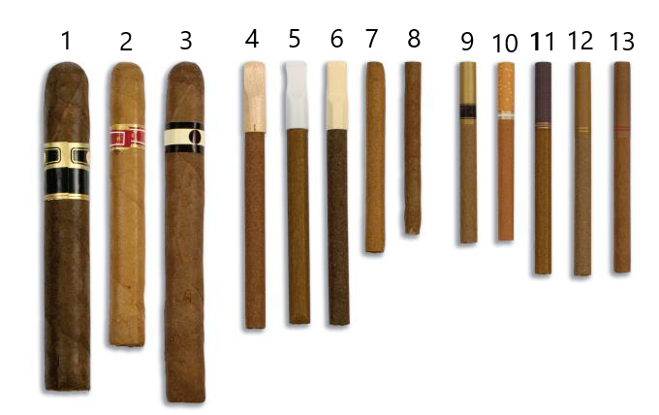
[SHOW GENERIC IMAGE OF TRADITIONAL CIGARS, CIGARILLOS AND FILTERED CIGARS]
  - Yes
  - No
- DON'T KNOW
- Prefer not to answer
Ask: All respondents
If No: skip to [CIG_SUSCEPT]

[CIG_EVER]
Have you ever smoked a traditional cigar, cigarillo, or filtered cigar, even one or two puffs?

[SHOW GENERIC IMAGE OF TRADITIONAL CIGARS, CIGARILLOS AND FILTERED CIGARS]

- Yes
- No
- DON'T KNOW
- Prefer not to answer

If No: skip to [CIG_SUSCEPT]

[CIG_TYPE]
Which type of product have you ever smoked? Choose all that apply [note: example brands to be updated before fielding based on focus group data]
- Traditional cigars like Macanudo, Romeo y Julieta, Arturo Fuente, Cohiba, or others
- Cigarillos like Black & Mild, Swisher Sweets, Dutch Masters, Phillies Blunts, Zig Zag, or others
- Filtered cigars like Cheyenne
- DON'T KNOW
- Prefer not to answer

[LCC_TYPE]
Which of the following kinds of cigarillos or filtered cigars have you ever smoked? Choose all that apply.
The kind…
[SHOW GENERIC IMAGE OF CIGARILLOS WITH TIPS, FILTERED CIGARS, AND CIGARILLOS
WITHOUT TIPS]
- With a plastic or wooden tip
- With a filter (like a cigarette filter)
- Without a tip or filter
- Don’t know
- Prefer not to answer
ASK: Respondents who have ever smoked cigarillos or filtered cigars

[CIG_SUSCEPT]
Thinking about the future…

 |  | Definitely Yes | Probably Yes | Probably Not | Definitely Not | Prefer Not to Answer
a. | Do you think that you will smoke cigarillos or filtered cigars soon? | ₁ | ₂ | ₃ | ₄ | ₉₉
b. | Do you think you will smoke cigarillos or filtered cigars at any time in the next year? | ₁ | ₂ | ₃ | ₄ | ₉₉
c. | If one of your best friends were to offer you a cigarillo or filtered cigar would you use it? | ₁ | ₂ | ₃ | ₄ | ₉₉

ASK: All respondents

[CIG_CURIOUS] [IF CIG_HEARD = 2-4]
Have you ever been curious about smoking cigarillos or filtered cigars?
- Definitely yes
- Probably yes
- Probably not
- Definitely not
- Prefer not to answer

ASK: Respondents who have never smoked cigarillos or filtered cigars (or PNTA)

[VAPE_USE]
The next question is about vaping products or vapes. You may also know them as JUUL, e-cigarettes, vape pens, Suorin, or mods. Some look like cigarettes, and others look like small boxes, pens, or pipes.

Please do NOT include vaping marijuana when answering this questions.
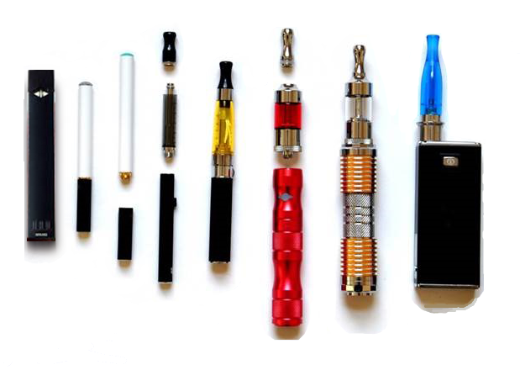

Have you ever tried vaping, even one time?
- Yes
- No
- Prefer not to answer

ASK: All respondents.

[STATE]
What state do you live in?

[PROGRAMMER note: INCLUDE DROP DOWN LIST OF 50 STATES & WASHINGTON DC. INCLUDE AN OPTION for ‘I don’t live in the United States’. SHOULD APPEAR FIRST IN DROP DOWN. INCLUDE AN OPTION FOR 99. Prefer not to answer. SHOULD APPEAR LAST IN DROP DOWN.]

ASK: All respondents

[DOB]
What is your date of birth?

Please use the following format (MM/DD/YYYY)
____/______/_______
99. Prefer not to answer

ASK: All respondents

[EMAIL]
Please enter your email address: _____________________ [OPEN TEXT]
99. Prefer not to answer

The email address you provide is used only for the purposes of this survey and will not be sold or shared.

ASK: All respondents

[EMAIL_VER] [IF EMAIL ≠ 99]
[PROGRAMMER NOTE: VERIFY EMAIL FORMAT AND THAT BOTH EMAIL ADDRESSES MATCH. Verify that this email was not used IN THE PAST 6 MONTHS.]
Please verify your email address: _____________________
99. Prefer not to answer

ASK: Respondents who provide an email address in EMAIL

[CHECKPOINT, INCLUDE IF:
- 15-24 years old based on age provided
- 15-24 years old BASED ON DOB
- STATE ≠ I DON’T LIVE IN THE US AND ≠ 99
- Age provided and age calculated by DOB must match
- Provided a valid email address (EMAIL ≠ 99 AND EMAIL_VER = 1)
- LCC_USE = 1 OR
- LCC_SUSCEPT A, B, OR C ≠ 4 and ≠ 99]
- HISPANIC = 2-5 OR RACE = 3

[THANK_YOU] [IF FAIL CHECKPOINT CRITERIA]
Thank you for taking the time to take our eligibility screener. Unfortunately, based on your responses, you do not qualify to participate in our survey.

[EXIT]

OMB No: 0910-0810 Expiration Date: 10/31/2021
Paperwork Reduction Act Statement: The public reporting burden for this collection of information has been estimated to average 2.5 minutes per response. Send comments regarding this burden estimate or any other aspects of this collection of information, including suggestions for reducing burden to PRAStaff@fda.hhs.gov.

ASK: Participants who fail the inclusion criteria

[CONTINUE] [IF PASS CHECKPOINT CRITERIA]
You are invited to complete our web survey for a $5 electronic gift card. The survey will take about 15 minutes. Please click the “Next” button to continue and take the survey now.
- Next

OMB No: 0910-0810 Expiration Date: 10/31/2021
Paperwork Reduction Act Statement: The public reporting burden for this collection of information has been estimated to average 2.5 minutes per response. Send comments regarding this burden estimate or any other aspects of this collection of information, including suggestions for reducing burden to PRAStaff@fda.hhs.gov.

ASK: Respondents who pass the inclusion criteria

MONTHLY MONITORING STUDY LCC INSTRUMENT 1

[CONSENT] [IF SCREENER AGE ≥ 18]
[ATTACHMENT X. MONTHLY MONITORING STUDY CONSENT FORM]

ASK: All respondents who are 18 years old or older

[ASSENT] [IF SCREENER AGE < 18]
[ATTACHMENT X. MONTHLY MONITORING STUDY ASSENT FORM]

ASK: All respondents who are 15 to 17 years old

[CONSENTREF] [IF CONSENT = 2 OR ASSENT = 2]
[PROGRAMMER: CODE AS REFUSAL]
Thank you for your time.

ASK: Respondents who refuse to provide consent or assent.

SECTION A: TOBACCO USE BEHAVIOR

[A_INTRO]
This section asks about your experiences with tobacco products.
- Next

ASK: All respondents

[A1]
Have you ever tried cigarette smoking, even one or two puffs?
- Yes
- No
- Prefer not to answer

ASK: All respondents

[A2] [IF A1=1 OR 99]
During the past 30 days, on how many days did you smoke cigarettes?
- 0 days
- 1 or 2 days
- 3 to 5 days
- 6 to 9 days
- 10 to 19 days
- 20 to 29 days
- All 30 days
- Prefer not to answer

ASK: Respondents who ever tried cigarette smoking, even one or two puffs, or preferred not to answer whether they ever tried cigarette smoking.

[A3] [IF A1=1 OR 99]
About how many cigarettes have you smoked in your entire life? Your best guess is fine.
- 0 cigarettes
- 1 or more puffs but never a whole cigarette
- 1 cigarette
- 2 to 5 cigarettes
- 6 to 15 cigarettes (about ½ a pack total)
- 16 to 25 cigarettes (about 1 pack total)
- 26 to 99 cigarettes (more than 1 pack, but less than 5 packs)
- 100 or more cigarettes (5 or more packs)
- Prefer not to answer

ASK: Respondents who ever tried cigarette smoking, even one or two puffs, or preferred not to answer whether they ever tried cigarette smoking.

COGNITIVE ASSESSMENT
We are now going to ask you some questions about tobacco products.

[A4]
Below is an image of different types of tobacco products. Looking at this image, as best you can tell, are there products in the image you do not recognize? If so, which ones are unfamiliar?
[insert image with numbered cigars, cigarillos, little cigars][note: example images to be updated before fielding based on focus group data]

Select all that apply:

- 1
- 2
- 3
- 4
- 5
- 6
- 7
- 8
- 9
- 10
- 11
- 12
- 13____
99. Prefer not to answer
ASK: All respondents

[A5]
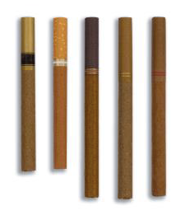
What do you call the tobacco products pictured here? [show picture of filtered cigars]
- _________ [OPEN TEXT]
99. Prefer not to answer

ASK: All respondents

[A6]
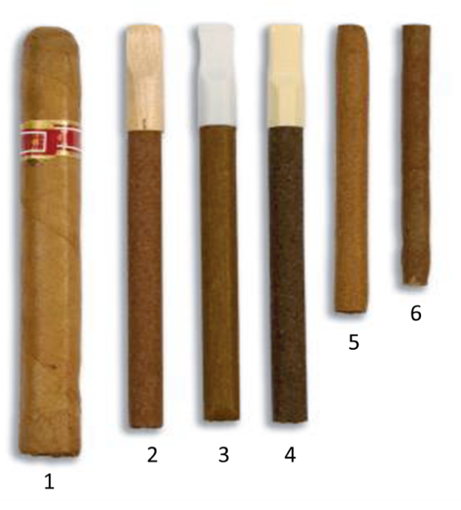
What do you call the tobacco products pictured here? [show picture of cigarillos]
- 1_________ [OPEN TEXT]
- 2 - 4 _______[OPEN TEXT]
- 5 & 6______[OPEN TEXT]
99. Prefer not to answer

ASK: All respondents
[A7]
Have you ever used any of the products pictured here?
[insert full array of cigarillos and filtered cigars]

ASK: All respondents

[A8]
When you were thinking about whether you have ever smoked the items pictured, did you include smoking marijuana in a cigar wrapper, also called smoking a blunt?
- Yes
- No
- Don’t know
- Prefer not to answer

ASK: Respondents who reported ever smoking cigarillos or filtered cigars in previous item

[A9]
Is there anything confusing about the term “cigarillo or filtered cigar”?
- _________ [OPEN TEXT]
99. Prefer not to answer

ASK: All respondents

[A10]
Does “cigarillo” mean the same thing as “filtered cigar” to you?
- _________ [OPEN TEXT]
99. Prefer not to answer

ASK: All respondents

LCC USE
[A11]
The next questions are about cigarillos, filtered cigars, and traditional cigars. These products go by lots of different names, so please use these descriptions and photos to understand what they are.

Some common brands of cigarillos and filtered cigars are Black & Mild, Swisher Sweets, Dutch Masters, Phillies Blunts, Zig Zag, Prime Time, Game cigars and Cheyenne [Note: brands to be updated based on focus group data before fielding].Cigarillos and filtered cigars contain tightly rolled tobacco that is wrapped in a tobacco leaf and are usually brown. Some are the same size as cigarettes, and some come with filters or with plastic or wooden tips.
[SHOW GENERIC IMAGES OF CIGARILLOS AND FILTERED CIGARS]

Traditional cigars are larger than cigarillos and filtered cigars. Some common brands of cigars include Macanudo, Romeo y Julieta, Arturo Fuente, and Cohiba, but there are many others.
[SHOW GENERIC IMAGE OF TRADITIONAL CIGARS]

These products can be used with or without marijuana added. For example, some people smoke marijuana in a cigar wrapper, also called smoking a blunt. For the purposes of this survey, please think about cigarillos and filtered cigars without marijuana, unless specified.
In the past 12 months, have you smoked a traditional cigar, cigarillo, or filtered cigar, even one or two
puffs?
- Yes
- No
- Don’t know
- Prefer not to answer

ASK: All respondents

[A12] [IF A11 = 1 OR 99]
Which type of cigar have you smoked in the past 12 months? [note: example brands to be updated before fielding based on focus group data]
  - Traditional cigars like Macanudo, Romeo y Julieta, Arturo Fuente,Cohiba, or others
  - Cigarillos like Black & Mild, Swisher Sweets, Dutch Masters, Phillies Blunts, Zig Zag, or others
  - Filtered cigars like Cheyenne, or others
- Don’t know
- Prefer not to answer

ASK: Respondents who have smoked a traditional cigar, cigarillo, or filtered cigar in the past 12 months

[A13] [IF A12 = 2 OR 3 OR 99]
Which of the following kinds of cigarillos or filtered cigars have you smoked in the past 12 months? Choose all that apply.
The kind…
[SHOW GENERIC IMAGE OF CIGARILLOS WITH TIPS, FILTERED CIGARS, AND CIGARILLOS
WITHOUT TIPS]

- With a plastic or wooden tip
- With a filter (like a cigarette filter)
- Without a tip or filter
- Don’t know
- Prefer not to answer

ASK: Respondents who have smoked cigarillos in the past 12 months

[A14] [IF A12 = 2 OR 3 OR 99]
When did you last smoke a cigarillo or filtered cigar, even one or two puffs?

- Earlier today
- Not today but sometime during the past 7 days
- Not during the past 7 days but sometime during the past 30 days
- Not during the past 30 days but sometime during the past 6 months
- Not during the past 6 months but sometime in the past year
- 1 to 4 years ago
- 5 or more years ago
- Don’t know
- Prefer not to answer

ASK: Respondents who have smoked cigarillos or filtered cigars in the past 12 months

[A15] [IF A14=1-7 OR 99]
During the past 30 days, on how many days did you smoke cigarillos or filtered cigars?
- __________ [0-30 Days]
- Prefer not to answer

ASK: Respondents who reported ever smoking cigarillos or filtered cigars or did not answer the question about ever smoking cigarillos or filtered cigars

[A16] [IF A12 = 2 OR 3 OR 99]
What is your favorite brand of cigarillo or filtered cigar?
- _________ [OPEN TEXT]
99. Prefer not to answer

ASK: Current LCC users

[A17] [IF A15 = 1-30]
On the days you smoked cigarillos or filtered cigars, how many did you smoke per day, on average?
- Less than 1 cigarillo or filtered cigar
- 1 cigarillo or filtered cigar
- 2 to 5 cigarillos or filtered cigars
- 6 to 10 cigarillos or filtered cigars
- 11 to 20 cigarillos or filtered cigars
- More than 20 cigarillos or filtered cigars
- Don’t know
- Prefer not to answer

ASK: Respondents who smoked LCCs on one or more days in the past 30 days

[A18] [IF A15 = 1-30]
On the days you smoked cigarillos or filtered cigars, did you smoke them alone, in a group, or both?
- Alone
- In a group
- Both
- Don’t know
- Prefer not to answer

ASK: Respondents who smoked LCCs on one or more days in the past 30 days

[A19] [IF A15 = 1-30]
When you smoke cigarillos or filtered cigars, how often do you use it for blunts?
- Always
- Often
- Sometimes
- Never
- Don’t know
- Prefer not to answer

ASK: Respondents who smoked LCCs on one or more days in the past 30 days

[A20] [IF A15 = 1-30]
When you smoke cigarillos or filtered cigars, how often do you inhale the smoke?
- Always
- Often
- Sometimes
- Never
- Don’t know
- Prefer not to answer

ASK: Respondents who smoked LCCs on one or more days in the past 30 days

Nicotine dependence

[A21]
Do you want to stop or cut back on how much you smoke cigarillos or filtered cigars?
- Yes
- No
- Prefer not to answer

ASK: Respondents who smoked LCCs on one or more days in the past 30 days

[A22]
How soon do you smoke cigarillos or filtered cigars after getting up?
- Within 5 minutes
- 5 to 30 minutes
- 30 to 60 minutes
- After 60 minutes
- Prefer not to answer

ASK: Respondents who smoked LCCs on one or more days in the past 30 days

SECTION B: MARIJUANA

[B_INTRO_MJ]
In this section, we’d like to know about your use of different forms of marijuana. A blunt is cigar with the tobacco removed and replaced with marijuana or a blunt wrap filled with marijuana. A spliff is a mix of marijuana and tobacco.
- Next

ASK: All respondents

[B1]
Have you ever smoked marijuana (like a pipe, joint, spliff, or blunt) even one time?
- Yes
- No
- Prefer not to answer

ASK: All respondents.

[B2] [IF B1 = 1 OR 99]
During the past 30 days, on how many days did you smoke marijuana (like a pipe, joint, spliff or blunt)?
- 0 days
- 1 or 2 days
- 3 to 5 days
- 6 to 9 days
- 10 to 19 days
- 20 to 29 days or
- All 30 days
- Prefer not to answer

ASK: Respondents who ever tried marijuana.

[B3] [IF B1 = 1 OR 99]
During the past 30 days, on how many days did you smoke blunts?
- 0 days
- 1 or 2 days
- 3 to 5 days
- 6 to 9 days
- 10 to 19 days
- 20 to 29 days or
- All 30 days
- Prefer not to answer

ASK: Respondents who ever tried marijuana

SECTION C: CORONAVIRUS

[C_INTRO_COVID]
The novel Coronavirus (the virus that causes COVID-19, a new disease with flu-like symptoms) is spreading across the world.
- Next

ASK: All respondents

[C1]
Have you heard of the coronavirus (COVID-19)?
- Yes
- No
- Don’t Know
- Prefer not to answer

ASK: All respondents

[C2] [IF C1 = 1]
Do you think smoking cigarillos or filtered cigars makes it more likely that you will get the coronavirus (COVID-19)?
- Yes
- No
- Don’t Know
- Prefer not to answer

ASK: All respondents

[C3] [IF C1 = 1]
Does smoking cigarillos or filtered cigars make coronavirus symptoms worse?
- Yes
- No
- Don’t Know
- Prefer not to answer

ASK: All respondents

[C4] [IF C1 = 1]
Are you smoking cigarillos or filtered cigars more, less, or about the same as you did before the coronavirus crisis?
- Less often than before
- About the same as before
- More often than before
- Prefer not to answer

ASK: All respondents who have heard of Coronavirus and have ever used LCCs

SECTION D: BELIEFS

[D_INTRO_BELIEFS]
In the next set of questions, we will ask about your beliefs related to cigarillos and filtered cigars. These products can be used with or without marijuana added. For example, some people smoke marijuana in a cigar wrapper, also called smoking a blunt. For the purposes of these next questions, though, please think about cigarillos and filtered cigars without marijuana, unless specified.
NEXT

[D1]
Imagine that you smoke cigarillos or filtered cigars regularly. What do you think your chances are of having each of the following happen to you if you continue to smoke cigarillos or filtered cigars regularly?
 | No chance  (0) | (1) | (2) | (3) | (4) | (5) | Very good chance  (6) | I don’t know  (98) | I do not wish to answer  (99)
[D1_a] Lung cancer
[D1_b] Heart disease
[D1_c] Stroke
[D1_d] Gum disease

ASK: All respondents

[D2]
Is smoking cigarillos or filtered cigars more harmful, less harmful, or just as harmful as smoking cigarettes?
 | D2_a. Cigarillos | D2_b. Filtered cigars
- More harmful than cigarettes
- Less harmful than cigarettes
- Same
- Don’t know
99. Prefer not to answer

ASK: All respondents

[D3]
Is smoking cigarillos or filtered cigars more harmful, less harmful, or just as harmful as vaping?
 | D3_a. Cigarillos | D3_b. Filtered cigars
- More harmful than vaping
- Less harmful than vaping
- Same
- Don’t know
99. Prefer not to answer
ASK: All respondents

[D4]
Are cigarillos and filtered cigars more addictive, less addictive, or just as addictive as cigarettes?
 | D4_a. Cigarillos | D4_b.Filtered cigars
- More addictive
- Less addictive
- Same
- Don’t know
99. Prefer not to answer

ASK: All respondents

[D5]
Do you think that unflavored cigarillos or filtered cigars are less harmful, as harmful, or more harmful than flavored cigarillos or filtered cigars (like ones with a fruity, sweet, savory, or alcohol flavor)?
 | D5_a. Unflavored cigarillos | D5_b. Unflavored filtered cigars
- Less harmful than flavored
- As harmful as flavored
- More harmful than flavored
- Don’t know
99. Prefer not to answer

ASK: All respondents

[D6]
How risky is smoking cigarillos or filtered cigars every day?
 | D6_a. Cigarillos | D6_b.Filtered cigars
- Very risky
- Somewhat risky
- A little risky
- Not at all risky
- Don’t know
99. Prefer not to answer

ASK: All respondents

[D7]
How risky is smoking cigarillos or filtered cigars occasionally?
 | D8_a. Cigarillos | D8_b.Filtered cigars
- Very risky
- Somewhat risky
- A little risky
- Not at all risky
- Don’t know
99. Prefer not to answer
ASK: All respondents

[D8]
The next questions are about the reasons people smoke cigarillos. How important is each reason for you.
 | 1. not important at all | Slightly important | moderately important | very important | 5. Extremely important | 99. Prefer not to answer
D8_a. Come in flavors I like
D8_b. Help me feel relaxed
D8_c. Give me a good buzz
D8_d. Cheaper than cigarettes
D8_e. Safer than cigarettes
D8_f. My friends use them
ASK: Respondents who use cigarillos.

[D9]
If I smoke cigarillos I will…
 | 1. Strongly agree | Agree | Disagree | 4. Strongly disagree | Don’t know/refused
D9_a. Become addicted
D9_b. Be able to stop when I want to
D9_c. Expose my brain to nicotine
D9_d. Be controlled by smoking

ASK: All respondents

[D10] The next questions are about the reasons people smoke filtered cigars. How important is each reason for you.
 | not important at all | Slightly important | moderately important | very important | Extremely important
D10_a. Come in flavors I like
D10_b. Help me feel relaxed
D10_c. Give me a good buzz
D10_d. Cheaper than cigarettes
D10_e. Safer than cigarettes
D10_f. My friends use them

ASK: Respondents who currently use filtered cigars.

How much do you agree or disagree with the following statements?
[D11]
If I smoke filtered cigars I will…
 | Strongly agree | Agree | Disagree | Strongly disagree | Don’t know/refused
D11_a. Become addicted
D11_b. Be able to stop when I want to
D11_c. Expose my brain to nicotine
D11_d. Be controlled by smoking

ASK: All respondents

[D12]
If I smoke blunts (cigars with marijuana added) I will…
 | Strongly agree | Agree | Disagree | Strongly disagree | Don’t know/refused
D12_a. Become addicted
D12_b. Be able to stop when I want to
D12_c. Expose my brain to nicotine
D12_d. Be controlled by smoking

ASK: All respondents

[D13]
 | D13_a. Cigarillo smoke contains nicotine | D13_b. Filtered cigar smoke contains nicotine
- Yes
- No
- Don’t know
99. Prefer not to answer

ASK: All respondents

[D14]
 | D14_a. Smoking cigarillos may cause nicotine addiction | D14_b. Smoking filtered cigars may cause nicotine addiction
- Strongly disagree
- Disagree
- Neither agree nor disagree(neutral)
- Agree
- Strongly agree

ASK: All respondents

[D15]
Out of every 10 people your age, how many do you think…
Radio buttons 1 - 10
D16_a. Smoke cigarillos?
D16_b. Smoke filtered cigars?
D16_c. Smoke blunts?

ASK: All respondents

[D16]
[Placeholder for additional belief item]

SECTION E: DEMOGRAPHICS AND CLOSING

[EDUCATION]
What is the highest grade or year of school you have completed?

[IF AGE = 15-18: USE THE FOLLOWING RESPONSE OPTIONS]
- Less than grade 7
- Grade 8
- Grade 9
- Grade 10
- Grade 11
- Grade 12
- Some college
- Prefer not to answer

[IF AGE = 19-24: USE THE FOLLOWING RESPONSE OPTIONS]
1. Some high school or less
2. GED
3. High school diploma
4. Some college but no degree
5. Associate degree
6. Bachelor’s degree
7. Master’s degree or higher
- Prefer not to answer

ASK: All respondents

[EMPLOYMENT] [IF AGE = 19-24]
Which of the following best describes your current status (Please select only one response, your main status now.)?
- Employed for wages
- Self-employed
- Out of work
- Student
- Unable to work
- Prefer not to answer

ASK: All respondents

[VERIFY]
Including this one, how many surveys about tobacco have you taken in the past six months?

__________ (Range: 1-10)
99. Prefer not to answer

ASK: All respondents

[COMMNT]
Thank you for completing the survey. Please enter any comments that you have about the survey.

______________________ PROGRAMMER: PROGRAM OPEN ENDED ITEM WITH 2000 CHARACTER LIMIT. MAKE ITEM OPTIONAL.
- Next

ASK: All respondents

[THANKS]
To thank you for completing the survey, you will receive an electronic gift card for $5. If you would like to decline receiving this payment, you can select “No” to continue to the next screen.

Would you like to receive this gift card?
- Yes
- No

ASK: All respondents

[INCENT_EMAIL] [IF THANKS=1]
Please provide the email address you would like to use to receive your gift card.
e-mail__________________________[ALLOW 50 CHARACTERS]
Confirm e-mail___________________[THIS FIELD MUST MATCH ABOVE]

ASK: Participants who indicate they would like to receive a gift card.
[CLOSE]
Thank you again for your participation. You may now close your browser or navigate away from this page.

OMB No: 0910-0810 Expiration Date: 10/31/2021
Paperwork Reduction Act Statement: The public reporting burden for this collection of information has been estimated to average 12 minutes per response. Send comments regarding this burden estimate or any other aspects of this collection of information, including suggestions for reducing burden to PRAStaff@fda.hhs.gov.

ASK: All respondents

