Science Experiment

Key Frame

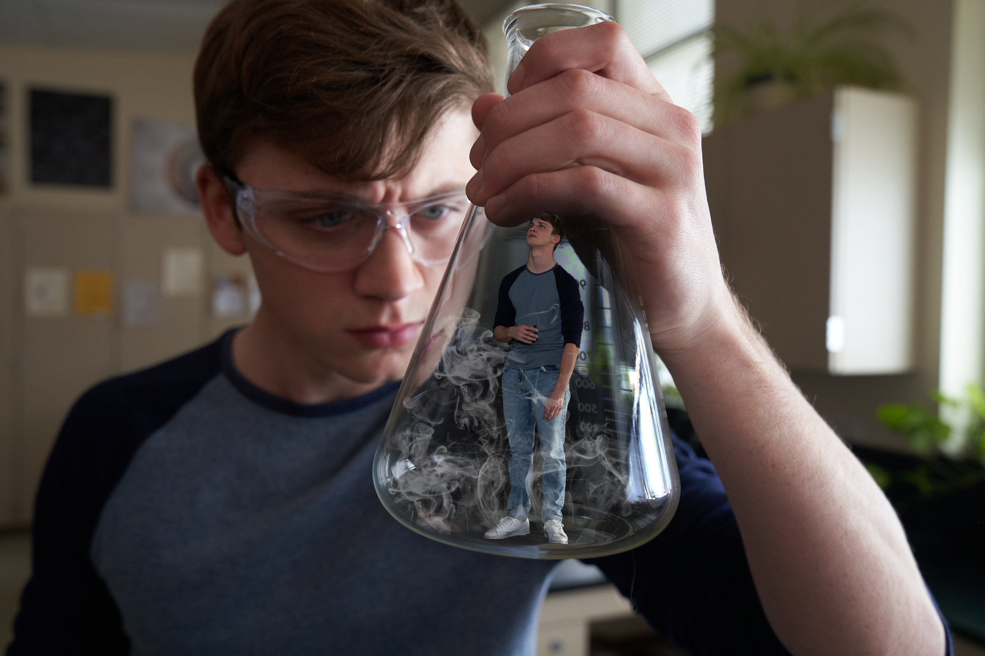

Script

We open on teens in a high school chemistry class during lab.
TEACHER: Come on everybody, let’s focus. This may be the most dangerous experiment you do.
We see the teacher gesturing and speaking.
TEACHER: This stuff is toxic. Izzy, stop messing around. Doug, pay attention.
We see a close-up of a teen transferring liquid with a dropper into a very small metallic cylinder. It’s being held between the thumb and forefinger, like a small part of a larger electronics device. Another teen presses a button on a very small, rectangular device, and we see an LED light turn green. Like the cylinder, this device is held between the thumb and forefinger, and is similar in size to a small electronics part.
TEACHER: Give the stimulus to the test subjects.
We see three teens lower these mini devices by hand into the glass boxes in front of them. We see three glass boxes with miniature versions of the teens inside. The mini teens take the devices being handed to them. We see the mini versions blow clouds of vapor. Standing amid the hazy vapor, the teens react in various ways: coughing, looking up and around, etc. We see a teen peer into the glass box that contains the mini version of herself vaping.
AVO: If you vape, you’re experimenting on yourself. You could be inhaling cancer-causing chemicals, like formaldehyde, and metals, like lead, that can damage your lungs. TRC Logo

Possessed by Nicotine

Key Frame

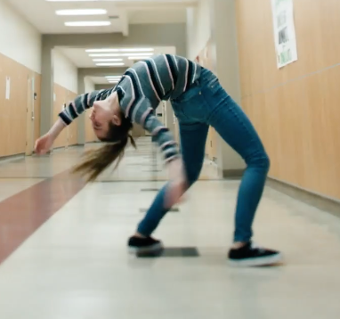

Script

We open on a STUDENT in a high school class.

She looks at the clock, then back at the teacher. Suddenly, she’s yanked from her seat as if being pulled sideways by an unseen force. The girl’s head starts to rotate 180 degrees.

SFX: twisting, cracking neck bones
Her classmates are horrified. Her waist and legs then twist violently until they also do a 180.

SFX: bones cracking

Her legs take heavy steps as she shuffles toward the door and leaves the classroom. She walks into the girls’ restroom. With her head and legs facing one direction and her torso and arms facing the other, she awkwardly jams her hand into her pocket and pulls out a vape.

AVO: If you vape, nicotine cravings could take control of you.

She raises it toward her mouth. Cut to title card.

SUPER: Are you possessed by nicotine?

CARD: TRC Logo

Macroscopic Metals
Key Frame

Script
This spot opens as if we’re inside a mesmerizing “cloud” or “asteroid belt” of small metal fragments floating in the air.
The fragments vary in shape, texture, and finish, but most are sharp and crude.
After a few seconds, they begin to move in one direction, colliding along the way, splintering in mini-explosions of metal. They accelerate and get sucked off the screen.
The camera pulls out to reveal that we’ve been in a vape device, in the hand of a teen. He exhales. The teen begins to raise the vape toward his mouth again.
VO: If you vape, you could be inhaling toxic metals like nickel, chromium, and lead that can damage your lungs.
CARD: TRC Logo

Addiction Isn’t Pretty: Purse
Key Frame
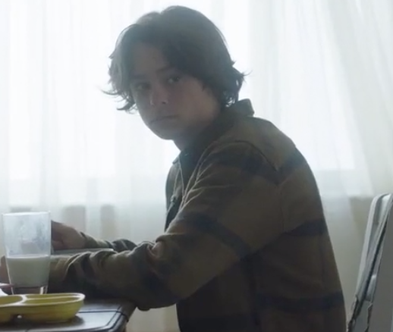
Script
A boy is in the kitchen with his family during breakfast. He’s nervously glancing at his mom’s purse, waiting for her to turn her back.
SUPER: What drug is so addictive that you’d hurt those closest to you to get your fix?
We see the kid leaving home, and him holding money that he’s exchanged for vape pods.
SUPER: Most vapes contain seriously addictive levels of nicotine.
SUPER: Addiction isn’t pretty.
CARD: TRC logo

Addiction Isn’t Pretty: Toilet
Key Frame

Script
An anxious girl frantically takes something out of her purse and accidentally drops it into the toilet. She’s dismayed and considers fishing it out.
SUPER: What drug is so addictive that you’d lower your standards to get a hit?
She retrieves the item, and we see that it’s a vape. She wipes it down. Embarrassed, she nonetheless vapes, as another grimaces.
SUPER: Most vapes contain seriously addictive levels of nicotine.
SUPER: Addiction isn’t pretty.
CARD: TRC logo

Addiction Isn’t Pretty: Athlete
Key Frame
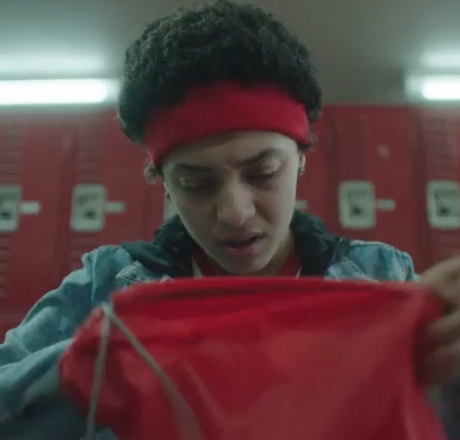
Script
We open on a panicked teen in a basketball uniform in a school locker room. She’s fishing through her backpack looking for something. Another player pokes her head in.
COACH: Alright girls, let’s go, let’s go!
OTHER BALLPLAYER (urgently): Tallulah, come on! The bus is about to leave! What are you doing?
TALLULAH: OK, OK. One second.
The other ballplayer watches as Tara now frantically searches her locker. The other teen leaves, irked.
SUPER: What drug is so addictive, you’d choose it over those who are counting on you most?
We see the bus pull away through the window.
Camera pans down under the locker room bench to discover Tara’s vape.
SUPER: Most vapes contain seriously addictive levels of nicotine.
Tara discovers the vape, picks it up and runs out of the locker room to try to catch the bus. She reacts with panic and shame.
SUPER: Addiction isn’t pretty.
CARD: TRC logo
Addiction Isn’t Pretty: Skateboard
Key Frame

Script
A teen is holding his skateboard, twisting it slowly back and forth in his hands, and looking at it. He’s steeped in thought. An older teen stands next to him, waiting for him to say something.
SUPER: What drug is so addictive that you’d give away a part of yourself to get more?
OLDER TEEN: So, you want to trade or what?
TEEN: Deal.
The teen hands the older teen his skateboard, and the older teen hands over a vape and pod(s).
OLDER TEEN: Thanks, man.
The older teen drops in to a skate park on his newly acquired board. The other teen can only watch as he pockets the vape. After a moment or two, he walks slowly away.
SUPER: Most vapes contain seriously addictive levels of nicotine.
VO: Addiction isn’t pretty.
CARD: TRC logo

Scary Enough
Key Frame

Script
Open on a man walking down a dimly lit hallway, showing us various horrors along the way. The first is a series of scary metal creatures that lunge at the man. He’s unfazed as he continues walking.
MAN: If you vape, you could be inhaling toxic metals into your lungs.
MAN: To show how scary that is, we made metal monsters.
We come across a team of computer designers working on CGI.
MAN: With special effects that show metal particles being inhaled.
We hear violins as we happen upon an orchestra practicing the kind of music that builds and intensifies in horror movies.
MAN: And music, - music that would’ve made your heart race.
The man approaches a table that has nothing on it except a vape.
MAN: But nothing is as scary as the facts.
He picks up the vape and holds it up to camera.
MAN: Vaping can deliver toxic metals – like nickel and lead – into your lungs. That’s metal. In your lungs. CARD: The Real Cost

My Vaping Mistake
Key Frame
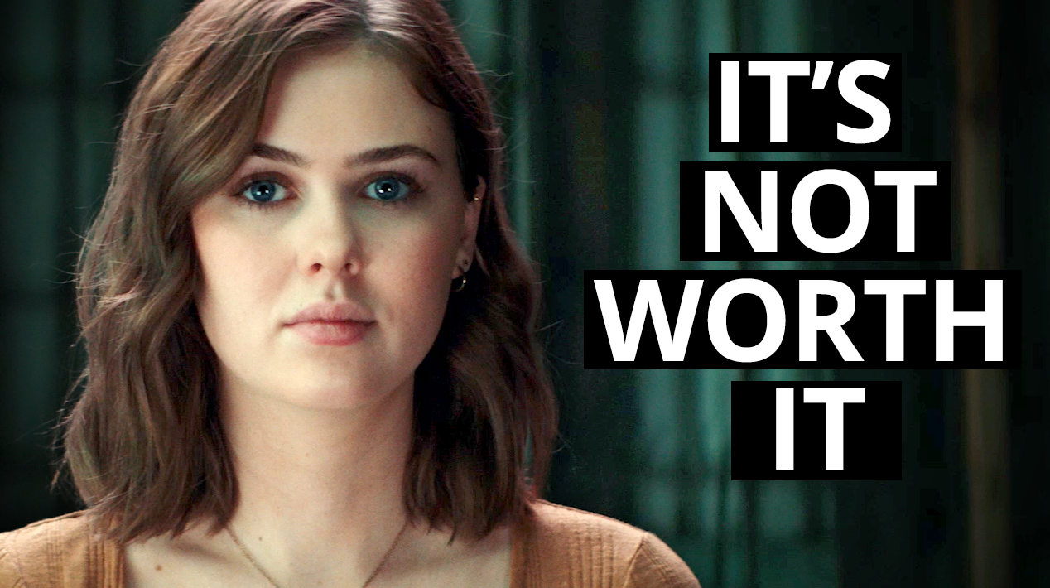
Script
Caitlin: Hi, it's [Caitlin 00:00:04].
Isaac: Hey, guys, it's Isaac.
Chloe: Hey, it's Chloe.
Katie: It's Katie. I have the craziest story to tell you. My chest would start to hurt. I'd get really, really dizzy.
Chloe: I couldn't really breathe.
Isaac: My heart started cramping up.
Chloe: It was beating so fast.
Caitlin: My chest would feel like it was on fire.
Katie: Sometimes I would even pass out. My name [00:00:30] is Katie Jo. I'm 11 years old, and I started vaping in July.
Caitlin: I'm Caitlin. I started vaping three years ago.
Isaac: My name's Isaac, and I started vaping at 17.
Chloe: I'm Chloe. I'm 17. I started vaping when I was 15. As soon as I started vaping, I started having panic attacks.
Katie: I thought it just affected your body and not your mindset.
Caitlin: It was making me feel less than who I was. My confidence [00:01:00] was just dropping.
Isaac: I thought vaping could be a stress reliever, because most of my friends were doing it, and they were telling me how it helped them through school and homework. And I was trying to make a decision of where I wanted to play college football at, and I was just extremely stressed, so I picked it up and tried it.
Katie: Vaping does not make you relaxed. If anything, it makes it so that you are more anxious.
Chloe: At first, I didn't think it was addictive. [00:01:30] I thought I was kind of stronger than it, but soon I realized, it was holding a, kind of a power over me. I would leave class and use it, and I was always craving more and more. Like, it was never enough.
Isaac: A lot of people assumed I was happy all the time. But once I got home, I would go to my room, and it'd just be depression and sadness and loneliness. And I felt like no one was there for me.
Katie: I started isolating myself from lot of people, friends, family [00:02:00] in the world.
Chloe: My anxiety got really bad after I started vaping. It wouldn't even have to do with vaping. It would just be like about anything, really. And it was odd, because I was never an anxious person before
Isaac: I realized what vaping really did to me. It was not helping me cope. It was canceling out my ability to cope.
Caitlin: I started to feel anxious, and it wasn't happening to anybody else. So that meant that something was wrong with me. That just made me feel [00:02:30] even more anxious, and even more sad.
Katie: It made my anxiety so bad, I couldn't even leave the house. I was scared to go to school. And then once I stopped, everything got better.
Chloe: I started a club at my school because my friend Tommy. We decided that other people needed a support group, to know that they're backed, when they wanted to quit.
Caitlin: You don't have to keep doing it if it's not something that you really want to be doing.
Chloe: I'm someone that has done it, and so, I kind of want to be that [00:03:00] voice for the generation coming up, to make sure they don't make the same mistakes.

