APPENDIX C

First Federal Register Announcement
and Public Comment

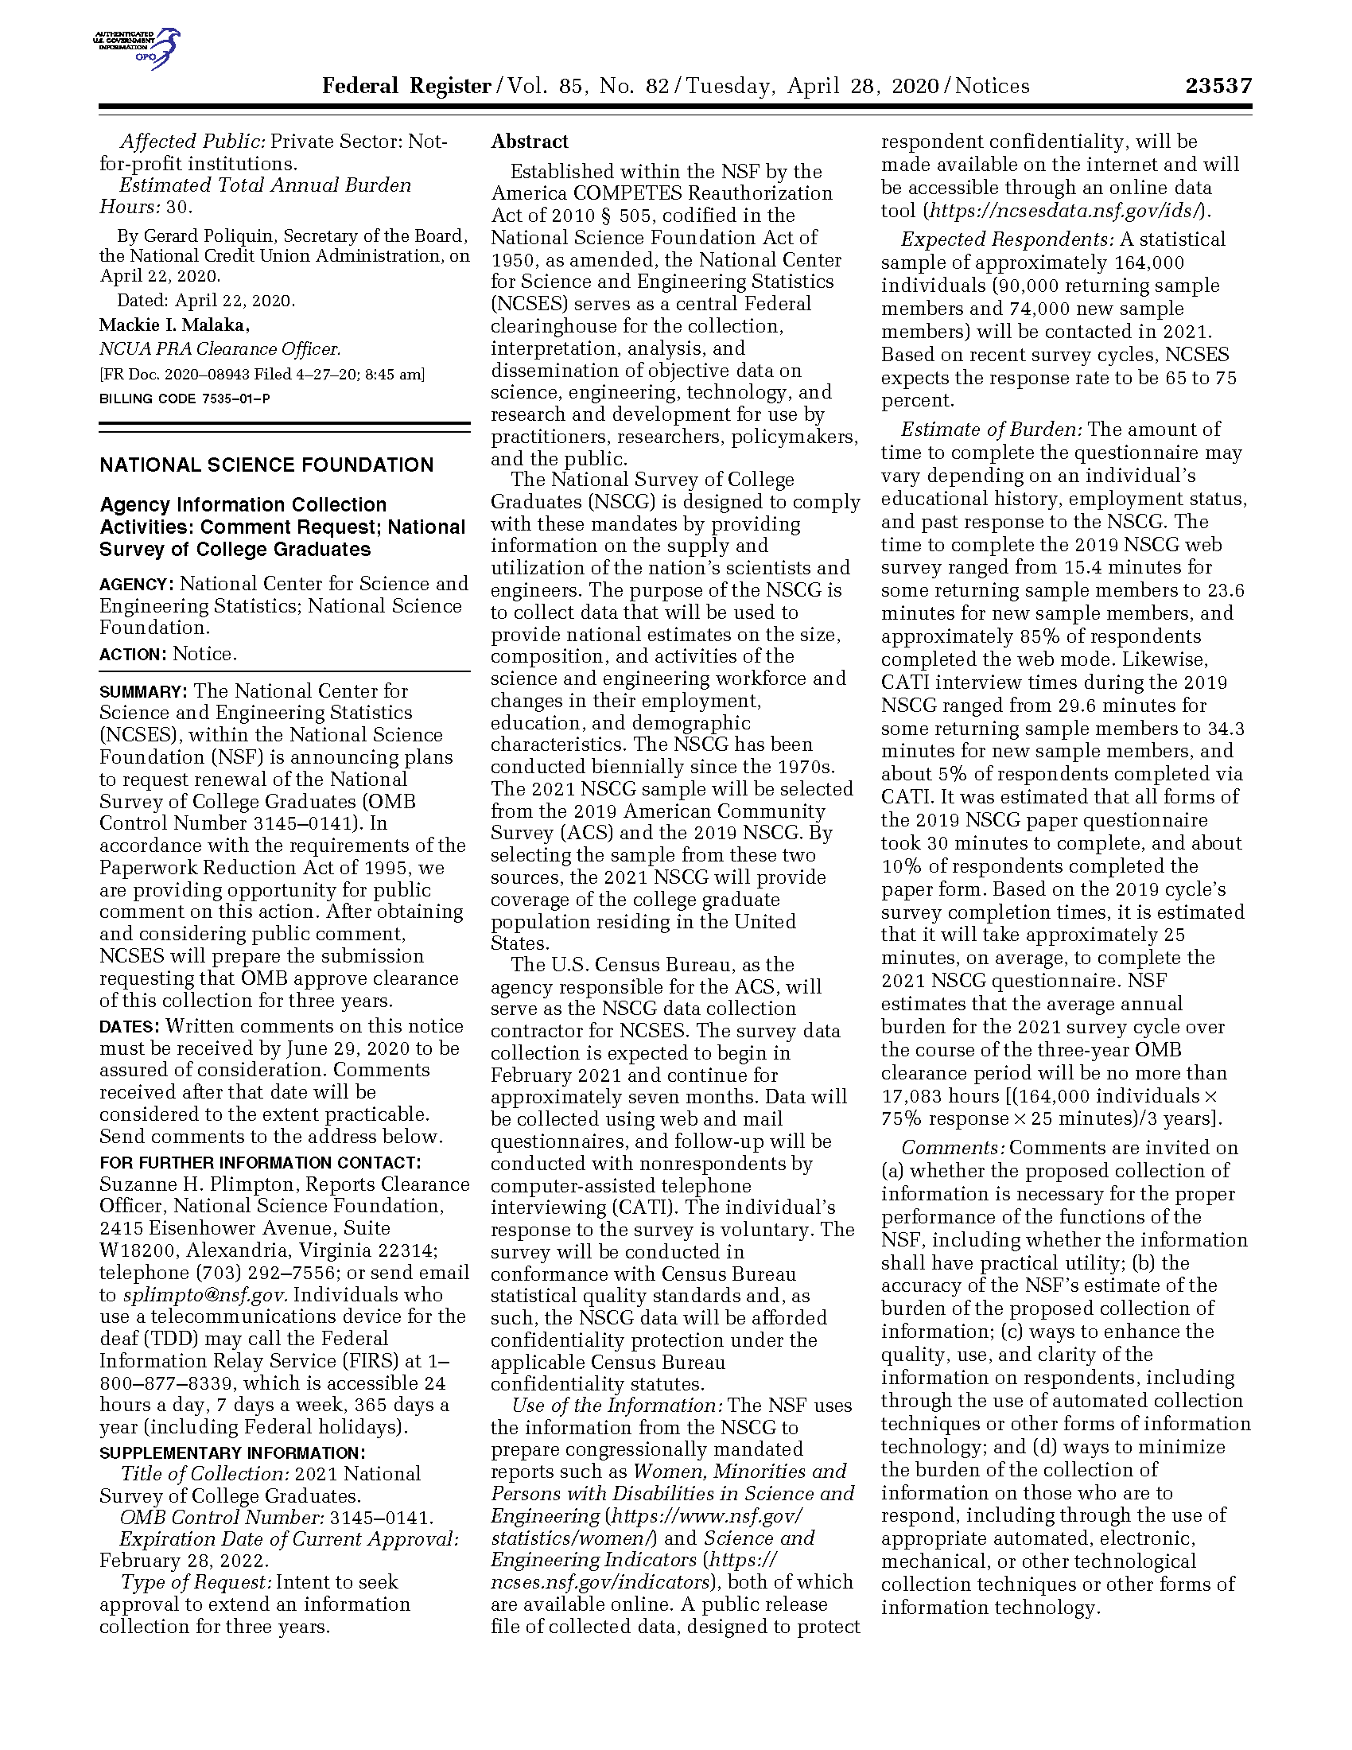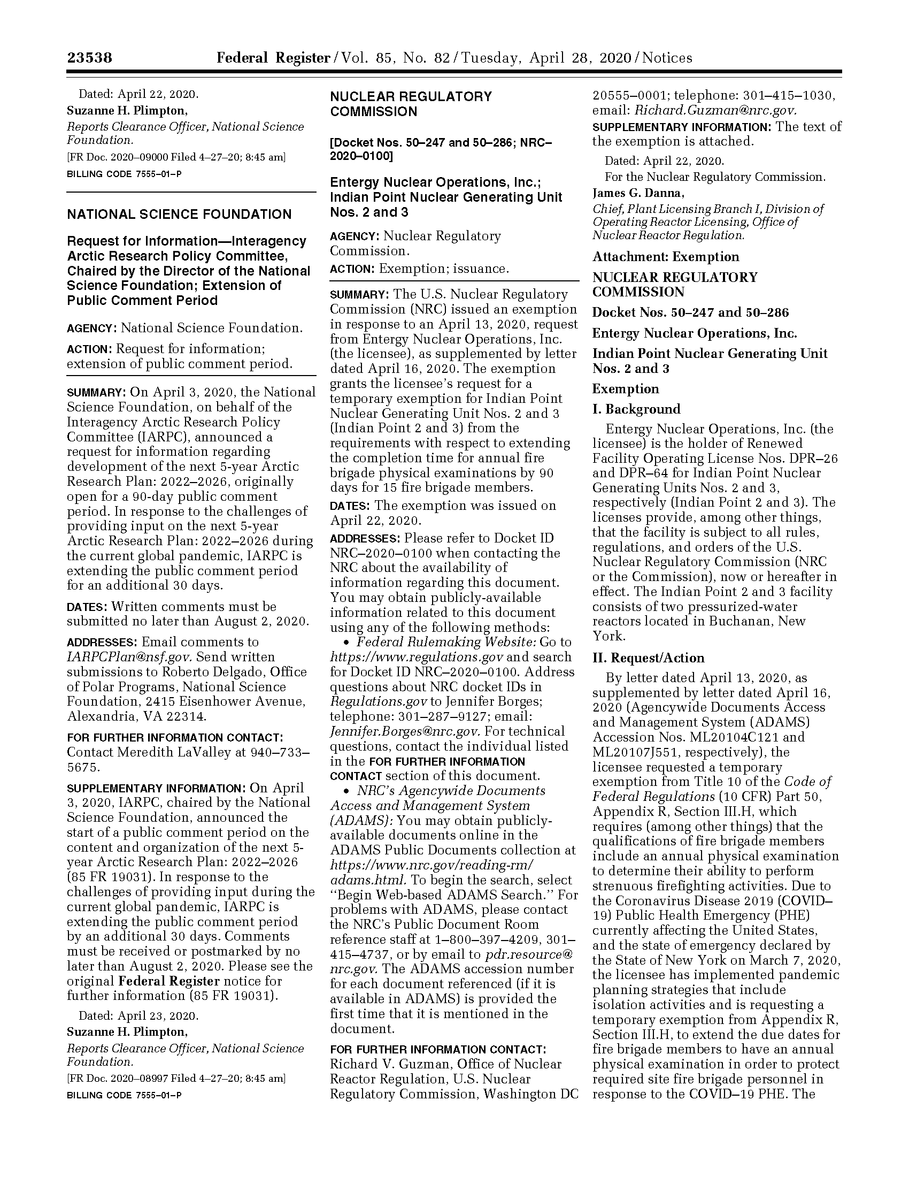

Public Comment to the First Federal Register Announcement
June 29, 2020

Ms. Suzanne H. Plimpton Reports Clearance Officer National Science Foundation
2415 Eisenhower Ave., Suite W18200 Alexandria, VA 22314
Via regulations.gov and email

RE: National Science Foundation (NSF); Notice of Intent to Seek Approval to Extend an Information Collection for Three Years; 2021 National Survey of College Graduates (Federal Register Doc. 2020-09000)

Dear Ms. Plimpton:

We are writing to comment on NSF’s proposed information collection request related to the 2021 National Survey of College Graduates (NSCG). See 85 Fed. Reg. 23537 (April 28, 2020). This public comment is in line with our previous comment regarding the 2019 NSCG that was submitted to the Federal Register on August 13, 2018 and is appended below. Our previous comment was cosigned by 17 scientific organizations and authorities in higher education research, including the American Association for the Advancement of Science and the American Educational Research Association, and 244 scientists, engineers, and legal and policy scholars, including 17 members of the National Academies.

Following our previous comment, we were grateful to have had the opportunity to meet with the leadership of NSF’s National Center for Science & Engineering Statistics (NCSES) to discuss the inclusion of sexual orientation and gender identity (SOGI) measures in NCSES surveys, most notably the NSCG, Survey of Doctorate Recipients (SDR), and Survey of Earned Doctorates (SED). We were pleased to learn in October 2018 that NCSES was planning to conduct internal methodological piloting of SOGI measures for NCSES surveys, which was expected to begin with the NSCG and produce preliminary results by early 2019. We hope that the piloting was a success and that SOGI measures will be added to the 2021 NSCG and other future NCSES surveys. We write now to reaffirm the importance, feasibility, and precedent of including SOGI measures in NCSES surveys.

As you know, NSF is responsible for broadening the participation of underrepresented groups in STEM as it is “in the national interest to promote the full use of human resources in science and engineering” (42 U.S.C. § 1885). Although NSF has not tracked the STEM participation of LGBTQ people, also called sexual and gender minorities, via NCSES surveys, evidence for LGBTQ disparities in STEM is now substantial. Studies estimate that LGBTQ people are 17-21% less represented in the STEM workforce than statistically expected.1 In the U.S., LGBTQ people currently comprise 4.5% of the population, and this number rises to 8.2%

1 As cited in Freeman, J.B. (2018). LGBTQ scientists are still left out. Nature, 559, 27-28

for those 18-37 years of age.2 Thus, early-career age LGBTQ people have a higher prevalence in the U.S. than several other groups whose disparities have long been carefully tracked via NCSES surveys, including Black women (7.0%), Asians (5.9%), and Native Americans (1.3%).3 Indeed, LGBTQ people are “one of the largest, but least studied, minority groups in the workforce”.4 With a U.S. STEM workforce size of 7 million people,5 these findings suggest that the U.S. may have lost approximately 54,000 to 121,000 LGBTQ people who would currently otherwise be in STEM.6 Adding SOGI measures to NCSES surveys is critically needed to track LGBTQ people from U.S. undergraduate and graduate programs through to the STEM workforce, and to understand and address the challenges they face along the way.

Indeed, the challenges for LGBTQ individuals begin early in the STEM pipeline. A 2016 study of 87,996 undergraduates across 18 research universities found that LGBTQ students were significantly less likely to major in STEM fields than their non-LGBTQ peers.7 Among undergraduates at 78 universities who declared a STEM major in their freshman year, sexual minority students (i.e., lesbian, gay, bisexual, and queer) were more likely than their heterosexual peers to leave STEM for a non-STEM major by their senior year. This was true despite the fact that sexual minority students showed greater engagement in STEM (e.g., lab participation) than their heterosexual peers, suggesting that they left STEM due to non- supportive STEM environments.8 Data from the 2009-2018 American Community Survey (ACS) and 2013-2018 National Health Interview Survey (NHIS) showed that sexual minorities were
less likely to earn a bachelor’s degree in STEM and to hold a STEM occupation, relative to their heterosexual counterparts.9 The sexual orientation gap for STEM degrees was smaller than the gender gap (i.e., less STEM degrees for women than men) but larger than the race gap (i.e., less STEM degrees for Black people than White people).

Non-supportive STEM environments and harmful biases and stereotypes appear to be partly responsible for these disparities. LGBTQ people report more negative workplace experiences in STEM fields than do non-LGBTQ people in those same fields, or than do LGBTQ people in non-STEM industries.1 Among sexual minority STEM faculty members who are out at work, 70% report feeling uncomfortable in their academic department.10 Some STEM fields have

2 Gallup (2018). In U.S., Estimate of LGBT Population Rises to 4.5%. https://news.gallup.com/poll/234863/estimate-lgbt-population-rises.aspx
3 U.S. Census Bureau. (2020). National Population by Characteristics: 2010-2019.
https://www.census.gov/data/tables/time-series/demo/popest/2010s-national-detail.html
4 Ragins, B.R. (2004). Sexual orientation in the workplace: The unique work and career experiences of gay, lesbian and bisexual workers. In J. Martocchio (Ed.), Research in personnel and human resources management, 23, 35–129. 5 National Science Board (2020). The State of U.S. Science & Engineering. https://ncses.nsf.gov/pubs/nsb20201
6 Freeman, J.B. (2020). Measuring and Resolving LGBTQ disparities in STEM. Policy Insights in the Behavioral & Brain Sciences.
7 Greathouse M. et al. (2018). Queer-spectrum and trans-spectrum student experiences in American higher
education: The analyses of national survey findings. https://rucore.libraries.rutgers.edu/rutgers-lib/60802/PDF/1/
8 Hughes, B.E., 2018. Coming out in STEM: Factors affecting retention of sexual minority STEM students. Science advances, 4(3), p.eaao6373.
9 Sansone, D., & Carpenter, C.S. (2020). Turing's Children: Representation of Sexual Minorities in STEM. arXiv,
https://arxiv.org/abs/2005.06664. For the ACS, sexual orientation was inferred via those in a same-sex couple. 10 Patridge, E.V., Barthelemy, R.S. and Rankin, S.R. (2014). Factors impacting the academic climate for LGBQ STEM faculty. Journal of Women and Minorities in Science and Engineering, 20.

conducted internal surveys that included SOGI questions. In U.S. physics, more than 20% of LGBTQ people reported being excluded, intimidated, or harassed at work due to their LGBTQ identity, and 15-30% reported feeling uncomfortable at work, and these negative experiences predicted a desire to leave the field.11

In assessing the feasibility of asking SOGI questions on surveys, NCSES may be concerned that SOGI measures are too sensitive to include. However, government surveys on the
U.S. population have already successfully collected SOGI data for years, including federal surveys with smaller sample sizes than NCSES surveys (e.g., the NHIS, which as mentioned earlier has already been used to provide evidence for LGBTQ disparities in STEM). The Federal Interagency Working Group on Improving Measurement of SOGI in Federal Surveys has warned that federal agencies may perceive SOGI questions as overly sensitive, which hinders them from adopting SOGI measures even when “inclusion of these measures would support agency mission and data needs” and even though that perception is inconsistent with past survey experience.12 For instance, SOGI questions in federal surveys do not cause issues such as survey break-off or high non-response rates, and they are voluntary.12 Options such as “I don’t wish to respond” are always available; and for those who do wish to respond, federal law protects the confidentiality of individually identifiable data. Thus, SOGI questions cannot expose respondents to potential discrimination, nor do they impact the statistical robustness of the data collected.

Adding SOGI measures has value for other important efforts at NCSES. The National Academies’ 2018 report on Measuring the 21st Century Science and Engineering Workforce Population: Evolving Needs recommended that NCSES develop a sexual harassment and discrimination module for its surveys,13 and NSF’s Broad Agency Announcement (BAA) on March 6, 2020 indicates that NCSES is seeking new measures on the incidence and experience of sexual harassment and discrimination.14 Clearly, SOGI measures – which have already been vetted by the Federal Interagency Working Group – are a necessary component to any
measurement of sexual harassment, as respondents’ sexual harassment experiences can only be correctly interpreted in the context of their sexual orientation and gender identity.15 Indeed, NSF’s BAA defines sexual harassment as “not only related to sex but gender identity”,14 and under federal law sexual harassment and discrimination of employees includes adverse behavior “because of gender identity, including transgender status, or because of sexual orientation”.16 Existing federal surveys that include sexual harassment modules, such as the Merit Principles Survey (MPS), also regularly include SOGI questions.17 Thus, adding well-studied SOGI

11 American Physical Society (2016). LGBT Climate in Physics. https://www.aps.org/programs/lgbt/upload/LGBTClimateinPhysicsReport.pdf
12 FCSM (2016). Evaluations of Sexual Orientation and Gender Identity Survey Measures: What Have We Learned?
https://nces.ed.gov/FCSM/pdf/Evaluations_of_SOGI_Questions_20160923.pdf
13 NASEM (2018), Measuring the 21st Century Science and Engineering Workforce Population: Evolving Needs. www.nap.edu/catalog/24968/measuring-the-21st-century-science-and-engineering-workforce-population-evolving 14 National Science Foundation, Broad Agency Announcement for National Center for Science & Engineering Statistics (March 6, 2020). https://beta.sam.gov/opp/4265001c1dc242b38f718bc61aebf7a0/view
15 NASEM (2018), Sexual Harassment of Women: Climate, Culture, and Consequences in Academic Sciences, Engineering, and Medicine. https://www.ncbi.nlm.nih.gov/books/NBK519455/
16 U.S. Equal Employment Opportunity Commission (2020). https://www.eeoc.gov/sex-based-discrimination
17 U.S. Merit Systems Protection Board. 2016 Merit Principles Survey. https://www.mspb.gov/foia/SurveyData.htm

demographic measures now to the 2021 NSCG and other NCSES surveys would be a necessary change to ensure high-quality assessment of sexual harassment and discrimination in the future.

In short, we cannot reduce disparities if we do not measure them. It has become clear that LGBTQ people – who comprise an estimated 4.5% of the U.S. population (and 8.2% among early-career age individuals) – are facing educational and career barriers in STEM fields.
However, the lack of SOGI measures in NCSES surveys is hindering our ability to understand and address these barriers. Including SOGI measures in the 2021 NSCG and future NCSES surveys is paramount to resolving the challenges faced by the U.S. STEM workforce, while also highly feasible and with clear precedent in other federal agencies.

Thank you for your consideration. We look forward to opportunities to discuss with you further. Please direct any correspondence to jon.freeman@nyu.edu.

Respectfully Submitted,


Jonathan B. Freeman, PhD
Associate Professor of Psychology and Neural Science New York University

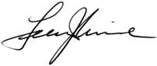
Felice J. Levine, PhD Executive Director
American Educational Research Association


Sudip S. Parikh, PhD
____________
Chief Executive Officer and Executive Publisher, Science
American Association for the Advancement of Science

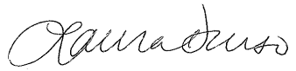
Laura E. Durso, PhD
Executive Director and Chief Learning Officer Whitman-Walker Institute
____________________

August 13, 2018

Ms. Suzanne H. Plimpton Reports Clearance Officer National Science Foundation
2415 Eisenhower Ave., Suite W18253 Alexandria, VA 22314
Via regulations.gov and email

RE: National Science Foundation; Notice of Intent To Seek Approval To Extend a Current Information Collection; Notice and request for comments; 2019 National Survey of College Graduates (Federal Register Doc. 2018-12622)

Dear Ms. Plimpton:

We are grateful for the opportunity to comment on the National Science Foundation’s proposed information collection request related to the 2019 National Survey of College Graduates (NSCG). See 83 Fed. Reg. 27354 (June 12, 2018). Together we are a group of scientific organizations, national associations of higher education, scientists, engineers, university faculty, and members of the National Academies, committed to promoting diversity in science, technology, engineering, and mathematics (STEM) fields and inclusion of under- represented groups in our nation’s STEM workforce. We write jointly with scholars at the Williams Institute and other institutions who have long worked with federal agencies to improve data collection on the U.S. population and have produced widely-cited best practices for the collection of sexual orientation and gender identity information on population-based surveys.1 The Williams Institute is an interdisciplinary center at the UCLA School of Law dedicated to rigorous and independent research on sexual orientation and gender identity, including on employment and education of lesbian, gay, bisexual, and transgender (LGBT) people.

Our comments address the importance and feasibility of including sexual orientation and gender identity measures on the NSCG and related surveys administered by the National Science Foundation’s National Center for Science & Engineering Statistics, including the Survey of Doctorate Recipients (SDR) and the Survey of Earned Doctorates (SED). Incorporating measures of sexual orientation and gender identity into the NSCG, SDR, and SED would enhance the quality and utility of the information collected, because doing so would provide vital data on the

1 See Sexual Minority Assessment Research Team (SMART), Williams Institute, Best Practices for Asking Questions about Sexual Orientation on Surveys (2009), https://williamsinstitute.law.ucla.edu/wp- content/uploads/SMART-FINAL-Nov-2009.pdf; Gender Identity in U.S. Surveillance (GenIUSS) Group, Williams Institute, Best Practices for Asking Questions to Identify Transgender and Other Gender Minority Respondents on Population-Based Surveys (2014), https://williamsinstitute.law.ucla.edu/wp-content/uploads/geniuss-report-sep- 2014.pdf.

participation of LGBT people, also called sexual and gender minorities, in STEM education and their representation in our nation’s STEM workforce.

Like race, sex, and other personal demographic data already collected on the NSCG, SDR, and SED,2 data on the sexual orientation and gender identity of college graduates and doctoral degree holders in STEM fields would enhance the ability of the National Science Foundation, the Census Bureau, the National Science Board, and the surveys’ co-sponsoring agencies – the National Institutes of Health, Department of Education, Department of Agriculture, National Endowment of the Humanities, and National Aeronautics and Space Administration – to improve the understanding of the U.S. STEM workforce. Collecting sexual orientation and gender identity information would increase the utility of official reports, including the National Science Board’s Science & Engineering Indicators report and the National Science Foundation’s Women, Minorities, and Persons with Disabilities in Science and Engineering report. These reports and data from the NSCG, SDR, and SED more generally are used not only by their sponsoring agencies but also by policymakers, the Office of Management and Budget, the Office of Science and Technology Policy, state and local government agencies, and educational and research institutions across the nation. Adding sexual orientation and gender identity information would further these reports’ goals of providing important information on the condition and progress of the nation’s STEM fields, including demographic trends, and of understanding and strengthening the participation of under-represented groups in the U.S. STEM workforce and U.S. undergraduate and graduate programs.

Including Sexual Orientation and Gender Identity Measures in the NSCG, SDR, and SED Would Enhance the Quality and Utility of the Information Being Collected

As in previous versions of the survey, the proposed 2019 NSCG would collect some types of personal information from respondents, including race, ethnicity, sex, age, income, and disability status,3 which we support. However, while the proposed NSCG would collect a variety of personal demographic information from respondents, it would not collect data on respondents’ sexual orientation or gender identity. Including measures of sexual orientation and gender identity in the NSCG (as well as the SDR and SED) would enhance the quality and utility of the information being collected.

There has been a growing recognition of the need to measure sexual orientation and gender identity in the STEM workforce.4 As summarized last month in the scientific journal Nature, recent studies show that LGBT people are experiencing disadvantages and disparities in STEM fields similar to other under-represented groups, such as racial and ethnic minorities and

2 We note that some demographic information (e.g., race, sex) is not re-collected on the NSCG or SDR if already collected from a given respondent in a previous survey cycle (or, for the SED, if previously collected from the SDR). Throughout our comment, by collection of demographic information we refer to the availability of that information, whether it is collected on a present or previous cycle.
3 National Science Foundation, National Center for Science and Engineering Statistics, National Survey of College Graduates (2018), https://www.nsf.gov/statistics/srvygrads.
4 Wimberly, G. L. (2015). Conclusion and recommendations for further research. In G.L. Wimberly (Ed.), LGBTQ Issues in Education: Advancing a Research Agenda, pp. 237–251. American Educational Research Association. https://books.google.com/books?hl=en&lr=&id=2YElDwAAQBAJ

women.5 Estimates suggest that LGBT people are approximately 20% less represented in STEM fields than expected based on their prevalence in the U.S. population.6 A 2018 study found that sexual-minority undergraduates were 8% more likely than their heterosexual counterparts to drop out of STEM majors, even though they were more likely to pursue relevant research experience – a pattern commonly associated with difficulties in retaining women and racial and ethnic minorities in STEM fields due to a non-supportive STEM culture.7

Indeed, several studies have shown that LGBT people encounter non-supportive environments in STEM fields. LGBT people report more negative workplace experiences in STEM fields than do non-LGBT people in those same fields, or than do LGBT people in non- STEM industries.6 Among sexual-minority STEM faculty members who are ‘out’ about their sexual orientation, 69% report feeling uncomfortable in their academic department, which is related to exclusion and harassment they report.8 Some STEM fields, such as chemistry, have conducted surveys on the professional environment that included questions of sexual orientation and gender identity. In a 2016 survey in chemistry, 44% of LGBT people reported that they were harassed, intimidated, or excluded at work.9

As noted by the 2018 National Academies’ Measuring the 21st Century Science and Engineering Workforce Population: Evolving Needs report, the science and engineering workforce “is becoming increasingly diverse…in terms of gender, race/ethnicity, and other characteristics”.10 In this respect, the report highlights an evolving need:

Future recruitment, growth, and development of the nation’s scientists and engineers will depend on greater understanding not only of the diverse composition of the science and engineering workforce but also of the factors that facilitate or impede the entry, retention, and advancement of underrepresented groups in the workforce.10

Inclusion of sexual orientation and gender identity measures on the NSCG, SDR, and SED would directly address such evolving needs identified by the National Academies. Doing so would provide important data regarding how LGBT people navigate the STEM environment – from their undergraduate and graduate education through to the workforce – and where they may experience barriers to entering or remaining in STEM fields. Such data would also provide information about the experiences of LGBT people in STEM more generally, including, for

5 Freeman, J. B. LGBTQ scientists are still left out, 36 Nature, 559, pp. 27-28 (July 3, 2018).
6 Cech, E. A., and Pham, P.V. Queer in STEM organizations: Workplace disadvantages for LGBT employees in STEM related federal agencies. Social Sciences 6.1 (2017); Cech, Erin A. "LGBT professionals’ workplace experiences in STEM-related federal agencies." Proceedings of the 2015 American Society for Engineering Education (ASEE) National Conference, Seattle, WA, USA. 2015., https://peer.asee.org/lgbt-professionals- workplace-experiences-in-stem-related-federal-agencies
7 Hughes, B.E., 2018. Coming out in STEM: Factors affecting retention of sexual minority STEM students. Science advances, 4(3), p.eaao6373.
8 Patridge, E.V., Barthelemy, R.S. and Rankin, S.R., 2014. Factors impacting the academic climate for LGBQ STEM faculty. Journal of Women and Minorities in Science and Engineering, 20(1).
9 Wang, L (2016) LGBT chemists seek a place at the bench. Chemical Engineering and News, 94:41, 18–20.
10 National Academies, Measuring the 21st Century Science and Engineering Workforce Population: Evolving Needs (2018), https://www.nap.edu/catalog/24968/measuring-the-21st-century-science-and-engineering-workforce- population-evolving

example, whether they are satisfied with their jobs, receiving sufficient professional support, or experiencing pay inequality.

There are many potential uses of sexual orientation and gender identity data in STEM workforce surveys. For example, such data would inform institutions, agencies, and researchers developing strategies to address under-representation or career or educational barriers experienced by LGBT people. Reports based on NSCG, SDR, and SED data, including the Science & Engineering Indicators and Women, Minorities, and Persons with Disabilities in Science and Engineering reports, are routinely used by policymakers overseeing diversity initiatives at educational and research institutions across the nation and at funding agencies, including the National Science Foundation and National Institutes of Health. Data on LGBT representation could therefore similarly inform such diversity programs, as these programs may be interested to address under-representation of LGBT people in specific STEM fields and career stages, if and where it exists. As with other under-represented groups, such diversity initiatives could include fellowships for doctoral students, scholarships for undergraduate students, or recruitment strategies for faculty, graduate students, and/or post-doctoral researchers. More generally, the data would also inform research aimed at developing interventions or paradigms to reduce disadvantages experienced by LGBT scientists and engineers.

In short, including sexual orientation and gender identity measures in the NSCG, SDR, and SED would increase the quality and utility of the information collected, because such data would enhance the understanding of diverse and under-represented groups’ participation in STEM education and their representation in the STEM workforce.

Importance of Governmental Data Collection on Sexual Orientation and Gender Identity (SO/GI); SO/GI Data Collection is Becoming Increasingly Common

Adding sexual orientation and gender identity measures to the NSCG, SDR, and SED would reflect a growing trend among federal, state, and other data collections that include demographic measures. This trend is responsive to a need succinctly described by the Federal Interagency Working Group on Improving Measurement of Sexual Orientation and Gender Identity in Federal Surveys:

At a time when sexual and gender minority (SGM) populations are becoming more visible in social and political life, there remains a lack of data on the characteristics and well-being of these groups. In order to understand the diverse needs of SGM populations, more representative and better quality data need to be collected.11

A growing number of federal government surveys allow people to voluntarily disclose their sexual orientation and/or gender identity. Examples of federal government surveys that collect these data include the National Health Interview Survey, Behavioral Risk Factor

11 Federal Interagency Working Group on Improving Measurement of Sexual Orientation and Gender Identity in Federal Surveys, Current Measures of Sexual Orientation and Gender Identity in Federal Surveys (2016), https://s3.amazonaws.com/sitesusa/wp- content/uploads/sites/242/2014/04/WorkingGroupPaper1_CurrentMeasures_08-16.pdf.

Surveillance System, Youth Risk Behavior Surveillance System, National Survey for Family Growth, and National Crime Victimization Survey, among others.11 Further, several state and local government surveys also collect data on sexual orientation and gender identity, such as the California Health Interview Survey,12 as do several large surveys administered by private entities, most notably Gallup through its Daily Tracking Survey.13

While more and better data are needed, governmental and other data collections that include measures of sexual orientation and gender identity have allowed researchers to begin to describe the size of the LGBT population and LGBT people’s demographics; employment, housing, and family circumstances; health and well-being; and the discrimination and disparities they face. These data are vital to policymaking in order to ensure that stereotypes and myths are not driving policies that impact LGBT people, and so that programs and services are appropriately targeted at vulnerable LGBT populations. For example, we now know that there are an estimated 11 million LGBT individuals living in the U.S.13 We also know from the data that the LGBT population is remarkably diverse and that the experiences of LGBT people are not uniform but, rather, are shaped by factors such as race, ethnicity, socioeconomic status, geographical location, primary language, education, disability, religion, family composition, and age.14 We have also learned that LGBT people are more likely to be in poverty than non-LGBT people,15 contrary to the popular stereotype of LGBT affluence, and that LGBT people face persistent and pervasive discrimination in employment, housing, educational, and other important settings.16 Noting the disadvantages LGBT people are facing in STEM fields (see Section I), the inclusion of sexual orientation and gender identity measures in STEM workforce surveys (NSCG, SDR, and SED) would provide similarly vital information about the experiences, career trajectory, and representation of LGBT people in STEM fields.

Experience Indicates NSCG, SDR, and SED Respondents Would Willingly and Accurately Disclose Their Sexual Orientation And Gender Identity

Federal and other population-based surveys that collect sexual orientation and gender identity data indicate NSCG, SDR, and SED respondents would be willing and are able to answer questions about their sexual orientation and gender identity, and doing so would not raise privacy or other concerns. As an initial matter, we note that the National Science Foundation’s National Center for Science & Engineering Statistics and the Census Bureau (who directly administers the NSCG) remove respondents’ names and other identifying information, in

12 National Cancer Institute, Division of Cancer Control and Population Sciences, National Health Interview Survey
(2018), https://healthcaredelivery.cancer.gov/chis
13 Gallup, In U.S., Estimate of LGBT Population Rises to 4.5% (2018), https://news.gallup.com/poll/234863/estimate-lgbt-population-rises.aspx
14 Institute of Medicine, The Health of Lesbian, Gay, Bisexual, and Transgender People: Building a Foundation for
Better Understanding (2011), http://www.iom.edu/Reports/2011/The-Health-of-Lesbian-Gay-Bisexual-and- Transgender-People.aspx.
15 Badgett et al., Williams Institute, New Patterns of Poverty in the Lesbian, Gay, and Bisexual Community (2013), http://williamsinstitute.law.ucla.edu/wp-content/uploads/LGB-Poverty-Update-Jun-2013.pdf.
16 See, e.g., Pizer et al., Evidence of Persistent and Pervasive Workplace Discrimination Against LGBT People, 45 Loy. L.A. L. Rev 715 (2012); James et al., Nat’l Ctr. for Transgender Equality, Report of the 2015 U.S. Transgender Survey 44-45 (2016), http://www.transequality.org/sites/default/files/docs/usts/USTS%20Full%20Report%20-
%20FINAL%201.6.17.pdf.

addition to other measures, to protect respondents’ confidentiality. And federal law protects the confidentiality of individually identifiable information collected by these agencies.17

Experience shows that respondents are willing to answer questions about their LGBT status. Indeed, the Federal Interagency Working Group on Improving Measurement of Sexual Orientation and Gender Identity in Federal Surveys has explained that “[m]ost surveys incorporating [sexual orientation and gender identity] items have not found higher nonresponse rates than other ‘sensitive’ questions, such as personal or household income.”18 Likewise, federal surveys incorporating these measures and other research demonstrate that including sexual orientation and gender identity questions does not cause survey breakoff.19

Although nearly all college graduates and doctoral degree holders taking the NSCG, SDR, and SED are adults, the sample includes those who would be considered young adults. Experiences with other federal government and population-based surveys show that youth and young adults are capable and willing to answer questions about sexual orientation and gender identity. For example, as the Sexual Minority Assessment Research Team report explained, “[s]exual orientation questions have been asked on large-scale school-based surveys of adolescents around the world since the mid-1980’s.”1 For instance, the National Survey of Youth in Custody includes a measure of sexual orientation,20 and the National Youth Risk Behavior Survey successfully includes respondents as young as 13 and has included sexual orientation measures since 2015. The National Survey of Family Growth, which includes respondents as young as 15, has included a sexual orientation behavior measure for many years.21

While sexual orientation and gender identity data should be treated with the same concern for confidentiality of respondents as any other demographic category, there is no rational basis to single out the questions on sexual orientation and gender identity as warranting special concern about the sensitivity of this type of information. As noted above, sexual orientation and gender identity measures do not have materially higher non-response rates than other potentially

17 U.S. Census Bureau, National Survey of College Graduates, Frequently Asked Questions (2018), https://www.census.gov/programs-surveys/nscg/respondent/faqs.html
18 Federal Interagency Working Group on Improving Measurement of Sexual Orientation and Gender Identity in Federal Surveys, Current Measures of Sexual Orientation and Gender Identity in Federal Surveys (2016), https://s3.amazonaws.com/sitesusa/wp- content/uploads/sites/242/2014/04/WorkingGroupPaper1_CurrentMeasures_08-16.pdf; see also Saewyc, E.M. et al., Measuring sexual orientation in adolescent health surveys: Evaluation of eight school-based surveys, 35 J. of Adolescent Health 345 (2004) (“These studies indicate that orientation items, although sensitive questions, are no more sensitive or more likely to be skipped than other sexual risk behavior questions. This finding can reassure researchers and school administrators who are concerned that such items might be too sensitive for most students to answer, and who worry that nonresponse rates will render the results inaccurate and of limited use.”).
19 See, e.g., Landers et al., Presentation: Developing Data for Advocacy (National LGBTI Health Summit: 2007); Case, Disclosure of Sexual Orientation and Behavior in the Nurses’ Health Study II: Results from a Pilot Study, 51
J. Homosexuality 13 (2006).
20 Bureau of Justice Statistics, Data Collection: National Survey of Youth In Custody (NSYC), https://www.bjs.gov/index.cfm?ty=dcdetail&iid=321 (last visited May 5, 2018); Bureau of Justice Statistics, NYSC Questionnaire—Younger Youth 5 (2011) https://www.bjs.gov/content/pub/pdf/nsyc_yy12.pdf; Bureau of Justice Statistics, NYSC Questionnaire—Older Youth, 5 (2011), https://www.bjs.gov/content/pub/pdf/nsyc_oy12.pdf.
21 See Anjani Chandra et al., Sexual Behavior, Sexual Attraction, and Sexual Identity in the United States: Data From the 2006–2008 National Survey of Family Growth, 36 National Health Statistics Reports 1 (Mar. 3, 2011), https://www.cdc.gov/nchs/data/nhsr/nhsr036.pdf.

sensitive personal questions. Moreover, according to the Federal Interagency Working Group, “[the] perceived sensitivity of questions can affect the willingness of survey practitioners to include [sexual orientation and gender identity] questions even when inclusion of these measures would support agency mission and data needs.”22 In this case, the inclusion of these measures strongly supports the mission of the National Science Foundation and furthers the goals of several federal agencies, as described in Section I.

We recognize that sexual orientation and gender identity questions could be sensitive for certain respondents, although there is no reason to believe they would be more sensitive than other questions, such as income or disability status. And even if the sexual orientation and gender identity questions would be sensitive for some respondents, the questions would be voluntary, as is the case in other federal government surveys and recommended by the Federal Interagency Working Group. Thus, no respondent would be forced to answer these questions. In other federal government surveys, these questions frequently have “don’t know” and “something else” or “none of these” response options, giving respondents options for responding to these questions if they are uncomfortable disclosing or unsure about their sexual orientation or gender identity.1 In addition, as described earlier, responses are highly confidential and are strongly protected under federal law.

In short, previous experiences in governmental and other data collection suggest that NSCG, SDR, and SED respondents will not encounter any issues in willingly and accurately disclosing information about sexual orientation and gender identity. Nor will such disclosures introduce issues of confidentiality or privacy, a high non-response rate, or survey breakoff.

The NSCG, SDR, and SED Have Sufficiently Large Samples to Produce Reliable Estimates Related to Sexual Orientation And Gender Identity

The Federal Interagency Working Group on Improving Measurement of Sexual Orientation and Gender Identity in Federal Surveys cautions that small samples may lead to significant errors in estimation and description and/or an inability to produce reliable estimates related to sexual orientation and gender identity.22 However, the current sample sizes of the NSCG, SDR, and SED are all sufficiently large, and thus there is no rational basis for concerns related to small sample sizes in the context of these STEM workforce surveys.

For instance, recent versions of other federal government surveys, such as the National Health Interview Survey and National Survey of Family Growth, entailed sample sizes of approximately 87,500 23 and 10,000,24 respectively, and both surveys currently collect information about sexual orientation. Sample sizes of the NSCG are far larger: the NSCG has a

22 Federal Interagency Working Group on Improving Measurement of Sexual Orientation and Gender Identity in Federal Surveys, Evaluations of Sexual Orientation and Gender Identity Survey Measures: What Have We Learned? (2016), https://s3.amazonaws.com/sitesusa/wp- content/uploads/sites/242/2014/04/Evaluations_of_SOGI_Questions_20160923.pdf.
23 Center for Disease Control and Prevention, National Health Interview Survey (2018), https://www.cdc.gov/nchs/nhis/about_nhis.htm
24 Center for Disease Control and Prevention, National Survey of Family Growth (2018) https://www.cdc.gov/nchs/nsfg/about_nsfg.htm

sample of approximately 135,000, the SDR approximately 120,000, and the SED approximately 55,000.10 Thus, concerns of small sample size are unwarranted.

The NSCG, SDR, and SED routinely ask about race and ethnicity information, and many of the race and ethnicity classifications have a prevalence in the U.S. population that is smaller than that of LGBT people. For instance, the 2017 Women, Minorities, and People with Disabilities in Science and Engineering report provides recent estimates of each race and ethnicity classification’s prevalence in the U.S. population, so as to permit comparison with corresponding percentages in science and engineering fields. For the following four race and ethnicity classifications included in the 2017 report (and collected in the NSCG, SDR, and SED), their prevalence estimate in the U.S. population is:

  - Asian: 5.3%
  - American Indian or Alaska Native: 0.7%
  - Native Hawaiian or other Pacific Islander: 0.2%
  - Two or more races (not Hispanic): 2.0% 25

Despite being quite small, STEM workforce surveys currently provide full data on each of these race and ethnicity classifications. Most recent estimates of the prevalence of LGBT people in the
U.S. adult population, according to the Gallup’s 2017 Daily Tracking Survey (n=340,604), is 4.5%.13 This prevalence is roughly on par or only slightly smaller than that of the U.S. Asian population, and is considerably higher than those of the other three race and ethnicity classifications. Thus, the NSCG, SDR, and SED currently collect information on race and ethnicity classifications that have expected samples smaller than those of LGBT people.

Finally, reports of NSCG, SDR, and SED data, such as the Women, Minorities, and People with Disabilities in Science and Engineering report, typically suppress a cell of data only if the sample constituting that data cell is less than 0.1% (due to concerns of an unreliable estimate or that so few respondents raises concerns of identifiability), and this is far lower than 4.5%. Dividing into specific subgroups and intersections with other demographic information in theory could lead to subgroup samples constituting less than 0.1% or where concerns of unreliability of identifiability are relevant. However, as with the race and ethnicity classifications currently collected with even smaller samples, such specific LGBT subgroup data could be suppressed wherever necessary. That certain subgroups or intersections may have overly small sample sizes does not warrant the wholesale exclusion of sexual orientation and gender identity information more generally.

Given that federal surveys with smaller sample sizes than the NSCG, SDR, and SED already currently collect sexual orientation and gender identity information, and that these STEM workforce surveys routinely collect information related to race and ethnicity classifications that have smaller prevalence in the U.S. population than LGBT people, concerns of unreliable or invalid estimates of LGBT people in STEM workforce surveys have no substantive support.

25 National Science Foundation, National Center for Science & Engineering Statistics, 2017 Women, Minorities, and Persons with Disabilities in Science and Engineering Report https://www.nsf.gov/statistics/2017/nsf17310/data.cfm

Conclusion

The National Science Foundation is committed to promoting diversity in STEM fields and providing resources to ensure that science and engineering are inclusive to all.26 Collecting sexual orientation and gender identity data on the NSCG, SDR, and SED would provide vital information about LGBT participation in the STEM pipeline – from undergraduate and graduate education through to the workforce – and LGBT representation among our nation’s scientists and engineers. This information would enhance the ability of the National Science Foundation and other federal agencies to provide critical data and support to the scientific community and to advance the future of the U.S. STEM workforce.

Thank you for your consideration. We look forward to opportunities to discuss with you further. Please direct any correspondence to jon.freeman@nyu.edu.

Respectfully Submitted,

Jonathan B. Freeman, PhD
Associate Professor of Psychology and Neural Science New York University

Adam P. Romero, JD
Arnold D. Kassoy Scholar of Law
Director of Legal Scholarship and Federal Policy The Williams Institute, UCLA School of Law

Laura Durso, PhD
Vice President, LGBT Research and Communications Center for American Progress

Institutional Signatories:

American Anthropological Association (AAA) American Association of University Professors (AAUP) American Educational Research Association (AERA) American Psychological Association (APA)
American Society for Engineering Education (ASEE) Consortium of Social Science Associations (COSSA)
26 National Science Foundation, Office of the Director, Broadening Participation (2018), https://www.nsf.gov/od/broadeningparticipation/bp.jsp

Federation of Associations in Behavioral and Brain Sciences (FABBS) Inter-university Consortium for Political and Social Research (ICPSR)
National Organization of Gay and Lesbian Scientists and Technical Professionals (NOGLSTP) Out in Science, Technology, Engineering, and Mathematics (oSTEM)
Society for Personality and Social Psychology (SPSP)

Individual Signatories (members of the National Academies listed first):

Natalie G. Ahn, PhD
Member, National Academy of Sciences Professor of Chemistry and Biochemistry University of Colorado at Boulder

Mahzarin R. Banaji, PhD
Member, National Academy of Sciences Richard Clarke Professor of Social Ethics Harvard University

Carolyn R. Bertozzi, PhD
Member, National Academy of Sciences
Anne T. and Robert M. Bass Professor of Chemistry Stanford University

Lynn Ann Conway, PhD
Member, National Academy of Engineering
Professor of Electrical Engineering and Computer Science, Emerita University of Michigan, Ann Arbor

Ronald S. Duman, PhD
Member, National Academy of Medicine
Elizabeth Mears and House Jameson Professor of Psychiatry, Professor of Neuroscience Yale School of Medicine

Susan T. Fiske, PhD
Member, National Academy of Sciences
Eugene Higgins Professor of Psychology and Public Affairs Princeton University

Susan A. Gelman, PhD
Member, National Academy of Sciences
Heinz Werner Distinguished University Professor University of Michigan

Richard L. Huganir, PhD
Member, National Academy of Sciences Bloomberg Distinguished Professor
Johns Hopkins University School of Medicine

Raymond Jeanloz, PhD
Member, National Academy of Sciences
Professor of Earth & Planetary Sciences and Astronomy University of California, Berkeley

Jay D. Keasling, PhD
Member, National Academy of Engineering
Professor of Chemical & Biomolecular Engineering and Bioengineering University of California, Berkeley

John H. Krystal, MD
Member, National Academy of Medicine
Robert L. McNeil, Jr. Professor of Translational Research, Professor of Psychiatry Yale School of Medicine

Robert C. Malenka, MD, PhD
Member, National Academy of Sciences Member, National Academy of Engineering Member, National Academy of Medicine
Nancy Friend Pritzker Professor in Psychiatry and Behavioral Sciences Stanford University

Eric J. Nestler, MD, PhD
Member, National Academy of Medicine Nash Family Professor of Neuroscience Icahn School of Medicine at Mount Sinai

James T. Randerson, PhD
Member, National Academy of Sciences
Ralph J. and Carol M. Cicerone Professor of Earth System Science University of California, Irvine

Henry L. Roediger, III, PhD
Member, National Academy of Sciences
James S. McDonnell Distinguished University Professor Washington University in St. Louis

Elizabeth S. Spelke, PhD
Member, National Academy of Sciences Marshall L. Berkman Professor of Psychology Harvard University

Lisa Feldman Barrett, PhD
Fellow, American Association for the Advancement of Science Fellow, American Academy of Arts and Sciences
University Distinguished Professor of Psychology Northeastern University

Walter Bockting, PhD
Professor of Medical Psychology (in Psychiatry and Nursing) Columbia University

Anke A. Ehrhardt, PhD
Professor of Medical Psychology (in Psychiatry) Columbia University

Andrew R. Flores, PhD
Assistant Professor of Political Science, Mills College Visiting Scholar
Williams Institute, UCLA School of Law

Nanette Gartrell, MD
Visiting Distinguished Scholar
Williams Institute, UCLA School of Law

Oliver Grundmann, PhD
Clinical Associate Professor of Medicinal Chemistry University of Florida

Jody L. Herman, PhD Scholar of Public Policy
Williams Institute, UCLA School of Law

Jennifer S. Hirsch, PhD
Professor of Sociomedical Sciences
Columbia University, Mailman School of Public Health

Nicole Horenstein, PhD Associate Professor of Chemistry University of Florida

Tonda L. Hughes, PhD, RN, FAAN
Henrik H. Bendixin Professor of International Nursing, Professor of Nursing (in Psychiatry) Columbia University Medical Center

Shamus Khan, PhD
Professor of Sociology, Department Chair Columbia University

Laura A. King, PhD
Curators' Distinguished Professor University of Missouri Columbia

Christy Mallory, JD
Director of State and Local Policy Williams Institute, UCLA School of Law

Pranjal Mehta, PhD
Senior Lecturer of Experimental Psychology University College London

Ilan H. Meyer, PhD
Williams Distinguished Senior Scholar of Public Policy Williams Institute, UCLA School of Law

James S. Nowick, PhD
Fellow, American Association for the Advancement of Science Professor of Chemistry
University of California, Irvine

Kristina Olson, PhD
Associate Professor of Psychology University of Washington

Elizabeth Levy Paluck, PhD MacArthur Fellow, 2017
Professor of Psychology and Public Affairs Princeton University

Jocelyn Samuels, JD
Executive Director and Roberta A. Conroy Scholar of Law Williams Institute, UCLA School of Law

Eric J. Schelter, PhD
Fellow, Royal Society of Chemistry Professor of Chemistry
University of Pennsylvania

Wolfgang Sigmund, PhD
Member, European Academy of Sciences Professor of Materials Science and Engineering University of Florida

Jennifer Silvers, PhD
Assistant Professor of Psychology University of California, Los Angeles

Abigail L. S. Swann
Assistant Professor of Atmospheric Sciences and Biology University of Washington

Amy O. Tsui, PhD
Fellow, American Association for the Advancement of Science Professor of Population, Family and Reproductive Health Johns Hopkins Bloomberg School of Public Health

Bianca D.M Wilson, PhD
Rabbi Barbara Zacky Senior Scholar of Public Policy Williams Institute, UCLA School of Law

Arnold M. Zwicky, PhD
Fellow, American Association for the Advancement of Science Fellow, American Academy of Arts and Sciences Distinguished University Professor of Linguistics, Emeritus The Ohio State University

