NATIONAL CENTER FOR EDUCATION STATISTICS NATIONAL ASSESSMENT OF EDUCATIONAL PROGRESS

National Assessment of Educational Progress (NAEP)2021

Appendix J2

2021 Teacher Questionnaires

OMB# 1850-0928 v.20

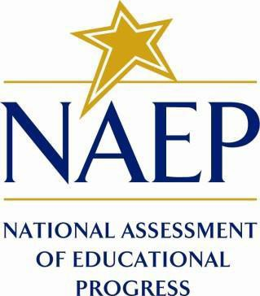

June 2020

Table of Contents
Teacher Questionnaires
Teacher Questionnaire Login Screens 3
Appendix J2-1: Summary of Changes Operational Grade 4 CORE 5
Appendix J2-2: Operational Grade 4 CORE 12
Appendix J2-3: Summary of Changes Operational Grade 8 CORE 20
Appendix J2-4: Operational Grade 8 CORE 28
Appendix J2-5: Summary of Changes Operational Grade 4 Mathematics 38
Appendix J2-6: Operational Grade 4 Mathematics 43
Appendix J2-7: Summary of Changes Operational Grade 8 Mathematics 50
Appendix J2-8: Operational Grade 8 Mathematics 57
Appendix J2-9: Summary of Changes Operational Grade 4 Reading 65
Appendix J2-10: Operational Grade 4 Reading 70
Appendix J2-11: Summary of Changes Operational Grade 8 Reading 75
Appendix J2-12: Operational Grade 8 Reading 80
Appendix J2-13: Summary of Changes Operational Grade 8 Social Studies 86
Appendix J2-14: Operational Grade 8 Social Studies 95

Teacher Questionnaire Login Screens
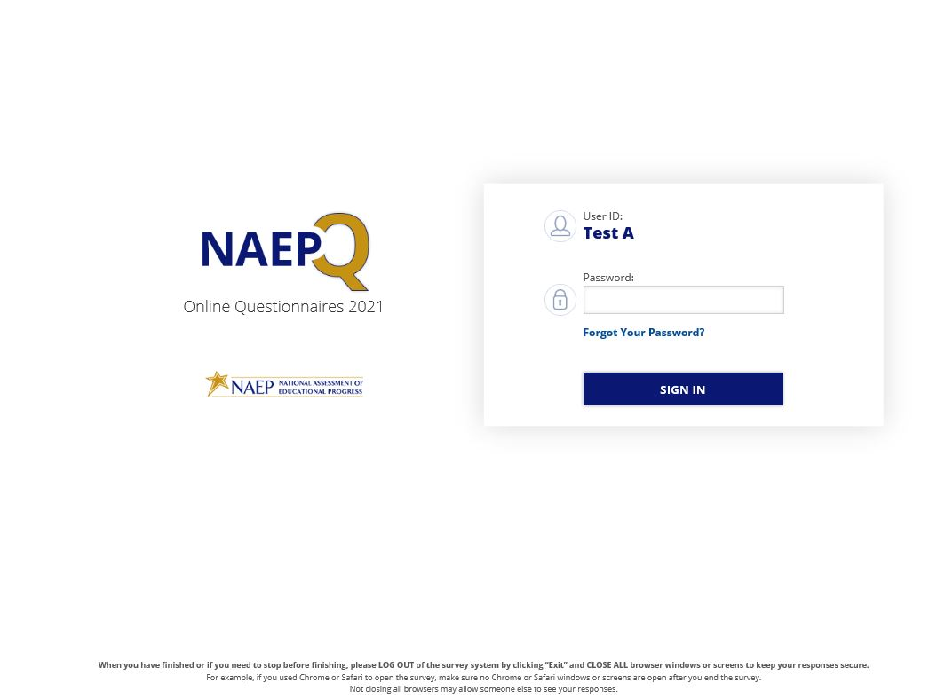
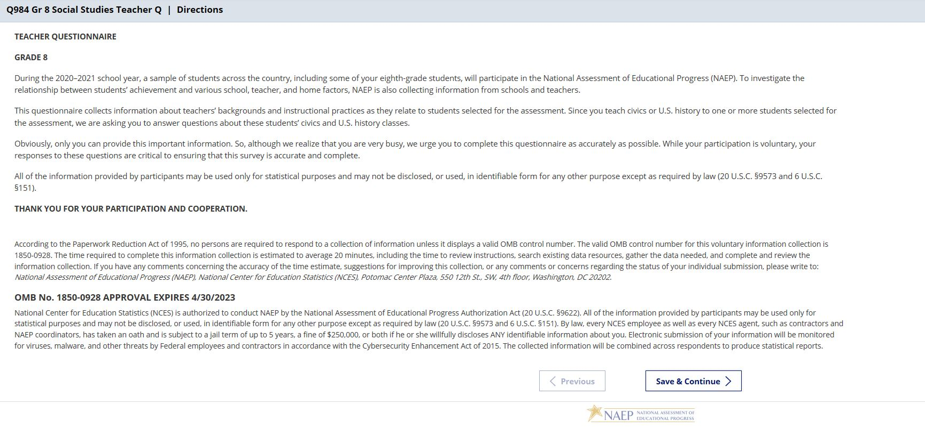

NOTE: The final version of the login screen was not available for this amendment and will be included in Amendment 2 scheduled to be submitted in October 2020. The PRA text will be revised with the updated language below.
According to the Paperwork Reduction Act of 1995, no persons are required to respond to a collection of information unless it displays a valid OMB control number. The valid OMB control number for this voluntary information collection is 1850-0928. The time required to complete this information collection is estimated to average about 30 minutes, including the time to review instructions, search existing data resources, gather the data needed, and complete and review the information collection. If you have any comments concerning the accuracy of the time estimate, suggestions for improving this collection, or any comments or concerns regarding the status of your individual submission, please write to: National Assessment of Educational Progress (NAEP), National Center for Education Statistics (NCES), Potomac Center Plaza, 550 12th St., SW, 4th floor, Washington, DC 20202.
OMB No. 1850-0928 APPROVAL EXPIRES 4/30/2023
National Center for Education Statistics (NCES) is authorized to conduct NAEP by the National Assessment of Educational Progress Authorization Act (20 U.S.C. §9622) and to collect students’ education records from education agencies or institutions for the purposes of evaluating federally supported education programs under the Family Educational Rights and Privacy Act (FERPA, 34 CFR §§ 99.31(a)(3)(iii) and 99.35).All of the information provided by participants may be used only for statistical purposes and may not be disclosed, or used, in identifiable form for any other purpose except as required by law (20 U.S.C. §9573 and 6 U.S.C. §151). By law, every NCES employee as well as every NCES agent, such as contractors and NAEP coordinators, has taken an oath and is subject to a jail term of up to 5 years, a fine of $250,000, or both if he or she willfully discloses ANY identifiable information about you. Electronic submission of your information will be monitored for viruses, malware, and other threats by Federal employees and contractors in accordance with the Cybersecurity Enhancement Act of 2015. The collected information will be combined across respondents to produce statistical reports.

Appendix J2-1: Summary of Changes Operational Grade 4 CORE
2021 Operational Grade 4 Core Teacher

Previous item | 2021 item | D/A/ R/NC+ | Rationale
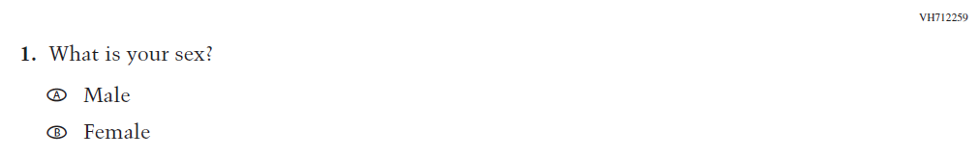  (2019 Grade 4) | 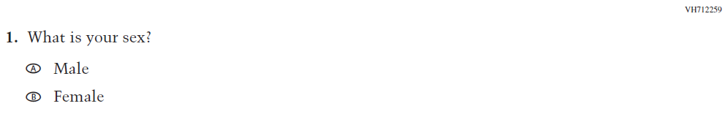  Issue: Gender | NC | N/A
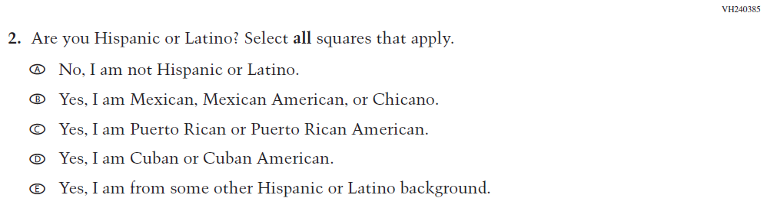  (2019 Grade 4) | 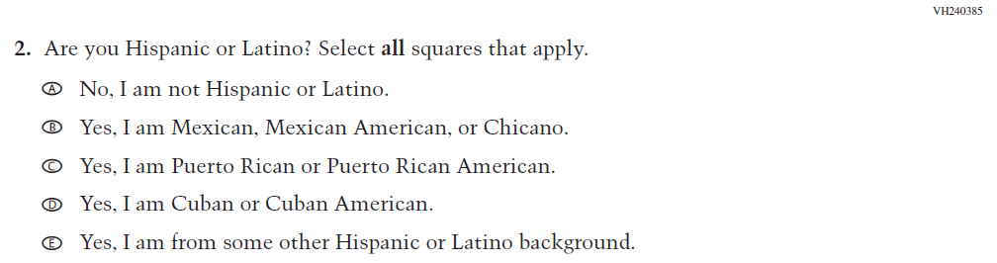  Issue: Race/Ethnicity | NC | N/A
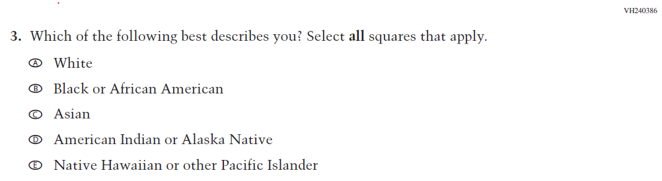  (2019 Grade 4) | 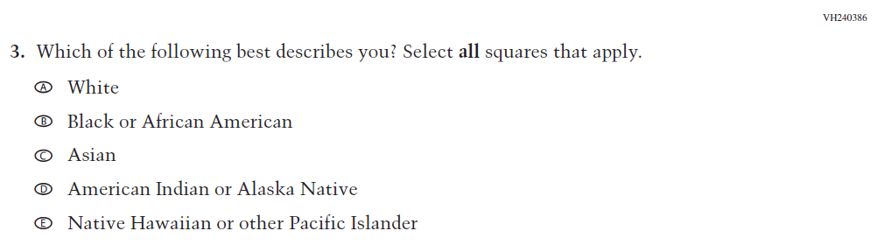  Issue: Race/Ethnicity | NC | N/A
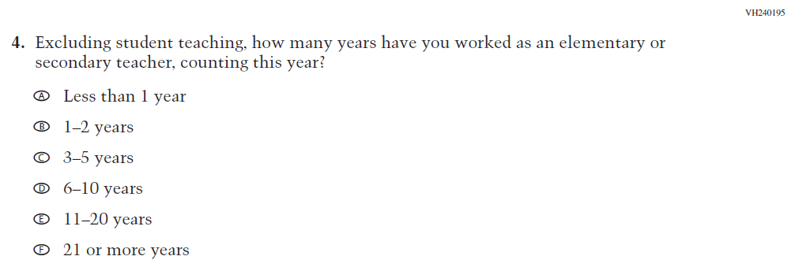  (2019 Grade 4) | 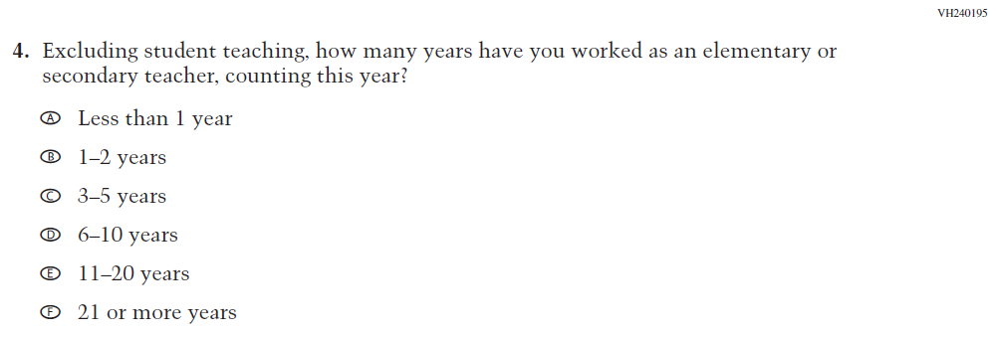  Issue: Teacher Preparation | NC | N/A

2021 Operational Grade 4 Core Teacher

Previous item | 2021 item | D/A/ R/NC+ | Rationale
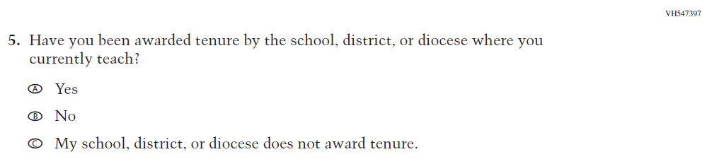  (2019 Grade 4) | 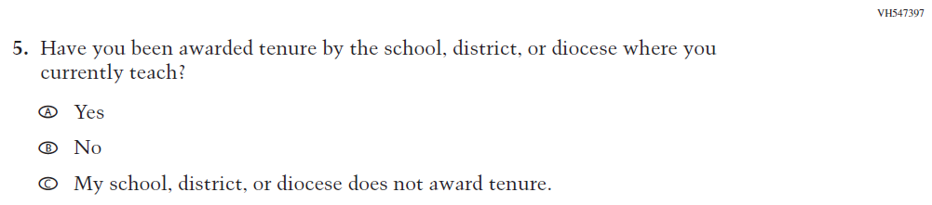  Issue: Teacher Preparation | NC | N/A
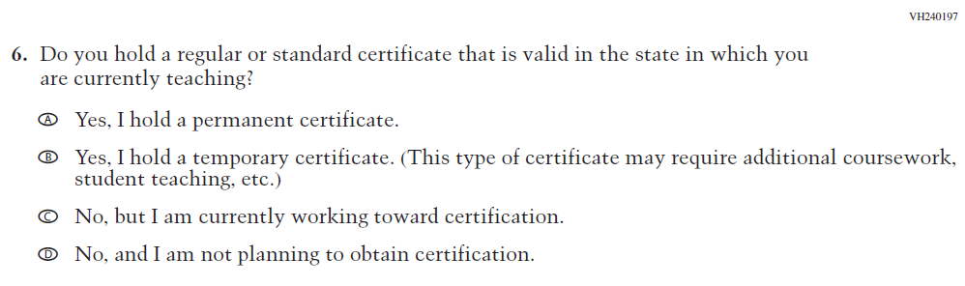  (2019 Grade 4) | 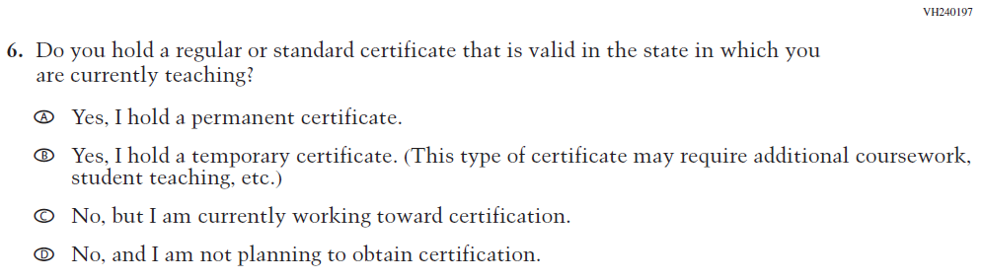  Issue: Teacher Preparation | NC | N/A
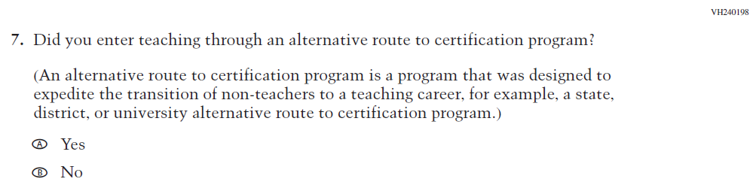  (2019 Grade 4) | 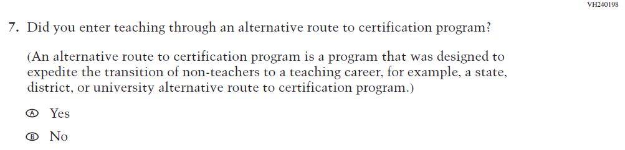  Issue: Teacher Preparation | NC | N/A

2021 Operational Grade 4 Core Teacher

Previous item | 2021 item | D/A/ R/NC+ | Rationale
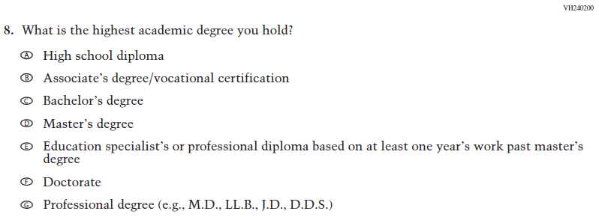  (2019 Grade 4) | Issue: Teacher Preparation | N/A | N/A
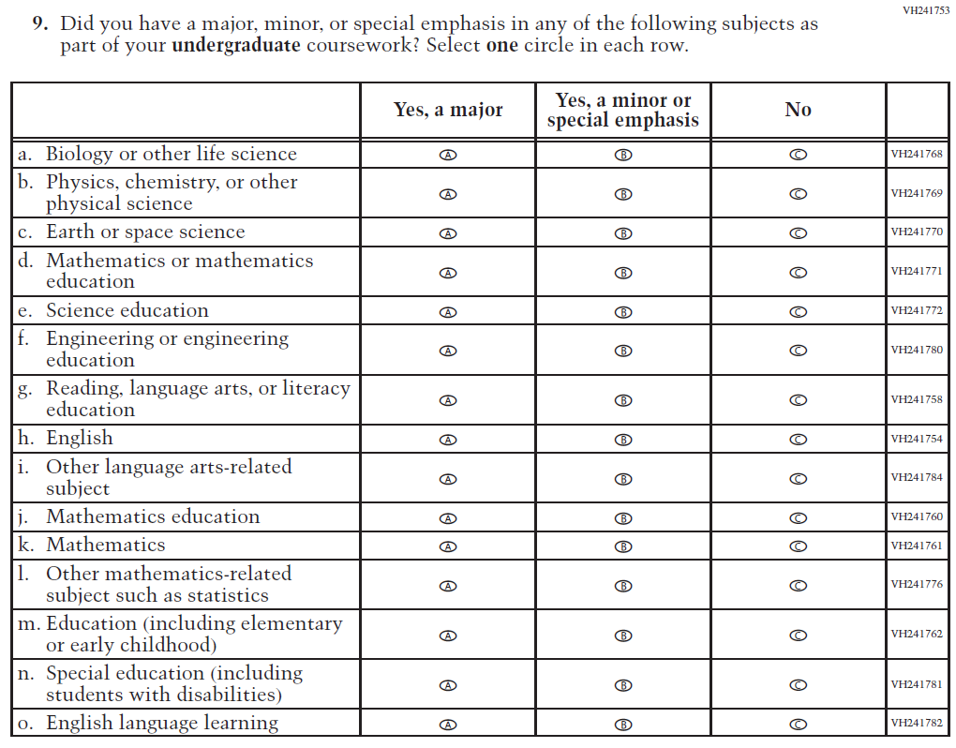  (2019 Grade 4) | 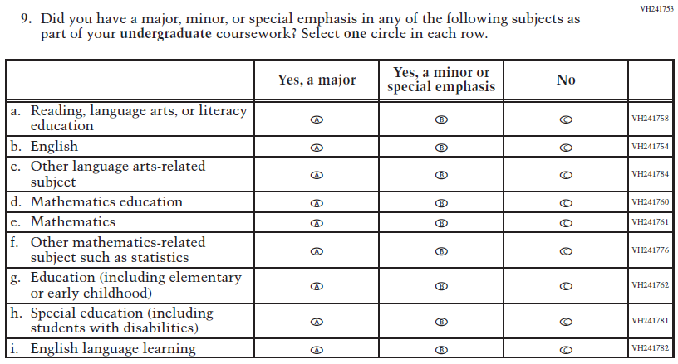  Issue: Teacher Preparation | R | This item is customized by subject and has been revised to remove sub-items for science.
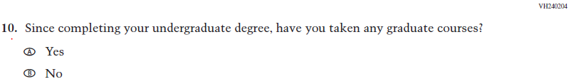  (2019 Grade 4) | Issue: Teacher Preparation | NC | N/A

2021 Operational Grade 4 Core Teacher

Previous item | 2021 item | D/A/ R/NC+ | Rationale
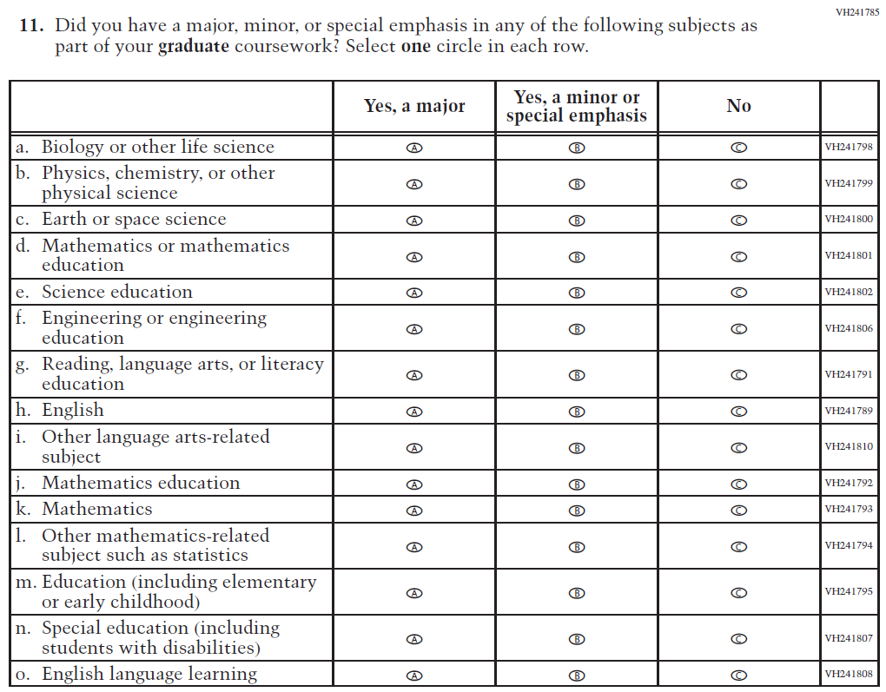  (2019 Grade 4) | 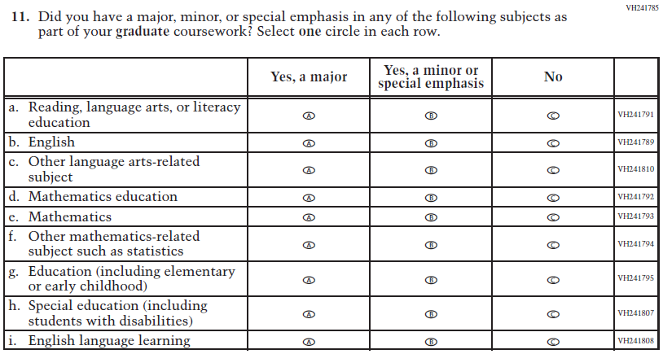  Issue: Teacher Preparation | R | This item is customized by subject and has been revised to remove sub-items for science.
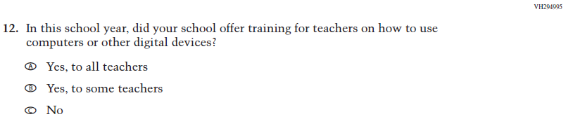  (2019 Grade 4) | 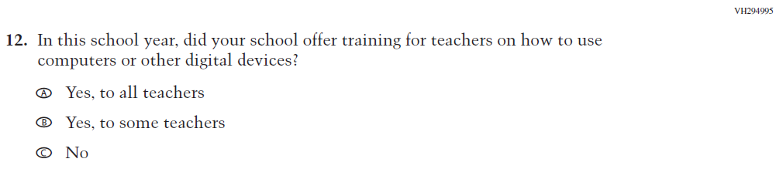  Issue: Technology Use | NC | N/A
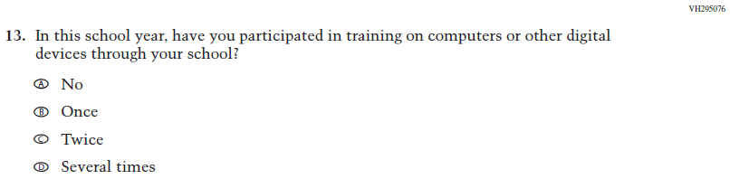  (2019 Grade 4) | Issue: Technology Use | NC | N/A
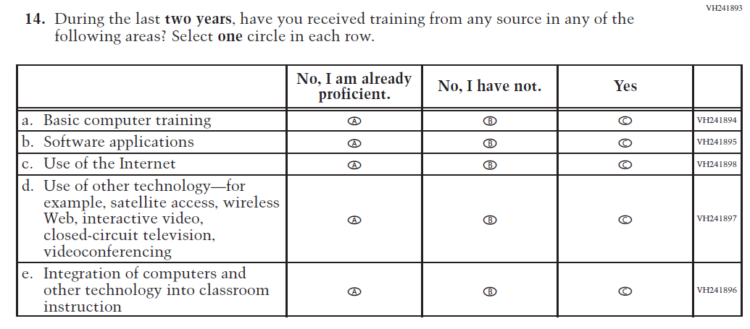  (2019 Grade 4) | 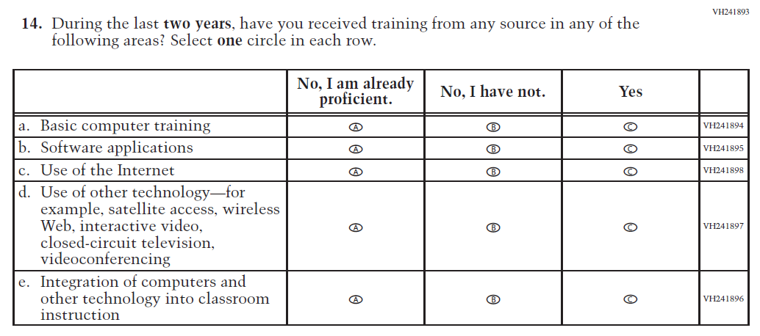  Issue: Teacher Preparation | NC | N/A
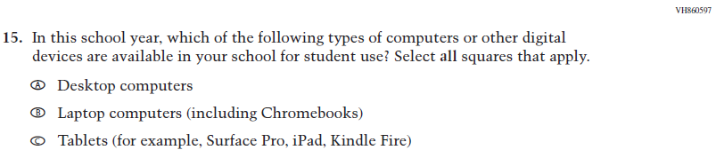  (2019 Grade 4) | Issue: Technology Use | NC | N/A
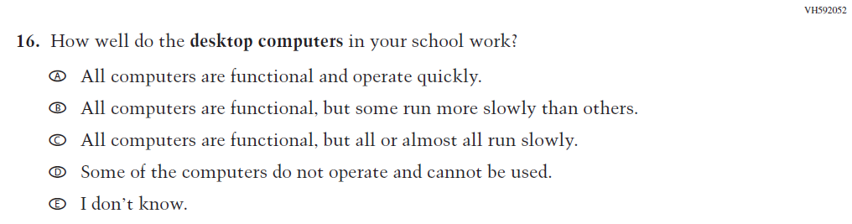  (2019 Grade 4) | Issue: Technology Use | NC | N/A
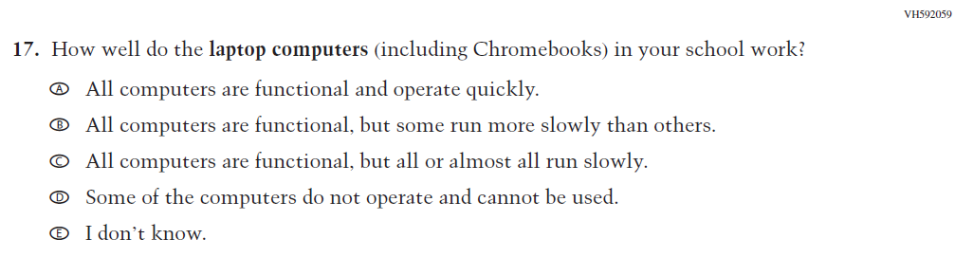  (2019 Grade 4) | Issue: Technology Use | NC | N/A

2021 Operational Grade 4 Core Teacher

Previous item | 2021 item | D/A/ R/NC+ | Rationale
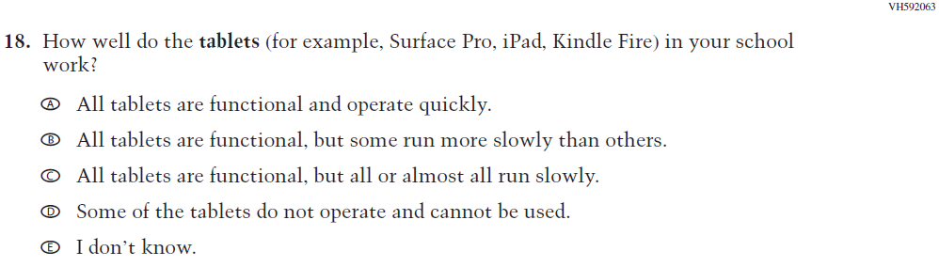  (2019 Grade 4) | Issue: Technology Use | NC | N/A
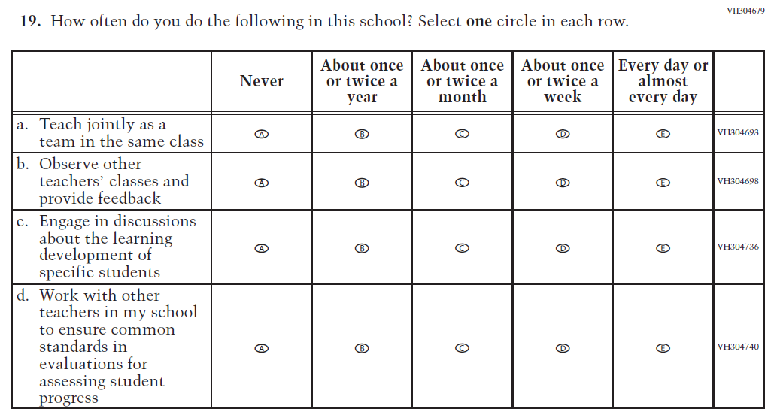  (2019 Grade 4) | Issue: School Climate | NC | N/A
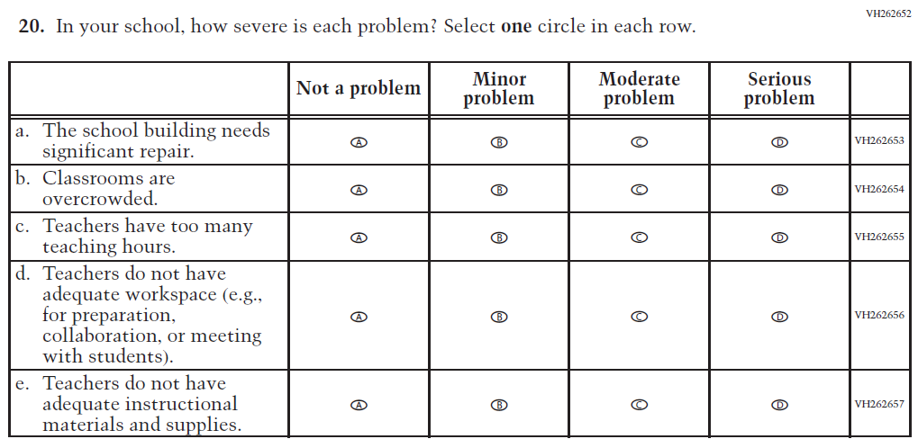  (2019 Grade 4) | Issue: School Climate | NC | N/A

2021 Operational Grade 4 Core Teacher

Previous item | 2021 item | D/A/ R/NC+ | Rationale
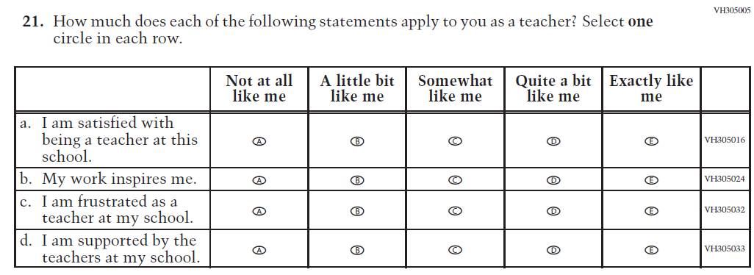  (2019 Grade 4) | Issue: School Climate | NC | N/A
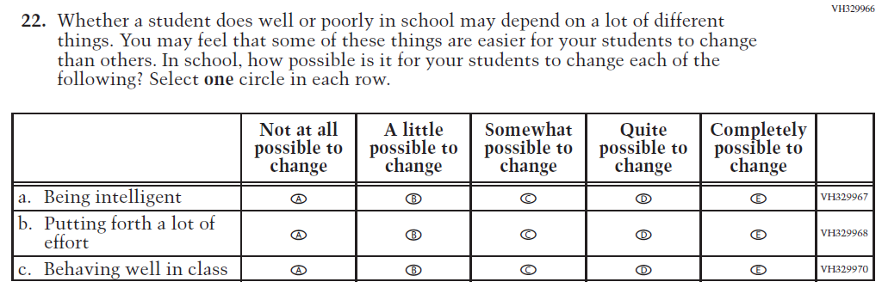  (2019 Grade 4) | Issue: Desire for Learning | NC | N/A

Appendix J2-2: Operational Grade 4 CORE
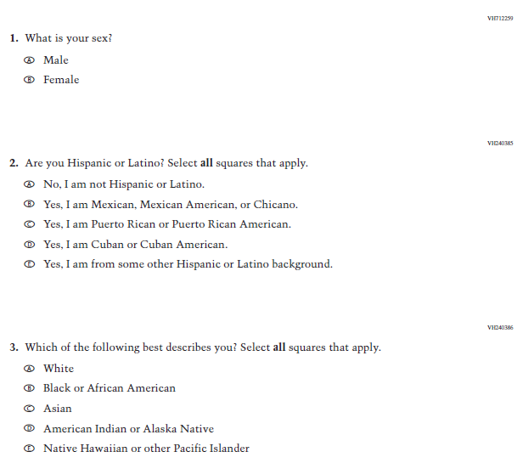

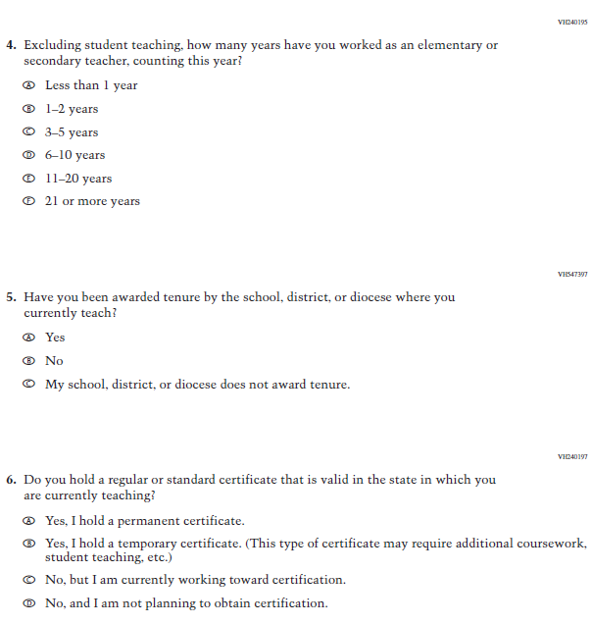
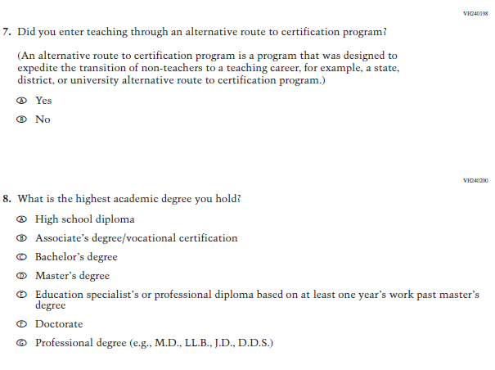
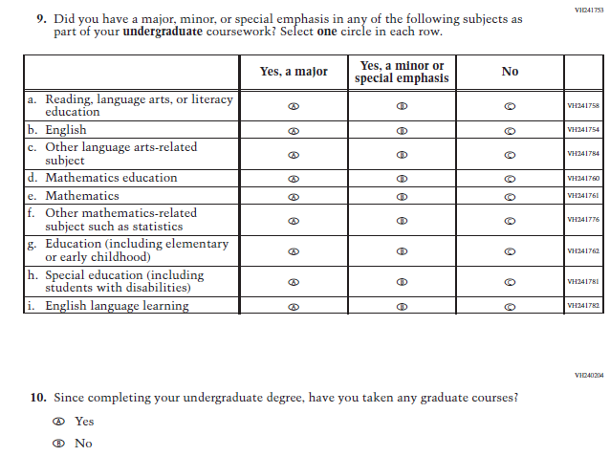
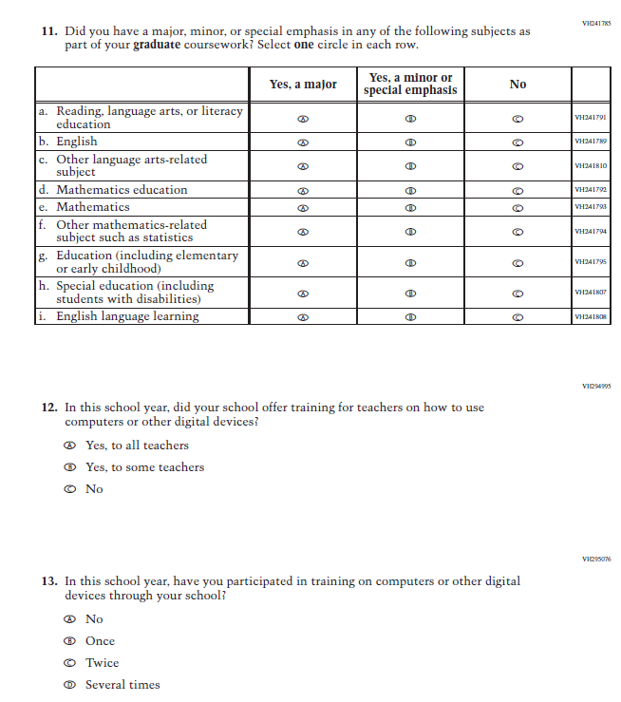

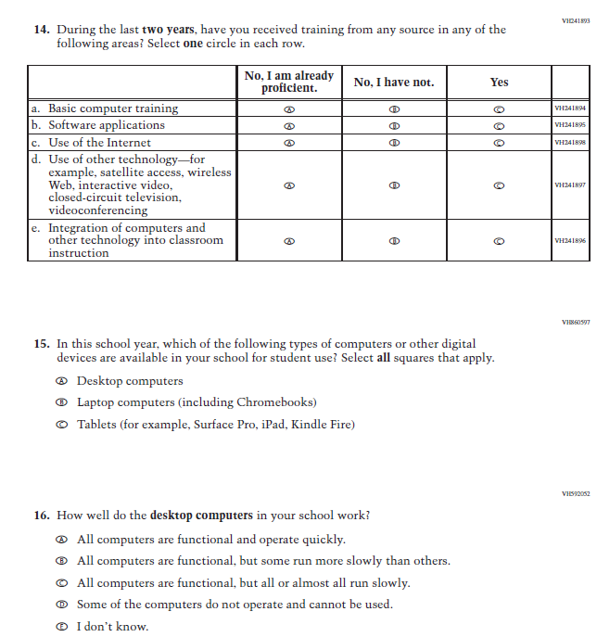

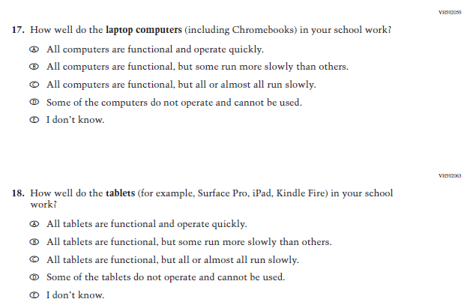

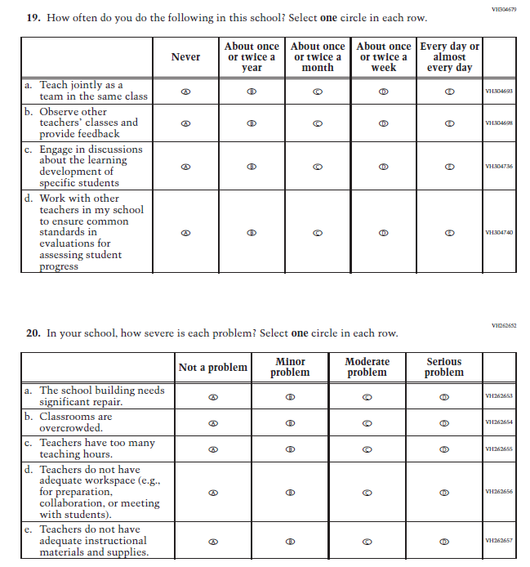

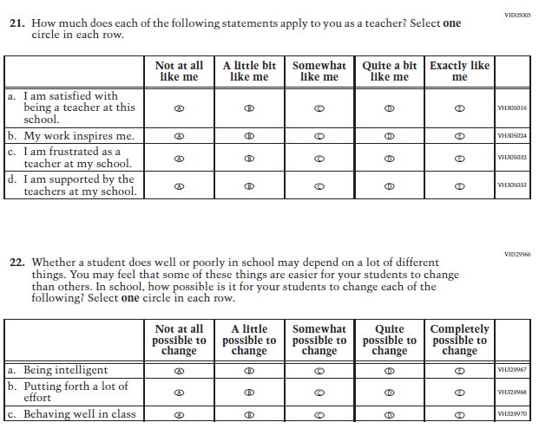

Appendix J2-3: Summary of Changes Operational Grade 8 CORE
2021 Operational Grade 8 Core Teacher

Previous item | 2021 item | D/A/ R/NC+ | Rationale
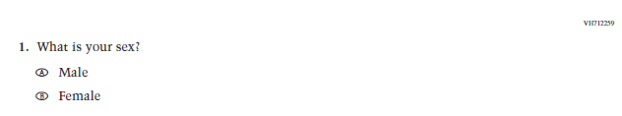  (2019 Grade 8) | Issue: Gender | NC | N/A
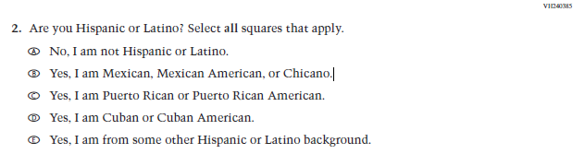  (2019 Grade 8) | Issue: Race/Ethnicity | NC | N/A
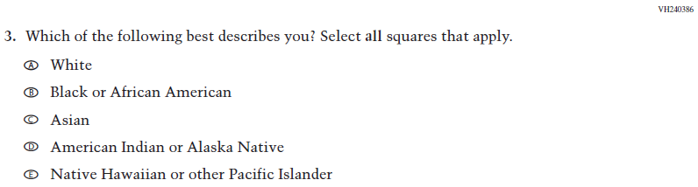  (2019 Grade 8) | Issue: Race/Ethnicity | NC | N/A
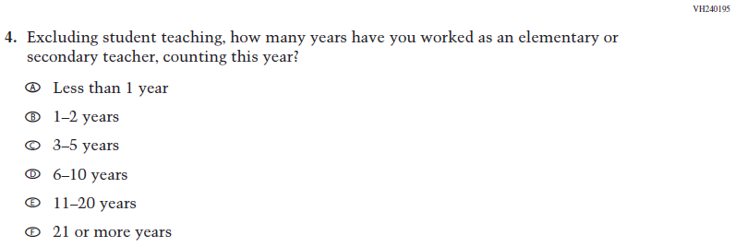  (2019 Grade 8) | Issue: Teacher Preparation | NC | N/A
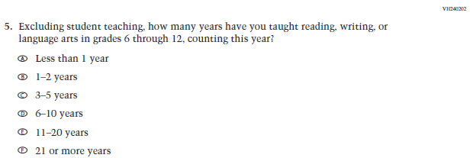  (2019 Grade 8) | Issue: Teacher Preparation | NC | N/A
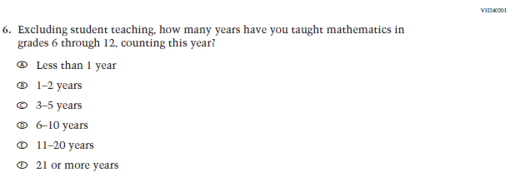  (2019 Grade 8) | Issue: Teacher Preparation | NC | N/A
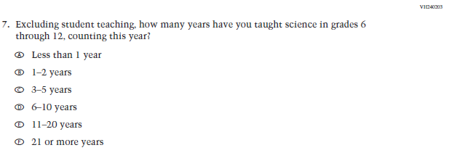  (2019 Grade 8) | N/A | D | The item was dropped because science will not be administered in 2021.
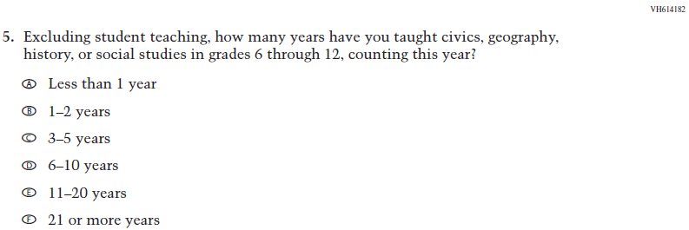  (2018 Grade 8) | 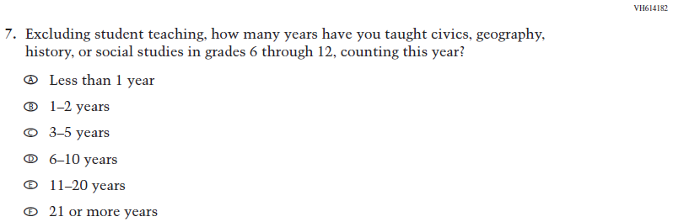  Issue: Teacher Preparation | NC | N/A
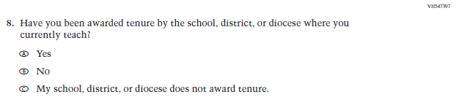  (2019 Grade 8) | Issue: Teacher Preparation | NC | N/A
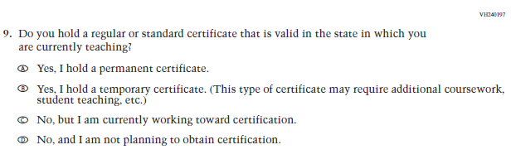  (2019 Grade 8) | Issue: Teacher Preparation | NC | N/A
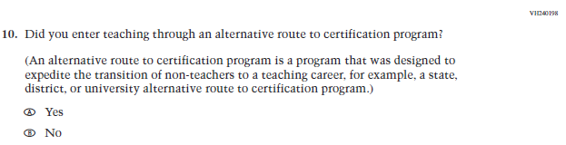  (2019 Grade 8) | Issue: Teacher Preparation | NC | N/A
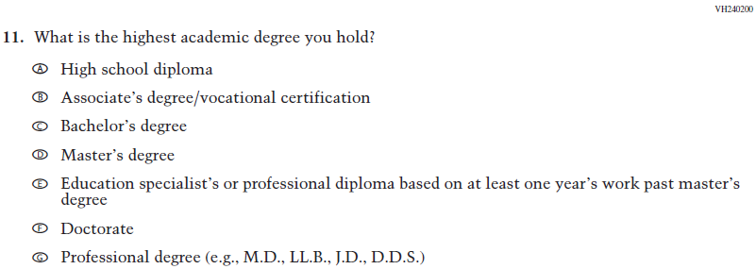  (2019 Grade 8) | Issue: Teacher Preparation | NC | N/A
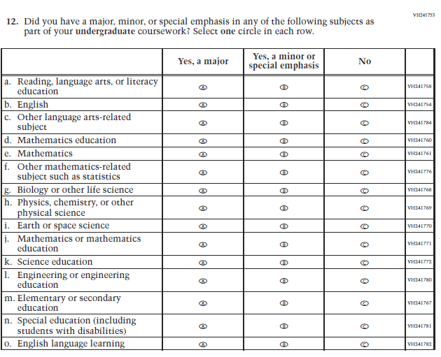  (2019 Grade 8) | 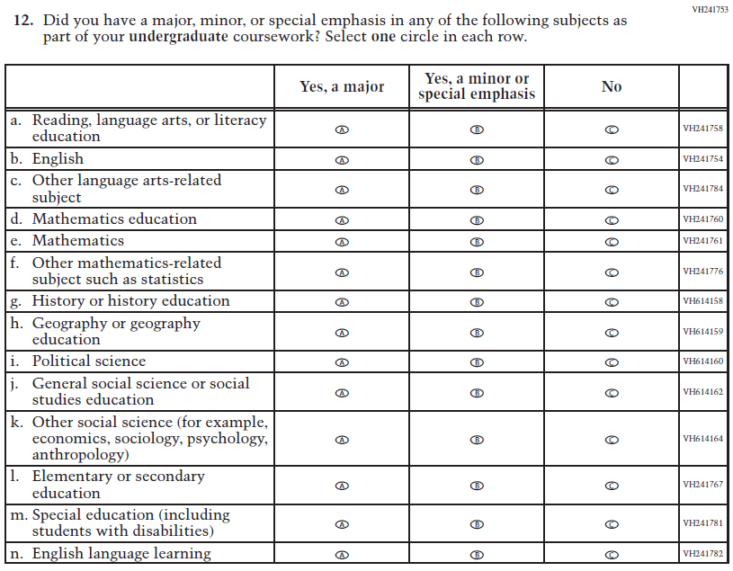  Issue: Teacher Preparation | R | This item is customized by subject and has been revised to remove sub-items for science and expanded to also include sub-items for social studies.
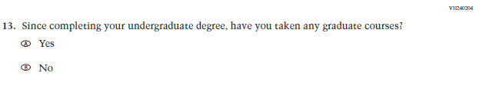  (2019 Grade 8) | Issue: Teacher Preparation | NC | N/A
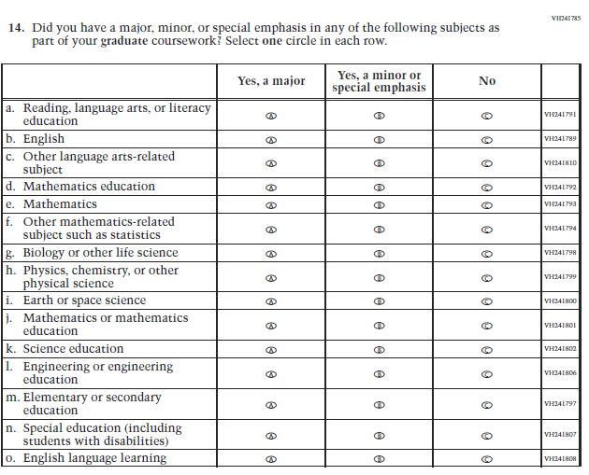  (2019 Grade 8) | 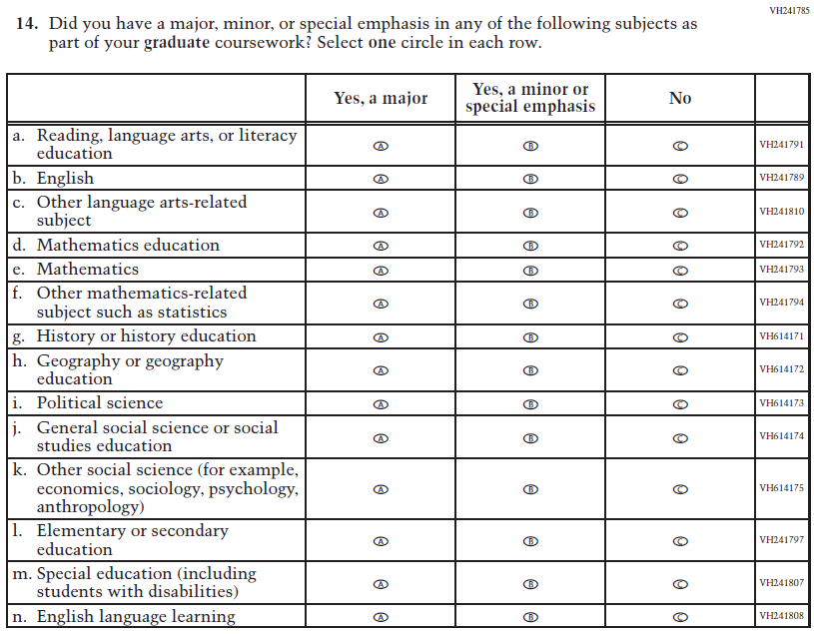  Issue: Teacher Preparation | R | This item is customized by subject and has been revised to remove sub-items for science and expanded to also include sub-items for social studies.
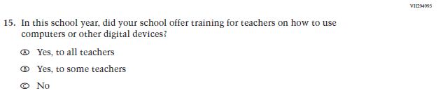  (2019 Grade 8) | Issue: Technology Use | NC | N/A
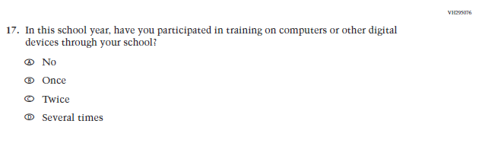(2019 Grade 8) | 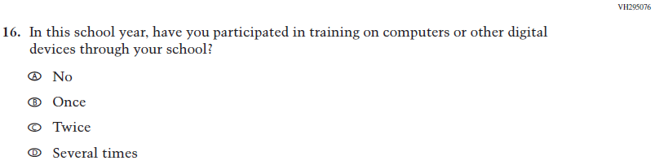  Issue: Technology Use | NC | N/A
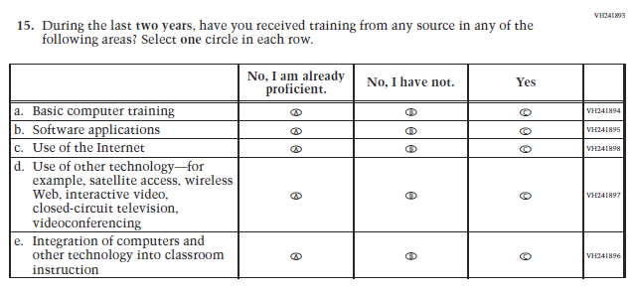  (2019 Grade 8) | 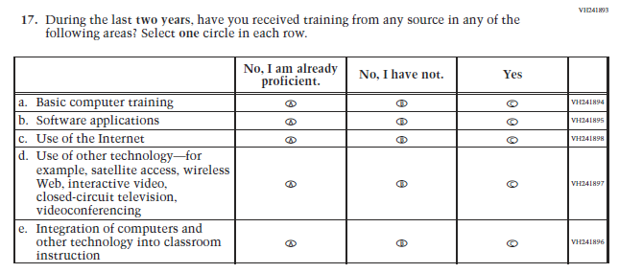  Issue: Teacher Preparation | NC | N/A
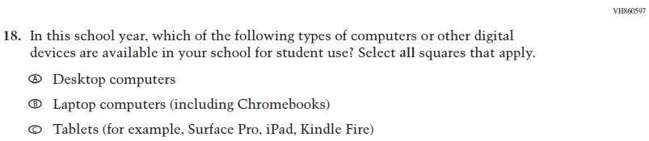  (2019 Grade 8) | Issue: Technology Use | NC | N/A
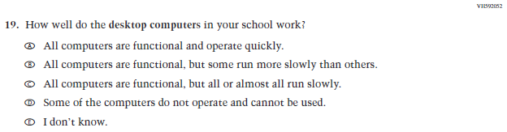  (2019 Grade 8) | Issue: Technology Use | NC | N/A
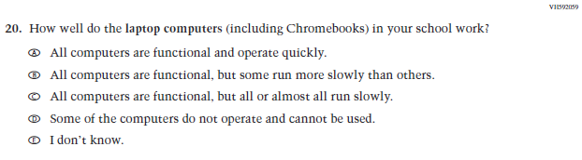  (2019 Grade 8) | Issue: Technology Use | NC | N/A
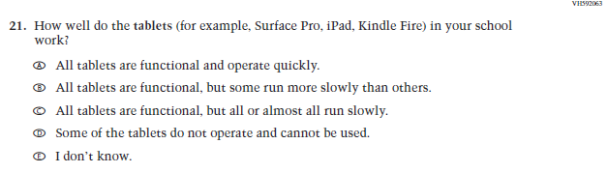  (2019 Grade 8) | Issue: Technology Use | NC | N/A
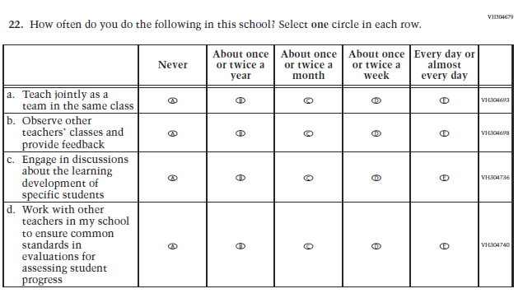  (2019 Grade 8) | Issue: School Climate | NC | N/A
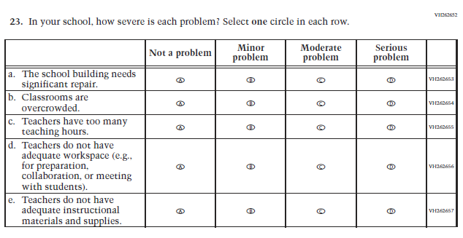  (2019 Grade 8) | Issue: School Climate | NC | N/A
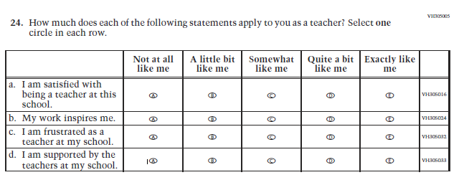  (2019 Grade 8) | Issue: School Climate | NC | N/A
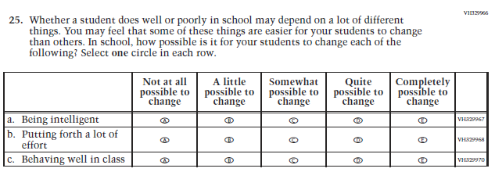  (2019 Grade 8) | Issue: Desire for Learning | NC | N/A

Appendix J2-4: Operational Grade 8 CORE
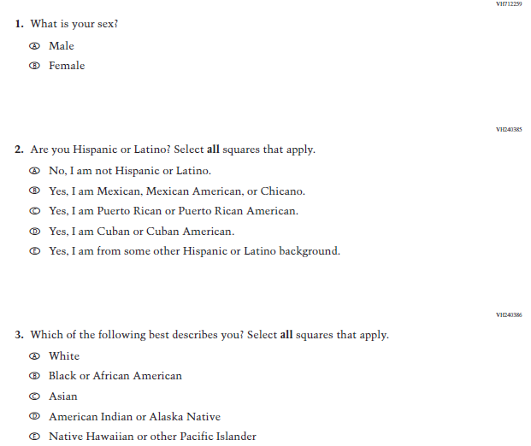

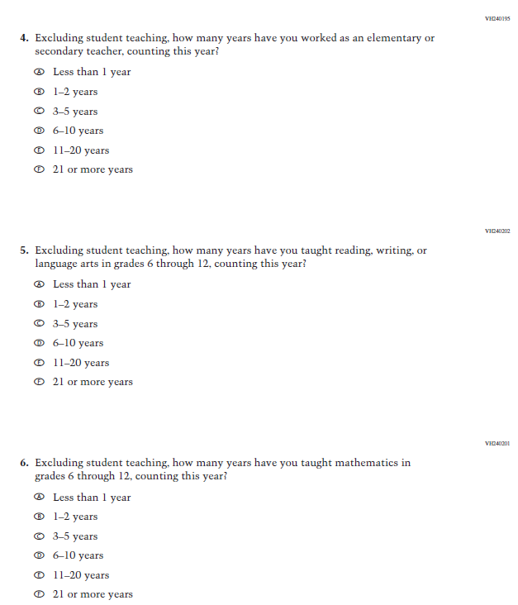
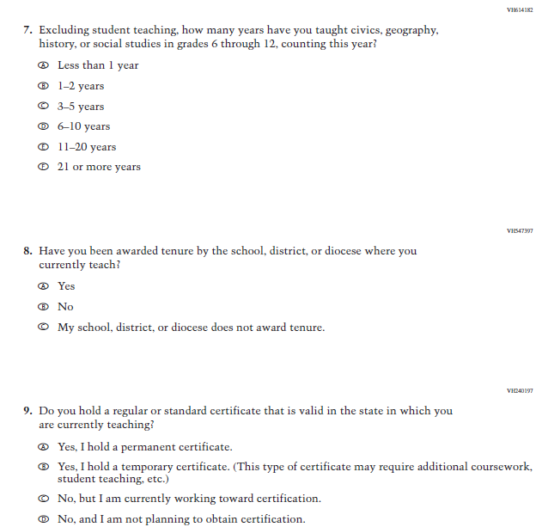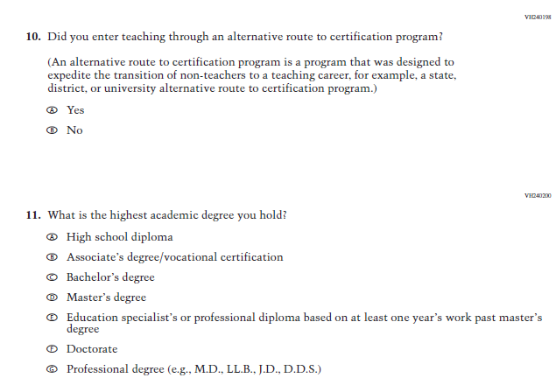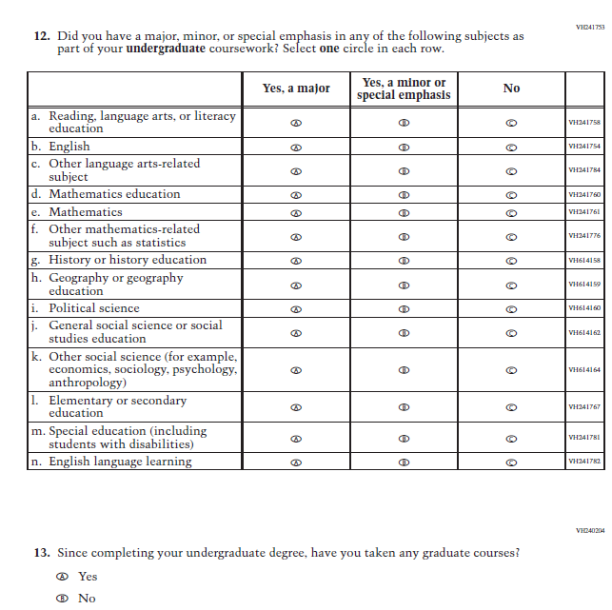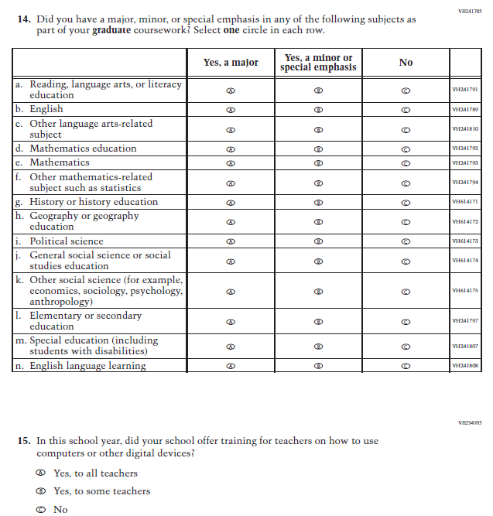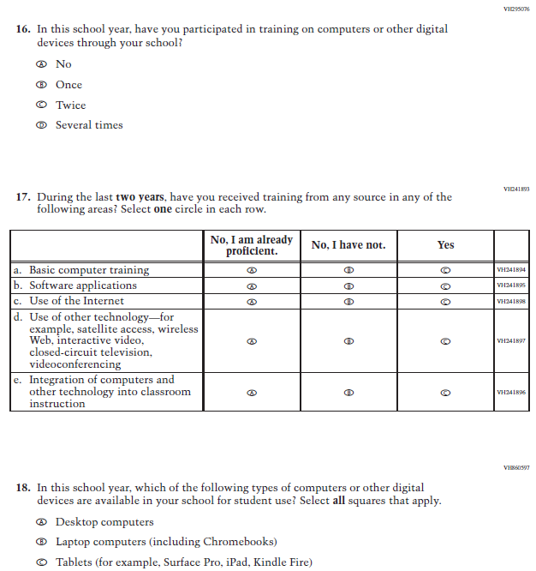
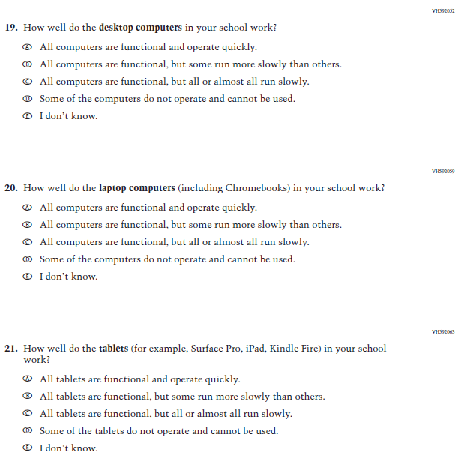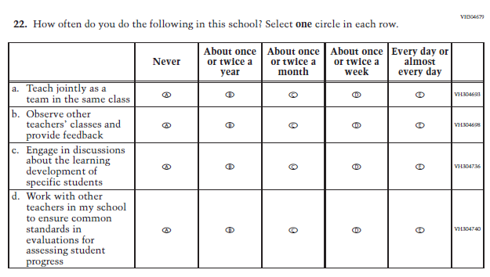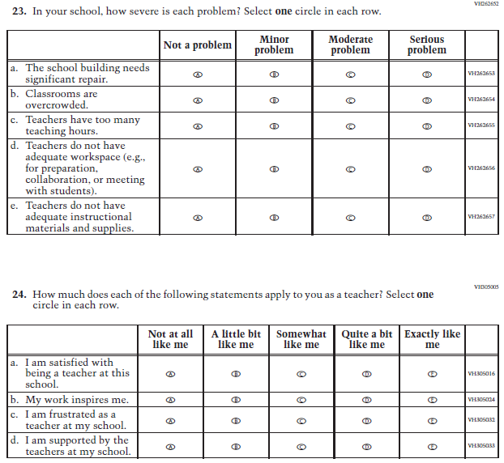
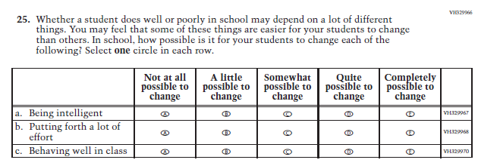

Appendix J2-5: Summary of Changes Operational Grade 4 Mathematics
2021 Operational Grade 4 Mathematics Teacher

Previous item | 2021 item | D/A/ R/NC+ | Rationale
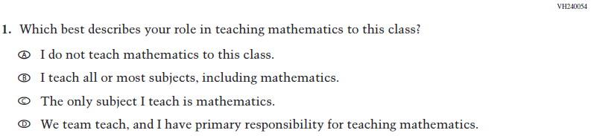  (2019 Grade 4) | Issue: Resources for Learning and Instruction | NC | N/A
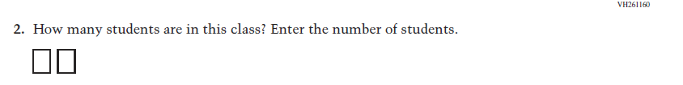  (2019 Grade 4) | Issue: Resources for Learning and Instruction | NC | N/A
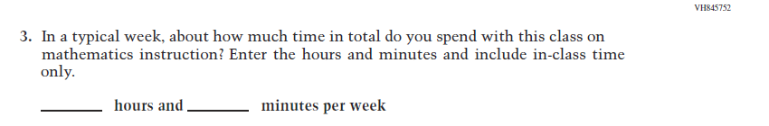  (2019 Grade 4) | Issue: Resources for Learning and Instruction | NC | N/A
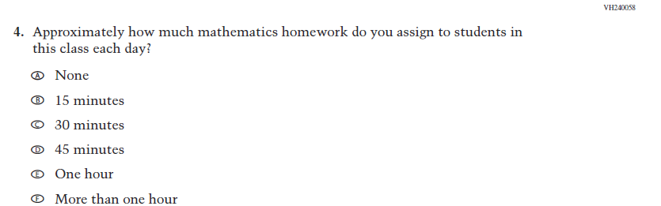  (2019 Grade 4) | Issue: Organization of Instruction | NC | N/A
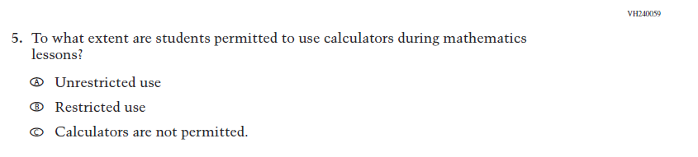  (2019 Grade 4) | Issue: Organization of Instruction | NC | N/A
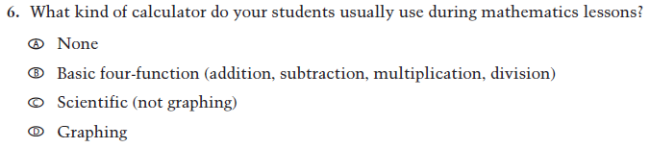  (2019 Grade 4) | Issue: Resources for learning and instruction | NC | N/A
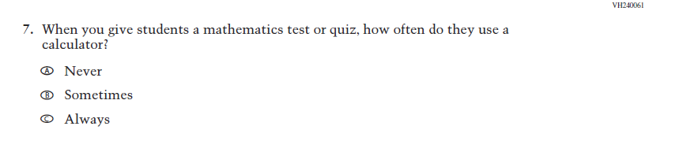  (2019 Grade 4) | Issue: Organization of Instruction | NC | N/A
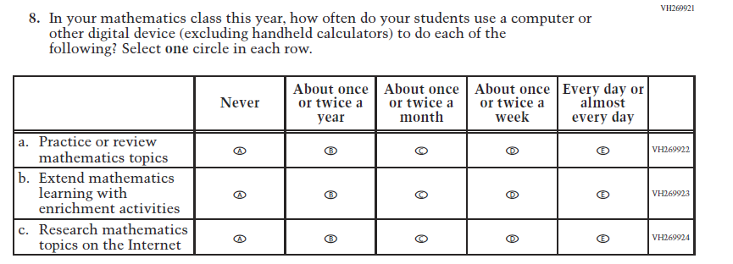  (2019 Grade 4) | Issue: Organization of Instruction | NC | N/A
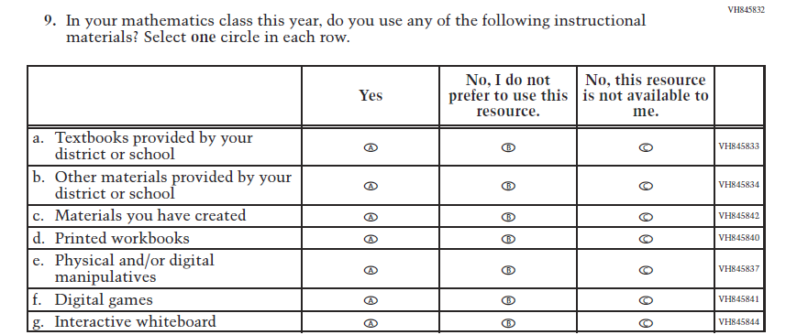  (2019 Grade 4) | Issue: Resources for Learning and Instruction | NC | N/A
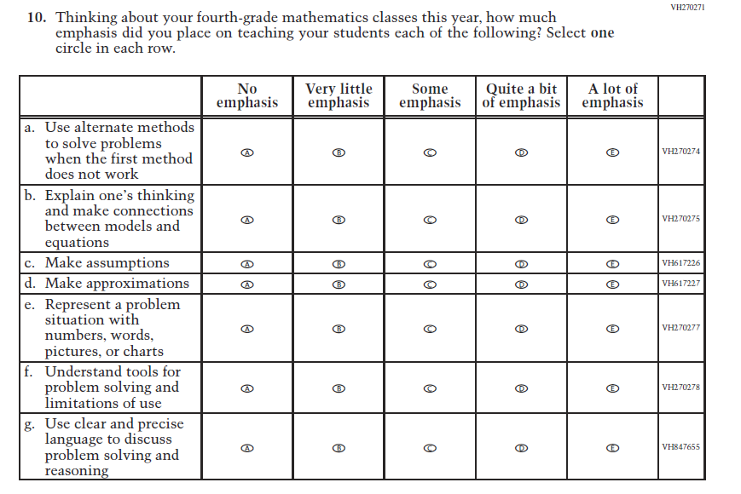  (2019 Grade 4) | Issue: Organization of Instruction | NC | N/A
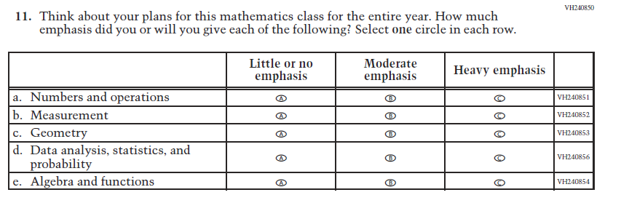  (2019 Grade 4) | Issue: Organization of Instruction | NC | N/A
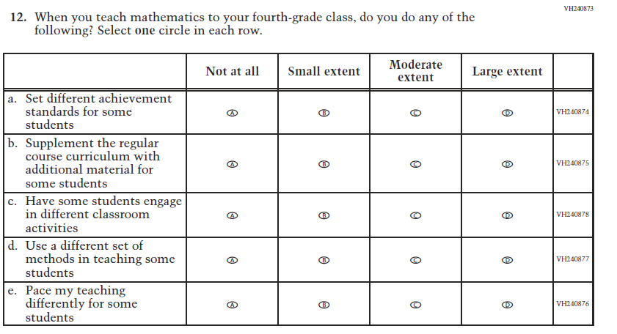  (2019 Grade 4) | Issue: Organization of Instruction | NC | N/A
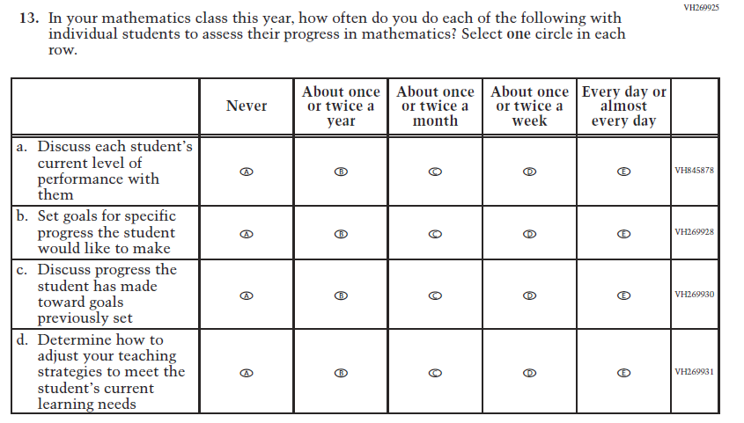  (2019 Grade 4) | Issue: Organization of Instruction | NC | N/A
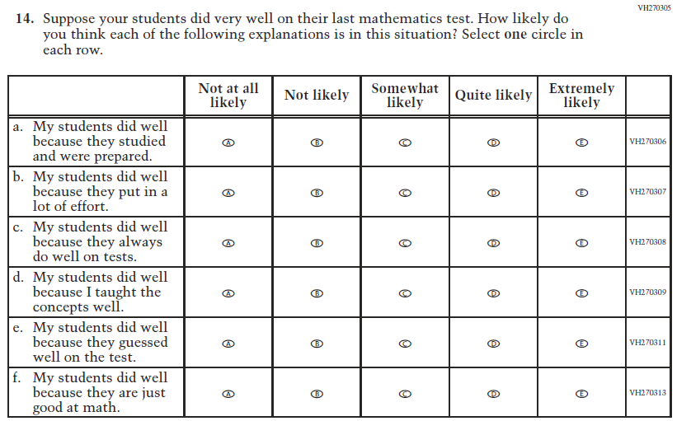  (2019 Grade 4) | Issue: Teacher Preparation | NC | N/A
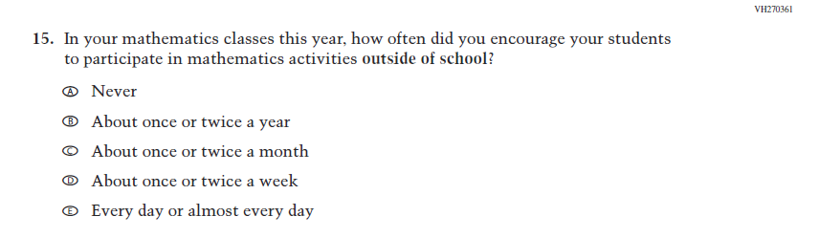  (2019 Grade 4) | Issue: Resources for Learning and Instruction | NC | N/A
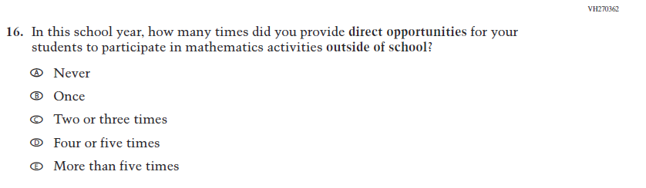  (2019 Grade 4) | Issue: Resources for Learning and Instruction | NC | N/A

Appendix J2-6: Operational Grade 4 Mathematics
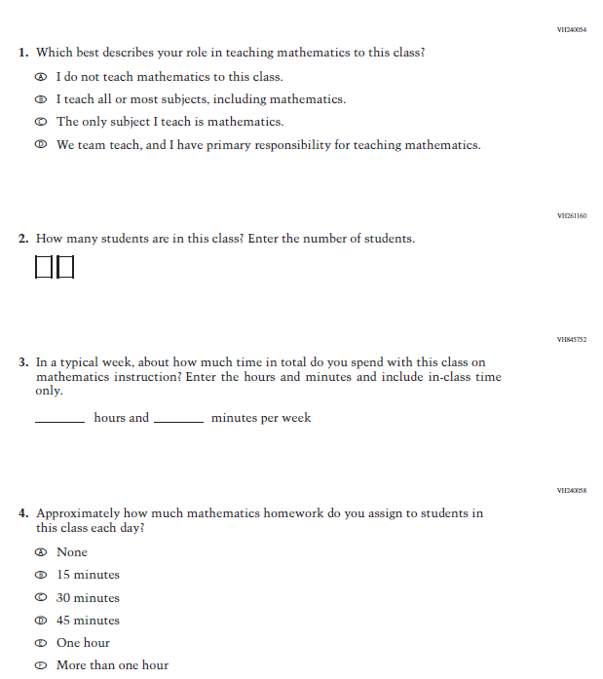

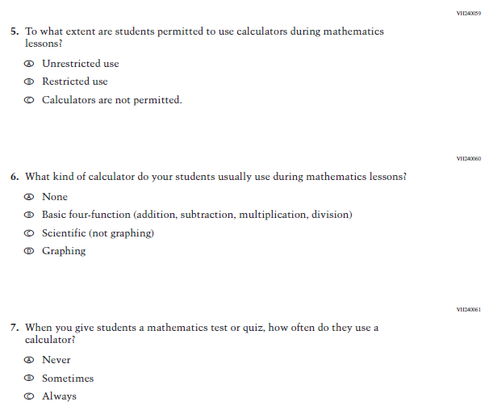

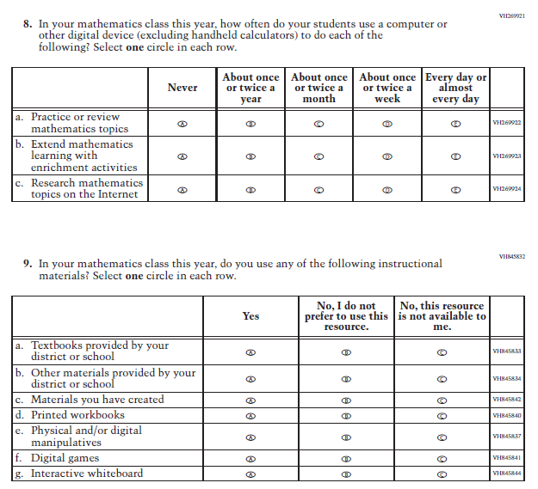

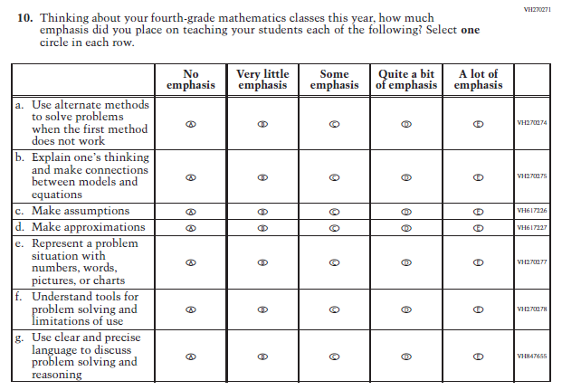
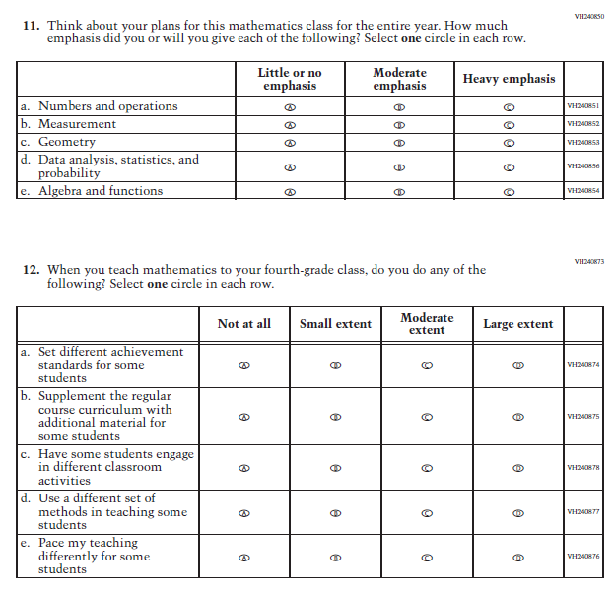
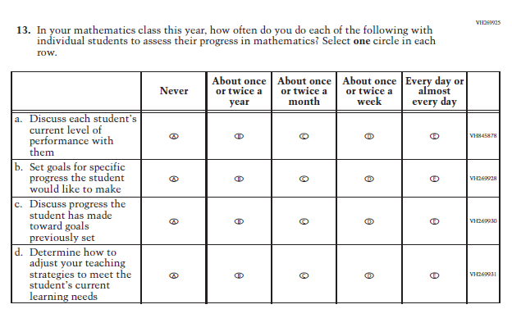

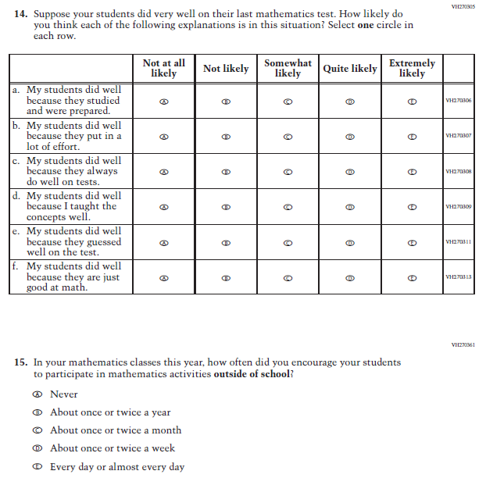
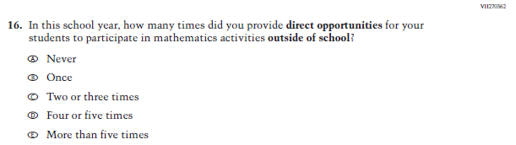

Appendix J2-7: Summary of Changes Operational Grade 8 Mathematics
2021 Operational Grade 8 Mathematics Teacher

Previous item | 2021 item | D/A/ R/NC+ | Rationale
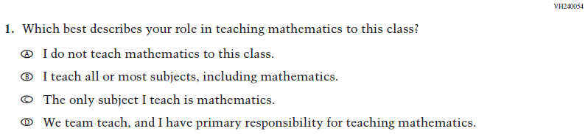  (2019 Grade 8) | Issue: Resources for Learning and Instruction | NC | N/A
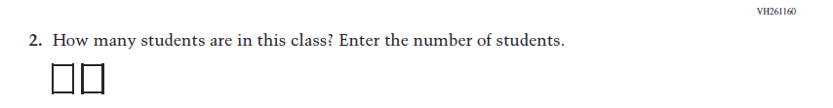  (2019 Grade 8) | 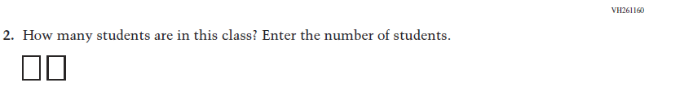  Issue: Resources for Learning and Instruction | NC | N/A
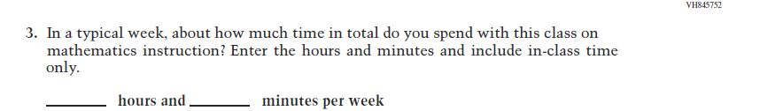  (2019 Grade 8) | Issue: Resources for Learning and Instruction | NC | N/A
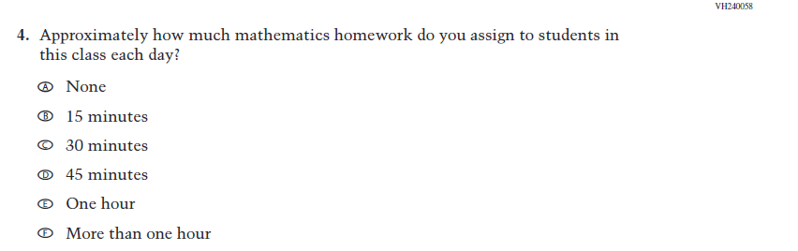  (2019 Grade 8) | Issue: Organization of Instruction | NC | N/A
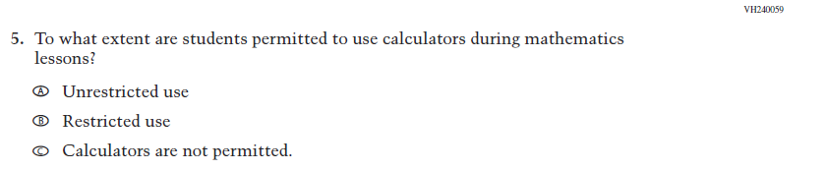  (2019 Grade 8) | Issue: Organization of Instruction | NC | N/A
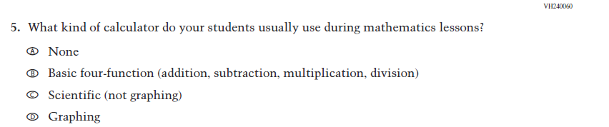  (2019 Grade 8) | 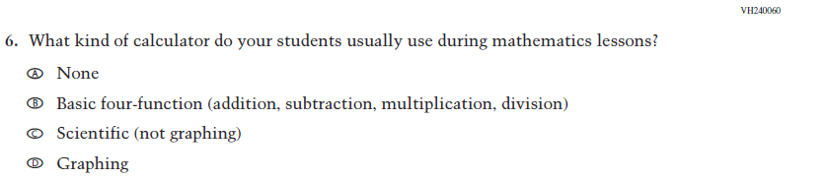  Issue: Resources for Learning and Instruction | NC | N/A
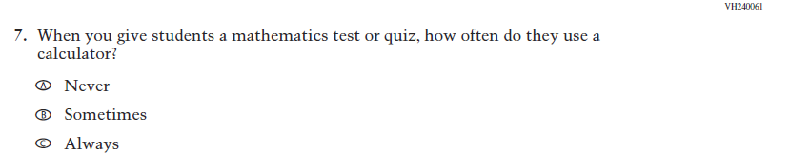  (2019 Grade 8) | Issue: Organization of Instruction | NC | N/A
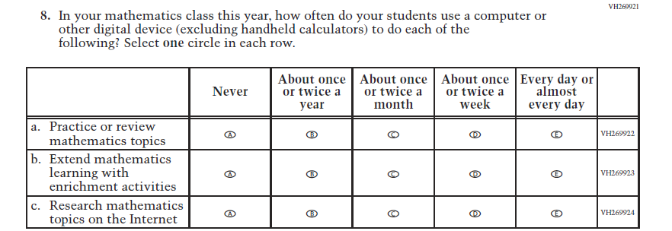  (2019 Grade 8) | Issue: Organization of Instruction | NC | N/A
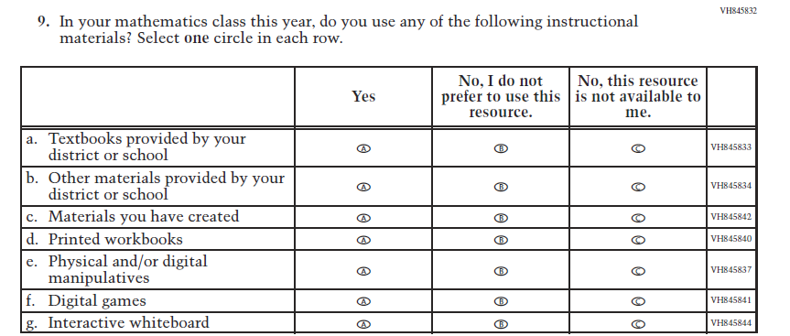  (2019 Grade 8) | Issue: Resources for Learning and Instruction | NC | N/A

2021 Operational Grade 8 Mathematics Teacher

Previous item | 2021 item | D/A/ R/NC+ | Rationale
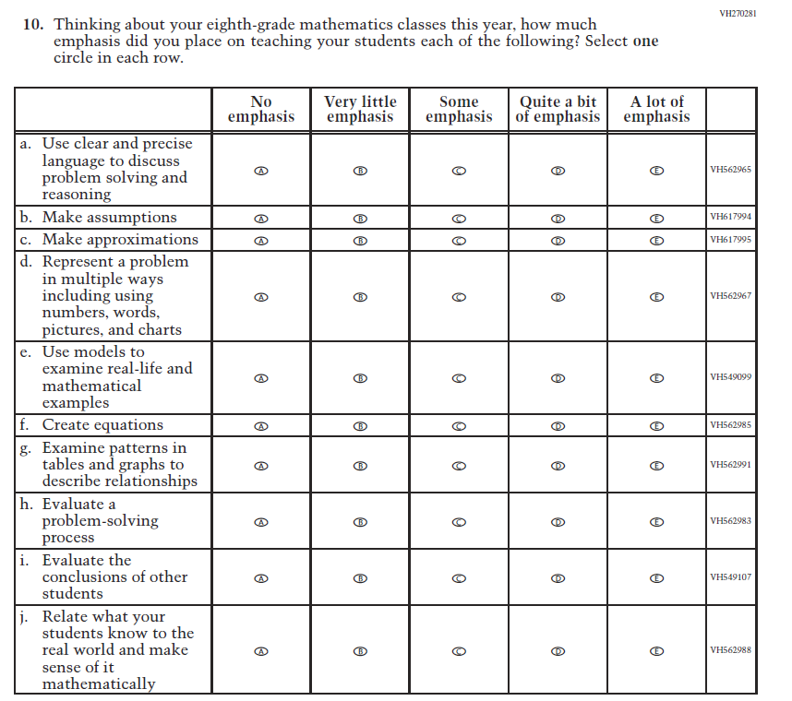  (2019 Grade 8) | Issue: Organization of Instruction | NC | N/A
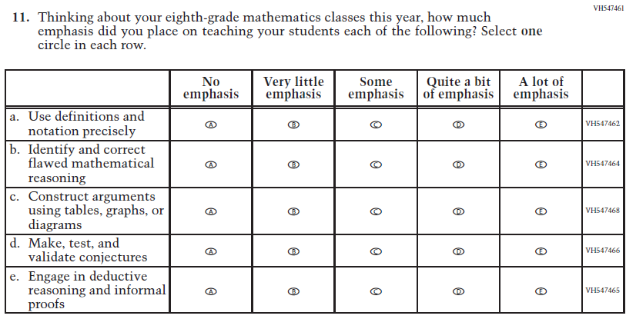  (2019 Grade 8) | Issue: Organization of Instruction | NC | N/A

2021 Operational Grade 8 Mathematics Teacher

Previous item | 2021 item | D/A/ R/NC+ | Rationale
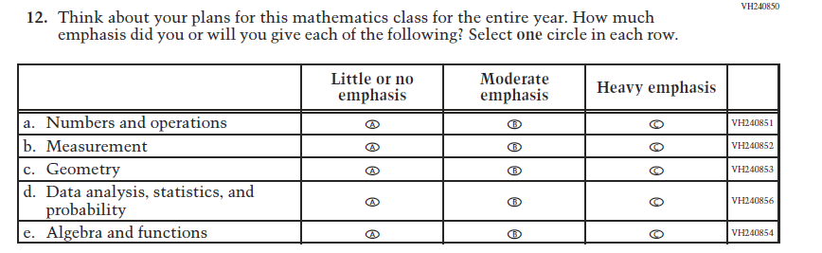  (2019 Grade 8) | Issue: Organization of Instruction | NC | N/A
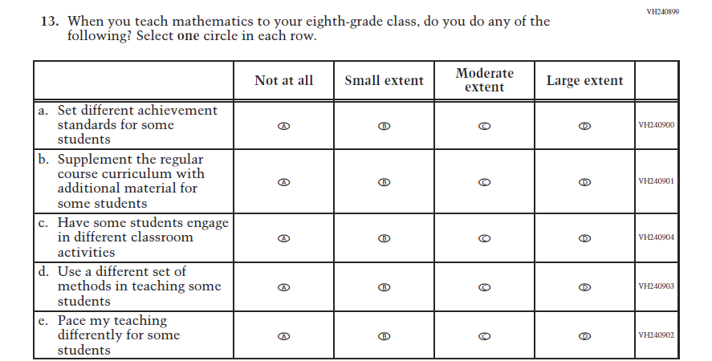  (2019 Grade 8) | Issue: Organization of Instruction | NC | N/A

2021 Operational Grade 8 Mathematics Teacher

Previous item | 2021 item | D/A/ R/NC+ | Rationale
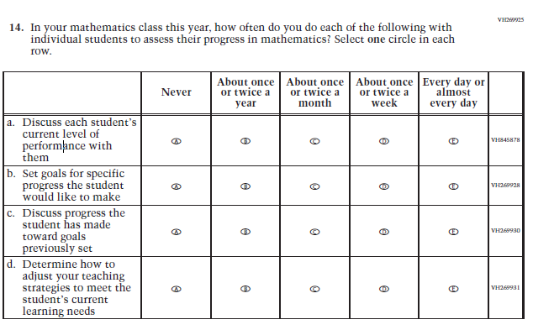  (2019 Grade 8) | Issue: Organization of Instruction | NC | N/A
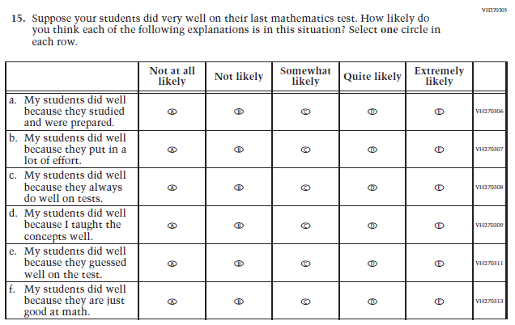  (2019 Grade 8) | Issue: Teacher Preparation | NC | N/A

2021 Operational Grade 8 Mathematics Teacher

Previous item | 2021 item | D/A/ R/NC+ | Rationale
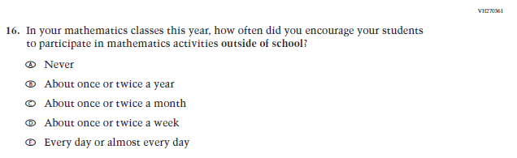  (2019 Grade 8) | Issue: Resources for Learning and Instruction | NC | N/A
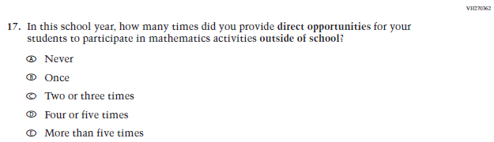  (2019 Grade 8) | Issue: Resources for Learning and Instruction | NC | N/A
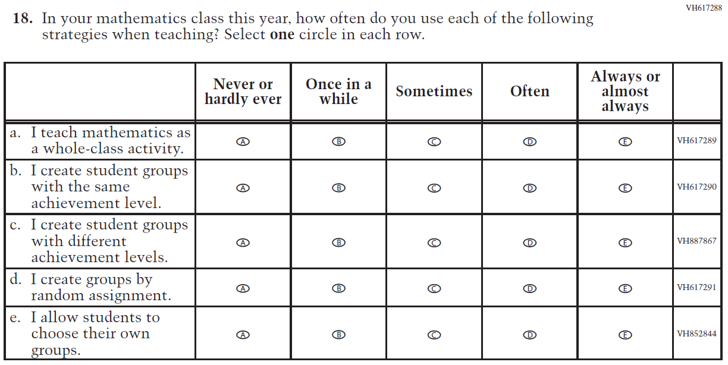  (2019 Grade 8) | Issue: Organization of Instruction | NC | N/A

Appendix J2-8: Operational Grade 8 Mathematics
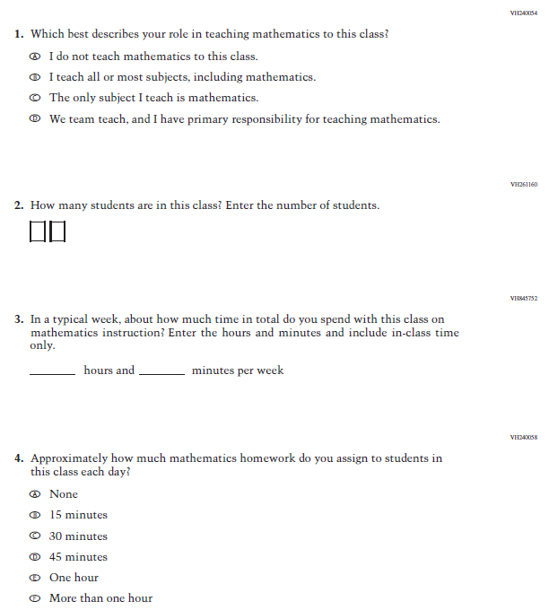

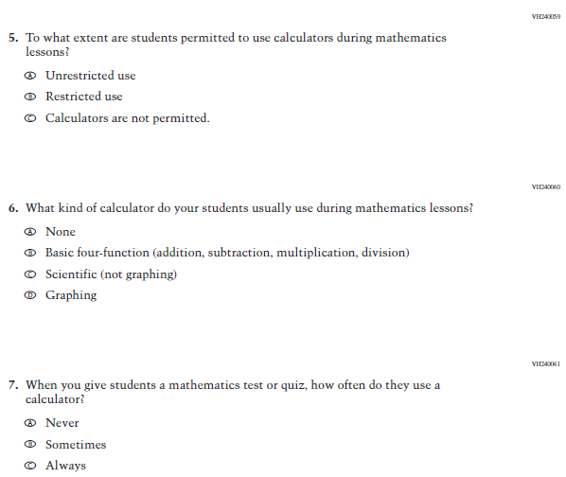
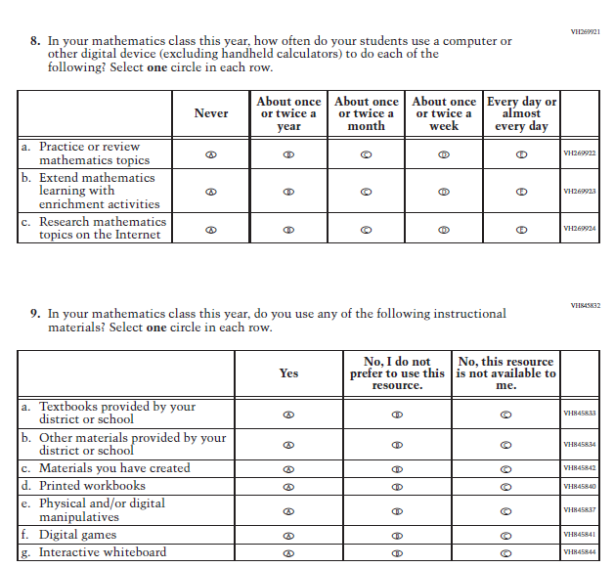

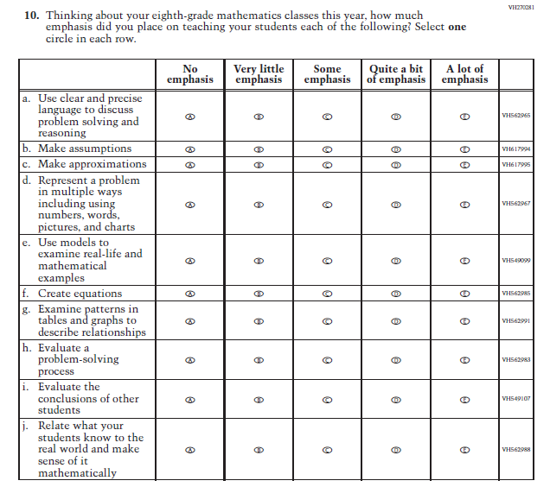
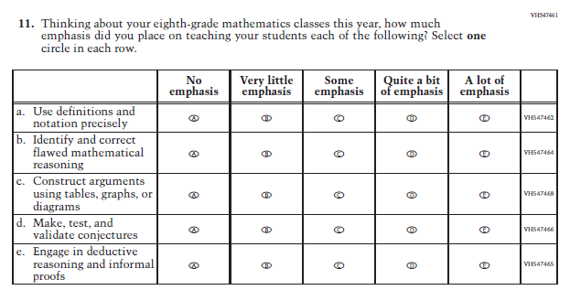
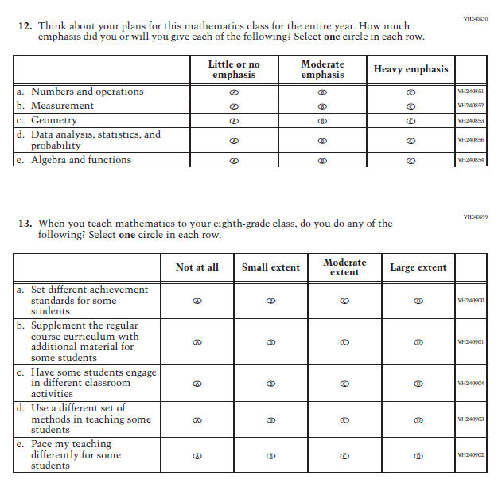
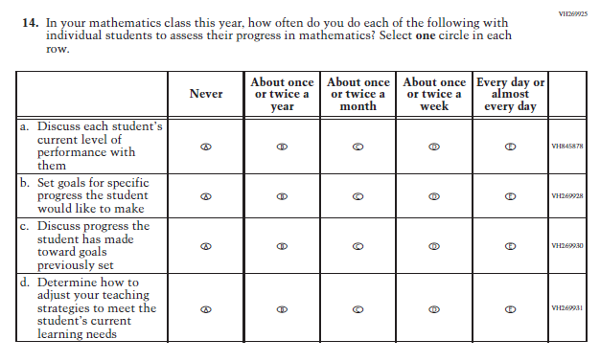
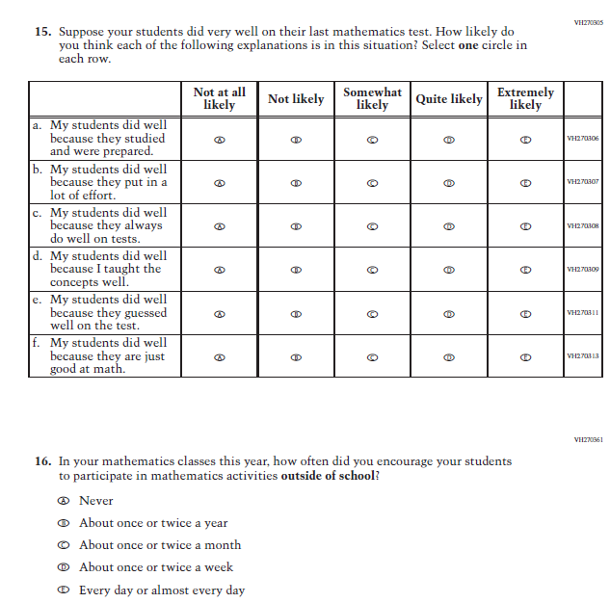
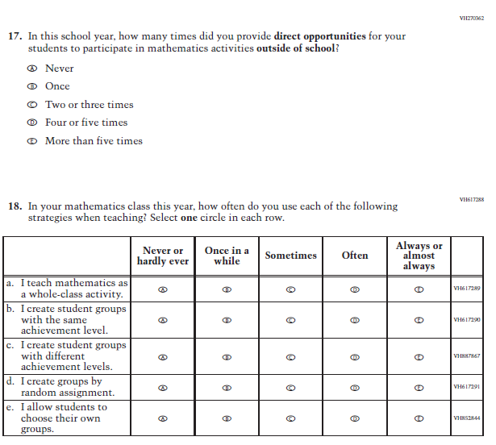

Appendix J2-9: Summary of Changes Operational Grade 4 Reading
2021 Operational Grade 4 Reading Teacher

Previous item | 2021 item | D/A/ R/NC+ | Rationale
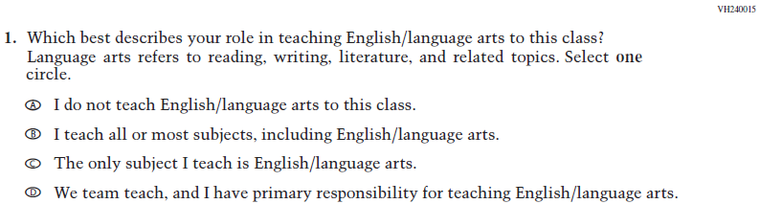  (2019 Grade 4) | Issue: Resources for Learning and Instruction | NC | N/A
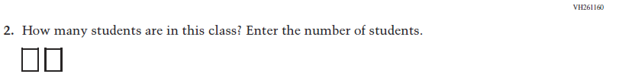  (2019 Grade 4) | Issue: Resources for Learning and Instruction | NC | N/A
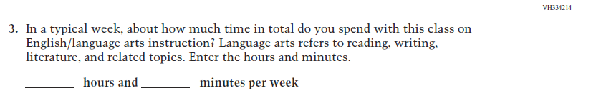  (2019 Grade 4) | Issue: Resources for Learning and Instruction | NC | N/A
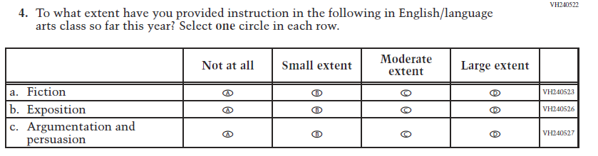  (2019 Grade 4) | Issue: Organization of Instruction | NC | N/A

2021 Operational Grade 4 Reading Teacher

Previous item | 2021 item | D/A/ R/NC+ | Rationale
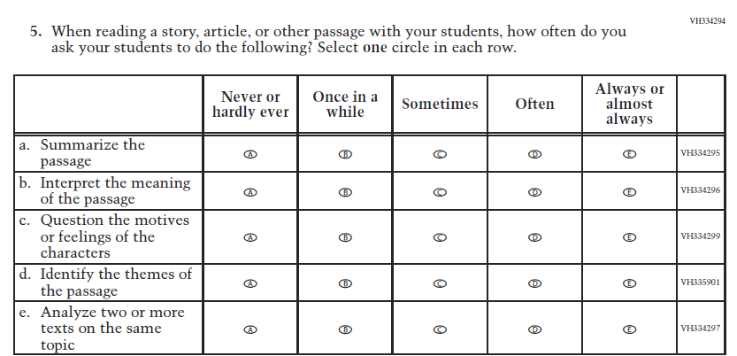  (2019 Grade 4) | Issue: Organization of Instruction | NC | N/A
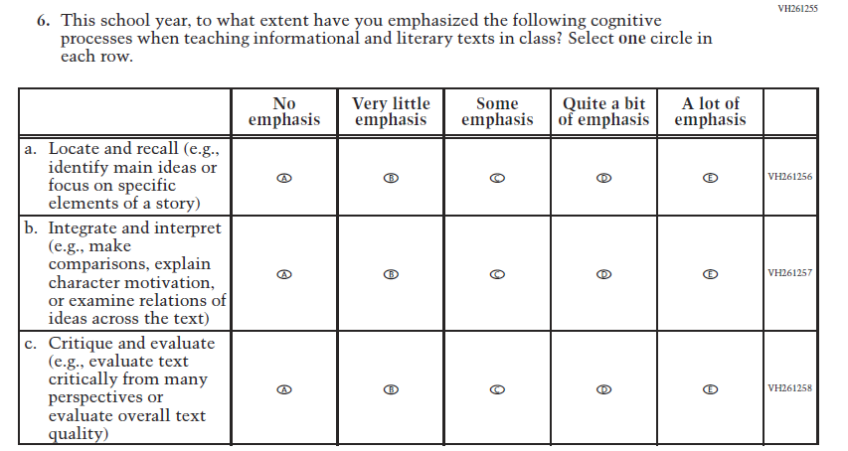  (2019 Grade 4) | Issue: Organization of Instruction | NC | N/A

2021 Operational Grade 4 Reading Teacher

Previous item | 2021 item | D/A/ R/NC+ | Rationale
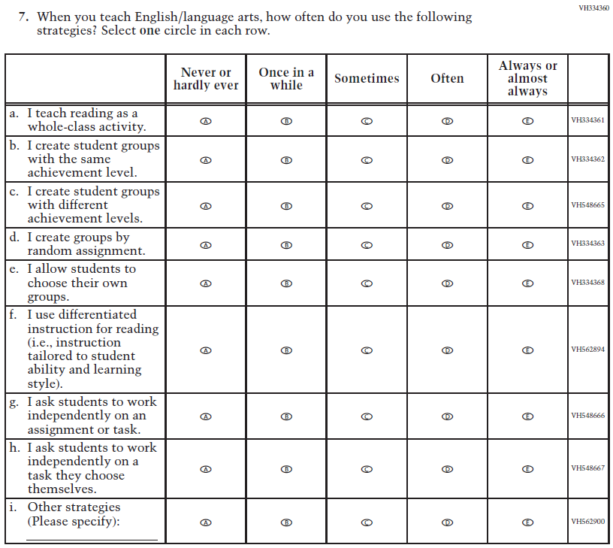  (2019 Grade 4) | Issue: Organization of Instruction | NC | N/A

2021 Operational Grade 4 Reading Teacher

Previous item | 2021 item | D/A/ R/NC+ | Rationale
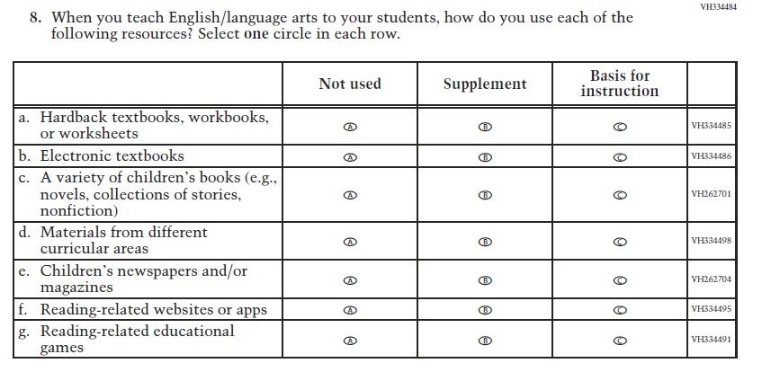  (2019 Grade 4) | Issue: Organization of Instruction | NC | N/A
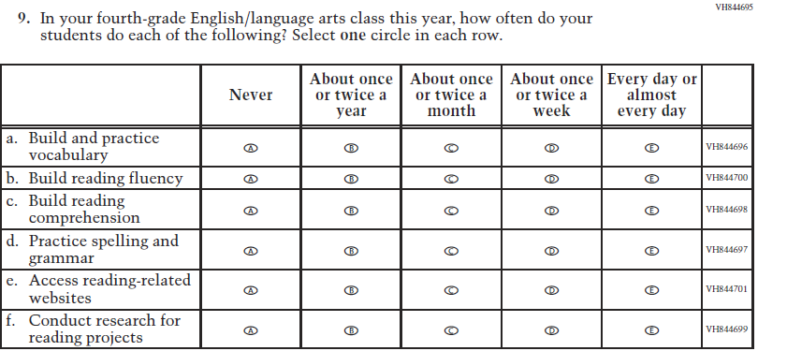  (2019 Grade 4) | Issue: Organization of Instruction | NC | N/A

2021 Operational Grade 4 Reading Teacher

Previous item | 2021 item | D/A/ R/NC+ | Rationale
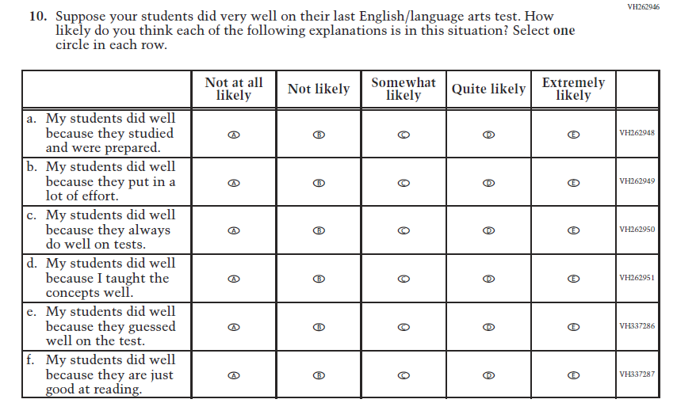  (2019 Grade 4) | Issue: Teacher Preparation | NC | N/A
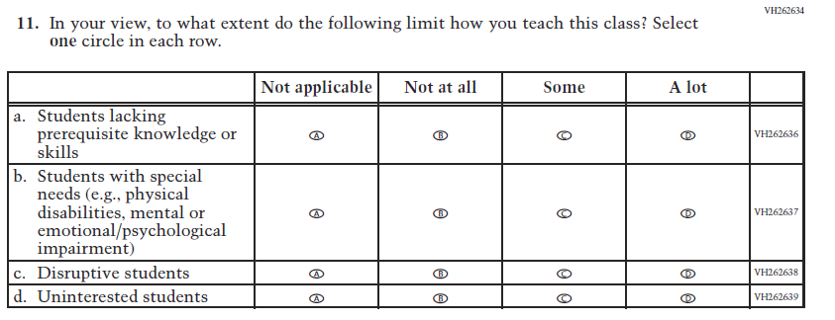  (2019 Grade 4) | Issue: Resources for Learning and Instruction | NC | N/A

Appendix J2-10: Operational Grade 4 Reading
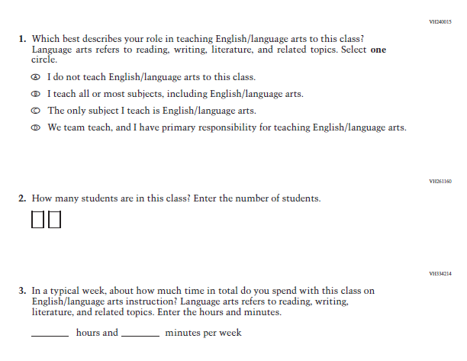

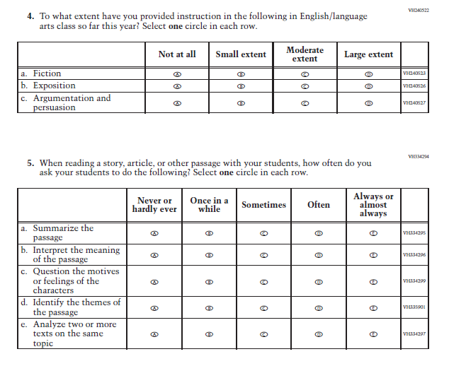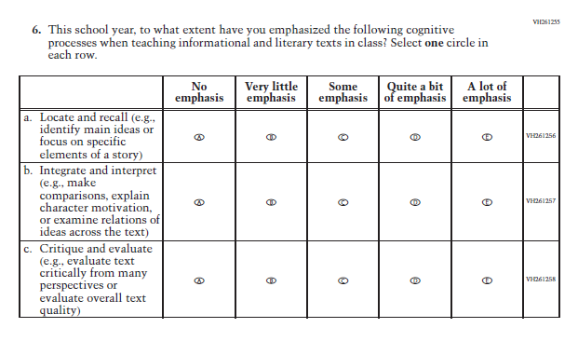
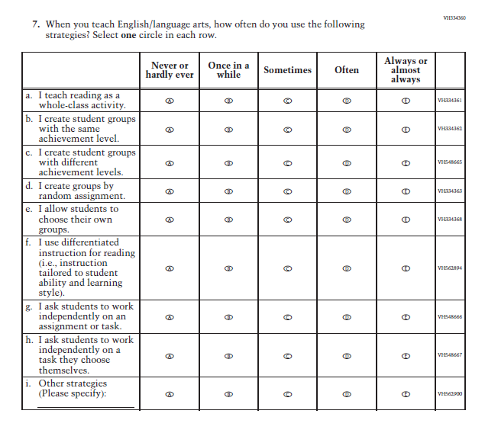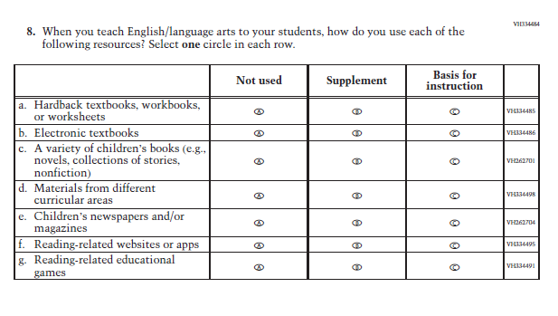

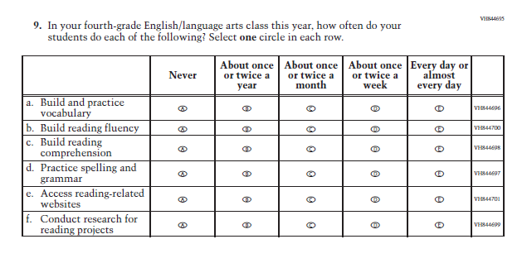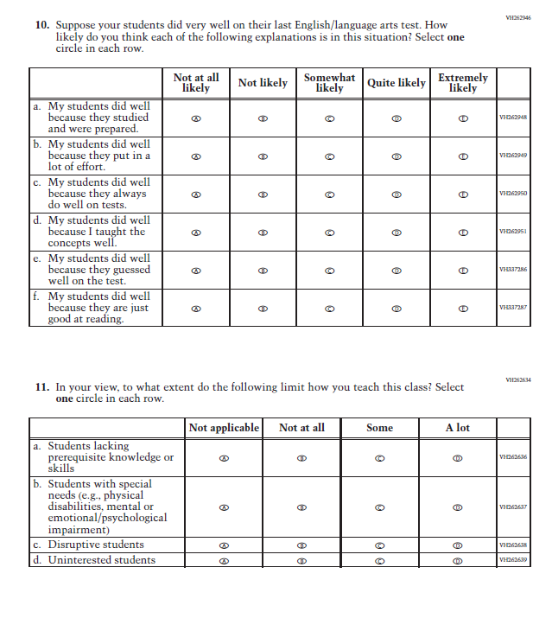

Appendix J2-11: Summary of Changes Operational Grade 8 Reading
2021 Operational Grade 8 Reading Teacher

Previous item | 2021 item | D/A/ R/NC+ | Rationale
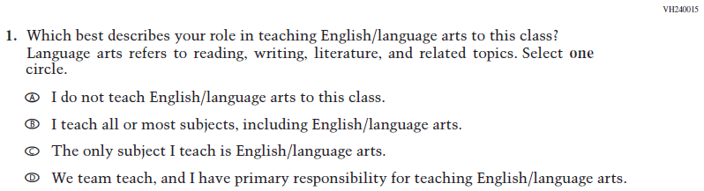  (2019 Grade 8) | Issue: Resources for Learning and Instruction | NC | N/A
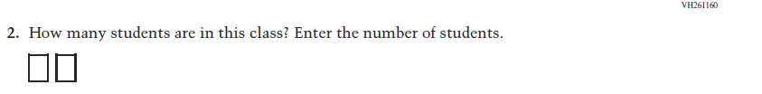  (2019 Grade 8) | Issue: Resources for Learning and Instruction | NC | N/A
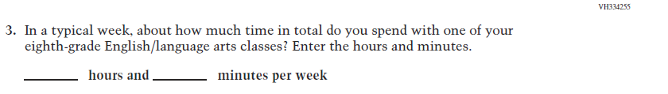  (2019 Grade 8) | Issue: Resources for Learning and Instruction | NC | N/A
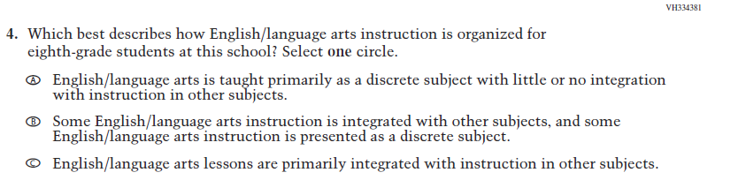  (2019 Grade 8) | Issue: Organization of Instruction | NC | N/A

2021 Operational Grade 8 Reading Teacher

Previous item | 2021 item | D/A/ R/NC+ | Rationale
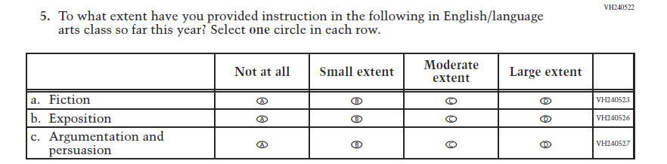  (2019 Grade 8) | Issue: Organization of Instruction | NC | N/A
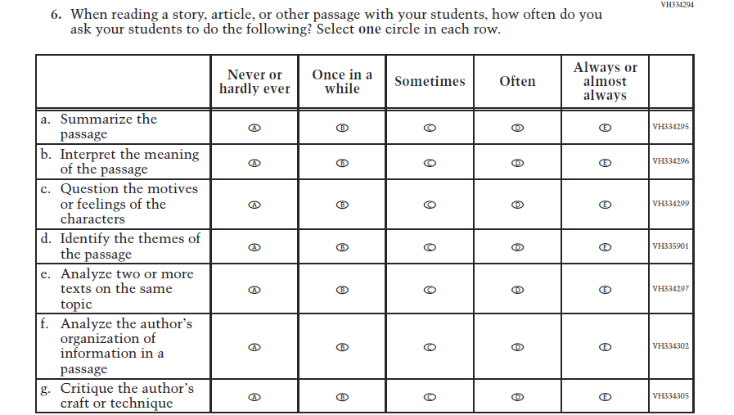  (2019 Grade 8) | Issue: Organization of Instruction | NC | N/A

.
2021 Operational Grade 8 Reading Teacher

Previous item | 2021 item | D/A/ R/NC+ | Rationale
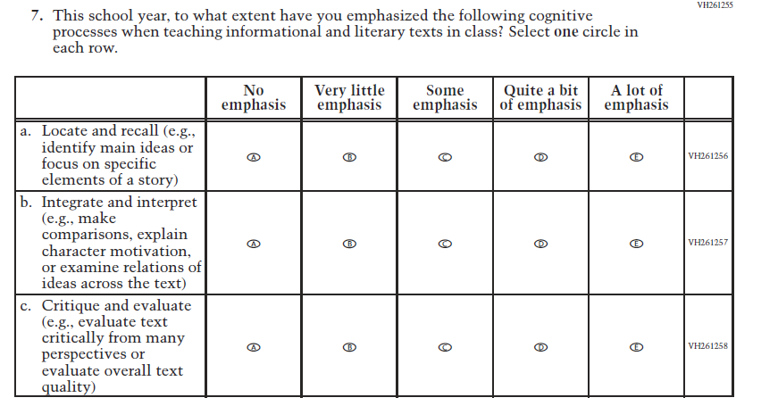  (2019 Grade 8) | Issue: Organization of Instruction | NC | N/A
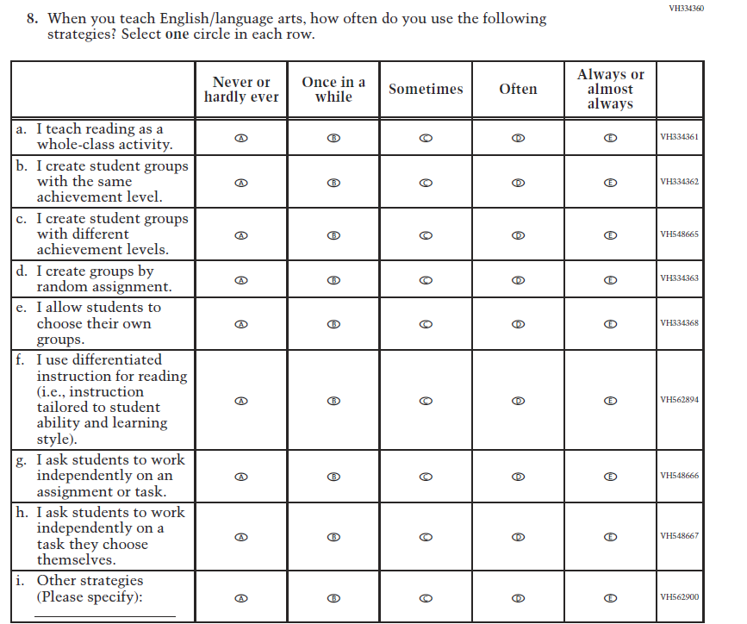  (2019 Grade 8) | Issue: Organization of Instruction | NC | N/A

2021 Operational Grade 8 Reading Teacher

Previous item | 2021 item | D/A/ R/NC+ | Rationale
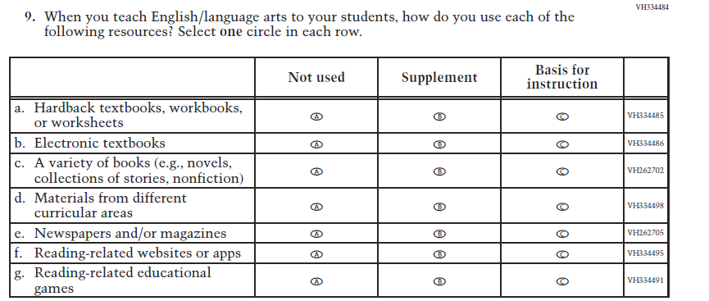  (2019 Grade 8) | Issue: Organization of Instruction | NC | N/A
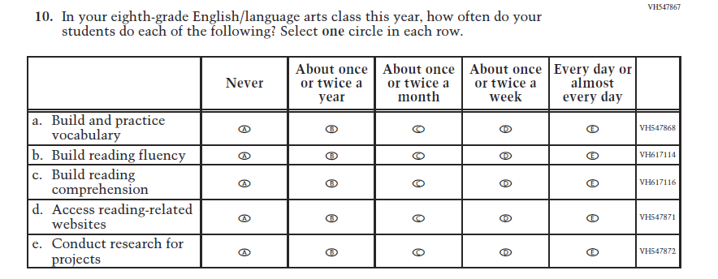  (2019 Grade 8) | Issue: Organization of Instruction | NC | N/A

2021 Operational Grade 8 Reading Teacher

Previous item | 2021 item | D/A/ R/NC+ | Rationale
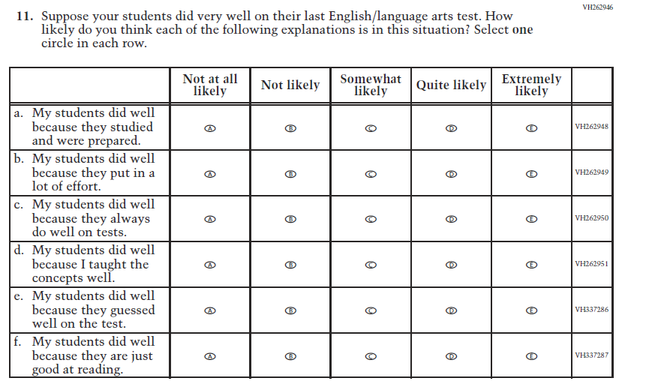  (2019 Grade 8) | Issue: Teacher Preparation | NC | N/A
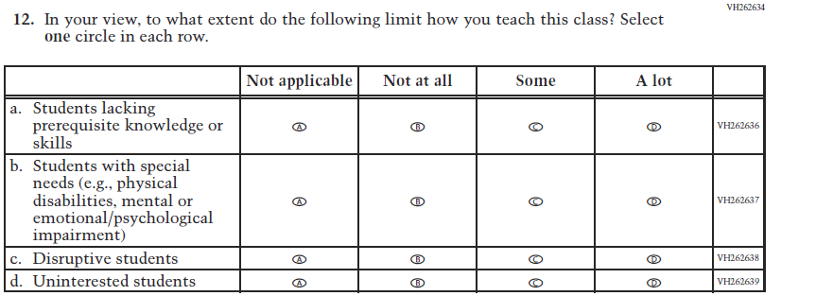  (2019 Grade 8) | Issue: Resources for Learning and Instruction | NC | N/A

Appendix J2-12: Operational Grade 8 Reading
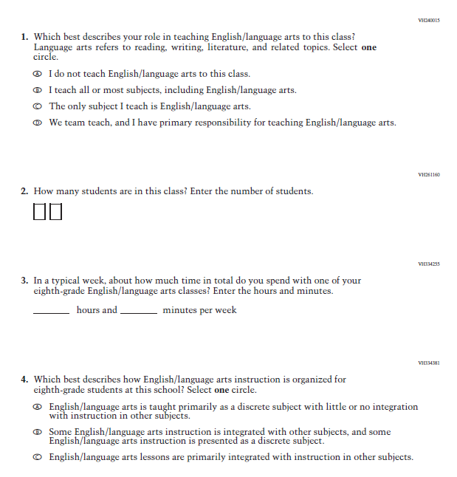

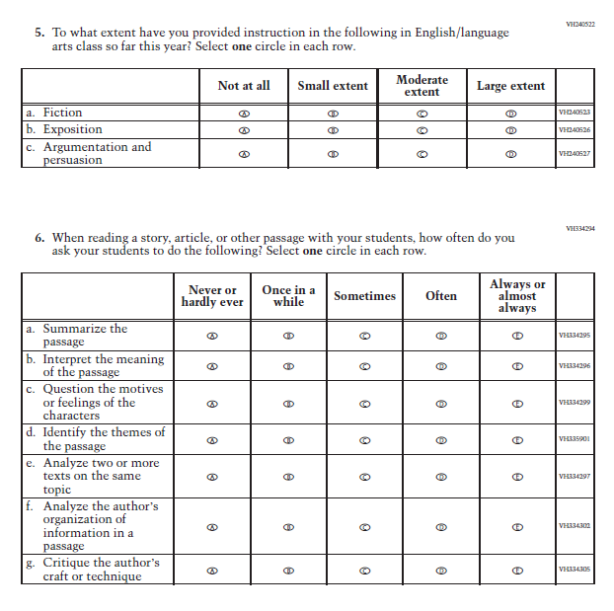

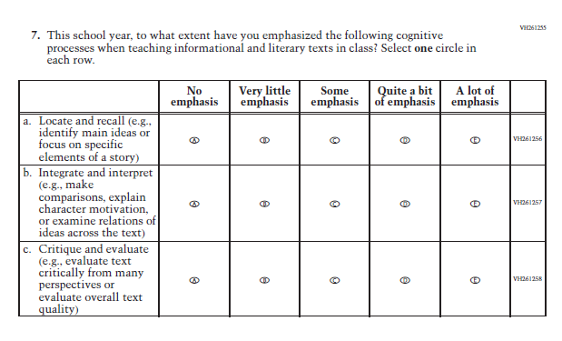

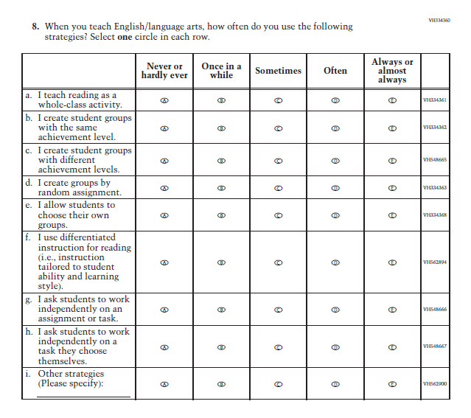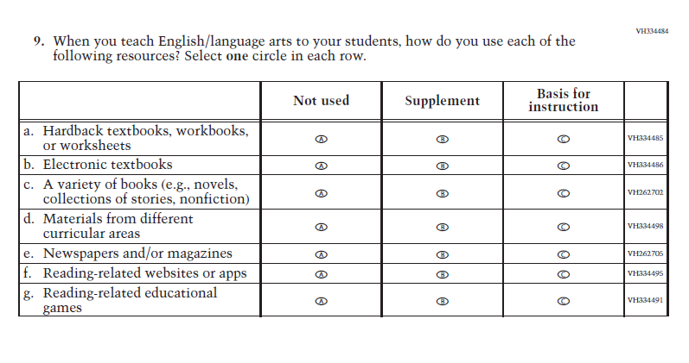

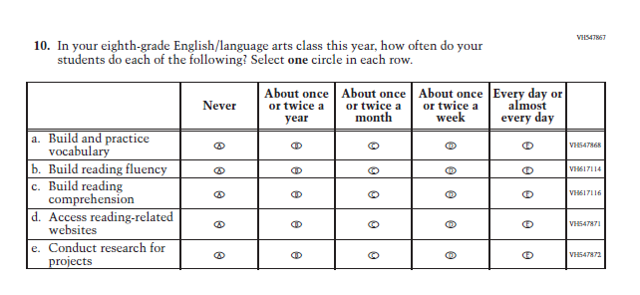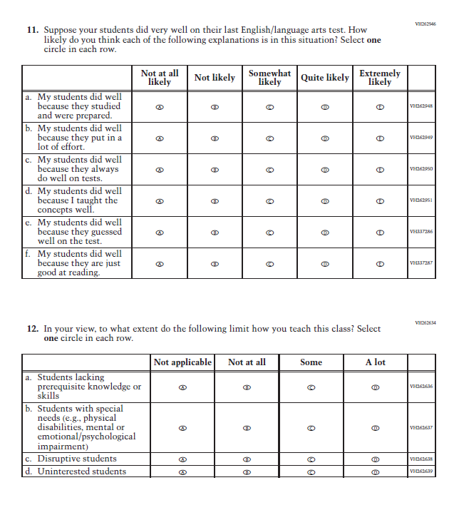

Appendix J2-13: Summary of Changes Operational Grade 8 Social Studies
2021 Operational Grade 8 Social Studies Teacher
Previous item | 2021 item | D/A/ R/NC+ | Rationale
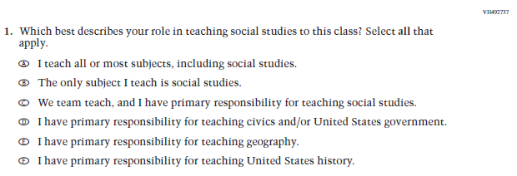  (2018 Grade 8) | Issue: Resources for Learning and Instruction | NC | N/A
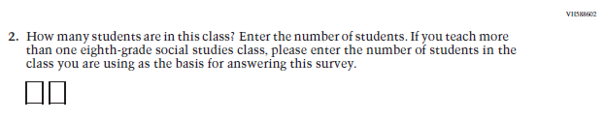  (2018 Grade 8) | Issue: Resources for Learning and Instruction | NC | N/A
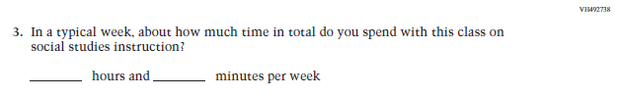  (2018 Grade 8) | Issue: Resources for Learning and Instruction | NC | N/A
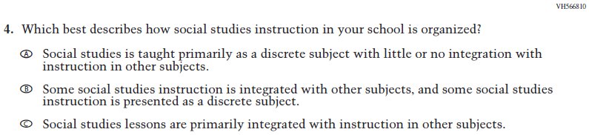  (2018 Grade 8) | Issue: Organization of Instruction | NC | N/A
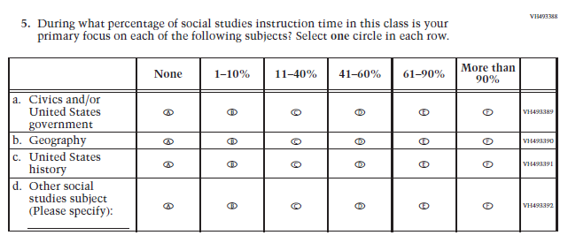  (2018 Grade 8) | Issue: Resources for Learning and Instruction | NC | N/A
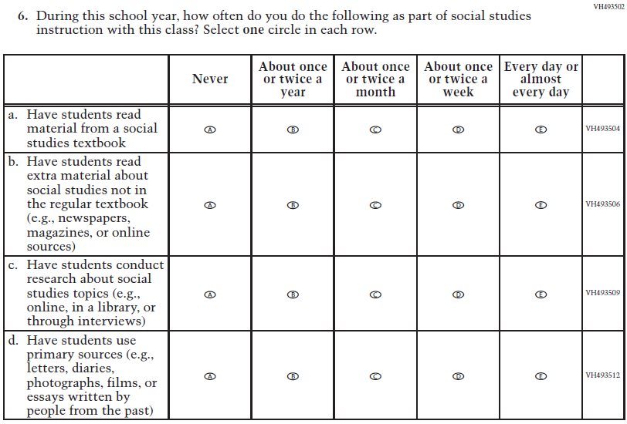  (2018 Grade 8) | Issue: Organization of Instruction | NC | N/A
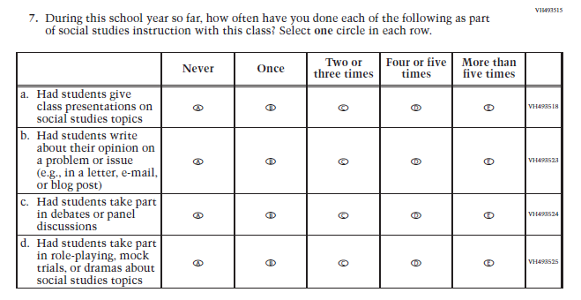  (2018 Grade 8) | Issue: Organization of Instruction | NC | N/A
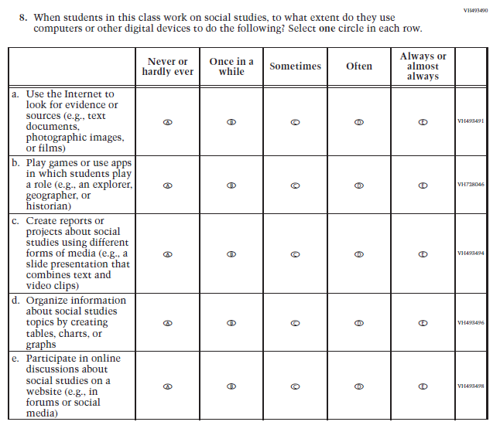  (2018 Grade 8) | Issue: Organization of Instruction | NC | N/A
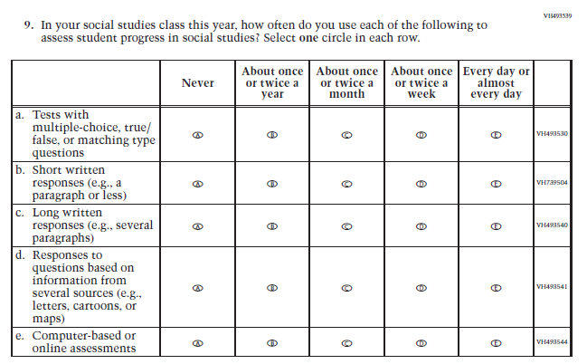  (2018 Grade 8) | Issue: Organization of Instruction | NC | N/A
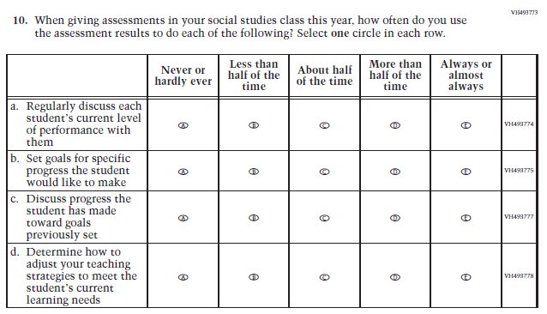  (2018 Grade 8) | Issue: Organization of Instruction | NC | N/A
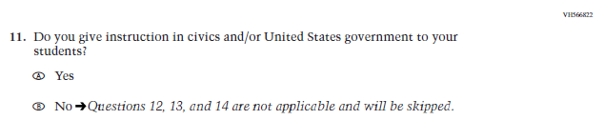  (2018 Grade 8) | 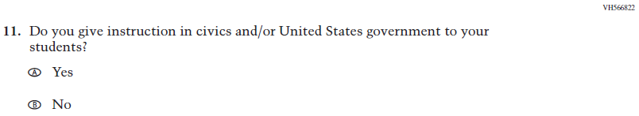  Issue: Organization of Instruction | NC | Please note skip pattern directions have been removed given the transition from PPT to DBA.
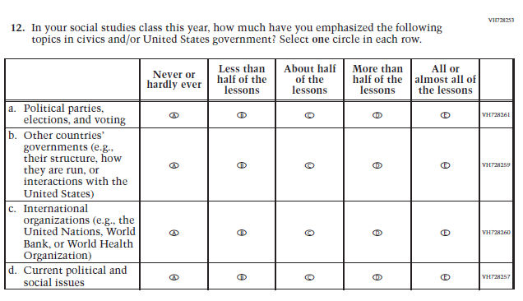  (2018 Grade 8) | Issue: Organization of Instruction | NC | N/A
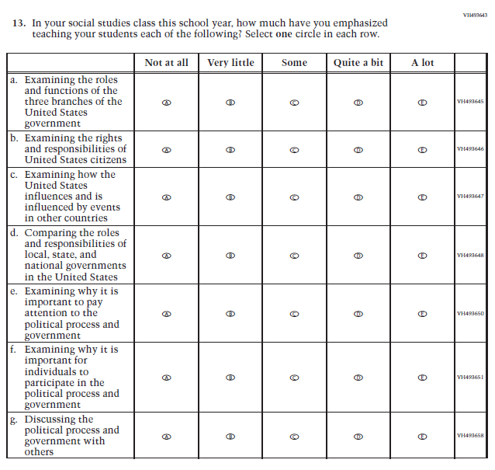  (2018 Grade 8) | Issue: Organization of Instruction | NC | N/A
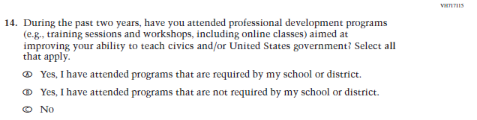  (2018 Grade 8) | Issue: Teacher Preparation | NC | N/A
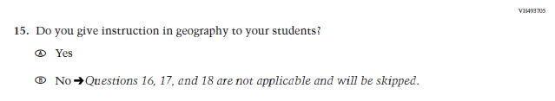  (2018 Grade 8) | N/A | D | The item was dropped because geography will not be administered in 2021.
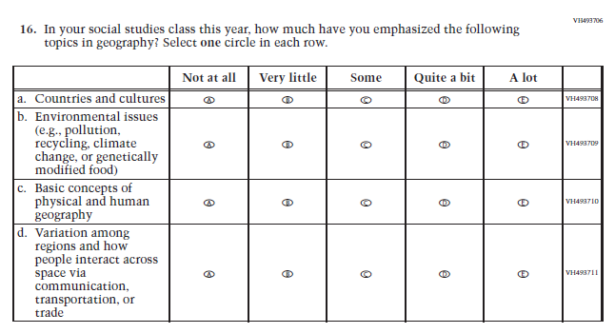  (2018 Grade 8) | N/A | D | The item was dropped because geography will not be administered in 2021.
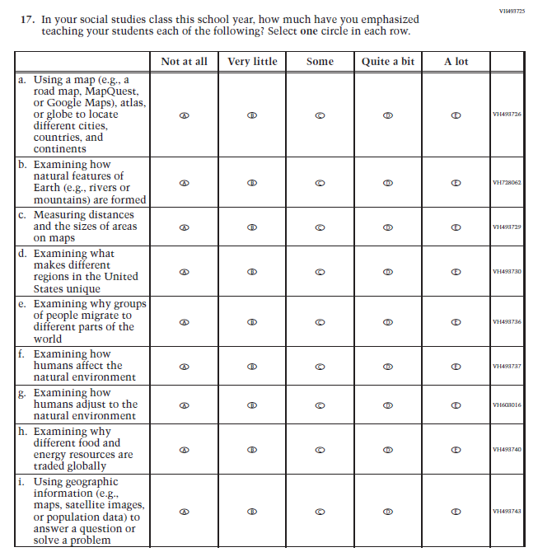  (2018 Grade 8) | N/A | D | The item was dropped because geography will not be administered in 2021.
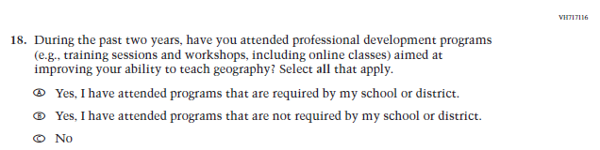  (2018 Grade 8) | N/A | D | The item was dropped because geography will not be administered in 2021.
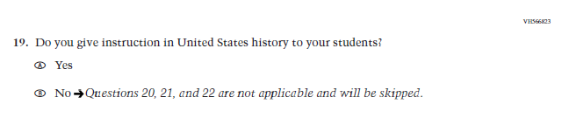  (2018 Grade 8) | 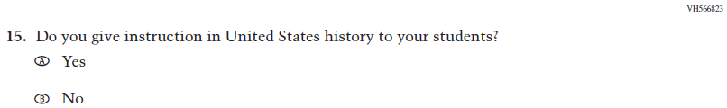  Issue: Organization of Instruction | NC | Please note skip pattern directions have been removed given the transition from PPT to DBA.
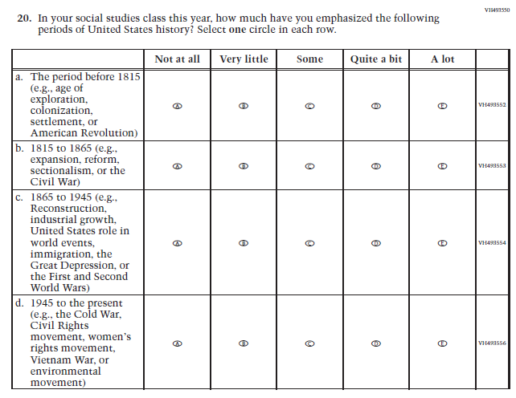  (2018 Grade 8) | 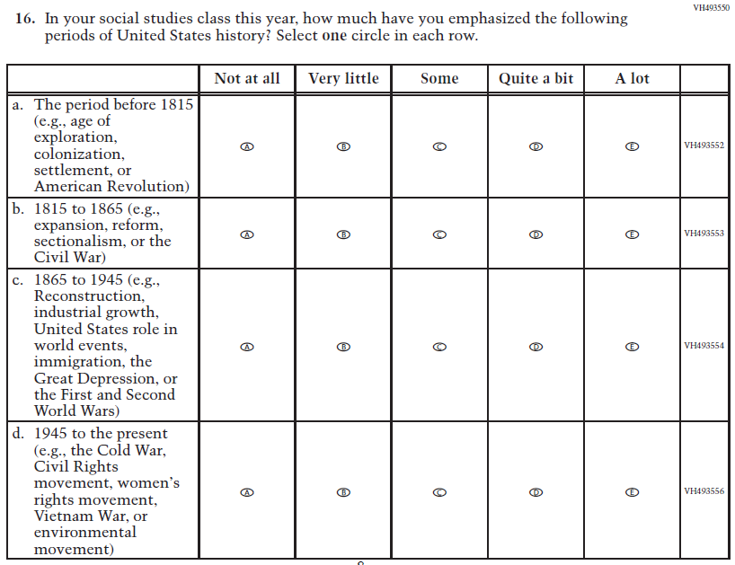  Issue: Organization of Instruction | NC | N/A
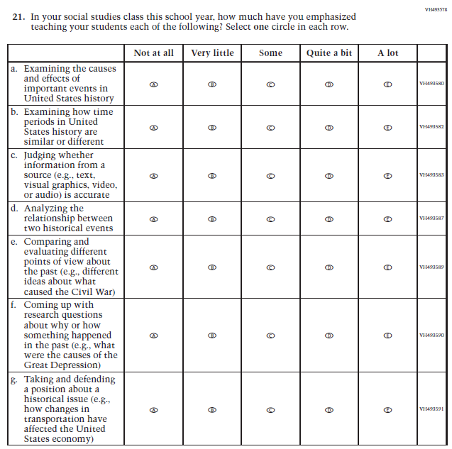  (2018 Grade 8) | 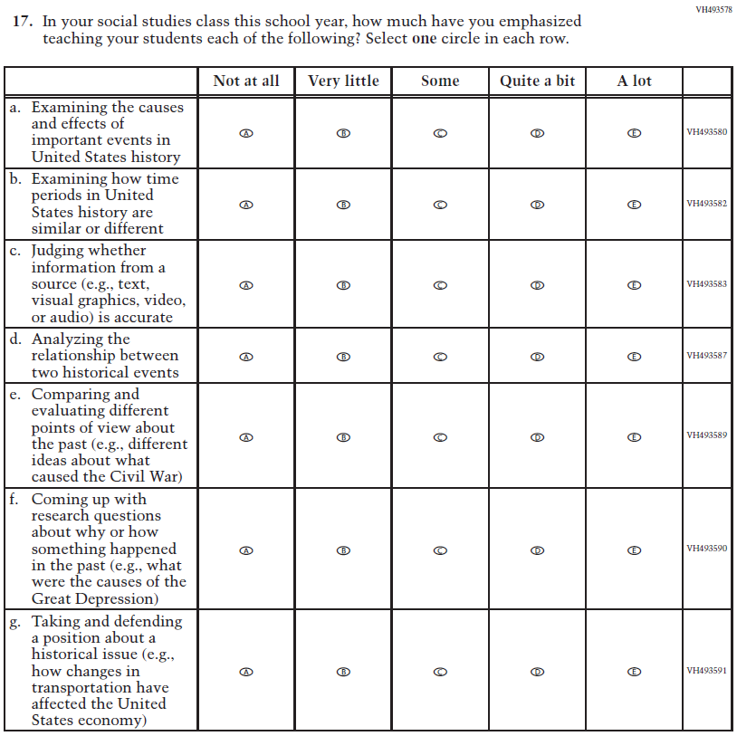  Issue: Organization of Instruction | NC | N/A
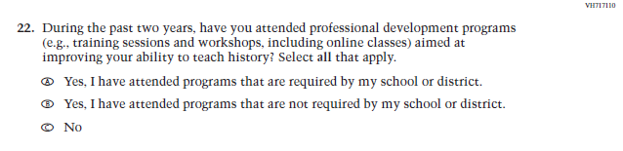  (2018 Grade 8) | Issue: Teacher Preparation | NC | N/A
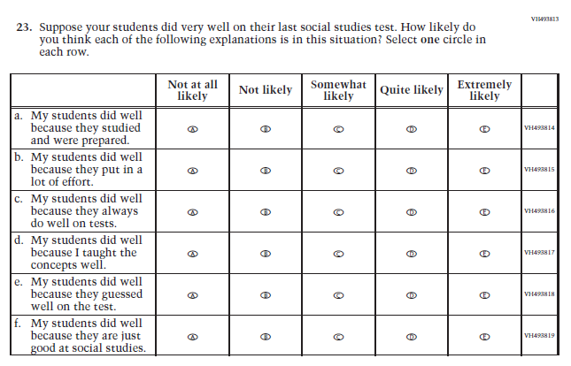  (2018 Grade 8) | 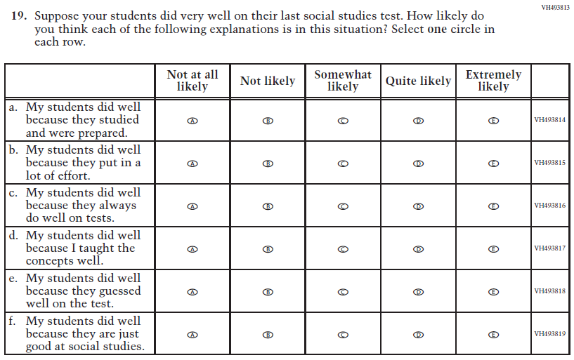  Issue: Teacher Preparation | NC | N/A

Appendix J2-14: Operational Grade 8 Social Studies
