OMB Control No. 1505-0164
Reporting, Procedures and Penalties Regulations
Justification for Card Format for Blocked or Rejected Financial Transactions

This justification is submitted to request approval of a non-substantive change to the information collection authority pertaining to the Office of Foreign Assets Control’s (OFAC) Reporting, Procedures and Penalties Regulations (31 CFR part 501) (the Regulations). To reduce burden on certain business and to facilitate compliance with existing OFAC reporting requirements for blocked and rejected transaction reports pursuant to §§ 501.603 and 501.604 of the Regulations, OFAC is planning to issue a “Card” format option (called Card Format for Blocked or Rejected Financial Transactions) for reporting blocked and rejected transactions in mid-August 2020 pending approval of this information collection authority by the Office of Management and Budget (OMB). The Card format (which contains 25 fields) is a shorter version of the existing form for blocked and rejected financial transactions (which contains 31 fields) with some different terms used that more closely align with the credit card processing industry to facilitate their ability to identify and report the information required. The collections of information relevant to this request are contained in §§ 501.603 and 501.604 of the Regulations, and pertain to the operation and implementation of various economic sanctions programs administered by OFAC under 31 CFR chapter V.

Section 501.603 of the Regulations imposes reporting requirements pertaining to blocked property and retained funds, as well as property that is released from blocked status (unblocked property). Section 501.604 of the Regulations requires the filing of reports for compliance purposes by U.S. persons where a transaction is not required to be blocked but where processing or otherwise engaging in the transaction would nonetheless violate, or facilitate a transaction that is prohibited under, other provisions in 31 C.F.R. chapter V. All U.S. persons are currently required to make individual reports on property that they have blocked or transactions they have rejected within 10 days from the blocking or rejection, and are also required to report on an annual basis all blocked property under their control. Current information is required for the purpose of compiling the Department of the Treasury’s congressionally mandated annual report on terrorist assets as well as for U.S. national security and foreign policy purposes concerning negotiations with impacted countries or sanctions targets, when applicable.

OFAC utilized feedback it received from credit card companies to develop a “Card” format to help the card processing industry (e.g., credit and debit cards) to identify and more easily report to OFAC information required by §§ 501.603 and 501.604 of the Regulations when blocking or rejecting such transactions. OFAC had previously made available on its website the following two forms to assist persons in submitting blocked and reject reports: Form TD-F 93.02, Report on Blocked Property – Financial; and Form TD-F 93.07, Report on Rejected Transactions. The data fields for the “Card” format of these forms are functionally the same as the existing forms, but the terminology has some differences for card-related transactions. Below is a chart showing the newly created “Card” format fields and the equivalent field in the wire transfer context that is already reported, mainly using Forms TD-F 93.02, Report on Blocked Property – Financial, and Form TD-F 93.07, Report on Rejected Transactions.

Card-related fields | Wire transfer-related fields
Issuer | Originating Bank
Merchant Name | Beneficiary
Acquirer Name | Beneficiary Bank
Card Number | Sender Reference Number / Bank Reference Number

Note that persons are required to report to OFAC under § 501.603(b)(1) and (b)(2) and § 501.604 of the Regulations but are not required to use these forms when submitting the required reports. OFAC is providing these forms, including the “Card” format option, to streamline and simplify the identification and reporting process for submitters. OFAC expects the compliance burden to slightly decrease for credit card companies and those who issue and process card transactions through the use of this new format “Card” format.

APPENDIX

Card Format for Blocked or Rejected Financial Transactions

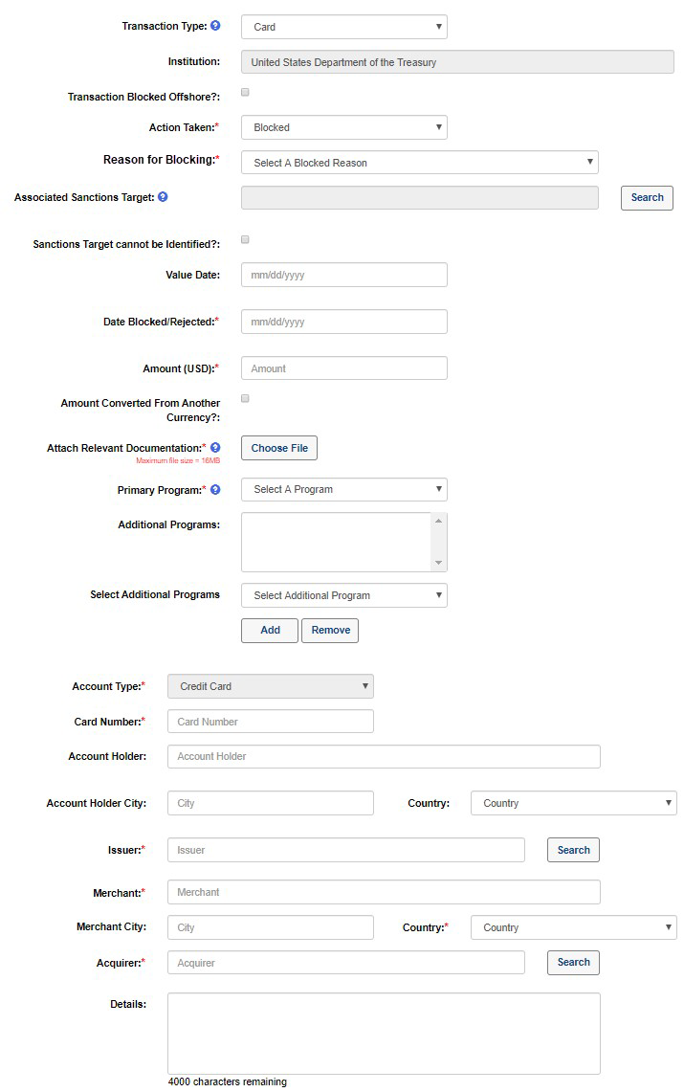

See Appendix - Report Form for Blocked or Rejected Card Transactions

