Supporting Statement A

OAT Telehealth Outcome Measures

OMB Control No. 0915-0311

Revision

- Justification

- Circumstances Making the Collection of Information Necessary

The Health Resources and Services Administration’s (HRSA) Federal Office of Rural Health Policy (FORHP), Office for the Advancement of Telehealth (OAT) is requesting the Office of Management and Budget’s (OMB) continued approval for telehealth outcome measures of the telehealth grantees. Specifically, we are asking for continued approval to use a performance measurement tool to collect data from grantees receiving funds under the Telehealth Network Grant Program.

The Telehealth Network Grant Program is authorized by Section 330I of the Public Health Service Act. The Health Care Safety Net Amendments of 2002 (Public Law 107-251) amended the Public Health Service Act by adding Section 330I. Under this authority, grants may be awarded to eligible entities to develop telehealth network projects in rural areas, in medically underserved areas, in frontier communities, and for medically underserved populations, to (a) expand access to, coordinate, and improve the quality of health care services; (b) improve and expand the training of health care providers; and (c) expand and improve the quality of health information available to health care providers, and patients and their families. The primary objective of the Telehealth Network Grant Program is to help communities build the human, technical, and financial capacity to develop sustainable telehealth programs and networks. The data collected with the performance measurement tool provides HRSA’s OAT with information about outcome measures including the effectiveness of service programs and monitor their progress through the use of performance reporting data. In addition, the data collected from grantees meets the administrative requirement of assessing programs via the Government Performance Review Act of 1993 (GPRA).

The Telehealth Network Grant Program (TNGP) awards demonstration grants to networks that show how telehealth technologies can expand access to quality healthcare; improve and expand training of healthcare providers; and expand and improve the quality of health information available to providers and patients. Because the primary focus of the program has been to fund grantees to build and demonstrate the usefulness and financial viability of telehealth systems in providing health care, this tool provides the needed measures to determine the program's impact on clinical outcomes. As required by GPRA, all federal agencies must develop strategic plans describing their overall goal and objectives. HRSA’s OAT has worked with its grantees to develop performance measures to be used to evaluate and monitor the progress of the grantees. Specific categories were designed to be reported through a performance monitoring website.

The HRSA’s OAT was established in 1998 with the mission to lead, coordinate and promote the use of telehealth technologies by fostering partnerships within HRSA and other Federal agencies, states and private sector groups to expand the field of telehealth by: administering telehealth grant programs; providing technical assistance; assessing technology investment strategies; developing distance learning and training programs for health care providers; evaluating the use of telehealth technologies; developing telehealth policy initiatives to improve access to quality health services; and promoting knowledge about “best practices.” HRSA envisions the use of telehealth technology playing an integral role in facilitating linkages between health care institutions over distance to improve access to quality health care services in this nation and provide educational opportunities or those who would otherwise not have or would have difficulty accessing such opportunities. OAT is the operational focal point within HRSA’s Federal Office of Rural Health Policy for advancing the cost-effective use of telehealth technologies throughout the agency. OAT is responsible for allocating and administering funds, evaluating programs and their impact on the population served, and improving the quantity and quality of care. The data collection tool extracts valuable information on services provided that are critical to the mission of HRSA and provides valid and complete information about methods used to measure the impact of the telehealth program on improving access to healthcare services for residents of communities that did not have such services locally before the program. Projects are able to measure the impact of the telehealth program on rural hospitalization rates and emergency room visit rates per year for patients receiving disease management services for diabetes, congestive heart failure, stroke and other chronic diseases, as well for patients receiving home care/home monitoring services. Projects can measure impact of the telehealth program on controlling blood glucose levels in diabetic patients and can assure the impact of the telehealth program improving efficiency of health care. In addition, projects also measure the impact of the telehealth program on reducing medical errors and collect data to measure other clear outcomes.

Additionally, the performance measurement tool allows OAT to:
  - Fulfill obligations for GPRA requirements and to report to Congress on impact of the OAT Telehealth Network Grant Program;
  - justify budget requests;
  - create a data-reporting tool for grantees to report on their projects’ performance relative to the mission of OAT/HRSA as well as individual goals and objectives of the program;
  - collect uniform, consistent data which enables OAT to monitor programs;
  - provide guidance to grantees on important indicators to track over time for their own internal program management;
  - identify topics of interest for future special studies;
  - identify changes of healthcare needs to rural communities allowing programs to shift focus in order to meet those needs, thereby improving access to needed services;
  - reduce rural practitioner isolation;
  - improve health system productivity and efficiency; and
  - enhance quality of care.

For FY20, the TNGP aimed towards promoting rural Tele-emergency services with an emphasis on tele-stroke, tele-behavioral health, and Tele-Emergency Medical Services (Tele-EMS). This will be achieved by enhancing telehealth networks to deliver 24-hour Emergency Department (ED) consultation services via telehealth to rural providers without emergency care specialists.
TNGP recipients will support a range of Tele-emergency service programs that will allow for the analysis of a significant volume of patient encounters. The goal is for each TNGP recipient to analyze the provision of Tele-emergency services under common metrics and protocols that will allow for a multi-site analysis of the effectiveness of those services. As a result, a common set of measures are being implemented, for this effort, which will inform future policy changes and sustainability efforts.

For this information collection request, OAT is requesting a revision of existing telehealth measures to better capture data at the patient and setting level for a number of specialties, more specifically, behavioral and mental health services (see highlights on attached instrument). In addition, OAT will add new measures that focus on Tele-Emergency services that serve rural Emergency Departments as the new focus of the grant program emphasizes support for this setting.

- Purpose and Use of Information Collection

In order to evaluate existing programs, data are obtained from the OAT Performance Improvement Measurement System (PIMS), which can be accessed thru HRSA’s Electronic Handbook (EHB). The data are used to identify quality improvements, disparities in health care, health status and clinical outcome measures. The tool is also used to address GPRA initiatives. This system provides the government, health centers, patients, general academic and constituent communities with critical information on health care issues that directly affect rural, minority and under-served populations.

During the reporting periods, data are reported for the previous 12 months of activity. Programs have approximately six weeks to enter their data into HRSA’s Electronic Handbook (EHB).

The instrument was developed with the following four goals in mind:

- improving access to needed services,
- reducing rural practitioner isolation,
- improving health system productivity and efficiency, and
- improving patient outcomes.

For each of these categories, specific indicators were designed and data are reported regularly through a performance monitoring website. In addition to providing the required GPRA data, OAT uses the reported information to demonstrate the "value-added" that telehealth services contribute to improving health care. OAT has incorporated these performance assessment tools into the routine reporting required as part of the annual reports required of their grantees.

All grantees are asked to address access to telehealth technologies at their respective institutions. Telehealth activities include the practice of telemedicine, delivery of distance education in allied health fields health informatics, health care staff supervision from remote sites, and the provision of consumer health information using telecommunications technologies. Grantees will be asked to provide network members or satellite site information. In addition, the data collection tool for the FY20 TNGP recipients will collect uniform measures data using an EXCEL spreadsheet tool. Each TNGP recipient will serve as a data coordinating center for their participating rural settings. These TNGP recipients forward their assembled data to FORHP through a secure data transfer arrangement.

User Level Data
  - A unique user identifier: Each grantee selects a member from the organization to submit data into PIMS. The selected staff member is assigned a unique EHB login and password code to access the system.
  - Configuration: This feature allows participants to establish sites, specialties and settings. Participants can update information when necessary.
Specialties and Services
This allows participants to report the number of encounters by specialty/service, by patient care setting and by the type of telemedicine encounter.

Specialty Areas: This allows users to indicate the medical specialties and services provided through their telehealth system for the current reporting period.

Settings Include:
- Community or migrant health centers or other Federally Qualified Health Centers.
- Health care providers, including pharmacists, in private practice.
- Entities operating clinics, including rural health clinics.
- Local health departments.
- Nonprofit hospitals, including community access hospitals.
- Other publicly funded health or social service agencies.
- Long-term care providers.
- Providers of health care services in the home.
- Providers of outpatient mental health services and entities operating outpatient mental health facilities.
- Local or regional emergency health care providers.
- Institutions of higher education.
- Entities operating dental clinics.
- Rural emergency departments (ED).
- Emergency medical services (EMS) that serve rural populations and ambulances that serve rural entities.

Encounter Types:
- Interactive/Real-Time Encounters: Encounters done in an interactive (real-time) video-conferencing format.
- Store-and-Forward: Encounters done in a format where information/images are gathered and sent electronically to be viewed at a later time by a telehealth provider; therefore, encounters are not interactive and not in real-time.

Service Availability in Remote Communities

Participants are asked to report information about the availability of services in the community. Specifically, they are asked to report whether a specialty/service is available in the community, whether a visiting specialist provides the service regularly, whether their OAT telemedicine program offers the services to the site, and whether another telemedicine program offers the service/specialty. Participants indicate how far one would have to drive from the community to see a specialist in-person.

Patient Travel

Users measure patient travel that is ‘saved’ or avoided through the use of telemedicine. Distance is measured by both miles and time from the patient’s location to where the patient could receive health services in the absence of telehealth. For group sessions/clinics, each patient is counted separately, as each would have had to travel for those sessions.

- Use of Improved Information Technology and Burden Reduction

The OAT PIMS tool is fully electronic within HRSA’s Electronic Handbook. The system design provides pre-formatted and interactive data entry that helps assure standardized data across the Telehealth Network Grant Programs and greatly simplifies the data entry process. The grantee provides sites and services information and the system only generates forms based on this data. Patient travel, chronic disease, dermatology and homecare information will be in spreadsheet format. The worksheets collect specific information about each service provided. Calculations in the spreadsheets are fully automated. Drop down menus are also used to simplify selections. Instructions are attached to each individual worksheet.

- Efforts to Identify Duplication and Use of Similar Information

Data of the type required to evaluate or monitor the telehealth program are not available elsewhere. The information is not intended to reflect all telemedicine activity nationwide; it reflects only the activity of the telemedicine programs funded by HRSA’s OAT. As such, this gives an indication of telemedicine programs and services, but not the total volume of this activity nationwide. The OAT PIMS tool is necessary for the program to monitor the objectives that the funding initiative is designed to meet.

- Impact on Small Businesses or Other Small Entities

This project does not significantly impact small business or small entities.

- Consequences of Collecting the Information Less Frequently

Without annual reporting on the use of Telehealth Network Grant Program funds, HRSA’s OAT would not be able to carry out its responsibility to oversee compliance with the intent of congressional appropriations in a timely manner. Because Telehealth is a critical component of health care, specifically in rural areas, annual reporting of the characteristics of the Public Health Service Act, Section 330I - Telehealth Network Grants is necessary to determine whether the administration of the funds is responding to the changes in the affected population(s).
If the information is not collected at all, HRSA’s OAT will not be able to provide critical data that are needed to justify the GPRA, as mandated by OMB. The information being reported supports the following:

    - whether program funds are being spent for their intended purposes;
    - what types of and how many individuals are receiving services;
    - whether telehealth expands access to, coordinates, and improves the quality of health care services
    - whether telehealth enhances telehealth networks to deliver 24-hour Emergency Department (ED) consultation services via telehealth to rural providers without emergency care specialists
    - whether there is an increase in the number of communities that have access to pediatric and adolescent, and adult mental health services where access did not exist in the community prior to the Telehealth Network Grant Program;
    - whether there is an increase in the number of services and/or sites that provide access to health care as a result of the Telehealth Network Grant Program per federal program dollar expended.
    - helps build telehealth’s evidence base and determine if it is effective in serving rural emergency departments, particularly in regards to access, quality, and cost effectiveness.

- Special Circumstances Relating to the Guidelines of 5 CFR 1320.5

The data is being collected in a manner fully consistent with the guidelines in 5 CFR 1320.5.

- Consultation Outside the Agency

A 60-day Federal Register Notice was published in the Federal Register on Thursday, March 26, 2020, vol. 88, No. 59; pp. 17089. There were no public comments.

OAT consulted and shared the reporting instructions, and measures for the monitoring system, with current grantees providing telemedicine services to their communities. Their expertise was crucial in identifying key performance measures/indicators to be used to evaluate and monitor the progress of the program, specifically for rural clinical settings in high poverty areas. The representatives provided advice/input during 2019. The names of these individuals are listed in the table below.

Name | Location |  | Address/Phone Number
Donna Dittman Hale | Bay Rivers Telehealth Alliance  Tappahannock, VA |  | Executive Director  Bay Rivers Telehealth Alliance  The Area Health Education Center for the Rappahannock Region  Tappahannock, Virginia
Sarah Wovcha, JD, MPH | Children’s Dental Services  Minneapolis, MN |  | Executive Director  Children’s Dental Services  636 Broadway St NE  Minneapolis, MN 554132164  swovcha@msn.com
Ági Erickson | Community Health Center, Inc.  Middletown, CT |  | Director of Project ECHO  Weitzman Institute  Phone: 860.347.6971 Ext. 3741;  Agi@chc1.com  http://weitzmaninstitute.org
Jill Jennings, RDN, LDN | East Carolina University  Greenville, NC | Healthier Lives Project Coordinator  East Carolina University, Brody School of Medicine  Department of Family Medicine, Research Division  101 Heart Drive  Greenville, NC 27834  (252) 744-0089  JENNINGSJ@ECU.EDU
Mary Leppert, MD | Kennedy Krieger Children’s Hospital  Baltimore, MD | Assistant Professor of Pediatrics  Johns Hopkins School of Medicine Director,  Center for Development and Learning, Kennedy Krieger Institute  Physician, Division of Neurology and Developmental Medicine  Kennedy Krieger Institute  801 N. Broadway  Baltimore, MD 21205  Phone: (443) 923-3252  leppert@kennedykrieger.org
Kathy Hsu Wibberly, PhD | Rector and Visitors of the University of Virginia  Charlottesville, VA | Director, Mid-Atlantic Telehealth Resource Center  Karen S. Rheuban Center for Telehealth, University of Virginia  P.O. Box 800711  Charlottesville, VA 22908-0711  Kathy.Wibberly@virginia.edu
Eve-Lynn Nelson, PhD | University of Kansas Medical Center Research Institute  Fairway, KS | Director, Center for Telemedicine & Telehealth  Professor, Pediatrics  University of Kansas Medical Center  enelson2@kumc.edu  (913) 588-2413

Kari B. Law, MD | West Virginia University  Morgantown, WV | Assistant Professor, Adult, Child & Adolescent, & Forensic Psychiatry  Director, Telepsychiatry  West Virginia University  Department of Behavioral Medicine  930 Chestnut Ridge Road  Morgantown, WV 26505  (304) 293-5181 - office  klaw@hsc.wvu.edu

- Explanation of any Payment/Gift to Respondents

Respondents will not be remunerated.

- Assurance of Confidentiality Provided to Respondents

The OAT PIMS does not require any information that could identify individual clients. Names and personal identifiers will not be included in an aggregate data report. All reports and tabulated data that will be released to the general public will be summaries of information across grantees.

- Justification for Sensitive Questions

There are no questions of a sensitive nature collected through the OAT PIMS. No patient or client-level identifying data will be reported. Identification of the grantees as recipients of telemedicine funds is a matter of public record, as these recipients receive funds directly from HRSA.

12A. Estimated Annualized Burden Hours

The average annual burden hours of 203 are displayed in the table below. The estimate is based on trials regarding the amount of time it would take to review and complete data entry.

Form | Number of Respondents | Responses per Respondent | Total Responses | Hour Burden | Total Burden Hours
Performance Improvement Measurement System (PIMS) | 29 | 1 | 29 | 7 | 203

12B. Estimated Annualized Burden Costs
Estimated Annualized Burden Costs

Type of  Respondent | Total Burden  Hours | Hourly  Wage Rate | Total Respondent Costs
Nursing, Psychiatric and Home Health Aides | 128 | $24.62 | $3,151
Medical Records and Health Information Technicians | 75 | $37.66 | $2,825
Total | 203 |  | $5,976
Total Respondent Costs include fringe benefits and overhead of 2%.
- Estimates of other Total Annual Cost Burden to Respondents or Recordkeepers/Capital Costs
There are no capital or startup costs for respondents related to this effort.
- Annualized Cost to Federal Government

The cost of the contract to collect the information is $50,000. A Grade 13 Federal employee with a salary of $102,663 will work on this project 15% of the time for $15,399.45. Therefore, the total annual cost to the Federal Government is $65,399.45.

- Explanation for Program Changes or Adjustments

There is currently 147 hours of burden in the inventory. This package is requesting 203 hours. The estimated number of respondents is increasing from 21 to 29 due to a larger appropriation of grant dollars in FY2020 to support more recipients.

The number of respondents increased as a result of the TNGP new initiative to focus telehealth support for rural hospitals. In previous reporting periods, the TNGP supported all major healthcare settings and clinical services.

- Plans for Tabulation, Publication, and Project Time Schedule

The OAT data web application that grantees access was migrated into HRSA’s EHB immediately following OMB’s initial approval of this information collection request.

As a result of the application, grantees have been submitting their data, that corresponds to the GPRA measures, on a semi-annual basis. The first data submission occurred in 2002. Since then, grantees have provided data on a variety of service and outcome measures related to access, travel miles saved, diabetes, and other chronic disease conditions. A HRSA contractor published an instruction manual for the PIMS tool, and currently provides grantees with technical assistance support for the application as they complete and submit their OAT data reporting requirements. Data was last published in January 2013, documenting aggregate data captured during years 2004-2010.

17. Reason(s) Display of OMB Expiration Date is Inappropriate

The expiration date will be displayed.

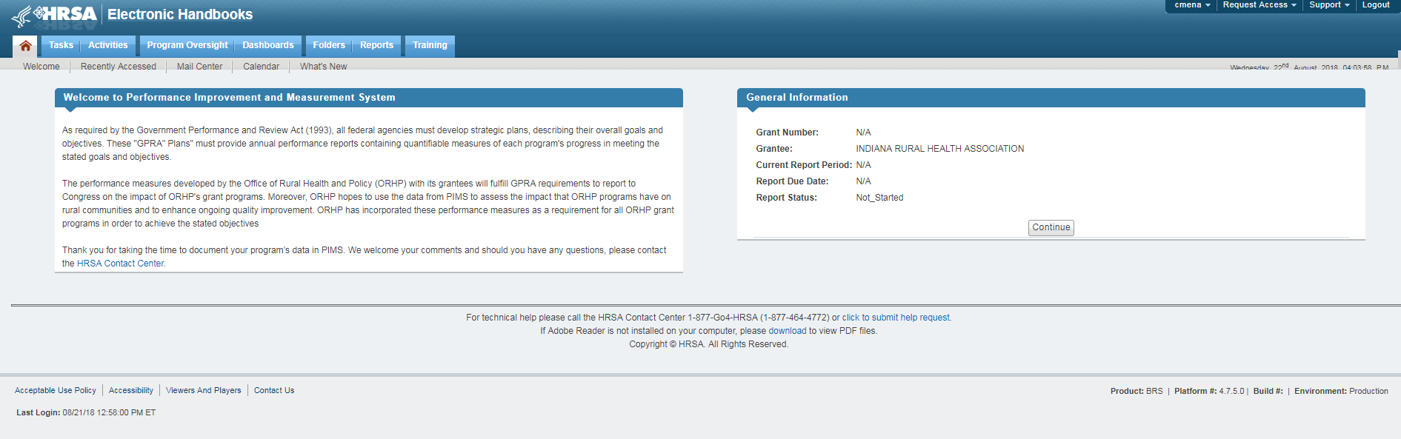

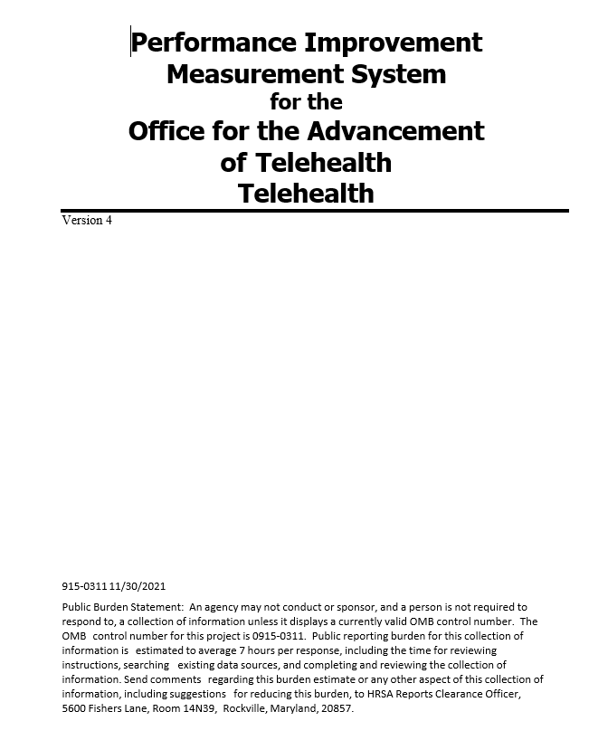

18. Exceptions to Certification for Paperwork Reduction Act Submissions

There are no exceptions to the certification.

GPRA is a law that passed in 1993 which requires that federally funded agencies develop and implement an accountability system based on performance measurement including setting goals and objectives and measuring progress toward achieving them.
The EHB allows business processes such as grants management to be broken down into discrete role-based handbooks. The EHB contains electronic forms that can be used in real-time.
U.S. Office of Personnel Management: 2020 General Schedule (GS) Locality Pay Table for the locality pay area of Washington-Baltimore-Arlington, DC-MD-VA-WV-PA https://www.opm.gov/policy-data-oversight/pay-leave/salaries-wages/salary-tables/pdf/2020/DCB.pdf

