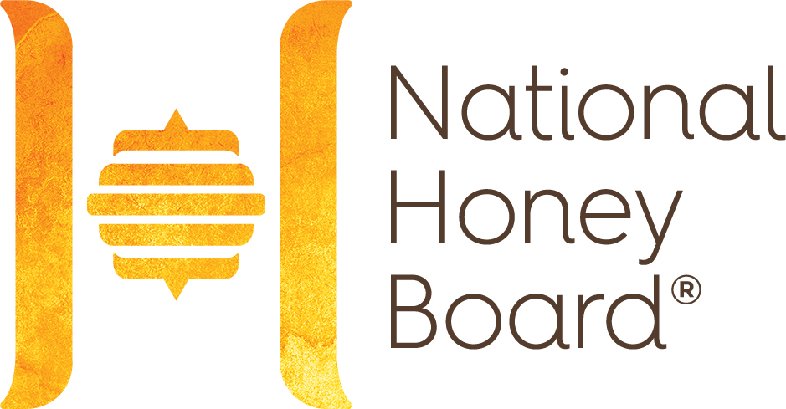

CONFIDENTIAL QUESTIONNAIRE

Use an estimate of pounds for the past 2 years to complete this questionnaire.

Company Name: ____________________________________________________________________

- Who in your organization is responsible for maintaining the records for honey purchases?

Name: ___________________________________ Title: ______________________________

Email Address: _________________________________

- Approximately how many pounds of honey did you sell in each of the past 2 years?

Year/Pounds____________________________Year/Pounds___________________________

- Do you produce your own honey and package it for sale? _________ (Yes or No)

3a. Approximately how many pounds of honey did you produce in each of the past 2 years?

Year/Pounds________________________Year/Pounds_________________________

- Approximately how many pounds of honey did you purchase in each of the past 2 years?

Year/Pounds___________________________Year/Pounds____________________________

- Do you import honey or honey products directly as the importer of record? _________ (Yes or No)

5a. If so, approximately how many pounds of honey or honey products did you import directly in each of the past 2 years?

Year/Pounds________________________Year/Pounds_________________________

- Do you buy imported honey through a broker or other agency? ___________ (Yes or No)

6a. If so, approximately how many pounds of honey did you import through a broker or agency in each of the past 2 years?

Year/Pounds________________________Year/Pounds_________________________

HON-HIQ (Expiration Date XX/XX/20XX) Page 1 of 3

- Do you buy bulk honey from another honey packer? ___________ (Yes or No)

7a. If so, approximately how many pounds of bulk honey did you purchase from other honey packers in each of the past 2 years?

Year/Pounds________________________Year/Pounds_________________________

- Do you buy already packaged honey from another honey packer? _________ (Yes or No)

8a. If so, approximately how many pounds of packaged honey did you buy from other honey
packers in each of the past 2 years?

Year/Pounds________________________Year/Pounds_________________________

- Which best describes your organization (check all that apply)?

_____I produce honey and package it for sale.
_____I produce and purchase honey and package it for sale.
_____I don’t produce honey, but I buy it in bulk to pack for sale.
_____I don’t produce honey, but I buy it in bulk to use in other products.
_____I import honey (directly or indirectly).
_____I produce, import, and pack honey.
_____I buy already packaged honey for resale.
_____Other_____________________________________________________________________

_______________________________________________________________________________

_______________________________________________________________________________

PLEASE Return to xx@nhb.org or mail to:
National Honey Board
Street Address
City, State Zip

We appreciate your time completing this voluntary questionnaire.
All information provided is held in confidence by the National Honey Board.

HON-HIQ (Expiration Date XX/XX/20XX) Page 2 of 3

NOTE: According to the Paperwork Reduction Act of 1995, an agency may not conduct or sponsor, and a person is not required to respond to a collection of information unless it displays a valid OMB control number. The valid OMB control number for this information collection is 0581-0093. The time required to complete this information collection is estimated to average 15 minutes per response, including the time for reviewing instructions, searching existing data sources, gathering and maintaining the data needed, and completing and reviewing the collection of information.

In accordance with Federal civil rights law and U.S. Department of Agriculture (USDA) civil rights regulations and policies, the USDA, its Agencies, offices, and employees, and institutions participating in or administering USDA programs are prohibited from discriminating based on race, color, national origin, religion, sex, gender identity (including gender expression), sexual orientation, disability, age, marital status, family/parental status, income derived from a public assistance program, political beliefs, or reprisal or retaliation for prior civil rights activity, in any program or activity conducted or funded by USDA (not all bases apply to all programs). Remedies and complaint filing deadlines vary by program or incident.

Persons with disabilities who require alternative means of communication for program information (e.g., Braille, large print, audiotape, American Sign Language, etc.) should contact the responsible Agency or USDA’s TARGET Center at (202) 720-2600 (voice and TTY) or contact USDA through the Federal Relay Service at (800) 877-8339. Additionally, program information may be made available in languages other than English.

To file a program discrimination complaint, complete the USDA Program Discrimination Complaint Form, AD-3027, found online at http://www.ascr.usda.gov/complaint_filing_cust.html and at any USDA office or write a letter addressed to USDA and provide in the letter all of the information requested in the form. To request a copy of the complaint form, call (866) 632-9992. Submit your completed form or letter to USDA by: 1) mail: U.S. Department of Agriculture Office of the Assistant Secretary for Civil Rights, 1400 Independence Avenue, SW., Washington, D.C. 20250-9410; 2) fax: (202) 690-7442; or 3) email: program.intake@usda.gov.

USDA is an equal opportunity provider, employer, and lender.

HON-HIQ (Expiration Date XX/XX/20XX) Page 3 of 3

