Reproduce locally. Include form number and date on all reproductions. Approved - OMB No. 0581-0093

U.S. DEPARTMENT OF AGRICULTURE AGRICULTURAL MARKETING SERVICE
DAIRY PROGRAMS

NOMINATION OF MILK PRODUCERS OR IMPORTERS TO SERVE ON THE NATIONAL DAIRY PROMOTION AND RESEARCH BOARD
(Under the Dairy Production Stabilization Act of 1983 and the Dairy Promotion and Research Order (7 CFR 1150.101 et seq.))

The Dairy Promotion and Research Order (Order) provides that producer and farm organizations, and importer and importer organizations may nominate milk producers or dairy product importers to serve on the National Dairy Promotion and Research Board. Each producer and importer organization may submit to the Secretary nomination(s) for each appointment to be made as defined in §1150.131 and §1150.133 of the Order in which the organization represents producers or importers. The nominee must be a milk producer located in the region such person is to represent, or a dairy product importer as defined in §1150.121 of the Order.

Attach a separate sheet if additional space is needed. Please submit a separate form for each nominee.
NAME OF NOMINEE
PLEASE IDENTIFY:

Producer Nominee -- Region number
Importer Nominee
If any nominee(s) is named as a result of a caucus of organizations representing milk producers in the same region or importers, identify the nominee(s) and list for each the
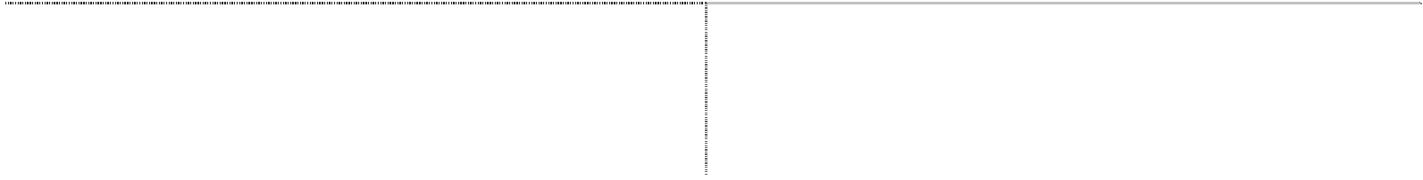
names and addresses of the organizations participating in the caucus.
NOMINEE(S) NAMES AND MAILING ADDRESSES OF ORGANIZATIONS

NAME AND MAILING ADDRESS OF ORGANIZATION SUBMITTING THIS NOMINATION FORM

NAME OF RESPONDING OFFICIAL (PRINT)
SIGNATURE
TITLE OF RESPONDING OFFICIAL (PRINT)
DATE

RETURN ORIGINAL TO: USDA, AMS, DAIRY PROGRAMS
PROMOTION AND RESEARCH BRANCH
Street
City, State, and Zip

According to the Paperwork Reduction Act of 1995, an agency my not conduct or sponsor, and a person is not required to respond to a collection of information unless it displays a valid OMB control number. The valid OMB control number for this information collection is 0581-0093. The time required to complete this information collection is estimated to average 30 minutes per response, including the time for reviewing instructions, searching existing data sources, gathering and maintaining the data needed, and completing and reviewing the collection of information.

In accordance with Federal civil rights law and U.S. Department of Agriculture (USDA) civil rights regulations and policies, the USDA, its Agencies, offices, and employees, and institutions participating in or administering USDA programs are prohibited from discriminating based on race, color, national origin, religion, sex, gender identity (including gender expression), sexual orientation, disability, age, marital status, family/parental status, income derived from a public assistance program, political beliefs, or reprisal or retaliation for prior civil rights activity, in any program or activity conducted or funded by USDA (not all bases apply to all programs). Remedies and complaint filing deadlines vary by program or incident.

Persons with disabilities who require alternative means of communication for program information (e.g., Braille, large print, audiotape, American Sign Language, etc.) should contact the responsible Agency or USDA’s TARGET Center at (202) 720-2600 (voice and TTY) or contact USDA through the Federal Relay Service at (800) 877-8339. Additionally, program information may be made available in languages other than English.

To file a program discrimination complaint, complete the USDA Program Discrimination Complaint Form, AD-3027, found online at http://www.ascr.usda.gov/complaint_filing_cust.html and at any USDA office or write a letter addressed to USDA and provide in the letter all of the information requested in the form. To request a copy of the complaint form, call (866) 632-9992. Submit your completed form or letter to USDA by: 1) mail: U.S. Department of Agriculture Office of the Assistant Secretary for Civil Rights, 1400 Independence Avenue, SW., Washington, D.C. 20250-9410; 2) fax: (202) 690-7442; or 3) email: program.intake@usda.gov.

USDA is an equal opportunity provider, employer, and lender.

