ICR Section 2
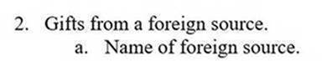
System:
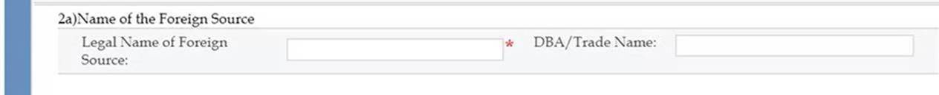
ICR Section 3
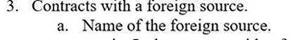
System:
ICR Section 3
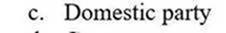
System:
ICR Section 4
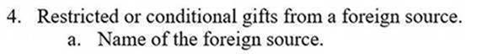
System:
ICR Section 5
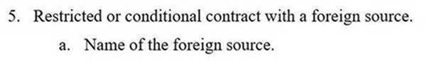
System (screenshots not yet available):

5a) Name of the Foreign Source
Legal Name: DBA/Trade Name:

