Justification for No Material Change

We have a need to add country field to this form to accommodate foreign entities.

Current:

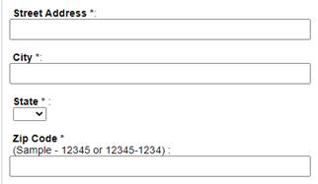

Suggested Design:

- Add Country field
- If Country = United States of America, no changes.
- If Country <> United States of America…thus a Foreign Address, then

