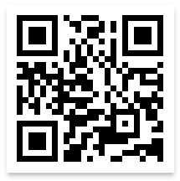

Questions? Want to request a paper questionnaire?
Telephone Helpline: 1-888-324-8337 (8 a.m. to 8 p.m. ET)
E-mail: nssatsweb@mathematica-mpr.com
STATE ID: [STATE ID]
[FAC NAME1]: [FAC NAME 2]
[LOCATION ADDRESS 1]
[LOCATION ADDRESS 2]
[CITY], [STATE] [ZIP]

Scan the QR Code Open the camera application on your smartphone and scan it over the QR code to get to the survey and enter your USER ID and PASSWORD.
USER ID:
PASSWORD:

Thank you in advance for your participation!
2nd Option

Complete the 2021 N-SSATS Online!
1st Option

Access the survey at: https://survey.nssats.com

Enter User ID and Password

