Instructions for RFG030X: Gasoline and Gasoline Blendstock Batch Summary Report

Who must report
Any of the following entities for each of its facilities must report on a per-batch basis for gasoline, gasoline blendstocks and ULSD with sulfur greater than 15 ppm.
- Gasoline manufacturers
- Transmix processors
- Oxygenate producers
- Certified pentane producers
- Certified pentane blenders
- Certified butane blenders
- Diesel manufacturers producing ULSD with sulfur greater than 15 ppm
A separate batch report must be submitted for each batch of product produced or imported during the averaging period.

Reporting requirements
- 40 CFR 1090 subpart J provides key requirements and reporting information (available at [link to ECFR.gov]).
- Page 2 of this document contains summary level reporting requirements by product type and parameter.
- Special Instructions for butane blending reporting – Butane reports are a combination of three reports with three separate batch IDs to include:
  - Butane batch – volume and properties of only the butane blendstock as received by the butane producer as shown in table 1
  - PCG + butane or the properties of the finished batch of gasoline as shown in table 1
- Special instructions for pentane blending reporting – Pentane reports are a combination of three reports with three separate batch IDs to include:
  - Pentane batch – volume and properties of only the pentane blendstock as received by the butane producer as shown in table 1
  - PCG + pentane or the properties of the finished batch of gasoline as shown in table 1
- Special instructions for diesel manufacturers producing ULSD with sulfur greater than 15 ppm
  - For any ULSD batch with a sulfur test result greater than 15 ppm, report the facility ID, production date, batch ID, batch volume and sulfur parameter test result
  - Enter “NA” for other gasoline specific parameters (i.e, RVP)

Reporting deadlines
- Entities shall report on all batches produced or imported by March 31st each year for the prior calendar year averaging period.

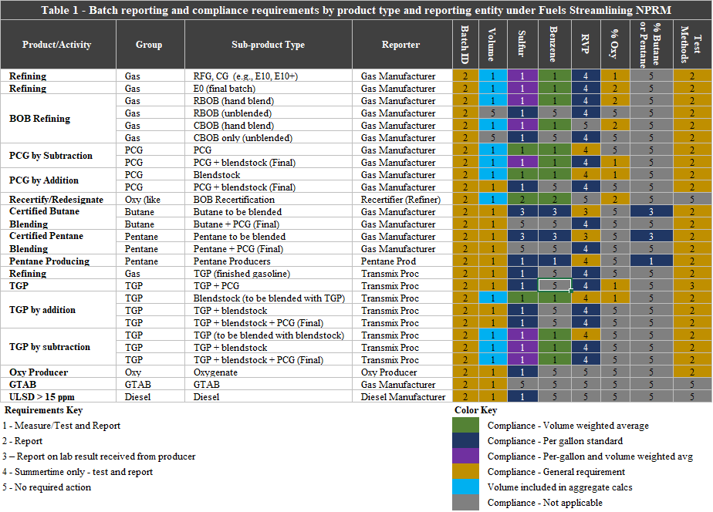

Field Instructions
Field No. | Field Name | Units | Field Formats, Codes & Special Instructions
1 | Report Form ID |  | AAAAAA; Character.  Enter RFG030#
2 | Report Type |  | A; Character. Specify if the data submitted in this report is original or if it is being resubmitted. Submit only one original report; any corrections or updates should be marked as a resubmission.  O = Original  R = Resubmission
3 | CBI |  | A; Character. Specify if the data contained within the report is claimed as Confidential Business Information (CBI) under 40 CFR Part 2, subpart B:  Y = Confidential Business Information  N = Non-Confidential Business Information
4 | Report Date |  | MM/DD/YYYY; Character. Enter the date the original or resubmitted report is created.
5 | Averaging/Compliance Period |  | YYYY; Character. Enter the averaging/compliance year the report covers.
6 | Reporter ID |  | AAAA; Character. Enter the EPA-assigned four-character ID of the submitter. This may be the company itself or a third party, such as an independent lab.
7 | Company ID |  | AAAA; Character. Enter the EPA assigned four-character ID for the refiner or importer that produced or imported the batch of gasoline.
8 | Reporting (or “Facility ID”)(alt. Compliance Level) |  | AAAAA; Character. Enter EPA-assigned five-character ID for the facility reporting ID. Include leading zeros as needed.
9 | Batch Number |  | AAAAAA; Character. The batch number assigned by the Refiner/Importer identifying the gasoline batch this report describes. This six digit batch number must form a unique identifier when combined with company ID, facility and averaging/compliance period (e.g., 4321-54321-2014-000001, 4321-54321-2014-000002, etc.), as described in 40 CFR 1090.##(#)(#). Please include leading zeros where applicable.
10 | Volume Type |  | AAA; Character. Enter the one appropriate volume type code from the following list.  Volumes reported with positive values  DOM = Any domestically produced batch volume  IMP = Any imported product  DBS = Any previously certified gasoline complying by addition  Volumes reported with negative values  PCG = Previously certified gasoline complying by subtraction  REC = Recertification of the BOB with less oxygenate  EXP = Exported Batch  Other Volume  ZER = Cancelled batch – zero volume
11 | Batch Volume | Gallons | + 999999999; Number. Production volume of the reported batch.  Positive batch volumes include volume types of DOM, IMP, DBS  Negative batch volumes include volume types EXP, REC, PCG  Zero batch volume include volume types ZER  BOB Product Type – This volume is the sum of the BOB volume and the oxygenate volume that the gasoline manufacturer specifies to be blended with the BOB.  If reporting a zero batch volume other than a cancelled batch, please provide additional detail in comments field
12 | Production Date |  | MM/DD/YYYY; Character. Date the reported batch was produced or imported.  For Gasoline manufacturers that recertify BOB to gasoline only – Enter the date the batch was recertified.
13 | Date PCG, Butane, or Pentane Batch Received |  | MM/DD/YYYY; Character. Enter date received for PCG, Butane, or Pentane.  -PCG received from another company or site - Enter the date the batch was received.  -PCG originating on-site - enter the date the PCG was designated to be used to produce a new batch of gasoline.  -Butane Blendstock – Date butane blendstock received  -Pentane Blendstock – Date pentane blendstock received  -Other Product Type - If the volume type is not PCG, butane, or pentane, enter “NA”.
14 | Product Type |  | AA; Character. Enter the one appropriate product  description code from the following list.  Reformulated gasoline:  RG = Reformulated Gas  RD = RBOB including oxygenate  RU = RBOB not including oxygenate  RP = Direct blendstock or complying by addition reporting for PCG  RQ = PCG batch after addition of blendstock or complying by addition reporting for PCG  BC = certified butane blended with PCG RFG/RBOB  PC = certified pentane blended with PCG RFG/RBOB  Conventional gasoline:  CG = Conventional Gasoline  CD = Conventional Gasoline Blendstock for Oxygenate Blending (CBOB) including oxygenate  CU = CBOB not including oxygenate  CP = Direct blendstock or complying by addition reporting for PCG  CQ = PCG batch after addition of blendstock or complying by addition reporting for PCG  BX = certified butane blended with PCG CG/CBOB  PX = certified pentane blended with PCG CG/CBOB  Oxygenate batches:  DE – Denatured ethanol using certified ethanol denaturant  DU – Denatured ethanol from non-certified denaturant  DO – Oxygenate other than ethanol  Other products:  DL = ULSD with sulfur greater than 15ppm  GT = Gasoline Treated as Blendstock (GTAB)  TB = Blendstock recovered from transmix and added to gasoline  PP = Pentane producer batch where pentane content is greater than or equal to 95 volume percent  PL = Pentane producer batch where pentane content is less than 95 volume percent  BU = Certified butane batch reported by blender  PU = Certified pentane batch reported by blender
15 | Gasoline Volatility Standards |  | AA; Character.  • Identify the designation under the gasoline volatility standards found at 1090.315.  Summer Gasoline  V1 = Federal 7.8 psi standard  V2 = Federal 9.0 psi standard  V4 = Federal SIP  V5 = Federal 7.4 psi standard  EX = Exempt from RVP control  Winter Gasoline  VN = Not VOC Controlled  Unknown Designation  UN = Unknown designation
16 | Oxygenate | volume % | 99.99; Number.
17 | Oxygenate Parameter Test Method |  | AAAAA; Character. Identify test method used to measure parameter for each oxygenate.  ASTM Test methods – Provide the ASTM Method number (e.g., D5191)  PBMS - provide the descriptive title name.  Default value provided in part 1090 - state “Default”  Otherwise untested - If batch was un-tested and no default value can be used, state “Untested”.
18 | Oxygenate Type |  | AAAAA; Character. Identify each type of oxygenate used by providing one of the codes below:  ETOH – denatured fuel ethanol  MTBE – methyl tertiary butyl ether (MTBE)  ETBE – ethyl tertiary butyl ether (ETBE)  ISOB - isobutanol  TAME – tertiary amyl methyl ether (TAME)  MTHL – methanol  TBUT – tert-butanol  UNKN – Unknown  OTHR – Other  If “Other”, enter the name of the oxygenate in the “Comments” field
19 | Sulfur - BOB | ppm | 999; Number.  Enter “NA” only if field does not apply to the reported batch.
20 | Sulfur – Hand Blend, Finished Gasoline, or Blendstock | ppm | 999; Number. Enter result only for calculated hand blend, finished gasoline or blendstock (oxygenate, butane, etc). Otherwise, enter “NA”.
21 | Sulfur Parameter Test Method |  | AAAAA; Character. Identify test method(s) used to measure parameter.  ASTM Test methods – Provide the ASTM Method number (e.g., D5191)  PBMS - provide the descriptive title name.  Default value provided in part 1090 - state “Default”  Otherwise untested - If batch was un-tested and no default value can be used, state “Untested”.
22 | Benzene | volume % | 9.99; Number.
23 | Benzene Parameter Test Method |  | AAAAA; Character. Identify test method used to measure parameter.  ASTM Test methods – Provide the ASTM Method number (e.g., D5191)  PBMS - provide the descriptive title name.  Default value provided in part 1090 - state “Default”  Otherwise untested - If batch was un-tested and no default value can be used, state “Untested”.
24 | RVP - BOB | psi | 99.99; Number. Enter result only for BOB.  Enter “NA” only if field does not apply to the reported batch.
25 | RVP – Hand Blend, Finished Gasoline, or Blendstock | psi | 99.99; Number. Enter result only for calculated hand blend, finished gasoline or blendstock (oxygenate, butane, etc).  Enter “NA” only if field does not apply to the reported batch.
26 | RVP Parameter Test Method |  | AAAAA; Character. Identify test method(s) used to measure parameter.  ASTM Test methods – Provide the ASTM Method number (e.g., D5191)  PBMS - provide the descriptive title name.  Default value provided in part 1090 - state “Default”  Otherwise untested - If batch was un-tested and no default value can be used, state “Untested”.
27 | Benzene deficit |  | 999999; Number. Gasoline manufacturers who recertify BOB to gasoline calculate the benzene deficit for the batch using 1090.740(b)(2)
28 | Sulfur deficit |  | 999999; Number. Gasoline manufacturers who recertify BOB to gasoline calculate the sulfur deficit for the batch using 1090.740(b)(1)
29 | Butane or Pentane | Volume % | 999.99; Number. The volume percentage of butane in certified butane batches or pentane in certified pentane batches for blending.
30 | Pentane Parameter Test Method |  | AAAAA; Character. Identify test method used to measure parameter.  ASTM Test methods – Provide the ASTM Method number (e.g., D5191)  PBMS - provide the descriptive title name.  Default value provided in part 1090 - state “Default”  Otherwise untested - If batch was un-tested and no default value can be used, state “Untested”.
31 | Comments | N/A | AAAAA – Enter any additional information or recordkeeping specific to this batch as needed.  Butane blenders and Pentane Producers – Enter statement here affirming that the reported batch meets or does not meet all applicable standards in subpart C of part 1090.

