WEST DAKOTA DEPT OF LABOR 1000 MAIN STREET
TOWNMARK, WD 55522-8877
Phone: (888) 432-1234
UNITED STATES DEPARTMENT OF LABOR
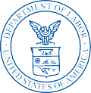
Bureau of Labor Statistics Postal Square Building Suite 4840 2 Massachusetts Ave., NE
Washington, DC 20212-0001

THE CORNER BAKERY PAYROLL
PO BOX 987
FARMVILLE, UT 98765-4321

September 22, 2018 Dear Employer,
The U.S. Bureau of Labor Statistics (BLS) and West Dakota Dept of Labor request that you provide your company’s employment and wages each quarter using the BLS 3020 - Multiple Worksite Report (MWR). You normally receive a paper MWR form that you fill out by hand and return in the mail. This notice is to encourage you to report your MWR data online, which saves your time and saves tax dollars.

Please use the User ID and password below to log into our secure website: https://idcf.bls.gov/

USER ID: 10600012345 PASSWORD: Ab123456

For you convenience, a paper MWR form will still be mailed to your attention this quarter. If you decide to report online, you can disregard this paper form.

This survey is authorized by 29 U.S. Code, Section 2. It is approved by O.M.B. No. 1220-0134.

Information collected in this report by BLS and State agencies cooperating in its statistical programs will be used for statistical and Unemployment Insurance program purposes, and other purposes in accordance with law. Additional information can be found online: http://www.bls.gov/cew/cewmwr00.htm.

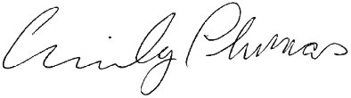
The due date for this report is October 31, 2018. Thank you for your participation. Sincerely,

Emily Thomas
U.S. Bureau of Labor Statistics



