HydroAdd Workflow
Michael Tinker 4/30/2020
The Hydrography Addressing Tool (HydroAdd) is a website built by the USGS National Geospatial Program (NGP). It is a platform which allows users to address (make coincident, or reference) their own data to the National Hydrography Dataset (NHD). Users must make their geospatial data available as a web feature service, either from their own server hardware or from a third-party service such as Esri ArcGIS Online (AGOL). The owner of the service layer grants editing permission to other users at the level of the service layer. For example, AGOL allows the owner of the service layer to grant editing permissions to specific users. HydoAdd honors the editing permissions set by the owner of the service layer. HydroAdd then ‘consumes’ the service from AGOL and displays it in the browser for editing, along with a read-only NHD layer. In this way, a team of users with editing permission can work on common projects with HydroAdd.
In summary, HydroAdd allows permitted users to update attributes and to edit the geometry of features in a service layer to be coincident with NHD features. Users cannot edit the NHD or any other USGS data. The NHD is only a reference layer for display in HydroAdd.
Users will be Federal employees, such as USGS or other DOI employees; or members of the public, such as state, academic, or other users with knowledge of GIS and knowledge of how to create a web feature service.
USGS HydroAdd Administrators are a limited group of the USGS NHD Partner Support Team. HydroAdd Administrators must be able to contact users directly in case there are issues with the functioning of HydroAdd that could affect the users’ editing work, issues with their user role assignments, problems with their data, or other issues with HydroAdd.

Login
- Users log in with an existing DOI or Esri ArcGIS Online account. 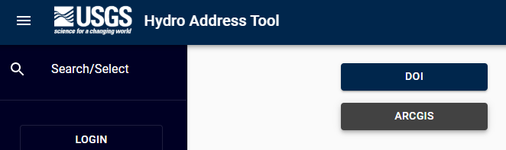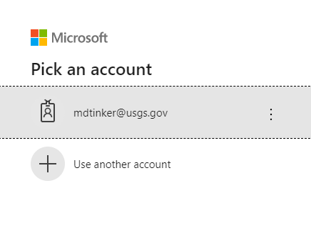

- If a user has added a web feature service from Esri Arc GIS Online (AGOL), HydroAdd prompts the user for one additional authorization for Esri login credentials.
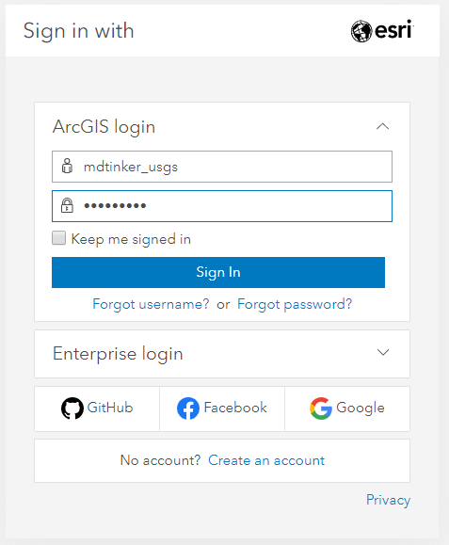

User Profile
After login, users have the option to add a username to their user profile, but this is not required. Recommendation to users is to use a simple username, or nickname, but not full names.
- Standard Editors can view their own profile, but not the profiles of other users.
- Standard Editors can view the edits that have occurred in their service layer by other users but cannot determine which users performed the edits.
- USGS HydroAdd Administrators can view the profiles of all users.
- USGS HydroAdd Administrators can also view editing activity of all users, by username and email.
- USGS HydroAdd Administrators are a limited group of the USGS NHD Partner Support Team . HydroAdd Administrators must be able to contact users directly in case there are issues with the functioning of HydroAdd that could affect the users’ editing work, issues with their user role assignments, problems with their data, or other issues with HydroAdd.
- . 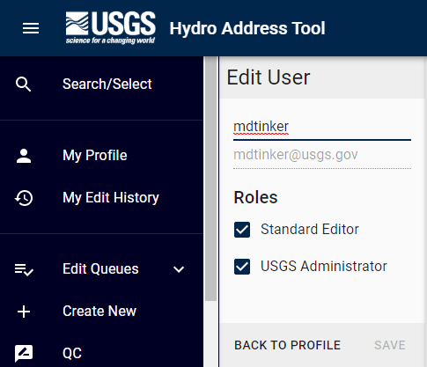

Workflow for creating or updating the web service layer with HydroAdd
HydroAdd allows users to address their own data to the NHD. HydroAdd displays the user’s web feature service from AGOL, along with the NHD. Users update their own data with HydroAdd to make their data coincident to the NHD features. Users can only edit their own data as it exists in their own web feature service. Users cannot edit the NHD; it is only a reference layer for display in the HydroAdd.

Add a service layer from ArcGIS Online
- User adds a service layer from AGOL
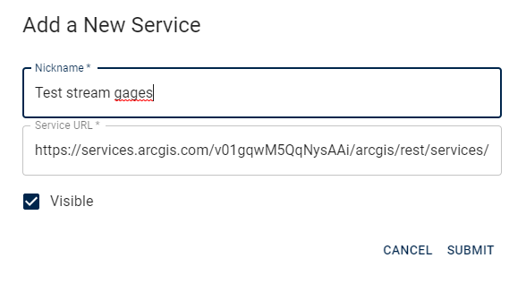
- User’s data becomes visible in HydroAdd.
- User can create new points in their data.
- Users can select points from their data they wish to add to an edit queue.
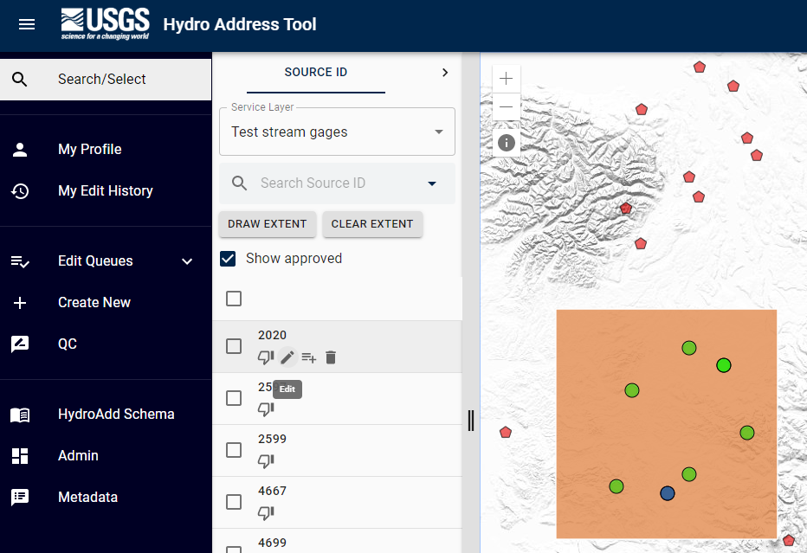

Edit Service Layer
- Users then edit the items in the queue.
Users click a row in the queue to zoom to the feature.
This screenshot shows the editing queue.
- This screen shots shows the user editing, zoomed into their data from the queue.

- When the user is done editing their data with HydroAdd, they can retrieve their data from AGOL.
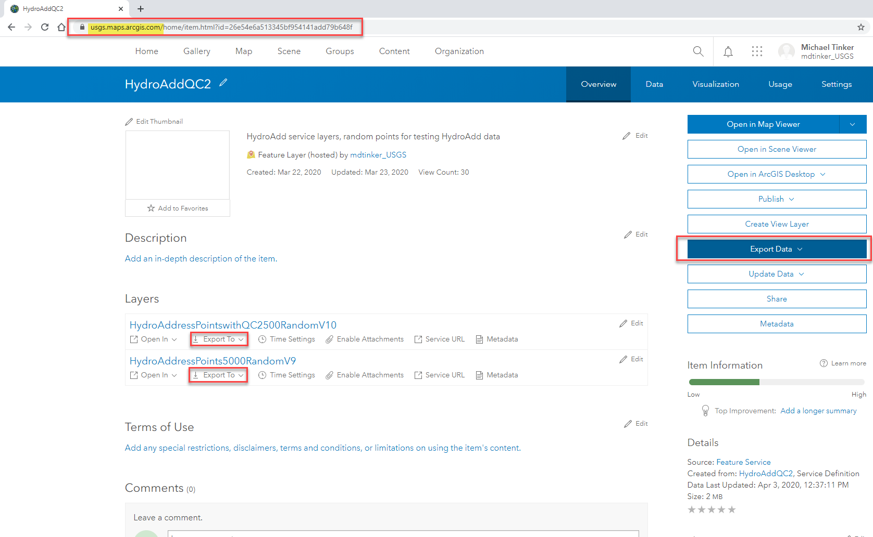

Administrator Functions
USGS Administrators of HydroAdd can view all user profiles in the Admin panel, including username, user email, and their associated service layers. 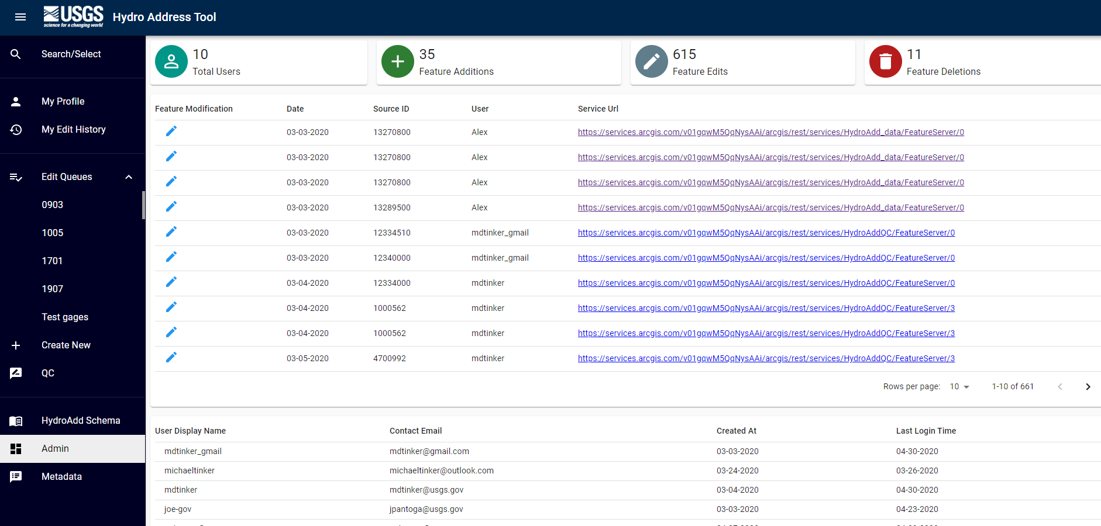
Administrators can also search for users by username.
