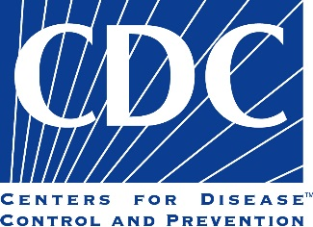

Do you get your drinking water from a Private Well?

Here’s a chance to help <Public Health Entity> and Centers for Disease Control and Prevention learn more about potential exposures from drinking water from private wells
The <Public Health Entity> and the National Center for Environmental Health (NCEH), Centers for Disease Control and Prevention (CDC) want to know if there potential exposures from drinking water provided by private wells.

We hope you want to help us. To take part, you must be at least 18 years old and get your household drinking water from a private well.

We will ask you some questions about your drinking water. We will also ask you to collect a water sample from your kitchen tap and a urine sample first thing in the morning. We will give you kits and directions for collecting and mailing these samples to us. The water and urine samples will be used for some tests that will tell us if there are any toxins in your drinking water or urine.

There is no cost to be in this investigation of exposures. We will give you the results from the tests on your water sample and urine sample.

If you want to learn more, please call <XXX-XXX-XXXX. Please leave a message with your name, phone number with area code, and best times to call you back. Thank you for your interest!

