ATTACHMENT A
Survey On Substance Use Disorder Patient Placement Criteria
This page has been left blank for double-sided copying.

Survey on Substance Use Disorder Patient Placement Criteria
Thank you for agreeing to help the US Department of Health and Human Services (HHS) understand patient placement requirements for substance use disorder (SUD) treatment throughout the nation. Your participation in this survey is voluntary and you may stop at any time. This survey includes up to 17 questions and is anticipated to take approximately 10 minutes to complete. If you need to stop in the middle, you can re-enter the survey using the same link sent to you in the introductory letter/email. Please complete the survey within two weeks of when you received the introductory letter. To help ensure confidentiality, no identifying information will be requested of you in this survey. Your name will not be linked to any of the responses provided or analyses conducted. Responses for your organization will be kept private to the extent provided by law.
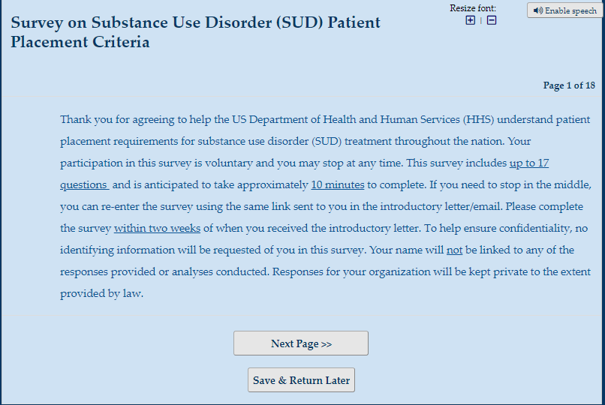

1. Please fill in the following information:
Your state: [List of states and DC in a drop-down menu]
Your organization:
☐Single State Agency (SSA) for Substance Use Services
☐State Medicaid Authority
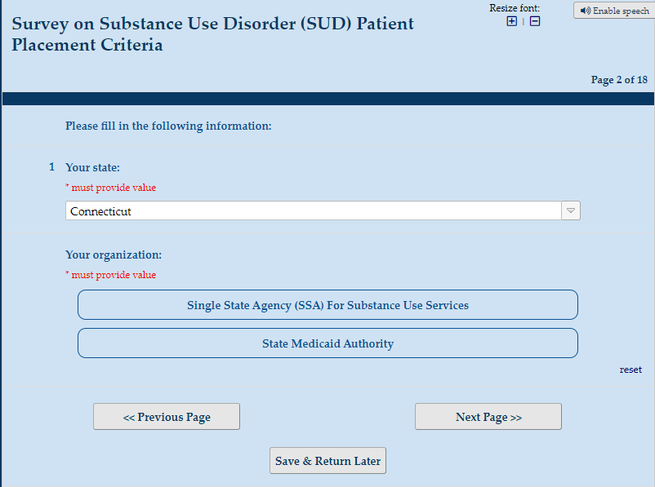
____________________________________________________________________________

For the purposes of this survey, please use the following definitions for “SUD patient placement criteria” and “assessment tools”:
1. SUD patient placement criteria: Standards to guide referral to a level of care based on the patient’s needs. Referral can be made during the intake assessment or from a referring doctor or substance use disorder service provider.
2. Biopsychosocial assessment tools: Structured or semi-structured questions used to determine the recommended intensity and level of care and the composition of the treatment plan. The term biopsychosocial means that the recommendation accounts for physical factors, factors relating to the brain or mind, and factors concerning relationships.
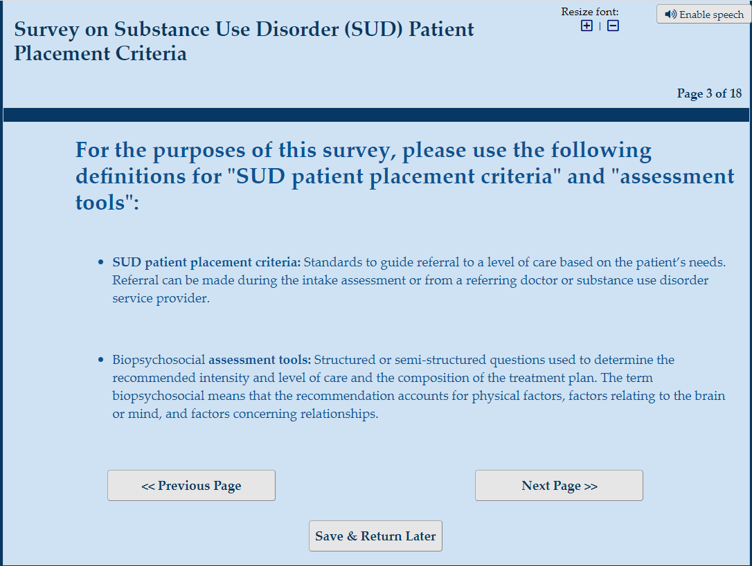
____________________________________________________________________________

Section 1: Placement Criteria
2. Does your organization require or recommend the use of patient placement criteria?
☐Criteria are required uniformly across the state
☐Criteria are required, but requirements vary by county or local jurisdiction
☐Criteria are recommended but not required GO TO 14
☐No criteria are recommended or required GO TO 15
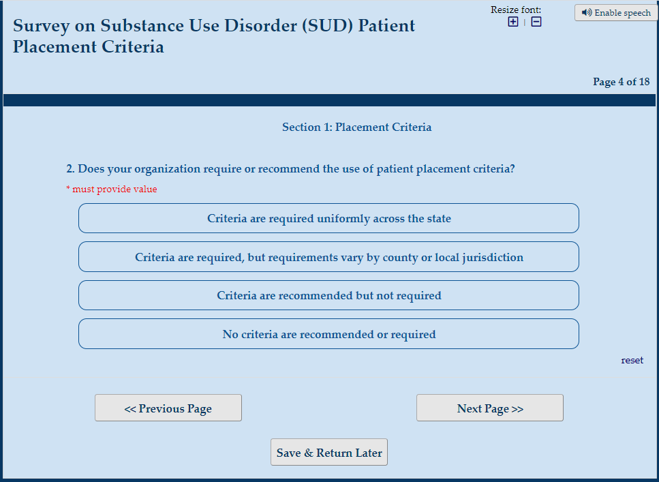

Section 1: Placement Criteria
3. What mechanisms are used by your organization to require the use of patient placement criteria? (Check all that apply)
☐Contracts
☐Licensure regulations
☐State statutes
☐Other requirements
[If “other” is selected] Please specify what other mechanisms are used:
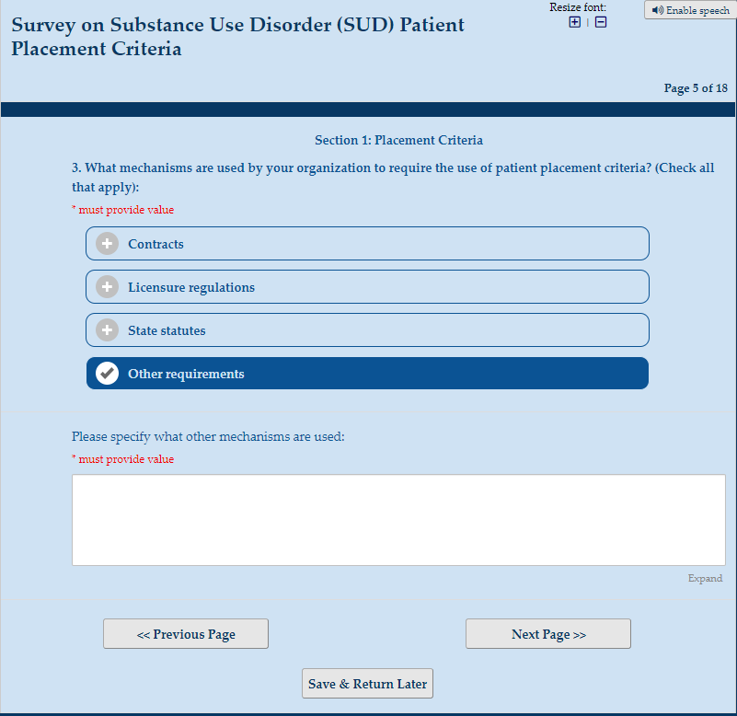
Section 1: Placement Criteria
4. For which groups does your organization require the use of patient placement criteria? (Check all that apply)
☐State publicly funded patients
☐County or locally funded patients
☐Medicaid patients
☐Adolescent patients
☐Other patient subgroups
[If “Other patient subgroups” is selected] Please specify the other subgroups for which patient placement criteria are required: ____________
☐All patients
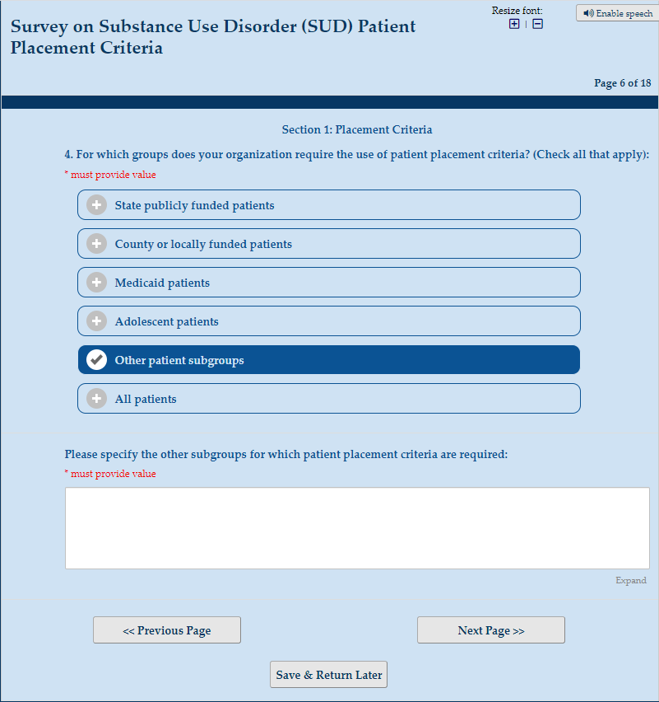
Section 1: Placement Criteria
5. What SUD placement criteria does your organization require providers to use? (Check all that apply)
☐American Society of Addiction Medicine (ASAM) criteria GO TO 7 [If this response is checked, even if they select both, do not ask Q6]
☐Other criteria (e.g., state-specific criteria)
[If “other is selected] Please describe what other criteria are required by your organization: __________
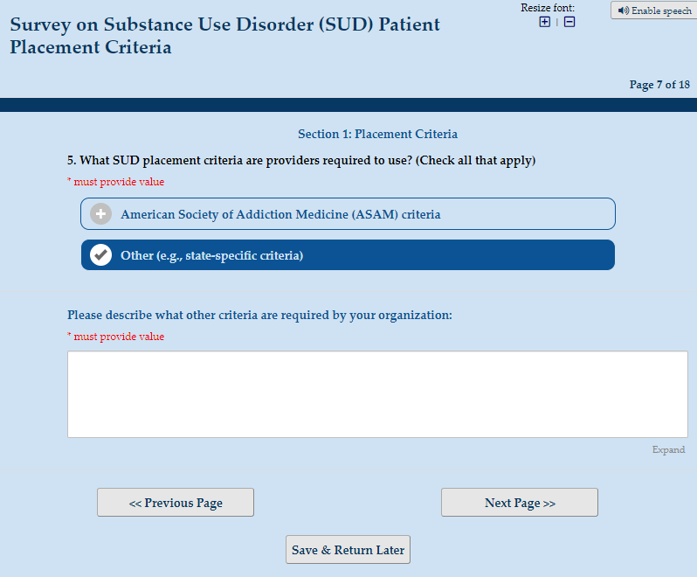

Section 1: Placement Criteria
6. Does your organization define levels of care that can crosswalk with the ASAM Levels of Care?
☐Yes
☐No
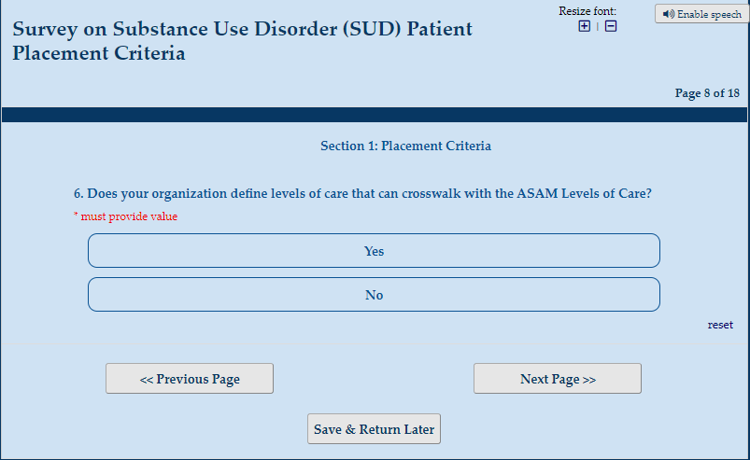

Section 2: Placement Assessments
7. Are providers who are funded or regulated by your organization also required to use a state accepted assessment tool to inform patient placement?
☐Yes
☐No
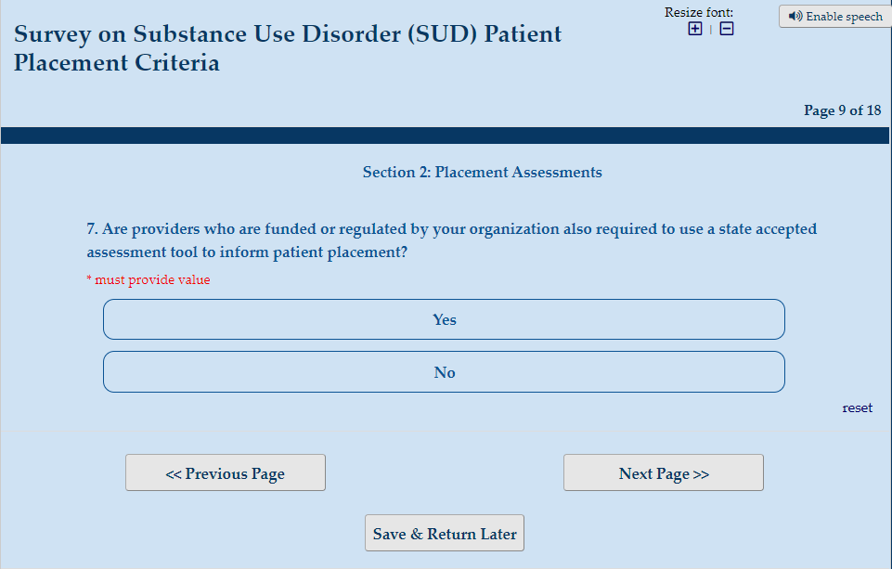

8 [Show if “yes” is selected in 7] What assessment tool(s) are providers required to use? (Check all that apply)
☐ASAM Continuum software
☐Global Appraisal of Individual Needs (GAIN)
☐Addiction Severity Index (ASI)
☐ASI-Lite
☐Treatment Assignment Protocol (TAP)
☐Other
[If “other” is selected] Please specify what other assessment tool(s) are used to help determine the level of care: ________________
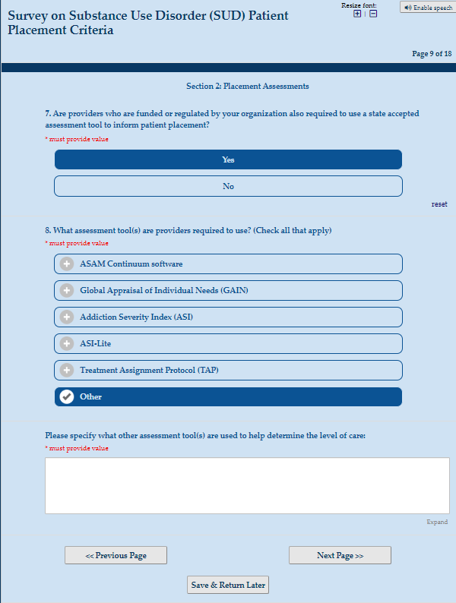

8 [Show if “no” is selected in 7] What assessment tool(s) do providers typically use? (Check all that apply)
☐ASAM Continuum software
☐Global Appraisal of Individual Needs (GAIN)
☐Addiction Severity Index (ASI)
☐ASI-Lite
☐Treatment Assignment Protocol (TAP)
☐Other
[If “other” is selected] Please specify what other assessment tool(s) are used to help determine the level of care: ________________
☐I do not know
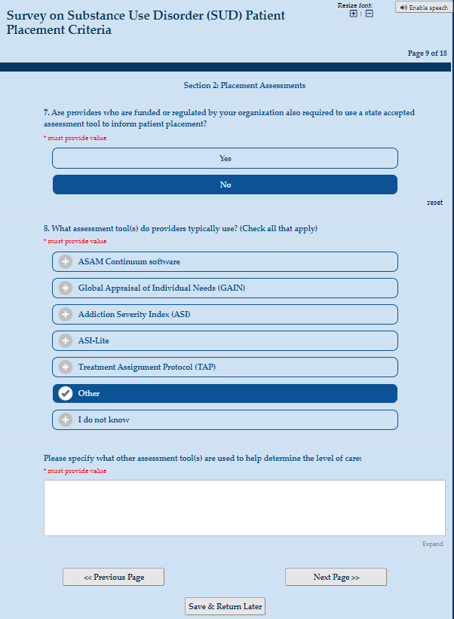
Section 2: Placement Assessments
9. Does your organization require a patient placement assessment for the following ASAM or other levels of care? (Check a response for each applicable row)
 | Placement Assessment Is Required for Patients Funded by My Organization | Placement Assessment Is Required for All Patients | Placement Assessment Is Not Required
All ASAM levels of care that are listed below | ☐ | ☐ | ☐
0.5 Early intervention | ☐ | ☐ | ☐
1 Outpatient services | ☐ | ☐ | ☐
1-WM Ambulatory withdrawal management without extended on-site monitoring | ☐ | ☐ | ☐
2.1 Intensive outpatient services | ☐ | ☐ | ☐
2.5 Partial hospitalization | ☐ | ☐ | ☐
2-WM Ambulatory withdrawal management with extended on-site monitoring | ☐ | ☐ | ☐
3.1 Clinically managed low-intensity residential services | ☐ | ☐ | ☐
3.2-WM Clinically managed residential withdrawal management | ☐ | ☐ | ☐
3.3 Clinically managed population-specific high-intensity residential services | ☐ | ☐ | ☐
3.5 Clinically managed high-intensity residential services | ☐ | ☐ | ☐
3.7 Medically monitored intensive inpatient services | ☐ | ☐ | ☐
3.7-WM Medically monitored inpatient withdrawal management | ☐ | ☐ | ☐
4 Medically managed intensive inpatient services | ☐ | ☐ | ☐
4-WM Medically managed intensive inpatient withdrawal management | ☐ | ☐ | ☐
Opioid treatment services | ☐ | ☐ | ☐
Other levels of care | ☐ | ☐ | ☐
[If “other” is selected] Please specify what other levels of care have a placement assessment requirement for those funded by your organization or for all patients: __________
WM= Withdrawal management
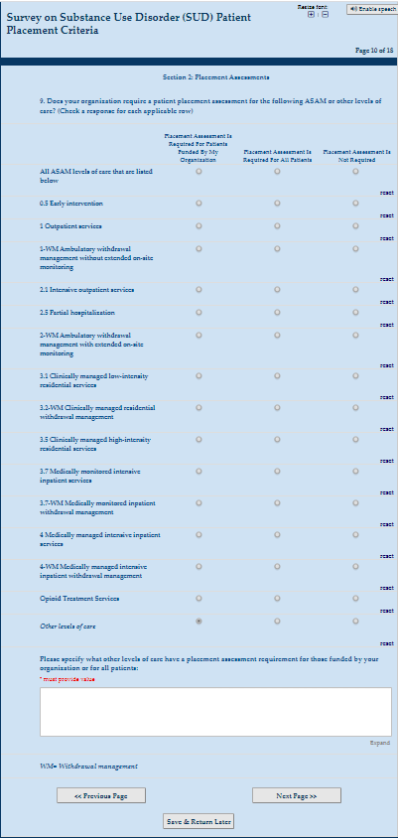

Section 3: Data
10. Among clients served by your organization, what information from the patient placement criteria and/or assessment tools is recorded in data systems available to your state organization? (Check all that apply)
☐Assessed SUD level of care based on the patient placement criteria and/or assessment tools
☐Assessment tool that was used by the provider
☐Initial SUD level of care placement
☐Reasons why the initial SUD level of care differs from the assessed level of care (e.g., service not available locally)
☐Continued SUD level of care received by the patient
☐Clinical observations or itemized responses that detail the need for recommended services (e.g., raw data from the criteria or assessments)
☐None. No data related to patient placement criteria and/or assessment tools are recorded in data systems available to my state organization. [This response is mutually exclusive; if this box is checked, no others can be selected.] GO TO 14

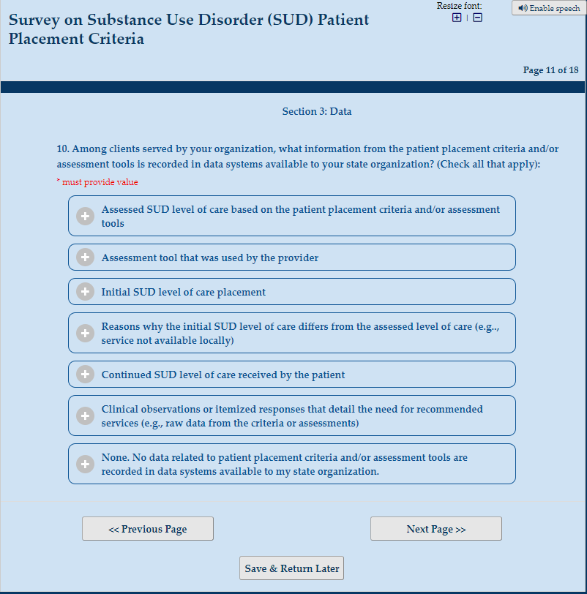

Section 3: Data
11. What other client-level data can be linked with level of care data that is available to your organization? (Check all that apply)
☐Electronic health records
☐Service utilization or billing data (e.g., administrative claims)
☐Treatment Episode Data Set (TEDS) National Outcome Measures (NOMS)
☐Government Performance and Results Act (GPRA) NOMS
☐Substance Abuse Prevention and Treatment Block Grant NOMS
☐State-specific outcome measures
☐Program-specific outcome measures
☐Prior authorization determinations
☐Other client-level data
[If “other” is selected] Please specify what other client-level data can be linked with the patient placement data: __________
☐No client-level data can be linked with the patient placement data [This response is mutually exclusive; if this box is checked, no others can be selected.]
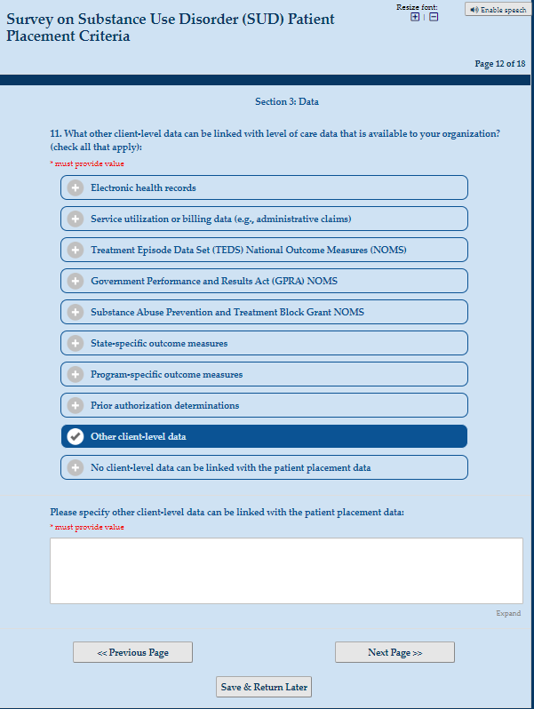

Section 3 Data:
12. Has your organization used level of care data to help determine service gaps and need for greater capacity?
☐Yes
[If “yes” is selected] Please explain how your organization has used level of care data to help determine service gaps and need for greater capacity: ___________
☐No, but we are planning on it
[If “no, but we are planning on it” is selected] Please explain how your organization plans to use level of care data to help determine service gaps and need for greater capacity: ___________
☐No, we have no current plans to do this
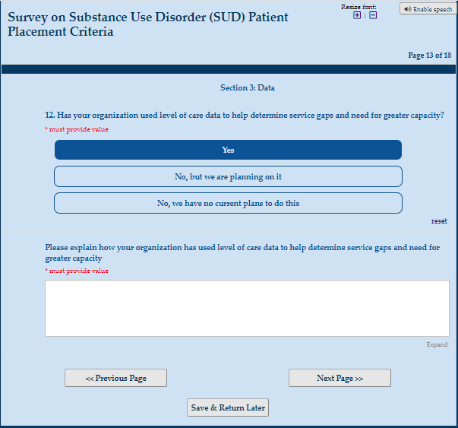
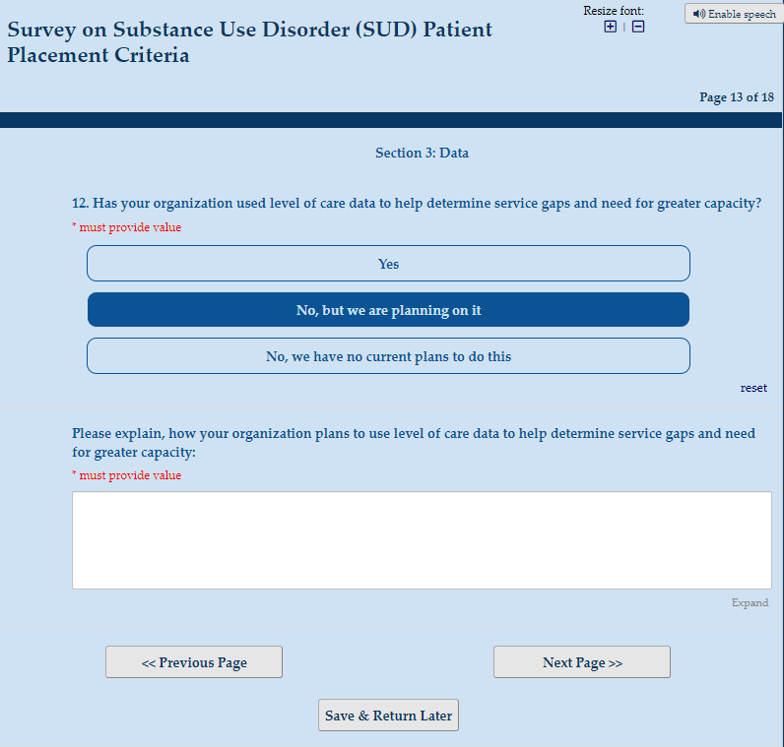

Section 3: Data
13. How likely is it that your state organization would share aggregate de-identified patient placement data with HHS to examine the distribution of SUD needs by levels of care across the United States?
☐Very likely
☐Somewhat likely
☐Somewhat unlikely
☐Very unlikely
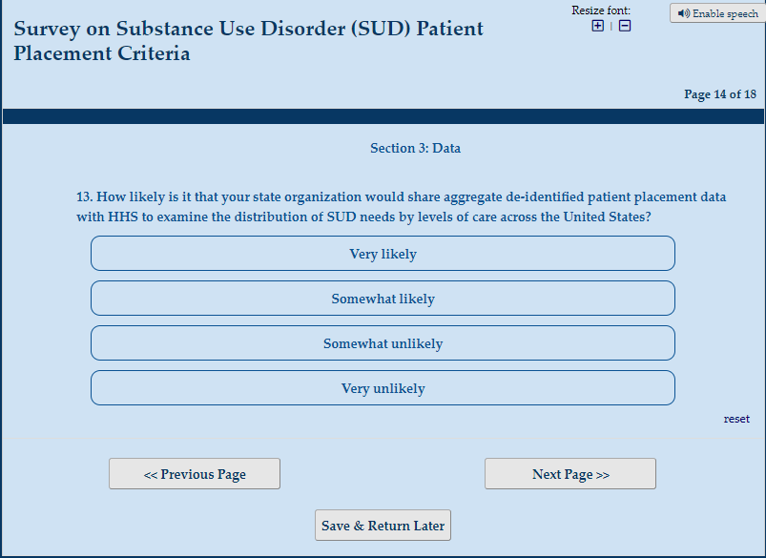

Section 4: Resources and Other Guidelines
14. What resources does your organization offer providers to help implement and use patient placement criteria? (Check all that apply)
☐In-person training
☐Online training
☐Ongoing technical assistance
☐Printed documents and guidebooks
☐Electronic documents and guidebooks
☐Software or licenses to software
☐Incentives and grants to implement the criteria
☐Other resources (please specify):Click or tap here to enter text.
☐No resources are given to providers (This response is mutually exclusive, if this box is checked, no others can be selected)
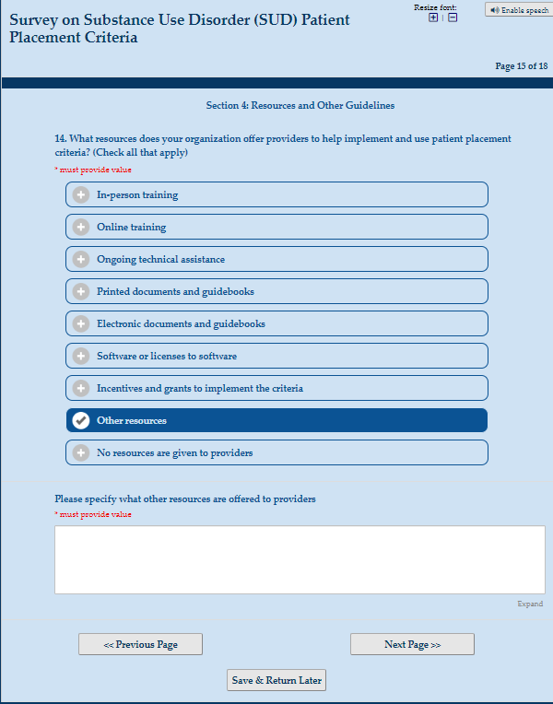

Section 4: Resources and Other Guidelines
15. Other than SUD patient placement criteria and standardized assessment tools, does your organization have any other guidelines for providers regarding the initial SUD assessment and placement process?
☐Yes
[If “yes” is selected] Please describe what other guidelines your organization has established: ________
☐No
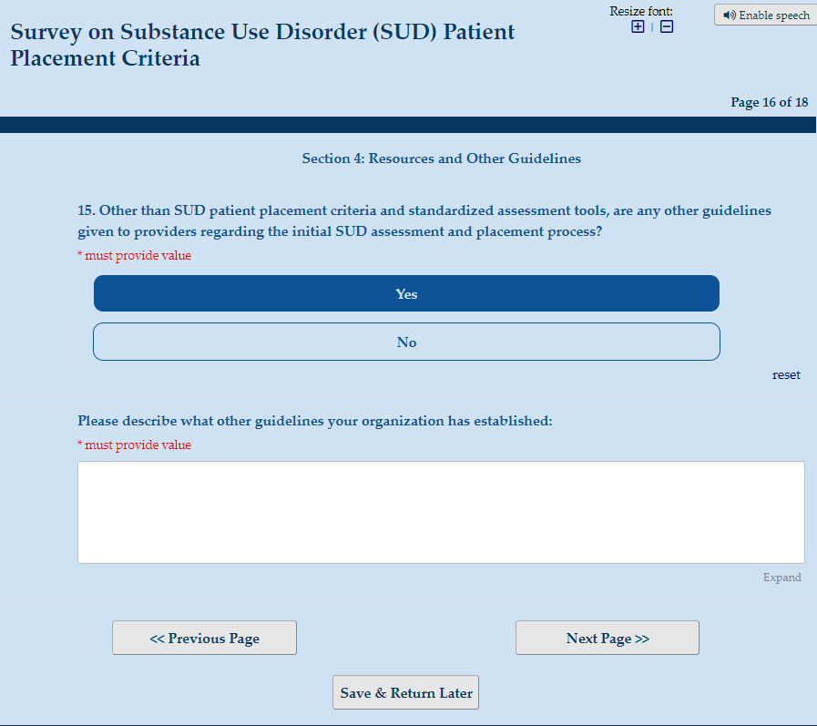
Section 5: Contextual Information
16. Please share links to any documents or websites regarding the patient placement criteria, assessment tools, and guidelines required by your state organization:
_____________
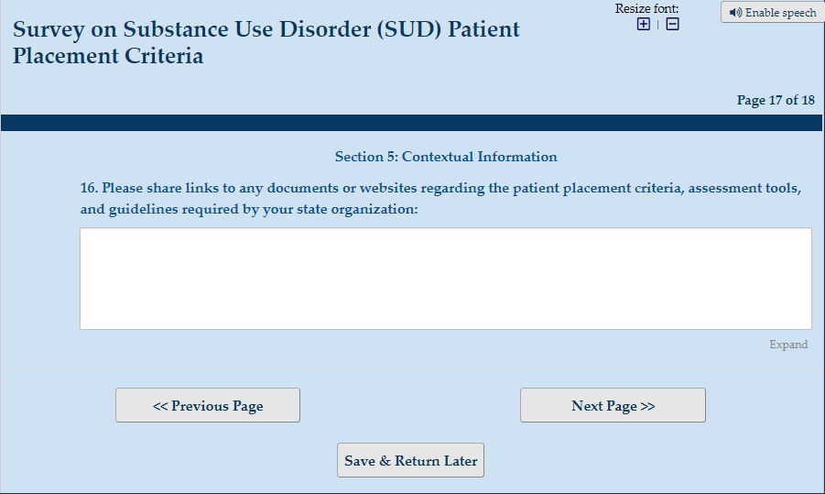

Section 5: Contextual Information
17. Please share any other contextual information that may be impacting your organization’s current patient placement and data collection practices: _____________
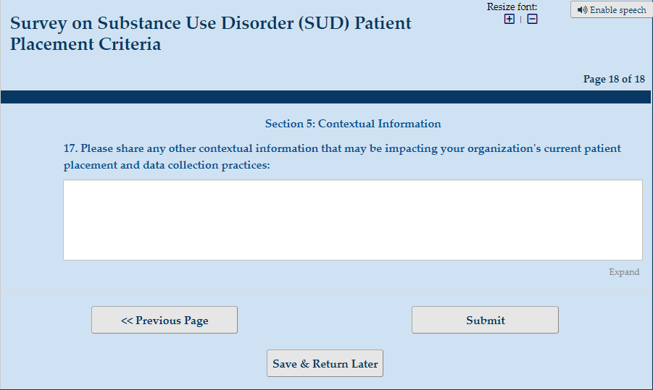

Thank you for your responses to this survey!
