Qualitative Research to Design Advertising to Encourage Quitting Among Adult Cigarette Smokers (SGM Population)

STIMULI



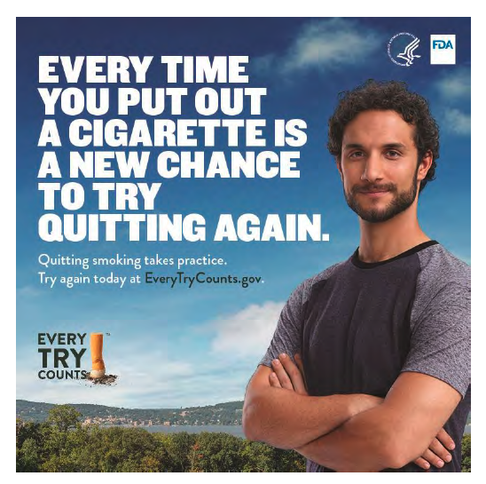

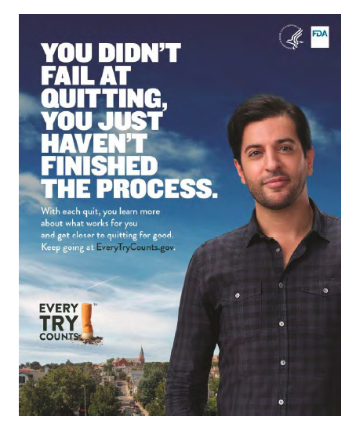

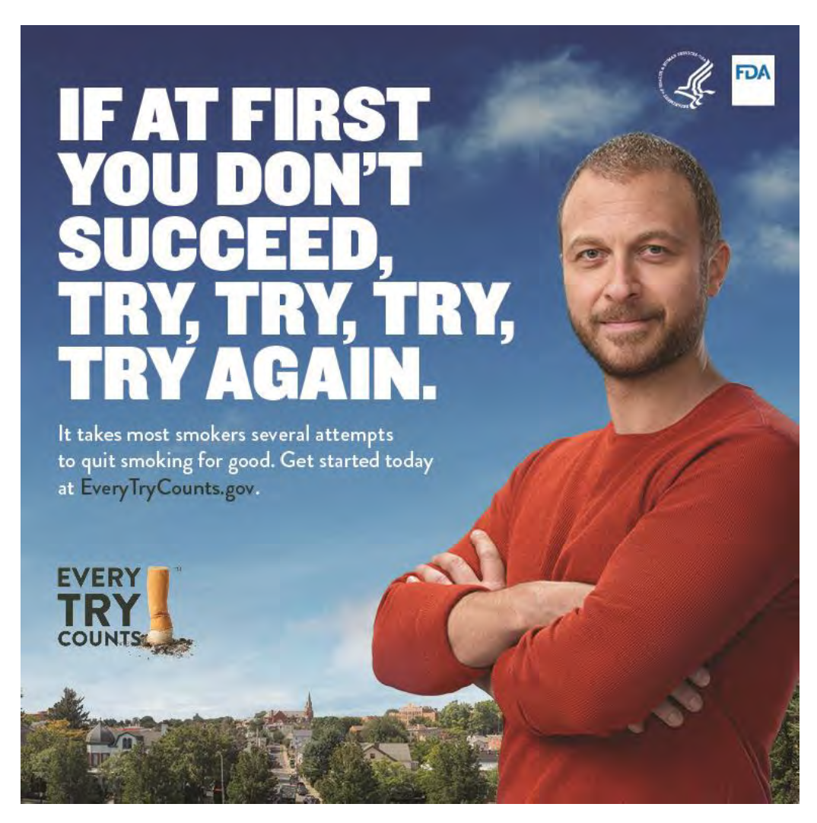

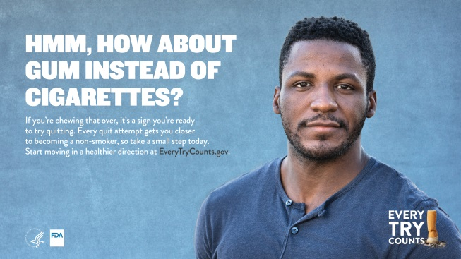

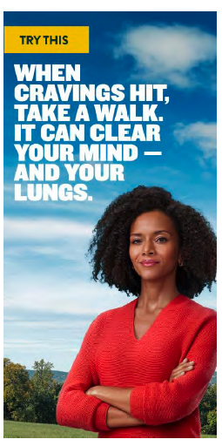

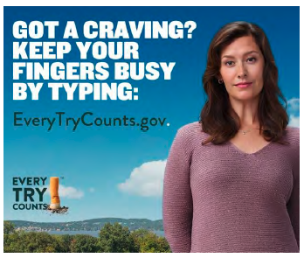

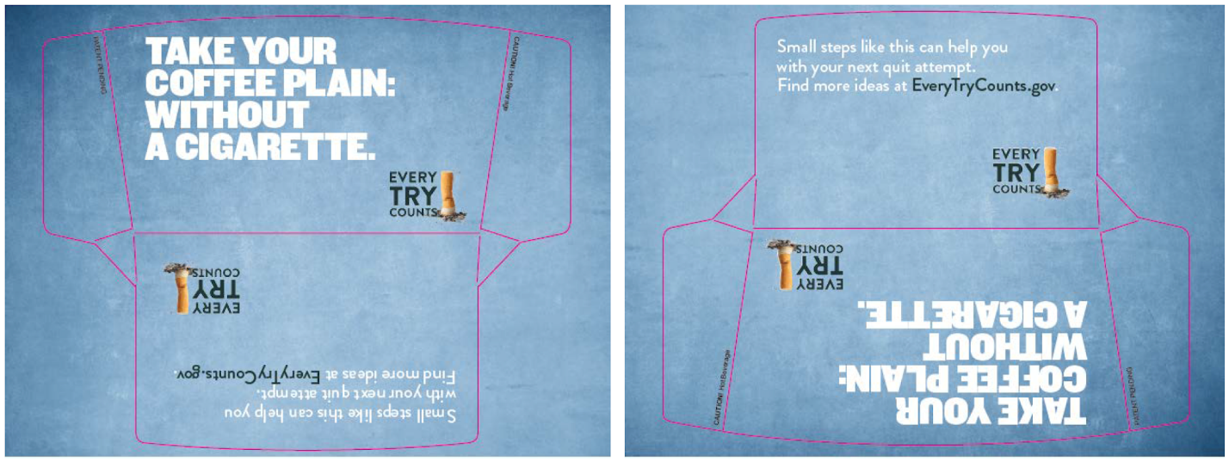

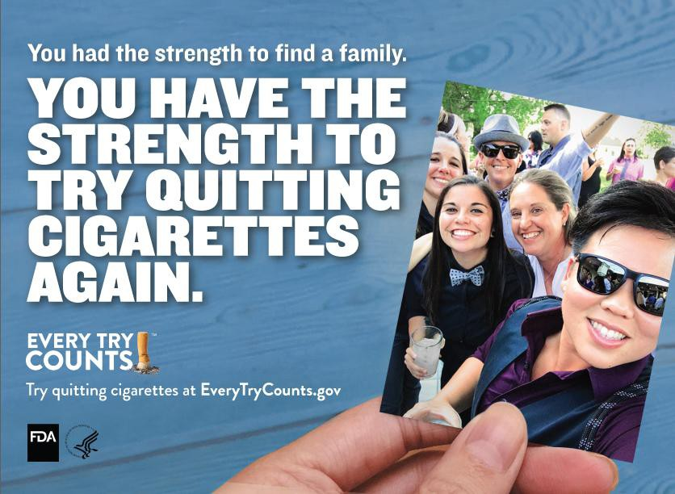

Headline: This Isn’t Just a Celebration of Us.
This is Our Reason to Try Quitting Cigarettes Again.
Body Copy: The power of our community is that we never give up. Try quitting cigarettes again at EveryTryCounts.Gov

Headline: She Isn’t Just Your #1.
She’s Your #1 Reason to Try Quitting Cigarettes Again.
Body Copy: Having a great reason can be just the motivation you need to try again. Learn how at EveryTryCounts.Gov

Headline: This isn’t just a new love.
This is your inspiration to try quitting cigarettes again.
Body Copy: A new partner, a new job — there are lots of reasons to try quitting again. Find yours at EveryTryCounts.gov

Headline: OUR FUTURE IS WORTH TRYING TO QUIT CIGARETTES FOR.
Body Copy: For the extra years you’ll have together
and for the memories you’ll get to share, it’s worth trying again. Get help quitting cigarettes at EveryTryCounts.Gov

Headline: THESE MOMENTS ARE WORTH TRYING TO QUIT CIGARETTES FOR.
Body Copy: Trying to quit is hard, but moments like this are a good reason to try again. .
Get help quitting cigarettes at EveryTryCounts.gov

Headline: WE ARE WORTH TRYING TO QUIT CIGARETTES FOR.
Body Copy: Our community never gives up, and neither will you. Your next try starts at EveryTryCounts.Gov

Headline: You had the strength to find a family. Your family is one reason to try quitting cigarettes again.
Body Copy: Try quitting cigarettes at EveryTryCounts.gov

Headline: YOU’VE HAD THE STRENGTH TO HOLD HIS HAND FOR 20 YEARS.
For the more years you’ll have holding his hand, it’s worth trying to quit cigarettes again.
Body Copy: Plan your next quit at EveryTryCounts.gov

Headline: You had the strength to live your truth. For the extra years you’ll be living your truth it’s worth it to try quitting cigarettes again.
Body Copy: Plan your next quit at EveryTryCounts.gov

Headline: MY FIRST TRY I LEARNED THAT QUITTING CIGARETTES TAKES PRACTICE.
Body Copy: Everything worth it in life takes practice. Quitting cigarettes is one of those things that takes practice. Try again at EveryTryCounts.gov

Headline: MY FIFTH TRY QUITTING CIGARETTES,
I LEARNED I NEED MY FAMILY.
Body Copy: Quitting isn’t easy, but encouragement from the ones you love might make it easier. Try again at EveryTryCounts.gov

Headline: MY SEVENTH TRY QUITTING CIGARETTES, I LEARNED TO CHOOSE A START DATE THAT MATTERS.
Body Copy: Whether it’s your anniversary or another special day, planning your quit date can help with your next try. Try again at EveryTryCounts.gov

Headline: MY LAST TRY QUITTING CIGARETTES
I FAILED PRACTICED
Body Copy: “Every try toward quitting cigarettes is practice. Each try, I learned new ways to overcome some of my triggers. I didn’t fail, I learned.” - Soni, 33
Get support at EveryTry Count.Gov

Headline: MY LAST TRY QUITTING CIGARETTES
I FAILED LEARNED
Body Copy: “I learned it helps to put a photo of my reason to quit in the places I am tempted the most. Each try I’m learning more.” - Joanie, 49
Get support at EveryTry Count.Gov

Headline: MY LAST TRY QUITTING CIGARETTES
I FAILED LEARNED ABOUT MYSELF
Body Copy: “Every try I write down what works and doesn’t.
Each try I’m learning more about myself.” - Dylan, 35
Get support at EveryTry Count.Gov

Headline: AFTER SEVEN DAYS, CIGARETTE CRAVINGS BEGIN TO DISAPPEAR.
Body Copy: Try again, one day at a time, at EveryTryCounts.gov

Headline: THERE ARE A LOT OF REASONS TO TRY QUITTING CIGS AGAIN
Body Copy: Find your reason and get support at EveryTryCounts.gov

Headline: Any time is a good time to try quitting cigarettes again.
Body Copy: Plan your perfect quit date at EveryTryCounts.gov

Headline: TRY A CIGARETTE-FREE COFFEE BREAK.
Body Copy: A latte and good conversation can be just what you need to get through a craving. Find more ways to try at EveryTryCounts.gov

Headline: TRY SWAPPING YOUR SMOKING TIME FOR QUALITY TIME.
Body Copy: Special moments with your partner can help take your mind off cigarettes and reduce stress. Get more help quitting at EveryTryCounts.gov

Headine: TRY UNINVITING CIGARETTES TO BRUNCH.
Body Copy: Making one meal smoke-free might make your next smoke-free meal easier. Find more ways to try at EveryTryCounts.gov

