Email to states to invite them to submit fluoride testing data
Form Approved
OMB No. 0920-XXXX (for CDC)
Exp. Date xx/xx/20xx

Date: | January xx, 20xx
To: | State Dental Directors  State Drinking Water Administrators  State Fluoridation Specialists
From: | <name>, National Fluoridation Engineer
 | CDC Division of Oral Health

Re: Invitation to submit fluoride level testing data

Dear Colleagues,

Fluoridation of community water systems has been recognized by the Centers for Disease Control and Prevention as one of 10 great public health achievements of the 20th Century.

To maintain these achievements, increase the number of Americans that benefit from community water fluoridation, and reduce the burden on states to monitor water systems, CDC is requesting your participation in the annual collection of fluoride level testing data for adjusted public community water systems.

The fluoride testing data are essential to monitor and ensure the quality of state community water fluoridation programs. States may choose to publish the data on CDC’s My Water’s Fluoride (MWF) website by selecting the “Advanced Level” report setting for the display preferences in the Water Fluoridation Reporting System (WFRS).

The data will also be used to monitor and facilitate adoption of the 2015 recommended beneficial fluoride target level and the expected operational control range. State programs as well as Public Water Systems (PWS) which achieve consistent fluoride levels in the recommended range will be eligible for awards from the Association of State and Territorial Dental Directors, the American Dental Association, and CDC if data for the previous calendar year are entered in WFRS by March 12 and May 14 respectively for the state awards and the water system award (see attached criteria).

Please share this information with your state drinking water administrators. Instructions for submitting data are included below. Please refer to the WFRS technical guide for further information

If you have questions, please contact <name>, CDC National Fluoridation Engineer, at xx@cdc.gov or by phone at (xxx) xxx-xxxx.

Thank you for your participation.

Sincerely,

Division of Oral Health
National Center for Chronic Disease Prevention and Health Promotion
Centers for Disease Control and Prevention
www.cdc.gov/oralhealth

Fluoride Level Testing Data
- Log into WFRS. (For assistance setting up an account, please contact the CDC Fluoridation Engineer.)
- Select “Fluoride Data” from the left navigation menu of the WFRS home page.
- Select the year from the “Select Year” drop down list in “Option A” to enter fluoride data for 12 months for a single water system.
- Select an adjusted water system from the list or search by entering the PWS ID or PWS name. As you type, the system displays the matching water systems.
- Enter fluoride level testing data for each month of the previous calendar year 20xx, including monthly average, highest, and lowest daily concentrations.
- Check the “Sufficient Samples” and “In Range” fields if meeting the adequate number of daily samples and percentage of the daily samples within control range, as determined by your state. See WFRS technical guide for more information.

States may also choose “Option B” from the “Fluoride Data” page to enter fluoride data for a selected year and month for all adjusted water systems.

For states that choose “Option C” to upload or email the data to CDC rather than enter it directly, please login to the WFRS Help Page online for instructions to download the template.
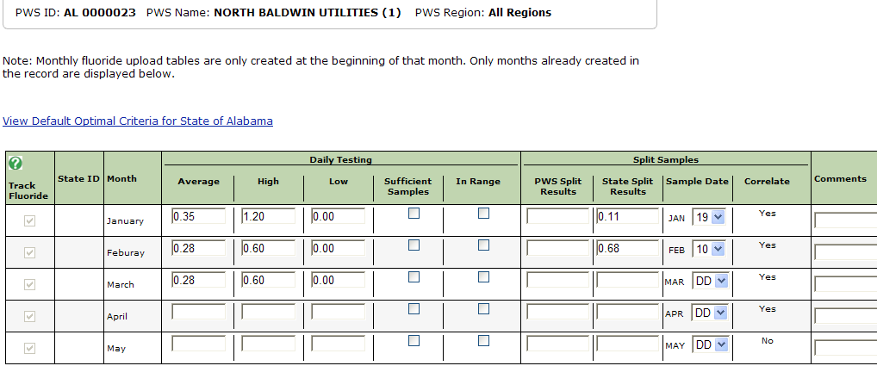

Frequently Asked Questions
- Some PWS are not appearing as optimally fluoridated even though their testing data is correct.
A common problem is that the “Sufficient Samples” or “In Range” boxes are not checked. Ensure that all required boxes are properly checked.
- I have a PWS that does not appear in all 12 months in the WFRS monthly upload tables. What should I do?
Monthly upload tables are created based on the census profiles on the first day of the month. If the PWS was not included as an adjusted system in WFRS at the beginning of a month, or if the census profile changed during the year, it may not be included; contact CDC to request that additional months are added.

