
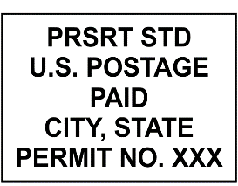

1600 Research Blvd.
RC B16
Rockville, MD 20850
The Household Residing at
123 Anywhereville Ave.
Anywhere, US 12345

ABS Post Card Nonprobability

Recently you received a letter asking for your participation in the Health and Injury Survey for the Centers for Disease Control and Prevention (CDC).
If you have already completed your survey, thank you! If not…
Please have the {youngest/oldest» adult «female/male» in this household complete the online survey using the website and access code below.
If there are no adult «males/females» live here, then please ask the «youngest/oldest» adult «female/male», to complete the survey.

Survey Website: www.healthinjurysurvey.com
Your Access Code: «PIN»
If you have any questions about this study, please call 1-8XX-XXX-XXXX or email healthinjurysurvey@westat.com.
There is still time
to complete your survey!


ABS postcard Probability

Recently you received a letter asking for your participation in the Health and Injury Survey for the Centers for Disease Control and Prevention (CDC).
If you have already completed your survey, thank you! If not…

Please have an adult, 18 or older, fill complete the 5-minute survey online as soon as possible. The website and access code are listed below.

Survey Website: www.healthinjurysurvey.com
Your Access Code: «PIN»

If you have any questions about this study, please call 1-8XX-XXX-XXXX or email healthinjurysurvey@westat.com.
There is still time
to complete your survey!

