Regional Purse-Seine Logsheet (RPL): Supplemental Instructions
Whale Shark Encirclement Reporting

Pursuant to regulations implementing decisions of the Western and Central Pacific Fisheries Commission and the Inter-American Tropical Tuna Commission, in the event that one or more whale sharks are encircled by purse seine fishing operations, the following information must be recorded on the Regional Purse-Seine Logsheet (RPL) (see 50 CFR 300.218). This information must be recorded for each set in which an encirclement occurs:
- The number of whale sharks encircled in the set:
  - Enter the information regarding the set in which the whale shark interaction occurred as you would for any other set
  - In the fields for DISCARDS, enter “whale shark” or “RHN” under ”Name” and enter the number of individuals that were encircled under “Number”

- A brief description of any conditions or circumstances that might have led to the encirclement:
  - On the blank line(s) directly below the line of information for that set, enter a brief description of any conditions or circumstances
  - E-Log: Add a comment for the set and enter the description

- A brief description of the steps taken to ensure the safe release of the whale shark(s):
  - On the same line(s) used for the information in element 2, enter the steps taken to ensure the safe release of the whale shark(s)
  - For E-Log: Enter the steps taken to ensure the safe release of the whale shark(s) in the same comments section used for the information in element 2

- Whether each of the animals was alive or dead upon release, to the best of your knowledge:
  - On the same line(s) used for the information in elements 2 and 3, enter an indication of whether the animal was alive or dead upon release
For E-Log: Enter the indication in the same comments section used for elements 2
Sample Whale Shark Encirclement Report

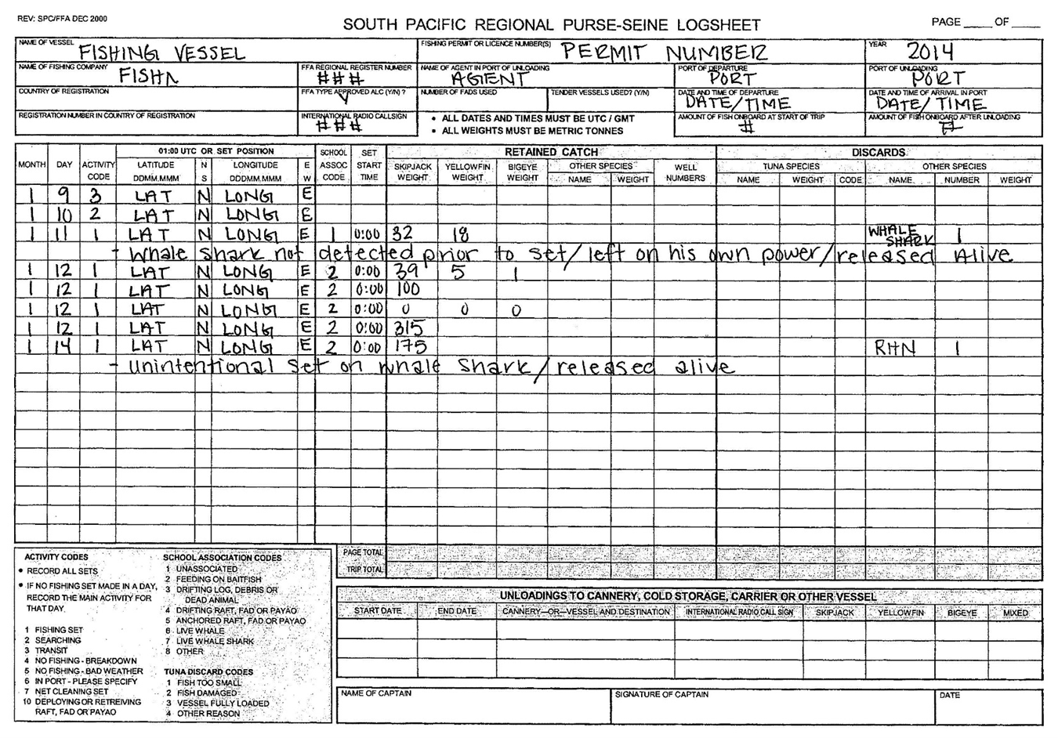

Privacy Act Statement

Authority: The collection of this information is authorized under the Western and Central Pacific Fisheries Convention Implementation Act (WCPFCIA; 16 U.S.C. 6901 et seq.).
Purpose: In order to fulfill obligations under the WCPFCIA, the NOAA National Marine Fisheries Service (NMFS) requires the submission of information for NMFS to monitor daily catch and effort information of the U.S. purse seine vessels fishing for highly migratory species in the Commission’s area of competence for compliance-related and scientific purposes.
Routine Uses: The Department will use this information to collect information on U.S. purse seine daily catch and effort information. Disclosure of this information is permitted under the Privacy Act of 1974 (5 U.S.C. Section 552a), to be shared within NMFS offices, in order to coordinate monitoring and management of sustainability of fisheries and protected resources, as well as with the applicable State or Regional Marine Fisheries Commissions and International Organizations. Disclosure of this information is also subject to all of the published routine uses as identified in the Privacy Act System of Records Notice COMMERCE/NOAA-6, Fishermen’s Statistical Data.
Disclosure: Furnishing this information is mandatory.

