United States Environmental Protection Agency | Office of Pollution Prevention and Toxics  Washington, DC 20460 | 740B19040  January 2020


TOXICS RELEASE INVENTORY
Supplier Notification Requirements

Section 313 of the Emergency Planning and Community Right-to-Know Act of 1986 (EPCRA) requires certain facilities manufacturing, processing, or otherwise using listed toxic chemicals to report the annual quantity of such chemicals entering each environmental medium. Such facilities must also report pollution prevention and recycling data for such chemicals, pursuant to section 6607 of the Pollution Prevention Act, 42 U.S.C. 13106. EPCRA section 313 is also known as the Toxics Release Inventory (TRI).

CONTENTS
Section 1.0 WHO MUST SUPPLY NOTIFICATION 1
Section 2.0 WHO MUST BE NOTIFIED 1
Section 3.0 SUPPLIER NOTIFICATION CONTENT 1
Section 4.0 HOW THE NOTIFICATION MUST BE MADE 2
Section 5.0 WHEN NOTIFICATION MUST BE PROVIDED 2
Section 6.0 WHEN NOTIFICATIONS ARE NOT REQUIRED 3
Section 7.0 TRADE SECRETS 4
Section 8.0 RECORDKEEPING REQUIREMENTS 5

LIST OF TABLES
Table 1: De Minimis Supplier Notification Limit for PBT Chemicals 4

LIST OF FIGURES
Figure 1: Example Supplier Notification Within an SDS 6

DISCLAIMER
This guidance document is intended to assist industry with EPCRA section 313 supplier notification requirements. These recommendations do not supersede any statutory or regulatory requirements, are subject to change, and are not independently binding on either EPA or covered facilities. Additionally, if a conflict exists between guidance on this site and the statutory or regulatory requirements, the conflict must be resolved in favor of the statute or regulation.
Although EPA encourages industry to consider these recommendations, in reviewing this document, industry should be aware that these recommendations were developed to address common circumstances at typical facilities. Facilities are encouraged to contact the Agency with any additional or clarifying questions about the recommendations in this document, or if the facility believes that EPA has incorrectly characterized a particular process or recommendation.
For general instruction regarding compliance with EPCRA section 313 requirements and form completion, please see the most recent version of the Toxic Chemical Release Inventory Reporting Forms and Instructions, available at: https://ofmpub.epa.gov/apex/guideme_ext/f?p=guideme:rfi-home.
Additional guidance documents, including industry specific and chemical specific guidance documents, are also available on TRI’s GuideME website: https://ofmpub.epa.gov/apex/guideme_ext/f?p=guideme:gd-list
OVERVIEW
EPA requires some suppliers of mixtures or other trade name products containing one or more of the EPCRA section 313 chemicals to notify their customers.
This document explains which suppliers must notify their customers, who must be notified, what form the notice must take, and when it must be sent.

WHO MUST SUPPLY NOTIFICATION
You are covered by the section 313 supplier notification requirements if you own or operate a facility which meets all of the following criteria:
- Your facility is in a North American Industry Classification System (NAICS) code that corresponds to Standard Industrial Classification [SIC] codes 20-39;
- You manufacture (including import) or process an EPCRA section 313 chemical; and
- You sell or otherwise distribute a mixture or other trade name product containing the EPCRA section 313 chemical to either:
  - A facility in a covered NAICS code (see the TRI Reporting Forms and Instructions Table I).
  - A person that then may sell the same mixture or other trade name product to a firm in a covered NAICS code (see the TRI Reporting Forms and Instructions Table I).
Note that you may be covered by the supplier notification rules even if you are not covered by the section 313 release reporting requirements. For example, even if you have fewer than 10 fulltime employees or do not manufacture or process any of the EPCRA section 313 chemicals in sufficient quantities to trigger the release and other waste management reporting requirements, you may still be required to notify certain customers.

WHO MUST BE NOTIFIED
Industries whose primary NAICS code does not correspond to SIC codes 20 through 39 are not required to initiate the distribution of notifications for EPCRA section 313 chemicals in mixtures or other trade name products that they send to their customers.
However, if these facilities receive notifications from their suppliers about EPCRA section 313 chemicals in mixtures or other trade name products, they should forward the notifications with the EPCRA section 313 chemicals they send to other covered users.
An example would be if you sold a lacquer containing toluene to distributors who then may sell the product to other manufacturers. The distributors are not in a covered NAICS code, but because they sell the product to companies in covered NAICS codes, they must be notified so that they may pass the notice along to their customers, as required.
The language of the supplier notification requirements covers mixtures or other trade name products that are sold or otherwise distributed. The “otherwise distributes” language includes intra-company transfers and, therefore, the supplier notification requirements at 40 CFR Section 372.45 apply.

SUPPLIER NOTIFICATION CONTENT
The supplier notification must include the following information:
- A statement that the mixture or other trade name product contains an EPCRA section 313 chemical or chemicals subject to the reporting requirements of EPCRA section 313 (40 CFR 372);
- The name of each EPCRA section 313 chemical and the associated Chemical Abstracts Service (CAS) registry number of each chemical if applicable. (CAS numbers are not used for chemical categories, since they can represent several individual EPCRA section 313 chemicals.); and
- The percentage, by weight, of each EPCRA section 313 chemical (or all EPCRA section 313 chemicals within a listed category) contained in the mixture or other trade name product.
- For example, if a mixture contains a chemical (i.e., 12 percent zinc oxide) that is a member of a reportable EPCRA section 313 chemical category (i.e., zinc compounds), the notification must indicate that the mixture contains a zinc compound at 12 percent by weight. Supplying only the weight percent of the parent metal (zinc) does not fulfill the requirement. The customer must be told the weight percent of the entire compound within an EPCRA section 313 chemical category present in the mixture.

HOW THE NOTIFICATION MUST BE MADE
The required notification must be provided at least annually in writing. Acceptable forms of notice include letters, product labeling, and product literature distributed to customers. If you are required to prepare and distribute a Safety Data Sheet (SDS) for the mixture under the Occupational Safety and Health Act (OSHA) Hazard Communication Standard, your section 313 notification must be attached to the SDS or the SDS must be modified to include the required information. A sample letter and recommended text for inclusion in an SDS appear in Section 9.0 and Section 10.0.
You must make it clear to your customers that any copies or redistribution of the SDS or other form of notification must include the section 313 notice. In other words, your customers should understand their requirement to include the section 313 notification if they give your SDS to their customers.

WHEN NOTIFICATION MUST BE PROVIDED
You must notify each customer receiving a mixture or other trade name product containing an EPCRA section 313 chemical with the first shipment of each calendar year. You may send the notice with subsequent shipments as well, but it is required that you send it with the first shipment each year. Once customers have been provided with an SDS containing the section 313 information, you may refer to the SDS by a written letter in subsequent years (as long as the SDS is current).
If EPA adds EPCRA section 313 chemicals to the section 313 list, and your products contain the newly added EPCRA section 313 chemicals, notify your customers with the first shipment made during the next calendar year following EPA’s final decision to add the chemical to the list. For example, if EPA adds chemical ABC to the list effective for reporting year 2019, supplier notification for chemical ABC would have begun with the first shipment in 2019.
You must send a new or revised notice to your customers if you:
- Change a mixture or other trade name product by adding, removing, or changing the percentage by weight of an EPCRA section 313 chemical; or
- Discover that your previous notification did not properly identify the EPCRA section 313 chemicals in the mixture or correctly indicate the percentage by weight.
In these cases, you must:
- Supply a new or revised notification within 30 days of a change in the product or the discovery of misidentified EPCRA section 313 chemical(s) in the mixture or incorrect percentages by weight; and
- Identify in the notification the prior shipments of the mixture or product in that calendar year to which the new notification applies (e.g., if the revised notification is made on August 12, indicate which shipments were affected during the period January 1-August 12).

WHEN NOTIFICATIONS ARE NOT REQUIRED
Supplier notification is not required for a “pure” EPCRA section 313 chemical unless a trade name is used. The identity of the EPCRA section 313 chemical will be known based on label information.
You are not required to make a “negative declaration.” That is, you are not required to indicate that a product contains no EPCRA section 313 chemicals.
If your mixture or other trade name product contains one of the EPCRA section 313 chemicals, you are not required to notify your customers if:
- Your mixture or other trade name product contains the EPCRA section 313 chemical in percentages by weight of less than the following levels (These are known as de minimis levels)
  - 0.1 percent if the EPCRA section 313 chemical is defined as an “OSHA carcinogen;”
  - 1 percent for other EPCRA section 313 chemicals.
De minimis levels for each EPCRA section 313 chemical and chemical category are listed in the TRI Reporting Forms and Instructions Table II. PBT chemicals are not eligible for the de minimis exemption. Therefore, de minimis levels are not provided for these chemicals in TRI Reporting Forms and Instructions Table II. However, for purposes of supplier notification requirements only, such notification is not required when the following PBT chemicals are contained in mixtures below their respective de minimis levels listed in Table 1.
- Your mixture or other trade name product is one of the following:
  - An article that does not release an EPCRA section 313 chemical under normal conditions of processing or otherwise use.
  - Foods, drugs, cosmetics, alcoholic beverages, tobacco, or tobacco products packaged for distribution to the general public.
  - Any consumer product, as the term is defined in the Consumer Product Safety Act, packaged for distribution to the general public. For example, if you mix or package one-gallon cans of paint designed for use by the general public, notification is not required.
- A waste sent off site for further waste management. The supplier notification requirements apply only to mixtures and trade name products. They do not apply to wastes.
- You are initiating distribution of a mixture or other trade name product containing one or more EPCRA section 313 chemicals and your facility is in any of the covered SIC codes added during the 1997 industry expansion rulemaking, including facilities whose SIC code is within SIC major group codes 10 (except 1011, 1081, and 1094), 12 (except 1241); industry codes 4911 (limited to facilities that combust coal and/or oil for the purpose of generating power for distribution in commerce), 4931 (limited to facilities that combust coal and/or oil for the purpose of generating power for distribution in commerce), or 4939 (limited to facilities that combust coal and/or oil for the purpose of generating power for distribution in commerce); or 4953 (limited to facilities regulated under the Resource Conservation and Recovery Act, subtitle C, 42 U.S.C. Section 6921 et seq.) or 5169, or 5171, or 7389 (limited to facilities primarily engaged in solvents recovery services on a contract or fee basis).

Table 1: De Minimis Supplier Notification Limit for PBT Chemicals
Chemical or Chemical Category Name | CAS Number or Chemical Category Code | Supplier Notification Limit (%)
Aldrin | 309-00-2 | 1.0
Benzo[g,h,i]perylene | 191-24-2 | 1.0
Chlordane | 57-74-9 | 0.1
Dioxin and dioxin-like compounds (manufacturing; and the processing or otherwise use of dioxin and dioxin-like compounds if the dioxin and dioxin-like compounds are present as contaminants in a chemical and if they were created during the manufacturing of that chemical | N150 | 1.0*
Heptachlor | 76-44-8 | 0.1
Hexachlorobenzene | 118-74-1 | 0.1
Isodrin | 465-73-6 | 1.0
Lead | 7439-92-1 | 0.1
Lead compounds | N420 | 0.1**
Mercury | 7439-97-6 | 1.0
Mercury compounds | N458 | 1.0
Methoxychlor | 72-43-5 | 1.0
Octachlorostyrene | 29082-74-4 | 1.0
Pendimethalin | 40087-42-1 | 1.0
Pentachlorobenzene | 608-93-5 | 1.0
Polychlorinated biphenyls (PCBs) | 1336-36-3 | 0.1
Polycyclic aromatic compounds category | N590 | 0.1***
Tetrabromobisphenol A | 79-94-7 | 1.0
Toxaphene | 8001-35-2 | 0.1
Trifluralin | 1582-09-8 | 1.0
* The de minimis level is 1.0 for all members except for 2,3,7,8-Tetrachlorodibenzo-p-dioxin which has a 0.1% de minimis level.
** The de minimis level is 0.1 for inorganic lead compounds and 1.0 for organic lead compounds.
*** The de minimis level is 0.1 except for benzo(a)phenanthrene, dibenzo(a,e)fluoranthene, benzo(j,k)fluorene, and 3-methylcholanthrene which are subject to the 1.0% de minimis level.

TRADE SECRETS
Chemical suppliers may consider the chemical name or the specific concentration of an EPCRA section 313 chemical in a mixture or other trade name product to be a trade secret. If they consider:
- The specific identity of an EPCRA section 313 chemical to be a trade secret, the notice must contain a generic chemical name that is descriptive of the structure of that EPCRA section 313 chemical (for example, decabromodiphenyl oxide could be described as a halogenated aromatic);
- The specific percentage by weight of an EPCRA section 313 chemical in the mixture or other trade name product to be a trade secret, the notice must contain a statement that the EPCRA section 313 chemical is present at a concentration that does not exceed a specified upper bound. For example, if a mixture contains 12 percent toluene and you consider the percentage a trade secret, the notification may state that the mixture contains toluene at no more than 15 percent by weight. The upper bound value chosen must be no larger than necessary to adequately protect the trade secret.
If you claim this information to be trade secret, you must have documentation that provides the basis for your claim.

RECORDKEEPING REQUIREMENTS
You are required to keep records of the following for three years:
- Notifications sent to recipients of your mixture or other trade name product;
- All supporting materials used to develop the notice;
- If claiming a specific EPCRA section 313 chemical identity a trade secret, you should record why the EPCRA section 313 chemical identity is considered a trade secret and the appropriateness of the generic chemical name provided in the notification; and
- If claiming a specific concentration a trade secret, you should record explanations of why a specific concentration is considered a trade secret and the basis for the upper bound concentration limit.
Information retained under 40 CFR 372 must be readily available for inspection by EPA.

SAMPLE NOTIFICATION LETTER
January 2, 2020
Mr. Edward Burke
Furniture Company of North Carolina
1000 Main Street
Anytown, North Carolina 99999
Dear Mr. Burke:
This letter is to inform you that a product that we sell to you, Furniture Lacquer KXZ1390, contains one or more chemicals subject to section 313 of Emergency Planning and Community Right-to-Know Act (EPCRA). We are required to notify you of the presence of these chemicals in the product under EPCRA section 313. This law requires certain industrial facilities to report on annual emissions and other waste management of specified EPCRA section 313 chemicals and chemical categories. Our product contains:
Toluene, Chemical Abstract Service (CAS) number 108-88-3, 20 percent, and
Zinc compounds, 15 percent.
If you are unsure whether you are subject to the reporting requirements of EPCRA section 313, or need more information, call the EPA/TRI Information Center. For contact information, please see the TRI Home Page at https://www.epa.gov/tri. Your other suppliers should also be notifying you about EPCRA section 313 chemicals in the mixtures and other trade name products they sell to you.
Finally, please note that if you repackage or otherwise redistribute this product to industrial customers, a notice similar to this one should be sent to those customers.
Sincerely,
Emma Sinclair
Sales Manager
Furniture Products

SAMPLE NOTIFICATION ON AN EXAMPLE SDS
Figure 1 demonstrates an example recommended text for supplier notification in Section 15 – Regulatory Information of a SDS.
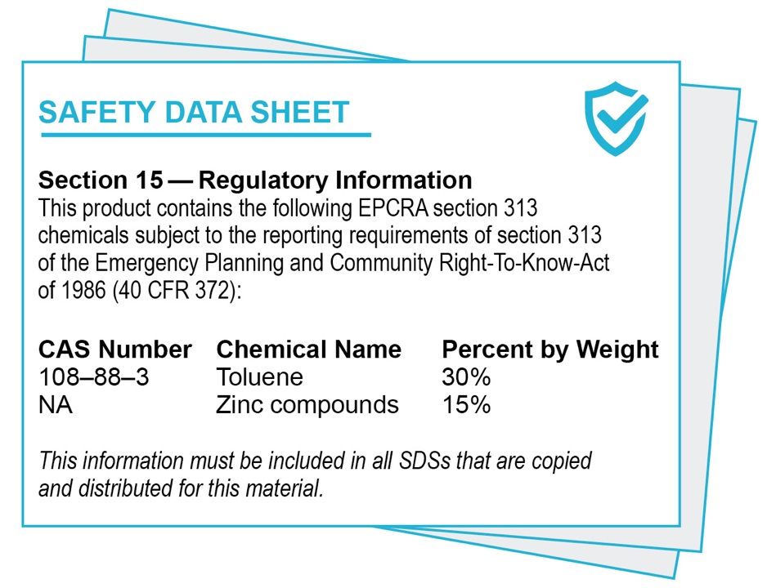
Figure 1: Example Supplier Notification Within an SDS

