Attachment A

SAMHSA SOAR Web-Based Data Form

Part I: SSI/SSDI Application Outcomes

Screenshots of the Current Form

Registration Page for New Users to the System
New users, who are caseworkers, agency directors, local leads, or state leads, need to complete and submit this registration form. Users create a username and password, select their role, location, funding source and SOAR training completed.
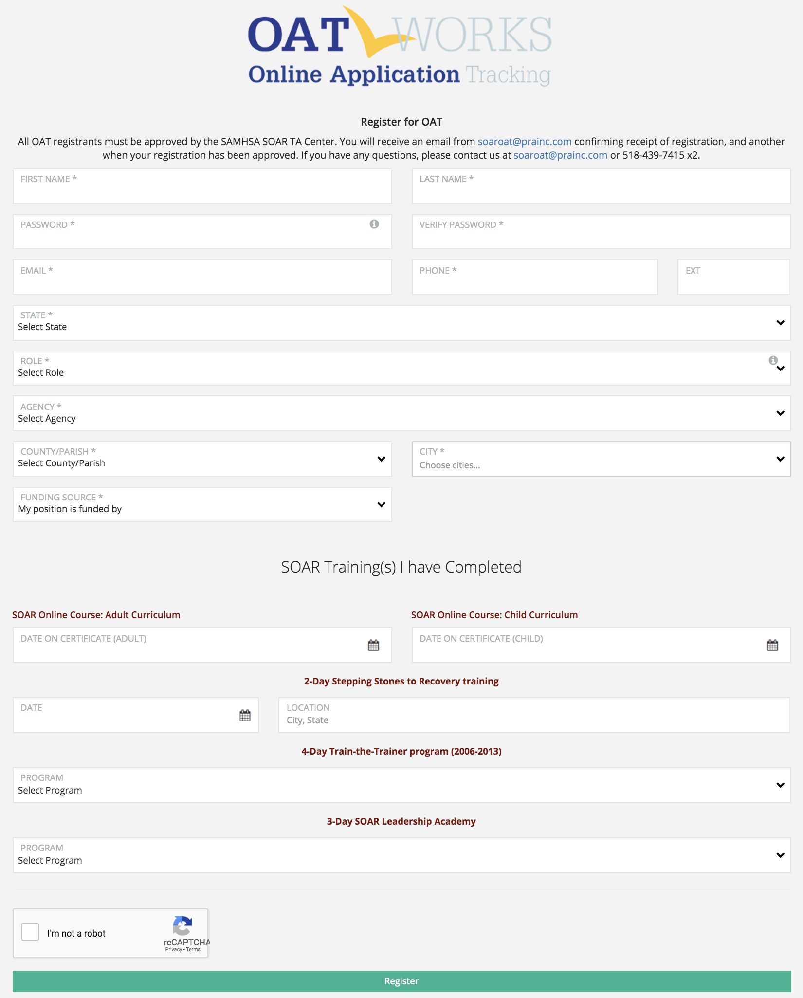
Demographic Information
The demographic information on each applicant is collected on this screen. Basic information including gender, age, military service, benefits received, employment status and housing status are included.

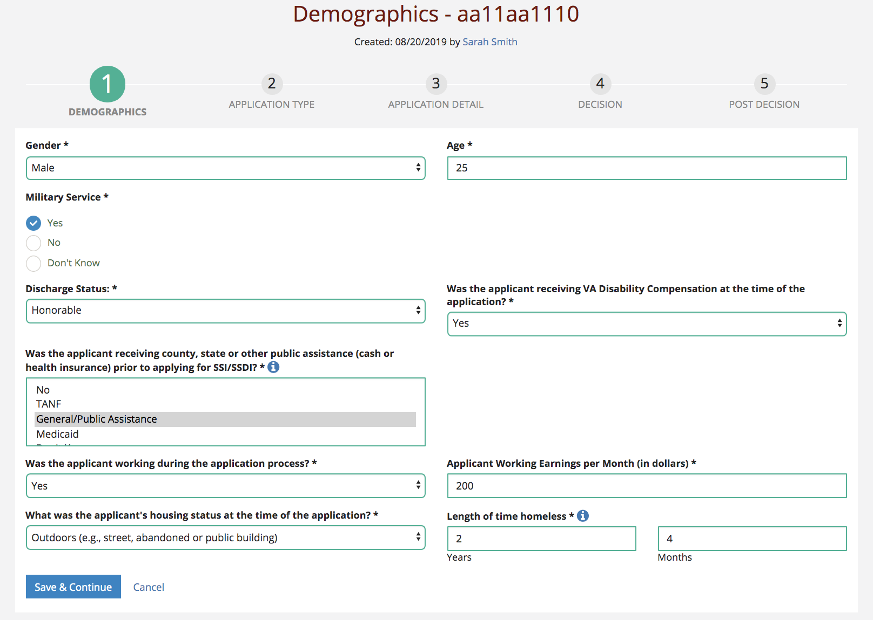

Application Type
The second section asks about the application type. There are four types: initial, reconsideration, ALJ hearing and non-SOAR claim.

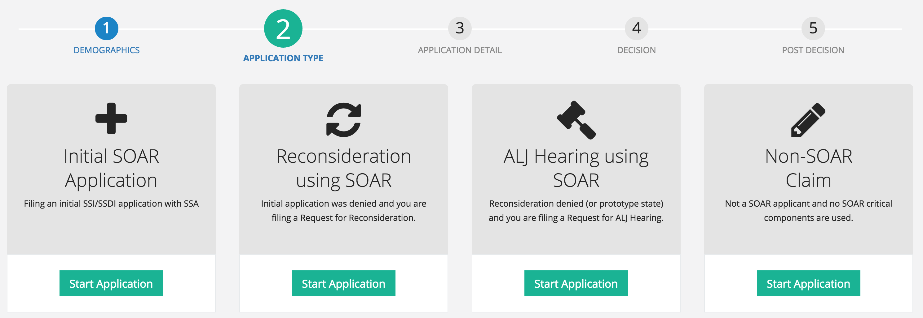

Application Detail
The third section asks a few questions about what SOAR critical components were used while assisting with the application. Questions include the protective filing date, forms and records that are submitted, whether quality review was done, if the application is complete, if consultative exams were ordered, (and if so, the total number), and the application date.
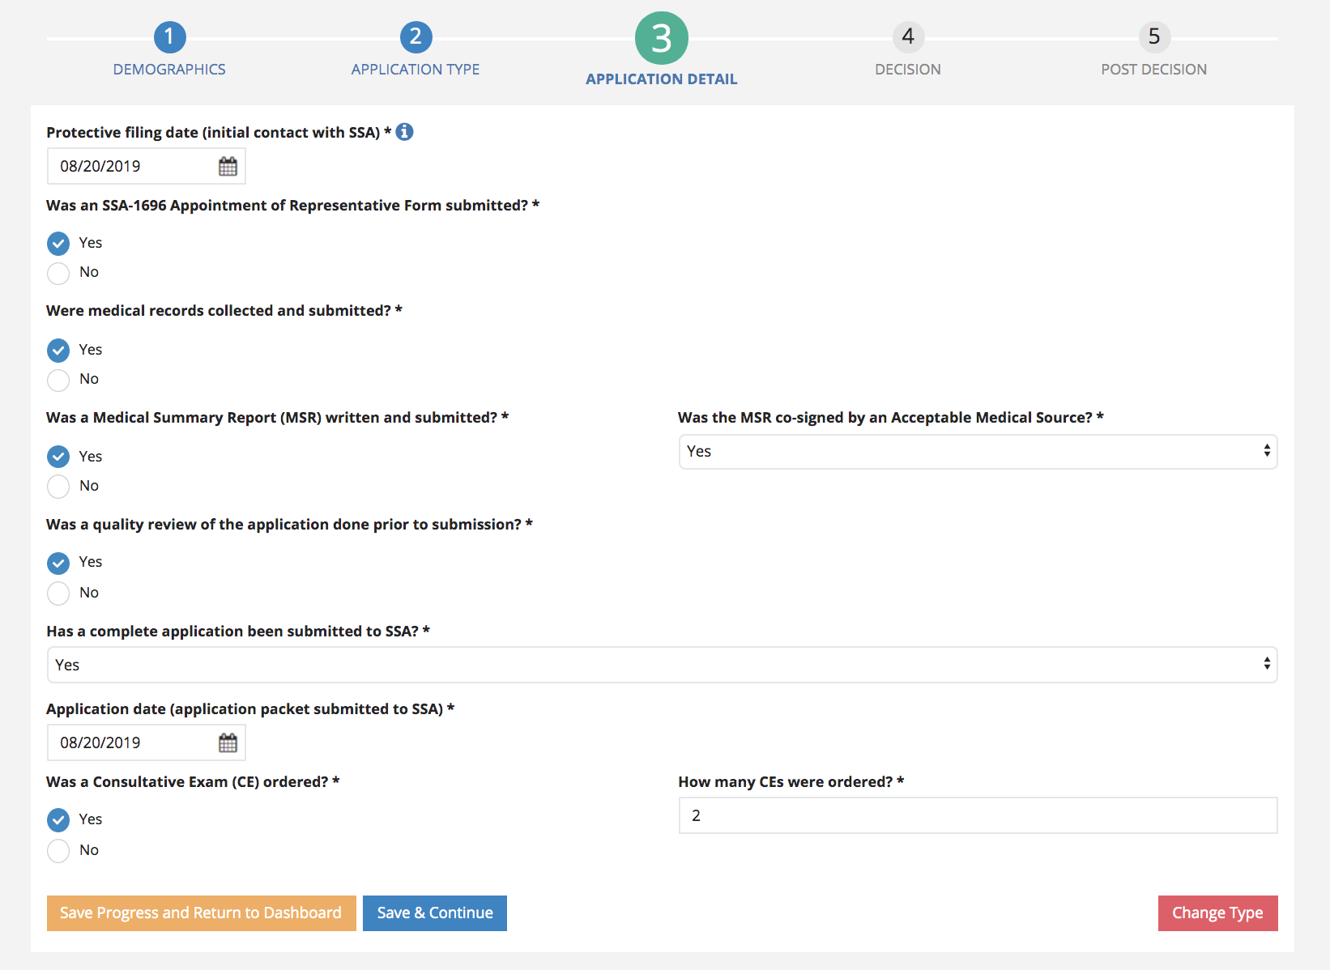

Decision
These questions ask if there has been notification of a decision, the date of the decision, and if denied, whether an appeal was filed.
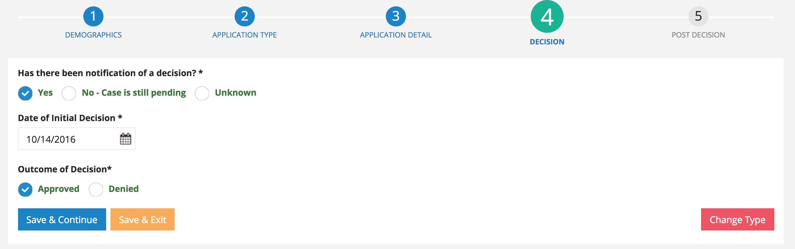

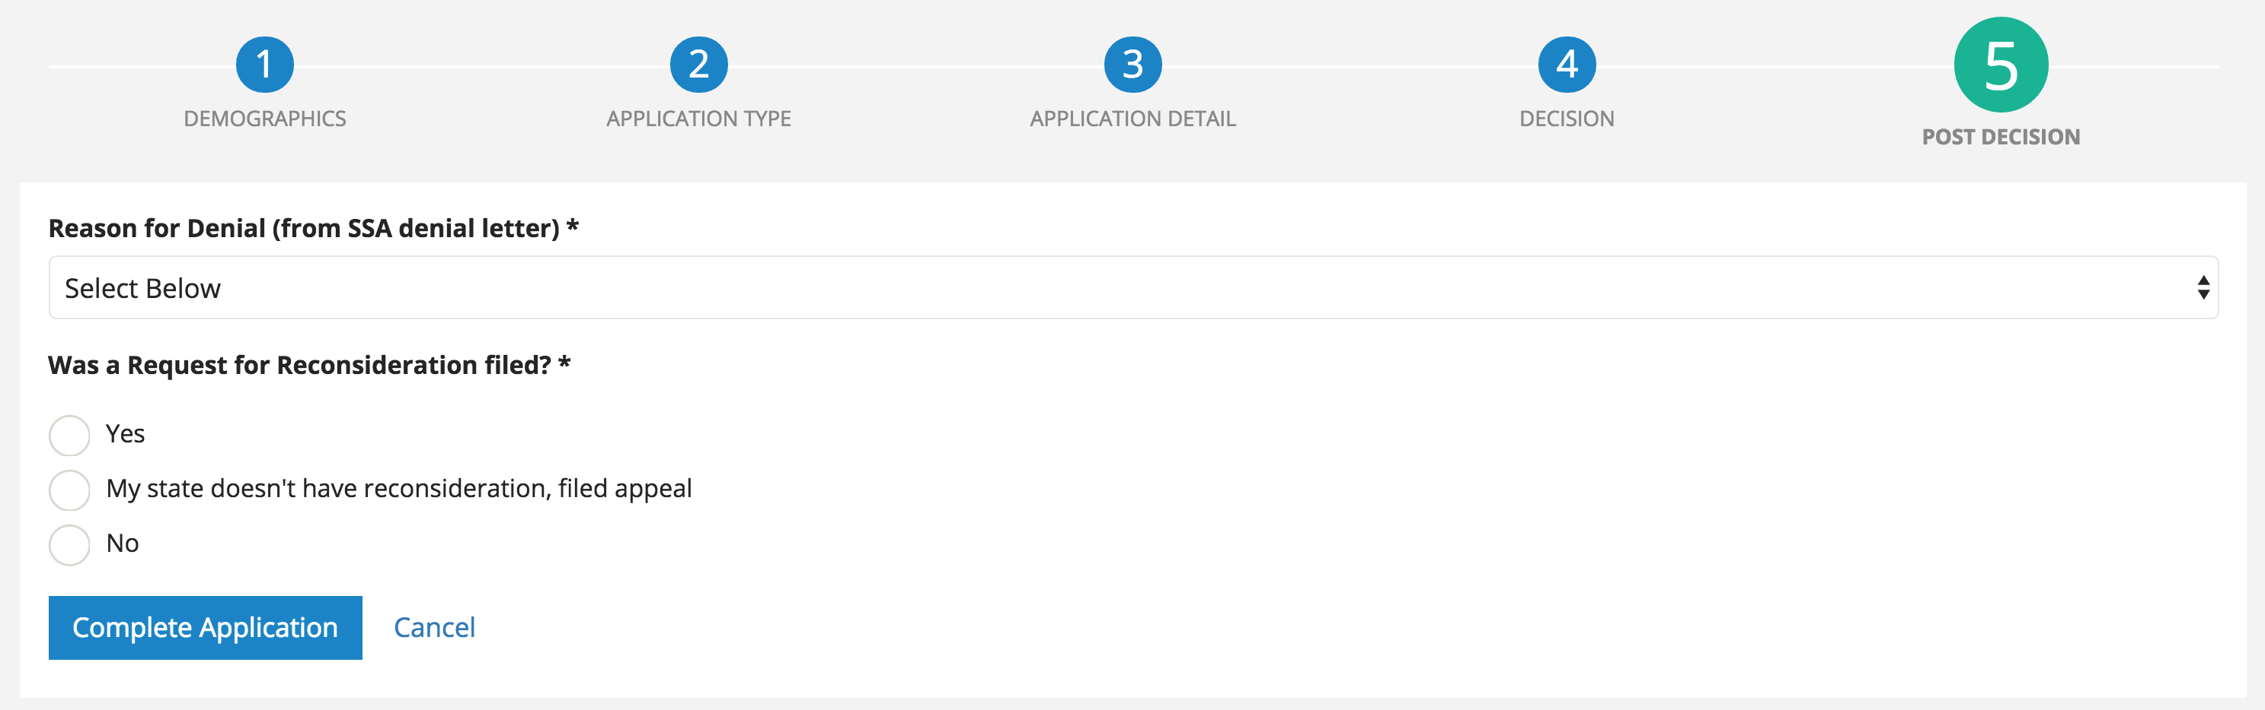

Post Decision
Most of the questions that are asked post-decision are optional for the user. They are asked the amount the applicant was approved for, and then can optionally track other reimbursement amounts and qualitative outcomes including housing status, employment status and hours to complete the claim.
