Individual Information Collection Request
Under GSA’s Generic Clearance: Improving Customer Experience - Implementation of Section 280 of OMB Circular A-11
OMB Control No. 3090-002

SCREENSHOTS:

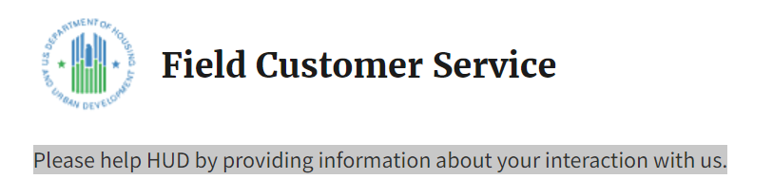

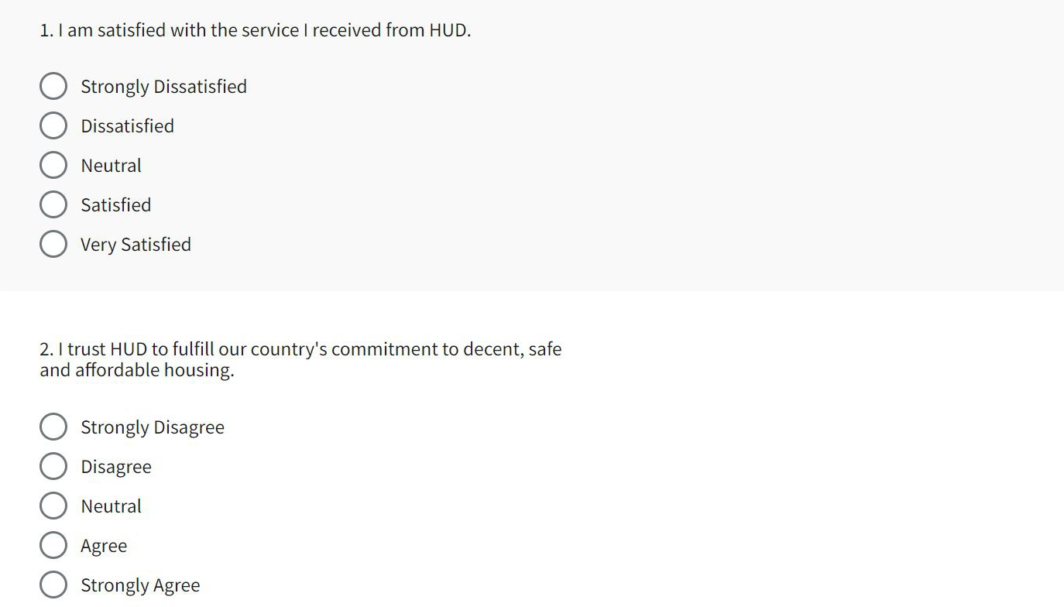
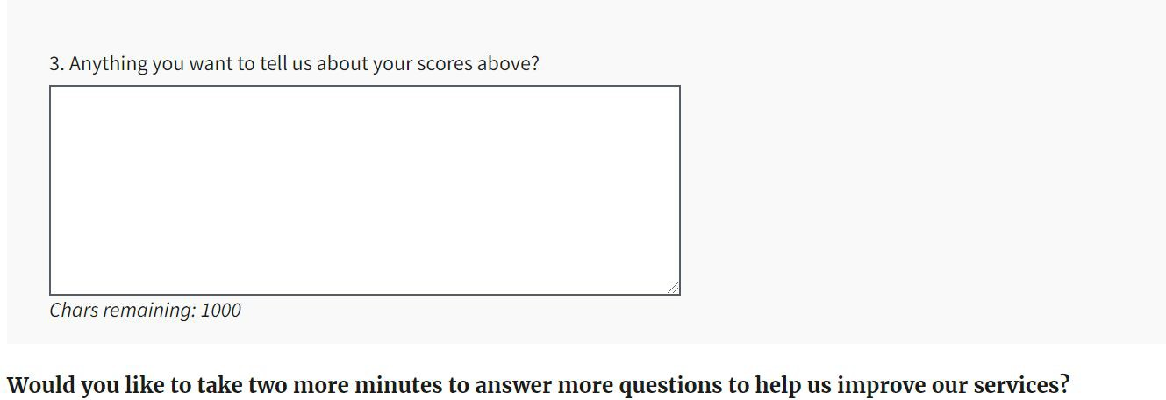
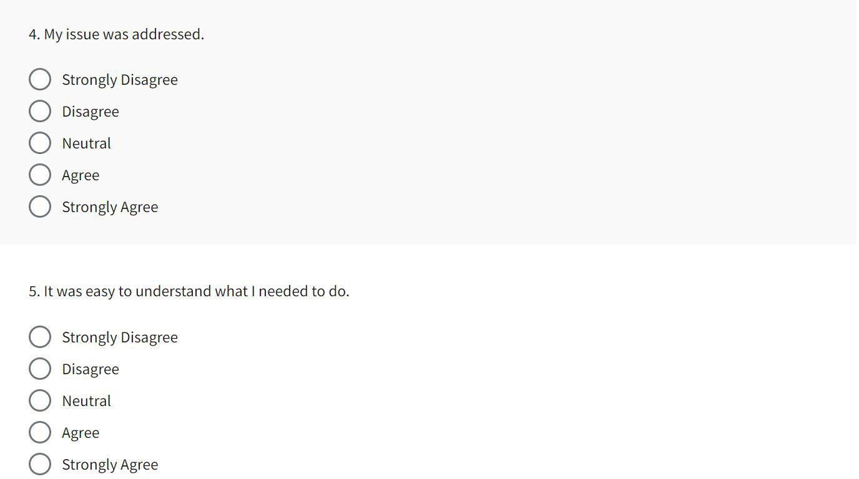

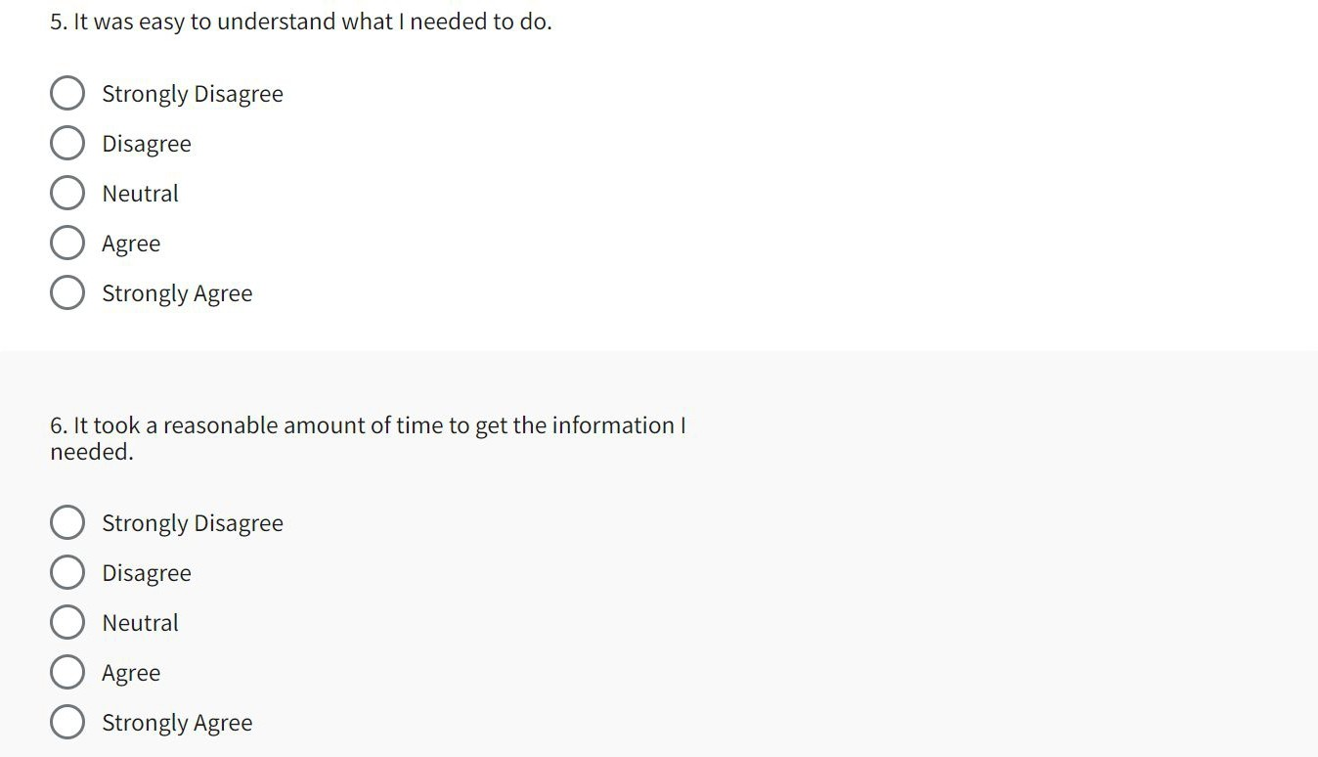

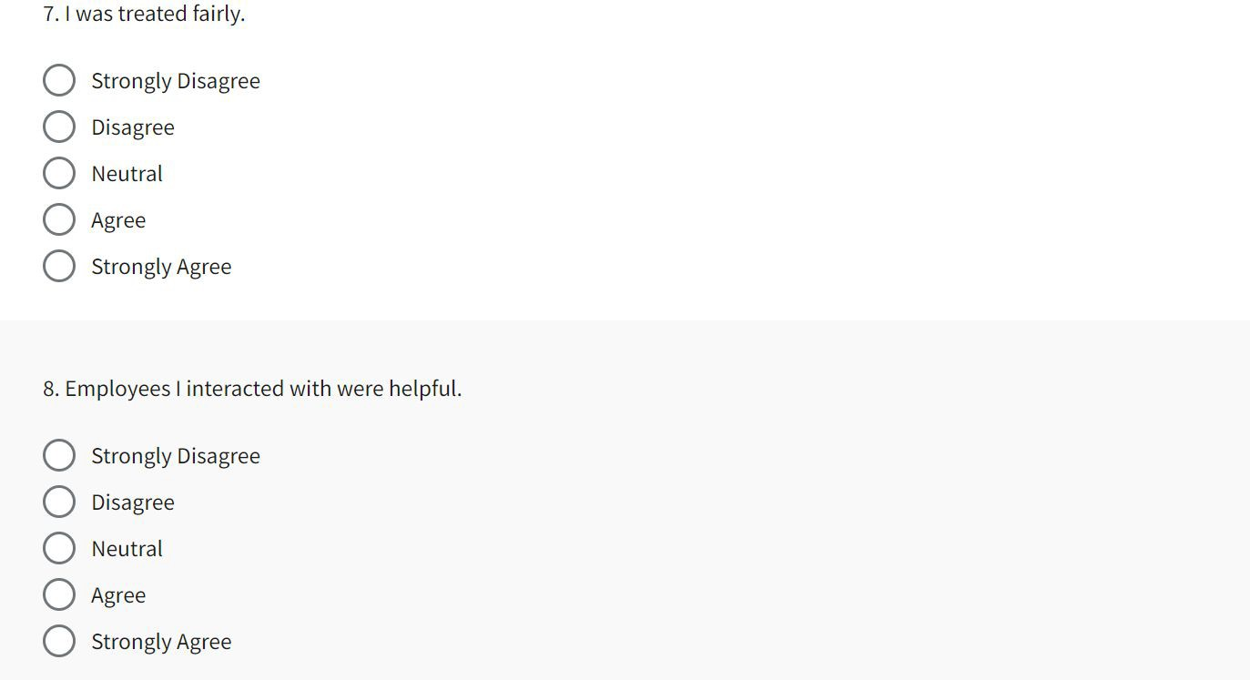

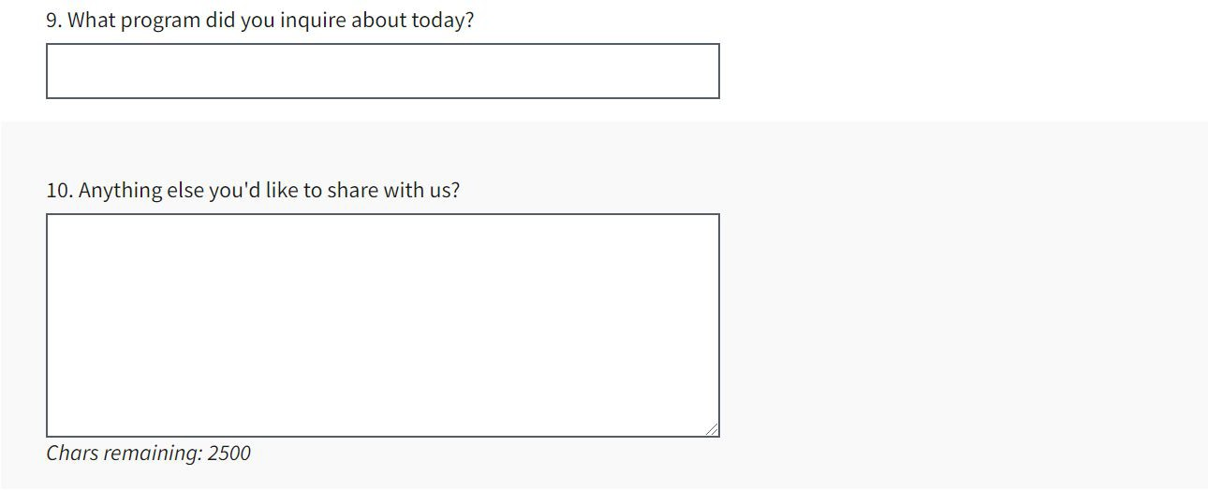

ADMINISTRATION DETAILS:
The following will be displayed on this Touchpoints survey:

OMB Control No. 0690-0030, Expiration Date: XX/XX/XXXX

