Supporting Document - Screenshot
Air Taxi and Commercial Operator Airport Activity Survey (FAA Form 1800-31) (OMB Control Number: 2120-0067)

FAA Electronic submittal Screenshots – July 2021

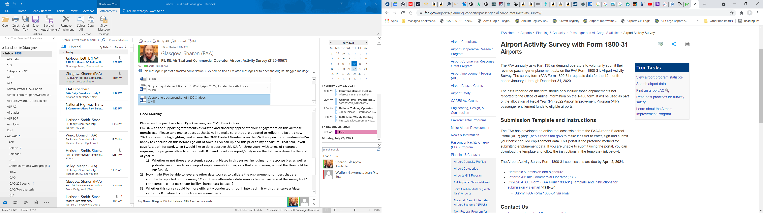

FAA Electronic submittal Screenshots – July 2021
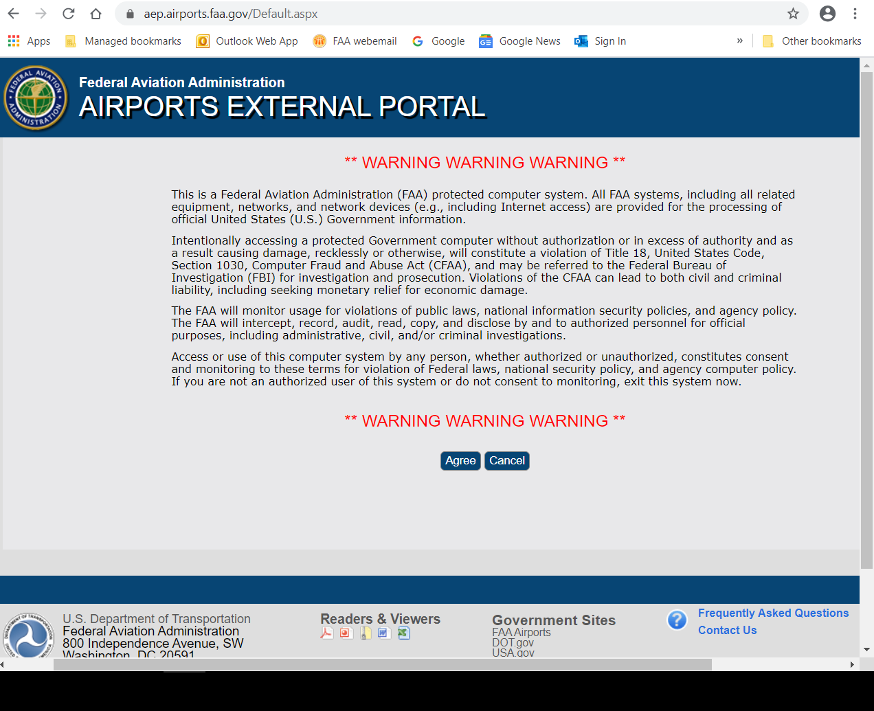

FAA Electronic submittal Screenshots – July 2021

